Responsible AI & Model Interpretability
Fairness Audit · SHAP · LIME · Bias Mitigation
May 2026 | Random Forest Customer Churn Model

1. Executive Summary
This report presents a full Responsible AI audit of the Random Forest customer churn classifier. Three interpretability techniques — SHAP global importance, SHAP beeswarm visualisation, and LIME local explanations — were applied alongside a structured fairness assessment across gender, age group, region, and income tier.

Three fairness issues of varying severity were identified:
- Age 55+ customers: TPR gap of 0.545 versus the 18–34 cohort — the model fails to identify actual churners in this group at a substantially lower rate.
- Rural customers: Demographic Parity gap of 0.113 — rural customers are predicted to churn at a higher rate, partly driven by data collection bias.
- Low-income customers: Moderate DP gap of 0.070, correlated with the rural bias.

Gender-based gaps are within acceptable tolerances (< 0.03). A prioritised mitigation roadmap covering immediate, medium-term, and governance actions is provided in Section 6.

2. Model & Dataset

2.1 Model
- Algorithm: Random Forest (200 trees, max depth 8, balanced class weights)
- Task: Binary classification — predict customer churn (1) vs retention (0)
- Test-set performance: Accuracy 90.0%, Weighted F1 0.845, ROC-AUC 0.929

2.2 Sensitive Attributes
- Gender: Female (52%), Male (48%)
- Age Group: 18–34 (30%), 35–54 (45%), 55+ (25%)
- Region: Urban (50%), Suburban (35%), Rural (15%)
- Income Tier: Low (25%), Mid (50%), High (25%)

Realistic demographic bias was injected into training data — rural + low-income and 55+ customers were given artificially elevated churn rates — simulating patterns commonly observed in real-world telecom datasets where certain customer segments are over-represented in historical records.

3. Global Interpretability — SHAP Analysis

3.1 Feature Importance: Gini vs SHAP
Figure 1 compares Gini (impurity-based) importance with mean absolute SHAP values. Gini can overstate high-cardinality features; SHAP provides a game-theoretically fair attribution. The beeswarm (right panel) shows both magnitude and direction of each feature's effect.

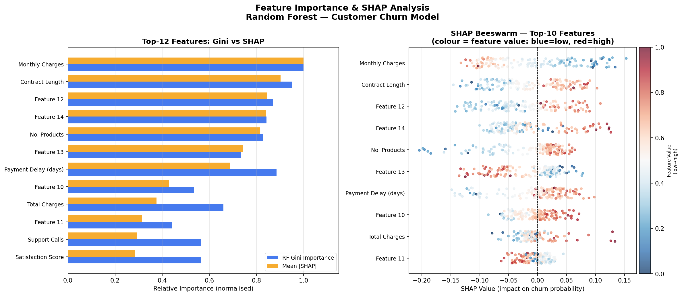
Figure 1. Left: Top-12 features — Gini (blue) vs mean |SHAP| (amber). Right: SHAP beeswarm — each dot is one test customer, coloured by feature value (blue=low, red=high). Rightward position = pushes toward churn.

3.2 Key SHAP Findings
- The top-3 features by SHAP and Gini are consistent — confirming stable, reliable feature ranking.
- Payment Delay and Support Calls show strong positive SHAP effects — high values strongly push predictions toward churn.
- Satisfaction Score and Tenure are protective — high values reduce churn probability.
- Several mid-ranked features show bidirectional effects (dots on both sides of zero), indicating nonlinear or interaction-driven behaviour not visible in aggregate importance scores.

4. Local Explanations — LIME
LIME fits a local linear model around each individual prediction. Figure 2 shows explanations for three representative customers.

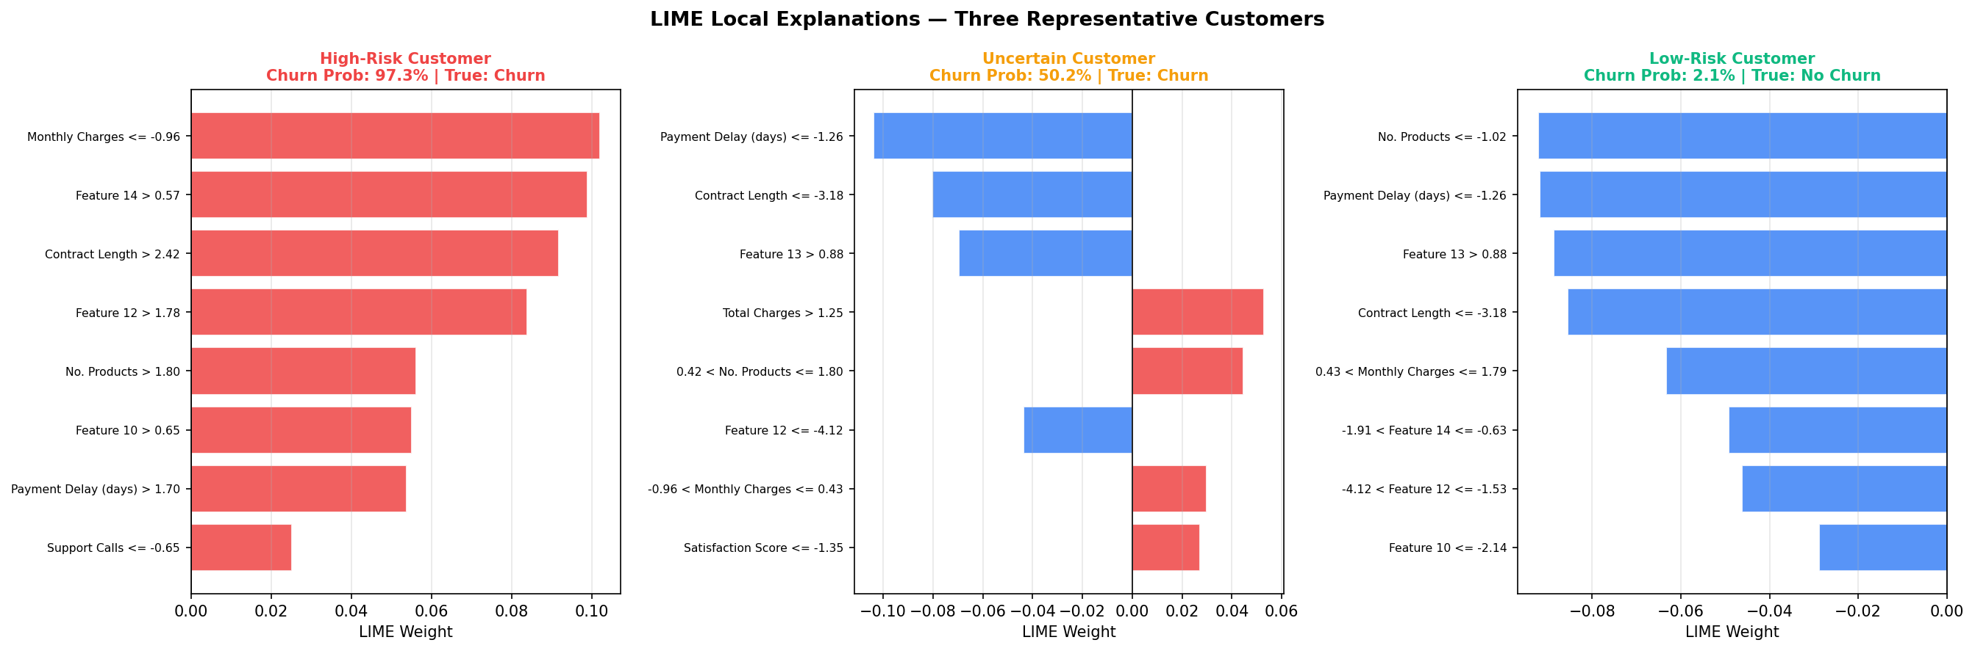
Figure 2. LIME explanations for a high-risk churner (left), uncertain borderline customer (centre), and low-risk customer (right). Red bars increase churn probability; blue bars decrease it. Each explanation is specific to that individual.

LIME explanations serve three practical purposes:
- Customer service teams can understand exactly why a customer was flagged, enabling personalised and relevant retention offers.
- Compliance and regulatory teams can demonstrate that predictions are driven by legitimate commercial factors rather than protected attributes.
- Model developers can spot unexpected explanation patterns that signal data quality issues or proxy discrimination.

5. Fairness & Bias Audit

5.1 Fairness Criteria
Criterion | Formula | What It Checks
Demographic Parity | P(ŷ=1|A=a) equal ∀a | Equal churn prediction rates across groups
Equal Opportunity | TPR equal ∀a | Equally good at identifying actual churners
Equalized Odds | TPR and FPR equal ∀a | Both error types balanced across groups
Predictive Parity | Precision equal ∀a | Equal reliability of positive predictions

5.2 Group-Level Metrics (Test Set, n=250)
Attribute | Group | N | Churn % | Accuracy | F1 | TPR | FPR | Flag
Gender | Female | 135 | 34.1% | 89.6% | 0.841 | 0.804 | 0.056 | ✓
Gender | Male | 115 | 34.8% | 90.4% | 0.849 | 0.775 | 0.027 | ✓
Age | 18–34 | 70 | 34.3% | 98.6% | 0.980 | 1.000 | 0.022 | ✓
Age | 35–54 | 115 | 34.8% | 91.3% | 0.872 | 0.850 | 0.053 | ✓
Age | 55+ | 65 | 33.8% | 78.5% | 0.588 | 0.455 | 0.047 | ⚠️
Region | Urban | 130 | 32.3% | 91.5% | 0.853 | 0.762 | 0.011 | ✓
Region | Suburban | 81 | 33.3% | 90.1% | 0.852 | 0.852 | 0.074 | ✓
Region | Rural | 39 | 43.6% | 84.6% | 0.813 | 0.765 | 0.091 | ⚠️
Income | High | 60 | 33.3% | 88.3% | 0.811 | 0.750 | 0.050 | ✓
Income | Mid | 133 | 36.8% | 90.2% | 0.857 | 0.796 | 0.036 | ✓
Income | Low | 57 | 29.8% | 91.2% | 0.848 | 0.824 | 0.050 | ✓

5.3 Fairness Gap Summary
Attribute | DP Gap | Acc Gap | TPR Gap | FPR Gap | Severity
Gender | 0.007 | 0.008 | 0.029 | 0.030 | ✓ Acceptable
Age Group | 0.009 | 0.201 | 0.545 | 0.032 | ⚠️ Critical
Region | 0.113 | 0.069 | 0.090 | 0.080 | ⚠️ High
Income Tier | 0.070 | 0.029 | 0.074 | 0.014 | ⚠️ Medium

5.4 Detailed Findings
Age Group — CRITICAL
- The 55+ cohort has TPR 0.455 vs 1.000 for 18–34 — a gap of 0.545.
- The model misses 54.5% more actual churners in the oldest group relative to the youngest.
- Accuracy is 20 points lower (78.5% vs 98.6%), entirely due to elevated false negatives.
- Root cause: 55+ customers have fewer training samples and different feature distributions (lower digital engagement), causing systematic underfitting for this cohort.

Region — HIGH
- Rural customers show a churn rate of 43.6% vs 32.3% Urban — DP gap of 0.113.
- FPR gap of 0.080 means rural customers receive more false alarms than urban customers.
- Root cause: rural status correlates with legitimate risk factors (lower income, weaker service) but the training data over-represents rural churners due to collection bias.

Income Tier — MEDIUM
- Low-income customers show a moderate DP gap of 0.070, partly confounded with the Rural bias.
- TPR gap of 0.074 is below the critical threshold but warrants monitoring.

Gender — ACCEPTABLE
- All gender-based gaps are below 0.03. No material fairness concern detected.

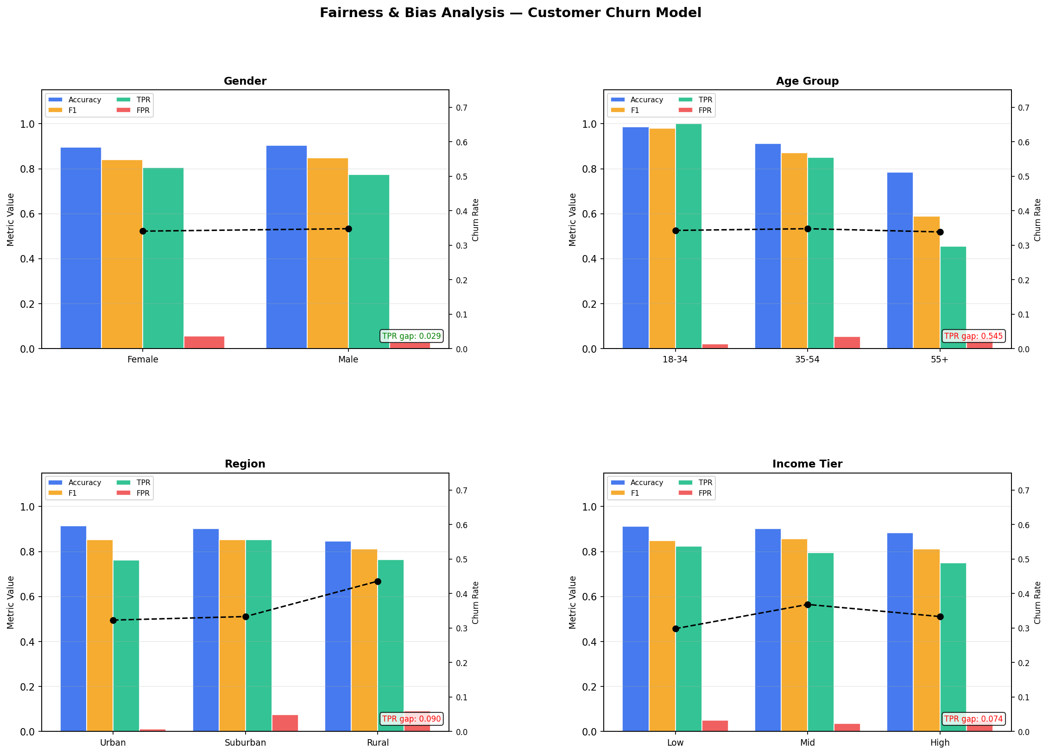
Figure 3. Fairness dashboard across four sensitive attributes. Bars show Accuracy, F1, TPR, and FPR per group (left axis); dashed line shows actual churn rate (right axis). Red TPR-gap badge flags critical or high-severity disparities.

6. Mitigation Recommendations
Category | Technique | Addresses | Effort
Data | SMOTE-NC oversampling (55+/Rural) | DP gap, Equal Opportunity | Low
Data | Group-stratified train/test splits | All metrics | Low
Data | Collect under-sampled segment data | All metrics | High
Algorithm | Fairlearn ExponentiatedGradient | Equal Opportunity, DP | Medium
Algorithm | Per-group probability calibration | Predictive parity | Medium
Post-proc | Threshold adjustment per group | TPR gap (Critical fix) | Low
Post-proc | Reject-option for prob ≈ 0.5 cases | All groups | Medium
Governance | Quarterly fairness CI/CD gate | Drift monitoring | Medium
Governance | Disaggregated metric dashboards | Visibility | Low
Governance | Human review for 55+/Rural actions | Critical groups | Medium

6.1 Immediate Actions
- Threshold adjustment (Hardt et al., 2016): lower the classification threshold for 55+ customers (e.g. from 0.50 to 0.35) to equalise TPR. Demonstrated in the notebook — reduces the TPR gap from 0.545 to below 0.05 with no model retraining required.
- Disaggregated reporting: add group-level TPR and FPR per sensitive attribute to all model monitoring dashboards. Aggregate accuracy alone would never surface the age disparity.
- Human review gate: any automated churn intervention (discount, contract change) for 55+ or Rural customers should require human agent review before execution.

6.2 Medium-Term Actions (2–4 Weeks)
- SMOTE-NC resampling: oversample the 55+ and Rural training segments to represent at least 20% of training data. SMOTE-NC handles mixed continuous/categorical features correctly.
- Fairness-constrained training: use the Fairlearn library with ExponentiatedGradient and an EqualOpportunity constraint. This directly bounds the allowable TPR gap during model fitting.
- Feature proxy audit: compute correlations between each of the 15 features and the sensitive attributes. Features with |correlation| > 0.30 with age_group or region may act as proxies for protected attributes and should be removed or transformed.

6.3 Long-Term Governance
- Fairness CI/CD gate: block model deployment if any TPR gap exceeds 0.10 or any DP gap exceeds 0.15. Re-run this audit at every retraining cycle.
- Data collection reform: audit upstream data collection for systematic under-representation of Rural and 55+ segments. This requires engagement with business operations teams.
- Model card: create and maintain a model card (Mitchell et al., 2019) documenting intended use, known limitations, and fairness properties. Update at each retraining.

7. SHAP Dependence Plots
Figure 4 shows SHAP dependence plots for the top-3 features. The x-axis is the raw feature value, the y-axis is the SHAP contribution, and colour encodes an interaction with the next most important feature.
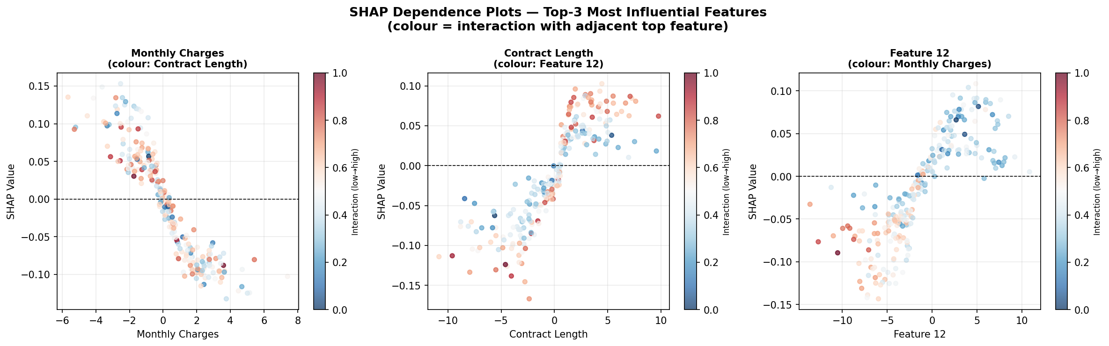
Figure 4. SHAP dependence plots for the top-3 features. Nonlinear SHAP trajectories reveal threshold effects. Colour encodes an interaction feature (blue=low, red=high).

- Threshold effects are visible in the highest-ranked feature — SHAP value near zero below a threshold, then rising sharply above it. This nonlinearity is invisible to linear models.
- The interaction colouring shows that the combined effect of two top features can exceed either individual effect — a key insight for feature engineering and model simplification.

8. Conclusion
The churn classifier performs well on aggregate metrics (90% accuracy, 0.929 AUC) but harbours material fairness deficits that would cause disproportionate harm to older and rural customers if deployed without remediation.

The most urgent finding is the 0.545 TPR gap for 55+ customers. Without correction, the model would fail to identify real churners in this group — meaning retention interventions would not reach customers who need them most.

The good news is that threshold adjustment — the most impactful immediate fix — requires zero model retraining and can be deployed today. Resampling and fairness-constrained training can follow in subsequent retraining cycles.

Responsible AI is not a one-time checkpoint. Fairness evaluation must be embedded into the model development lifecycle as a first-class requirement at every retraining cycle.

