**Assignment 1**

**Simple SQL Query with a single table with where clause.**

* **Products Schema:**

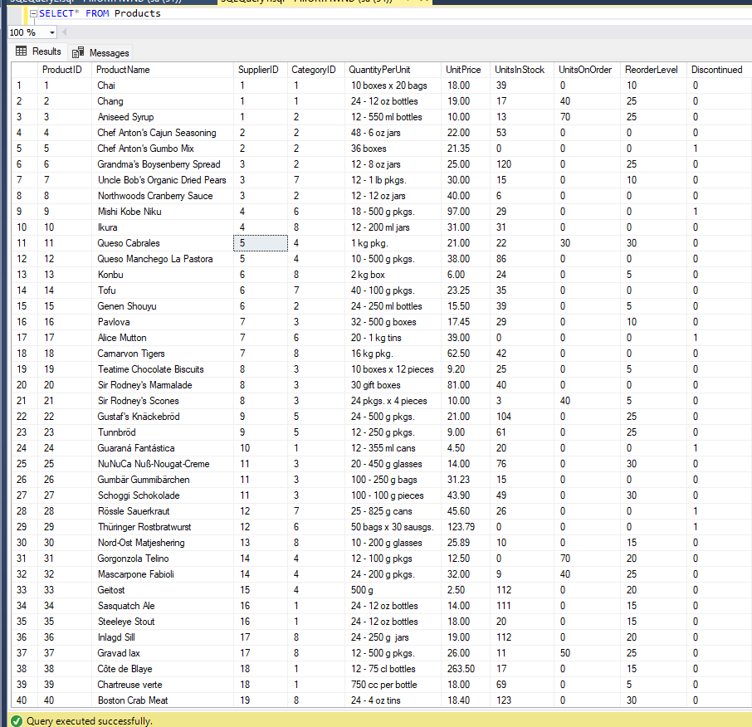

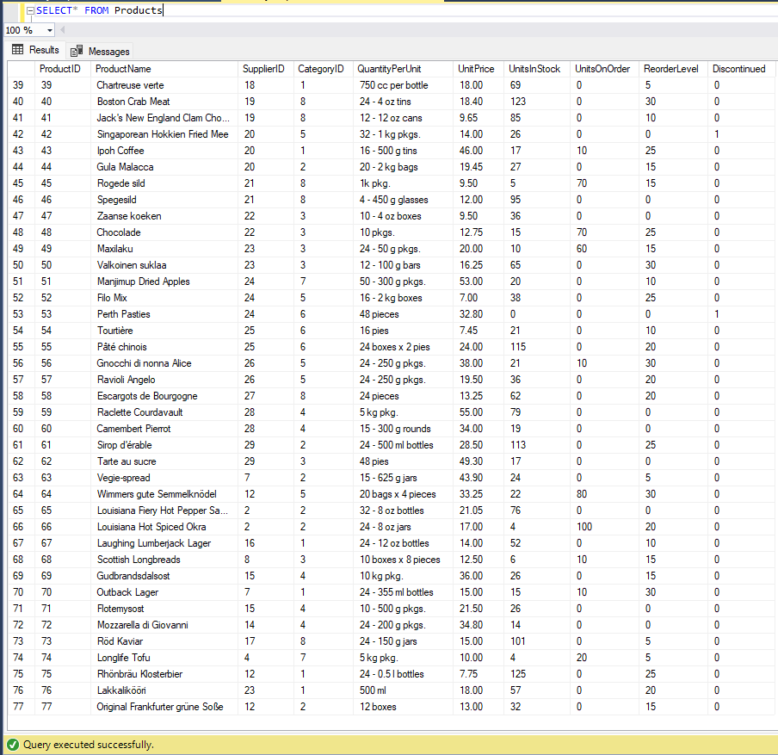

1. **Write a query to get a Product list (id, name, unit price) where current products cost less than $20.**

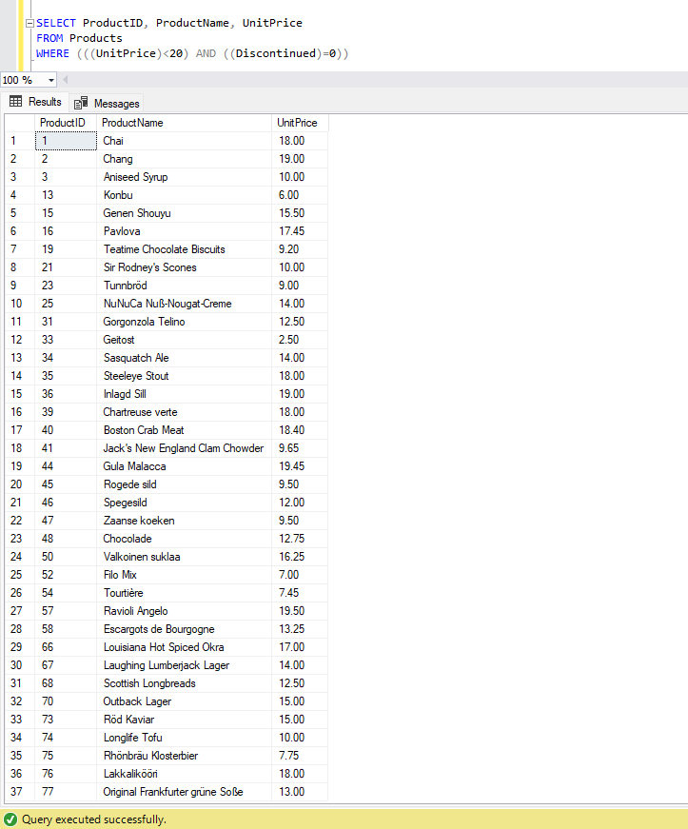

1. **Write a query to get Product list (id, name, unit price) where products cost between $15 and $25.**

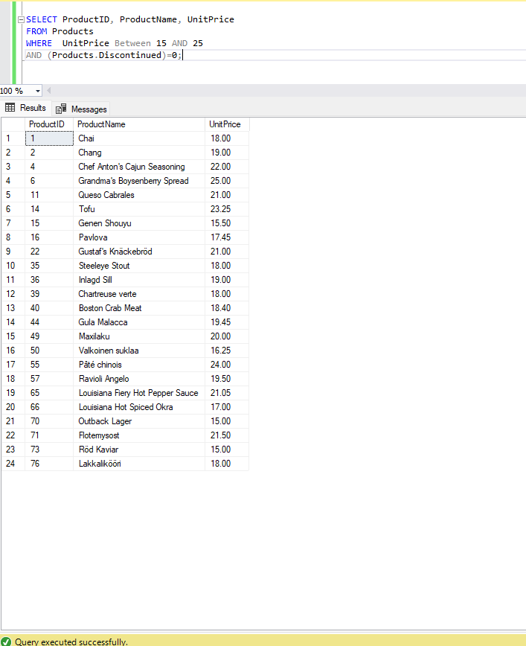

1. **Write a query to get Product list (name, unit price) of above average price.**

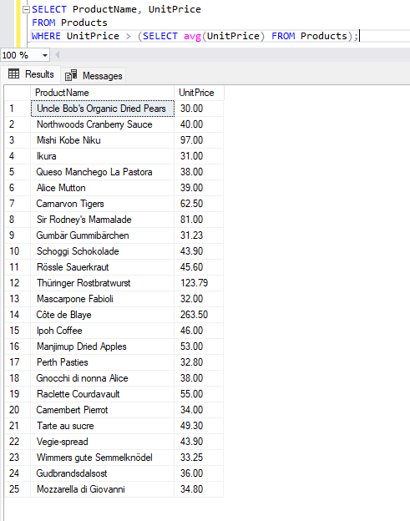

1. **Write a query to get Product list (name, unit price) of ten most expensive products.**

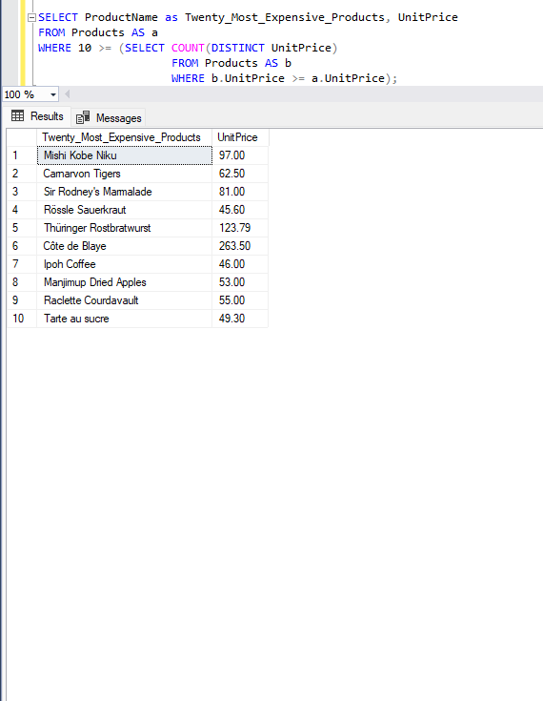

1. **Write a query to count current and discontinued products.**

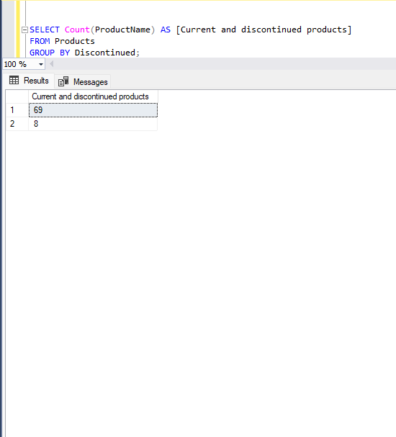

1. **Write a query to get Product list (name, units on order, units in stock) of stock is less than the quantity on order.**

