**Assignment 3**

**Retrieve data using Group By clause.**

**Sample table1: Department**

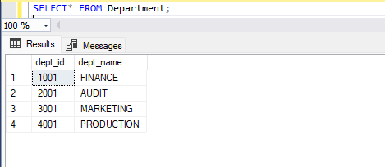

**Sample table2: Employee**

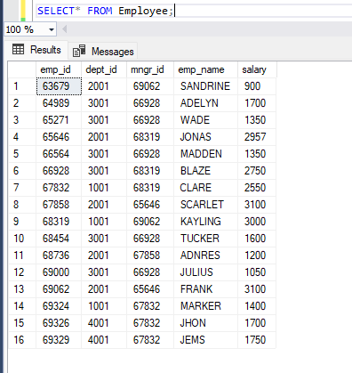

1. **write a SQL query to find Employees who have the biggest salary in their department.**

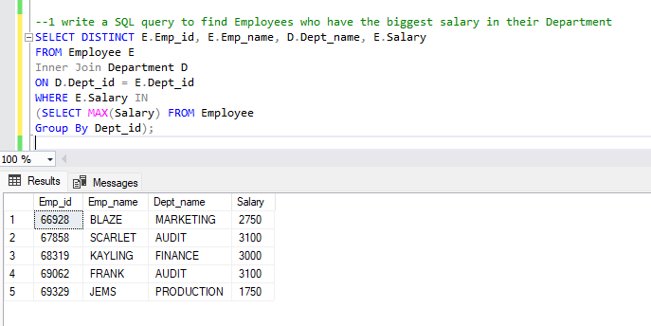

1. **write a SQL query to find Departments that have less than 3 people in it.**

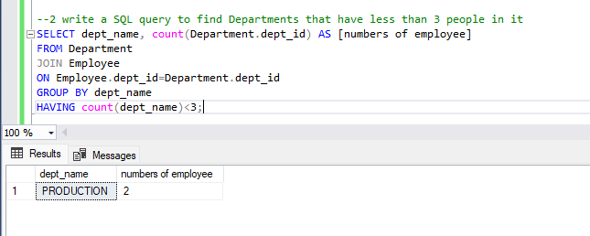

1. **write a SQL query to find All Department along with the number of people there.**

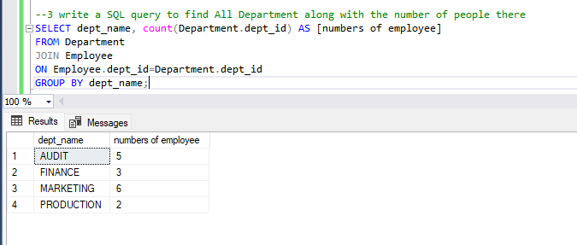

1. **write a SQL query to find All Department along with the total salary there.**

