Assignment 4
Create Stored procedure in Northwind database to insert or update a
record in a table.

1. Create a stored procedure in the Northwind database that will calculate the average value of Freight for a specified customer. Then, a business rule will be added that will be triggered before every Update and Insert command in the Orders controller, and will use the stored procedure to verify that the Freight does not exceed the average freight. If it does, a message will be displayed and the command will be cancelled.

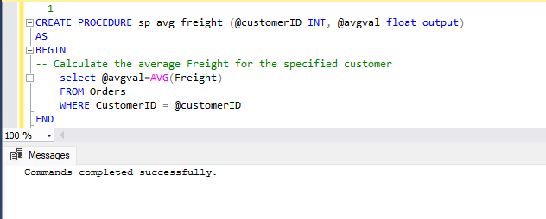
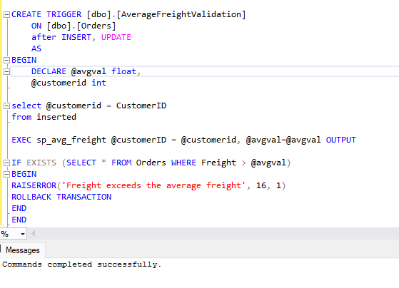
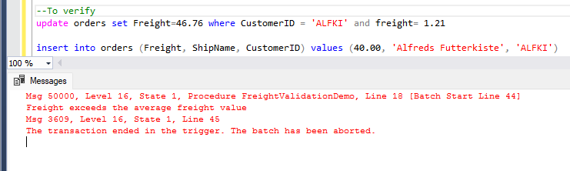
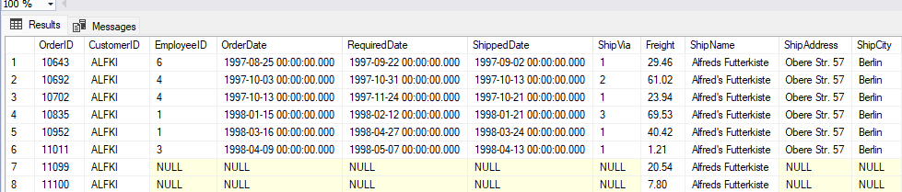

2. write a SQL query to Create Stored procedure in the Northwind database to retrieve Employee Sales by Country.

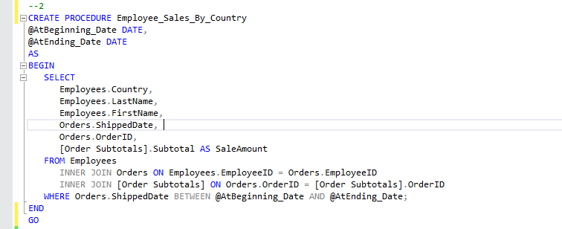

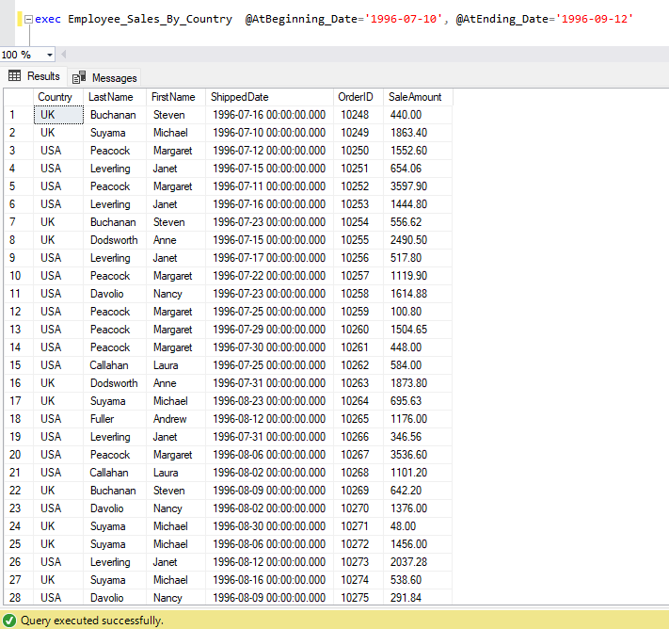
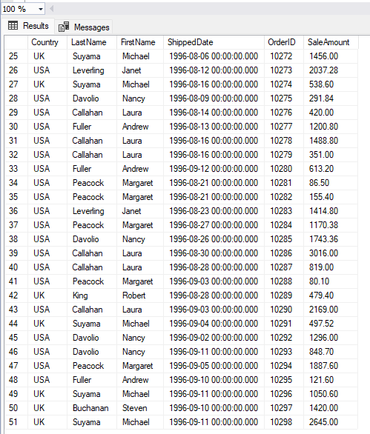
3. write a SQL query to Create Stored procedure in the Northwind database to retrieve Sales by Year.

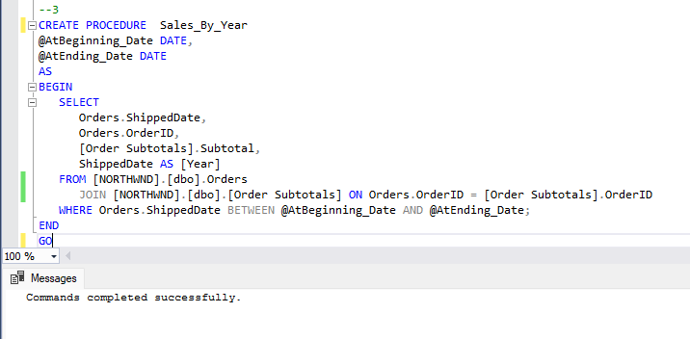
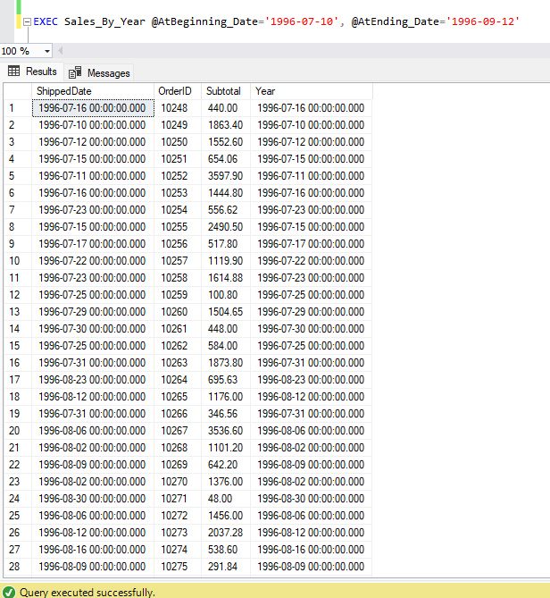
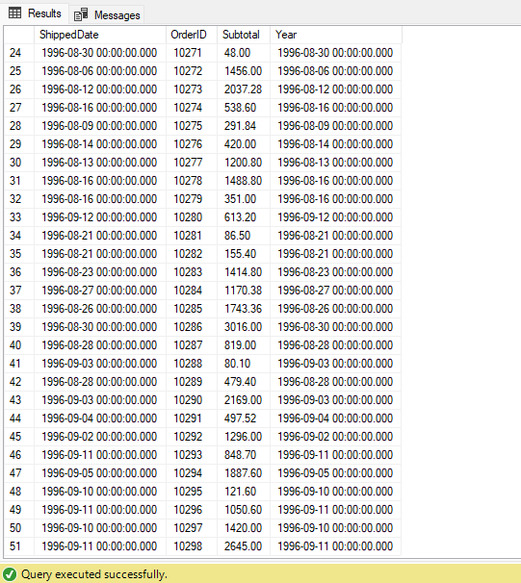

4. write a SQL query to Create Stored procedure in the Northwind database to retrieve Sales By Category.

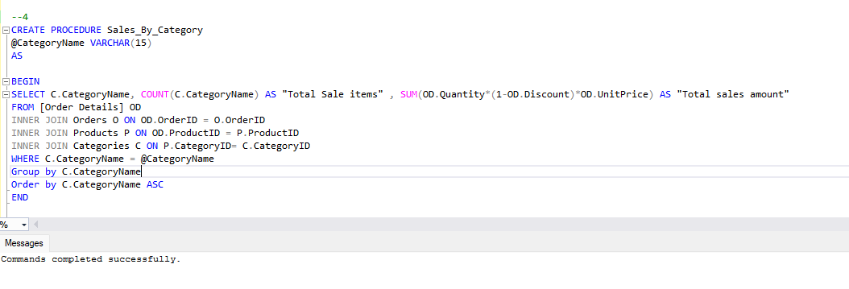
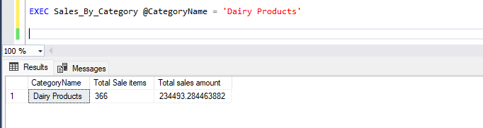
5. write a SQL query to Create Stored procedure in the Northwind database to retrieve Ten Most Expensive Products.

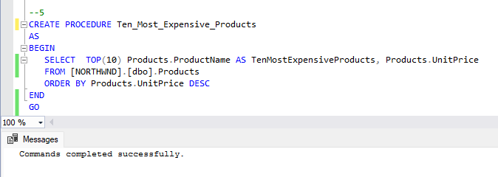

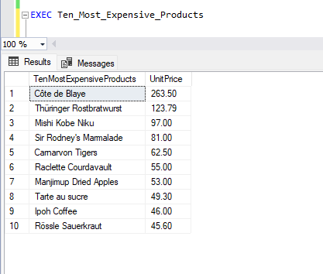
6. write a SQL query to Create Stored procedure in the Northwind database to insert Customer Order Details.

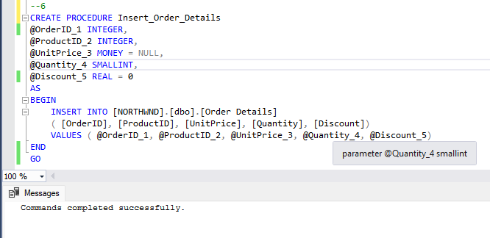
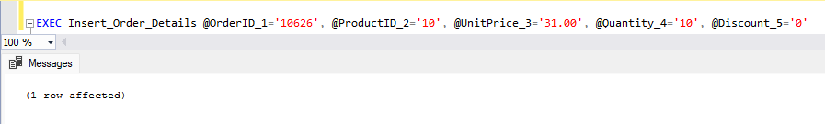
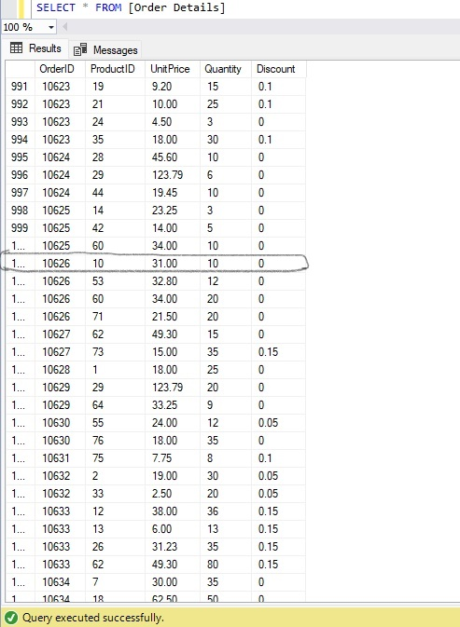
7. write a SQL query to Create Stored procedure in the Northwind database to update Customer Order Details.

