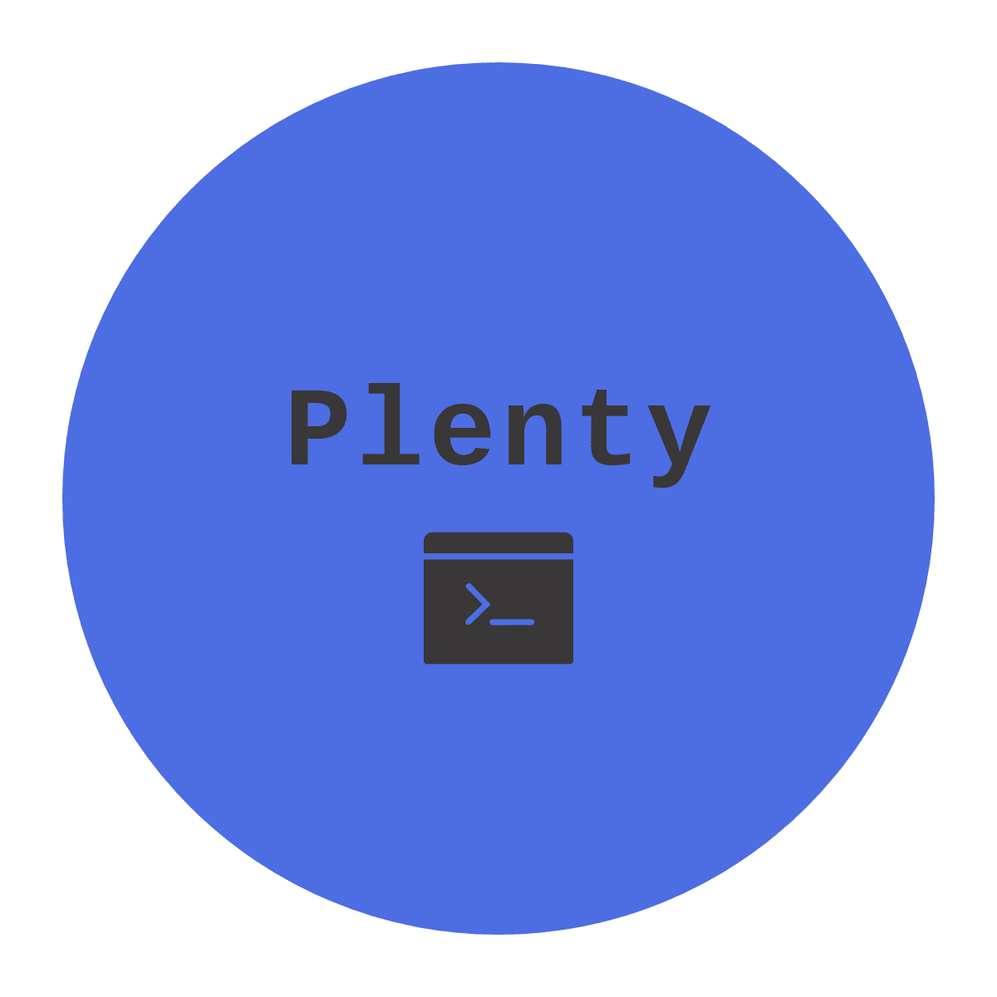

TABLE OF CONTENTS

OUR TEAM 1

OUR GOALS 1

Realization path 1

Issues passed 2

Used Technologies 2

# OUR TEAM

* **Georgi Milev** GNMilev19@codingburgas.bg (Scrum Trainer)
* **Nikola Peshev** NDPeshev19@codingburgas.bg (Back-End developer)
* **Dimitar Grudov** DHGrudov19@codingburgas.bg (Front-End developer)
* **Niya Runcheva** NSRuncheva19@codingburgas.bg (QA developer)

# OUR GOALS

* We want to make our application faster**.**
* We want to make it easier to use.
* Make it even more educational

# Realization path

* We had a meeting where we discussed what we will be doing
* We did the Back-End of the project
* Then we did the Front-End
* We made the documentation and the presentation

# Issues passed

* We had organization problems
* We had bugs in the Back-End of the project
* We had problems in the main menu of our application
* But all issues were fixed very quickly

# Used Technologies

* Teams - communication
* GitHub - source control system
* Photoshop – logo design
* Microsoft Word, PowerPoint - Documentation and presentation
* Visual Studio - Making the project