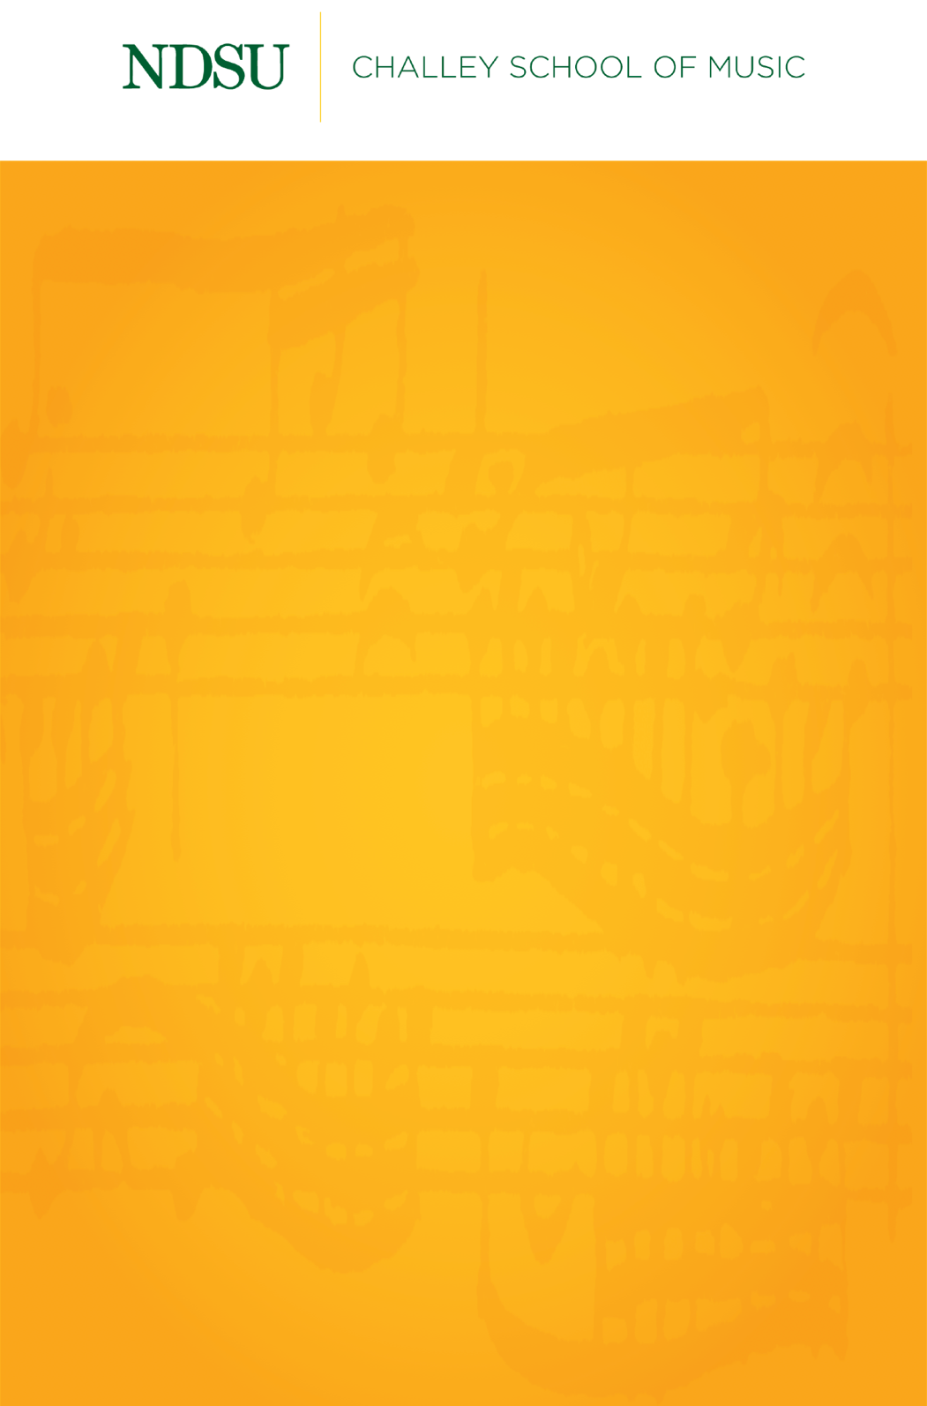

Name, Instrument

Name, Instrument

Someday, January 30, 2009

Beckwith Recital Hall

5:30 PM

*Delete italic lines before submitting*

*For works with composer:*

Title Composer

(1000 – 2000)

Performer, Instrument

*For works with arranger:*

Title Composer (1000 – 2000)

arr. Arranger

Performer, Instrument

*For works with living composers:*

Title Composer (b. 1000)

Performer, Instrument

Intermission

Title Composer

(1000 – 2000)

Title Composer

(1000 – 2000)

Title Composer

(1000 – 2000)

**NDSU Division of Performing Arts**

**Upcoming Events**

*Go to* [*https://ndsu.edu/performingarts/calendar*](https://ndsu.edu/performingarts/calendar)*, click on “Agenda,” and copy the first four events in this format:*

**Bassoon Quartet Recital**Sunday, Jun. 36 | Festival Concert Hall

**Kazoo Colloquium Concert**Monday, Jul. 15 | Beckwith Recital Hall

**Bagpipe Day**Tuesday, Oct. 16 | Festival Concert Hall

**Fargo Moorhead Flugelhorn Symphony Concert**Wednesday, Teb. 17 | Festival Concert Hall



**NDSU Performing Arts Box Office**

701.231.7969 | ndsu.performing.arts@ndsu.edu

All events subject to change.

Please visit ndsu.edu/performingarts for current event schedule.

