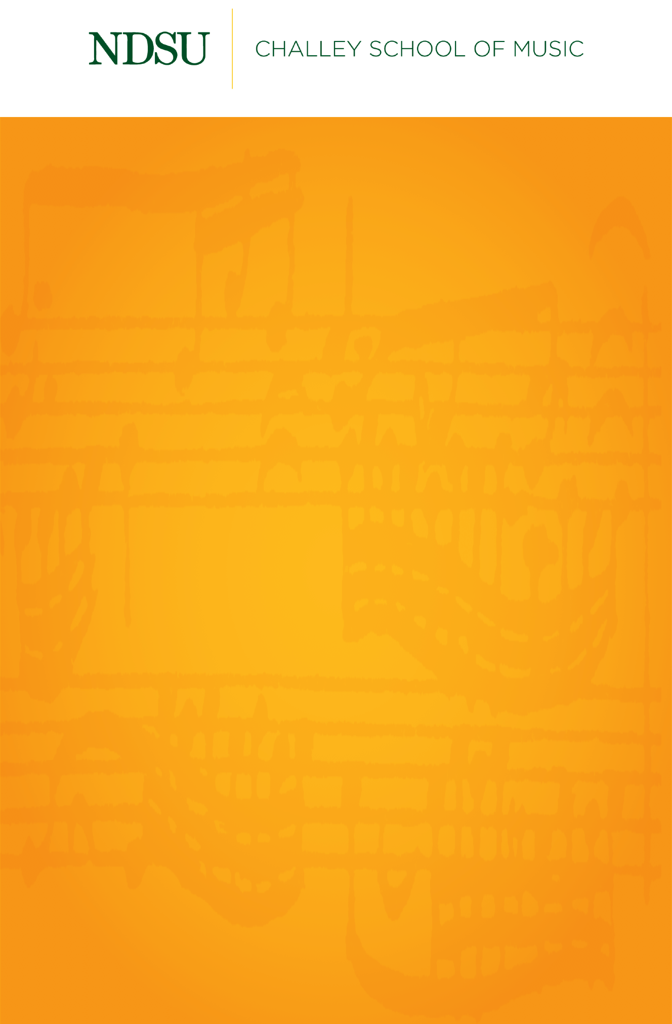

Gold Star Brass Quintet

*Featuring:*

Isaac Homuth, trumpet

Zackary Carlson, trumpet

Matthew Pasch, horn

Kate Hicks, trombone

Connor McCormick, tuba

Friday, November 6, 2020

Beckwith Recital Hall

7:30 PM

## 

## [@NDSUPerformingArts](https://www.facebook.com/NDSUPerformingArts)

**Connect with us on Facebook to stay up to date on upcoming performance and streaming opportunities.**   
  
We will not have public audiences for any indoor concerts, except for supervising faculty members and technical staff.

All performances in Beckwith Recital Hall and Festival Concert Hall will be recorded and livestreamed to the general public.

Events are subject to change.

Quintet No. 1 (Op. 5)…………………………………...………………………….…Victor Ewald

(1860-1935)

1. Moderato
2. Adagio non troppo lento
3. Allegro Moderato

Scherzo………………………………………………………………………………… John Cheetham

(b. 1939)

That’s A Plenty……………………………………………………...…………………… Lew Pollack

(1895-1946)

*The Gold Star Brass Quintet is coached by Dr. Jeremy Brekke.*