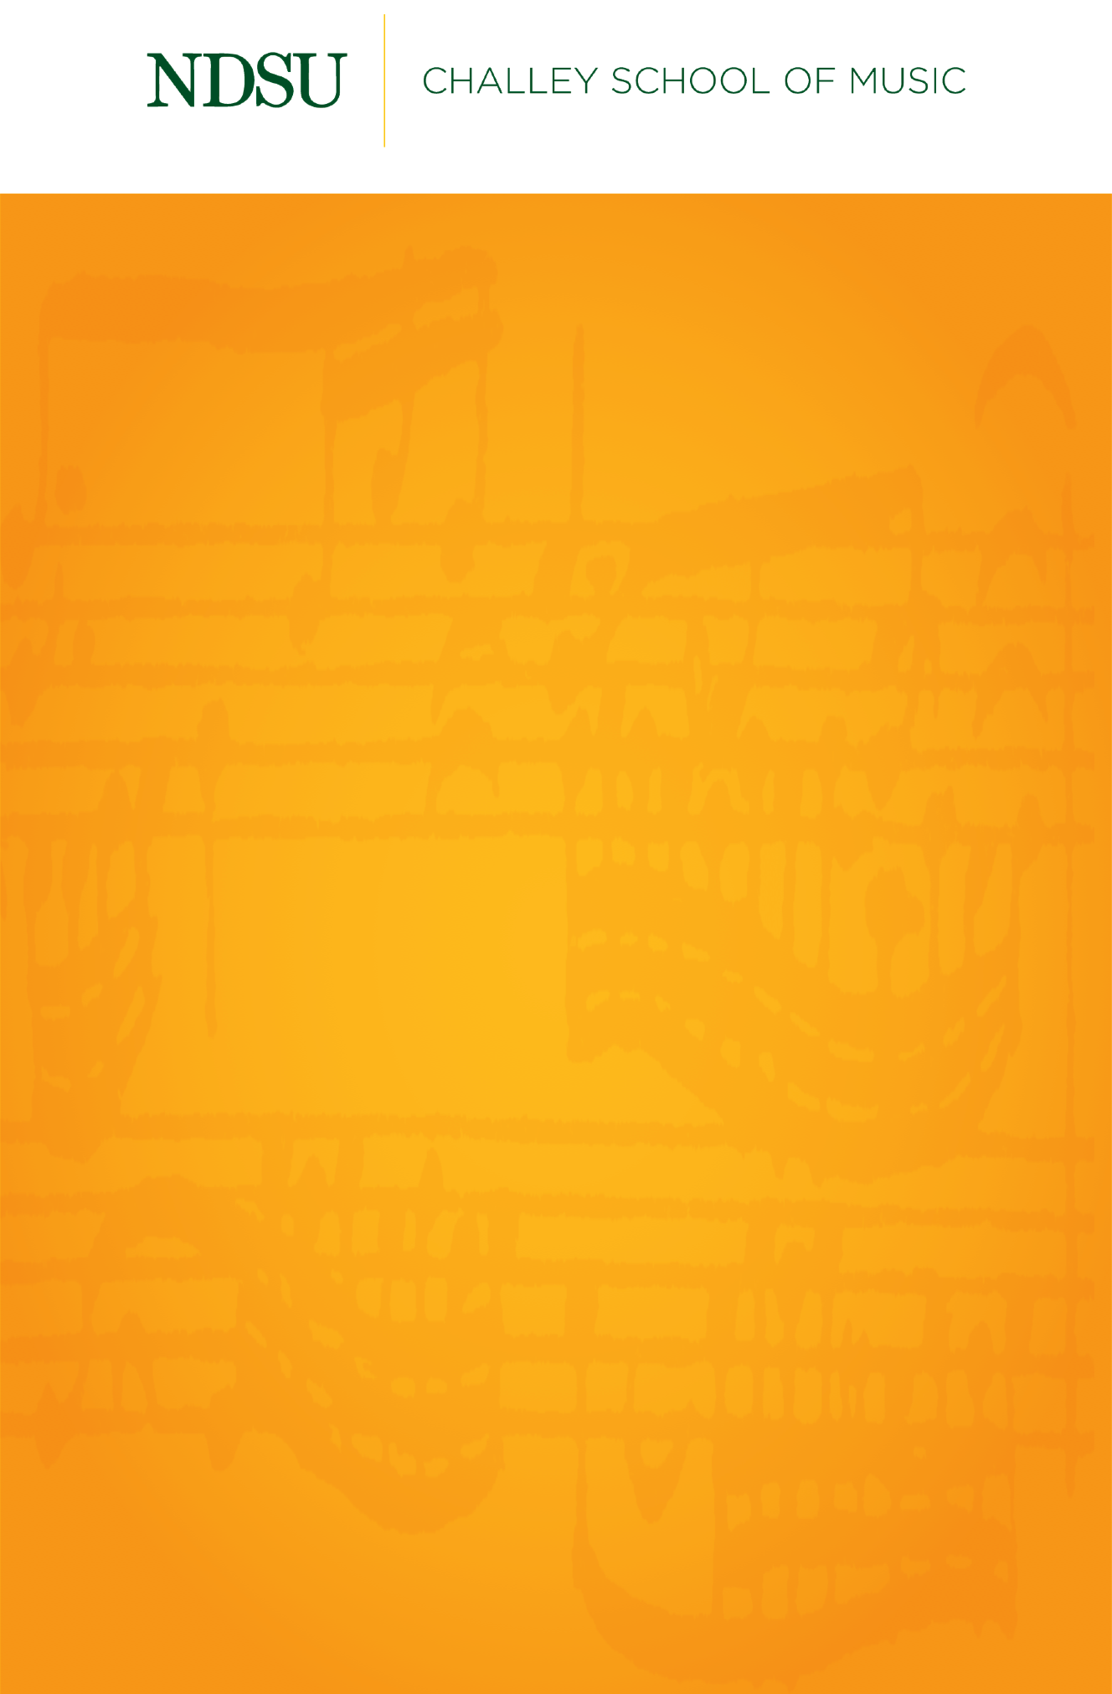

## 

## [@NDSUPerformingArts](https://www.facebook.com/NDSUPerformingArts)

**Connect with us on Facebook to stay up to date on upcoming performance and streaming opportunities.**   
  
We will not have public audiences for any indoor concerts, except for supervising faculty members and technical staff.

All performances in Beckwith Recital Hall and Festival Concert Hall will be recorded and livestreamed to the general public.

Events are subject to change.

Graduate Recital

**José Romero, saxophone**

*Featuring*

Amy Mercer, piano

Sunday, October 25th, 2020

Beckwith Recital Hall

4:00 PM

Sonata, per a oboè o saxòfon soprano i piano ……………….……... Albert Guinovart

(b. 1962)

I. Moderato

II. Andante

III. Allegro

Amy Mercer, piano

Etude #2 …………………………………………………………………………….Charles Koechlin

(1867-1950)

*Pour les sons liés et le charme de la sonorité*

Sonate en Ut#, pour saxophone alto et piano ……………………. Fernande Decruck

(1896-1954)

1. Très modéré, expressif
2. Noel. Andante
3. Fileuse. Légèrement animé
4. Nocturne et Rondel. Calme, très modéré

José Romero is a student of Dr. Matthew Patnode. This recital is given in partial fulfillment of the requirements for the degree of DMA in saxophone performance.

(1896-19José Romero is a student of Dr. Matthew Patnode.

This recital is given in partial fulfillment of the requirements for the

degree of DMA in saxophone performance.

*Bachelor of Music in piano performance.*