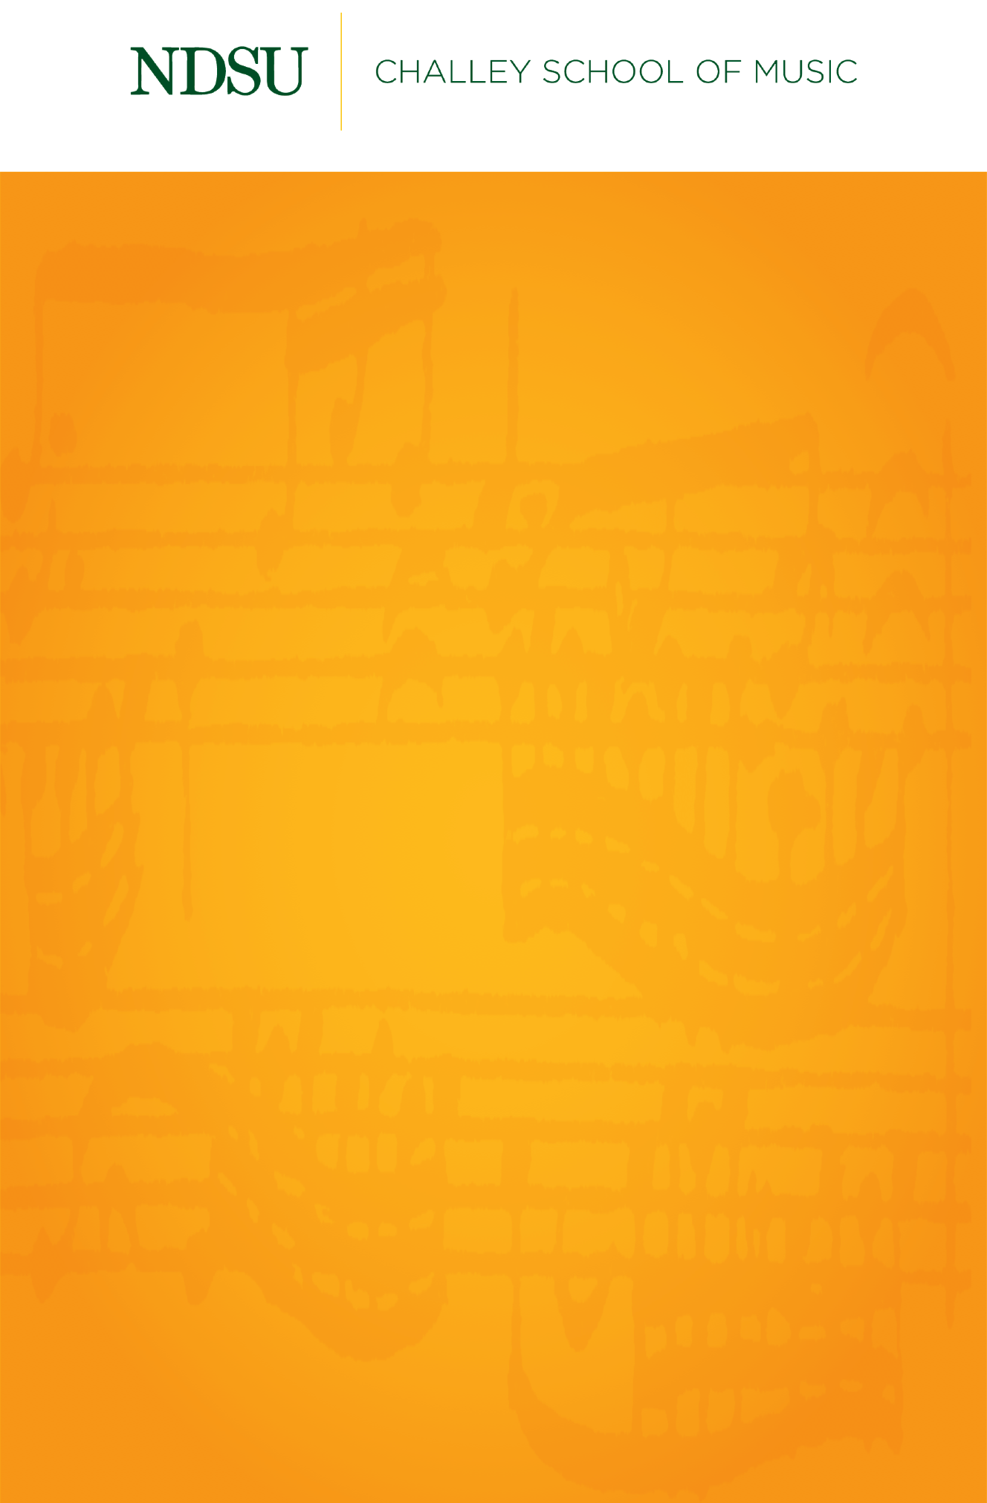

## 

## [@NDSUPerformingArts](https://www.facebook.com/NDSUPerformingArts)

**Connect with us on Facebook to stay up to date on upcoming performance and streaming opportunities.**   
  
We will not have public audiences for any indoor concerts, except for supervising faculty members and technical staff.

All performances in Beckwith Recital Hall and Festival Concert Hall will be recorded and livestreamed to the general public.

Events are subject to change.

Undergraduate Recital

Bailey Noel Roth, soprano

*Featuring*

Hong Liang Andre Ng, piano

Jessica Livdahl, soprano

Friday, November 13, 2020

Beckwith Recital Hall

5:30 PM

Les temps a laissié son manteau…….………………………………….…….Claude Debussy

(1862-1918)

Love’s Philosophy.……………………………………..…………………..………….Roger Quilter

(1877-1953)

At the River…………………………..……………………………………..…..………….Charles Ives

(1874-1954)

*Dedicated to my Uncle Charlie, who passed away this June of 2020.*

La clemenza di Tito…………………………………………..……Wolfgang Amadeus Mozart

(1756-1791)

1. Eccola, oh Dei!
2. Ah, perdona al primo affetto

Jessica Livdahl, soprano

*Bailey Noel Roth is a student of Dr. Mariane Lemieux.*

*This recital is given in partial fulfillment of the requirements for the degree of Bachelor of Science in Music.*

Giulio Cesare………..……………………………………..……………George Frideric Handel

(1685-1759)

1. Va tacito e nascosto

Messiah…………..…………………………………...……………..…….George Frideric Handel

(1685-1759)

1. Thy rebuke hath broken his heart
2. Behold and see

St. Matthew’s Passion…………………………………...……………Johann Sebastian Bach

(1685-1750)

1. Wiewohl mein Herz in Tränen schwimmt
2. Ich will dir mein Herze schenken

Ganymed………..……………………………………..……………………………..Franz Schubert

(1797-1828)

Sonntag………..……………………………………..…………………………….Johannes Brahms

(1833-1897)

Les berceuax…………………………..……………………………………..………..Gabriel Fauré

(1845-1924)