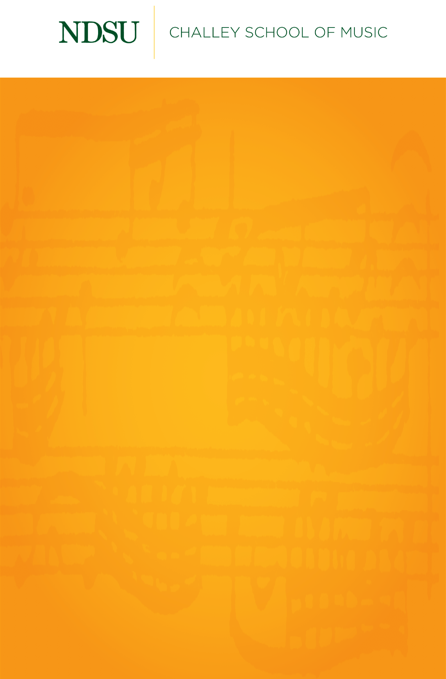

## 

## [@NDSUPerformingArts](https://www.facebook.com/NDSUPerformingArts)

**Connect with us on Facebook to stay up to date on upcoming performance and streaming opportunities.**   
  
We will not have public audiences for any indoor concerts, except for supervising faculty members and technical staff.

All performances in Beckwith Recital Hall and Festival Concert Hall will be recorded and livestreamed to the general public.

[ndsu.edu/music/stream](https://www.youtube.com/channel/UCqtD6NMzplHIhHFY-MvfRtQ/live)

Events are subject to change.

Senior Recital

Erin Ehlis, soprano

*Featuring*

Caleb Lawson, piano

Max Sommers, clarinet

Saturday, December 7th, 2020

Beckwith Recital Hall

2:00 PM

Der Hirt auf dem Felsen………………………..……………………………..….Franz Schubert

*(1797-1828)*

Max Sommers, clarinet

~

Chi sa, chi sa, qual sia, K.582………………………………………………………W.A. Mozart

*(1756-1791)*

Musique Anodine No. III……………………………………………………Gioachino Rossini

*(1792-1868)*

*Erin Ehlis is a student of Dr. Mariane Lemieux-Wottrich*

*She graduated with a Bachelors of Music is Vocal Performance in May, 2020.*

Sweeter than Roses…………………………………………………..…………….Henry Purcell

*(1659-1695)*

The Babe………………………………………………………………………………………JohnDuke

*(1899-1984)*

*~*

Hello! Oh Margaret, its you………………………………..….………….Gian Carlo Menotti

From “The Telephone” *(1911-2007)*

~

Mélodies Passagères……………………………………………………………...Samuel Barber

*(1910-1981)*

1. Puisique tout passe
2. Un cygne
3. Tombeau dans un parc
4. Le clocher chante
5. Départ

~