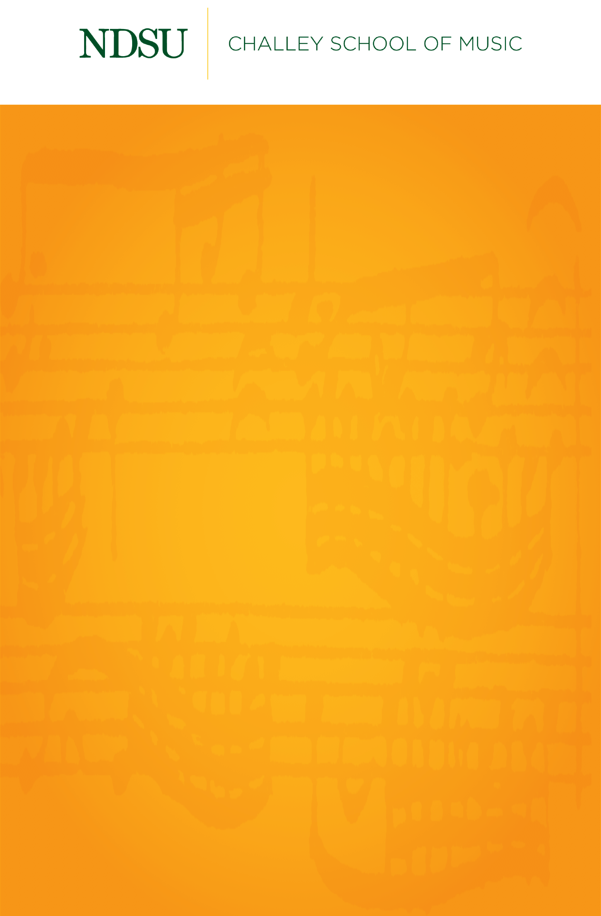

Junior Recital

Micah Nicolai, baritone

*Featuring*

Tori Hoplin, piano

Thursday, February 4, 2021

Beckwith Recital Hall

7:30 PM

L’heure exquise Reynaldo Hahn

(1874–1947)

L’absent Charles Gounod

(1818–1893)

Priez pour paix Francis Poulenc

(1899–1963)

*****

Loveliest of Trees John Duke

(1899–1984)

Spring Dominick Argento

(1927–2019)

Song of a Nightclub Proprietress Madeleine Dring

(1923–1977)

From *Kiss Me, Kate* Cole Porter

So in Love (1891–1964)

*Micah Nicolai is a student of Dr. Kelly W. Burns.*

*This recital is given in partial fulfillment of the requirements for the degree of Bachelor of Music in Vocal Performance.*

**PROGRAM**

From *Berenice,* HWV 38 George Frideric Handel

Si, tra i ceppi (1685–1759)

Spirate, pur spirate Stefano Donaudy

(1879–1925)

From *Così fan tutte,* K. 588 Wolfgang Amadeus Mozart

Non siate ritrosi (1756–1791)

*****

Der Gärtner Hugo Wolf

(1860–1903)

From *Winterreise* Franz Schubert

Gute Nacht (1912–2002)

Der Leiermann

*Intermission*