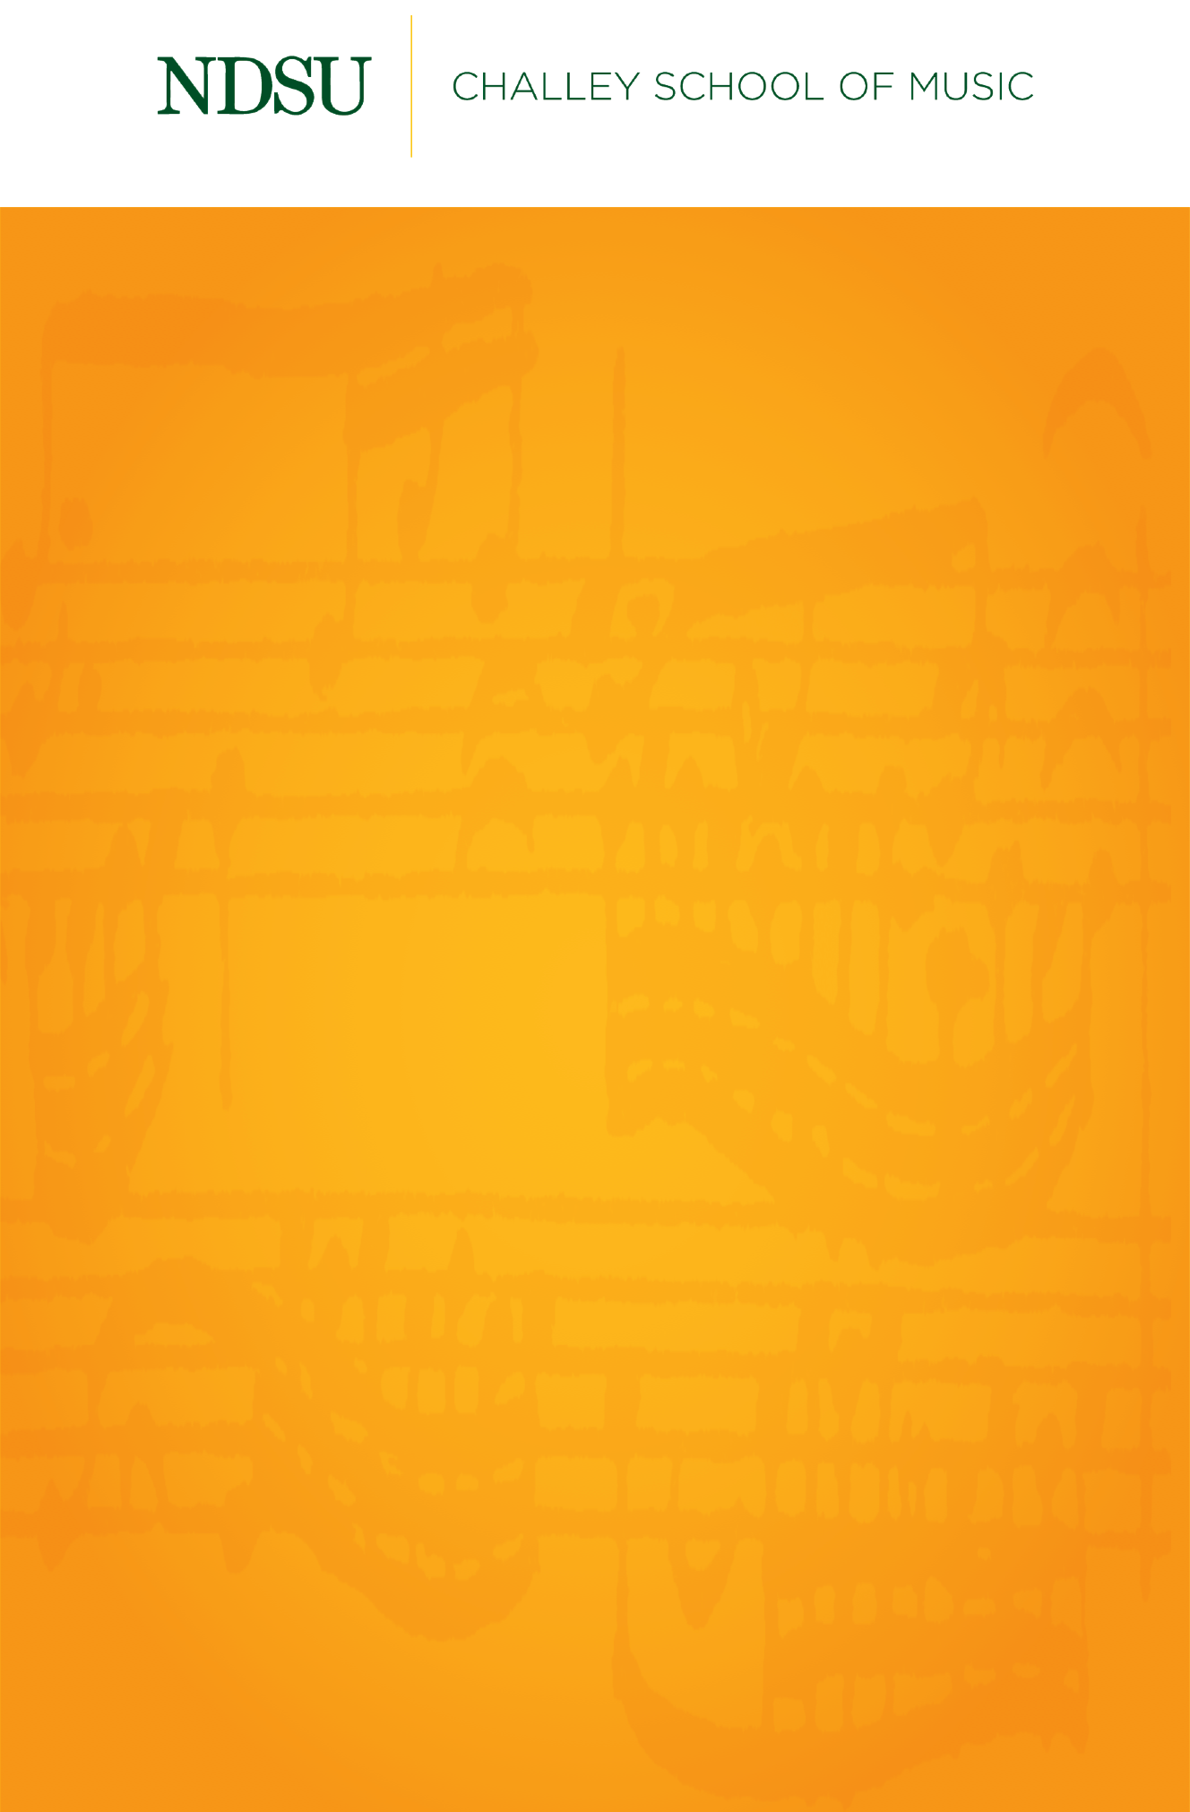

FACULTY RECITAL

KELLY W. BURNS

TENOR

TYLER WOTTRICH

PIANO

Monday, March 8, 2021

Beckwith Recital Hall

7:30 PM

## 

## [@NDSUPerformingArts](https://www.facebook.com/NDSUPerformingArts)

**Connect with us on Facebook to stay up to date on upcoming performance and streaming opportunities.**   
  
We will not have public audiences for any indoor concerts, except for supervising faculty members and technical staff.

All performances in Beckwith Recital Hall and Festival Concert Hall will be recorded and livestreamed to the general public.

Events are subject to change.

**Program**

*Nightsongs* H. Leslie Adams

(b. 1932)

Prayer

Drums of Tragedy

The Heart of a Woman

Night Song

Sense You Went Away

Creole Girl

*though love be a day* Gwyneth Walker

(b. 1947)

thy fingers make early flowers

lily has a rose

after all white horses are in bed

maggie and millie and molly and may

Still

*Silver Rain,* Op. 90 Robert Owens

(1925–2017)

In time of silver rain

Fulfillment

Night song

Silence

Carolina Cabin

Songs

Sleep