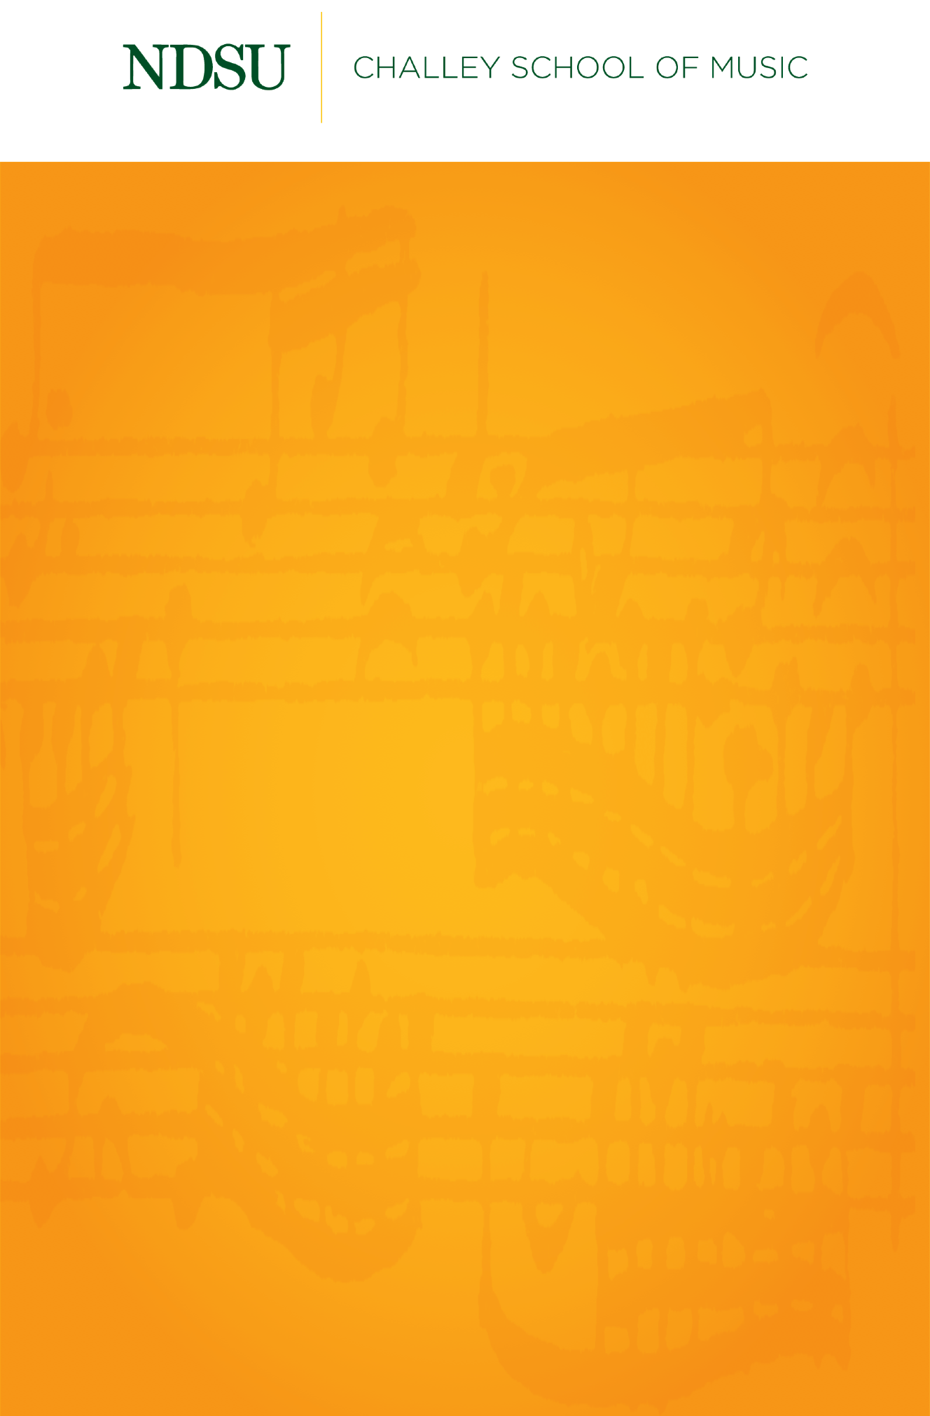

## 

## [@NDSUPerformingArts](https://www.facebook.com/NDSUPerformingArts)

**Connect with us on Facebook to stay up to date on upcoming performance and streaming opportunities.**   
  
We will not have public audiences for any indoor concerts, except for supervising faculty members and technical staff.

All performances in Beckwith Recital Hall and Festival Concert Hall will be recorded and livestreamed to the general public.

Events are subject to change.

Unity Series of Artists

NEW MUSIC CONCERT

Thursday, April 8, 2021

Beckwith Recital Hall

7:30 PM

My Lord, What a Mornin’ Burleigh

Austin Fitterer, *tenor*

Caleb Lawson, *piano*

From *Miss Wheatley’s Garden* Rosephanye Powell

I want to die while you love me (b. 1962)

Emily Paulson, *soprano*

Caleb Lawson, *piano*

From *Five Millay Songs* H. Leslie Adams

For You There Is No Song (b. 1932)

Seth Brandl, *baritone*

Hong Liang Andre Ng, *piano*

*****

From *Framed* Cecilia McDowell

(b. 1951)

1. Ball at the Moulin de la Galette

2. Nocturne in Blue and Gold

3. Walking Man

4. Winter Landscape with Skaters

Jonas Biles, *trumpet*

Hong Liang Andre Ng, *piano*

**FACULTY PERFORMANCE**

*Concerto for Trumpet and Five Players* Ellen Taaffe Zwilich

(b. 1939)

I. Marziale

II. Lento con moto

III. Allegro energico

Jeremy Brekke, *trumpet*

Laura Kellogg, *flute*

Cassie Keogh, *clarinet/bass clarinet*

Doug Neil, *contrabass*

Tyler Wottrich, *piano*

Sigurd Johnson, *percussion*

Warren Olfert, *conductor*

**STUDENT PERFORMANCES**

*Lyric Quartet* William Grant Still

(1895–1978)

I. Quiet One

II. Jovial One

**NDSU Clarinet Choir**

Eric Dill, Rachel Danielson, Camden Loth, Luke Olsby, Breanna Olson,

Allison Renner, Jose Romero, Lauren Sampson, Max Sommers,

Jessica Spencer, Cassandra Syvinski, and Julianna Wolff

*****

Les Filles de Cadix Pauline Viardot

(1821–1910)

Mariah Seidel, *soprano*

Anne Voglewede Green, *piano*

From *Clairières dans le ciel* Lili Boulanger

Vous m’avez regardé avec toute votre âme (1893–1918)

Natalie Harrison, *soprano*

Anne Voglewede Green, *piano*

Liebst du um Schönheit Clara Schumann

(1874–1947)

Julie Ly, *mezzo-soprano*

Caleb Lawson, *piano*

*****

*Mother and Child* William Grant Still

(1895–1978)

Lauren Sampson, *clarinet*

Larry Swingen, *piano*

*****

Will there really be a morning? Ricky Ian Gordon

(b. 1956)

Joshua Kainz, *tenor*

Anne Voglewede Green, *piano*

Sometimes I Feel Like a Motherless Child Harry T. Burleigh

(1866–1949)

Luke Anderson, *baritone*

Anne Voglewede Green, *piano*