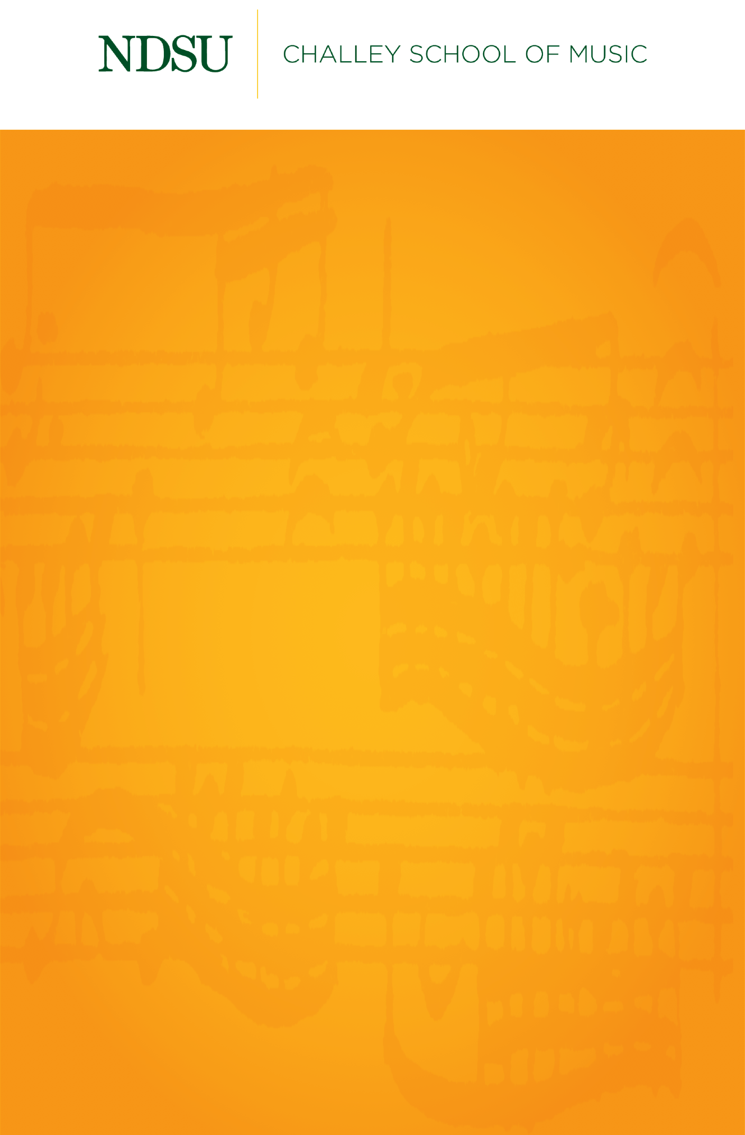

Student Chamber Music

NDSU Saxophone Ensembles

12th Avenue Saxophone Quartet

Bison Saxophone Quartet

NDSU Saxophone Trio

NDSU Saxophone Choir

Friday, April 9, 2021

Beckwith Recital Hall

5:30 PM

## 

## [@NDSUPerformingArts](https://www.facebook.com/NDSUPerformingArts)

**Connect with us on Facebook to stay up to date on upcoming performance and streaming opportunities.**   
  
We will not have public audiences for any indoor concerts, except for supervising faculty members and technical staff.

All performances in Beckwith Recital Hall and Festival Concert Hall will be recorded and livestreamed to the general public.

Events are subject to change.

Don’t Get Around Much Anymore ) . . . . . . . . . . . . . . . . . . . . . . . . . . . . . Duke Ellington (1899-1974)

arr. Peter Witte

Sir Sax . . . . . . . . . . . . . . . . . . . . . . . . . . . . . . . . . . . . . . . . . . . . . . . . . . . . . . . . Lennie Niehaus (1929 – 2020)

**12th Avenue Saxophone Quartet**

Gabriel Hagerott, alto

Katilynn Lee, alto

Colin Ceasonl, tenor

Jack Wilson, baritone

Introduction et Scherzo (1938) . . . . . . . . . . . . . . . . . . . . . . . . . . . . . . Robert Clerisse (1899-1973)

Suite from Carmen . . . . . . . . . . . . . . . . . . . . . . . . . . . . . . . . . . . . . Georges Bizet ( 1838-1875)

arr. Bill Holcombe

1. Prelude Act I
2. Habañera
3. Carmen Fantasia

**Bison Saxophone Quartet**

Cameron Solberg, soprano

Rachel Olsen, alto

Adam Madrigal, tenor

Sidney Woitalawicz, baritone

Trio for Saxophones (1984) . . . . . . . . . . . . . . . . . . . . . . . . . . . . . . . . . . . . Walter S. Hartley (1927-2016)

1. Andante molto
2. Presto agitato
3. Tempo di Valse
4. Largo
5. Allegro con brip

**NDSU Saxophone Trio**

José Romero, alto

Matthew Patnode, tenor

Nicholas Lero, baritone

Yes, with a BANG! (2014) . . . . . . . . . . . . . . . . . . . . . . . . . . . . . . . . . . . . . Gregory Wanamaker (b. 1968)

Devil’s Rag (1985) . . . . . . . . . . . . . . . . . . . . . . . . . . . . . . . . . . . . . . . . . . . . . . . . . . . . Jean Matitia (b. 1952)

**NDSU Saxophone Choir**

The 12th Avenue Saxophone Quartet is coached by José Romero.

The Bison Saxophone Quartet is coached by Matthew Patnode.

**NDSU Saxophone Choir**

**Sopranos**

José Romero,

Nicholas Lero

**Altos**

Adam Madrigal

Rachel Olsen

Abigail Trautman

**Tenors**

Hana Nilles,

Cameron Solberg

Eric Dill

**Baritones**

Sidney Woitalawicz,

Isabelle Jipson

**Bass/ Baritone**

Camden Loth