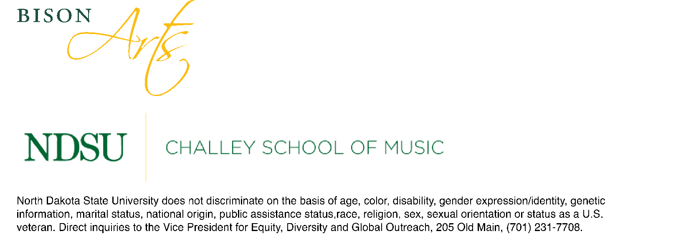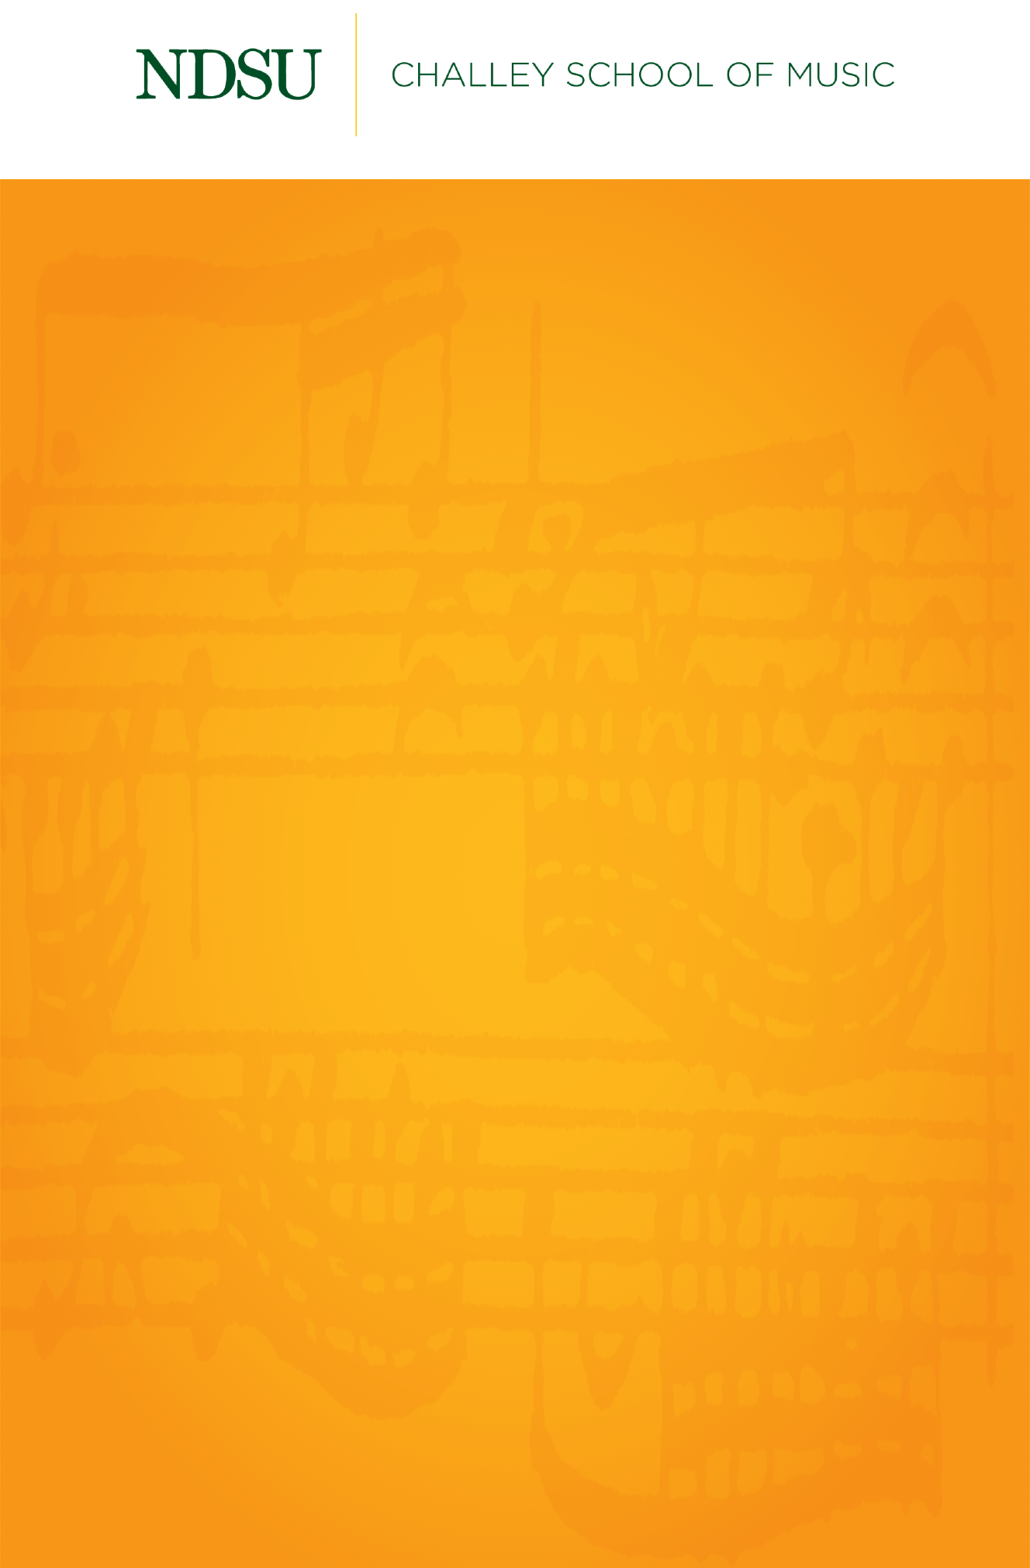

D.M.A. Graduate Chamber Recital

Matthew Winarski, instrumental conducting

Friday, April 16, 2021

Festival Concert Hall

5:30 PM

Concertino for Wind and Brass Quintets………….……………….…Robert Washburn

(1928-2013)

Ava Brewster, flute

Cameron Solberg, oboe

Rebecca Haller, clarinet

Evren Akyuz, bassoon

Will Forrette, trumpet

Isaac Homuth, trumpet

Joshua Sperr, horn

Matthew Pasch, horn

Sam Sharpe, trombone

Tom Houser, tuba

Serenade No. 1 for Ten Wind Instruments……...………..………Vincent Persichetti

(1915-1987)

Prelude

Episode

Song

Interlude

Dance

Divertimento for Brass and Percussion…………………...……….….Karel Husa

(1921-2016)

Overture

Scherzo

Song

Slovak Dance

Isaac Homuth, trumpet

Travis Elliason, trumpet

Zackary Carlson, trumpet

Joshua Sperr, horn

Matthew Pasch, horn

Shawn Postovit, horn

Ki Blaser, horn

Sam Sharpe, trombone

Kenzie Johnson, trombone

Hared Hartl, Bass trombone

Connor Challey, tuba

Danny Kocher, percussion

Jake Henneford, percussion

Sigurd Johnson, percussion

Petite Symphony…….…………………………..........................……………..…Charles Gounod

(1818-1893)

Intrada (Fanfares Entrances and Marches)

Pavane (Elegy)

Toccata (Rock)

Jess Patnode, flute

Nick Lero, soprano sax

Cameron Solberg, oboe

Breanna Olson, clarinet

Julia Lee, clarinet

Evren Akyuz, bassoon

Nathan Murphy, basson

Joshua Sperr, horn

Ki Blaser, horn

Fratres………………………………………………………………………………………….Arvo Pärt

(b. 1935)

Hana Nilles, clarinet

Julia Lee, clarinet

Carly Fox, clarinet

Luke Olsby, clarinet/bass clarinet

Jessica Spencer, bass clarinet

Jose Roméro, bari sax

Matthew Pasch, horn

Ki Blaser, horn

*Matthew Winarski is a student of Dr. Warren Olfert.*

*This recital is given in partial fulfillment of the requirements for the degree of Doctor of Musical Arts in Instrumental Conducting.*