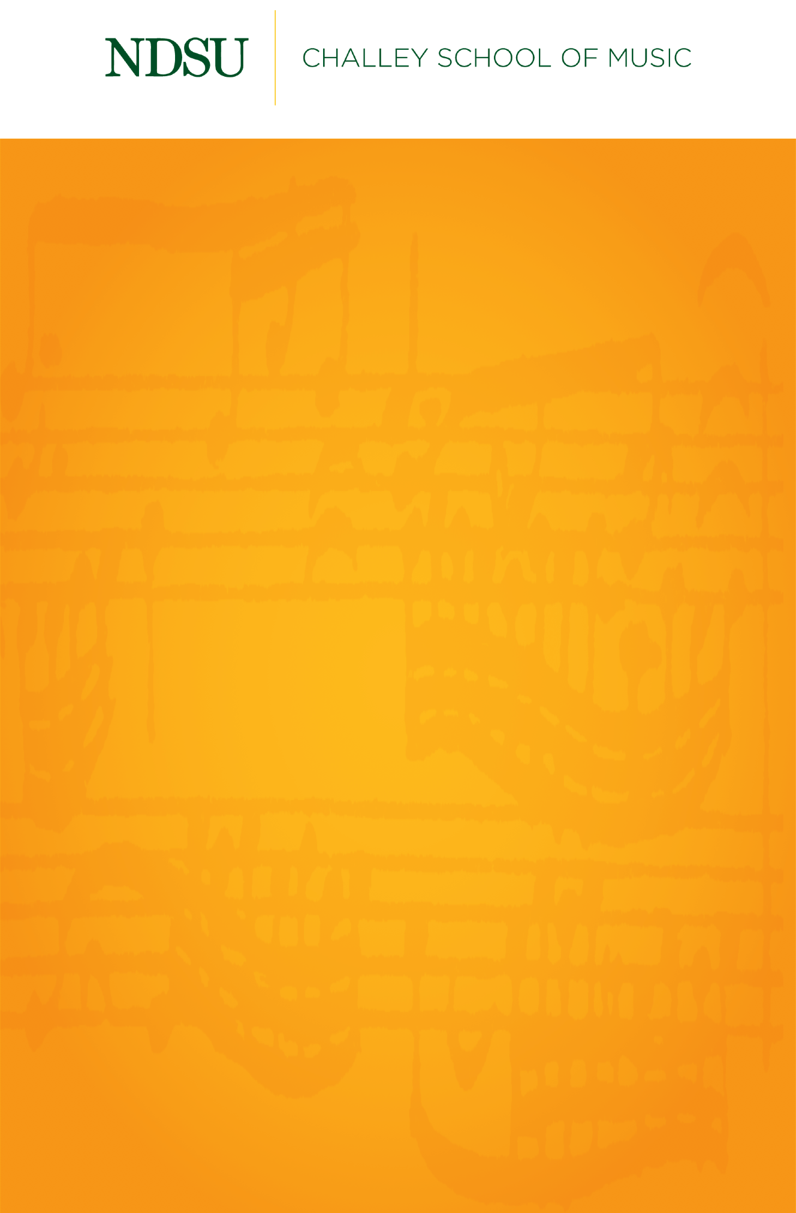

NDSU Brass Quintets

*Featuring*

The Bolley Street Brass

Graduate Brass Quintet

*and*

Gold Star Brass Quintet

Thursday, April 22, 2021

Beckwith Recital Hall

7:30 PM

## 

## [@NDSUPerformingArts](https://www.facebook.com/NDSUPerformingArts)

**Connect with us on Facebook to stay up to date on upcoming performance and streaming opportunities.**   
  
We will not have public audiences for any indoor concerts, except for supervising faculty members and technical staff.

All performances in Beckwith Recital Hall and Festival Concert Hall will be recorded and livestreamed to the general public.

[ndsu.edu/music/stream](https://www.youtube.com/channel/UCqtD6NMzplHIhHFY-MvfRtQ/live)

Events are subject to change.

Just a Closer Walk

Amazing Grace……………………………………………………………...Arr. Walter H. Barnes

Coup de Brass………………………………………………………………………..……..Fisher Tull

(1934-1994)

West Side Story ……………………………………………………..……….Leonard Bernstein

(1918-1990)

1. Prologue

3. Maria

5. America

**Gold Star Brass Quintet**

Somewhere Out There…………………………………………..………………….James Horner

(1953-2015)

Arr. John Wasson

The Pink Panther……………………………………………………..……………Henry Mancini

(1924-1994)

Arr. Arthur Frackenpohl

I Want You Back……………………………………………………………….………The Jackson 5

Arr. Seb Skelly

**The Bolley Street Brass**

**The Bolley Street Brass** **Gold Star Brass Quintet**

Byron Ward, trumpet Isaac Homuth, trumpet

Jonas Biles, trumpet Zackary Carlson, trumpet

Laura Jossund, horn Matthew Pasch, horn

Andrew Nicholson, euphonium Kate Hicks, trombone

Doug Neill, tuba Connor McCormick, tuba

*The Bolley Street Brass and Gold Star Brass Quintet*

*are coached by Dr. Jeremy Brekke*

Challey Fanfare for double brass quintet………………………..………..Jocelyn Hagen

(b. 1980)

**The Bolley Street Brass and Gold Star Brass Quintet**

Es ist ein Ros’ entserungem………………………………………...……..Johannes Brahms

(1833-1897)

Killer Tango…………………………………………………..…………………..Sonny Kompanek

(c. 1951-)

**Gold Star Brass Quintet**

Sonata from Die Bänkelsängerlieder………………………..….…………..….Anonymous

(c. 1684)

Edited Robert King

Badinerie from Orchestral Suite No. 2 in B minor………………..……………J.S. Bach

(1685-1750)

Arr. Caleb Hudson

Frost Fire…………………………………………………………..……………….…..…Eric Ewazen

(b. 1954)

I. Bright and Fast

**The Bolley Street Brass**