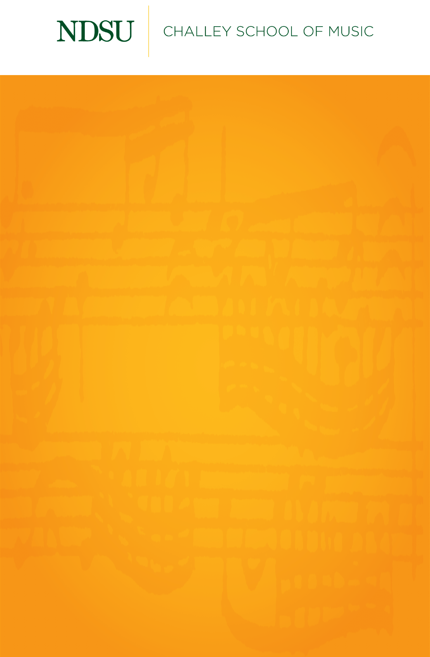

## 

## [@NDSUPerformingArts](https://www.facebook.com/NDSUPerformingArts)

**Connect with us on Facebook to stay up to date on upcoming performance and streaming opportunities.**   
  
We will not have public audiences for any indoor concerts, except for supervising faculty members and technical staff.

All performances in Beckwith Recital Hall and Festival Concert Hall will be recorded and livestreamed to the general public.

[ndsu.edu/music/stream](https://www.youtube.com/channel/UCqtD6NMzplHIhHFY-MvfRtQ/live)

Events are subject to change.

Video streaming and recording is made possible through a grant from the NDSU Foundation Impact Fund.



Graduate Recital

Byron Ward, trumpet

*Featuring*

Hong Liang Andre Ng, piano, harpsichord

Hannah Overbey, soprano

Elise Nelson, cello

Tuesday, May 4, 2021

Beckwith Recital Hall

7:30 PM

Su le sponde del Tebro (c. 1690)..……………….……………..…..….Alessandro Scarlatti

(1660-1725)

1. Sinfonia

Rompe sprezza (1706)……………………………………………………Alessandro Scarlatti

(1660-1725)

In terra la guerra (1706)...……………………………………………….Alessandro Scarlatti

(1660-1725)

Hannah Overbey, soprano

Elise Nelson, cello

Concertpiece No. 1 (1910)………………...…………………………….….....…Vassliy Brandt

(1869-1923)

INTERMISSION

Impromptu (1950)……………..…….……..……..……..………………………..….Jacques Ibert

(1890-1962)

Sonatine (1952)..………………………………………………………………………Jean Françaix

(1912-1997)

1. Prélude
2. Sarabande
3. Gigue

Masks (2001)..………………………………………...…………………………………Dana Wilson

(b. 1946)

1. Mask I
2. Mask II
3. Mask III

*Byron Ward is a student of Dr. Jeremy Brekke.*

*This recital is given in partial fulfillment of the requirements for the degree of Doctor of Musical Arts in trumpet performance.*