1. **Introduction:**

An Online Shopping system is a software system that helps users view and order computer products online via the internet, replacing manual shopping processes. The system is expected to evolve over several releases. Finally, connect to credit and debit card authorization services.

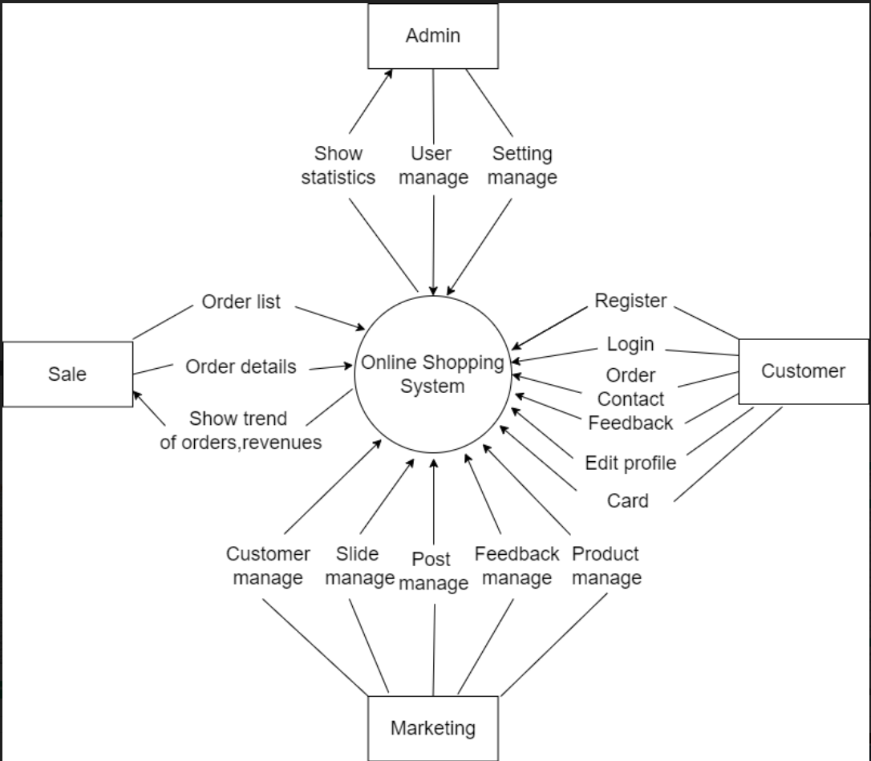

1. **System Functions:**
2. **Screen Flow:**

This part shows the system screens and the relationship among screens.

`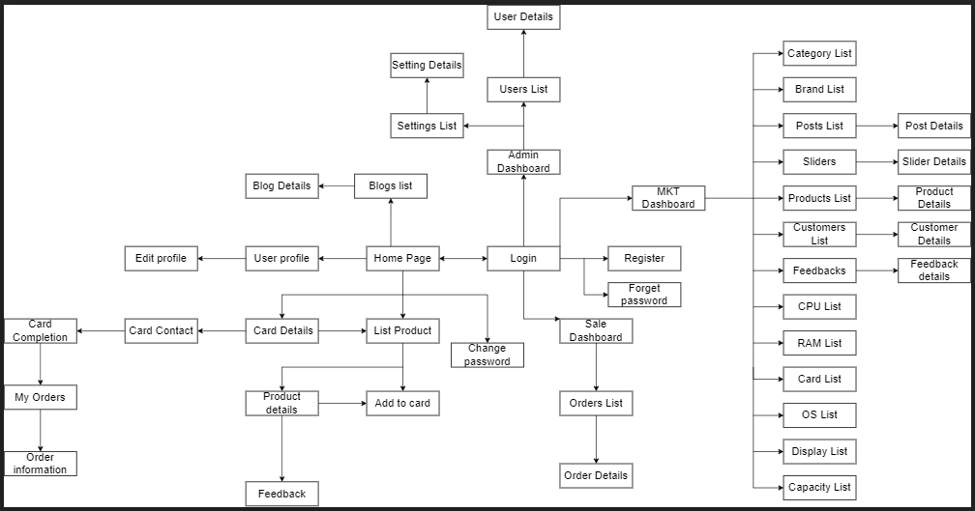

1. **Screen Details:**

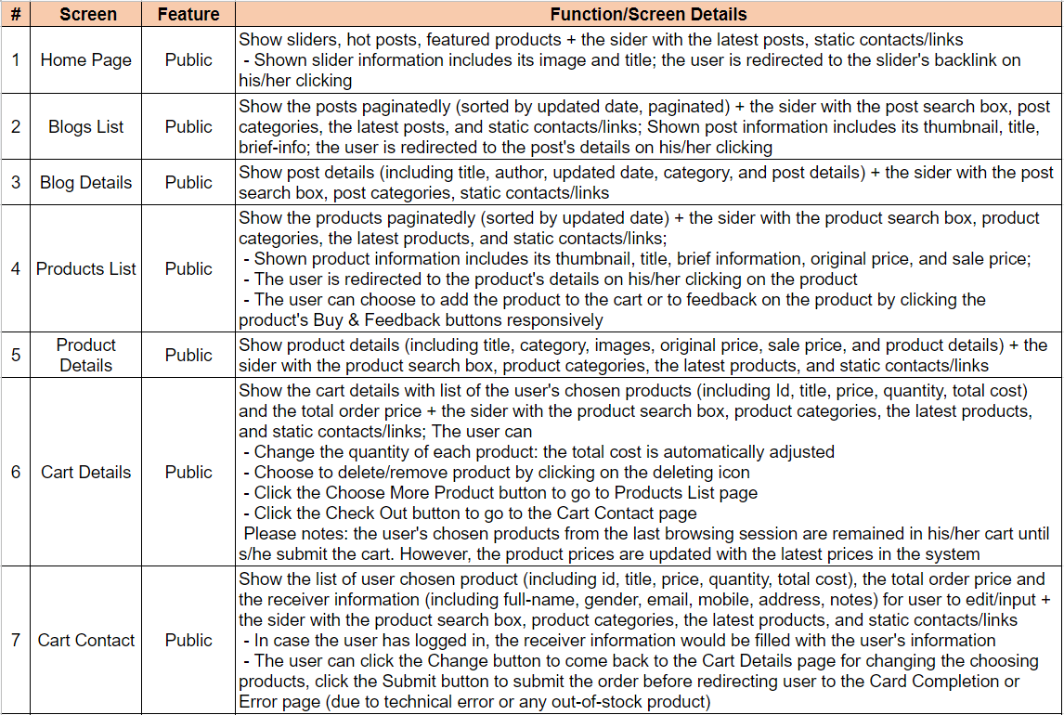

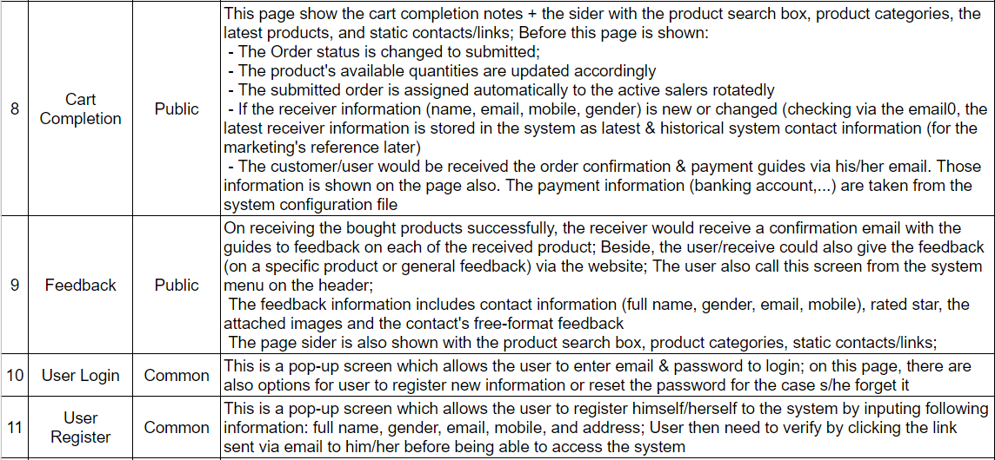

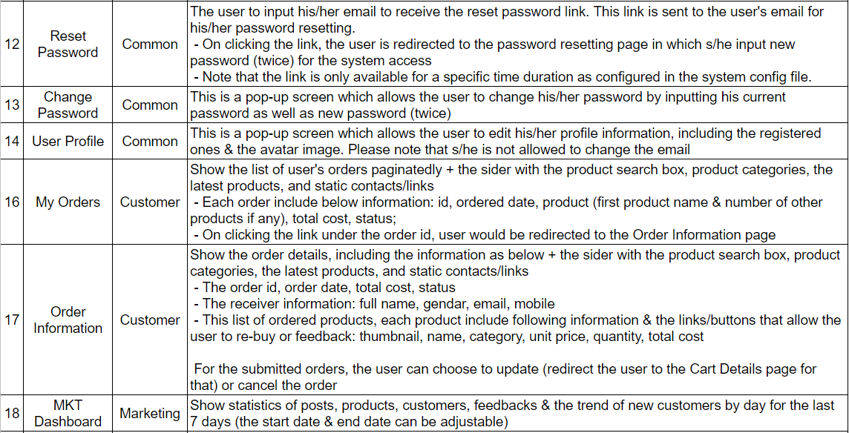

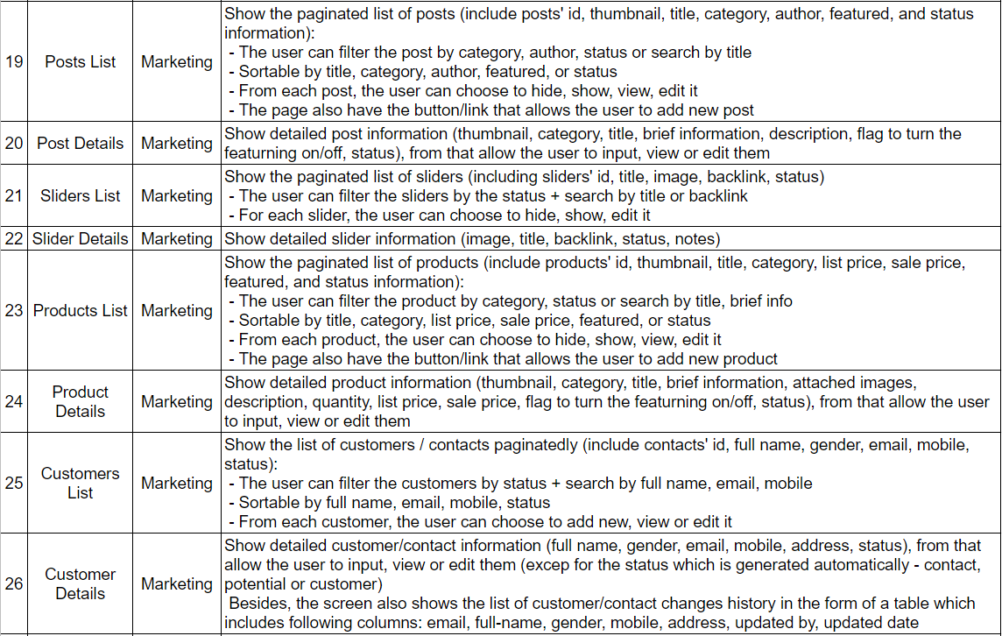

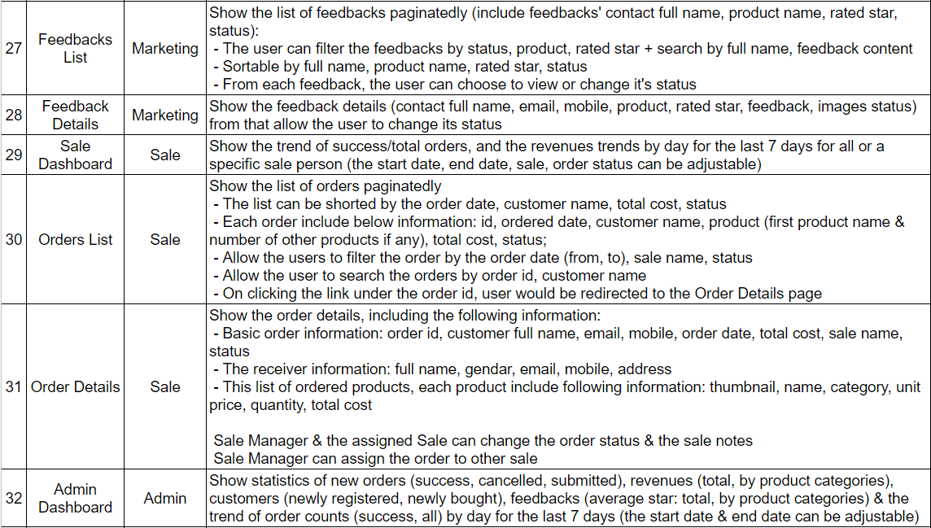

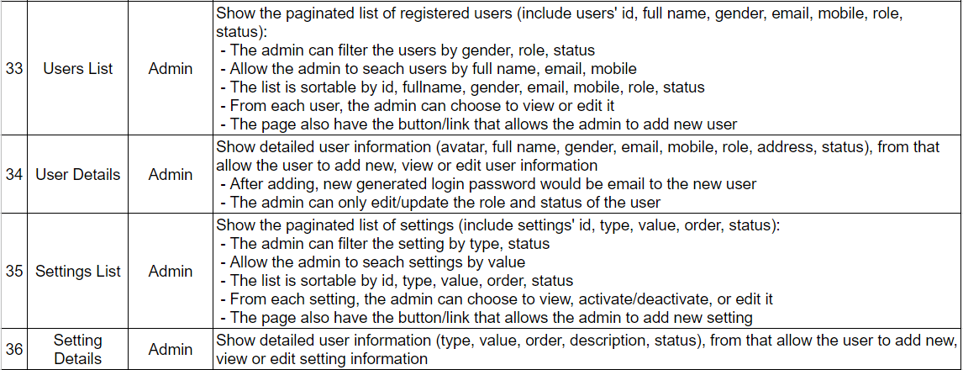

1. **User Authorization:**

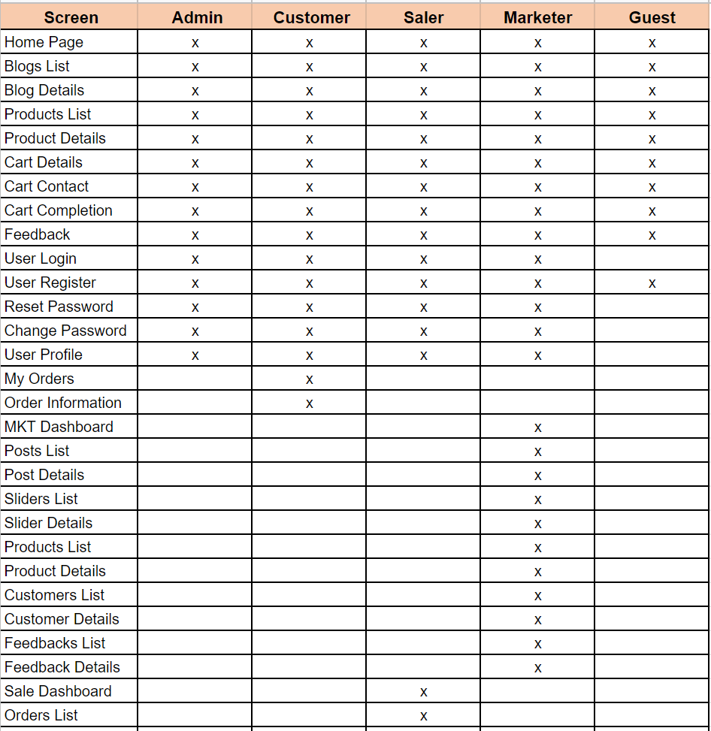

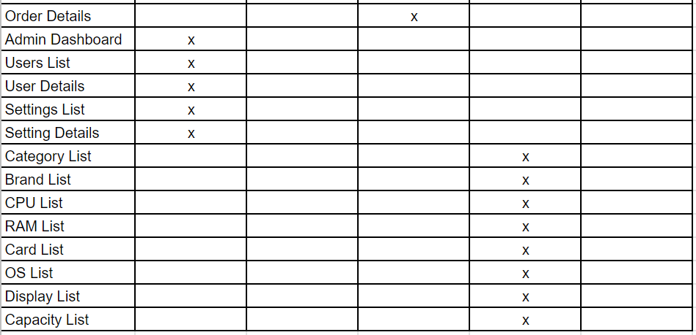

**In which:**

**Admin:** manage all system data and settings, assign user rights.

**Guest:** Those who want to buy products, stop by to see the products and do not have an account yet.

**Customer:** Those who have needs want to buy products in the sales system and already have an account.

**Saler:** the person who manages the activities related to the purchase and sale of products.

**Marketer:** product managers, product-related parameters, marketing and advertising activities.

**3. Common Requirements:**

* **User Login:** This is a pop-up screen which allows the user to enter email & password to login; on this page, there are also options for user to register new information or reset the password for the case s/he forget it.
* **User Register:** This is a pop-up screen which allows the user to register himself/herself to the system by inputing following information: full name, gender, email, mobile, and address; User then need to verify by clicking the link sent via email to him/her before being able to access the system.
* **Reset Password:** The user to input his/her email to receive the reset password link. This link is sent to the user's email for his/her password resetting.

+ On clicking the link, the user is redirected to the password resetting page in which s/he input new password (twice) for the system access.

+ Note that the link is only available for a specific time duration as configured in the system config file.

* **Change Password:** This is a pop-up screen which allows the user to change his/her password by inputting his current password as well as new password (twice).
* **User Profile:** This is a pop-up screen which allows the user to edit his/her profile information, including the registered ones & the avatar image. Please note that s/he is not allowed to change the email.

**4. Database:**

