

International School

**Capstone Project 1**

CMU-SE 450

**User Interface Design Document**

Version 1

Date: 23/09/2021

**COVID-19 iCONSULTANT**

**Submitted by**

Nguyen Dang Tuong Lam

Hoang Quang Dat

Nguyen Thanh Quoc

Le Anh Khoa

**Approved by** Ha Nhu Hang

PROJECT INFORMATION

|  |  |  |  |
| --- | --- | --- | --- |
| **Project acronym** | CIC | | |
| **Project Title** | COVID-19 iConsultant | | |
| **Start Date** | 24 Aug 2021 | **End Date** | 12 Dec 2021 |
| **Lead Institution** | International School, Duy Tan University | | |
| **Project Mentor** | Ha Nhu Hang | | |
| **Scrum master / Project Leader & contact details** | Hoang Quang Dat  Email: hoanguyquangdat@gmail.com  Tel: 0379782308 | | |
| **Partner Organization** |  | | |
| **Project Web URL** |  | | |
| **Team members** | Name | Email | Tel |
| 24211215599 | Nguyen Dang Tuong Lam | nguyendangtuonglam2106  @gmail.com | 0347327837 |
| 24211206390 | Le Anh Khoa | skhoa15499@gmail.com | 0905833919 |
| 24211202635 | Nguyen Thanh Quoc | quochades2000@gmail.com | 0774959050 |

REVISION HISTORY

|  |  |  |  |  |
| --- | --- | --- | --- | --- |
| Version | Date | Comments | Author | Approval |
| 1.0 | 01/09/2020 | Initial Release | Lam |  |

TABLE OF CONTENTS

**1. Introduction** 4

**1.1 Purpose** 4

**1.2 Scope** 4

**2. Describe User Interface Application in Detail** 4

**2.1 UI-Tourist** 4

2.1.1 UI-01: Home 4

2.1.2 UI-02: Page “Số liệu” 5

2.1.3 UI-03: Q&A COVID-19 6

2.1.4 UI-04: Task Question 7

2.1.5 UI-05: Task Answer 8

2.1.6 UI-06: Page “Tin tức” 9

2.1.7 UI-07: Page “Nội dung” 10

2.1.8 UI-08: Login 11

# Introduction

## Purpose

* This document serves the purpose of specifying application’s UI design

## Scope

* Create complete interfaces, and describe them clearly.
* Overview of the stages and modules of the system.

# Describe User Interface Application in Detail

## UI-Tourist

### UI-01: Home

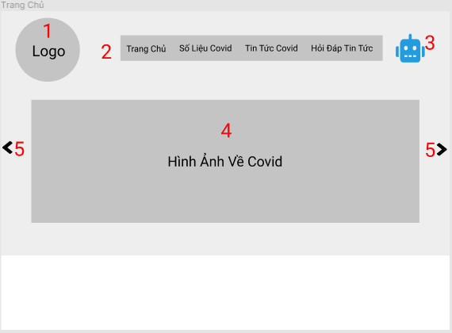

|  |  |  |  |  |
| --- | --- | --- | --- | --- |
| ID | Condition | Control Type | Target | Notes |
| 1 | Nothing | Picture | Logo of app |  |
| 2 | Click | Link | Click select to move to the content pages |  |
| 3 | Click | Button | View chatbot |  |
| 4 | Nothing | Picture | List of 10 image about COVID-19 |  |
| 5 | Click | Button | Scroll to see photos of COVID-19 |  |

### UI-02: Page “Số liệu”

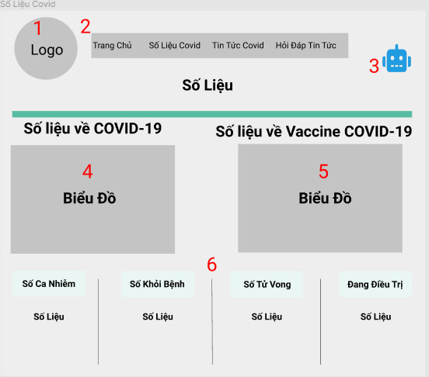

|  |  |  |  |  |
| --- | --- | --- | --- | --- |
| ID | Condition | Control Type | Target | Notes |
| 1 | Nothing | Picture | Logo of app |  |
| 2 | Click | Link | Click select to move to the content pages |  |
| 3 | Click | Button | View chatbot |  |
| 4 | Nothing | Chart | Chart related to COVID-19 figures |  |
| 5 | Nothing | Chart | Chart related to Vaccine COVID-19 |  |
| 6 | Nothing | Table | Data sheet on COVID-19 |  |

### UI-03: Q&A COVID-19

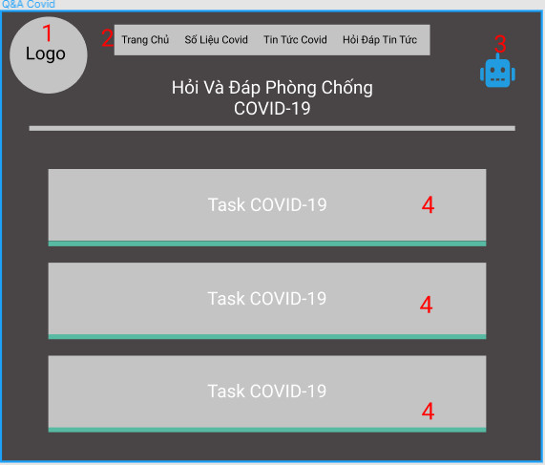

|  |  |  |  |  |
| --- | --- | --- | --- | --- |
| ID | Condition | Control Type | Target | Notes |
| 1 | Nothing | Picture | Logo of app |  |
| 2 | Click | Link | Click select to move to the content pages |  |
| 3 | Click | Button | View chatbot |  |
| 4 | Click | Button | Go to page “Task Question” |  |

### UI-04: Task Question

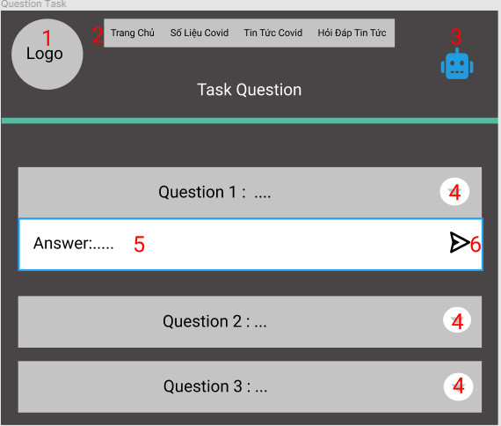

|  |  |  |  |  |
| --- | --- | --- | --- | --- |
| ID | Condition | Control Type | Target | Notes |
| 1 | Nothing | Picture | Logo of app |  |
| 2 | Click | Link | Click select to move to the content pages |  |
| 3 | Click | Button | View chatbot |  |
| 4 | Click | Text | Click for short answers or advice on COVID-19 prevention |  |
| 5 | Nothing | Text box | Short answer content or advice on prevention of COVID-19 |  |
| 6 | Click | Button | Go to page “Task Answer” |  |

### UI-05: Task Answer

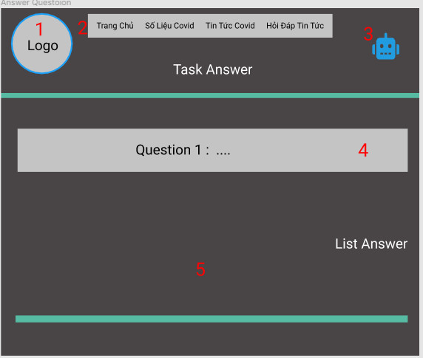

|  |  |  |  |  |
| --- | --- | --- | --- | --- |
| ID | Condition | Control Type | Target | Notes |
| 1 | Nothing | Picture | Logo of app |  |
| 2 | Click | Link | Click select to move to the content pages |  |
| 3 | Click | Button | View chatbot |  |
| 4 | Nothing | Text | Question |  |
| 5 | Nothing | Text | Contents of detailed answers to the question. |  |

### UI-06: Page “Tin tức COVID-19”

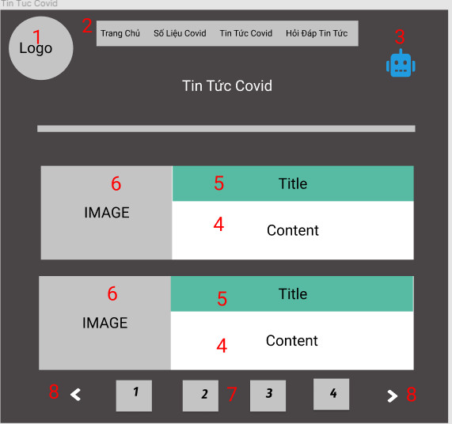

|  |  |  |  |  |
| --- | --- | --- | --- | --- |
| ID | Condition | Control Type | Target | Notes |
| 1 | Nothing | Picture | Logo of app |  |
| 2 | Click | Link | Click select to move to the content pages |  |
| 3 | Click | Button | View chatbot |  |
| 4 | Nothing | Text | Brief description of the content |  |
| 5 | Click | Link | Title to click to go to the page “Nội Dung” |  |
| 6 | Nothing | Picture | Images related to news articles |  |
| 7 | Click | Button | Click to go to the following news sites |  |
| 8 | Click | Button | Scroll to the following news sites |  |

### UI-07: Page “Nội dung”

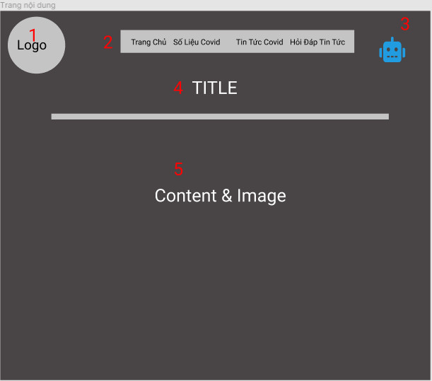

|  |  |  |  |  |
| --- | --- | --- | --- | --- |
| ID | Condition | Control Type | Target | Notes |
| 1 | Nothing | Picture | Logo of app |  |
| 2 | Click | Link | Click select to move to the content pages |  |
| 3 | Click | Button | View chatbot |  |
| 4 | Nothing | Text | The title line |  |
| 5 | Nothing | Text | Contents of news articles |  |

### UI-08: Login

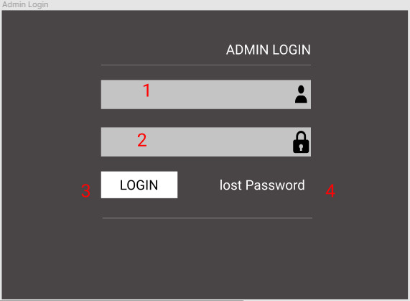

|  |  |  |  |  |
| --- | --- | --- | --- | --- |
| ID | Condition | Control Type | Target | Notes |
| 1 | Click | Text Box | Enter account name |  |
| 2 | Click | Text Box | Enter your account password |  |
| 3 | Click | Button | Login on the system |  |
| 4 | Click | Link | Reset their password when a tourist forgets it |  |