1.kata kunci abstrak

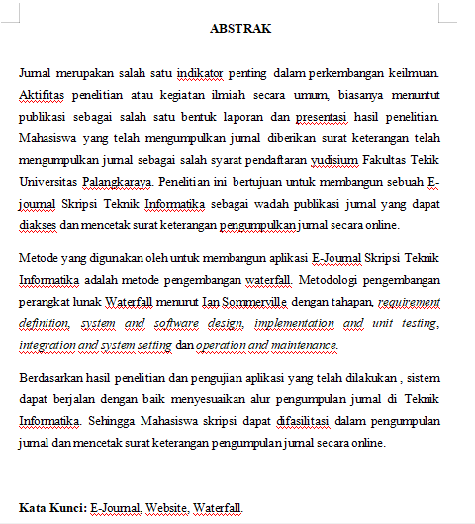

1. tabel yang dilanjutkan di halaman berikutnya harus diberi keterangan/header
2. **Tabel *User***

Tabel 3. 1 Tabel User

|  |  |  |  |
| --- | --- | --- | --- |
| **Field** | **Tipe** | **Ukuran** | **Keterangan** |
| id_*user* | int | 11 | primary key |
| nip_nim | varchar | 20 | - |
| nama | varchar | 50 | - |
| tempat_lahir | varchar | 20 | - |
| tgl_lahir | date | - | - |
| no_hp | in | 15 | - |
| email | varchar | 30 | - |
| foto | varchar | 128 | - |
| tanggal_logout | date |  | - |
| alamat | varchar | 50 | - |
| id_kategori | int | 11 | foreign key |
| **Field** | **Tipe** | **Ukuran** | **Keterangan** |
| id_jk | int | 11 | foreign key |
| id_agama | int | 11 | foreign key |
| id_status | int | 11 | foreign key |
| password | varchar | 128 | - |
| online | in | 11 | default 0 |

1. **Tabel Komentar**

**Tabel 3. 2 Tabel Komentar**

|  |  |  |  |
| --- | --- | --- | --- |
| **Field** | **Tipe** | **Ukuran** | **Keterangan** |
| id_komentar | int | 11 | primary key |
| id_jurnal | int | 11 | foreign key |
| id_*user* | int | 11 | foreign key |
| komentar | longtext | - | - |
| tanggal | datetime | - | - |

1. **Tabel Kategori**

Tabel 3. 3. Tabel Kategori

|  |  |  |  |
| --- | --- | --- | --- |
| **Field** | **Tipe** | **Ukuran** | **Keterangan** |
| id_kategori | int | 11 | primary key |
| nama_kategori | varchar | 20 | - |

1. **Tabel Jenis Kelamin**

Tabel 3. 4. Tabel Jenis Kelamin

|  |  |  |  |
| --- | --- | --- | --- |
| **Field** | **Tipe** | **Ukuran** | **Keterangan** |
| id_jk | int | 11 | primary key |
| nama_jk | varchar | 20 | - |

1. **Tabel Agama**

Tabel 3. 5. Tabel Agama

|  |  |  |  |
| --- | --- | --- | --- |
| **Field** | **Tipe** | **Ukuran** | **Keterangan** |
| id_agama | int | 11 | primary key |
| nama_agama | varchar | 20 |  |

1. **Tabel Status**

Tabel 3. 6. Tabel Status

|  |  |  |  |
| --- | --- | --- | --- |
| **Field** | **Tipe** | **Ukuran** | **Keterangan** |
| id_status | int | 11 | primary key |
| nama_status | varchar | 20 | - |

1. **Tabel Jurnal**

Tabel 3. 7. Tabel Jurnal

|  |  |  |  |
| --- | --- | --- | --- |
| **Field** | **Tipe** | **Ukuran** | **Keterangan** |
| id_jurnal | int | 11 | primary key |
| id_penulis | int | 11 | foreign key |
| id_pembimbing1 | varchar | 128 | foreign key |
| id_pembimbing2 | varchar | 128 | foreign key |
| id_status_jurnal | int | 11 | foreign key |
| judul | text | - | - |
| abstrak | longtext | - | - |
| tgl_upload | datetime | - | - |
| tgl_edit | timestamp | - | - |
| file | varchar | 128 | - |
| id_kategori_skripsi | int | 11 | - |
| no_seri | varchar | 128 | - |
| id_status_jurnal1 | int | 11 | foreign key |
| Kata_kunci | text | - | - |

1. **Tabel Status Jurnal**

Tabel 3. 8. Tabel Status Jurnal

|  |  |  |  |
| --- | --- | --- | --- |
| **Field** | **Tipe** | **Ukuran** | **Keterangan** |
| id_status_jurnal | int | 11 | primary key |
| nama_status_jurnal | varchar | 30 | - |

1. **Tabel Status Jurnal1**

**Tabel 3. 9 Tabel Status Jurnal1**

|  |  |  |  |
| --- | --- | --- | --- |
| **Field** | **Tipe** | **Ukuran** | **Keterangan** |
| id_status_jurnal1 | int | 11 | primary key |
| nama_status_jurnal1 | varchar | 30 | - |

1. **Tabel Statistik**

Tabel 3. 10. Tabel Statistik

|  |  |  |  |
| --- | --- | --- | --- |
| **Field** | **Tipe** | **Ukuran** | **Keterangan** |
| id_statistik | int | 30 | primary key |
| ip | varchar | 20 | - |
| tanggal | date |  | - |
| os | varchar | 40 | - |
| browser | varchar | 20 | - |
| online | int | 11 | - |

1. **Tabel Layanan**

Tabel 3. 11. Tabel Layanan

|  |  |  |  |
| --- | --- | --- | --- |
| **Field** | **Tipe** | **Ukuran** | **Keterangan** |
| id_layanan | int | 11 | primary key |
| email | varchar | 30 | - |
| no_telepon | varchar | 40 | - |
| link_instagram | varchar | 50 | - |
| link_facebook | varchar | 20 | - |
| website | varchar | 50 | - |
| alamat | varchar | 50 | - |

1. **Tabel Ketegori Skripsi**

Tabel 3. 12. Ketegori Skripsi

|  |  |  |  |
| --- | --- | --- | --- |
| **Field** | **Tipe** | **Ukuran** | **Keterangan** |
| id_kategori_skripsi | int | 11 | primary key |
| nama_kategori | varchar | 50 | - |

1. **Tabel Token**

Tabel 3. 13. Token

|  |  |  |  |
| --- | --- | --- | --- |
| **Field** | **Tipe** | **Ukuran** | **Keterangan** |
| id_token | int | 11 | primary key |
| email | varchar | 128 | - |
| token | varchar | 128 | - |
| tanggal_buat | datetime |  | - |

1. **Tabel Tentang**

**Tabel 3. 14 Tabel tentang**

|  |  |  |  |
| --- | --- | --- | --- |
| **Field** | **Tipe** | **Ukuran** | **Keterangan** |
| id_tentang | int | 11 | primary key |
| isi | longtext | - | - |
| foto | varchar | 128 | - |
|  |  |  |  |

1. **Tabel Template Jurnal**

Tabel 3. 15 Template Jurnal

|  |  |  |  |
| --- | --- | --- | --- |
| **Field** | **Tipe** | **Ukuran** | **Keterangan** |
| id_template_jurnal | int | 11 | primary key |
| judul | varchar | 100 | - |
| file | varchar | 125 | - |

1. **use case keliru: simbol relasi, label case, (referensi penggambaran system boundary ?)**

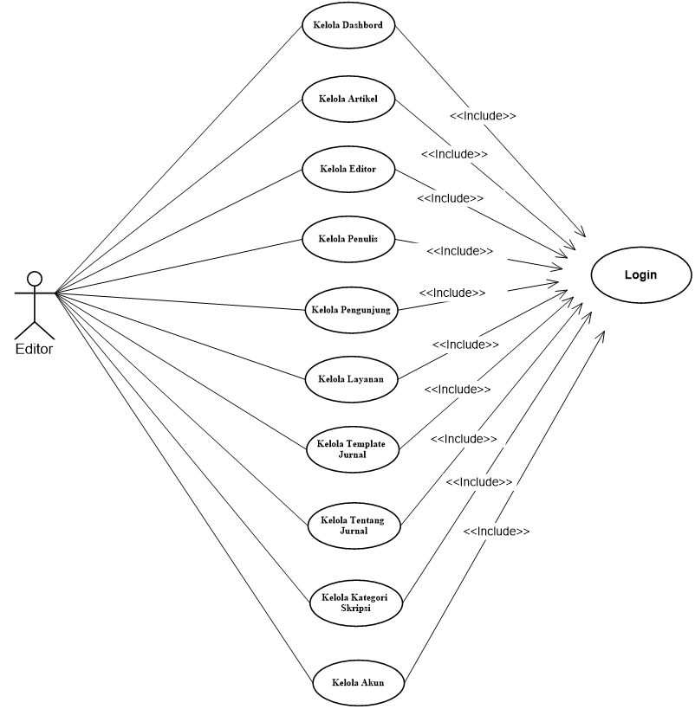

**Gambar 3. 4. Usecase Diagram Editor**

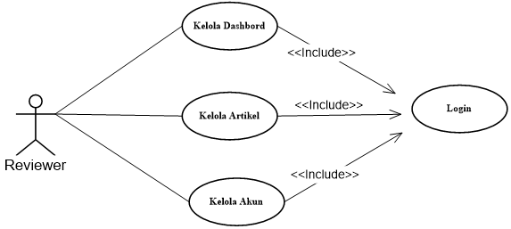

Gambar 3. **5 Usecase Diagram Reviewer**

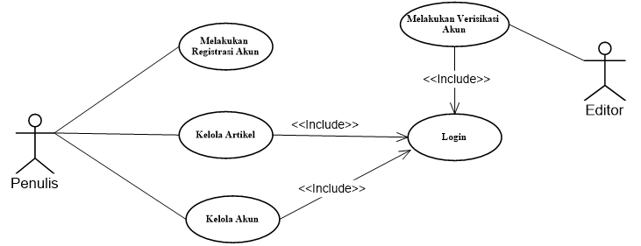

Gambar **3. 6 Usecase Diagram Penulis**

1. class diagram: partisi method dibag. ke. 3

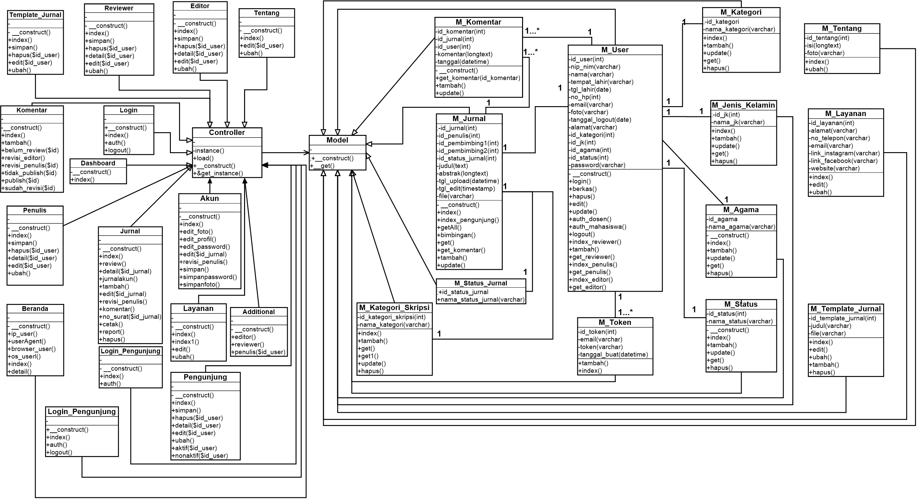

Gambar 3**. 7. Class Diagram Jurnal**