# Microsoft search engine:

## Structure and ads:

This score shows how competitive your ads are in marketplace by measuring how relevant your keywords, ads and landing pages are to customers search queries. The scale is of 1 to 10 with 10 being the best.

Advertising policy: Microsoft has advertising policy which defines what can be shown in the ad and what cannot be. Every ad created goes through the review and has to satisfy the criteria to get published. Failure of any criteria may lead to disqualification of advertisement.

Policy link: <https://about.ads.microsoft.com/en-us/policies/home>

## Bidding and Budgets:

Bidding: In advertising, bid is the max amount you are willing to pay for a click(PPC).

Initially, you define a Campaign, which consists of various Ad groups and ad groups consists of keywords. Initially when you define a adgroup, you define your budget and default bid value for your keywords. You can override this value by defining bid values for keywords. In case no value is defined the default value is considered.

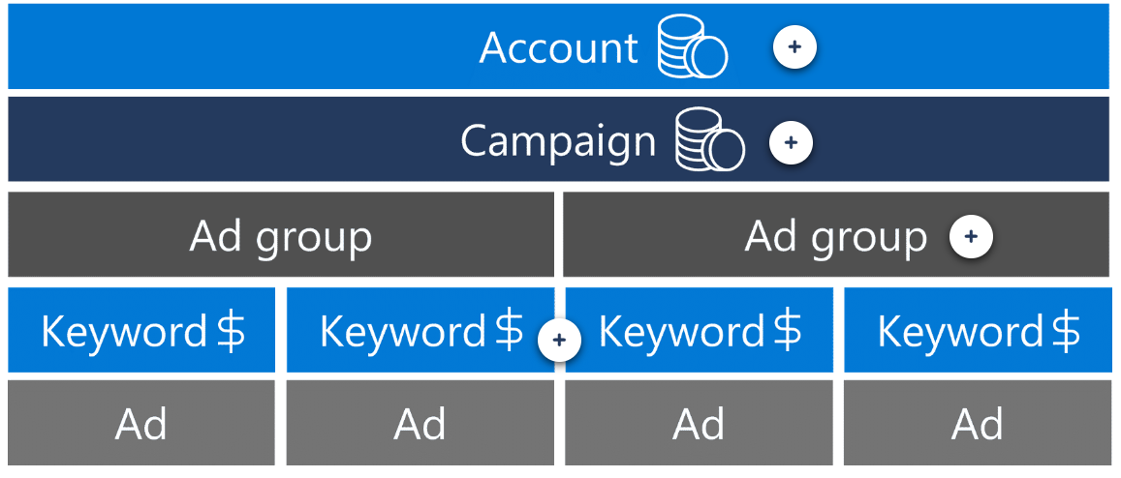

**Ad position on the Search Engine Results Page (SERP) is determined by many factors including your bid, ad relevance and ad performance**.

Bidding is not the only parameter for display of search ad on search query. The other parameter is quality score. In case if competitor’s quality score is higher than the highest bidder then the competitor will be displayed higher than highest bidder as its relevance is more than highest bidder. It’s necessary for search engine to provide better search experience to it’s user.

<https://learn.microsoft.com/en-us/advertising/guides/budget-bid-strategies?view=bingads-13#budgettypes>

One can use auto bidding feature using Microsoft advertising manage.

### Budgets:

Once you have decided your budget to spend on advertising, you need to prefund the wallet using CC or insertion order. When a campaign is decided, you allocate budget for the same from your wallet. This Campaign has Adgroups and each adgroup has keywords and ads.

There are two types of budgets: Individual and shared. In case of individual budget, a complete budget is allocated to a campaign and in case of Shared budget, the budget is allocated to various campaigns and the proportion of allocation can also be decided or if not decided based the budget will consumed as required by campaign.

How to set budget: <https://help.ads.microsoft.com/apex/index/3/en-us/53099/>

Refine your bids: <https://help.ads.microsoft.com/apex/index/3/en/53092>

Share budget across multiple campaign: <https://help.ads.microsoft.com/apex/index/3/en/56814>

## Targeting and bid adjustments:

Targeting can be done on basis of 5 parameters: These 5 parameters work individually or in combination: Geographical location, Day of the week and time of the day, Device type, Age and Gender, audience targeting.

Geographical location can be decided on the basis of the

* All available countries/regions.
* Selected countries/regions and states/provinces.
* Selected counties within the United States.
* Selected cities, metro areas, and postal codes* within Australia, Canada, France, Germany, United Kingdom, and United States.
* A specified radius around a postal code, coordinates*, landmark, or area.

How to target customers:

<https://help.ads.microsoft.com/#apex/ads/en/51051/0>

Targeting:

**Geographical location** feature allows you not just show advertisements to people of certain location but rather allows you to reject certain locations. You can also show advertisements when end user is specifically requesting for a certain location.

**Day of week and time of day targeting** can improve your conversion chances since your customer may be active only on certain time of day. While fixing the day and time, you need to specify the time zone. The time zone can be account’s time zone and Ad viewer’s time zone. If your account is different from the ad viewer’s time zone, it is better to leverage the time zone of ad viewer where the ad will be shown on the time zone of end user.

**Device type:**

You may want to show your ad on specific devices only as your ad might be tailored for just that device. In that scenario, it is recommended that you choose devices, where you may want to show the advertisements – Phone, tablet or PC.

**Age and gender (demographic targeting):**

In this targeting, you specify the age and the gender to whom you want to bid more.

**Bid Adjustments:**

The concept of bid adjustments states that based on the segmentation parameters of location, Day and time, Device and Age and Gender the bids can be customized based on the parameters selected.

In case of bid adjustment, you assign percentage change to default bid allocated at the time of keyword. The bid range to be assigned is from -90% to 900%.

This bid overrides the existing bid assigned and the allocation of space depends on these bids and relevant.

In targeting as well, the precedency of settings at lower level is higher than higher level i.e targeting settings done at ad group level has higher precedency than campaign level.

## Data Analytics fundamentals:

## The elements of data science:

#### Key issues in ML:

The key aspects determining the success of an ML model is data quality and model quality.

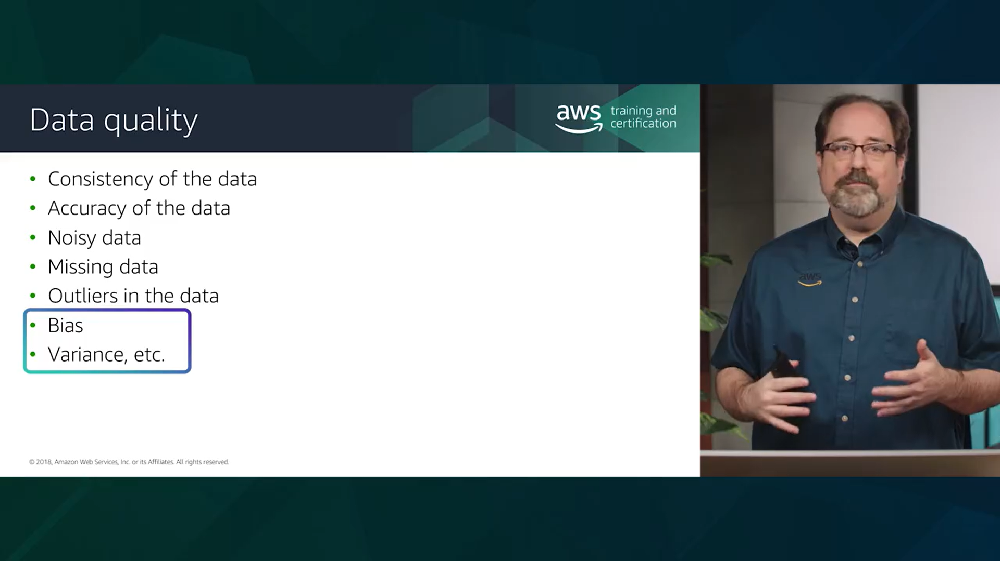

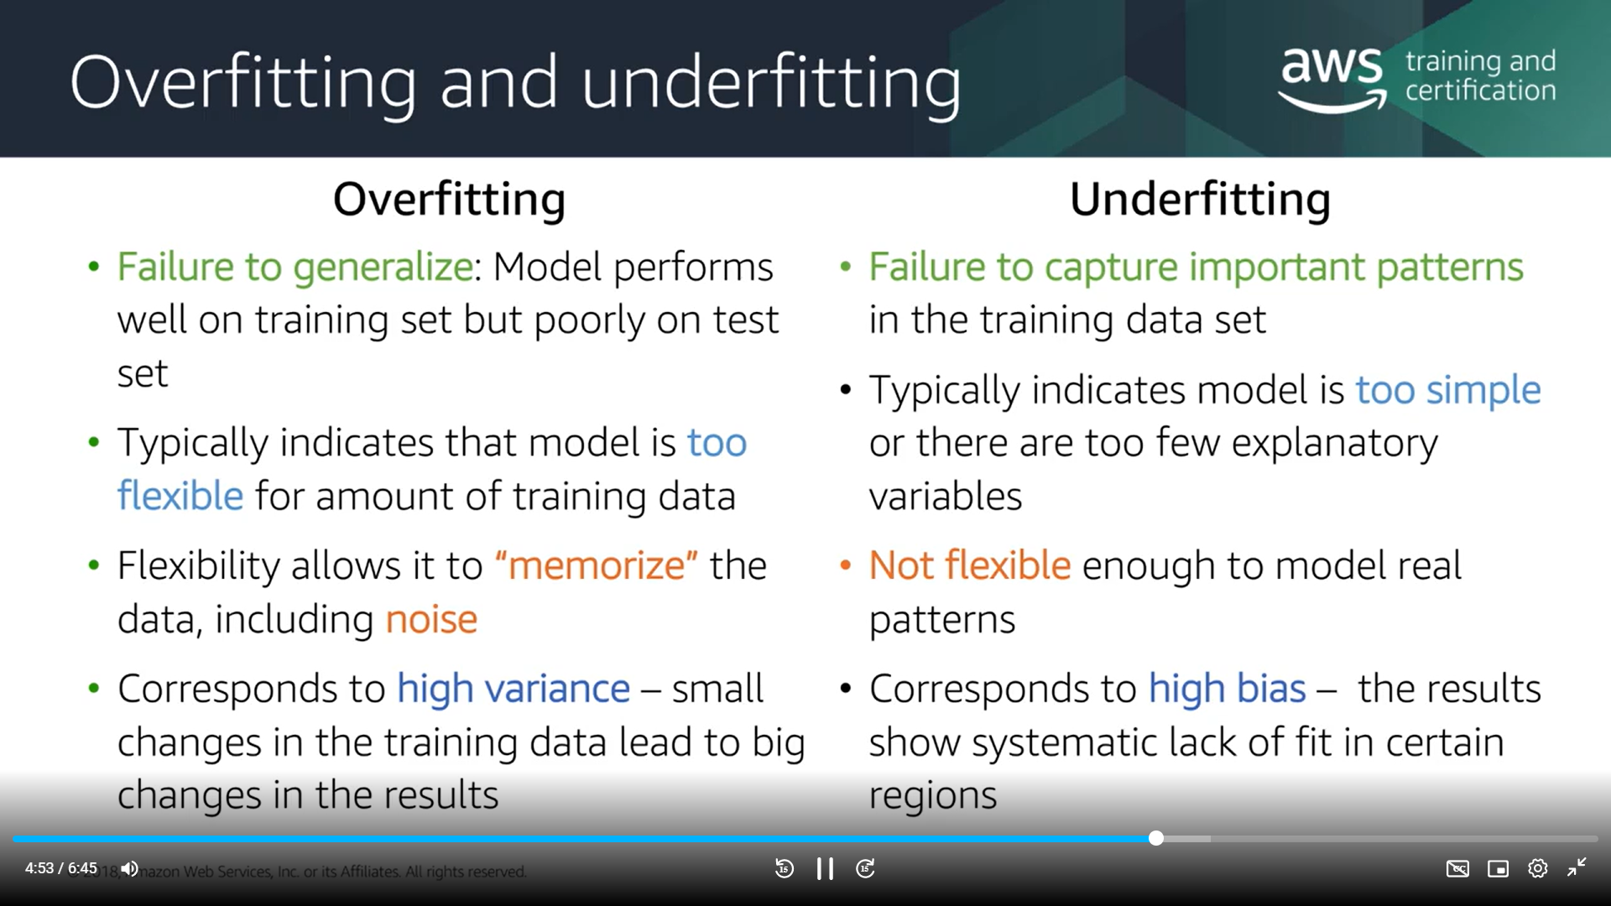

Apart from data quality, we need to ensure that the model is neither overfitted nor underfitted. In case of Overfitted data, we will include more variables than we should. This results in accommodation of noise in the model. But when it comes to production environment, the noise may not be there and model may be incorrect.

In case of underfitting, the variables are low than required and it doesn’t consider important independent variables. Bias implies unable to figure out true relation between output and input variables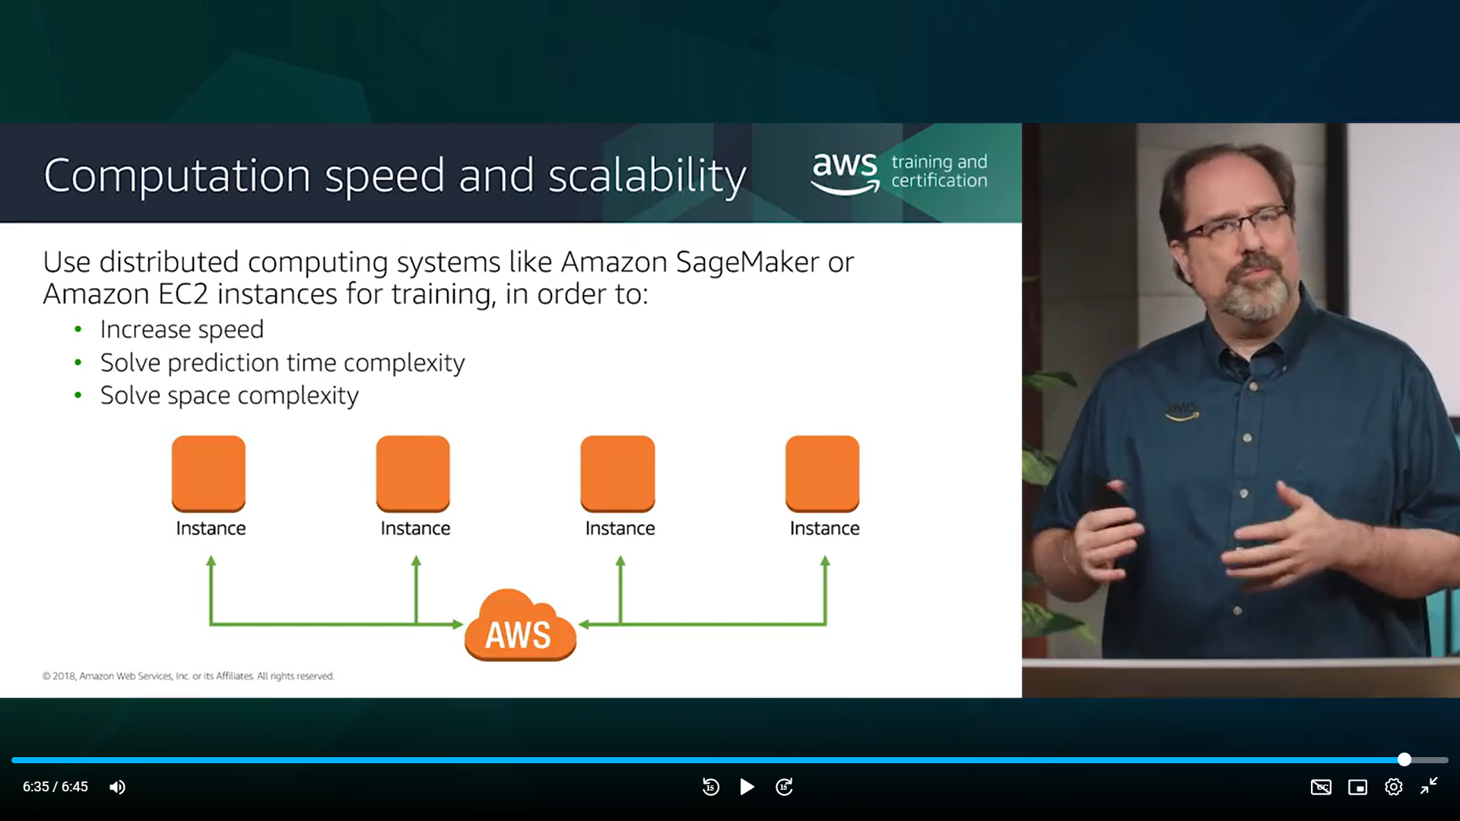

AWS sagemaker allows you to scale the model and address the response time based on the complexity of model.

#### Linear regression(supervised learning method):

Linear regression is good for numeric target outcome and Logistic regression is good for categorical target outcome. Linear regression is univariate and multivariate. In case of univariate, outcome variable is defined as function of one independent variable but whereas in case of multivariate, it is a function of number of number of variables.

In multi variable regression modelling, we may encounter multicollinearity which implies that in scenario of multivariate regression. This may result in large deviations.

Logistic regression:

We use logistic regression to take categorical variable as output. Sigmoid curve is a better function at qualifying yes or no. 