Info type: Confidential

Company: NTT Data Payment Services India Limited

Info. owner: Product Management Group

**eNACH**



***CONFIDENTIALITY DISCLAIMER***

The information included in this document is confidential information relating to the business of NTT Data Payment Services, India(NDPS). It is being presented to you based on the understanding that it will not be used for any reason other than consideration of a commercial relationship with NDPS and in particular, will not be used in connection with any decision to trade in securities of NDPS. Please be advised that any disclosure of the information contained in this document/presentation to any other person, or any use of this information in connection with the trading of NDPS securities, may be a violation.

This document, or any part of it, may not be reproduced, copied, circulated and/or distributed nor quoted without prior written approval from NDPS.

Document Information

| **Document Attributes** | **Information** |
| --- | --- |
| ID | eNach |
| Owner | Product Management Group (PMG) |
| Author | Aditya Jain |
| CR Number | PRD_ eNach­_Draft |

Revision Chart

This chart contains a history of this document’s revisions.

| **Version** | **Primary Author** | **Description of Version** | **Date Completed** | **Reviewed By** |
| --- | --- | --- | --- | --- |
| 0.1 | Aditya Jain | eNach | November 3, 2023 |  |

Contents

Document Information 2

Revision Chart 2

1. Introduction 4

2. Current System 4

3. User Personas 4

4. Proposed Solution 4

Process Flow 5

Mandate Creation Flow: 5

Execute Mandate Flow: 7

5. Functional Specifications 9

6. Reconciliation & Settlement 12

7. Reports 13

8. Modules Impacted 13

9. Appendix 24

# Introduction

We are bringing eNach facility for our merchants. Where merchants will be available to provide eNACH services to their customers over our payment gateway. eNACH is a facility by which merchants can automate payments from their customers for service offered periodically/recurringly.

Merchant customers can create eNACH mandate using net banking or debit card. For eNACH the amount limit via net banking and debit card is Rs.1 crore for most of the categories.

# Current System

Currently we are offering recurring payment using UPI Autopay.

# User Personas

The user who will be impacted by implementing this product/service are:

1. **Merchants:** Merchants are the users of this product who will use this product to collect recurring payments from their customers for the product / service offered.
2. **NCA:** This will be our internal team who will be handling the merchant onboarding part which includes master bank configuration, master charges configuration and master merchant info upload.
3. **Operation team:** This will be our internal team who will be handling the operation part which includes reconciliation of the transaction & settlement to merchant account.

# Proposed Solution

ENACH enables the Merchants to create a plan as per which the subsequent debits take place on the customer’s bank account. For ENACH, mandate registration will be directly initiated with NPCI when mandate registration request is received from merchant and for debit transaction, merchant will initiate to NDPS using the API and NDPS will then take it forward with sponsor bank to NPCI. NDPS will provide a txt file to sponsor bank for debit transaction.

ENACH will have the following components & the Corresponding APIs when Merchant is availing Services from NDPS –

|  |  |  |
| --- | --- | --- |
| **Process** | **Definition** | **APIs (NDPS)** |
| Creation of Mandate | Generation of the NPCI Mandate to enable recurring payments for a customer | Create Mandate API |
| Debit as per Mandate | Debiting of amount from the Customer account | Execute Mandate API |
| Modification of an existing Mandate | Customer/Merchant requires the Mandate to be cancelled/revoked | Revoke Mandate API |
| Attain Status of any Transaction | Merchant requires the status of any request pertaining to the above APIs | Transaction Status API |
| Webhook based Updates | NDPS posts webhook update pertaining to any change / update in transaction status | Callback API |

ENACH will have the following components & the Corresponding APIs when availing Services from NPCI –

|  |  |  |
| --- | --- | --- |
| **Process** | **Definition** | **APIs (ICICI)** |
| Creation of Mandate | Generation of the NPCI Mandate to enable recurring payments for a customer | Create Mandate API |
| Modification of an existing Mandate | Merchant requires the Mandate to be updated or revoked | Revoke Mandate API |
| Attain Status of any Transaction | Merchant requires the status of mandate request | Transaction Status API |

### Process Flow

### Mandate Creation Flow:

* Considering seamless flow, merchant will collect the mandate details such as frequency, start date, end date etc along with bank account details such as account number, ifsc code, account holder name and account type and also collect the bank name with authentication method as Net Banking, Debit Card, Aadhar to register the mandate.
* Merchant will pass the mandate info to NDPS by calling the Create Mandate API of NDPS.
* For Create Mandate Merchant has to Pass requestType=“C” only (Refer API Details File Create Mandate Request Sheet, where column Source=Merchant).
* NDPS will validate the API request.
* Post validation of the API request, NDPS will check in Titan System whether in Channel Information Channel: Online, Product: ENACH is allowed or not and bank has been configured in the ‘Scheme Information’ menu in ‘Bank Information’ accordion.
* If validation fails, merchant get the API response with error code & error description.
* Once validation is done successfully, NDPS will trigger Create Mandate API of NPCI.

**Note:** From Merchant to NDPS the API request will be in JSON format. NDPS need to convert the JSON Format to XML and need to pass the XML request to NPCI.

* NPCI will validate the request and forward the request to Destination Bank (Customer Bank).
* Customer will validate & authorize the transaction on Destination Bank page by entering the OTP received on customer mobile number.
* Destination Bank will validate the OTP and send the response to the NPCI.
* NPCI will provide the response to NDPS and NDPS will share the response with Merchant.
* NDPS will update the create mandate table with mandate status.
* Once API response is received from NPCI, a callback notification will also be triggered to merchant for mandate registration status.

**Note:** From NPCI to NDPS the API response will be in XML format. NDPS need to convert the XML Format to JSON and need to share the response with merchant.

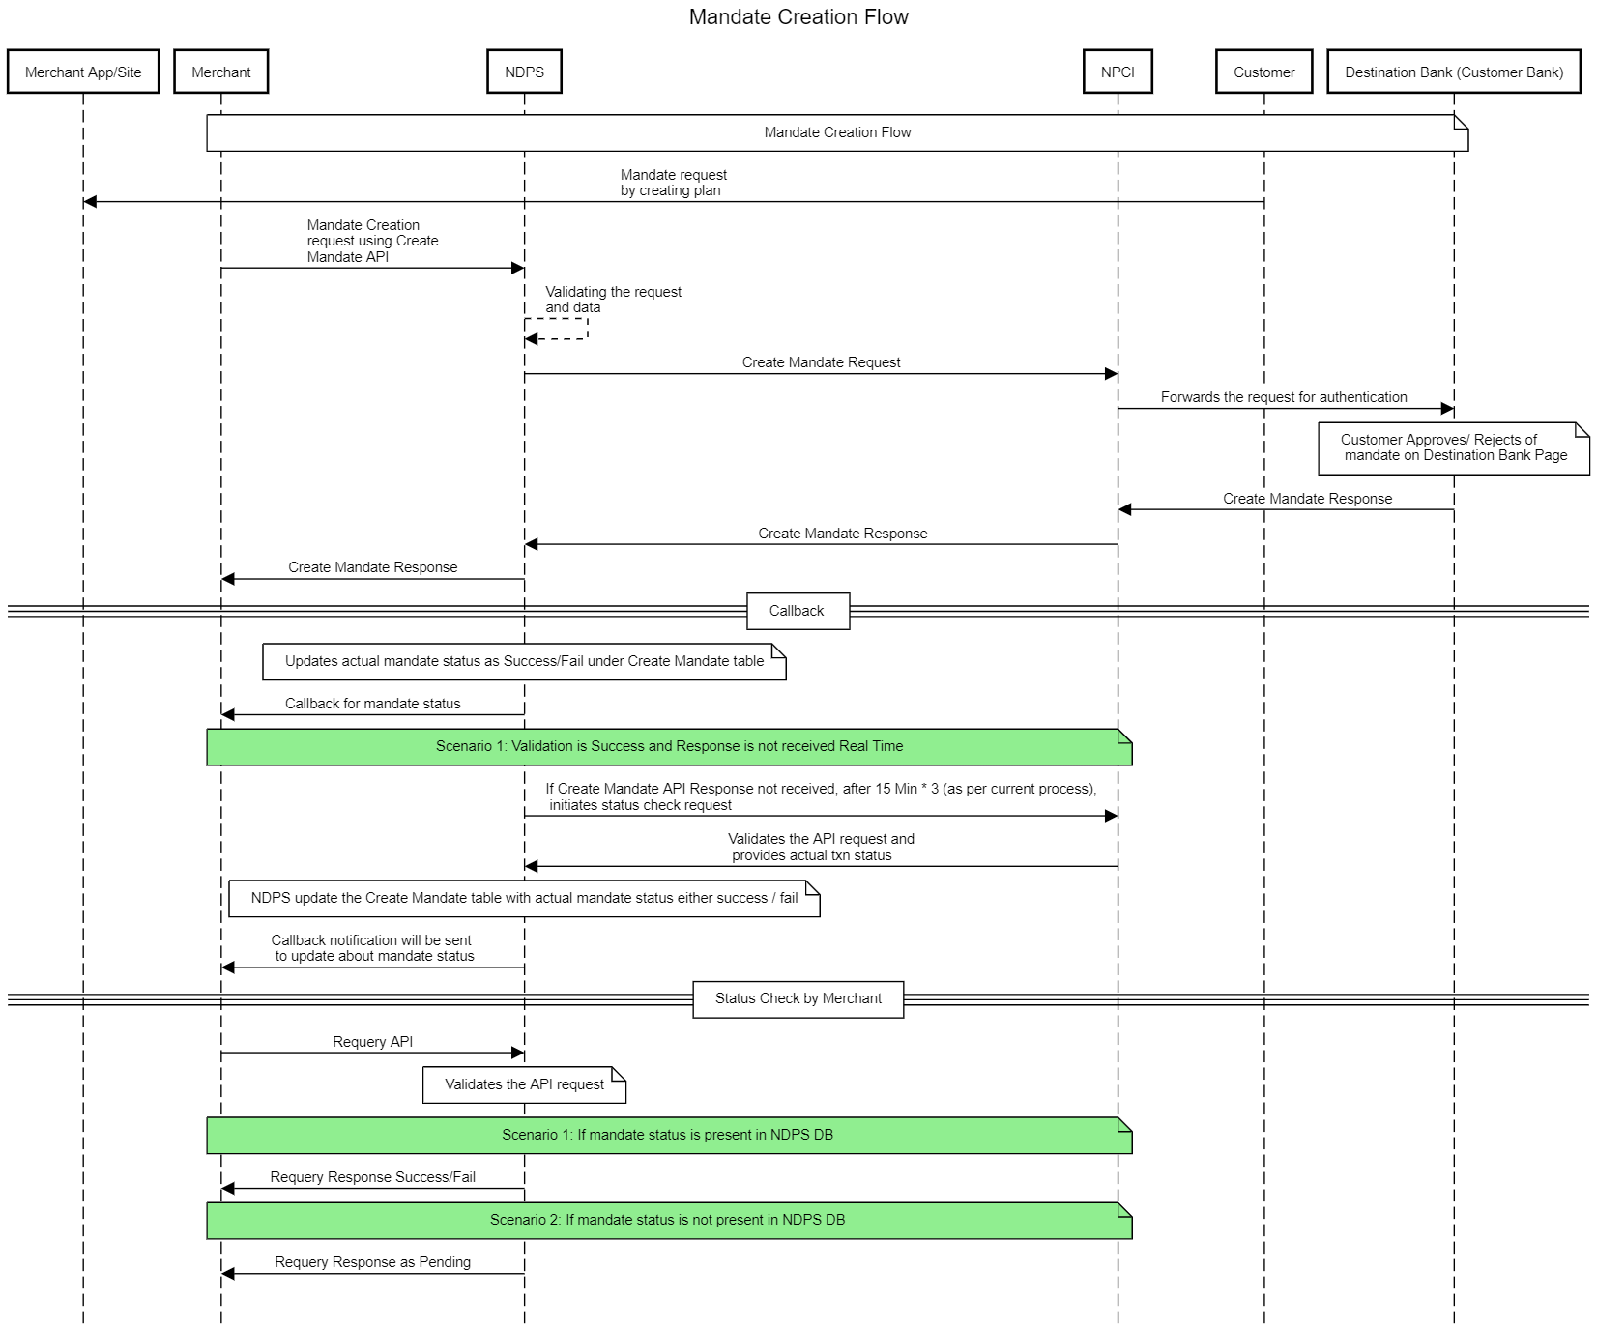

**Mandate Status Check:**

**Scenario 1: Create Mandate API response is not received in real time**

* If the Create Mandate API response is not received in real time, then NDPS will initiate the status check API to NPCI after 15 mins.
* NPCI will validate the request and provide the actual transaction status to NDPS. NDPS will update the Create Mandate table with actual mandate status which is success / fail.
* NDPS will send a callback notification to merchant to update about the actual mandate status.

**Scenario 2: Merchant initiates status check to NDPS & mandate status is present in NDPS DB**

* If mandate status is available with NDPS, then NDPS will share the status check API response to merchant with mandate status as Success / fail.

**Scenario 3: Merchant initiates status check to NDPS & mandate status is not present in NDPS DB**

* If mandate status is not available with NDPS, then NDPS will share the status check API response to merchant with mandate status as Pending.

### Execute Mandate Flow:

* Once the mandate is registered, either Merchant will initiate the debit transaction on T-2 day (T is transaction debit date) by calling the Execute Mandate API of NDPS or NDPS will initiate the debit transaction by running the schedular if merchant has opted for scheduler to be run by NDPS.
* The cutoff to receive details over Execute Mandate API from merchant is 23.00 PM on T-2 day. If merchant passes the data after the cutoff time the API request will be rejected and error code with error description will be shared with merchant in API response.
* When frequency is **‘Daily’ and ‘As and when presented’** the details over Execute Mandate API from merchant can be received on T Day before a cutoff time of 9.00 AM. If merchant passes the data after the cutoff time the API request will be rejected and error code with error description will be shared with merchant in API response.
* Only in below scenarios NDPS will run the Schedular:

|  |  |  |  |
| --- | --- | --- | --- |
| **API** | **Parameter** | | |
|  | autoExecute | amountLimit | Frequency |
| Create Mandate Merchant API | Y | F | Fixed (Daily, Weekly, bi-monthly, monthly, Quarterly, half yearly, yearly,) |
| Create Mandate Merchant API | Y | F | OT (Onetime) |

* Once request is received from merchant, NDPS validates the request, Post validation of the API request, NDPS will check in Titan System whether in Channel Information Channel: Online, Product: ENACH is allowed or not and under Grant Permission ENACH SMS enabled or not.
* If under Grant Permission, ENACH SMS is enabled for that merchant, then each record received in the API request will be validated & duplication check will be done,
  + If there is no duplication of records found, then each record will be processed individually, and entry will be created in the temporary DB and an SMS will be triggered to mobile number provided under the parameter ‘mobileNo’ for each record.
  + The SMS Template is provided here where merchant name will be fetched from Titan system and other details will be entered from OTS System which are Debit Date and amount.
  + SMS Template as “**Dear Customer, your payment has been scheduled on <DD/MM/YYYY> for Rs.<XXXXXXXX.XX> for <merchant name> and would get debited from your registered account. Pls ensure sufficient funds in your bank account. Atom Technologies**”

**Note:** Merchant name field will have upto 40 characters and if there are more than 40 characters the name will be concatenated.

* + If there is duplication of records found, then accordingly API response for that record/request with error code & error description will be shared with merchant.
  + Below fields received from merchant under Execute Mandate API request will be considered to perform the dedupe check:
    - merchId
    - merchantTranId
    - Amount
    - UMN
    - debitDate
    - txnBatchNo
* Each record received in the API request will be validated to check if we have received the debit transaction request on T-2 day (T is transaction debit date). The parameter needs to be checked is ‘debitDate’ to confirm if the request is received on T-2 day.
* If request is validated successfully for ‘debitDate’ we will process that request and if its not validated, then accordingly API response for that record/request with error code & error description will be shared with merchant.
* If under Grant Permission, ENACH SMS is not enabled for that merchant, then each record received in the API request will be processed individually and entry will be created in the temporary DB for each record and SMS will not be triggered.
* Once all the records are processed successfully and entry for each record is created in temporary database, the API response will be shared with merchant with message as ‘Transactions submitted successfully’ for valid request and where request is not valid the API response with error code & error description will be shared.
* Post saving the details of all records received through Execute Mandate API under temporary table for T-2 Day, NDPS will run the scheduler and create txt format-based transaction file at 1.00 AM on T-1 Day and will move the data from temporary DB to Permanent DB i.e., under the ‘Execute Mandate’ table.
* NDPS will submit the transaction file to sponsor bank (ICICI Bank or HDFC Bank) on T Day (T is transaction debit date) at 3.00 AM via SFTP or Host to Host server for execution with NPCI.
* The file name which needs to be submitted to sponsor bank should have proper naming convention. The sample file name is provided here as “**ACH-DR-ICIC-ICIC000000-08012024-NT0001-INP**”
  + Here **ACH-DR** will going to remain common as it denotes the NPCI product
  + **ICIC** is sponsor bank code as we are going with ICICI right now so need to mention ICIC
  + **ICIC000000** this value denotes ICICI Bank user name and this value will be provided by ICICI Bank
  + **08012024** this denotes the settlement date for which the transaction needs to be executed
  + **NT0001** this denotes the number of files for that day. If there is only one execution file then name will be provided as mentioned above and if there are more than one execution file for the single settlement date, then file name of second file will be mentioned as **NT0002** and so on
* Once the file is shared over SFTP or Host to Host server with sponsor bank an automated email will also need to be triggered to email ids provided by sponsor bank. If more than one file is shared, then accordingly those file details will be shared in the format below. The email will have content as:

**Dear Sir / Madam,**

**We have placed the transaction file for settlement date dd/mm/yyyy on the SFTP/H2H folder. Below are the file wise details:**

**Sr. no. File Name No. of transactions Total Amount Settlement Date**

* Sponsor Bank shares the TXT file with NPCI & NPCI validates the data at his end and shares the file with destination bank for debit execution.
* Once the sponsor bank uploads the transaction file on NPCI system, after a period of 1 or 2 hours NPCI will share the acknowledgement report for the transactions with sponsor bank.
* Sponsor bank will share the acknowledgement report with NDPS which will have data of either rejected transactions or if all the transactions are approved then it will have a single record in a acknowledgement report with status as approved for all transactions.
* If required database can be updated with rejected or approved transaction status and after updating the database, a callback notification can be sent to merchant to update about the transaction status as accepted or rejected.
* On T Day at around 21.00 PM NPCI will share the final transaction response file with sponsor bank & sponsor bank will share the final transaction response file with NDPS at around 21.30 PM.
* The response file received from sponsor bank will have transaction status either as success or return or extension (pending) and this status will overwrite the transaction status accepted or rejected under execute mandate table.
* After updating the database, a callback notification will be sent to merchant to update about the transaction status as success or return or extension.

**Transaction Status Check:**

**Scenario 1: Merchant initiates status check to NDPS & transaction is submitted to sponsor bank for execution**

* NDPS will share the status check API response to merchant with transaction execution status as ‘Transactions submitted successfully’.

**Scenario 2:** **Merchant initiates status check to NDPS & acknowledgement file received from sponsor bank**

* If acknowledgment file is available with NDPS, then NDPS will share the status check API response to merchant with transaction execution status as accepted or rejected

**Scenario 3:** **Merchant initiates status check to NDPS & response file received from sponsor bank**

* If response file is available with NDPS, then NDPS will share the status check API response to merchant with transaction execution status as success or return or extension (pending)

# Functional Specifications

#### Master Creation

The below Master files will be created in TITAN:

1. Bank Master
2. Bank Charges Master
3. Product Master
4. Bank Product Master

#### API’s

1. **Create Mandate API (Merchant-NDPS-NPCI)**

**Description:** This API will be used by Merchant to create the mandate (Refer attached Excel)

* Customer visits Merchant’s website/App and chooses ENACH to make payment
* Merchant initiates Create Mandate Request to NDPS with ‘transactionType’ parameter value as ‘EN’ for ENACH
* NDPS validates the request, Post validation of the API request, NDPS will check in Titan System whether in Channel Information Channel: Online, Product: ENACH is allowed or not and bank has been configured in the ‘Scheme Information’ menu in ‘Bank Information’ accordion and triggers Create Mandate Request to NPCI
* NPCI validates the request at his end and initiates for the authentication with destination bank
* End-customer Approves or Rejects the mandate on bank page
* NPCI shares the response through with NDPS along with UMRN Number
* NDPS share the response with Merchant

If NDPS do not receive the response from NPCI due to timeout or any other issue. Below scenarios are applicable:

**Scenario 1: Create Mandate API response is not received in real time**

* If the Create Mandate API response is not received in real time, then NDPS will initiate the status check API to NPCI after 15 mins.
* NPCI will validate the request and provide the actual transaction status to NDPS. NDPS will update the Create Mandate table with actual mandate status which is success / fail.
* NDPS will send a callback notification to merchant to update about the actual mandate status.

**Scenario 2: Merchant initiates status check to NDPS & mandate status is present in NDPS DB**

* Merchant calls Transaction Status API to NDPS.
* NDPS triggers response to Merchant via Transaction Status API response with mandate status as success / fail.

**Scenario 3: Merchant initiates status check to NDPS & mandate status is not present in NDPS DB**

* Merchant calls Transaction Status API to NDPS
* If mandate status is not available with NDPS, then NDPS will share the status check API response to merchant with mandate status as Pending.

**‘Firstdebit’ Parameter –**

* For ENACH the ‘firstDebit’ parameter in Create Mandate API will always remain ‘N’ whether amountLimit="M or F" as first debit is not required within 5 minutes of mandate creation and Execute Mandate request can be initiated by merchant or by NDPS if merchant has opted for scheduler to be run by NDPS.

1. **Execute Mandate + Notification API (Merchant-NDPS)**

**Description:** This single API will be used to perform two functions first to schedule the transaction for execution and second to send the notification to merchants’ customer via SMS, if merchant opts to send the notification by NDPS. This API will be an Array object API which can accommodate upto 25000 records in a batch.

* Execute Mandate API will be initiated by merchant to NDPS on T-2 Day (T is transaction debit date) or by NDPS if merchant has opted to run scheduler by NDPS.
* NDPS validates the request, Post validation of the API request NDPS will check in Titan System whether in Channel Information Channel: Online, Product: ENACH is allowed or not and under Grant Permission ENACH SMS enabled or not.
* If under Grant Permission, ENACH SMS is enabled for that merchant, then each record received in the API request will be processed individually and entry will be created in the temporary DB for each record and SMS will be triggered to mobile number provided under the parameter ‘mobileNo’ for each record.
* If under Grant Permission, ENACH SMS is not enabled for that merchant, then each record received in the API request will be processed individually and entry will be created in the temporary DB for each record and SMS will not be triggered.
* Once all the records are processed successfully and entry for each record is created in temporary database, NDPS will initiate the response of Execute Mandate API to merchant.

**Scheduler**

Note*- If Execution is done by NDPS (i.e. autoExecute = ‘Y’ in Create Mandate Request), then merchantTxnId will be same as atomTxnId. This is done based on the input in the ‘autoExecute’ parameter.

**Mandate Execution at NPCI end through Sponsor Bank**

* Post saving the details of all records received through Execute Mandate API under temporary table for T-2 Day, NDPS will run the scheduler and create txt format-based transaction file at 1.00 AM on T-1 Day and will move the data from temporary DB to Permanent DB.
* NDPS will submit the transaction file to sponsor bank (ICICI Bank or HDFC Bank) on T Day (T is transaction debit date) at 3.00 AM via SFTP or Host to Host server for execution with NPCI.
* Sponsor Bank shares the TXT file with NPCI & NPCI validates the same
* NPCI shares the file with Destination Bank and bank debits the customer account
* NPCI provides the response file to Sponsor Bank
* Sponsor Bank shares the response file with NDPS on T Day at around 21.00 PM
* NDPS will consume the response file and save the data under Execute Mandate table and shares the response to Merchant via Callback API

1. **Amend/Cancel/Suspend/Revoke Mandate API (Merchant-NDPS-NPCI)**

**Description:** This API will be used by Merchant to Amend/Cancel/Suspend/Revoke the mandate (Refer attached Excel)

* Merchant initiates Mandate Amend/Cancel/Suspend/Revoke Request to NDPS
* NDPS validates the request and forwards it to NPCI
* NPCI validates the request and forwards it to Destination Bank
* Destination Bank validates the request and customer approve / rejects the mandate update / cancellation by authentication using net banking or debit card
* Response is floated from Destination Bank to NPCI
* NPCI forwards the response to NDPS
* NDPS shares the response with merchant

Below parameter of an active Mandate can be Amended:

* Mandate request Initiate Party’s Category Description (“CatDesc”)
* Name of Initiator (required input for all operation like amend, cancel, suspend and revoke)
* Collection Amount
* Max Amount
* Recurring Frequency
* First Collection Date
* Final Collection Date

1. **Transaction Status API (Merchant-NDPS-NPCI)**

**Description:** This API will be used by Merchant to get the transaction status for create mandate and execute mandate (Refer attached Excel)

**To get the mandate registration status:**

* Once Mandate Creation API is executed Merchant will initiate the Transaction Status API to NDPS (Transaction Status Request)
* NDPS will validate the request and if transaction status is available with NDPS same will be shared with merchant as an API response
* If the Create Mandate API response is not received in real time, then NDPS will initiate the status check API to NPCI after 15 mins.
* NPCI will validate the request and provide the actual transaction status to NDPS. NDPS will update the Create Mandate table with actual mandate status which is success / fail.
* NDPS will send a callback notification to merchant to update about the actual mandate status.

**To get the transaction execution status:**

1. **Callback (Merchant-NDPS)**

**Description:** This callback will be used by NDPS to provide the status of mandate creation and transaction execution to merchant (Refer attached Excel).

1. **Mandate Registration Status Callback:**

Callback will be triggered by NDPS to Merchant when,

**Scenario 1:**

* Successful mandate registration status received as success / fail in Create Mandate API response along with UMRN number.

**Scenario 2:**

* If the Create Mandate API response is not received in real time, then NDPS will initiate the status check API to NPCI after 15 mins.
* NPCI will validate the request and provide the actual transaction status to NDPS. NDPS will update the Create Mandate table with actual mandate status which is success / fail.
* NDPS will send a callback notification to merchant to update about the actual mandate status.

1. UMN is Unique Mandate Number that Identifies the Mandate
2. Information received in Create Mandate API response will be stored in Titan DB (NDPS DB Mandate Creation). Post storing the data in the Titan DB, NDPS will initiate the Callback to Merchant
3. **Mandate Execution Status Callback:**

A callback will be sent to merchant twice, first on receiving Acknowledgement file,

* Sponsor bank will share the acknowledgement report with NDPS with status of transactions either as accepted or rejected and the status of transactions will be saved in execute mandate table in database.
* After updating the database, a callback notification will be sent to merchant to update about the transaction status as accepted or rejected.

Second on receiving the Response file from sponsor bank,

* On T day at around 21.00 PM NPCI will share the final transaction response file with sponsor bank & sponsor bank will share the final transaction response file with NDPS at around 21.30 PM.
* The response file received from sponsor bank will have transaction status either as success or return or extension (pending) and this status will overwrite the transaction status as accepted or rejected under execute mandate table.
* After updating the database, a callback notification will be sent to merchant to update about the transaction status as success or return or extension.

# Reconciliation & Settlement

* On T Day in the afternoon NPCI shares acknowledgement report for the transactions with Sponsor Bank.
* On T Day in the afternoon Sponsor Bank shares acknowledgement report for the transactions with NDPS & Credits the funds into NDPS Account for Approved transactions.
* On T Day at around 9 PM NPCI shares response report for the transactions with Sponsor Bank.
* On T Day at around 9 PM Sponsor Bank shares response report for the transactions with actual status of transactions with NDPS.
* On T+1 Day Sponsor Bank debits the NDPS account for Failed transaction, if any approved transaction status received as Failed in response file.
* On T+1 Day, Reconciliation is done using Response File with transactions available with NDPS for T Day.
* Once Reconciliation is done a Payout file is generated for settlement to merchants on T+1 Day.
* Payout is made to merchants.

# Reports

The following are the reports applicable to the Recurring Payments module -

1. Report as per NDPS will be exhibited on Merchant Console and Admin Console (Report Menu-> Mandate as Sub Menu)
2. Three reports are currently to be configured –
3. Transaction Report in ‘View Transaction Report’ menu
4. Mandate Report in new ‘Recurring Mandate’ menu
5. Notification Report in new ‘Recurring Mandate’ menu
6. Download File Type will be Excel and .CSV

# Modules Impacted

**Impact on Merchant Console**

Yes. The below are the changes –

1. Mandate Report
2. Notification Report
3. Transaction Report

1. Mandate Report: The mandates created in the system can be tracked using ‘Recurring Mandate’ sub-menu in the Transactions menu. Refer below snapshot –

1. Report Type is pre-selected as ‘Mandate Report’ with other option being ‘Notification’
2. Product type dropdown has ‘UPI Autopay’, ‘Standing Instructions’ & ‘E-NACH’ as options to select, based on the mode enabled
3. In the Bank menu, the bank name available across the respective Product (i.e., UPI Autopay, E-NACH), will be available to select
4. Mandates can be searched for specific MIDs by utilizing the ‘Merchant ID’ textbox
5. Mandates can be searched for specific mandate number by utilizing the ‘UMN’ textbox
6. Mandates can be searched for specific dates by utilizing the ‘from date’ and ‘to date’ where the date is selected using the date selector (non-mandatory)
7. Using the ‘Search’ button, the respective fields will be displayed with the respective data, based on the input criteria
8. Using the ‘XLSX’ download button, the respective fields will be displayed along with the data, based on the input criteria
9. Headers for the report can be customized using the ‘Customize Headers’ button
10. For specifications of the report, refer the attached Report.



1. Notification Report: In ‘Recurring Mandate’ menu, on selection of ‘Notification’ in ‘Report type’, the report for Notification shall exhibit based on the inputs for the parameters – Product Type, Bank, Merchant ID, UMN, From Date and To Date.

For the report specifications, refer the attached Report.



1. Transaction Report: ‘E-NACH’ will be exhibited in the Product Type and configuration shall be available as per the Masters.

For the report specifications, refer the attached Report.



**Impact on Admin Console**

1. **Merchant Onboarding –**

On selection of ‘MID’ -> In ‘Channel Information’ tab, ‘E-NACH’ will be available to select in ‘Product’, ‘Gross Settlement for’, ‘Surcharge Applicable For’, ‘Domestic Acceptance’, ‘International Acceptance’ & ‘Exceptional Bank Charges’. Also, the Product ‘E-NACH’ will be available for the selection of ‘Settlement Tenure’.

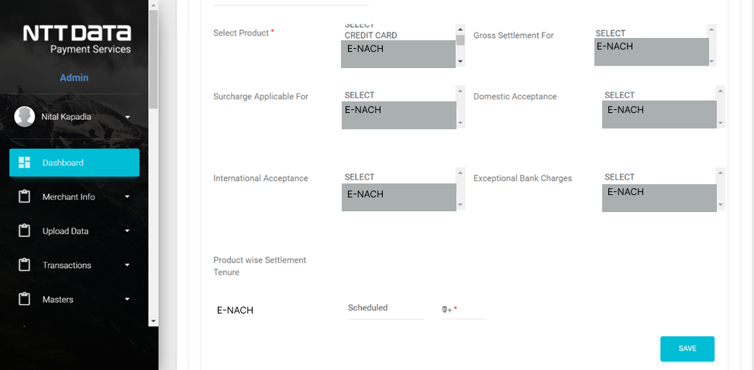Refer below snapshot –

**Bulk Merchant Onboarding:**

Merchant Bulk Onboarding can also be done from ‘Upload Data’ tab > ‘ONLINE MERCHANT UPLOAD’.

Attached is the bulk merchant onboarding sheet. Under this sheet the Column named as ‘GRANT PERMISSION’ will have a filed named as ‘Enable E-NACH SMS’.



1. **Enable E-NACH SMS:**

If merchants opts for ENACH SMS the same will be enabled at the time of merchant onboarding by selecting the ‘Enable E-NACH SMS’ checkbox under the ‘GRANT PERMISSION’ for that merchant when selected Select Channel ‘ONLINE’ and Select Product ‘E-NACH’ under ‘Merchant Info’ tab under ‘Merchant Onboarding’ tab under ‘Channel Information’ tab. Refer images below.

1. E-NACH needs to be considered as New Product for Channel (Online), refer Attachments.
2. In Merchant Onboarding - Channel Online -> Product E-NACH will be exhibited
3. **Bank Configuration -**

In the ‘Scheme information’ menu, on selection of channel ‘Online’, the PG BANK option will be populated by the Acquiring Bank as ICICI Bank. In this menu the below shall be configurable –

* 1. Merchant Type as TPV & Non-TPV
  2. Bank IFSC Code
  3. Utility Code
  4. Category Description
  5. Category Code

Refer below snapshot -

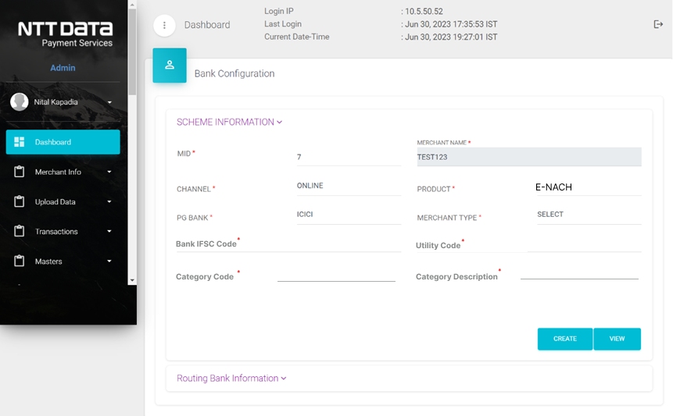

**Bulk Bank Configuration:**

Bulk Bank Configuration can also be done from ‘Upload Data’ tab > ‘PG Bank Config Upload’.

Below are the parameters that will be impacted under the bank configuration when the file is uploaded.

* ATOM MID
* PRODUCT
* Routing Bank
* Acceptance
* Type
* Scheme
* Scheme Product Type
* Merchant Type
* Access Code
* Bank IFSC Code – This will be the new field which is to be added
* Change Request
* Change Request Details
* Change Request Closure date
* Category Description – This will be the new field which is to be added.
* Category Code – This will be the new field which is to be added.

Attached is the sample upload file:



1. **View Transaction Menu –**

‘E-NACH’ will be exhibited in the Product Type and configuration shall be available as per the Masters.

Refer ‘Transaction Report’ in attachments section for report header fields specifications.

Refer below snapshot -

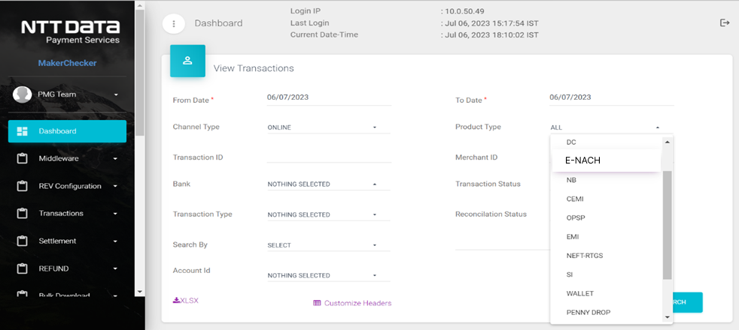

1. **Mandate Tracking:**

The mandates created in the system can be tracked using ‘Recurring Mandate’ sub-menu in the Transactions menu.

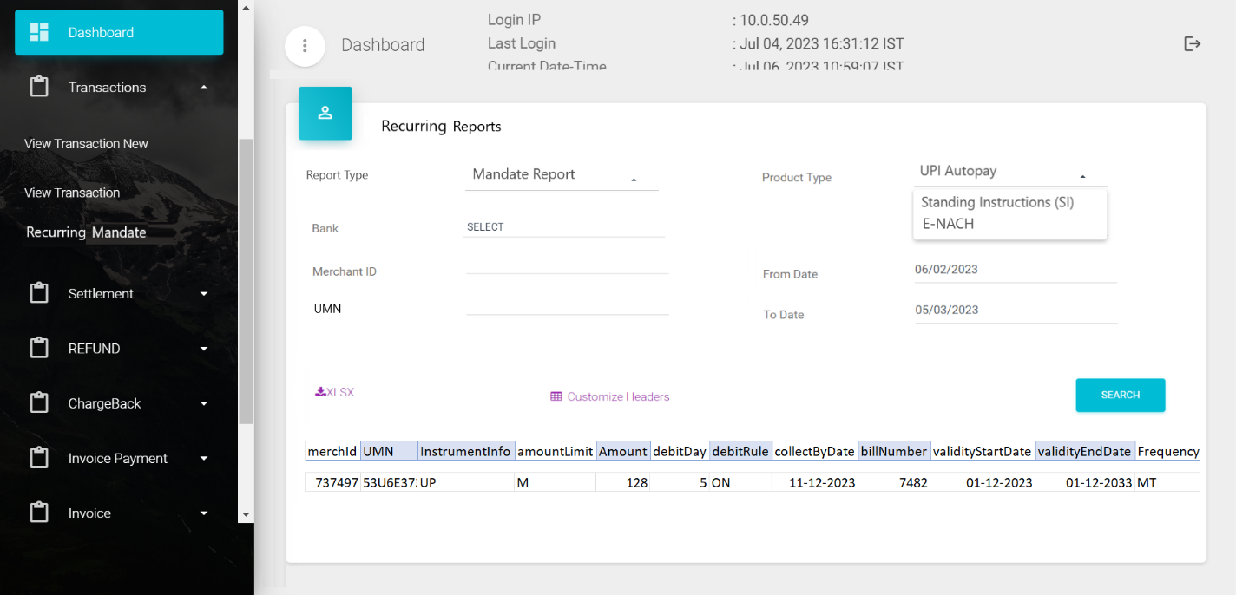Refer below snapshot –

1. Report Type is pre-selected as ‘Mandate Report’ with other option being ‘Notification’
2. Product type dropdown has ‘UPI Autopay’, ‘Standing Instructions’ & ‘E-NACH’ as options to select
3. In the Bank menu, the bank name available across the respective Product (i.e., UPI Autopay, E-NACH), will be available to select
4. Mandates can be searched for specific MIDs by utilizing the ‘Merchant ID’ textbox
5. Mandates can be searched for specific mandate number by utilizing the ‘UMN’ textbox
6. Mandates can be searched for specific dates by utilizing the ‘from date’ and ‘to date’ where the date is selected using the date selector (non-mandatory)
7. Using the ‘Search’ button, the respective fields will be displayed with the respective data, based on the input criteria
8. Using the ‘XLSX’ download button, the respective fields will be displayed along with the data, based on the input criteria
9. Headers for the report can be customized using the ‘Customize Headers’ button
10. For specifications of the report, refer the attached Report in attachments.
11. **Notification Tracking:** In ‘Recurring Mandate’ menu, on selection of ‘Notification’ in ‘Report type’, the report for Notification shall exhibit based on the inputs for the parameters – Product Type, Bank, Merchant ID, UMN, From Date and To Date.

For the report specifications, refer the attached Report in attachments.

1. **Reconciliation:** Yes

‘E-NACH’ Product will exhibit in the Reconciliation File Upload Menu and configured bank shall reflect in the ‘Bank’. Below parameters to be considered from acquiring bank recon file for reconciliation at NDPS end.

1. Reserved (Flag for success / return)
2. Reserved (Reason Code)
3. UMRN
4. Transaction Reference (This will be the NDPS transaction ID)
5. Amount

Refer below snapshot –

1. **Charges Configuration –**

In ‘Charges Config’ tab, on selection of ‘Online’, the below screen will exhibit and ‘E-NACH’ will be available to select in ‘Product type’ post selection of ‘MID’. Then on clicking the search button the page will be populated as per the below snapshot -

**Bulk Charges Configuration:**

Bulk Charges Configuration can also be done from ‘Upload Data’ tab > ‘ONLINE CHARGES UPLOAD’.

Below are the parameters that will be impacted under the Charges configuration when the file is uploaded.

* Atom MID
* Charges Action
* Product
* Charges Types
* ACCPETANCE
* Schemes (As per Master Data)
* SCHEMES VARIANTS

Attached is the bulk upload file format.



**Admin Modules that will get impacted:**

1. Payout and Settlement: Yes
2. Refund: No
3. Chargeback: No
4. Maker-Checker: No
5. Surcharge Applicability: No
6. Payment option and charges option: No
7. Other setting: Yes

**Impact on Payment Page**

No

**Impact on Payment Page (Mobile)**

No

# Appendix

|  |  |
| --- | --- |
| **Document Name** | **Attachment** |
| Mandate Report |  |
| Notification Report |  |
| Transaction Report |  |
| Sample Bank Recon File |  |
| E-NACH Transaction File format (To generate input txt file for sponsor bank) |  |
| Sample Input Txt file for sponsor bank |  |
| Sample Acknowledgement File received from Sponsor Bank |  |
| APIs, DB Structure & Validations |  |