**Project 1**

**~Pokemon RPG~**

CSC-17C-44049

Name: Najera, Enrique

Date Due: 17 April 2017

**Introduction**

Title: Pokemon RPG

In the world of Pokemon, one must level up their Pokemon in order to be the strongest trainer!

Leveling up Pokemon, however, requires battling other Pokemon and foes!

You can also catch Pokemon to expand your library of available fighters (from weak to strong).

Fighting monsters will make your Pokemon unhealthy and hurt, but using items can restore their health! Buy items at the Hospital or find them lying around!

First time players: press ‘h’ to bring up a legend and help menu!

Quitting the game or dying in-game will make you lose your progress, so be careful!

I chose this style of project because it contains a lot of logic and features. This helped me decide what concepts to use, and where, easier.

**Summary**

Program size: ~1160 lines (Excluded the header [file, author, date, purpose] and huge comments, then rounded up to the nearest 10th place)

Number of major variables: ~44

Number of constructs: ~17

It was fairly challenging to do. I had the most problems with buffer overflows caused by linked lists, displaying linked lists the way I wanted them to, making up how the project requirements would fit into a game, and thinking up what to do for the project in general. I also had no idea what to use a queue for (feels like it would be a repeat of something already in-game).

This project took me about 16 hours to do, with about 1 hour of debugging.

I had many challenges and features I would have loved to add, but sadly, time does not allow it at the moment.

I had fun making this project (although I admit some times were frustrating) and at the same time learned so much on how to use a few of the STL algorithms, containers, and iterators.

Other aspects that I used that have not been covered in this course are using allocators for sets. I used an allocator to sort the set based on string length. Everything else I haven’t really seen before was a requirement, so I don’t think it counts.

**Description**

At first, I tried to make a dice game of chance, but it was way too short and not enough to include all the concepts necessary. On the side I tried to make a map-panning program using pure ASCII characters and C++, which, in turn, gave me the idea to mix the two and this eventually led to a Pokemon-style game. Oddly enough, using a sheet of paper to solve problems I had helped a whole lot! Other than that, looking at documentation and redoing concepts on a separate program helped me get through my problems.

**Sample Input/Output**

Starting the program

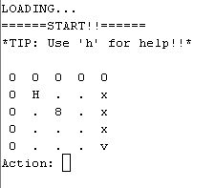

Pressing ‘h’ brings up a help menu

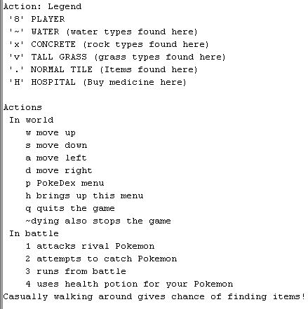

Pressing ‘q’ quits the game (output varies)

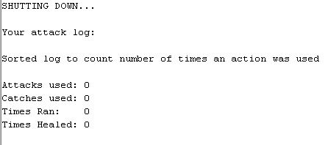

Pressing ‘p’ displays the “PokeDex”

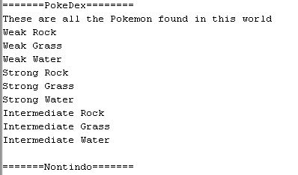

Pressing ‘w’ moves the player (‘8’) upward (camera also moves accordingly)

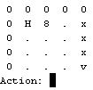

Pressing ‘s’ moves the player (‘8’) downward (camera also moves accordingly)

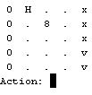

Pressing ‘d’ moves the player (‘8’) right (camera also moves accordingly)

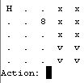

Pressing ‘a’ moves the player (‘8’) left (camera also moves accordingly)

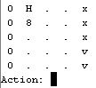

Walking on ‘H’ takes you to the hospital

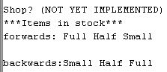

Walking on ‘.’ tiles has a chance of finding a heal potion (output varies)

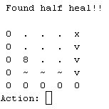

Walking on ‘~’ tiles has a chance of a Water-type Pokemon attacking (Pokemon strength varies)

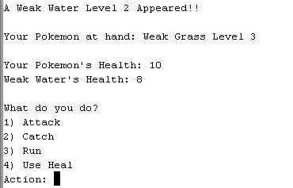

Walking on ‘v’ tiles has a chance of a Grass-type Pokemon attacking (Pokemon strength varies)

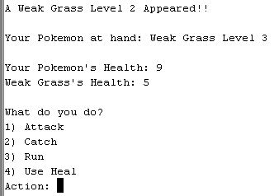

Walking on ‘x’ tiles has a chance of a Rock-type Pokemon attacking (Pokemon strength varies)

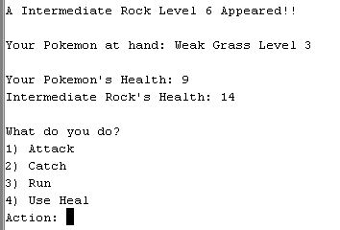

Selecting ‘1) Attack’ during battle

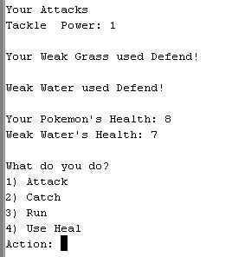

Selecting ‘1) Attack’ during battle if the attacker failed to attack

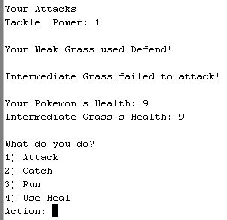

Selecting ‘1) Attack’ and winning (Pokemon type and level up varies)



Selecting ‘1) Attack’ and losing. ‘CIN ERROR’ displayed because I used arrow keys for the purpose of displaying ‘CIN ERROR’ on the log (output varies greatly)

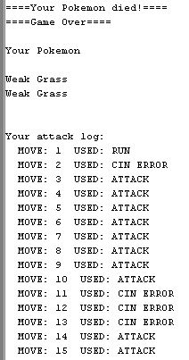

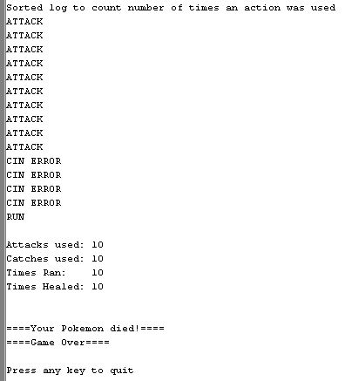

Selecting ‘2) Catch’ success (swaps your monster)



Selecting ‘2) Catch’ fail (does nothing, attacker attacks or misses)



Selecting ‘3) Run’ flees from battle



Selecting ‘4) Use Heal’ uses a found or bought health potion (output varies)



Selecting ‘4) Use Heal’ without items



**Flowchart**

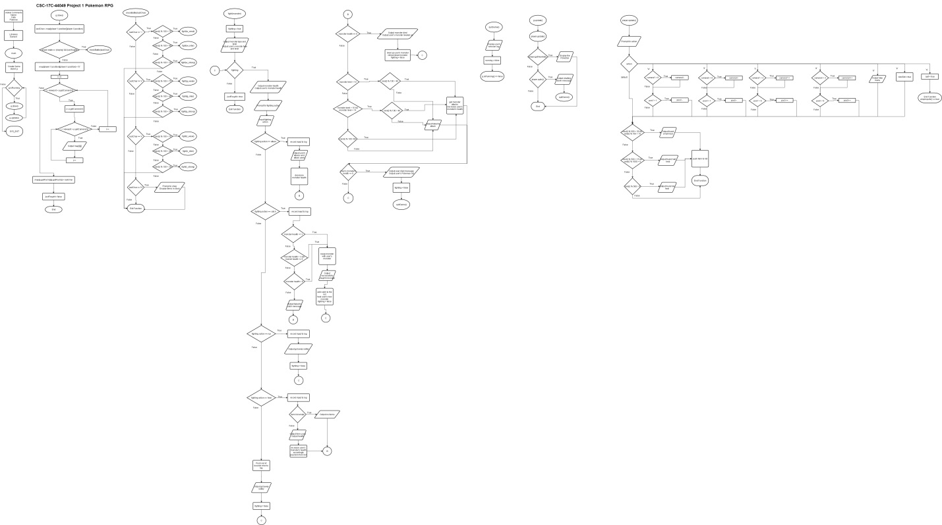

**Pseudocode**

*while game.isRunning() do*

*game.draw()*

*game.update()*

*exit*

*game.draw()*

*lastChar = map[playerPosY][playerPosX]*

*if player is playing and !justFought do*

*checkBattle(lastChar)*

*i = playerCameraY*

*for i < viewport + playerCameraY do*

*j = playerCameraX*

*for j < viewport + playerCameraX do*

*output map[i][j]*

*j++*

*i++*

*justFought = false*

*checkBattle(lastChar)*

*check lastChar*

*if (water or grass or rock) do*

*if (chance) do*

*fight(monster)*

*if (hospital) do*

*output items available to buy*

*fight(monster)*

*fighting = true*

*output who is fighting*

*while (fighting) do*

*output health of both monsters*

*prompt for fighting action*

*if (attack) do*

*log the action*

*output available attacks*

*attack the monster and decrease its health*

*if (catching) do*

*log the action*

*check health of monster*

*if (chance) do*

*swap monsters*

*add newly caught monster to list*

*heal the monster*

*fighting = false*

*else do*

*output failed to catch message*

*if (run from battle) do*

*log the action*

*fighting = false*

*if (healing) do*

*log the action*

*if (empty items list) do*

*output no items message*

*else do*

*output item used*

*heal accordingly*

*pop item from list of items*

*else do*

*log the action*

*fighting = false*

*if (monster health == 0) do*

*level up user’s monster*

*full heal dead monster*

*fighting = false*

*check monster’s level*

*if (chance) do*

*reduce user’s monster’s health accordingly*

*else do*

*output monster missed or failed to attack message*

*if (user’s monster’s health <= 0) do*

*output monster died message*

*output user’s monster list*

*fighting = false*

*quitGame()*

*quitGame()*

*display player’s action log*

*running = false*

*game.update()*

*player.update()*

*if (player.getViewSet()) do*

*display set or “PokeDex”*

*if (player.quits()) do*

*quitGame()*

*player.update()*

*prompt for action*

*if (action == ‘w’ or ‘a’ or ‘s’ or ‘d’) do*

*move player and camera accordingly*

*if (action == ‘h’) do*

*output a help menu*

*if (action == ‘p’) do*

*viewSet = true*

*if (action == ‘q’) do*

*quit = true*

*default do nothing*

*if (chance) do*

*output found item*

*push item to item list*

*else do nothing*

**Variables**

|  |  |  |
| --- | --- | --- |
| **Variable** | **Type** | **Location** |
| pokeDex | set<string, SortOrder> | Game.h:74  Game.cpp:105 – 115, 140, 506 |
| log | list<string> | Game.h:76  Game.cpp:262, 276, 299, 365, 373, 395, 520, 537, 540 |
| mList | MonList, linked list | Game.h:79  Game.cpp: 64, 65, 143, 146 – 149, 240, 309, 328, 347, 415, 419, 483 |
| sList_H | Shop, doubly linked list | Game.h:80  Game.cpp:76, 222 |
| sList_T | Shop, doubly linked list | Game.h:81  Game.cpp:77, 223 |
| mIt | map<string, int>::iterator | Game.h:100  Game.cpp:280 – 282, 289, 291, 294, 435, 437, 449, 451, 463 |
| sIt | set<string>::iterator | Game.h:101  Game.cpp:506, 507 |
| lIt | list<string>::iterator | Game.h:102  Game.cpp:520, 524, 540, 541, 545 - 548 |
| items | stack<string> | Player.h:21, 26, 40, 55  Player.cpp:91, 96, 101 |
| attacks | map<string, int> | Pokemon.h:40, 41, 45 – 47, 51 – 54, 59, 60, 64 – 66, 70 – 74, 78, 79, 83 – 85, 89 – 92, 99, 144, 153 |

**Concepts**

|  |  |  |
| --- | --- | --- |
| **Variable** | **Type** | **Location** |
| swap | Algorithm | Game.cpp:305, 324, 343, |
| sort | Algorithm | Game.cpp:537 |
| mIt | Iterator | Game.h:100  Game.cpp:280 – 282, 289, 291, 294, 435, 437, 449, 451, 463 |
| sIt | Iterator | Game.h:101  Game.cpp:506, 507 |
| lIt | Iterator | Game.h:102  Game.cpp:520, 524, 540, 541, 545 - 548 |
| pokeDex | Container | Game.h:74  Game.cpp:105 – 115, 140, 506 |
| log | Container | Game.h:76  Game.cpp:262, 276, 299, 365, 373, 395, 520, 537, 540 |
| mList | Container | Game.h:79  Game.cpp: 64, 65, 143, 146 – 149, 240, 309, 328, 347, 415, 419, 483 |
| sList_H | Container | Game.h:80  Game.cpp:76, 222 |
| sList_T | Container | Game.h:81  Game.cpp:77, 223 |
| items | Container | Player.h:21, 26, 40, 55  Player.cpp:91, 96, 101 |
| attacks | Container | Pokemon.h:40, 41, 45 – 47, 51 – 54, 59, 60, 64 – 66, 70 – 74, 78, 79, 83 – 85, 89 – 92, 99, 144, 153 |

**References**

* Previous homework
* Gaddis book
* Explains advanced C++ concepts

[**https://www.youtube.com/channel/UCcDGsN3JxMavDkM9INRLGFA**](https://www.youtube.com/channel/UCcDGsN3JxMavDkM9INRLGFA)

[**https://www.youtube.com/user/CodingMadeEasy**](https://www.youtube.com/user/CodingMadeEasy)

* Used to learn about libraries (documentation)

[**http://www.cplusplus.com/reference/**](http://www.cplusplus.com/reference/)

* NetBeans’ autocorrect feature with man pages

**Program**

main.cpp

/*

* File: main.cpp

* Author: Najera Enrique

* Purpose: Main game loop for Project 1 - Pokemon

* Date Due: 17 April 2017

*/

// User Libraries

#include "Game.h"

// Start method main handles game loop

int main(int argc, char** argv) {

// Declare Objects

Game g;

// After game has been initialized

while (g.isRunning()){

g.draw(); // Draw our game at default settings

g.update(); // Update our game

}

// SYS_EXIT

return 0;

}// End method main

Game.h

/*

* File: Game.h

* Author: Najera Enrique

* Date Due: 17 April 2017

* Purpose: The game's main logic and drawing

*/

#ifndef GAME_H

#define GAME_H

// System Libraries

#include <map>

#include <set>

#include <list>

// User Libraries

#include "Player.h"

#include "Pokemon.h"

#include "MonsterList.h"

#include "ShopList.h"

// Sorts the pokeDex set by string length

struct SortOrder {

// Operator overload

bool operator()(const string &first, const string &second){

// Get the length of strings

int length1 = first.length();

int length2 = second.length();

// If same length, return alphabetical order

if (length1 == length2)

return (first < second);

return (length1 < length2);

}

};

// Start class Game

class Game{

public:

// Constructor & Destructor

Game();

~Game();

// Function Prototypes

bool isRunning(){return running;} // Should our game run

void update(); // Update logic

void draw(); // Draw based on updated logic

void quitGame(); // Quits the game

void checkBattle(char); // Check if we are in a battle state

void fight(Pokemon *); // Actual fighting state

void dispSet(); // Displays the set, or PokeDex

void dispLog(); // Displays the list, or program log

Shop *stockShop(char); // Fills doubly linked list with items

void printShop_F(Shop *); // Print shop in a forward fashion

void printShop_B(Shop *); // Print shop in a backward fashion

// -Link List Functions

void addBefore(MonList *, string, string);

void prntList(MonList *);

private:

// Declare Variables

bool running; // is/should the game (be) running

bool justFought; // Did the player just fight

int fAction; // Holds fighting action player has provided

char map[8][8]; // Map/World container

// Was dynamic and read from a file, but

// that caused too much seg_fault errors

// and delimiter errors

int viewport; // How much of the world to display on camera

// Declare Objects

std::set<string, SortOrder>pokeDex; // Holds all pokemon names

// in the current world

std::list<string>log; // Holds log of player input

Player p; // Player

MonList *mList; // List of Pokemon the player has

Shop *sList_H; // List of item in shop (holds the Head)

Shop *sList_T; // List of item in shop (holds the Tail)

// -Pokemon Objects

Pokemon *starter; // Starter, or default, Pokemon

Pokemon *current; // Holds current Pokemon our player is using

Pokemon *w_weak; // Weak Water

Pokemon *w_inter; // Intermediate Water

Pokemon *w_strong; // Strong Water

Pokemon *g_weak; // Weak Grass

Pokemon *g_inter; // Intermediate Grass

Pokemon *g_strong; // Strong Grass

Pokemon *r_weak; // Weak Rock

Pokemon *r_inter; // Intermediate Rock

Pokemon *r_strong; // Strong Rock

// Declare iterators

std::map<string, int>::iterator mIt; // Loops through Pokemon attacks

std::set<string>::iterator sIt; // Loops through PokeDex

std::list<string>::iterator lIt; // Loops through log

};// End class Game

#endif /* GAME_H */

Game.cpp

/*

* File: Game.cpp

* Author: Najera Enrique

* Date Due: 17 April 2017

* Purpose: Main Game container

* Builds and draws map,

* Creates objects,

* Handles Game state: fighting, menu/pause

*/

// User Libraries

#include "Game.h"

// System Libraries

#include <iostream>

#include <iomanip> // setw()

#include <cstdlib> // rand()

#include <ctime> // time()

#include <set>

#include <typeinfo> // typeid()

#include <algorithm> // sort()

using namespace std;

// Start constructor Game

Game::Game(){

cout << "LOADING...\n";

// Set random number seed

srand(time(0));

// Initialize variables

viewport = 5; // View up to 5 elements on X and Y

// Changing this could cause seg_fault

// If change is wanted, however, must also

// change the Player object's "if (camera_ < [int]) camera_++;"

// where '_' means 'X' or 'Y' and [int] means any integer value

// Its all trial and error and depends on the 'map' array size!!

justFought = false; // Checks if player just fought a monster

// to prevent a fight loop on the same tile

// Create our Pokemon

// Format (type, health, level, power)

// -Starter

starter = new Pokemon("Weak Grass", 10, 3, 3);

current = starter; // Our current Pokemon

// -Water

w_weak = new Pokemon("Weak Water", 8, 2, 2);

w_inter = new Pokemon("Intermediate Water", 12, 5, 4);

w_strong = new Pokemon("Strong Water", 18, 9, 6);

// -Grass

g_weak = new Pokemon("Weak Grass", 5, 2, 1);

g_inter = new Pokemon("Intermediate Grass", 10, 5, 3);

g_strong = new Pokemon("Strong Grass", 14, 9, 5);

// -Rock

r_weak = new Pokemon("Weak Rock", 6, 2, 2);

r_inter = new Pokemon("Intermediate Rock", 14, 6, 6);

r_strong = new Pokemon("Strong Rock", 20, 9, 8);

// Fill our list with the starter

mList = new MonList;

MonList *prev = mList;

prev->data = starter->getType();

prev->linkPtr = NULL;

MonList *end=new MonList;

end->data=starter->getType();

end->linkPtr=NULL;

prev->linkPtr=end;

prev=end;

// End fill list

// Fill our shop list

sList_H = stockShop('h');

sList_T = stockShop('t');

// Create the map

for (int i = 0; i < 8; i++){

for (int j = 0; j < 8; j++){

// Create Border

if (i == 0 || j == 0 ||

j == 7 || i == 7)

map[i][j] = '0';

// Tall Grass

else if (i >= 4 && j >= 4 && map[i][j] != '0')

map[i][j] = 'v';

// Concrete

else if (i <= 4 && j >= 4 && map[i][j] != '0')

map[i][j] = 'x';

// Water

else if (i == 6 && map[i][j] != 'x')

map[i][j] = '~';

// Hospital

else if (i == 1 && j == 1)

map[i][j] = 'H';

// Floor

else map[i][j] = '.';

}

}

// End creating map

// Create our pokedex

pokeDex.insert("Weak Grass");

pokeDex.insert("Weak Water");

pokeDex.insert("Weak Rock");

pokeDex.insert("Intermediate Grass");

pokeDex.insert("Intermediate Water");

pokeDex.insert("Intermediate Rock");

pokeDex.insert("Strong Grass");

pokeDex.insert("Strong Water");

pokeDex.insert("Strong Rock");

p.setViewSet(false);

// Start our loop once elements successfully initialized

cout << "======START!!======\n";

cout << "*TIP: Use 'h' for help!!*\n\n";

running = true;

}// End constructor Game

// Start destructor Game

Game::~Game(){

// Destroy our Pokemon objects

delete w_weak;

delete w_inter;

delete w_strong;

delete g_weak;

delete g_inter;

delete g_strong;

delete r_weak;

delete r_inter;

delete r_strong;

// Delete the set just in case

// No pointers so we can just clear it

pokeDex.clear();

// Destroy MonList if it contains elements

if (mList==NULL) ;

else{

do{

MonList *temp=mList->linkPtr;

delete mList;

mList = temp;

}while (mList!=NULL);

}

}// End destructor Game

// Start method update

void Game::update(){

p.update(); // Update our player

// If player wants to see PokeDex, display

if (p.getViewSet())dispSet();

// If player quits, end game

if (p.quits()){

cout << "\nSHUTTING DOWN...\n";

quitGame();

}

}// End method update

// Start method checkBattle

// Checks if our player will fight

void Game::checkBattle(char lastCh){

// Check water types

if (lastCh == '~'){

// 50% chance of a weak pokemon

if (rand() % 100 < 75){

fight(w_weak);

}

// 40 % chance of an intermediate pokemon

else if (rand() % 100 < 40){

fight(w_inter);

}

// 20% chance of a strong pokemon

else if (rand() % 100 < 20){

fight(w_strong);

}

}

// Check grass type

if (lastCh == 'v'){

// 50% chance of a weak pokemon

if (rand() % 100 < 50){

fight(g_weak);

}

// 40 % chance of an intermediate pokemon

else if (rand() % 100 < 30){

fight(g_inter);

}

// 20% chance of a strong pokemon

else if (rand() % 100 < 20){

fight(g_strong);

}

}

// Check rock type

if (lastCh == 'x'){

// 50% chance of a weak pokemon

if (rand() % 100 < 75){

fight(r_weak);

}

// 40 % chance of an intermediate pokemon

else if (rand() % 100 < 40){

fight(r_inter);

}

// 20% chance of a strong pokemon

else if (rand() % 100 < 20){

fight(r_strong);

}

}

// Check if in hospital

if (lastCh == 'H'){

cout << "\nShop? (NOT YET IMPLEMENTED)\n";

cout << "***Items in stock***\n";

cout << "forwards: ";printShop_F(sList_H);

cout << "\nbackwards:";printShop_B(sList_T);

cout << endl;

}

}// End method checkBattle

// Start method fight

// Puts our game into a fighting state

void Game::fight(Pokemon *monster){

// Declare Variables

bool fighting = true; // Loops our fighting state

//log.push_back(monster->getType()); UGLY OTUPUT

// Output who approached us

cout << "\nA " << monster->getType()

<< " Level " << monster->getLevel() << " Appeared!!\n";

// Output our Pokemon's current state

cout << "\nYour Pokemon at hand: " << mList->data

<< " Level " << current->getLevel() << endl;

// The fighting loop

while (fighting){

// Output health of both

cout << "\nYour Pokemon's Health: " << current->getHealth() << endl;

cout << monster->getType() << "'s Health: " << monster->getHealth() << endl;

// Prompt for player fighting action

cout << "\nWhat do you do?\n";

cout << "1) Attack " << endl

<< "2) Catch " << endl

<< "3) Run " << endl

<< "4) Use Heal" << endl

<< "Action: ";

cin >> fAction;

// If bad input, just leave

if (cin.fail()) {

// Log cin fail as 999

log.push_back("CIN ERROR");

cout << "\nGot Away Safely\n";

cin.ignore();

cin.clear();

fighting = false;

return;

}

// Static cast to prevent wrong type errors

fAction = static_cast<int>(fAction);

// Chose to attack

if (fAction == 1){

// Insert to log

log.push_back("ATTACK");

// Outputs user's available attacks

cout << "\nYour Attacks\n";

for (mIt = current->getAttacks().begin();

mIt != current->getAttacks().end(); mIt++){

cout << mIt->first << " " << " Power: " << mIt->second;

cout << endl;

}

// Prompt for attack (SOON)

// Output attack used

mIt = current->getAttacks().begin();

cout << "\nYour " << current->getType() << " used "

<< mIt->first << "!" << endl;

// Decrease offending monster's attack

monster->hit(mIt->second);

}

// Chose to catch

else if (fAction == 2){

// Insert to log

log.push_back("CATCH");

// Dying health = easier catch (80%)

if (monster->getHealth() <= 3){

if (rand() % 100 < 80){

// Swap algorithm changes player's monster

std::swap(current, monster);

cout << "Successfully caught a " << current->getType()

<< "!" << endl;

// Add catch to our list

addBefore(mList, monster->getType(), current->getType());

// Fully heal new Pokemon

current->heal("full");

// Leave the fighting state

fighting = false;

return ;

}

else {

cout << "Failed to catch " << monster->getType() << endl;

}

}

// Sick health = decent chance (50%)

else if (monster->getHealth() > 3 && monster->getHealth() <=5){

if (rand() % 100 < 50){

// Swap algorithm changes player's monster

std::swap(current, monster);

cout << "Successfully caught a " << current->getType()

<< "!" << endl;

// Add catch to our list

addBefore(mList, monster->getType(), current->getType());

// Fully heal new Pokemon

current->heal("full");

// Leave the fighting state

fighting = false;

return ;

}

else {

cout << "Failed to catch " << monster->getType() << endl;

}

}

// Healthy = small chance (2%)

else if (monster->getHealth() > 6){

if (rand() % 100 < 2){

// Swap algorithm changes player's monster

std::swap(current, monster);

cout << "Successfully caught a " << current->getType()

<< "!" << endl;

// Add catch to our list

addBefore(mList, monster->getType(), current->getType());

// Fully heal new Pokemon

current->heal("full");

// Leave the fighting state

fighting = false;

return ;

}

else {

cout << "Failed to catch " << monster->getType() << endl;

}

}

// Other, output failed to catch message

else { cout << "Failed to catch " << monster->getType() << endl; }

}

// Chose to run

else if (fAction == 3){

// Insert to log

log.push_back("RUN");

cout << "\nGot Away Safely\n";

fighting = false;

return;

}

// Choose to heal player's monster

else if (fAction == 4){

// Log this event

log.push_back("HEAL");

// If no items, leave

if (p.getItems().empty()){

cout << "\nNO ITEMS!" << endl;

}

// If item, heal Pokemon accordingly

else {

cout << "\nUsed " << p.getItems().top() << " heal!" << endl;

current->heal(p.getItems().top());

cout << "\nYour Pokemon now has " << current->getHealth()

<< " health points!" << endl;

// Remove item from list

p.popItems();

}

}

// If error, just leave

else {

// Insert to log

log.push_back("OUT OF BOUNDS ERROR");

cout << "\nGot Away Safely\n";

fighting = false;

return;

}

/*** Monster Action Handler ***/

// Check if monster is dead before attacking

// BUG SINCE I'M USING LINKED LIST FOR DISPLAYING POKEMON TYPE!!

if (monster->getHealth() == 0){

cout << "\n" << monster->getType() << " killed!" << endl;

cout << "Your " << current->getType() << " leveled up "

<< monster->getLevel() / 2 << "!" << endl;

// Level up our monster

current->lvlUp(monster->getLevel() / 2);

// Change type if level is high

if (current->getLevel() >= 5 && current->getLevel() <= 13 ){

addBefore(mList, current->getType(), "Intermediate Grass"); // Add to list first!

current->setType("Intermediate Grass"); // Should split 'type' & 'element'

}

else if (current->getLevel() >= 14 && current->getType() != "Strong Grass"){

addBefore(mList, current->getType(), "Intermediate Grass"); // Add to list first!

current->setType("Strong Grass"); // Should split 'type' & 'element'

}

// Reset attacker's health to prevent infinite level up

monster->heal("full");

// Leave fighting state

fighting = false;

return ;

}

// Low level 40% chance of attacking

if (monster->getLevel() < 10){

if (rand() % 100 < 40){

// Outputs attack used

mIt = monster->getAttacks().begin();

cout << endl << monster->getType()

<< " used " << mIt->first << "!\n";

current->hit(monster->getPower()); // Decrease player health

}

else {

cout << endl << monster->getType() << " failed to attack!\n";

}

}

// Intermediate 60% chance of attacking

else if (monster->getLevel() > 10 && monster->getLevel() < 14){

if (rand() % 100 < 60){

// Outputs attack used

mIt = monster->getAttacks().begin();

cout << endl << monster->getType()

<< " used " << mIt->first << "!\n";

current->hit(monster->getPower()); // Decrease player health

}

else {

cout << endl << monster->getType() << " failed to attack!\n";

}

}

// High levels 80% attack

else {

if (rand() % 100 < 80){

// Outputs attack used

mIt = monster->getAttacks().begin();

cout << endl << monster->getType()

<< " used " << mIt->first << "!\n";

current->hit(monster->getPower()); // Decrease player health

}

else {

cout << endl << monster->getType() << " failed to attack!\n";

}

}

// End monster attack handler

// If our Pokemon's health has dropped to or below 0

// End game

if (current->getHealth() <= 0){

// Output game over message

cout << "\n====Your Pokemon died!====\n";

cout << "====Game Over====\n";

// Print the list of Pokemon the player had

prntList(mList);

// Leave this loop

fighting = false;

// Leave the game

quitGame();

cout << "\n====Your Pokemon died!====\n";

cout << "====Game Over====\n";

cout << "\nPress any key to quit\n\n";

}

}// End fighting loop

// Gives 1 step delay before Pokemon appear

justFought = true;

}// End method fight

// Start method dispSet

void Game::dispSet(){

cout << "\n=======PokeDex========\n";

cout << "These are all the Pokemon found in this world\n";

// Go through PokeDex set and output

for (sIt = pokeDex.begin(); sIt != pokeDex.end(); sIt++)

cout << *sIt << endl;

cout << "\n=======Nontindo=======\n";

p.setViewSet(false);

}// End method dispSet

// Start method dispLog displays the log

// Log contains user actions

void Game::dispLog(){

// Declare Variables

int i = 0; // Move counter

cout << "\nYour attack log:\n";

// Loop through log

for (lIt = log.begin(); lIt != log.end(); lIt++){

i++; // Increment move counter

// Output move number and what user used against monster

cout << setw(8) << "MOVE: " << i

<< setw(5) << " USED: " << *lIt << endl;

}// End for loop

cout << "\nSorted log to count number of times "

<< "an action was used\n";

// Declare counter variables

int numAttack = 0;

int numCatch = 0;

int numRun = 0;

int numHeal = 0;

// Sort algorithm

log.sort();

// Output and count

for (lIt = log.begin(); lIt != log.end(); lIt++){

cout << *lIt << endl;

// BUG: DOESN'T COUNT FOR EACH

// ONLY COUNTS FOR ONE ("ATTACK")!!

// DEBUGGER'S CONSOLE DOESNT COOPERATE!!

if (*lIt == "ATTACK") numAttack++;

else if (*lIt == "CATCH") numCatch++;

else if (*lIt == "RUN") numRun++;

else if (*lIt == "HEAL") numHeal++;

}

// Output count results

cout << endl;

cout << "Attacks used: " << numAttack << endl;

cout << "Catches used: " << numAttack << endl;

cout << "Times Ran: " << numAttack << endl;

cout << "Times Healed: " << numAttack << endl;

cout << endl;

}// End method dispLog

// Start method quitGame

void Game::quitGame(){

dispLog(); // Display the log

running = false; // Quit our game loop

}// End method quitGame

// Start method draw

// Draws our game elements

void Game::draw(){

// Get the last tile our player stepped on to overwrite it

char lastChar = map[p.getPosY()][p.getPosX()];

// Check if a Pokemon has approached us

// If our player just fought, skip this

if (p.getState() == 'p' && !justFought)checkBattle(lastChar);

// Place our player in the world

map[p.getPosY()][p.getPosX()] = '8';

// Draw our map/world

for (int i = p.getCameraY(); i < viewport + p.getCameraY(); i++){

for (int j = p.getCameraX(); j < viewport + p.getCameraX(); j++){

cout << setw(2) << map[i][j] << " ";

}

cout << endl;

}

// Overwrite the last character

map[p.getPosY()][p.getPosX()] = lastChar;

// We did not just fight

justFought = false;

}// End method draw

/*** Link List Functions ***/

// Start method addBefore

// BUG ADDS MORE THAN ONE!!

void Game::addBefore(MonList *front, string before, string val){

MonList *next = front; // Keeps track of next node

MonList *prev = new MonList; // Stores previous node

MonList *newNode = new MonList; // Creates new node for next value

newNode->data = val; // Store value in newNode's data

// Go through list until it hits position wanted

while (next->linkPtr != NULL && next->data != before){

// Clone everything before 'before'

prev = next;

next = next->linkPtr;

}

// Store newNode into the linked list

prev->linkPtr = newNode;

newNode->linkPtr = next;

}// End method addBefore

// Start method printList prints our Pokemon all game

void Game::prntList(MonList *front){

cout << "\nYour Pokemon\n";

MonList *next=front; //Start at the front of the list

cout<<endl; //Put the beginning on a new line

do{

cout<<setw(4)<<next->data<<" "; //Print the link

next=next->linkPtr; //Go to the next link

cout << endl;

}while(next!=NULL); //Stop when your at the end

cout<<endl;

}// End method printList

// Start method stockShop

// Takes in char 'h' for returning the HEAD

// Takes in char 't' for returning the TAIL

// else return HEAD

Shop *Game::stockShop(char loc){

Shop *head; // Head

Shop *tail; // End

Shop *n; // Next

// Full heal

n = new Shop;

n->data = "Full";

n->prev = NULL; // First node has no previous

head = n;

tail = n;

// Half heal

n = new Shop;

n->data = "Half";

n->prev = tail;

tail->next = n;

tail = n;

// Small heal

n = new Shop;

n->data = "Small";

n->prev = tail;

tail->next = n;

tail = n;

// Close list

tail->next = NULL;

// Check the argument for proper return

if (loc == 't' || loc == 'T') return tail;

else return head;

}// End method stockShop

// Start method printShop_F

void Game::printShop_F(Shop *head){

Shop *temp = head; // Points to front of list

// Print while data

do {

cout << temp->data << " ";

temp = temp->next; // Point to next node

}while(temp != NULL);

cout << endl;

}// End method printShop_F

// Start method printShop_B

void Game::printShop_B(Shop *tail){

Shop *temp = tail; // Points to end of list

// Print while data

do {

cout << temp->data << " ";

temp = temp->prev; // Point to previous node

}while(temp != NULL);

cout << endl;

}// End method printShop_B

Player.h

/*

* File: Player.h

* Author: Najera Enrique

* Date Due: 17 April 2017

* Purpose: Contains our Player properties

* Also updates movement

*/

#ifndef PLAYER_H

#define PLAYER_H

// System Libraries

#include <stack>

#include <string>

// Start class Player

class Player{

public:

// Constructor & Destructor

Player();

~Player(){items.empty();}

// Function Prototypes

void update(); // Handle user input

void outHelp(); // Outputs a help page

void popItems(){items.pop();} // Uses the stack's 'pop' algorithm

// Mutator Functions

void setState(char s){state = s;} // Sets player's state

void setViewSet(bool b){viewSet = b;} // Sets if PokeDex set

// should be displyed

// Accessor Functions

int getCameraX() const {return cameraX;} // Get our camera's x position

int getCameraY() const {return cameraY;} // Get our camera's y position

int getPosX() const {return posX;} // Get our player's x position

int getPosY() const {return posY;} // Get our player's y position

char getState() const {return state;} // Get our player's state

bool getViewSet() const { return viewSet;} // View pokeDex set?

std::stack<std::string> getItems() const {return items; } // Get inventory

bool quits() const {return quit;}; // Did player just quit

private:

// Declare Variables

int cameraX; // Holds camera's x position

int cameraY; // Holds camera's y position

int posX; // Holds player's x position

int posY; // Holds player's y position

char action; // Holds player input

char state; // Holds player's state

bool viewSet; // Tells game to display PokeDex set

bool quit; // Holds if player decided to quit

// Declare Objects

std::stack<std::string>items; // Holds all our items

};// End class Player

#endif /* PLAYER_H */

Player.cpp

/*

* File: Player.cpp

* Author: Najera Enrique

* Date Due: 17 April 2017

* Purpose: Contains our Player properties

* Also updates movement

*/

// User Libraries

#include "Player.h"

// System Libraries

#include <iostream>

#include <cstdlib> // rand()

using namespace std;

// Start constructor Player

Player::Player(){

// INIT variables

cameraX = 0;

cameraY = 0;

posX = 2; // Place at center of camera

posY = 2; // Place at center of camera

state = 'p'; // State playing

action = ' '; // No action taking place

quit = false;

}// End constructor Player

// Start method update

void Player::update(){

// Prompt for action

cout << "Action: ";

cin >> action;

// Action handler

switch(action){

// If playing in the world

// UP

case 'w':

// Moves everything UP

// if (state == 'p'){ /!\ ERROR: makes player freeze

if (cameraY > 0)cameraY--; // If camera in bounds

if (posY > 1)posY--; // If player in bounds

//}

break;

// LEFT

case 'a':

// Moves everything LEFT

// if (state == 'p'){ /!\ ERROR: makes player freeze

if (cameraX > 0)cameraX--; // If camera in bounds

if (posX > 1)posX--;//} // If player in bounds

break;

// DOWN

case 's':

// Moves everything DOWN

//if (state == 'p'){ /!\ ERROR: makes player freeze

if (cameraY < 3)cameraY++; // If camera in bounds

if (posY < 6)posY++;//} // If player in bounds

break;

// RIGHT

case 'd':

// Moves everything RIGHT

//if (state == 'p'){ /!\ ERROR: makes player freeze

if (cameraX < 3)cameraX++; // If camera in bounds

if (posX < 6)posX++;//} // If player in bounds

break;

// HELP

case 'h':

// Displays help page

//if (state == 'p'){ /!\ ERROR: makes player freeze

outHelp();//}

break;

// PAUSE (just displays PokeDex)

case 'p':

viewSet = true;

break;

// QUIT

case'q':

// Acknowledges game that player quit

quit = true;

break;

// Else do nothing

default:

break;

}// End action handler

// After every move, check for an item

// 6% chance to find 'small' heal

if (rand() % 500 < 30 && rand() % 100 > 15){

cout << "\n Found small heal!!\n";

items.push("small");

}

// 3% chance to find 'half' heal

else if (rand() % 500 < 15 && rand() % 1000 > 5){

cout << "\n Found half heal!!\n";

items.push("half");

}

// 1% chance to find 'full' heal

else if (rand() % 500 < 5){

cout << "\n Found full heal!!\n";

items.push("full");

}

// Found nothing!

else {}

cout << endl;

}// End method update

// Start method outHelp

void Player::outHelp(){

// Output help page

cout << "Legend "<<endl

<< " '8' PLAYER\n"

<< " '~' WATER (water types found here)\n"

<< " 'x' CONCRETE (rock types found here)\n"

<< " 'v' TALL GRASS (grass types found here)\n"

<< " '.' NORMAL TILE (Items found here)\n"

<< " 'H' HOSPITAL (Buy medicine here)\n"

<< endl

<< "Actions "<<endl

<< " In world\n"

<< " w move up\n"

<< " s move down\n"

<< " a move left\n"

<< " d move right\n"

<< " p PokeDex menu\n"

<< " h brings up this menu\n"

<< " q quits the game\n"

<< " ~dying also stops the game\n"

<< " In battle\n"

<< " 1 attacks rival Pokemon\n"

<< " 2 attempts to catch Pokemon\n"

<< " 3 runs from battle\n"

<< " 4 uses health potion for your Pokemon\n"

<< "Casually walking around gives chance of finding items!\n"

<< endl;

}// End method outHelp

Pokemon.h

/*

* File: Pokemon.h

* Author: Najera Enrique

* Date Due: 17 April 2017

* Purpose: Holds Pokemon properties

*/

#ifndef POKEMON_H

#define POKEMON_H

// System Libraries

#include <map> // Holds Pokemon's power

#include <string>

using namespace std;

// Start class Pokemon

class Pokemon{

public:

// Default constructor

Pokemon(){

// INIT everything to 1

health = 1;

type = 1;

level = 1;

};// End default constructor

// Constructor

// Takes in a type, total health, level, power of attacks

Pokemon(string t, int h, int l, int p){

health = h;

maxHealth = h;

type = t;

level = l;

power = p;

// Check type and assign attacks

// Map is

if (type == "Weak Grass"){

// Weak types only have 2 attacks

attacks["Tackle"] = 1;

attacks["Defend"] = 1;

}

else if (type == "Intermediate Grass"){

// Intermediate types have 3 attacks

attacks["Tackle"] = 1;

attacks["Whip"] = 3;

attacks["Absorb"] = 2;

}

else if (type == "Strong Grass"){

// Strong types have all 4 attacks

attacks["Whip"] = 3;

attacks["Absorb"] = 2;

attacks["Photosynthesis"] = 5;

attacks["Spore"] = 4;

}

else if (type == "Weak Water"){

// Weak types only have 2 attacks

attacks["Tackle"] = 2;

attacks["Defend"] = 1;

}

else if (type == "Intermediate Water"){

// Intermediate types have 3 attacks

attacks["Tackle"] = 2;

attacks["Splash"] = 2;

attacks["Wave"] = 4;

}

else if (type == "Strong Water"){

// Strong types have all 4 attacks

attacks["Splash"] = 2;

attacks["Wave"] = 4;

attacks["Whirlpool"] = 5;

attacks["Tsunami"] = 6;

}

else if (type == "Weak Rock"){

// Weak types only have 2 attacks

attacks["Tackle"] = 2;

attacks["Defend"] = 1;

}

else if (type == "Intermediate Rock"){

// Intermediate types have 3 attacks

attacks["Tackle"] = 1;

attacks["Throw"] = 6;

attacks["Quake"] = 5;

}

else if (type == "Strong Rock"){

// Strong types have all 4 attacks

attacks["Throw"] = 6;

attacks["Quake"] = 8;

attacks["Crush"] = 5;

attacks["Sandstorm"] = 8;

}

}; // End Constructor

// Destructor

~Pokemon(){

// Delete our map just in case

attacks.clear();

};

// Function Prototypes

void hit(int p){health -= p;} // Removes health by power of attacker

void lvlUp(int lU){level += lU;} // Levels Pokemon up

void heal(string med){

// If already at full health, leave

if (health == maxHealth) return;

// If given full medicine, fill health

// to max health

if (med == "full"){

health = maxHealth;

}

// If given half medicine, fill health

// half of max

else if (med == "half"){

health += maxHealth / 2;

// If previous calculation exceeds the max health,

// health is our maxHealth

if (health > maxHealth)

health = maxHealth;

}

// If given small dosage, add health by 2

else if (med == "small"){

health += 2;

// If previous calculation exceeds the max health,

// health is our maxHealth

if (health > maxHealth)

health = maxHealth;

}

// If some kind of arg error, return

else { return; }

}

// Mutator Functions

void setType(string t){type = t;}

// Accessor Functions

int getHealth() const {return health;}

string getType() const {return type;}

int getPower() const {return power;}

int getLevel() const {return level;}

map <string, int> getAttacks() const {return attacks;}

private:

// Declare Variables

int health; // Pokemon's total health

int maxHealth; // Pokemon's maxHealth for healing

string type; //Pokemon's type

int level; // Pokemon's level

int power; // Pokemon's attack power

map<string, int>attacks; // Holds list of attacks

// Keytype (string) = name of attack

// Value (int) = power of attack

};// End class Pokemon

#endif /* POKEMON_H */

MonsterList.h

/*

* File: MonsterList.h

* Author: Najera Enrique

* Date Due: 17 April 2017

* Purpose: Holds a list of monsters the player has caught

*/

#ifndef MONSTERLIST_H

#define MONSTERLIST_H

// System Libraries

#include <string>

//Start structure MonList

struct MonList {

string data; // Holds Pokemon's type

MonList *linkPtr; // Pointer to next data

};// End structure MonList

#endif /* MONSTERLIST_H */

ShopList.h

/*

* File: ShopList.h

* Author: Najera Enrique

* Date Due: 17 April 2017

* Purpose: Doubly linked list used as a shop

* so the user could buy items

*/

#ifndef SHOPLIST_H

#define SHOPLIST_H

// System Libraries

#include <string>

struct Shop{

std::string data;

Shop *next;

Shop *prev;

};

#endif /* SHOPLIST_H */