1.1 Experiment Results of Event Driven 1

1.1.1 Message Loss Rate 2

1.1.1 Average Message One-way-delay 3

1.1.1 Efficiency Metric 5

1.1.1 Delay CDF 9

## Experiment Results of Event Driven

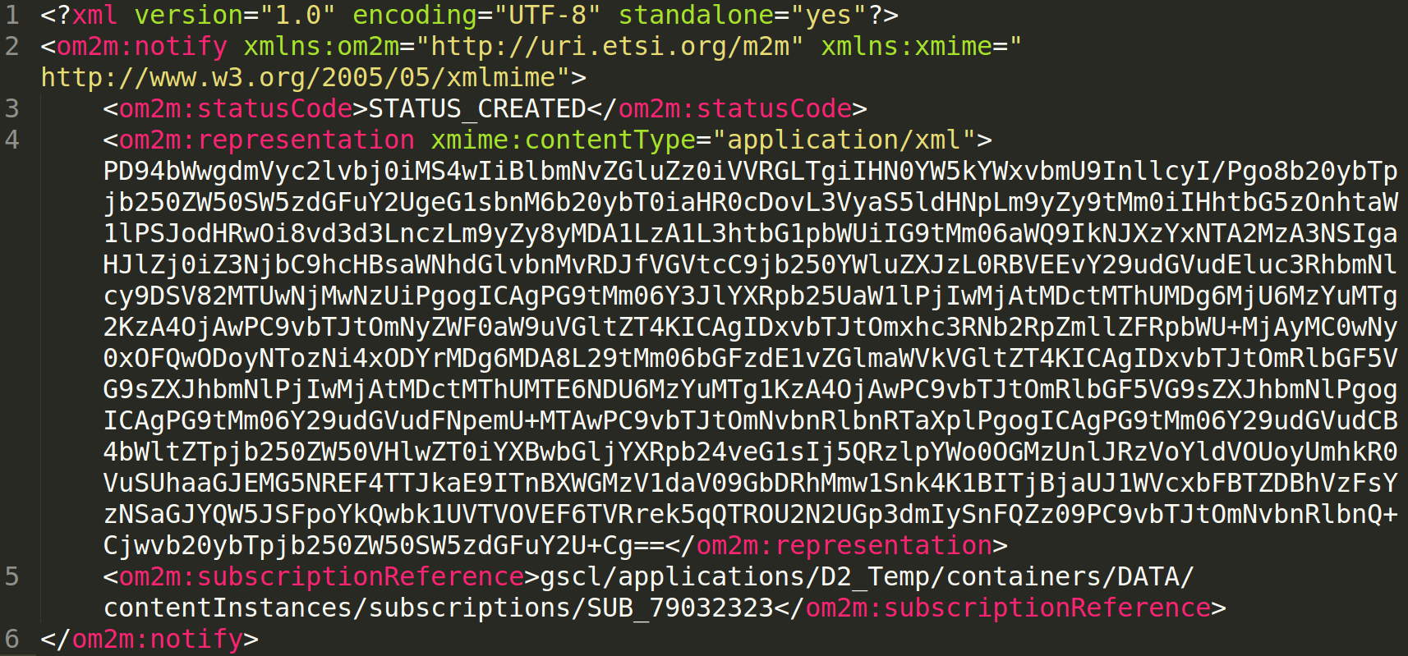

Figure ‑ Example of notification of 100 Bytes data

In the event driven application, GSCL notifies NSCL with the data transmitted by DA in the notification format. After the transformation from data to notification, the payload will be greater than the original data size. The sizes of notification of each size of data are shown in table 6.3-1. Where notifications of all data are bigger than 1024 Bytes and 1448 Bytes.

|  |  |  |  |  |
| --- | --- | --- | --- | --- |
| Data Size (Bytes) | 100 | 500 | 1000 | 1500 |
| Payload Size (Bytes) | 1538 | 2242 | 3138 | 4022 |

Table ‑ Payload size of notification of different data size

### Message Loss Rate

|  |  |  |  |  |
| --- | --- | --- | --- | --- |
| Ploss | CoAP | MQTT | WebSocket | XMPP |
| 0% | 0% | 0% | 0% | 0% |
| 5% | 18% | 0% | 0% | 0% |
| 10% | 24% | 0% | 0% | 0% |
| 15% | 39% | 0% | 0% | 0% |
| 20% | 45% | 0% | 0% | 0% |
| 25% | 44% | 0% | 0% | 0% |

Table ‑ Message loss rate result of event driven with 100 Bytes data size

|  |  |  |  |  |
| --- | --- | --- | --- | --- |
| Ploss | CoAP | MQTT | WebSocket | XMPP |
| 0% | 0% | 0% | 0% | 0% |
| 5% | 28% | 0% | 0% | 0% |
| 10% | 40% | 0% | 0% | 0% |
| 15% | 63% | 0% | 0% | 0% |
| 20% | 84% | 0% | 0% | 0% |
| 25% | 79% | 0% | 17% | 27% |

Table ‑ Message loss rate result of event driven with 500 Bytes data size

|  |  |  |  |  |
| --- | --- | --- | --- | --- |
| Ploss | CoAP | MQTT | WebSocket | XMPP |
| 0% | 0% | 0% | 0% | 0% |
| 5% | 38% | 0% | 0% | 0% |
| 10% | 65% | 0% | 0% | 0% |
| 15% | 81% | 0% | 0% | 0% |
| 20% | 84% | 0% | 0% | 0% |
| 25% | 93% | 0% | 38% | 33% |

Table ‑ Message loss rate result of event driven with 1000 Bytes data size

|  |  |  |  |  |
| --- | --- | --- | --- | --- |
| Ploss | CoAP | MQTT | WebSocket | XMPP |
| 0% | 0% | 0% | 0% | 0% |
| 5% | 40% | 0% | 0% | 0% |
| 10% | 67% | 0% | 0% | 0% |
| 15% | 81% | 0% | 0% | 0% |
| 20% | 93% | 0% | 0% | 0% |
| 25% | 95% | 17% | 55% | 41% |

Table ‑ Message loss rate result of event driven with 1500 Bytes data size

### Average Message One-way-delay

|  |  |  |  |  |
| --- | --- | --- | --- | --- |
| Ploss | CoAP | MQTT | WebSocket | XMPP |
| 0% | 23.75ms ± 0.635 | 49.526ms ± 2.832 | 58.83ms ± 5.973 | 60.15ms ± 6.166 |
| 5% | 113.792ms ± 70.038 | 59.158ms ± 5.91 | 77.74ms ± 17.242 | 57.39ms ± 16.626 |
| 10% | 850.631ms ± 1163.054 | 89.184ms ± 10.667 | 95.04ms ± 19.145 | 77.78ms ± 15.673 |
| 15% | 768.393ms ± 301.216 | 116.602ms ± 29.213 | 341.64ms ± 81.911 | 403.51ms ± 159.632 |
| 20% | 1135.49ms ± 531.919 | 260.91ms ± 68.175 | 341.64ms ± 81.911 | 409ms ± 143.152 |
| 25% | 1628.428ms ± 631.826 | 259.36ms ± 37.159 | 23834.208ms ± 4267.963 | 6481.56ms ± 1904.461 |

Table ‑ Message one-way-delay of event driven with 100 Bytes data size

|  |  |  |  |  |
| --- | --- | --- | --- | --- |
| Ploss | CoAP | MQTT | WebSocket | XMPP |
| 0% | 24.348ms ± 0.604 | 40.556ms ± 7.132 | 57.31ms ± 7.859 | 49.61ms ± 6.224 |
| 5% | 331.847ms ± 184.942 | 69.646ms ± 7.598 | 80.72ms ± 14.542 | 76.15ms ± 18.576 |
| 10% | 688.516ms ± 359.698 | 108.672ms ± 15.929 | 102.11ms ± 29.933 | 98.51ms ± 24.91 |
| 15% | 852.162ms ± 227.981 | 130.064ms ± 21.743 | 428.406ms ± 89.291 | 115.16ms ± 31.188 |
| 20% | 949.562ms ± 519.779 | 213.002ms ± 42.981 | 1727.302ms ± 296.122 | 2283.93ms ± 707.722 |
| 25% | 4208.35ms ± 1897.144 | 261.59ms ± 62.388 | 50949.956ms ± 3208.458 | 62808.869ms ± 6442.539 |

Table ‑ Message one-way-delay of event driven with 500 Bytes data size

|  |  |  |  |  |
| --- | --- | --- | --- | --- |
| Ploss | CoAP | MQTT | WebSocket | XMPP |
| 0% | 28.536ms ± 1.233 | 121.288ms ± 5.945 | 155.2ms ± 10.532 | 139.9ms ± 9.902 |
| 5% | 362.967ms ± 118.244 | 165.684ms ± 8.536 | 184.9ms ± 29.293 | 161.23ms ± 15.443 |
| 10% | 709.6ms ± 508.286 | 214.35ms ± 20.708 | 480.47ms ± 157.135 | 211.8ms ± 29.456 |
| 15% | 374.736ms ± 72.281 | 380.566ms ± 52.446 | 351.992ms ± 45.937 | 437.89ms ± 124.73 |
| 20% | 711.125ms ± 454.098 | 943.25ms ± 426.345 | 16318.8ms ± 2706.027 | 15063.824ms ± 1574.907 |
| 25% | 2316.142ms ± 481.813 | 3272.724ms ± 816.03 | 29826.027ms ± 3669.252 | 41454.392ms ± 6262.145 |

Table ‑ Message one-way-delay of event driven with 1000 Bytes data size

|  |  |  |  |  |
| --- | --- | --- | --- | --- |
| Ploss | CoAP | MQTT | WebSocket | XMPP |
| 0% | 30.168ms ± 0.628 | 118.884ms ± 2.45 | 151.94ms ± 12.319 | 138.15ms ± 11.626 |
| 5% | 347.166ms ± 66.235 | 170.738ms ± 9.064 | 190.87ms ± 23.628 | 175.25ms ± 23.578 |
| 10% | 576.878ms ± 216.526 | 211.842ms ± 15.237 | 248.83ms ± 38.516 | 222.8ms ± 33.999 |
| 15% | 721.157ms ± 162.307 | 1312.53ms ± 360.327 | 1424.92ms ± 455.215 | 348.206ms ± 33.813 |
| 20% | 1215.285ms ± 875.139 | 8192.69ms ± 1457.941 | 45344.76ms ± 5897.23 | 50058.855ms ± 6949.129 |
| 25% | 6096.8ms ± 1315.658 | 98109.58ms ± 11.702 | 56240.292ms ± 4975.387 | 40906.22ms ± 4150.637 |

Table ‑ Message one-way-delay of event driven with 1500 Bytes data size

### Efficiency Metric

|  |  |  |  |  |
| --- | --- | --- | --- | --- |
| Ploss | CoAP | MQTT | WebSocket | XMPP |
| 0% | 0.7628±0 | 0.8387±0.0001 | 0.8844±0.0003 | 0.8042±0.0002 |
| 5% | 0.6116±0.0036 | 0.8044±0.0004 | 0.8221±0.0014 | 0.7444±0.0014 |
| 10% | 0.5208±0.0039 | 0.768±0.0006 | 0.774±0.002 | 0.7317±0.0018 |
| 15% | 0.4038±0.0043 | 0.7335±0.0008 | 0.7713±0.0019 | 0.679±0.0018 |
| 20% | 0.3575±0.0042 | 0.701±0.0009 | 0.7436±0.0157 | 0.6375±0.0021 |
| 25% | 0.3575±0.0042 | 0.6519±0.001 | 0.7378±0.0193 | 0.6334±0.0412 |

Table 6.3.3‑1Efficiency metric of event driven, 100 Bytes data size

Figure ‑ Efficiency metric of event driven, 100 Bytes data size

|  |  |  |  |  |
| --- | --- | --- | --- | --- |
| Ploss | CoAP | MQTT | WebSocket | XMPP |
| 0% | 0.723±0.0058 | 0.8877±0.0029 | 0.9215±0.0054 | 0.8573±0 |
| 5% | 0.5013±0.0627 | 0.8357±0.0093 | 0.8561±0.0224 | 0.7865±0.0235 |
| 10% | 0.4091±0.0668 | 0.8013±0.0113 | 0.7756±0.0318 | 0.7502±0.0281 |
| 15% | 0.2472±0.0638 | 0.7765±0.0128 | 0.7712±0.0382 | 0.7259±0.0316 |
| 20% | 0.2455±0.0487 | 0.7497±0.0143 | 0.7477±0.0402 | 0.6798±0.0358 |
| 25% | 0.1239±0.0483 | 0.685±0.0261 | 0.6077±0.0302 | 0.4811±0.0297 |

Table 6.3.3‑2Efficiency metric of event driven, 500 Bytes data size

Figure ‑ Efficiency metric of event driven, 500 Bytes data size

|  |  |  |  |  |
| --- | --- | --- | --- | --- |
| Ploss | CoAP | MQTT | WebSocket | XMPP |
| 0% | 0.7269±0.0005 | 0.9054±0.0008 | 0.9083±0.0007 | 0.8765±0.0026 |
| 5% | 0.4508±0.078 | 0.8534±0.008 | 0.871±0.0072 | 0.8435±0.0147 |
| 10% | 0.2491±0.0675 | 0.8099±0.2497 | 0.7932±0.0139 | 0.7853±0.0219 |
| 15% | 0.1331±0.0542 | 0.7747±0.0125 | 0.7763±0.0303 | 0.7541±0.0284 |
| 20% | 0.1197±0.0548 | 0.7405±0.014 | 0.7598±0.0346 | 0.725±0.0164 |
| 25% | 0.0449±0.0325 | 0.7039±0.0156 | 0.4985±0.0368 | 0.4532±0.0288 |

Table 6.3.3‑3 Efficiency metric of event driven, 1000 Bytes data size

Figure ‑ Efficiency metric of event driven, 1000 Bytes data size

|  |  |  |  |  |
| --- | --- | --- | --- | --- |
| Ploss | CoAP | MQTT | WebSocket | XMPP |
| 0% | 0.7473±0.0014 | 0.9252±0.0005 | 0.9254±0.0042 | 0.8999±0.0045 |
| 5% | 0.4413±0.0711 | 0.8703±0.0077 | 0.876±0.0203 | 0.8629±0.0175 |
| 10% | 0.2463±0.071 | 0.8305±0.0113 | 0.8167±0.0272 | 0.8101±0.0248 |
| 15% | 0.1659±0.08 | 0.7883±0.0125 | 0.777±0.0323 | 0.7469±0.0139 |
| 20% | 0.0475±0.0343 | 0.7241±0.0243 | 0.6554±0.026 | 0.6045±0.0273 |
| 25% | 0.0487±0.0446 | 0.6783±0.0174 | 0.3133±0.0322 | 0.4074±0.0342 |

Table 6.3.3‑4 Efficiency metric of event driven, 1500 Bytes data size

### Delay CDF

#### Data Size 100 Bytes

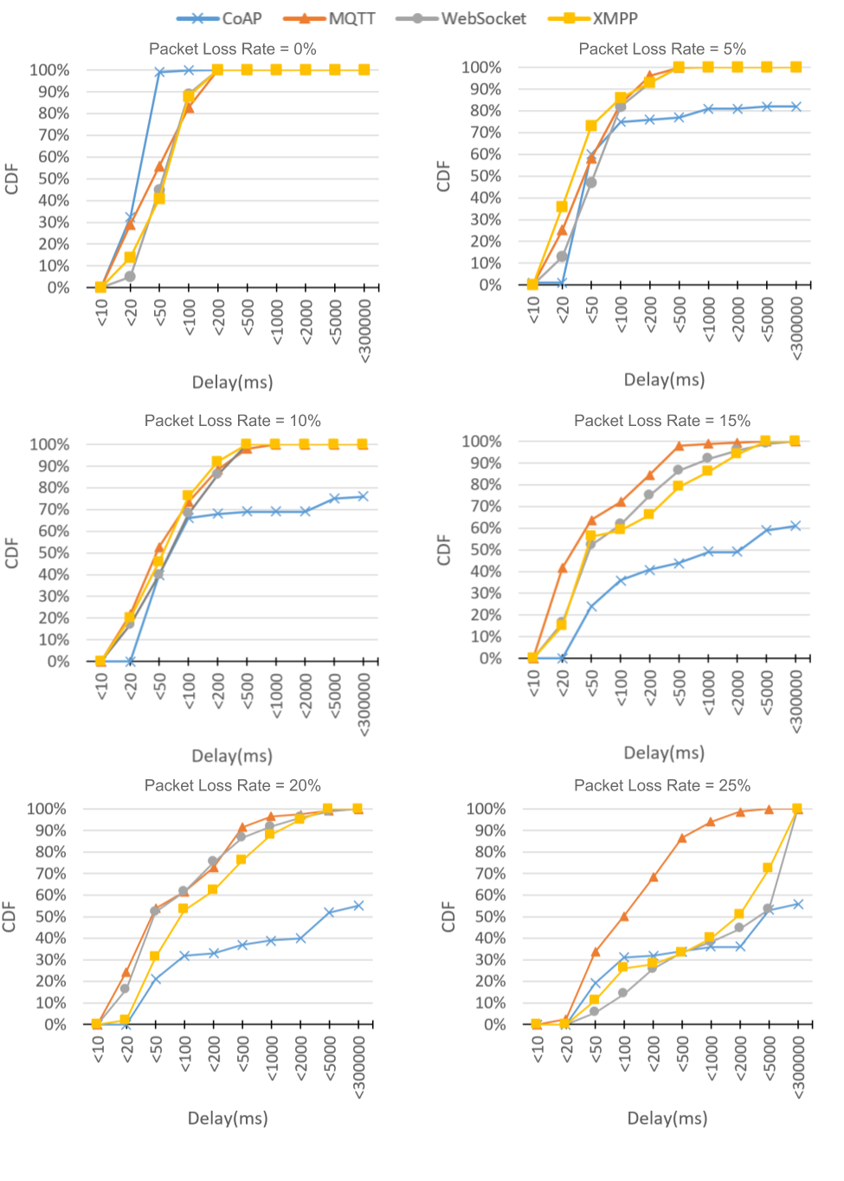

Figure ‑ Delay CDF of event driven 100 Bytes

#### Data Size 500 Bytes

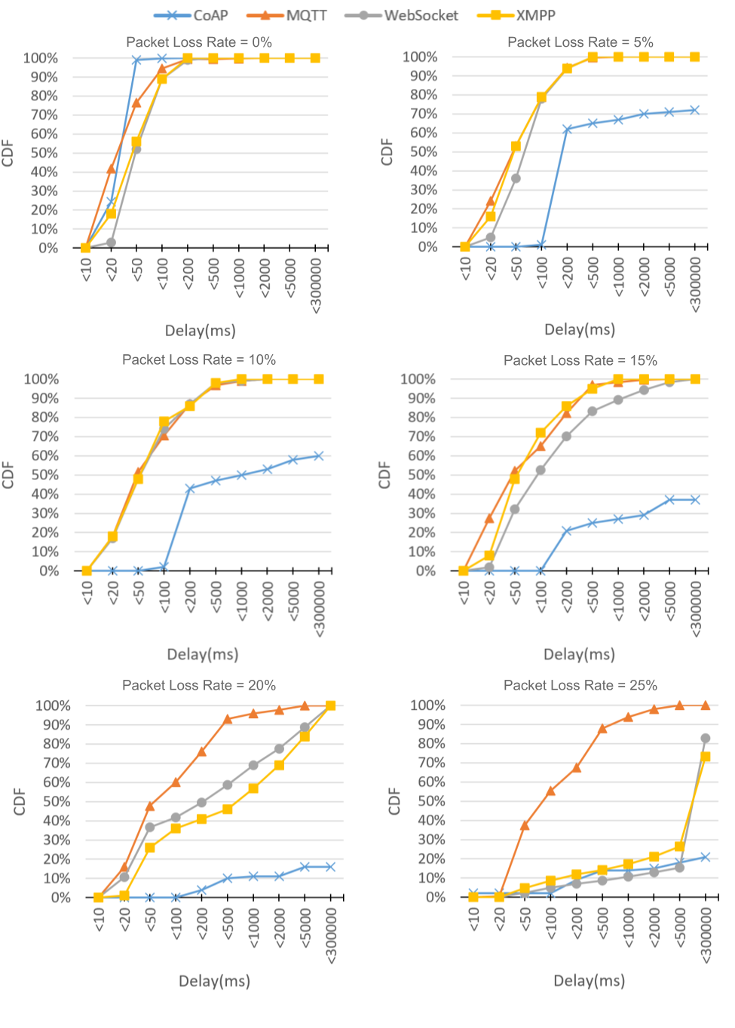

Figure ‑ Delay CDF of event driven 500 Bytes

#### Data Size 1000 Bytes

Figure ‑ Delay CDF of event driven 1000 Bytes

#### Data Size 1500 Bytes

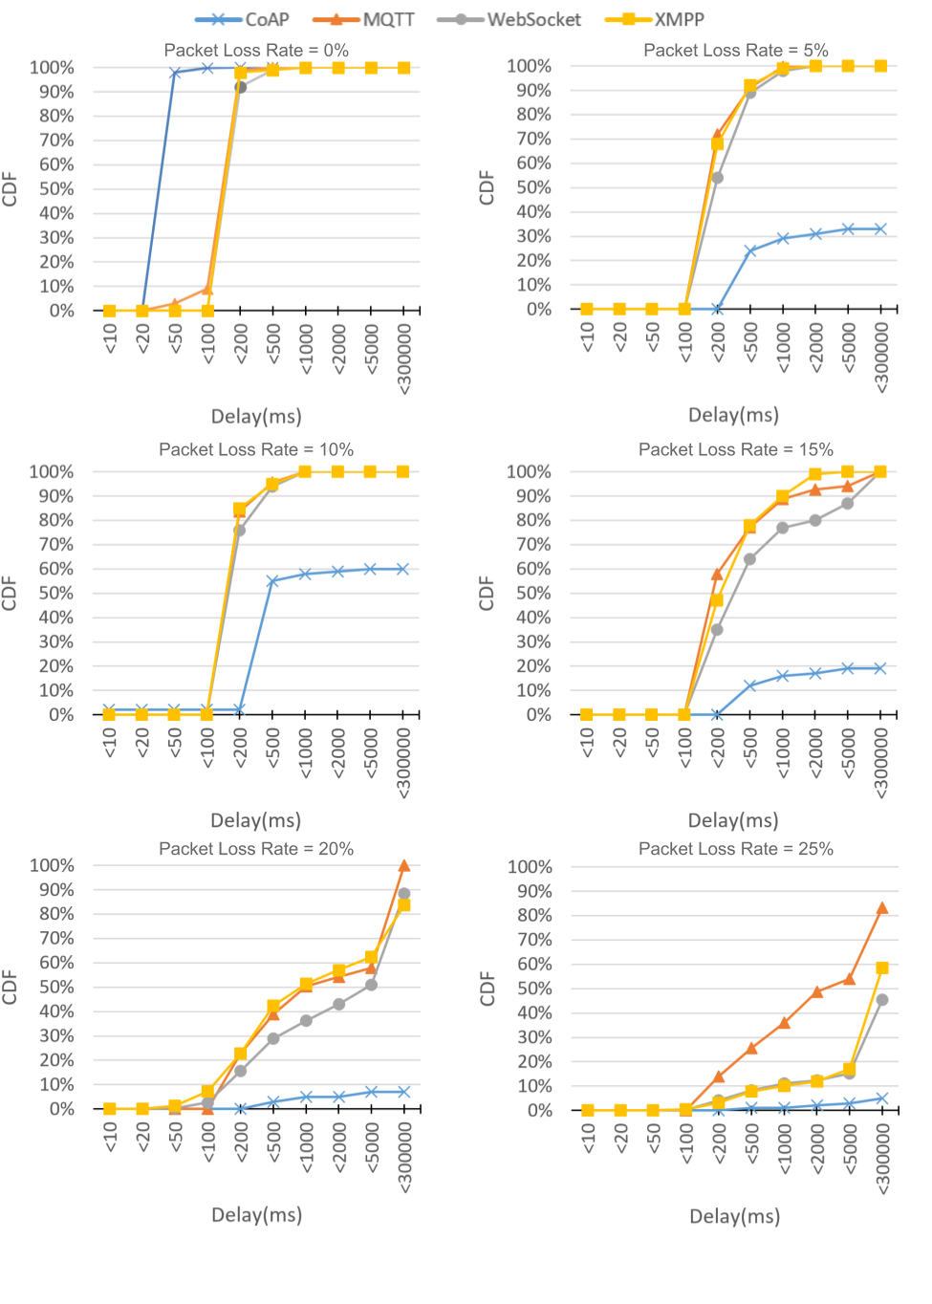

Figure ‑ Delay CDF of event driven 1500 Bytes