1.1 Experiment Results of Query Driven 1

1.1.1 Message Loss Rate 1

1.1.1 Average Message One-way-delay 2

1.1.1 Efficiency Metric 4

1.1.1 Delay CDF 8

## Experiment Results of Query Driven

This is the results of experiments of query driven application. Figure 5-4.1 is an example of 100 Bytes test data.

### Message Loss Rate

|  |  |  |  |  |
| --- | --- | --- | --- | --- |
| Ploss | CoAP | MQTT | WebSocket | XMPP |
| 0% | 0% | 0% | 0% | 0% |
| 5% | 0% | 0% | 0% | 0% |
| 10% | 0% | 0% | 0% | 0% |
| 15% | 0% | 0% | 0% | 0% |
| 20% | 0% | 0% | 0% | 0% |
| 25% | 0% | 0% | 0% | 0% |

Table 6.2.1‑1 Message loss rate result of query driven with 100 Bytes data size

|  |  |  |  |  |
| --- | --- | --- | --- | --- |
| Ploss | CoAP | MQTT | WebSocket | XMPP |
| 0% | 0% | 0% | 0% | 0% |
| 5% | 0% | 0% | 0% | 0% |
| 10% | 0% | 0% | 0% | 0% |
| 15% | 0% | 0% | 0% | 0% |
| 20% | 0% | 0% | 0% | 0% |
| 25% | 0% | 0% | 0% | 0% |

Table 6.2.1‑2 Message loss rate result of query driven with 500 Bytes data size

|  |  |  |  |  |
| --- | --- | --- | --- | --- |
| Ploss | CoAP | MQTT | WebSocket | XMPP |
| 0% | 0% | 0% | 0% | 0% |
| 5% | 0% | 0% | 0% | 0% |
| 10% | 0% | 0% | 0% | 0% |
| 15% | 0% | 0% | 0% | 0% |
| 20% | 0% | 0% | 0% | 0% |
| 25% | 0% | 0% | 0% | 0% |

Table 6.2.1‑3 Message loss rate result of query driven with 1000 Bytes data size

|  |  |  |  |  |
| --- | --- | --- | --- | --- |
| Ploss | CoAP | MQTT | WebSocket | XMPP |
| 0% | 0% | 0% | 0% | 0% |
| 5% | 0% | 0% | 0% | 0% |
| 10% | 0% | 0% | 0% | 0% |
| 15% | 1% | 0% | 0% | 0% |
| 20% | 1% | 0% | 0% | 0% |
| 25% | 4% | 0% | 0% | 0% |

Table 6.2.1‑4 Message loss rate result of query driven with 1500 Bytes data size

### Average Message One-way-delay

|  |  |  |  |  |
| --- | --- | --- | --- | --- |
| Ploss | CoAP | MQTT | WebSocket | XMPP |
| 0% | 10.006ms ± 0.25 | 16.66ms ± 0.899 | 10.412ms ± 0.278 | 12.026ms ± 0.293 |
| 5% | 91ms ± 39.318 | 25.9ms ± 5.1 | 35.87ms ± 7.585 | 25.39ms ± 3.077 |
| 10% | 282.69ms ± 67.898 | 34.44ms ± 7.298 | 39.344ms ± 7.49 | 38.502ms ± 7.427 |
| 15% | 1242.58ms ± 441.407 | 60.17ms ± 8.583 | 44.86ms ± 8.463 | 45.97ms ± 8.74 |
| 20% | 958.326ms ± 240.06 | 85.924ms ± 16.102 | 114.368ms ± 28.798 | 86.51ms ± 19.532 |
| 25% | 1036.3ms ± 229.642 | 106.8ms ± 16.502 | 145.91ms ± 26.544 | 127.69ms ± 24.655 |

Table 6.2.2‑1 Message one-way-delay of query driven with 100 Bytes data size

|  |  |  |  |  |
| --- | --- | --- | --- | --- |
| Ploss | CoAP | MQTT | WebSocket | XMPP |
| 0% | 10.8ms ± 0.252 | 14.18ms ± 0.331 | 11.018ms ± 0.268 | 12.438ms ± 0.541 |
| 5% | 85.44ms ± 36.043 | 23.56ms ± 4.081 | 25.86ms ± 5.322 | 23.46ms ± 3.113 |
| 10% | 312.65ms ± 106.253 | 41.356ms ± 9.477 | 43.746ms ± 9.221 | 28.338ms ± 5.164 |
| 15% | 513.4ms ± 114.296 | 68.96ms ± 10.139 | 48.57ms ± 9.99 | 66.47ms ± 11.206 |
| 20% | 776.55ms ± 186.759 | 90.548ms ± 16.962 | 240.888ms ± 65.599 | 87.206ms ± 19.527 |
| 25% | 964.976ms ± 257.986 | 359.3ms ± 74.988 | 4452.97ms ± 651.615 | 4798.02ms ± 618.41 |

Table 6.2.2‑2 Message one-way-delay of query driven with 500 Bytes data size

|  |  |  |  |  |
| --- | --- | --- | --- | --- |
| Ploss | CoAP | MQTT | WebSocket | XMPP |
| 0% | 11.746ms ± 0.205 | 13.986ms ± 0.352 | 12.164ms ± 0.35 | 12.62ms ± 0.278 |
| 5% | 211.42ms ± 74.746 | 32.46ms ± 5.532 | 22.86ms ± 4.107 | 21.95ms ± 3.091 |
| 10% | 330.853ms ± 85.81 | 37.888ms ± 7.934 | 33.988ms ± 7.082 | 50.92ms ± 14.776 |
| 15% | 547.06ms ± 135.394 | 62.08ms ± 10.489 | 78.3ms ± 13.569 | 52.384ms ± 9.017 |
| 20% | 632.698ms ± 166.492 | 112.428ms ± 26.36 | 261.352ms ± 83.325 | 139.234ms ± 44.313 |
| 25% | 954.65ms ± 219.015 | 143.89ms ± 29.61 | 1768.72ms ± 269.138 | 1397.92ms ± 415.876 |

Table 6.2.2‑3 Message one-way-delay of query driven with 1000 Bytes data size

|  |  |  |  |  |
| --- | --- | --- | --- | --- |
| Ploss | CoAP | MQTT | WebSocket | XMPP |
| 0% | 17.354ms ± 0.396 | 12.94ms ± 0.28 | 14.044ms ± 0.333 | 13.14ms ± 0.308 |
| 5% | 610.22ms ± 100.616 | 38.22ms ± 7.767 | 38.95ms ± 6.983 | 38.45ms ± 6.505 |
| 10% | 1982.192ms ± 327.062 | 65.728ms ± 11.266 | 67.832ms ± 12.757 | 68.214ms ± 12.509 |
| 15% | 3736.939ms ± 715.757 | 88.26ms ± 14.756 | 143.92ms ± 26.448 | 129.448ms ± 31.386 |
| 20% | 4258.222ms ± 551.091 | 129.846ms ± 21.779 | 1328.43ms ± 428.832 | 1378.308ms ± 289.093 |
| 25% | 7748.864ms ± 881.447 | 203.34ms ± 45.772 | 12594.61ms ± 1160.54 | 37862.83ms ± 2388.165 |

Table 6.2.2‑4 Message one-way-delay of query driven with 1500 Bytes data size

### Efficiency Metric

|  |  |  |  |  |
| --- | --- | --- | --- | --- |
| Ploss | CoAP | MQTT | WebSocket | XMPP |
| 0% | 0.352±0.0005 | 0.2823±0.0001 | 0.3267±0 | 0.2043±0.0009 |
| 5% | 0.3385±0.0048 | 0.2675±0.0029 | 0.2995±0.0053 | 0.197±0.0024 |
| 10% | 0.322±0.0061 | 0.2529±0.0039 | 0.2952±0.0057 | 0.1824±0.0039 |
| 15% | 0.3067±0.0077 | 0.2361±0.0049 | 0.2913±0.0061 | 0.1681±0.0048 |
| 20% | 0.286±0.0083 | 0.2221±0.0052 | 0.263±0.0082 | 0.1627±0.0049 |
| 25% | 0.2758±0.0085 | 0.2182±0.0053 | 0.256±0.0087 | 0.1491±0.0056 |

Table 6.2.3‑1 Efficiency metric of query driven, 100 Bytes data size

Figure 6.2.3‑1 Efficiency metric of query driven, 100 Bytes data size

|  |  |  |  |  |
| --- | --- | --- | --- | --- |
| Ploss | CoAP | MQTT | WebSocket | XMPP |
| 0% | 0.7311±0.0004 | 0.6631±0 | 0.7082±0 | 0.5622±0.0013 |
| 5% | 0.7058±0.009 | 0.636±0.007 | 0.6605±0.0109 | 0.5445±0.0061 |
| 10% | 0.6502±0.0139 | 0.6037±0.0094 | 0.6232±0.014 | 0.5078±0.0103 |
| 15% | 0.6268±0.0158 | 0.5752±0.0249 | 0.6153±9.9907 | 0.473±0.0126 |
| 20% | 0.5691±0.0179 | 0.5514±0.0123 | 0.5684±0.0173 | 0.4618±0.0136 |
| 25% | 0.5656±0.0191 | 0.4922±0.0111 | 0.5357±0.0188 | 0.4428±0.0149 |

Table 6.2.3‑2 Efficiency metric of query driven, 500 Bytes data size

Figure 6.2.3‑2 Efficiency metric of query driven, 500 Bytes data size

|  |  |  |  |  |
| --- | --- | --- | --- | --- |
| Ploss | CoAP | MQTT | WebSocket | XMPP |
| 0% | 0.8446±0.0002 | 0.7975±0.0001 | 0.8291±0 | 0.7223±0.0006 |
| 5% | 0.8015±0.0118 | 0.7506±0.0102 | 0.7909±0.0107 | 0.6875±0.0095 |
| 10% | 0.7596±0.0151 | 0.7369±0.011 | 0.749±0.015 | 0.643±0.0136 |
| 15% | 0.7112±0.0184 | 0.6897±0.0136 | 0.6847±0.0193 | 0.608±0.016 |
| 20% | 0.6834±0.0203 | 0.6416±0.0165 | 0.6606±0.0198 | 0.5733±0.0174 |
| 25% | 0.667±0.0209 | 0.597±0.0173 | 0.6606±0.0208 | 0.5339±0.0199 |

Table 6.2.3‑3 Efficiency metric of query driven, 1000 Bytes data size

Figure 6.2.3‑3 Efficiency metric of query driven, 1000 Bytes data size

|  |  |  |  |  |
| --- | --- | --- | --- | --- |
| Ploss | CoAP | MQTT | WebSocket | XMPP |
| 0% | 0.7262±0.0004 | 0.8233±0.0007 | 0.8717±0.0024 | 0.7865±0.0034 |
| 5% | 0.6794±0.0077 | 0.7889±0.0085 | 0.8264±0.01 | 0.7461±0.0096 |
| 10% | 0.6195±0.0106 | 0.762±0.0102 | 0.793±0.0133 | 0.7191±0.0166 |
| 15% | 0.5592±0.0125 | 0.7483±0.0105 | 0.7629±0.0158 | 0.6851±0.0156 |
| 20% | 0.5224±0.013 | 0.7118±0.0133 | 0.7437±0.037 | 0.6753±0.0206 |
| 25% | 0.4609±0.0156 | 0.6609±0.0157 | 0.6999±0.019 | 0.6361±0.0018 |

Table 6.2.3‑4 Efficiency metric of query driven, 1500 Bytes data size

Figure 6.2.3‑4 Efficiency metric of query driven, 1500 Bytes data size

### Delay CDF

#### Data Size 100 Bytes

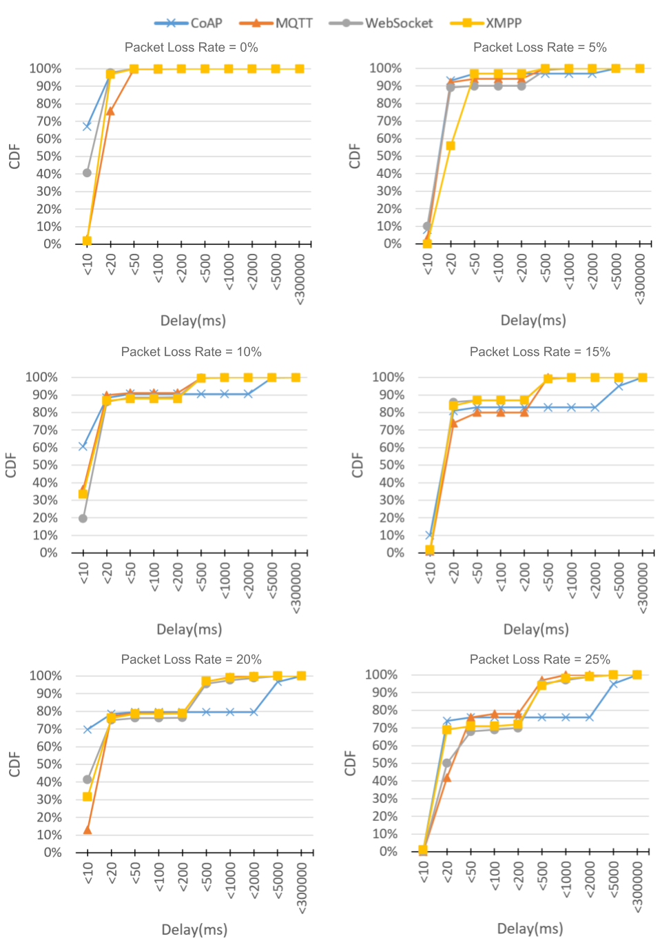

Figure 6.2.4‑1 Delay CDF of query driven 100 Bytes

#### Data Size 500 Bytes

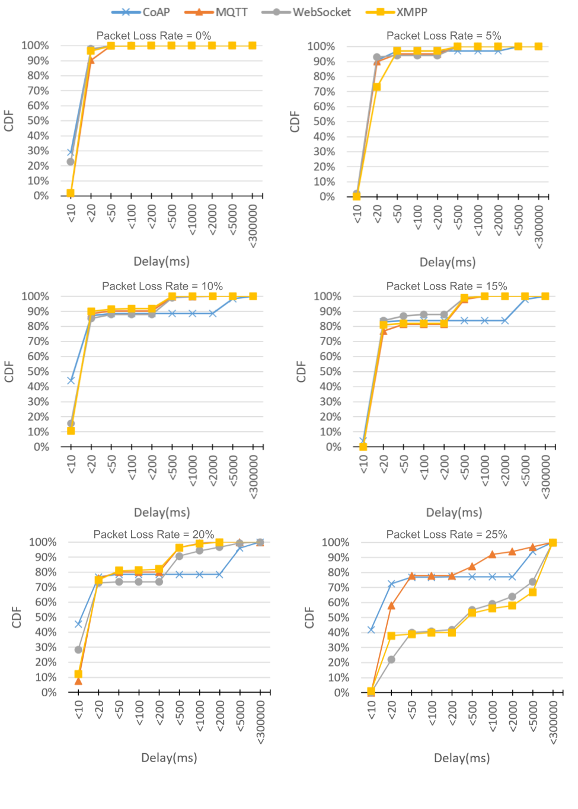

Figure 6.2.4‑2 Delay CDF of query driven 500 Bytes

#### Data Size 1000 Bytes

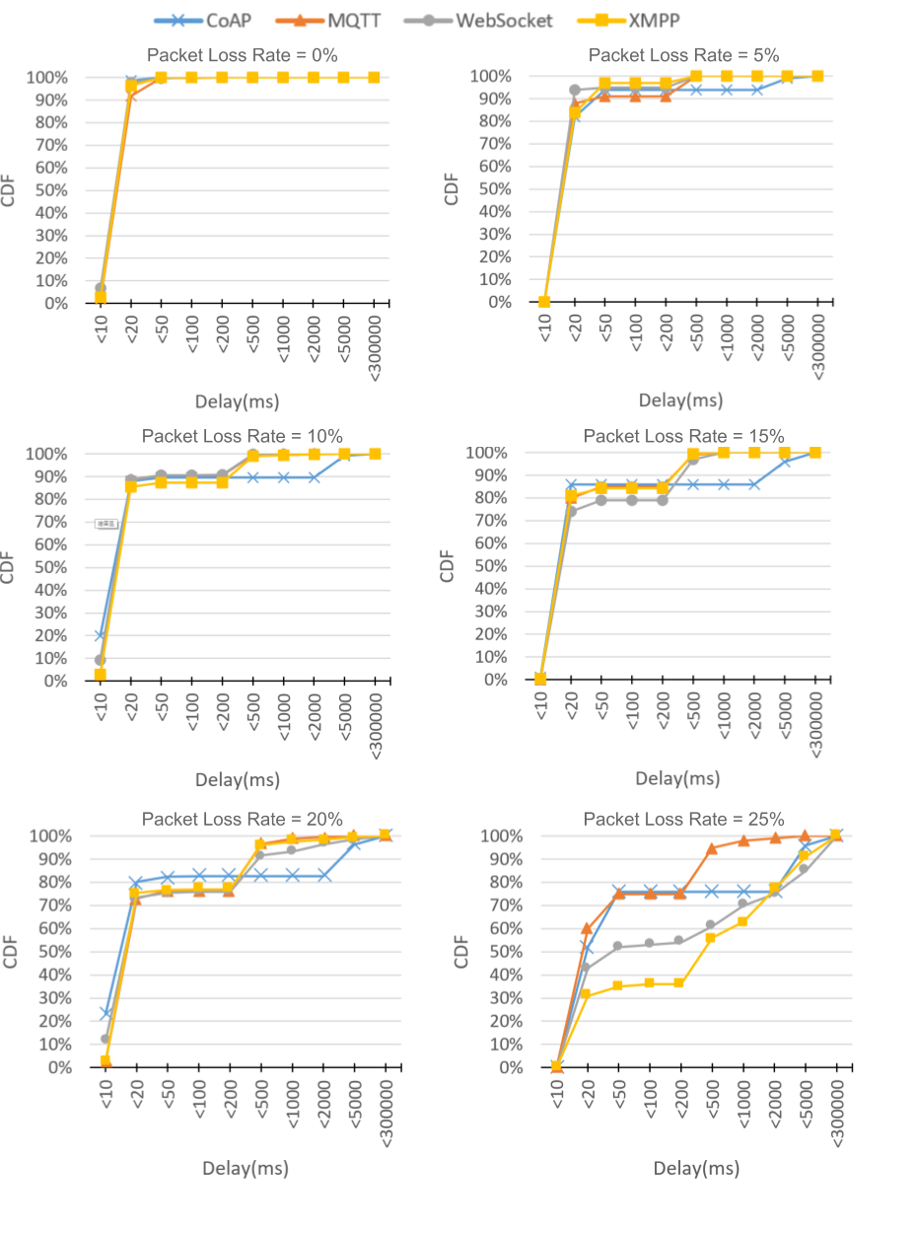

Figure 6.2.4‑3 Delay CDF of query driven 1000 Bytes

#### Data Size 1500 Bytes

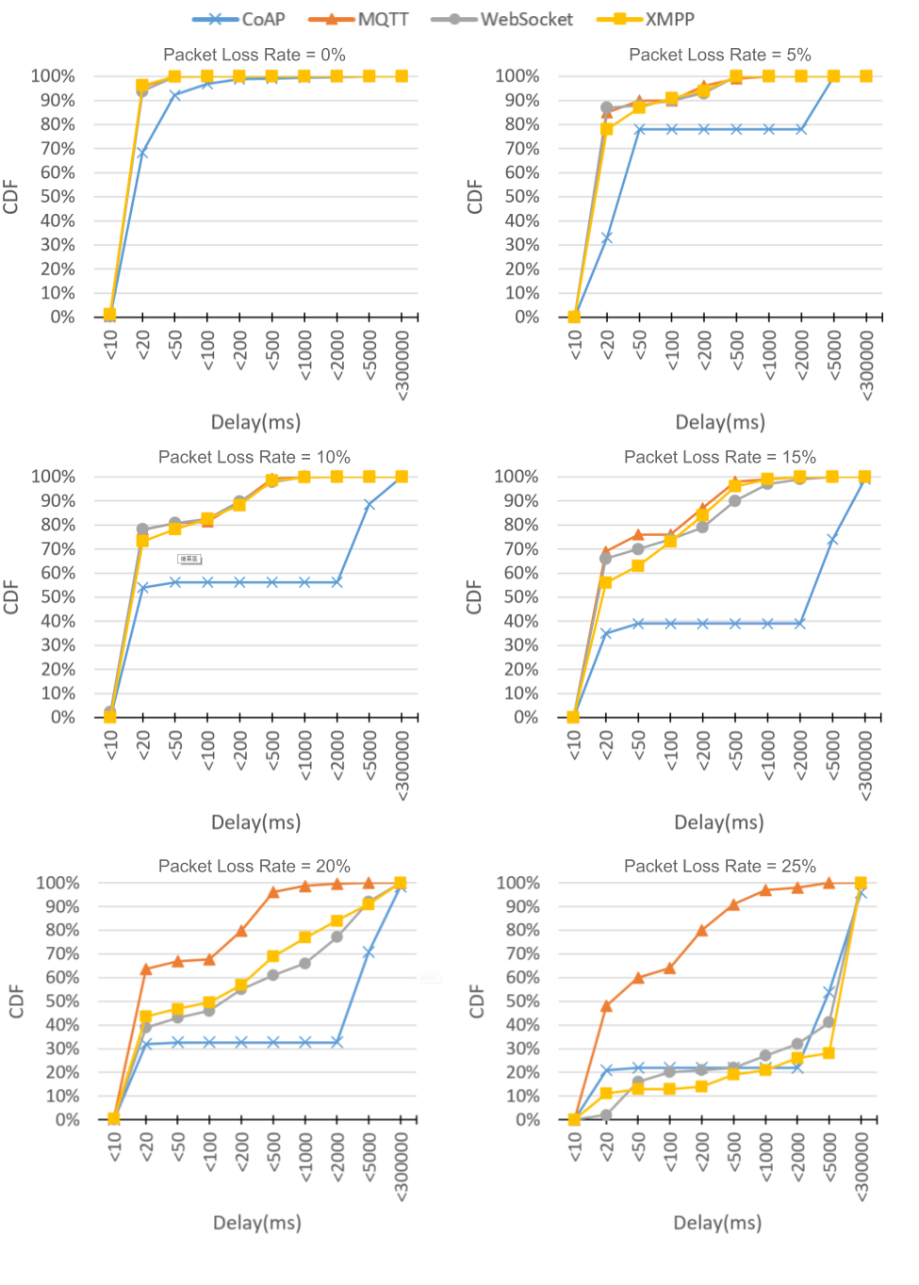

Figure 6.2.4‑4 Delay CDF of query driven 1500 Bytes