- 实时跟踪
http://www.gps902.net/api/GetTracking.aspx?id=356803210132270&mapType=baidu&key=20161222HLXTJDMW730XY
Id=设备唯一IMEI/ID号
mapType=需要的经纬度地图类型,如baidu则返回百度经纬度,如google,则返回谷歌经纬度,为空,则返回默认原始未纠偏经纬度
key=20161222HLXTJDMW730XY 固定值
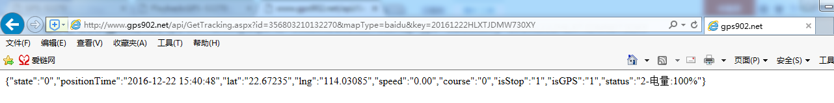

成功返回
{"state":"0","positionTime":"2016-12-22 15:30:53","lat":"22.67235","lng":"114.03085","speed":"0.00","course":"0","isStop":"1","isGPS":"1","status":"2-电量:100%"}
positionTime:设备定位时间
lat:纬度
lng:经度
speed:速度
course:角度
isStop:是否停止
satatus:行驶状态(0:未启用,1:运动,2:静止,3:离线,)-车辆状态
无结果或失败返回,参考最下方state值

- 历史轨迹
http://www.gps902.net/api/GetHistory.aspx?id=356803210132270&mapType=baidu&key=20161222HLXTJDMW730XY&startTime=2016-12-21 12:00&endTime=2016-12-21 12:03
startTime:轨迹查询开始时间,北京时区,格式yyyy-MM-dd HH:mm
endTime:轨迹查询结束时间,北京时区
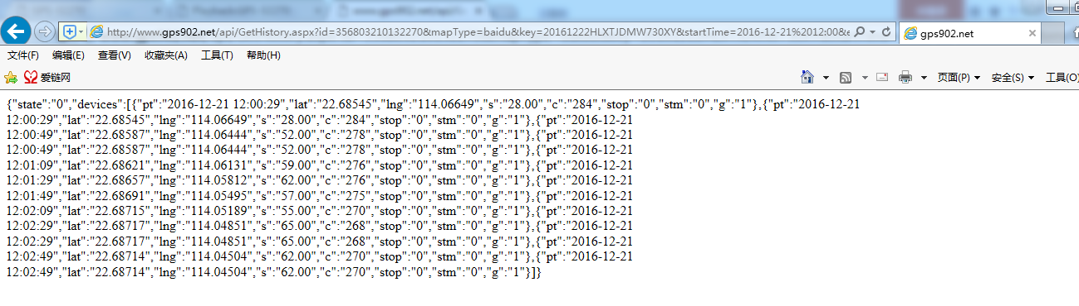
成功返回
{"state":"0","devices":[{"pt":"2016-12-21 12:00:29","lat":"22.68545","lng":"114.06649","s":"28.00","c":"284","stop":"0","stm":"0","g":"1"},{"pt":"2016-12-21 12:00:29","lat":"22.68545","lng":"114.06649","s":"28.00","c":"284","stop":"0","stm":"0","g":"1"},{"pt":"2016-12-21 12:00:49","lat":"22.68587","lng":"114.06444","s":"52.00","c":"278","stop":"0","stm":"0","g":"1"},{"pt":"2016-12-21 12:00:49","lat":"22.68587","lng":"114.06444","s":"52.00","c":"278","stop":"0","stm":"0","g":"1"},{"pt":"2016-12-21 12:01:09","lat":"22.68621","lng":"114.06131","s":"59.00","c":"276","stop":"0","stm":"0","g":"1"},{"pt":"2016-12-21 12:01:29","lat":"22.68657","lng":"114.05812","s":"62.00","c":"276","stop":"0","stm":"0","g":"1"},{"pt":"2016-12-21 12:01:49","lat":"22.68691","lng":"114.05495","s":"57.00","c":"275","stop":"0","stm":"0","g":"1"},{"pt":"2016-12-21 12:02:09","lat":"22.68715","lng":"114.05189","s":"55.00","c":"270","stop":"0","stm":"0","g":"1"},{"pt":"2016-12-21 12:02:29","lat":"22.68717","lng":"114.04851","s":"65.00","c":"268","stop":"0","stm":"0","g":"1"},{"pt":"2016-12-21 12:02:29","lat":"22.68717","lng":"114.04851","s":"65.00","c":"268","stop":"0","stm":"0","g":"1"},{"pt":"2016-12-21 12:02:49","lat":"22.68714","lng":"114.04504","s":"62.00","c":"270","stop":"0","stm":"0","g":"1"},{"pt":"2016-12-21 12:02:49","lat":"22.68714","lng":"114.04504","s":"62.00","c":"270","stop":"0","stm":"0","g":"1"}]}
Devices:数组
pt:设备定位时间
Lat:纬度
Lng:经度
S:速度
C:角度
Stop:是否停止,1停止,0运动
Stm:停止分钟
id:每条记录唯一标示ID
G:定位方式,0:LBS,1:GPS

- 多设备监控
http://www.gps902.net/api/GetMonitor.aspx?ids=356803210132270,353507000002012,353507100003389&mapType=baidu&key=20161222HLXTJDMW730XY
Ids:设备IMEI号,逗号分隔
返回数据格式,多了个数组,其他跟实时跟踪一样.
{"state":"0","devices":[{"sn":"353507000002012","positionTime":"2016-05-05 17:20:28","lat":"41.78977","lng":"123.46823","speed":"0.00","course":"999","isStop":"0","isGPS":"0","status":"3-电量:90%"},{"sn":"353507100003389","positionTime":"2016-05-03 11:34:10","lat":"22.67162","lng":"114.02816","speed":"0.00","course":"999","isStop":"1","isGPS":"0","status":"3-电量:100%"},{"sn":"356803210132270","positionTime":"2016-12-28 10:31:41","lat":"22.67299","lng":"114.02356","speed":"0.00","course":"0","isStop":"1","isGPS":"1","status":"3-电量:33%"}]}

State值

state值对应说明
0 | 成功
1001 | 参数不对
1002 | 程序报错,异常.可能参数错误等
1003 | 设备IMEI号不存在
2002 | 没有查询到任何结果
3001 | KEY不对

