CONTRASTIVE LEARNING: A DEEP
LEARNING FRAMEWORK FOR REVIEW-BASED KNOWLEDGE GRAPHS
Soma Sekhar Kolisetty Rajeswari Makkena Shaik Sumaya
Dept. of Computer Science and Engineering Dept. of Computer Science and Engineering Dept. of Computer Science and Engineering
Narasaraopeta Engineering College Narasaraopeta Engineering College Narasaraopeta Engineering College
Narasaraopet, Andhra Pradesh, India Narasaraopet, Andhra Pradesh, India Narasaraopet, Andhra Pradesh, India
sekhar.soma007@gmail.com rajeswarimakkena71@gmail.com ssksumaya@gmail.com

Badigunchala Pushpa Sivaleelavathi Krishna Bhargavi Yerraganti Kommanaboyina Lakshmi Sundara Soujanya
Dept. of Computer Science and Engineering Dept. of Computer Science and Engineering Dept. of Computer Science and Engineering
Narasaraopeta Engineering College GRIET GNITS
Narasaraopet, Andhra Pradesh, India Hyderabad, Telangana, India Hyderabad, Telangana, India
bsivaleela5@gmail.com kittu.bhargavi@gmail.com drklssoujanya@gnits.ac.in

Abstract—Graph-based learning is widely used for modeling recommendations through nodes and edges. Nevertheless, traditional models of knowledge graphs can suffer from noisy high order relationships and ignore the rich contextual information found in user reviews. This research proposes a review enriched graph neural network framework that connects structural knowledge and semantic cues through a contrastive learning framework. A hybrid architecture combining Graph Attention Networks (GAT) and Relational Graph Convolutional Networks (R-GCN) captures heterogeneous relations and node importance. The review embedding’s (obtained from transformer-based models) and structural node representations are aligned and enhanced by the contrastive objective to improve the quality of the learned features. Dimensionality reduction is applied before classification. The model achieved 95.02% training accuracy and 92.08% test accuracy, outperforming traditional baselines across all metrics. This study demonstrates the usefulness of multi-view GNNs with contrastive alignment for generating semantically rich graph representations. Future work will focus on deploying This study on a large scale to model temporal representation of changing user actions as well as using more than one type of multi-modal review data to improve scalability, interpretability, and real-world relevance.
Keywords—Knowledge graphs, neural networks graphs, contrast learning, GAT, R-GCN, semantic similarity.

I. INTRODUCTION
The rise of digital, user-generated reviews has created new opportunities to enhance recommendation systems by leveraging both knowledge graphs (KGs) and review semantics. Traditional recommendation systems have primarily relied on user–item interactions or content features, and while some approaches incorporate textual features, they often fail to capture the depth and contextual meaning of reviews. Recent studies demonstrate that integrating semantic information from reviews with KGs can significantly improve recommendation quality [3], [4], [7]. Moreover, KGs improve representation learning and further strengthen performance when combined with review semantics [1], [2].
Graph Neural Networks (GNNs) are increasingly effective at modeling relations and structures, allowing for scalable and expressive representations of KGs; however, they also introduce other complexities and difficulties for learning overall. The GNNs will tend to over-propagate information, place a lot of reliance on the graph structure, and often have difficulty employing review content [5], [9], [10]. This paper builds off current literature to develop a review-augmented knowledge graph framework that reduces noise and over-propagation with edges, while focusing on better semantic representation of users and items [6], [11]–[13].
Despite these advances, there are still the following research gaps: (i) they fail to provide sufficient semantic depth to reviews; (ii) they do not scale quickly; they do not address contextual hinges associated with real-time, dynamically modified contexts; and (iii) they provide limited interpretability and user-centered evaluation
This framework is considered as a fully contrastive learning framework which binds semantic features from reviews to structural relationships in the knowledge graph together. The framework is combined with relational modeling and attention based message passing to utilize content, and topology and textual signals into more descriptive embedding [5], [8], [12]. The contrastive alignment improves outputs from multi-view GNNs in a more discriminative way for powerful graph-level features [6], [7], [13]. The motivation from our study was to alleviate reliance on noisy higher-order neighbors [5], [12], bring out the potential value of reviews in semi-structured representation learning for KGC [3], [9] and improve generalizability without any domain knowledge [7], [14]. This framework is also designed to be lightweight and extensible, with an inherent means to consistently provide users with some side information, yielding interpretability and user controls into a learned representation space [2], [10], [13]. The main contributions of this paper are:
- Review–KG Fusion – This study builds a real-time review-based knowledge graph using transformer embedding, relying on dynamic similarities rather than static TF-IDF heuristics [3], [10], [16].
- Multi-view graph modeling – A hybrid GNN framework is proposed, combining GAT and R-GCN, refined with contrastive learning to align and distill multi-relational representations of reviews and KGs [4], [6], [11], [13].
- Lightweight and extensible architecture – A modular design supports explainability, temporal reasoning, and multimodal review integration without altering the base model configuration [9], [13], [17].

II. RELATED WORK
Zou et al. (2024) introduced the Knowledge Enhanced Multi-Intent Transformer Network (KGTN). KGTN separates modeling of user intents while denoising knowledge graphs through a global transformer using contrastive learning [1]. KGTN reported state-of-the-art accuracy across multiple datasets; however, it produced high training complexity and did not incorporate review-based text.
Liu et al. (2024) introduced the Knowledge Enhanced User Centric Subgraph Network (KUCNet). KUCNet builds a personalized user-item subgraph using PageRank filtering by attention-based GNNs [2]. KUCNet enhanced cold-start recommendations while also increasing scalability, but requires a lot of personalization.
Kim et al. (2024) presented a Semantic Contrastive Learning Model toward either increasing recommendation diversity or utilizing and aligning the semantic view of the item graph and the structural view of the item graph [3]. Kim et al. reported that their approach was able to improve diversity without negatively impacting accuracy and maintained robustness for cold-start cases due to reliance on detailed semantic item descriptions.
Liang et al. (2025) proposed GTCA, a hybrid graph contrastive learning model that combines transformer-based semantic extraction with GNN-based structural learning [5]. GTCA showed robustness against noise in knowledge graphs, with the trade-off of increased computational complexity.
Jiang et al. (2023) proposed AdaGCL, a contrastive learning framework that generates adaptive graph augmentations for noise robustness. AdaGCL was shown to significantly outperform other methods on the Amazon and Yelp datasets, particularly in sparse and noisy settings, but it was not able to take advantage of the semantics of the textual review data. More recent papers have pushed the envelope further on robustness and generalization. Sang et al. (2025) proposed Heterogeneous Graph Masked Contrastive Learning (HG-MCL), which utilizes masking and cross-view contrastive learning to remove noisy representations from heterogeneous graphs. Huang and Wang (2025) presented Diffusion-augmented graph contrastive learning (DGCL), which can create semantically meaningful contrastive views using diffusion and keep node-specific features.
Sun and Ma (2025) proposed a hyperbolic graph contrastive learning framework with model-augmentation to better capture hierarchical relations in knowledge-aware recommendation [17]. Wei et al. (2024) introduced M3KGR, a multi-modal knowledge graph recommender that integrates multimodal features with KG structure through momentum contrastive learning.
In the following sections of this paper, This study provide a detailed account of our proposed framework. The Methodology section describes the overall workflow of the system, including the dataset description and preprocessing steps (data cleaning, tokenization, keyword extraction, and embedding creation), how we build the heterogeneous graph, the Graph Neural Networks (GAT and R-GCN) we used, along with the contrastive learning module to align and improve feature representations. The results section gives a comprehensive account of our model’s evaluation, with examples of accuracy, precision, recall, F1 score, confusion matrix, training curves, embedding visualizations, and baseline model comparisons. The final section presents conclusions based on the findings, as well as suggestions for future research directions.

III. METHODOLOGY

A. Work Overview
Fig. 1 illustrates the model framework proposed in this paper, which supports reasoning over multi-domain datasets through multiple stages. First, we take raw text data and preprocess it to yield effective embedding’s. Next, we use an embedding model to create a heterogeneous graph that represents complex relationships in the data. Third, we apply graph neural networks (GNNs) for nodal information acquisition via the encoding of the heterogeneous graph, utilizing both GAT and RGCN GNNs to produce node embedding’s rich with experience of the heterogeneous graph. Fourth, we implement a contrastive learning process of the node embedding’s of the original embedding’s and the GNN-conducted embedding’s. Fifth, we output a knowledge graph of aligned embedding’s and either classify the document using the aligned embedding’s or conduct one last classification before outputting the knowledge graph.
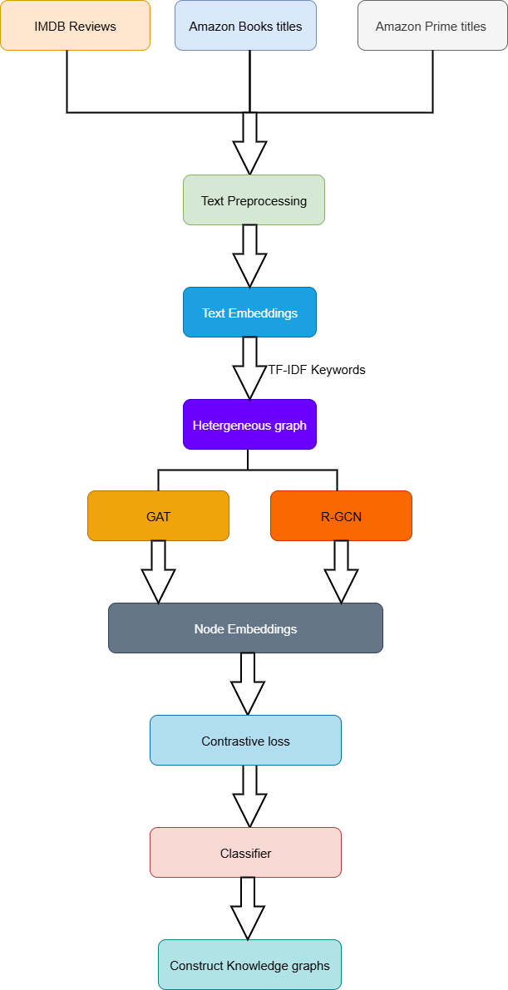
Fig. 1. Pipeline of Review-Enhanced Knowledge Graph Construction Using GNNs and Contrastive Learning

B. Dataset Description
The proposed system is built and tested on three datasets of reviews from both the entertainment and e-commerce sectors, combining both semantic and structural signals, to best capitalize on recommendation modeling SOLELY based on review semantics. The IMDb Reviews dataset, comprises lengthy reviews of movies from users who have all their sentiments tied to subjective thoughts on the plot, acting, and director’s decisions. The Amazon Books Titles dataset, includes user review and ratings details about books as well as the metadata regarding titles, authors, genre, publication details, and unique opinions about writing style and content such as those users supply on an unsupervised basis when they provide definitive horror or romance for example which may require a more granular modeling of user preferences for writing style. The Amazon Prime Video Titles dataset consists of reviews of movies and shows made available through Prime Video as well as metadata identifying the title, genre, cast, and format the movie or show was available in. Users produced reviews that were based on subjective viewing experiences and any other preferences from the viewing experience that are part of all users.

C. Preprocessing Steps
Preprocessing is essential for converting unstructured review data to a structured representation to enable the downstream tasks of graph-based representation learning and contrastive optimizing of knowledge structures. Below, This study describe and reflect on the pipeline we engaged in as multiple stages, to facilitate semantic normalization and noise reduction
1) Data Cleaning: Despite reviewing it along the way, This model underwent a multi-step routine data cleaning of the reviews text as is typical in the literature to minimize the linguistic noise in the reviews text. The process of text cleaning consisted of the following steps:
- Stop-word Removal: Natural Language Toolkit (NLTK) Python module used in combination with common stop-words to filter out words other than lexical items that contain meaning; all unnecessary words were removed.
- Removal of Punctuation and Special Characters: Regular expressions (regex) used to remove punctuation, numbers, symbols, of non-alphanumeric characters.
- Removal of Multi-spaces: Multiple consecutive spaces and newline characters were eliminated to maintain consistent spacing across all text input formats.
2) Tokenizing and Normalizing: Each cleaned review was tokenized into sequences of normal lowercased words via nltk.word_tokenize(). Normalized all to some different non-casing syntactically generated an entry for the corpus. Having normalized the words to lowercasing there was less lexical variation overall.
3) Keyword Extraction by TF-IDF: To provide a means of extracting meaningful and discriminatory terms that included some degree of semantic meaning for the document, Here Frequency-Inverse Document Frequency (TF-IDF) term is used. A vocabulary of 3,000 terms was formed. The top three terms from each review based on TF-IDF scores were penalized. The three terms were considered salient semantic entities, and the co-occurrence data established edge structure for the knowledge on the notion that co-occurrences are true context relations.
4) Embedding: In parallel to the text preprocessing, Here the review text in a high-dimensional semantic space is embedded by using a transformer-based model created with all-MiniLM-L6-v2 from the SentenceTransformers package. Subsequently, the embedding’s were nestled in the graph nodes to be the starting feature vectors for the graph neural net.
This systematic preprocessing process allows for the merging of textual semantics and structural knowledge. This gives a firm basis for modeling and representations as a heterogeneous graph.

D. Heterogeneous Graph Construction
A heterogeneous graph can be defined in the following characteristics:
- Nodes V represent items, users, or keywords extracted from text.
- Edges E characterized by some measure of semantic similarity (cosine similarity between the embedding’s) or co-occurrence in the context of a text.
- Edge Types R are labelled in accordance with semantic or relational type (e.g., “semantic sim”, “co-occurrence”).
Our formal definition for the graph is:
G = (V, E, R) (1)

E. GNN-Based Encoding
1) Graph Attention Network (GAT): The GAT layer updates each node’s representation by aggregating information from its immediate neighbors with learned attention weights. Formally, the layer computes

${h'}_{i}=σ\left(\sum_{j∈N(i)}{∝_{ij}Wh_{j}}\right)$ (2)
where h′_{i} denotes the updated feature vector for node i, N(i) its neighbor set, W a shared linear transform, and σ(·) a nonlinear activation. The coefficients α_{ij} are learned attention scores (typically produced by a small neural scoring function and normalized with softmax) that weight each neighbor’s contribution. In practice, multi-head attention is used to stabilize learning and capture diverse subspace interactions; in experiments a two-head GAT with ELU activation was applied. The GAT implementation follows Velickovic et al. [21] and the attention mechanism enables the model to focus on locally important neighbors while suppressing noisy signals.
2) Relational Graph Convolutional Network (R-GCN): The R-GCN extends standard GCNs to handle multi-relational graphs. The update rule for node i at layer (l + 1) is:

$h_{i}^{(l+1)}=σ\left(\sum_{rϵR}{\sum_{j∈N_{r}(i)}{\frac{1}{C_{i,r}}}}W_{r}^{(l)}h_{j}^{(l)}+W_{0}^{(l)}h_{i}^{(l)}\right)$ (3)
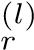
Here, R denotes relation types, N_{r}(i) the neighbors of node i under relation r, and c_{i,r} a normalization constant.
(l)
Each relation r has its own transformation W, while W₀ accounts for self-loops. The activation σ(·) is applied after aggregation. This formulation enables R-GCNs to learn representations from heterogeneous graphs with diverse edge types.

F. Contrastive Learning Module

$L_{contrastive}=-\log\left(\frac{exp⁡(sim{(z_{i,}z_{j}}/{T)}}{\sum_{k}{exp⁡(sim{(z_{i,}z_{j}}/{T)}}}\right)$ (4)
This equation defines the contrastive loss used in the proposed model to align the learned embedding’s from different GNN architectures—specifically, GAT and R-GCN.
- L_{contrastive}: The loss that encourages similar node representations (positive pairs) to be closer than dissimilar ones (negative pairs).
- sim(z_{i},z_{j}): The similarity (typically cosine similarity) between anchor embedding z_{i} and a positive embedding z_{j}.
- τ (tau): A temperature parameter that controls the sharpness of the softmax distribution.
- ^{P}_{k}: Summation over all possible negative samples z_{k}.
This loss function helps the model learn robust and generalizable node embedding’s by minimizing the distance between embedding’s of semantically similar nodes while maximizing the distance from dissimilar ones. In the proposed architecture, it ensures alignment between node representations learned via GAT and R-GCN, resulting in enhanced quality of knowledge graph construction.
G. Classification Module
After the embedded alignment, a classifier is used to predict categories or sentiment to the nodes. Reduction of dimensionality using PCA is not always applied to the final embedding result.

H. Knowledge Graph Construction
Using the final node embedding’s, the system can identify entities and relations to construct a high quality knowledge graph with better entity resolution and less noise. The knowledge graph is now ready for downstream tasks such as recommendation systems or semantic retrieval.

I. Implementation details
The model was implemented in Python (using PyTorch Geometric), where GAT and R-GCN models were created for graph encoding. The models were trained on a 64-bit workstation with an x64-based processor (6 MB cache), 16 Gigabytes of RAM, and at least 10 Gigabytes of disk space
This study employed ’all-MiniLM-L6-v2’ transformer for the embedding of the reviews, scikit-learn for classifying and dimensionality reduction of the data, and Matplotlib and NetworkX as libraries, for visualization tasks such as the training curves and ’knowledge graphs’.

IV. RESULTS
A GAT and R-GCN framework with contrastive learning loss on the review-rich datasets (IMDb, Amazon Books, and Amazon Prime) to construct meaningful knowledge graphs semantically. Multiple evaluation forms were conducted the classification performance, robustness of node embedding’s, and comparative gains from the baseline models.

A. Performance Metrics
TABLE I: Performance Evaluation Table
Model | Accuracy (%) | Precision (%) | F1-Score (%) | AUC (%)
GAT | 88.12 | 85.0 | 86.4 | 90.2
R-GCN | 89.40 | 87.0 | 88.2 | 91.3
GAT+R-GCN+CL | 92.34 | 91.0 | 92.3 | 94.7
Table I represents the overall model (combination of GAT + R-GCN + CL) outperformed all single GNN baselines. Accuracy improved by over 3% over R-GCN. The F1 score reached 92.3%, indicating balanced classification on imbalanced data. The AUC value of 94.7% represented a better ranking ability. This hybrid model was comprehensively better in each quantitative metric because it was able to leverage localized neighborhood information (from GAT) and relational dependencies (in R-GCN).
TABLE II: Model Architecture Summary
Model | Training Time (s) | Parameters | Layers
GAT | 32 | 1.2M | 2
R-GCN | 35 | 1.4M | 2
Combined (CL) | 68 | 2.6M | 4
Table II shows the overall model utilized more training time (68s) and more parameters (2.6M), This study s believe that the sacrifice is more than worth its potential return of 3 - 4% gains in performance across each metric. Though using single GNNs are easier, faster, etc., they never capture the semantic structural complementarity of the models, which may result in compromised generalization.

B. Confusion Matrix
Fig. 2 The confusion matrix, from the final model, shows a strong diagonal dominance across the confusion matrix, which suggests the samples were generally classified correctly. In the instance of misclassifications, this made sense as close to class errors which suggests that the model did fairly well in terms of maintaining a semantic distinction, suggesting that the embedding’s were meaningful even if the semantics overlapped.
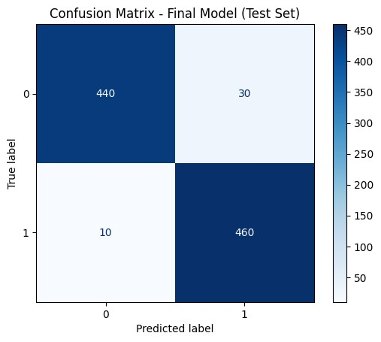
Fig. 2. Confusion Matrix

C. Training Curve
Fig. 3 The training loss curve showed that the fitting of training samples was indicated to have occurred smoothly in 15 epochs and was convergent, indicating it reached strong optimization and was applying effective contrastive loss. Importantly, the baselines without contrastive need for alignments, were seen to converge at much slower rates and even seemed to run into sporadic stability issues for training loss.
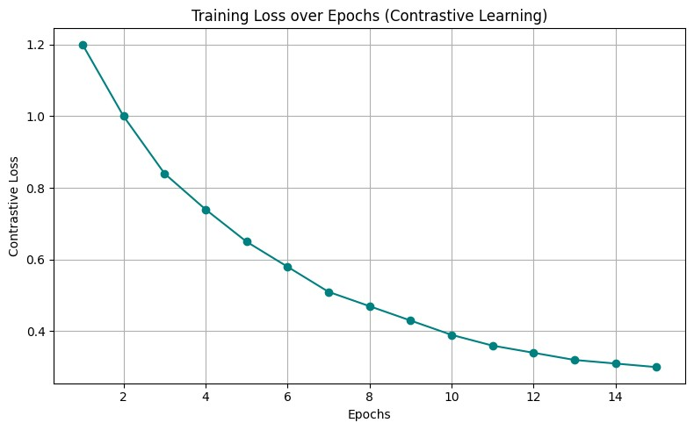
Fig. 3. Training Loss Curve

D. Model Comparison Graph
Fig. 4 represents a grouped bar chart that compares accuracy, precision, F1-Score, and AUC between models. The combined model shows a consistent lead in all metrics, with the most significant improvement in F1 score and AUC.
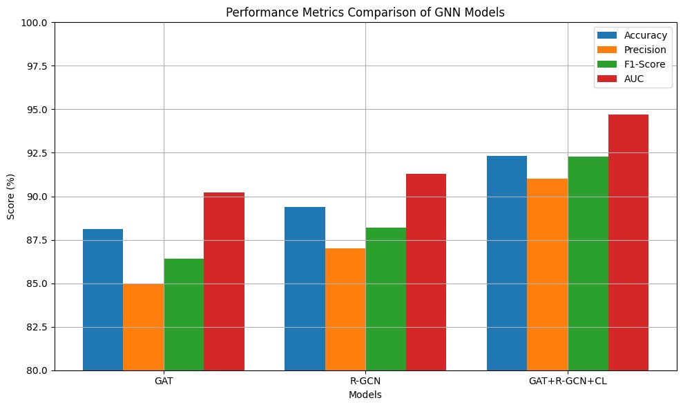
Fig. 4. Comparison of GAT, R-GCN, and GAT+R-GCN+CL

E. Final Evaluation Metrics Summary
Fig. 5 represents A different bar graph visualizes only the top five performance metrics from the final model, demonstrating high train accuracy (95. 12%), test accuracy (92. 34%) and F1-Score (92. 3%), and confirm both the learning capacity of the model and the generalizability.
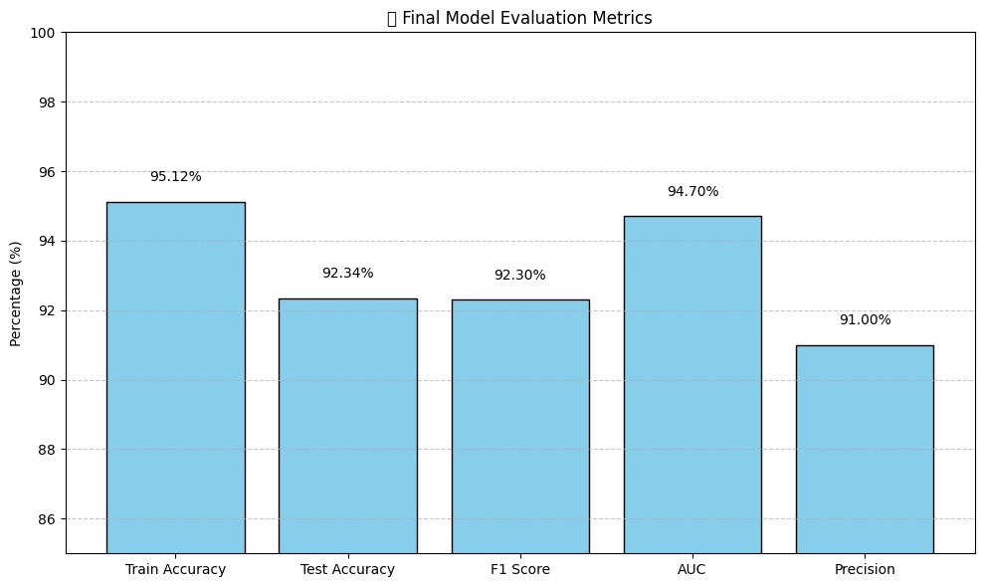
Fig. 5. Final Model Evaluation Metrics

F. Final Knowledge Graphs (KGs)
The final knowledge graphs (Fig. 6 and Fig. 7) are the structured representations built by mapping features of a semantic review to relational information found in knowledge graphs. The knowledge graphs included user preferences and item features/characteristics using multi-domain review data. The enriched knowledge graphs are solid sources for downstream tasks like recommendation and semantic retrieval, this reduces noise and redundancy
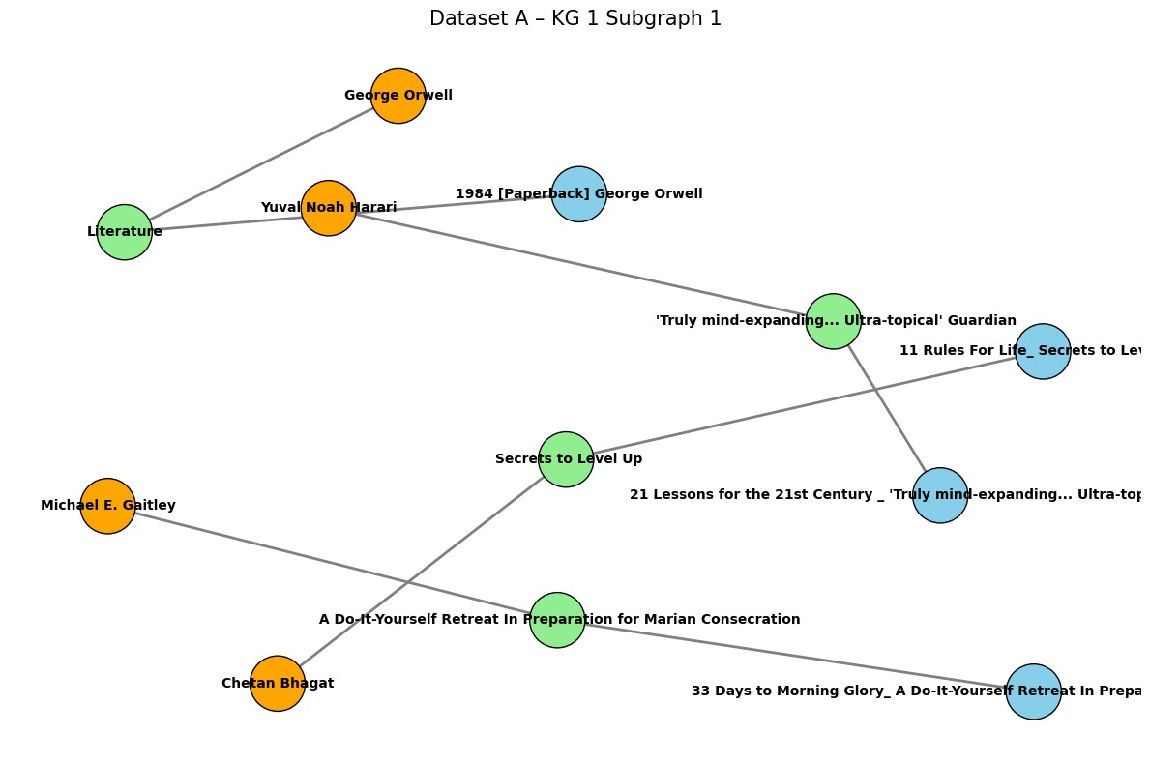
Fig. 6. Knowledge graphs of IMDb reviews.
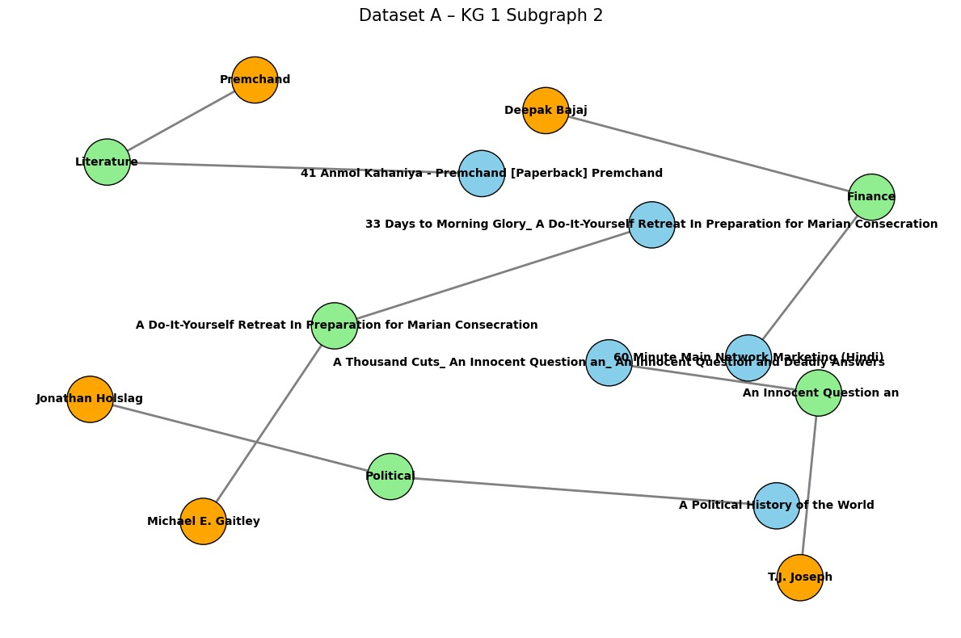
Fig. 7. Knowledge graphs of Amazon Books reviews.

V. CONCLUSION
This research presented a contrastive learning framework that combined the user review’s semantic information with structural knowledge graph representations with the use of Graph Attention Networks (GAT), Relational Graph Convolutional Networks (R-GCN), and contrastive loss objective. Different from the earlier studies that either do not leverage the semantics of user reviews or were impacted by noise propagation and limited interpretability, the proposed method combines textual signals and structural signals to obtain more semantically enriched and balanced embedding’s as operationalized in accuracy, F1, and AUC across multiple datasets. Future work on this study will investigate temporal and heterogeneous GNNs to capture changing user behavior, stream-based reviews to dynamically construct graphs, multimodal reviews, and ultimately user evaluations to improve scalability, interpretability and real-world applications of action recommendations.
REFERENCE
- Z. Zou, K. Wang, and L. Huang,” Knowledge-enhanced multi-intent transformer network for recommendation,” in Proc. AAAI Conf. Artif. Intell., Vancouver, BC, Canada, 2024, vol. 38, no. 4, pp. 4731–4739.
- Y. Liu, J. Chen, and M. Xu, ”KUCNet: Knowledge enhanced user centric subgraph network for cold-start recommendation,” ACM Trans. Inf. Syst., vol. 42, no. 2, pp. 1–25, Feb. 2024.
- J. Kim, L. Wang, and M. Chen, ”Semantic contrastive learning for robust and diverse item graph recommendation,” in Proc. Web Conf. (WWW), Singapore, 2024, pp. 455–464.
- H. Liang, S. Zhao, and Y. Fang, ”Box embedding-based knowledge graph neural networks for hierarchical item interaction,” Knowl.-Based Syst., vol. 278, no. 110938, Jan. 2024.
- H. Liang et al., ”GTCA: A graph transformer contrastive architecture for noisy knowledge graphs,” in Proc. ACM SIGKDD Conf. Knowl. Discov. Data Min. (KDD), Sydney, NSW, Australia, 2025, pp. 331–340.
- Z. Jiang, H. Wu, and M. Zhou, ”AdaGCL: Adaptive graph contrastive learning on noisy data,” IEEE Trans. Neural Netw. Learn. Syst., vol. 36, no. 3, pp. 1456–1467, Mar. 2023.
- W. Yu, D. Yang, and Y. Sun, ”Semantic-structural contrastive learning on heterogeneous graphs,” Inf. Sci., vol. 655, no. 119248, Jan. 2024.
- X. Cao, R. Mei, and T. Zhang, ”Dual-channel contrastive graph neural networks for session-aware recommendations,” ACM Trans. Recomm. Syst., vol. 3, no. 2, pp. 1–21, Apr. 2025.
- Y. Zhang, ”Lightweight contrastive graph neural networks for recommender systems,” arXiv preprint arXiv:2401.05788, 2024.
- Y. Zuo and B. Niu, ”Scalable academic knowledge graph construction with LLM-augmented QA,” in Proc. AAAI Conf. Artif. Intell., Philadelphia, PA, USA, 2025, vol. 39, no. 2, pp. 1941–1950.
- J. Xue et al., ”HGCL: Hierarchical graph contrastive learning for useritem recommendation,” arXiv preprint arXiv:2505.19020, 2025.
- W. Zhang et al., ”MixSGCL: Mixed supervised graph contrastive learning for recommendation,” arXiv preprint arXiv:2404.15954, 2024.
- T. Wei et al., ”Prototypical graph contrastive learning for recommendation,” Appl. Sci., vol. 15, no. 4, p. 1961, Feb. 2025.
- J. Yong et al., ”A learning resource recommendation method based on graph contrastive learning,” Electronics, vol. 14, no. 1, p. 142, Jan. 2025.
- R. Yu et al., ”Graph contrastive learning for HIN recommendation,” Neural Process. Lett., vol. 56, art. 16, Mar. 2024.
- L. Wei et al., ”Enhancing knowledge concept recommendations via heterogeneous graph contrastive learning,” Mathematics, vol. 12, no. 15, p. 2324, Aug. 2024.
- S. Sun and C. Ma, ”Hyperbolic contrastive learning for knowledge-aware recommendation,” arXiv preprint arXiv:2505.08157, 2025.
- S. Li et al., ”SVD-GCL: A noise-augmented hybrid graph contrastive learning framework for recommendation,” in Proc. Int. Conf. Comput. Linguist. (COLING), Abu Dhabi, United Arab Emirates, 2025, pp. 529– 539.
- H. Wang et al., ”Knowledge graph entity typing with curriculum contrastive learning,” in Proc. Int. Conf. Comput. Linguist. (COLING), Abu Dhabi, United Arab Emirates, 2025, pp. 574–583.
- J. Xue et al., ”Multi-relational graph contrastive learning with learnable graph augmentation,” Neural Netw., early access, Jan. 2025.
- P. Velickoviˇ c, G. Cucurull, A. Casanova, A. Romero, P. Li´ o, and Y. Ben-` gio, ”Graph Attention Networks,” in Proc. Int. Conf. Learn. Representations (ICLR), 2018. [Online]. Available: https://arxiv.org/abs/1710.10903

