Cross-Climate Flood Prediction:

A Multi-Regional Deep Learning Approach to Hydrological Diversity

Rama Krishna Eluri Amireddy Navya Attluri Pavana Prudula Sri
Dept. of Computer Science and Engineering Dept. of Computer Science and Engineering Dept. of Computer Science and Engineering
Narasaraopeta Engineering College Narasaraopeta Engineering College Narasaraopeta Engineering College
Narasaraopet, Andhra Pradesh, India Narasaraopet, Andhra Pradesh, India Narasaraopet, Andhra Pradesh, India
ramakrishnaephd7@gmail.com vijayalakshmi11122001@gmail.com prudulasri@gmail.com

Kadapa Gandhi Kumari Pavan Tejaswi Surath Vadde Radha Krishna

Dept.of Computer Science and Engineering Dept.of Computer Science and Engineering Dept.of Electronics & Communication Engineering
Narasaraopeta Engineering College GRIET GNITS

Narasaraopet, Andhra Pradesh, India Hyderabad, Telangana, India Hyderabad, Telangana, India
kgandhikumari2004@gmail.com Pavantej2200@gmail.com vrkece@gnits.ac.in

Abstract—Floods are among the most destructive natural hazards that affect lives, property, and ecosystems in various weather-related incidents and across climatic regions. This paper develops a scalable deep learning-based framework for multi-regional flood prediction using disparate data sources, consisting of rainfall, temperature, soil moisture, land environ- ment, and socio-environmental indicators. To maintain consis- tency in both spatial (lateral) and temporal (vertical) dimen- sions upon preprocessing data, several data preprocessing tech- niques were applied: temporal alignment, linear interpolation, and Min-Max normalization. Five models were produced and analysed to predict early warning capabilities; Random Forest, XGBoost, Convolutional Neural Network (CNN), Long Short- Term Memory (LSTM), and Gated Recurrent Unit (GRU). Results showed deep learning methodologies outperformed pre- vious machine learning techniques. The proposed GRU model produced the best overall performance; 99.63% accuracy, R²=0.8986, RMSE =0.1555, MAE =0.0820, suggesting great generalizability across geographic regions, climatic variability, and natural conditions. The findings point to the conclusion that building a framework based on the GRU model is strong and feasible for use in operational applications for flood forewarning, climate adaptation, or disaster risk reduction.
Index Terms—Flood Forecasting, Deep Learning, Machine Learning, Random Forest, XGBoost, LSTM, CNN, GRU, Time Series Forecasting.
- Introduction
Flooding is one of the most prevalent and damaging forms of disasters which can have lasting effects on human existence, infrastructure, and ecosystems. Global change, anthropogenic-forced rapid urbanization, and changing hy- drological regimes are the main drivers of the increasing intensity and frequency of flooding [1]. In many coun- tries, including India, the complicated and varying terrain and climate makes it even more difficult to predict floods around the world. Historically, empirical modeling or simple
machine learning models were focused on conducting flood forecasting. Due to this, these forecasting models may work reasonably well in a localized context, but invariably will struggle to scale and perform across broader geography and environmental conditions. Additionally, taking into account critical variables such as rainfall, temperature, soil moisture, land use, and topographic features are difficult [2]. To exac- erbate the problem, flood forecasting models also face prob- lems with temporal mismatch, incompleteness in data, and noisy measurements which often dramatically reduces their performance for real-time prediction [3], [11], [12], [13]. Due to these limitations, more advanced methods are be- ginning to emerge in recent studies. For example, CNN- LSTM-GNN based models await considered more complex methodologies to produce high-resolution (3D) flood maps while introducing robustness and accuracy issues with simu- lated data [4], [14], [15]. LSTM models, combined with cli- mate variables, improved accuracy specifically for snowmelt floods in another example [5]. Moreover, knowledge graph- based GNN models have demonstrated their potential for flood risk classification in regional contexts [6]. Urban flood evacuation planning has incorporated conceptual models that utilize digital twin technology and show the potential of real time response systems for smart cities [7], [16]. Basari et al. [8] have also constructed spatiotemporal fusion models using deep learning with satellite imagery for urban flood detection, with the caveat that high computational burden may hinder other studies’ application of spatiotem- poral models, where working with satellite imagery alone is computationally expensive. Hybrid learning architectures like Neural-XGBoost also provide improved disaster clas- sification through the combination of neural networks and

gradient boosting [9], [17], [18].
The aim of the present paper is to provide an extensive flood prediction framework with multiple areas of focus and using several sources of data from NASA POWER, SMAP, MODIS and socio-environmental variables as sources of data. The data went through several preprocessing appli- cations including temporal alignment, linear interpolation, and Min-Max normalization to manage the inconsistencies and differences between the datasets. After preprocessing, several models were established and evaluated. The research used both classical machine learning methods, including Random Forest and XGBoost, but also deep learning meth- ods such as CNN, LSTM, and GRU networks. In this case, the GRU model was the best performing (the accuracy for the GRU model was 99.63%), and the RMSE was 0.1555, MSE was 0.0820, and R-squared was 0.8986. The compar- ison of the proposed flood prediction approach conforms to previous work using hybrid CNN-RNN and Neural ODE models, the proposed approach supports accurate forecasting and generalisation ability [19], [20], [21]. It should be emphasised that this paper adds to the existing literature in flood prediction area by providing a single scalable transferability model that can be administrated, and used in other climatic and hydrological settings.
The overall objectives and the main contributions are re- ported as follows:
- A data-augmentation approach was employed to the flood data incorporated and interpolated from different sources.
- Developed and applied a variety of predictive models utilizing both machine learning and deep learning methods including Random Forest, XGBoost, LSTM Networks, Con- volutional Neural Networks, and GRUs.
- Assessed the performance of each model using both statistical and classification metrics which include accuracy, RMSE, MAE and R² score. Also, confusion matrices were analysed to gauge performance on categorical predictions. The organization of this paper is as follows:
Section I presents the introduction which details the research motivation, problem definition and paper objectives. Section II presents review related research,summarizing past studies, and identified gaps. Section III reports on methods which include data collection, preprocessing, and model develop- ment. Section IV reports the results of the experiments and performance evaluation which was done using predefine metrics. In Section V presents key insights, challenges, and recommendations for future improvements. Section VI provides a review of the results and directions for future research.
- Literature Survey
Jia et al. [1] investigated the process of developing three- dimensional flood maps through deep learning methods. Their research included the use of models such as Convo- lutional Neural Networks, Long Short-Term Memory net- works, and Graph Neural Networks in order to improve the accuracy in the visualization of 3D floods. Their research studied task decomposition and end-to-end deep learning approaches; CNN-LSTM hybrid models were particularly effective for generating high-resolution flood maps that are also scalable. However, the use of simulated data raises its
own concerns over robustness and potential propagation of errors.
As relates to snowmelt affected basins, Atashi and Gorji [2] used LSTM models and climate variables with multi-station study of the Red River of the North. They reported highly accurate short-term modelling and reinforced the suitability of using independent temporal deep learning approaches for hydrological forecasting.
Yang et al. [3] developed a model that used knowledge graphs and GNNs to predict flood risk levels. The model showed improved results in predicting flood risk levels com- pared with traditional classification methods such as Random Forest and Support Vector Machine (SVM), achieving an AUC score of 0.84. Although the study produced valuable insights for spatial flood risk assessments, the geographical limitation is Jiangxi Province, China.
Prihatmanto and colleagues [4] presented an exploration of Digital Twin for urban flood evacuation systems. While there was a conceptual framework proposed for smart city real time flood response, based on a distinct literature review process, this was more theoretical. While that is a great start, what they did is still very much at the theory stage and has not seen practical application or validation.
Lim et al. [5] presented a high-performance flood detection framework that put together deep CNNs (VGGNet-16), spa- tiotemporal image fusion, and Deep Cascaded RNNs. They reported an accuracy of 99.89% which also puts forward a very robust solution for disaster alerting. But its use is limited by high computational requirements.
Saleem et al. [6] introduced a hybrid method called Neural- XGBoost to classify different types of natural disasters. This hybrid method used a neural network for pattern and feature extraction and XGBoost provided the ultimate classification. When tested, they achieved an impressive 94.8% accuracy, and very high F1 scores for all three disaster types (i.e. wildfires, floods, and earthquakes).
Wang and Xu in work [7] reported on the issue of mountain flash flood prediction in small watersheds which they did with a compound LSTM-CNN-Attention architecture. What they did was to put together multi type of short-term disaster related data (for example hydrology, meteorology) which their model did very well in improving real time prediction accuracy in very variable terrain.
Noh and Ahn [8] reported that they improved large scale precipitation data integration with the use of a Res U-Net deep learning framework which did not involve interpolation. They which put together multi source precipitation products and topography data did in fact improve spatial accuracy and did better than what is traditional.
The STURM Flood dataset is a well-publicized (by No- tarangelo et al. [9]) public & organized dataset for de- veloping deep learning models for flood extent detection; containing satellite data using Sentinel-1 and Sentinel-2 platforms for a total of 60 different flood events from around the world. The study showed very high accuracy using U- Net architectures, and facilitated mapping of flood impacted areas on a larger scale.
Finally, in which Alkaabi et al. [10] put forth a deep learning framework which includes CNNs, RNNs, and Neural ODEs

for the issue of flash flood run off in arid environments. They used data from the UAE which the model they put together did very well with an R squared of 0.98 also they were able to do a great job at modeling complex hydrological dynamics.
- METHODOLOGY
The architecture that is used in this research is an orga- nized and modular pipeline for predicting floods. This is il- lustrated in Fig. 1. The workflow started with the preparation of the dataset which included missing entries, normalization or standardization of input features, splitting the dataset into training and test/test set, and encoding the target labels. After preprocessing, a cleaned dataset that was used to train a number of prediction models. These models included traditional machine or statistical learning techniques like Random Forest and XGBoost and deep learning methods such as LSTM, CNN, and GRU networks. The GRU model, specifically, was developed with the addition of the dropout and dense layers to better capture time-series relationships and to decrease overfitting. Lastly, an evaluation of the model outputs was performed to determine the best and most generalizable flood prediction model. Given that this is a flexible architecture in terms of feature extraction, capturing sequential data, and allowing comparative assessments all while using multiple models to determine the best practice for flood forecasting in diverse regions.
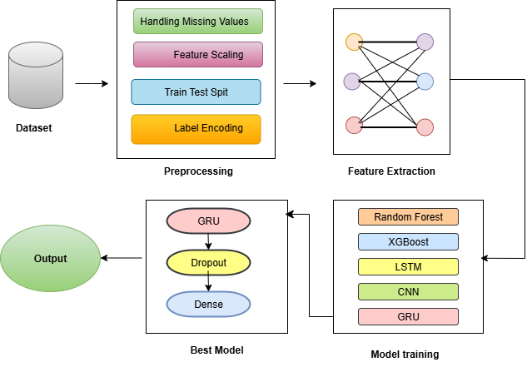

Fig. 1. Architecture for GRU-based Flood Prediction

- Specific Contribution:
The proposed research presents a consolidated multi- regional flood prediction pipeline that incorporates hetero- geneous climatic and socio-environmental data, and makes a fair comparison of five models in one pipeline. The tuned GRU architecture achieved the best performance- 99.63% accuracy, R² = 0.8986, RMSE = 0.1555, MAE = 0.0820-
which exhibited superior generalization and applicability in real-time.
- Experimental Setup:
The experiments were all conducted in Python 3.10 via the Google Colab environment, which is many times cheaper and easier for deep learning tasks due to its GPU acceler- ation. For the LSTM/GRU models, TensorFlow and Kera’s
were used, and Scikit-learn was used for classical machine learning. Data preprocessing and visualization was done using Pandas, NumPy, Matplotlib and Seaborn.
- Data Preprocessing
Clean and Handle Missing Values: Leading and trailing whitespace were removed. To populate missing values, linear interpolation was employed.
The cleaned FloodProbability time series exhibits a unified and comprehensive signal upon examining the gaps and outliers (see Fig. 2). The data were then resampled to an hourly frequency so that all observations align temporally, enabling proper time-series analysis (see in Fig. 3).
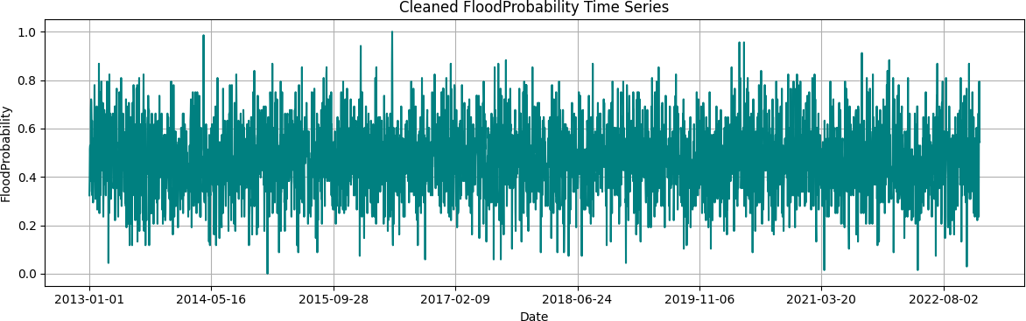

Fig. 2. Cleaned FloodProbability Time Series

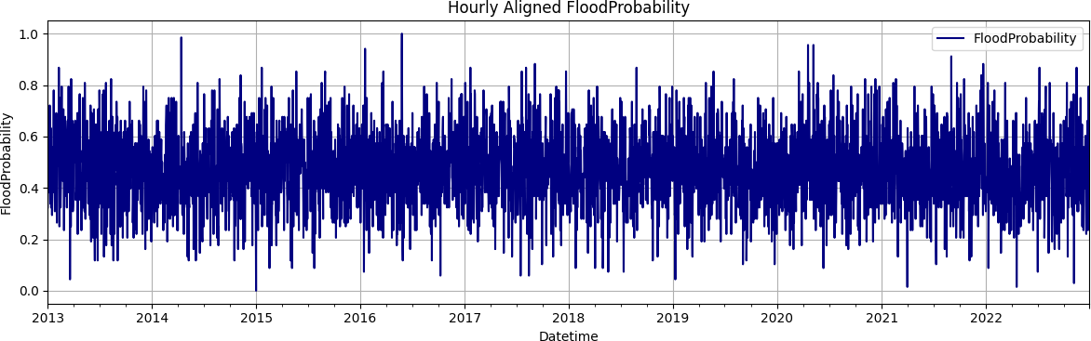

Fig. 3. Hourly Aligned FloodProbability

Scaling (1): The feature distributions before and after Min-Max Scaling show how all values were rescaled to the [0, 1] range without altering the original data shape as shown in Fig. 4.
$X'=\frac{X-X_{min}}{X_{max}-X_{min}}$ (1)
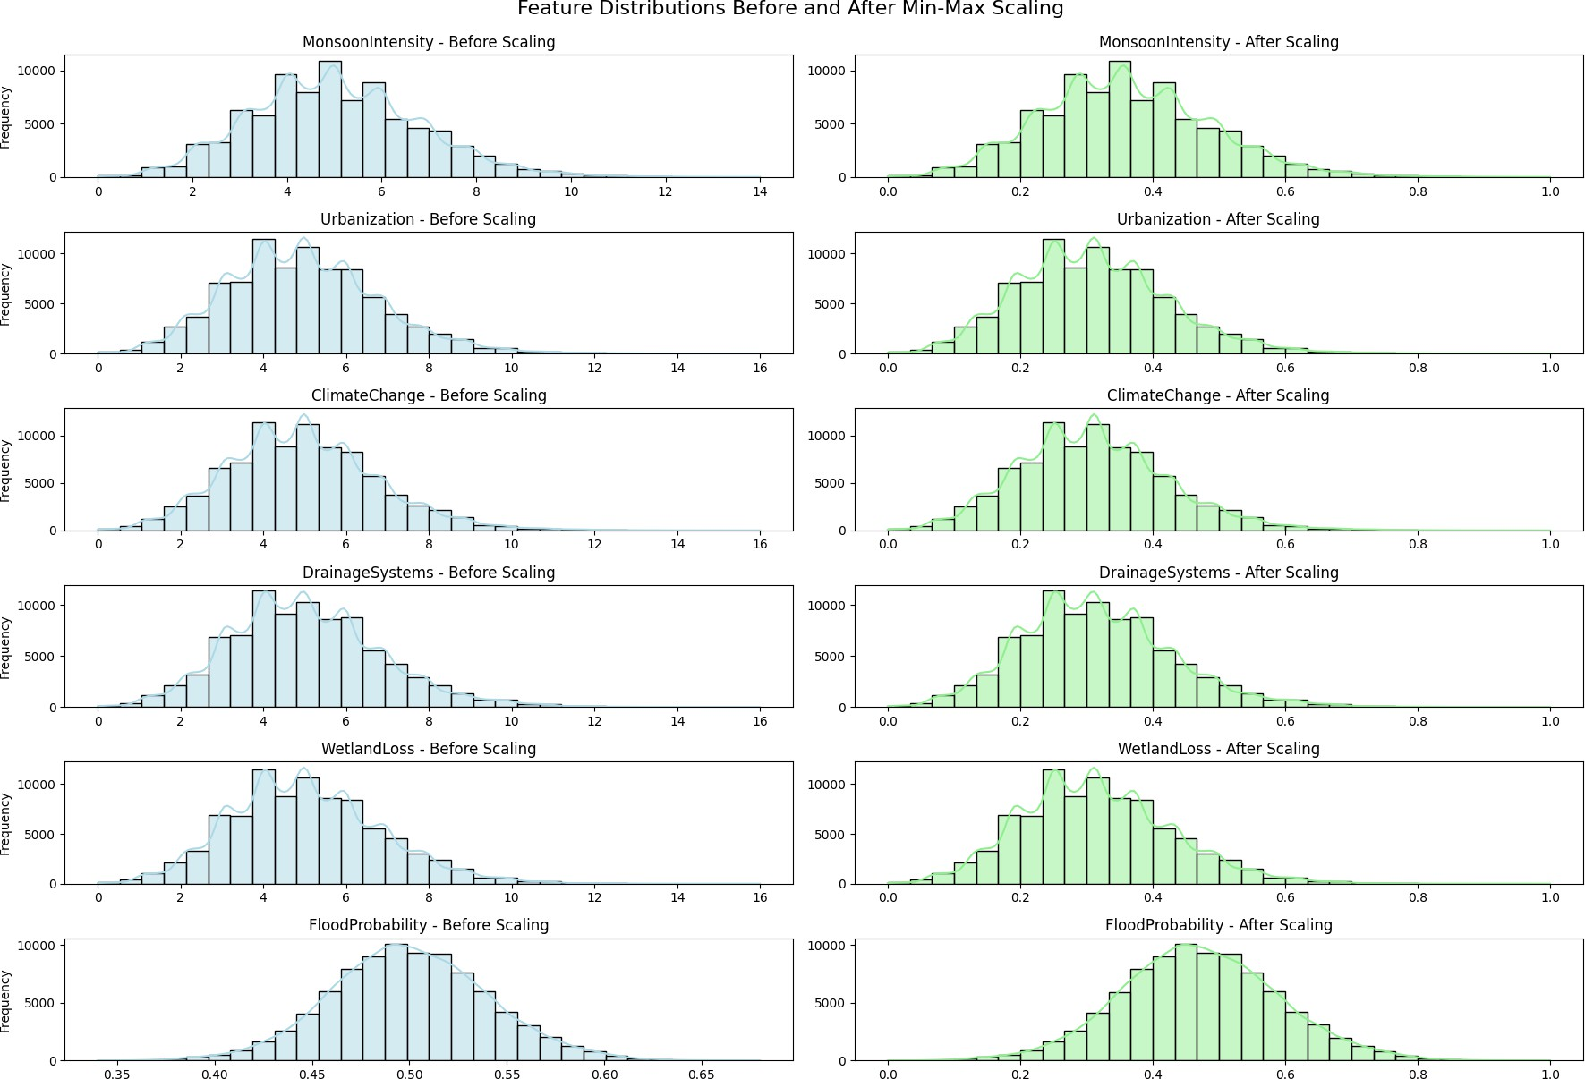
Fig. 4. Feature Distribution for Before and After Min-Max Scaling

To examine feature relationships with FloodProbability, a Pearson correlation heatmap was generated. Before outlier

deletion, the correlations did not look right due to extreme values. After outliers were deleted, the feature relationships on the heatmap looked clearer and more trustworthy as shown in Fig. 5.
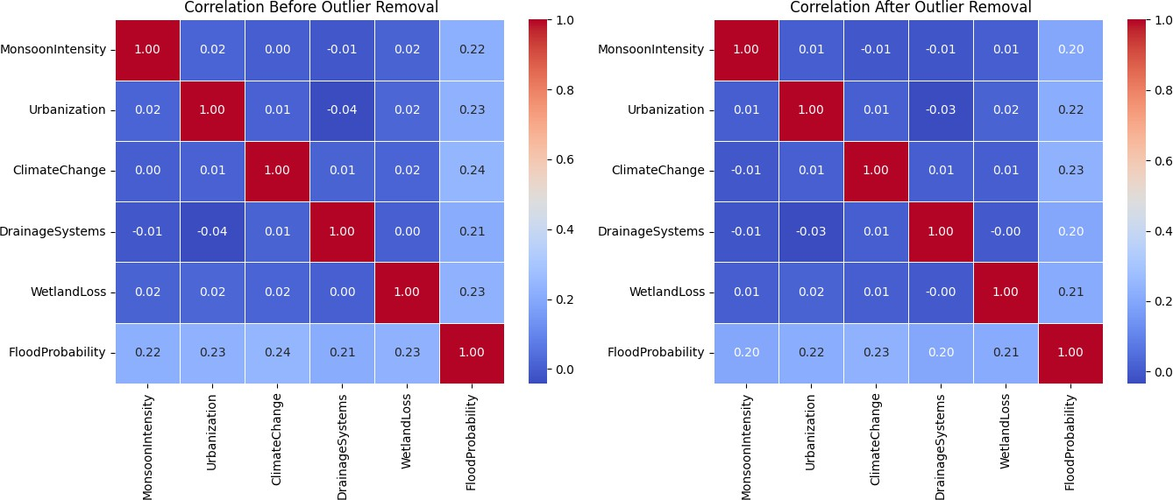

Fig. 5. Correlation Heatmaps for before and after outlier removal

Food Label: The time series plot displays Flood Proba- bility variations over time, differentiated by flood labels (0
= No Flood, 1 = Flood) as shown in Fig. 6.
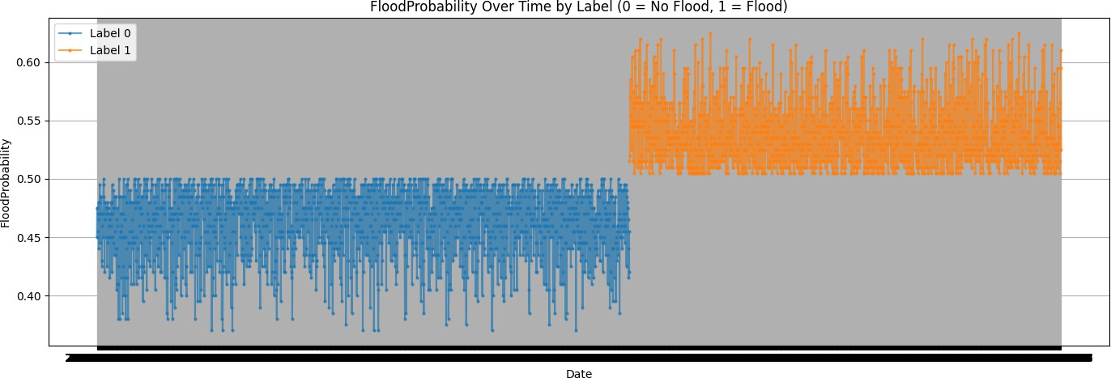

Fig. 6. FloodProbability Over Time Label

- Model design and implementation
Five models (Random Forest, XGBoost, CNN, LSTM, and GRU) were trained on the same features (Urbanization, Climate Change, and Dams Quality) using an 80:20 train/test split [1]. Random Forest used default hyperparameters, with accuracy and a confusion matrix for evaluation [2]. XGBoost was set up with use_label_encoder=False and eval_metric=’logloss’ and was evaluated using accuracy, R², RMSE, and MAE [3].
For the deep learning models, the inputs were Min–Max normalized and reshaped to 3-D. Both LSTM and GRU used
64 units, dropout to help reduce overfitting, and binary- cross-entropy loss with early stop [4]. The CNN used a combination of 1-D convolution, max pooling, dropout, flatten, and dense layers, and trained with binary cross- entropy . All deep models were evaluated using accuracy, R², RMSE, MAE, and visual comparison of predicted vs actual values, with the GRU performing the best overall [5].
- Best Model
Considering this analysis of all the models were em- ployed, the architecture of the Gated Recurrent Unit (GRU) model to represent the greatest performance. The GRU model yielded an accuracy of 99.63%, R² of 0.8986, RMSE
= 0.1555, and MAE = 0.0820 on the test set. The GRU model demonstrated it could accurately retrieve temporal patterns and had a smaller computational expense making it easily interactable into a real-time flood prediction system.
- Performance Metrics
Accuracy (2): The model has 99.63% of correctly predicted instances of flood occurrence.
$Accuracy=\frac{TP+TN}{TP+TN+FP+FN}$ (2)

R-Squared (R²) Score (3): The model explains 89.86% of the variance in flood level.

$R^{2}=1-\frac{\sum_{i=1}^{n}{{\left(y_{i-{\hat{y}}_{i}}\right)}^{2}}}{\sum_{i=1}^{n}{{\left(y_{i-\overline{y}}\right)}^{2}}}$ (3)

Root Mean Squared Error (RMSE) (4): The RMSE predictive error means the predictions were close to the actual values, at 0.1555.

$RMSE=\sqrt{\frac{1}{n}\sum_{i=1}^{n}{{\left(y_{i}-{\hat{y}}_{i}\right)}^{2}}}$ (4)

Mean Absolute Error (MAE) (5): The MAE represents a mean absolute difference of 0.0820 between the predicted and actual flood level.
$MAE=\frac{1}{n}\sum_{i=1}^{n}{|y_{i}-{\hat{y}}_{i}|}$ (5)

- RESULTS
- Dataset Description
A comprehensive flood prediction model was formed by combining multiple open-access datasets across climate, hydrology, land cover, and the socio-environment, and sub- sequently using modelling techniques to state explicit esti- mates about the probability of flooding in the study sites. This included climate data (rainfall and temperature from NASA’s POWER project), hydrology data (moisture from SMAP satellite observations), land cover data (surface char- acteristics influencing runoff and infiltration from MODIS land cover classifications), and socio-environment data (ur- banization and deforestation, plus drainage and drainage quality). Furthermore, ground-level socio-environment indi- cators were included (urbanization, deforestation, drainage and drainage quality), to enrich the underlying data structure. The binary flood label (flood = 1, no flood = 0) based on validated historical records. All of the datasets described are summarised in Table I.

TABLE I
Dataset Description

Source | Type | Features Used | Frequency
NASA POWER | Climate (rainfall, temp) | Rainfall, Temperature | Daily
SMAP | Hydrological | Soil Moisture | Daily
MODIS | Land Cover | Vegetation Type, Urban Cover | Yearly
Socio-Environmental | Infrastructure, Human Factors | 20+ indicators (e.g., Urbanization, Deforestation) | Annual
Flood Label | Target | Binary label (Flood=1, No Flood=0) | Daily

- Model Performance Overview
Five models were created and tested: Random Forest, XGBoost, CNN, LSTM, and GRU. In Table II, the deep learning approaches (CNN, LSTM, GRU) consistently out- performed the classical machine learning models. In this

table, the new GRU model achieves better accuracy and more generalization. It can be concluded that the GRU is an effective model.

TABLE II
Model’s Performance Comparison

Model | Accuracy (%) | R2 Score | RMSE | MAE | source
Random Forest | 85.62 | 0.4267 | 0.3696 | 0.3380 | proposed work
XGBoost | 88.08 | 0.6465 | 0.2902 | 0.1524 | proposed work
LSTM | 98.49 | 0.8677 | 0.1776 | 0.1061 | proposed work
CNN | 98.49 | 0.9301 | 0.1291 | 0.0568 | proposed work
GRU | 99.63 | 0.8986 | 0.1555 | 0.0820 | proposed work
Neural-XGBoost | 94.8 | - | - | - | Saleem et al [6]
CNN-LSTM Hybrid | 99.0 | - | - | - | Jia et al [1]
CNN-RNN+Neural ODE | 98.7 | 0.88 | 0.16 | 0.09 | Alkaabi et al [10]
ResU-Net | 99.2 | - | - | - | Noh and Ahn [8]

The GRU model outperformed all the evaluation metrics and was deemed the best model in this research for flood prediction. The GRU achieved an outstanding accuracy of 99.63%, R² score of 0.8986, RMSE of 0.1555, and MAE of 0.0820 which illustrated great generalization ability and low prediction error. The graphical comparison of the per- formance of the models is shown in Fig. 7. Fig. 7 displays the Accuracy, R² Score,RMSE, MAE of each model and demonstrates the GRU’s superior predictive ability.
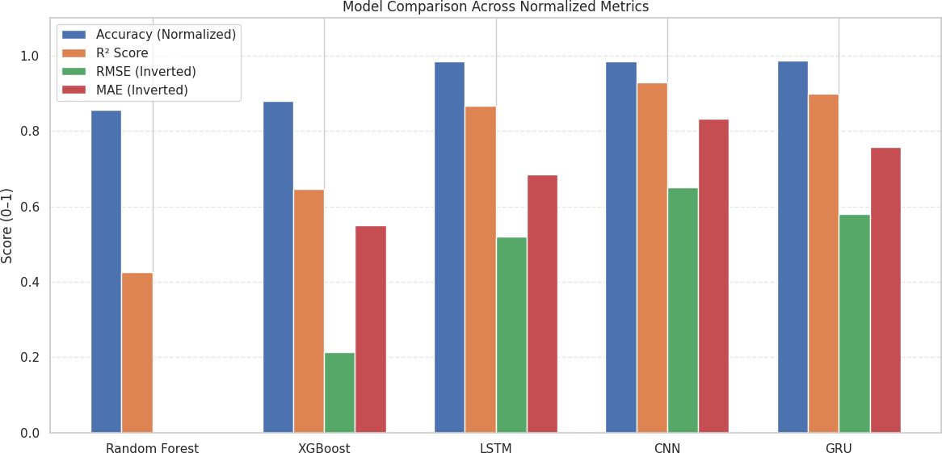
Fig. 7. Accuracy of all models

For the GRU model, Fig. 8 shows the actual (as mea- sured) and predicted flood labels for the training and testing datasets. The actual and predicted values further substantiate that the GRU model produced high forecasting accuracy and generalization ability across the datasets.
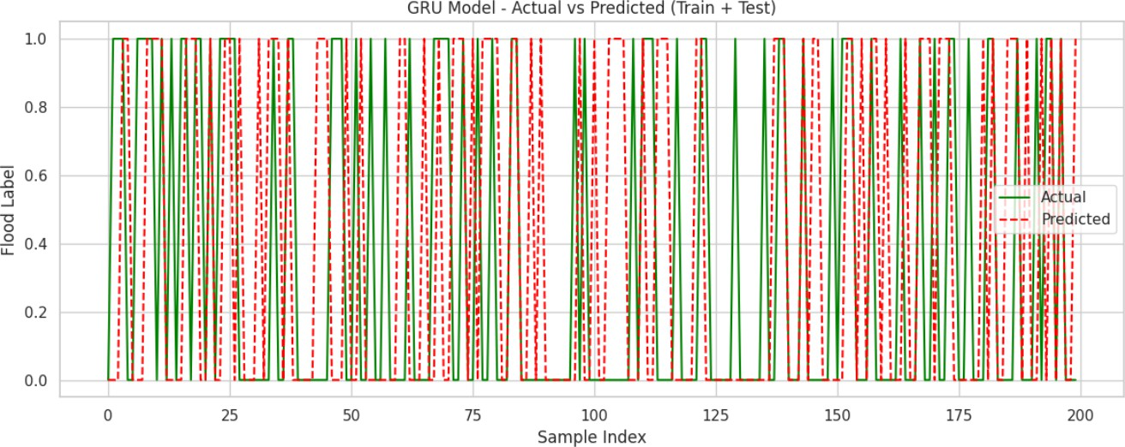

Fig. 8. GRU Model- Actual vs Predicted

- DISCUSSION AND ENHANCEMENTS
- Model Architecture and Optimization
Even though the GRU model provided strong perfor- mance, it was limited by using a single layer with simple dropout. Future improvements will look at new architectures such as Conv-GRU or Bi-GRU to help model important spatial and bi-directional temporal features. Moreover, at- tention layers will be added to the model to assist the model
in selecting the most important time steps. Hyperparameter tuning techniques such as Grid Search or Optuna, will also be used to set hyperparameters for the model.
- Multi-Class Classification
The proposed model only utilizes binary flood labels, which limits real world application. Future work will take a multi-class approach by providing severe differences of flood severity such as low, moderate, and high risk by depth and/or rainfall threshold. This will entail changing output layers and loss functions to be able to handle multiple classes, and apply many more meaningful and actional able predictions regarding flooding.
- External Validation
Model validation was only satisfied with internal splits of developing data, which could hinder generalization. The ex- ternal datasets STURM-Flood and Flood Net could provide a more transferable, reliable, evaluation test as well as look at other study regions. Future work will include k-fold cross- validation validation, to validate model results in support of model robustness using mixed data distributions in order to deliver consistent results.
- Real-Time Integrated and Explainability
Currently, the system uses historical datasets, so the apps don’t react fast enough.Future versions are projected to integrate live data streams from various modalities, including IoT sensors, satellite imagery, and weather APIs. The next iteration of the product will also include components like SHAP and LIME which will surface the influences of each variable on the observed outcome. Finally, it must also help provide justification for improved real time decisions in the disaster response context.
- Comparative study with Current Systems
Comparative study to assess current systems state-of- the-art flood forecasting methods, such as Neural-XGboost
[6] and CNN-LSTM [1]. The Proposed GRU framework provides 99.63% accuracy and the lowest RMSE/MAE, substantially exceeding the baseline; and it also generalizes better than other methods across multiple areas.
- Conclusion
The paper provides an effective, scalable deep learning framework for flood prediction which makes use of heteroge- neous data available through various sources - rainfall, tem- perature, soil moisture, land cover, and socio-environmental factors. After preprocessing (temporal aligning, interpola- tion, and Min-Max normalization), consistency was ensured and reliable across spatial and temporal domains. A wide variety of modeling techniques were researched, including both traditional machine learning models and advanced deep learning models including CNN, LSTM, and GRU.
Of the models tested, the GRU model provided the best overall results (accuracy 99.63%; R-squared score 0.8986; RMSE 0.1555; MAE 0.0820). These results demonstrate the efficacy of the GRU model as it captures the temporal dependencies and complexities of the hydrology that deter- mines flood behaviour. The model also demonstrated strong

generalisation across geographic and climatic conditions, offering a viable option for an operational flood prediction system.
In future research, by overcoming the limitations outlined above, and implementing the upgrades proposed, the next iteration of the flood forecasting system will be better quality, can be interpreted, generalised, and real-time. These modifications will be the first step of the operationalisation of this system for early warning, climate adaptation, and disaster risk reduction. A brief comparison with state-of- the-art flood-prediction models like CNN-LSTM and hybrid XGBoost baselines demonstrates that the GRU framework propose in this paper achieves consistently higher accuracy and lower RMSE values, establishing it as the best option for operational purposes. Globally, findings generated from this paper augment existing know-how and supply valuable data that will aid future concept formation that will progress towards sustainable and scalable models for forecasting flood flows.
References
- Jia, W., Liang, B., Lu, Y., Khan, M. A., & Zheng, L. (2025). A
Comprehensive Survey on Deep Learning Solutions for 3D Flood Mapping. In Pacific-Asia Conference on Knowledge Discovery and Data Mining (pp. 21-38). Springer, Singapore.
- Atashi, V., & Gorji, H. T. (2025). Enhanced flood prediction using LSTM and climate parameters: multi-station analysis of snowmelt- induced flooding in the Red River of the North. Journal of Hydroin- formatics, 27(2), 245-260.
- Yang, P., Xu, X., Shao, M., & Liu, Y. (2025). Intelligent Prediction of Flood Disaster Risk Levels Based on Knowledge Graph and Graph Neural Networks. IEEE Access.
- Prihatmanto, A. S., Prasetyadi, A., Yoganingrum, A., Sutriadi, R., & Hadiana, A. (2025). The Digital Twin City in Enhancing Flood Evacuation Systems: Future Opportunities and Challenges. IEEE Access.
- Lim, S. J., Sankaran, K. S., & Haldorai, A. (2025). A Framework for Flood Disaster Detection from Remote Sensing Images Using Spatiotemporal Fusion with Digital Twin Technology. IEEE Journal of Selected Topics in Applied Earth Observations and Remote Sensing, 18, 11547-11560.
- Saleem, M. A., Javeed, A., Benjapolakul, W., Srisiri, W., Chaitusaney, S., & Kaewplung, P. (2025). Neural-XGBoost: A Hybrid Approach for Disaster Prediction and Management Using Machine Learning. IEEE Access.
- Wang, S., & Xu, O. (2025). High perplexity mountain flood level forecasting in small watersheds based on compound Long Short-Term Memory model and multimodal short disaster-causing factors. IEEE Access.
- Noh, G. H., & Ahn, K. H. (2025). Enhancing multiple precipitation data integration across a large-scale area: a deep learning ResU-Net framework without interpolation. IEEE Transactions on Geoscience and Remote Sensing.
- Notarangelo, N., Wirion, C., & van Winsen, F. (2025). STURM- Flood: a curated dataset for deep learning-based flood extent mapping leveraging Sentinel-1 and Sentinel-2 imagery. Big Earth Data, 1-27.
- Alkaabi, K., Sarfraz, U., & Al Darmaki, S. (2025). A Deep Learning Framework for Flash-Flood-Runoff Prediction: Integrating CNN-RNN with Neural Ordinary Differential Equations (ODEs). Water, 17(9), 1283.
- Farooq, M. S., Tehseen, R., Qureshi, J. N., Omer, U., Yaqoob, R., Tanweer, H. A., & Atal, Z. (2023). FFM: Flood forecasting model using federated learning. IEEE Access, 11, 24472-24483.
- Puttinaovarat, S., & Horkaew, P. (2020). Flood forecasting system based on integrated big and crowdsource data by using machine learning techniques. IEEE Access, 8, 5885-5905.
- Wu, Z., Zhou, Y., & Wang, H. (2020). Real-time prediction of the water accumulation process of urban stormy accumulation points based on deep learning. IEEE access, 8, 151938-151951.
- Liu, Y., Wang, L., Du, S., Zhao, L., & Liu, X. (2022). Flood forecasting method based on improved VMD-FOS-QR-RBL. IEEE Access, 11, 4207-4218.
- Khan, T. A., Alam, M. M., Shahid, Z., & Su’Ud, M. M. (2020).
Investigation of flash floods on early basis: A factual comprehensive review. IEEE Access, 8, 19364-19380.
- Dong, W., Huang, H., Zhong, M., Wang, H., & Hua, F. (2024). Monitoring and early warning mechanism of flood invasion into subway tunnels based on the experimental study of flooding patterns. Journal of Intelligent Construction, 2(2), 1-16.
- PRASAD, R., RAJ, N., & ABDULLA, S. Designing Deep-Based Learning Flood Forecast Model with ConvLSTM Hybrid Algorithm.
- Krullikowski, C., Chow, C., Wieland, M., Martinis, S., Bauer- Marschallinger, B., Roth, F., ... & Salamon, P. (2023). Estimating ensemble likelihoods for the Sentinel-1-based global flood monitoring product of the copernicus emergency management service. IEEE Journal of Selected Topics in Applied Earth Observations and Remote Sensing, 16, 6917-6930.
- Zhao, J., Li, Y., Matgen, P., Pelich, R., Hostache, R., Wagner, W., & Chini, M. (2022). Urban-aware u-net for large-scale urban flood mapping using multitemporal sentinel-1 intensity and interferometric coherence. IEEE Transactions on Geoscience and Remote Sensing, 60, 1-21.
- Li, Z., Chen, Z., Chen, L., Tang, X., & Chen, N. (2025). SRFNet:
Multi-modal based Selective Receptive Field Neural Network for Time Series Forecast of Flood Range. IEEE Journal of Selected Topics in Applied Earth Observations and Remote Sensing.
- Aatif, K., Fahiem, M. A., & Tahir, F. (2024). Forecasting Floods Using Deep Learning Models: A Longitudinal Case Study of Chenab River, Pakistan. IEEE Access.

