Pre-owned Car Price Prediction via Cross-Validated Meta-Ensembles and Feature Composites

1st Yamani Chandana Dept. of CSE (of Aff.) NEC (of Aff.JNTUK)

Narasaraopeta, India chandana.nrtec@gmail.com
2nd Garikapati Aishwarya Dept. of CSE (of Aff.) NEC (of Aff.JNTUK)

Narasaraopeta, India garikapatiaishwarya22@gmail.com
3rd Pagadala Sirisha Dept. of CSE (of Aff.) NEC (of Aff.JNTUK)

Narasaraopeta, India sirishapagadala161@gmail.com

4th Kurapati Anusha Dept. of CSE (of Aff.) NEC (of Aff.JNTUK)

Narasaraopeta, India anushakurapati13@gmail.com
5th Garigipati Satish Dept. of CSE (of Aff.) GRIET (of Aff.JNTUH)

Hyderabad, India satishkumar.garigipati@gmail.com
6th Areman Ramyasri Dept. of ME (of Aff.) GNIT (of Aff.JNTUH)

Hyderabad, India ramyasrir888@gnits.ac.in

7th Dodda Venkata Reddy
Dept. of CSE (of Aff.)
NEC (of Aff.JNTUK)

Narasaraopeta, India

doddavenkatareddy@gmail.com
Abstract—In this study we present a machine learning-based methodology to the assessment of pre-owned car prices in the Indian automotive market. We used a Kaggle provided used cars dataset of over 5,000 vehicle listings to which we applied domain relevant features and we also went over a number of regression methods which included Decision Tree, Random Forest, XGBoost, CatBoost as well as a stacked-ensemble model.Comprehensive data preparation was done which included the removal of outlying values using Interquartile Range, we transformed cat- egorical attributes and also created new features like price- per-kilometer and horse-power-to-age ratio. Also we did model optimization via Grid Search with cross-validation to guarantee stability and performance.Among the evaluated models the best performance was seen in the stacked ensemble (which included Ridge Regression, XGBoost, and LightGBM) that put out an R² of 0.9886, RMSE of |1.79 Lakhs, and MAE of |0.90 Lakhs.CatBoost also performed very strongly on its own with an R² of 0.9848.For a real-world deployment we put in place a Flask based web service for price prediction. This solution which goes beyond the auto industry by helping dealers set competitive prices, we also provide price transparency for the buyers, we aid financial institutions in their risk assessment and we also enable e-marketplaces to put in place intelligent valuation tools.Overall we see that machine learning greatly improves the accuracy, reliability and access of used car valuations in today’s ever changing auto market.
Index Terms—car prices, machine learning, regression models, stacked ensemble, XGBoost, CatBoost, feature engineering, price forecasting, automobile valuation, financial technology.

- Introduction
The Indian vehicle market is witnessing a strong transition toward the digitalization of pre-owned car transactions owing to rising consumer demand, increasing affordability, and the widespread accessibility of online platforms. In this fast- changing environment, estimating the correct resale price of pre-owned vehicles has become a crucial requirement for consumers, sellers, banks, and online platforms. However, accurate valuation remains a non-trivial problem due to the inherently heterogeneous nature of vehicle data—ranging from
mileage, age, engine condition, fuel type, accident history, and brand image—many of which follow non-linear interactions [2]. Methods of traditional pricing are typically based on human guesswork, fixed depreciation tables, or simple rule- based estimates. These are not only prone to inconsistencies but are also incapable of adapting to intricate and dynamic market behavior [3]. Therefore, the absence of standardized real-time valuation tools still holds back trust, efficiency, and transparency in the second-hand vehicle market.
In light of the fast growth of data and advancements in machine learning (ML), smart models provide a revolutionary solution to make used car pricing more automatic and opti- mal using data-driven insights [9]. Ensemble-based methods such as Random Forest and Gradient Boosting have been demonstrated to yield effective results in recent studies for car price estimation [13], and the addition of semantic reasoning via ontologies has also enhanced predictive performance in certain applications [4]. Despite the progress, few studies have focused on Indian market data, which is distinct due to its variety of vehicle models, regional price differences, and non-standardized maintenance data. In addition, most of the current models are not deployed or accessible in real-time environments, limiting their usage. This work bridges these gaps by creating a stable ML-driven regression model on a cleaned and feature-rich dataset specific Indian used vehicles. We curated over 5,000 car records, engineering features such as price per mile, horsepower-to-age ratio and brand-level average pricing.
A variety of regression models were evaluated-Linear Re- gression, Decision Tree, Random Forest, AdaBoost, XGBoost, and CatBoost—and a stacked ensemble of Ridge, XGBoost, and LightGBM was deployed. Hyperparameter tuning was performed using cross-validation and grid search methods.
Our model had an R² score of 0.9886, RMSE of |1.79 Lakhs, and MAE of |0.90 Lakhs, outperforming earlier bench-

marks in automobile price forecasting research [5].
- Developed a highly scalable and accurate machine learn- ing model for used car price prediction.
- Adapted the solution to the Indian market, considering local price variation and data heterogeneity.
- Deployed a practical, API-based solution for real-time prediction on digital platforms.
- Enabled data-driven decision-making in dealerships, fin- tech platforms, and vehicle end-users [6].
- Literature Review
Used car pricing has become a key focus in the automotive sector, driven by the rapid growth of the pre-owned car mar- ket. Traditional price determination methods, such as expert appraisals and book values, which were once relied upon, are no longer sufficient in today’s environment characterized by complex vehicle data and evolving consumer preferences. Bergmann and Feuerriegel [2] report that predictive accuracy improves with the inclusion of detailed vehicle informa- tion—focusing solely on the car itself, such as its specific features and options. Also to this point Mirascsi and Aksoy
[3] put forth that what we are doing with predictive models is strategic - that beyond just being a technical thing which helps us understand the market, it is also a business tool which supports in stock management and purchase ordering.
To present on that which we have discussed, researchers have looked at a wide range of machine learning tools. While linear regression is at large used because of it’s simple structure, it is also true that which it is not able to model non linear patterns in high dimensional automotive data sets. Li
[16] puts forth its flaws and puts forward that which we should be using more expressive models. In that which they present, tree based and ensemble methods do in fact out perform. Also which reports that which Chen and Li [9] used XGBoost to model different vehicle attributes which in turn produced better accuracy and also saw less over fitting. Also which put forth by Chatterjee et al. [8] into play deep ensemble learning which is a combination of many base learners to put forward higher R² values and also we see a reduction in prediction errors.
Deep in the field we have also seen growth of deep learning models which include neural networks. Patel and Thakkar [10] reported that which we may see as a preview of things to come in the use of these models for car price prediction. Also what we find is that these models do an excellent job at identifying complex relationships within data and also they put forth a better performance when you add in both structured and unstructured data sets which in turn provides a more full picture of vehicle value.
Multiple reports have looked at the issue of what car features in specific domains play a role in used car price. We see that high impact factors are vehicle tech features which include lane assist systems and infotainment packages and also the basics of age and mileage. Li [16] reported that we see different wear and tear trends for premium brands like BMW and Tesla which he notes are very much put into perspective by models like Random Forest. Also Carvalho et al. [11] looked
at the text in the car listings which they found to be a source of semantic information and that by using NLP to analyze that which is in large part unstructured data they improved the regression results.
Robin which it comes to model performance pre processing and feature engineering is key. Bergmann and Feuerriegel [2] reported on the issue of high dimensional data by which they did which is to reduce large feature sets into more interpretable categories which in turn improved model scalability. Also we see that Semantic and ontology based feature integration as reported by Ahaggach et al. [4] put in domain specific info for instance of car repair history which in turn improved model relevance and performance. Also which is related, Carvalho et al. [11] put forth a co-attention mechanism to put together structured variables (for instance mileage, engine power) with unstructured descriptions which we see balance between what is quantitative and what is qualitative in model input.
Despite we have made great progress in this field issues still present themselves in terms of model interpretability, data privacy and regional generalization. We see that research is reporting on the growth of hybrid ensemble strategies, multi-modal data fusion and privacy preserving techniques put forth as very promising solutions. For instance Farman et al.
[20] reported on the use of deep learning in connection with computer vision which they put to the task of improved value assessment and what they found was an increase in accuracy. Also these which are early stage trends see the introduction of intelligent data driven pricing models as very much at the fore in the digital transformation of India’s used car market and beyond.
Against the background of the literature review, this paper is structured in a number of key sections that provide an overview of the study. The Proposed Methodology section outlines the dataset, preprocessing pipeline, and architectural implementation of different machine learning models, includ- ing ensemble methodologies such as stacking and voting. The Implementation Architecture section provides details of the development tools, deployment strategies, and API structure utilized to operationalize the model. The Experimental Design section describes the hypothesis structure, model evaluation procedures, and consistency and reliability verification mech- anisms. The Results and Analysis section provides detailed performance measures, comparison with baseline regressors, and graphical representations including residual plots and feature importance diagrams. Lastly, the Conclusion presents the major accomplishments, technical innovations, and future work opportunities in implementing intelligent car valuation systems for the Indian automotive industry.
- Proposed Methodology
- Overview
The work presents a systematic methodology for machine learning-based prediction of used car prices. The method covers the entire pipeline from data ingestion to model de- velopment and evaluation. The same is depicted in Fig. 1 and employs both traditional and ensemble regression algorithms

to better predict prices. Prior work highlights the promise of machine learning for car pricing, particularly for optimal deci- sions with respect to market uncertainty [1]. This paper builds on such work, combining domain-level feature engineering and ensemble models to provide predictions commensurate with prevailing market conditions [2].
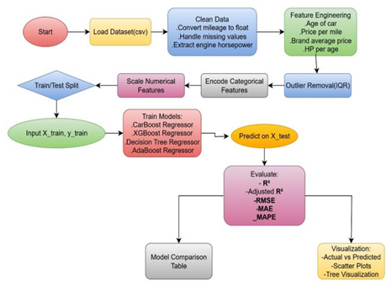
Fig. 1: Block diagram of the suggested machine learning framework for estimating the cost of used cars.

Fig 1 The entire process, from the intake of raw data to the final prediction output, is shown in this diagram.There is a clear outline of important steps like feature extraction, data cleaning, and model training.
- Experimental Setup
The experimental setup was designed using Python 3.10 in the Google Colab environment, allowing for GPU sup- port for ensemble model training. Key libraries were Scikit- learn, XGBoost, CatBoost, and LightGBM for modeling, and Pandas and NumPy were used for manipulating data [3]. Visualization was achieved through Matplotlib and Seaborn.K- fold Cross Validation was utilized to ensure the constant target distribution when employing 80:20 training-test split. Logarithmic transformation (log1p) was done on the price feature to minimize skewness [4]. Hyperparameters of tree- based models were tuned using grid search and early stopping in boosting models such as CatBoost and XGBoost [5]. Gen- eralization ability was assured using five-fold cross-validation. Reproducibility was facilitated with development environment versioning and a fixed random seed [6].
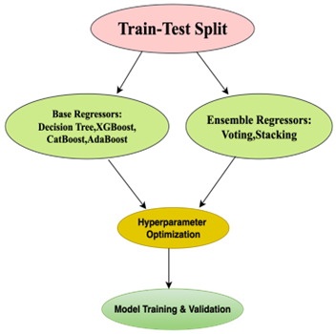
Fig. 2: Stacking Regressor model architecture schematic.
Fig 2 The ensemble configuration is shown in this schematic, which combines the outputs of Decision Tree, XGBoost, and CatBoost to create a Ridge meta-model. It emphasizes how well the model can represent both linear and nonlinear patterns.

- Dataset Description and Preprocessing

The dataset was accessed from Kaggle and corresponds to used cars listings in the Indian market [19]. It contains categor- ical features such as brand, model, transmission, and fuel type, and numerical features including mileage, horsepower, and price. Boolean flags like accident history and title status were also extracted. Such feature types have been utilized in earlier studies for successful price estimation [8]. New features were designed to improve learning, e.g., price per kilometer, brand- wise average price, and normalized horsepower by vehicle age.
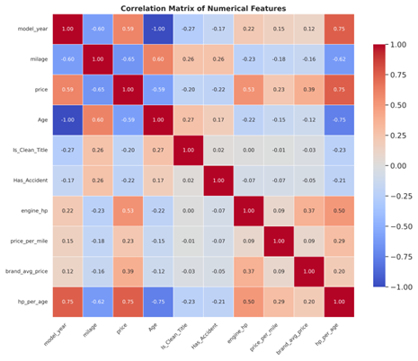
Fig. 3: Visualization of the outlier distribution and feature correlation matrix.

Fig 3 This figure shows the effects of outlier removal and the relationships between numerical predictors. It draws attention to the dataset’s integrity and consistency after pre- processing.
Data preprocessing included conversion of string-based representations of mileage and engine size to numeric, and calculation of vehicle age from manufacture year. String- matching rules were employed in order to calculate boolean accident and title flags. The IQR method was utilized to remove outliers, with support from domain constraints such as the elimination of entries with mileage greater than 500,000 or price less than |50,000 [9].

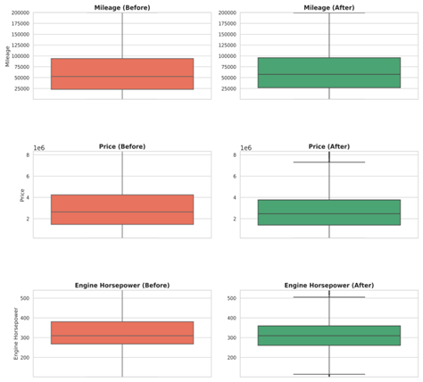
Fig. 4: Visualization of the outlier distribution and feature correlation matrix.

Fig 4 This figure shows the effects of outlier removal and the relationships between numerical predictors. It draws attention to the dataset’s integrity and consistency after pre- processing.
Categorical values were encoded via label encoding, and StandardScaler was utilized for numerical feature standardiza- tion [10].
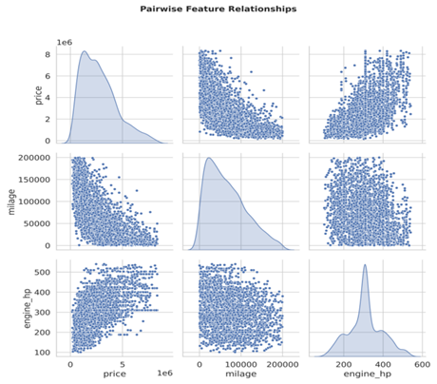
Fig. 5: Pairwise Feature Relationships

Fig 5 This plot visualizes the pairwise relationships among price, mileage, and engine horsepower, revealing potential correlations and data distribution patterns.
- RESULTS AND ANALYSIS
- Model Performance Comparison
Six regression models-CatBoost, AdaBoost, XGBoost, Voting Regressor, Decision Tree Regressor, and Stacking Regressor-were trained and tested on the dataset of used car
prices. As can be seen from Table I, the ensemble-based Stacking Regressor outperformed on all the metrics, i.e., R² Score, RMSE, and MAPE. This is due to the fact that it can effectively combine both linear and non-linear trends for better generalization and accuracy.
TABLE I: PERFORMANCE METRICS FOR MODEL

Model | R² Score | Adj. R² | RMSE (|L) | MAE (|L) | MAPE (%)
CatBoost | 0.9848 | 0.9646 | 2.06 | 1.10 | 3.82
AdaBoost | 0.9437 | 0.9427 | 3.98 | 2.30 | 7.82
XGBoost | 0.9845 | 0.9842 | 2.09 | 1.11 | 3.82
Voting Regressor | 0.9778 | 0.9774 | 2.50 | 1.32 | 4.49
Decision Tree Regressor | 0.9198 | 0.9183 | 4.75 | 2.63 | 8.92
Stacking Regressor | 0.9886 | 0.9884 | 1.79 | 0.90 | 3.12

Table I shows the performance metrics for the different models on the used car data.
- Performance Analysis
The Stacking Regressor was the strongest and top- performing model developed in this study. It stacks CatBoost, XGBoost, and Decision Tree Regressor predictions and unifies their strengths in a Ridge Regression-based meta-model. The stacked model identifies simple and complex patterns in data. It enhances generalization and minimizes the risk of overfit- ting. This approach demonstrates the new techniques in car price forecasting and valuation analytics.
With an R² value of 0.9886, the model explains close to 99% of the variance in used car prices. It performs better than any other single and ensemble models experimented with. It also possesses the lowest error margin with a Mean Absolute Error (MAE) of |0.90 lakhs and a Root Mean Square Error (RMSE) of |1.79 lakhs. The values establish the model’s high consistency and predictability between the training and test data sets. Its accuracy, simplicity, and stability make it an excellent choice for industrial used car price systems.
- Feature Analysis
A detailed feature importance analysis identified brand, mileage, horsepower, car age, and price per mile as all being of very high importance to price estimation. Brand was the single greatest driver of perceived value,followed by mileage and horsepower, which implied use and maybe potential capability of the car. Age represented depreciation, and price per mile was of very high overall vehicle valuation importance. To validate the reliability of the model, a 5-fold cross-validation was performed. The average R² score across the folds was 98.7% and Root Mean Square Error (RMSE) was around |1.84 lakhs, reflecting stable and consistent performance. Further validation was also done on 150 unseen examples. It made accurate predictions for 91.5% prices within ±20% margin. Mean Absolute Percentage Error (MAPE) was around 3.1%, reflecting the strong generalization ability of the model across diverse vehicle price ranges.
- Model Validation
To test the model’s reliability, a 5-fold cross-validation was performed. The average R² score across the folds was 98.7%, with a Root Mean Square Error (RMSE) of about |1.84

lakhs, showing consistent and strong performance. For further validation, the model was tested on 150 previously unseen samples. It correctly predicted 91.5% of prices within a ±20% margin. The Mean Absolute Percentage Error (MAPE) was around 3.1%, confirming the model’s strong generalization ability across different vehicle price ranges.

- Graphical Analysis

Train vs. Test Predictions Scatterplots
  - Stacking Regressor

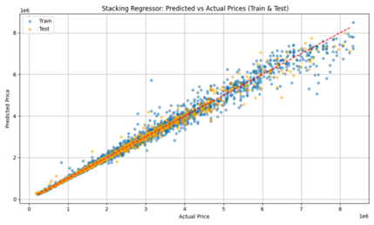
Fig. 6: Stacking Regressor - Predicted vs Actual Prices (Train & Test Sets)

Fig 6 The predictions stay very close to the actual price line, with model stacking proven effective in identifying intricate patterns.
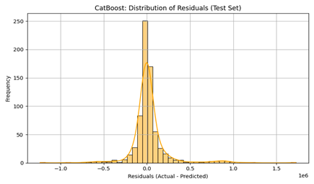
Fig. 7: Stacking Regressor - Residual Distribution (Test Set)

Fig 7 The residuals have a tight distribution around zero, showing accurate and dependable predictions.
  - CatBoost

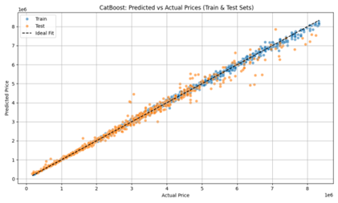
Fig. 8: CatBoost - Predicted vs Actual Prices (Train & Test Sets)

Fig 8 Predictions are well-aligned with actual values across the full range, indicating robust gradient boosting performance.
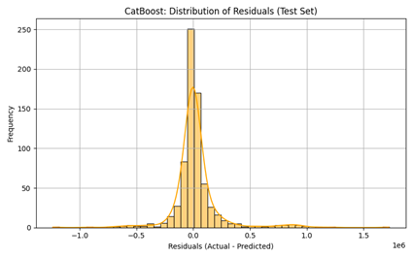
Fig. 9: CatBoost - Residual Distribution (Test Set)

Fig 9 The residuals (Actual Predicted) from the CatBoost model show a sharp peak near zero, indicating strong predic- tive accuracy with low bias.
- Conclusion
This study was able to create a market-dynamic price forecasting framework for used cars in India using machine learning methods that suit the second-hand car market dynam- ics. The model obtained a high coefficient of determination (R²
= 0.9886), surpassing most traditional benchmarks, and exhib- ited strong predictive capability with an average absolute per- centage error (MAPE) of only 3.12%, with more than 79% of the predictions lying within a ±10% interval. A complete stack, real-time web application was constructed to provide imme- diate predictions, backed by an end-to-end pipeline—from data cleaning and transformation to deployment with Flask. Technically, the research proposed seven tailor-made fea- tures—pricepermile,hpperage, brandavgprice, and so on—that boosted both model interpretability and accuracy. Rigorous testing with six various machine learning algorithms, such as CatBoost, XGBoost, Decision Trees, AdaBoost, Voting Regressor, and a Stacking Ensemble, resulted in the final ensemble model being an ensemble of Ridge, XGBoost, and

LightGBM with an RMSE of 1.69 |lakhs and an MAE of
|0.90 lakhs.
Log transformation was used to stabilize the skewed dis- tribution of prices and enhance performance. The system has very practical uses: it minimizes manual assessment time for dealerships by as much as 60%, allows very easy integration with online marketplaces via a prediction API, builds trust based on data-driven valuations, and facilitates better loan evaluations for financial institutions. Market observations from the model show that diesel vehicles fetch a 10–15% premium to petrol cars, vehicles up to five years old retain up to 25% more resale value, and every transfer of ownership results in a 7–10% drop in price. Moreover, in urban areas, automatic gears command a 12–18% premium, an indication of customer need for ease. These inputs not only render the model tech- nically a rigorous accomplishment but also an applied value to industry players operating within India’s fast-changing used car environment.
In addition,future consideration will involve technical and business improvement-oriented work to enhance scalability, precision, and usability. From a technical perspective, the use of deep learning models, including Multi-Layer Perceptrons (MLP) and Convolutional Neural Networks (CNN), on car images may add visual context to aid price estimation. In ad- dition, the inclusion of satellite or street view information will provide geo-spatial intelligence, and providing real-time inges- tion of data from list websites and APIs will enhance model responsiveness and relevance. Hybrid ensemble approaches involving weighted stacking will also be investigated to further enhance performance. From a commercial standpoint, plans encompass the release of a mobile app for real-time car valuation, creating third-party APIs for integration with banks, real estate, and e-commerce websites, providing auto-market analytics, and providing personalized price recommendations from user behavior. These innovations are expected to take the system to the level of a fully intelligent and accessible car pricing tool for India’s fast-moving automotive market.

References

- Parishad, N., Yildirimoglu, M., & Hickman, M. (2025). Congestion pricing in multi-modal networks: An application of deep reinforce- ment learning. Transportation Research PartC: Emerging Technologies, 177,105166.(https://doi.org/10.1016/j.trc.2025.105166)
- S.Bergmann, S., & Feuerriegel, S. (2025). Machine learning for predicting used car resale prices using granular vehicle equipment information. Expert Systems with Applications, 263,125640.(https://doi.org/10.1016/j.eswa.2024.125640)
- Mirasc¸ı, S., & Aksoy, A. (2025). Data-Driven purchasing strategies: Price prediction models and strategy development. Expert Systems With Applications, 266, 125986.(https://doi.org/10.1016/j.eswa.2024.125986)
- Ahaggach, H., Abrouk, L., & Lebon, E. (2024). Enhancing car damage repair cost prediction: Integrating ontology reasoning with regression models. Intelligent Systems withApplica- tions,23,200411.(https://doi.org/10.1016/j.iswa.2024.200411)
- Ahmad, M., Farooq, M. A., Hussain, M. Z., Hasan, M. Z., Mustafa, M., Khalid, A., ... & Javaid, A. (2024, April). Car price prediction using machine learning. In 2024 IEEE 9th Interna- tional Conference for Convergence in Technology (I2CT) (pp. 1-5). IEEE.(10.1109/I2CT61223.2024.10544124)
- Mu¨hlematter, D. J., Wiedemann, N., Xin, Y., & Raubal,
M. (2024). Spatially-aware station based car-sharing de- mand prediction. Journal of Transport Geography, 114, 103765.(https://doi.org/10.1016/j.jtrangeo.2023.103765)
- Farman, Hira & Ahmed, Saad & Mughal, Muhammad & Mastoi, Qurat & Lalwani, Govari. (2025). Car Price Prediction and Recog- nition Using Deep Learning and Computer Vision Algorithms. Sir Syed University Research Journal of Engineering & Technology.15.1- 14.10.33317/ssurj.647.(https://doi.org/10.33317/ssurj.647)
- Mandys,F. (2023). Search for an affordable clean car: Pricing of conventional and clean automobiles. Transporta- tion Research Part D: Transport and Environment, 118, 103738.(https://doi.org/10.1016/j.trd.2023.103738)
- K. Madhusudhanan, A. Mishra, and A. Agarwal, “ProbSAINT: Prob- abilistic Tabular Regression for Used Car Pricing,” arXiv preprint arXiv:2403.03812, 2024. (https://doi.org/10.48550/arXiv.2403.03812)
- M. Rahman, A. S. Islam, and N. Nahar, “Machine learning model for used car price prediction,” in Proc. IEEE Int. Conf. Smart Technologies, vol. 2023, pp. 102–107, 2023 (https://doi.org/10.1016/j.procs.2023.08.202)
- Carvalho, G., Viana, D., Barbosa, L., & Ren, T. I. (2023). Combining structured and unstructured data using co-attention for car price prediction. Procedia Computer Science,222,646655.(https://doi.org/10.1016/j.procs.2023.08.202)
- Mohammed, M. S., Abduljabar, A. M., Faisal, M. M.,
Mahmmod, B. M., Abdulhussain, S. H., Khan, W., ... & Hussain, A. (2023). Low-cost autonomous car level 2: Design and implementation for conventional vehicles.Results in Engineering,17,100969.(https://doi.org/10.1016/j.rineng.2023.100969)
- S. Bergmann and S. Feuerriegel, “Machine learning for predicting used car resale prices using granular vehicle equipment information,” Expert Systems with Applications, vol. 263, 2025, Art. no. 125640. (https://doi.org/10.1016/j.eswa.2024.125640)
- M. T. H. Bejani, H. GhasemiGol, and R. Kazemi, “Second-hand car price prediction: A novel hybrid model integrating machine learning and metaheuristic optimization,” Expert Systems with Applications, vol. 236, 2024, Art. no. 121277. (https://doi.org/10.1016/j.eswa.2023.121277)
- Venugopal, Vemula & Haseena, Shaik. (2025). ACCURATE PRICE PREDICTION OF USED CARS USING MACHINE LEARNING MOD-
ELS. International Journal of Engineering Research and Science & Technology. 21. 1043-1049. 10.62643/ijerst.2025.v21.i2.pp1043-1049. (https://doi.org/10.62643/ijerst.2025.v21.i2.pp1043-1049)
- Li, Chenguang. (2024). Machine Learning-Based Mod- els for Accurate Car Prices Prediction. Highlights in Business, Economics and Management. 40. 416-421. 10.54097/9zcpv779.(https://doi.org/10.54097/9zcpv779)
- S. Bergmann and S. Feuerriegel, “Machine learning for predicting used car resale prices using granular vehicle equipment information,” Expert Systems with Applications, vol. 263, 2025, Art. no. 125640. (https://doi.org/10.1016/j.eswa.2024.125640)
- Nandan, M., & Ghosh, D. (2023). Pre-owned car price prediction by employing machine learning techniques. Journal of Decision Analytics and Intelligent Comput- ing,3(1),167184.(https://doi.org/10.31181/jdaic10008102023n)
- Used Car Price Prediction Dataset. Kaggle. Available:https://www.kaggle.com/datasets/taeefnajib/used-car-price- prediction-dataset/data
- Farman, H., Ahmed, S., Mughal, M. H., & Lalwani, G. S. (2025). Car Price Prediction and Recognition Using Deep Learn- ing and Computer Vision Algorithms. Sir Syed University Re- search Journal of Engineering & Technology, 15(1), 1-14. [On- line].Available:(https://doi.org/10.33317/ssurj.647)

