THYROID DISEASE PREDICTION USING MACHINE LEARNING
Dr.M. Sireesha¹, Ch. Poojitha², B. Vandana ³, Sadhya⁴
¹ Professor, ^{2, 3 & 4} Student
¹msireesha123@gmail.com, ² psrgchakkapoojitha@gmail.com, ³ vandana.bethala@gmail.com, ⁴ mallelasandhya123@gmail.com
Department of Computer Science and Engineering,
Narasaraopeta Engineering College, Narasaraopet, Andhra Pradesh, India

Abstract— Thyroid diseases, including conditions such as hypothyroidism, hyperthyroidism, and thyroid nodules, has a substantial effect on the health of thousands of people internationally. Early and accurate prediction of these thyroid disorders plays a crucial role in facilitating timely interventions and ultimately improving patient outcomes. Our research suggests a comprehensive approach that makes use of machine learning approaches for tackling this problem. For this we utilized a diverse dataset containing patient records, encompassing thyroid function tests, medical history, and demographic information, for training and validating our Machine Learning models. For this we use some algorithms for the prediction thyroid disease. Conclusively, our research underscores the application of machine learning significance inpredicting thyroid diseases, promising enhanced diagnostic accuracy and personalized healthcare strategies. After evaluating these approaches, it can be seen that decision trees exceed other models for forecasting thyroid disease, with a success rate of 99.83. These developments add to the dynamic integration of medical treatment, emphasizing the possibility for novel strategies for better patient results in the treatment of thyroid disease.

Keywords— Classification models like Random Forest Classification, KNN, Decision trees, Multi-Layer Perceptrons, Naive Bayes, and Logistical Regression.

I.INTRODUCTION

Thyroid problems affect people of every generation worldwide and represent a serious global health concern. As a vital component of the endocrine system, the thyroid gland serves as vital for controlling essential metabolic functions that are crucial for overall well-being. Any disruptions or irregularities in thyroid function can result in a range of health complications, from minor discomfort to severe medical conditions [1]. Timely identification and precise thyroid test disorders are required for successful therapy as well as oversight. Conventional diagnostic methods typically involve clinical evaluations and laboratory analyses, which are time-consuming and subjective in nature. However, the emergence of Machine Learning methodologies has transformed healthcare by providing robust tools to enhance diagnostic procedures [2]. Our primary goal is to develop a predictive model capable of identifying individuals who may be predisposed to thyroid disorders. By achieving this, we aim to facilitate early intervention and implement tailored healthcare plans.
This study involves a dataset that contains anonymized patient records collected while evaluating thyroid disorders. The dataset comprises a variety of features, including demographic information like age and gender, test results such as TSH, TT4, and FTI, as well as medical history and symptoms. To ensure accurate data analysis, our methodology includes several important steps for preprocessing the data and training predictive models [3]. We start by standardizing mathematical characteristics, addressing values that are absent, and encoding grouping elements. ensuring consistency and compatibility throughout the dataset. Additionally, we use specialized techniques to address class imbalance, a common issue in medical datasets, which helps reduce biases during model training. Each algorithm is trained using the preprocessed dataset and evaluated using cross-validation techniques to determine its performance and ability to generalize to unseen data [4].
Summarizing our research, we emphasize the important role of Machine Learning in bettering diagnostic abilities and ultimately improving patient outcomes in the prediction of thyroid disorders. Thyroid disease, a medical condition, affects the gland's ability to produce thyroid hormones. It is located in the neck. These hormones regulate energy usage, fetal development, and growth in children. There are five main types of thyroid disease: hypothyroidism, hyperthyroidism, goiter, benign and malignant tumors, and abnormal thyroid function tests without symptoms [5]. Weakness, weight gain, and cold sensitivity are some of the symptoms of hypothyroidism. Although structural abnormalities often do not cause symptoms, they can be linked to hyperthyroidism or hypothyroidism symptoms, as well as neck swelling. Before a diagnosis can be made, a complete medical history and physical examination are necessary. Blood tests that detect anti-thyroid autoantibodies may indicate autoimmune thyroid disease. In some cases, additional diagnostic tests, such as iodine scanning, tissue samples, or ultrasound, may be necessary, particularly if a tumor is suspected. Surgical intervention can be considered for cosmetic purposes or to remove nodules or reduce goiters if they impinge on surrounding structures after a comprehensive medical history and physical examination.

II.LITERATURE SURVEY

Choubey et al. [1] introduced an investigation into applying neural network techniques for forecasting thyroid disease. Here various machine learning algorithms employed for prediction. This adds to the expanding corpus of studies on the use of data science in healthcare, especially in the area of initial illness diagnosis and prediction.
Mario Luca Bernardi et al. [2] mainly focuses on predicting treatment outcomes curing thyroid conditions by utilizing automated learning methods. It describes the machine learning algorithms employed for treatment prediction, including combination techniques, neural networks, decision tree models, and assistance vector machine models. It may also discuss data preprocessing techniques, feature engineering, and model evaluation methods.
Rithika Mehra et al. [3] develop an interactive system that allows users to predict thyroid disease risk using machine learning models. likely describes how users can interact with the prediction system to input relevant information. It may also discuss how the system provides predictions and interpretable explanations to users.
Anil Antony et al. [4] likely contributes to the advancement of healthcare technology by presenting an intelligent system capable of effectively classifying and diagnosing thyroid diseases, thereby assisting healthcare professionals in making informed decisions and providing timely treatment to patients.
K. Kalaiselvi et al. [5] likely adds an additional corpus of information on disease diagnosis by providing empirical evidence on the utility and effectiveness of data mining techniques in healthcare applications. It may also inform future research directions in the field of medical informatics and healthcare analytics.
Meganathan et al. [6] develop and evaluate data mining-based classification models for accurately categorizing thyroid diseases based on relevant patient data. It may provide valuable insights into the development of decision support systems for thyroid disease diagnosis and management. It may also highlight the implications of the research for healthcare professionals, patients, and healthcare systems.
Hanung Adhi Nugroho et al. [7] the aim may be to identify the most effective method or combination of methods for accurate disease diagnosis. It may inform healthcare practitioners and researchers in selecting appropriate methods for disease diagnosis and management.

III.PROPOSED WORK
This block diagram Fig.1. represents the entire process involved in Thyroid Disease Prediction using Machine Learning. Data Collection is the initial step where relevant data regarding patients and their medical history are gathered. In Data Preprocessing the collected data undergoes preprocessing steps to ensure its quality and suitability for analysis. Feature Selection stage involves extracting meaningful features from the pre-processed data or selecting the most relevant features for predicting thyroid disease. The core of the prediction process lies in the machine learning model. In Model Evaluation the model is trained, it needs to be evaluated to assess its performance and generalization ability. Through this systematic approach, accurate predictions can be made to assist healthcare professionals in diagnosing and managing thyroid disorders effectively.
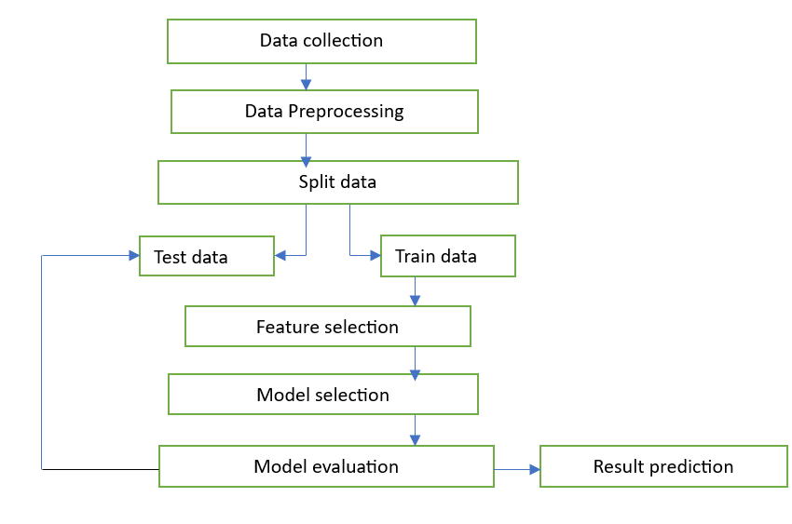 Fig.1.Block Diagram

A. Dataset Description
This dataset is chosen from Kaggle website [13]. The dataset contains patient information like their age, gender, blood samples details. The dataset contains 3758 rows and 24 columns as shown in fig.1 and the entire dataset contains only one binary class that describes whether it is a positive or negative shown in fig.2.We store all those details in database. From the dataset we take only few attributes. Those attributes it promotes thyroid illness most frequently and remaining neglected simply removed for better accuracy. Mostly my dataset features are Boolean values like t for True and f for False and M for Male and F for female. Most features are object and remaining are numeric. When I applied model to give me best features that affect patient record to give whether the person is having thyroid or not. They are Age, Gender, T3, T3 measured, Referral Source and FTI.

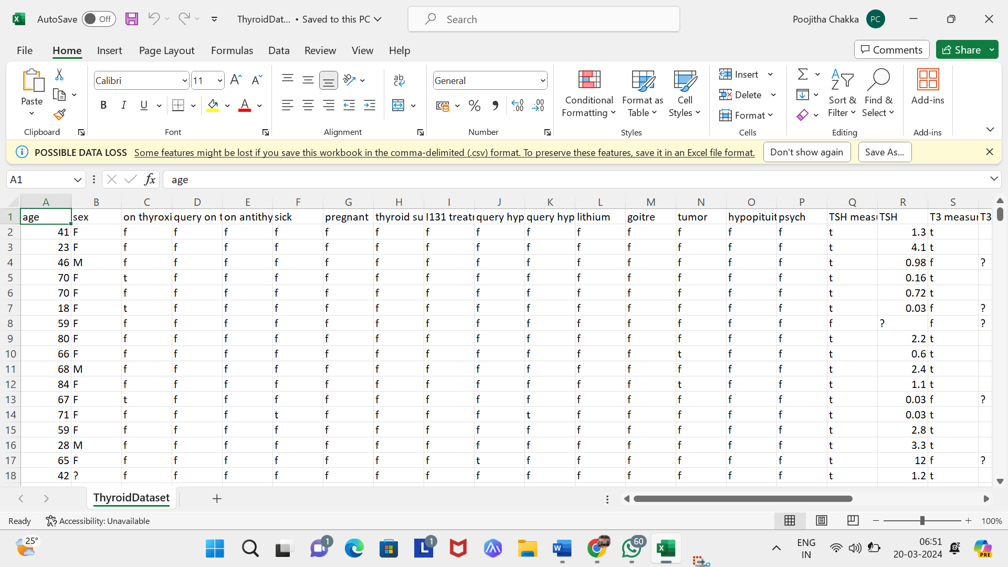
Fig. 2. Dataset

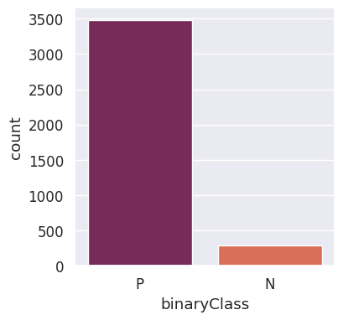
Fig. 3. Class Distribution
Here the table1 represents few attributes taken from the dataset. we take few attributes like age having value type continuous, gender having Boolean features like female (F) and male(M), T3 having value type continuous, T3 measured having Boolean features like true(T) and fail(F), FTI having value type continuous and referral source having value type categories like SVI, SHVC, STWC, others. These attributes are used to predict thyroid disease presence.
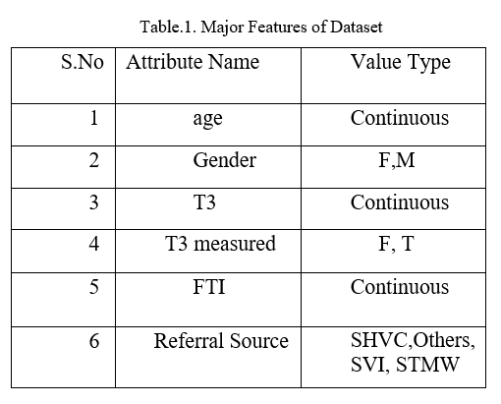
B. Preprocessing Techniques:
The dataset is loaded into memory. Initial cleaning steps are performed, such as handling missing values and dropping irrelevant columns. Missing values are imputed using appropriate strategies represented . Outliers are detected and removed from the dataset as shown in fig.4. Categorical features are encoded into numerical format.
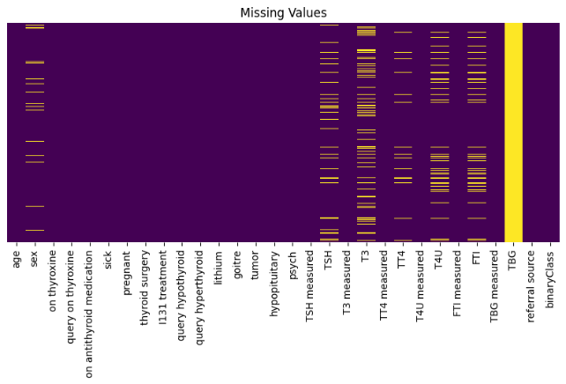
Fig. 4. Missing Values

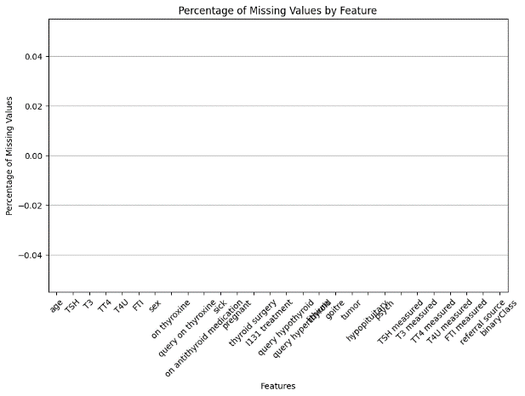
Fig. 5. After Removal of missing values

1.Null Values
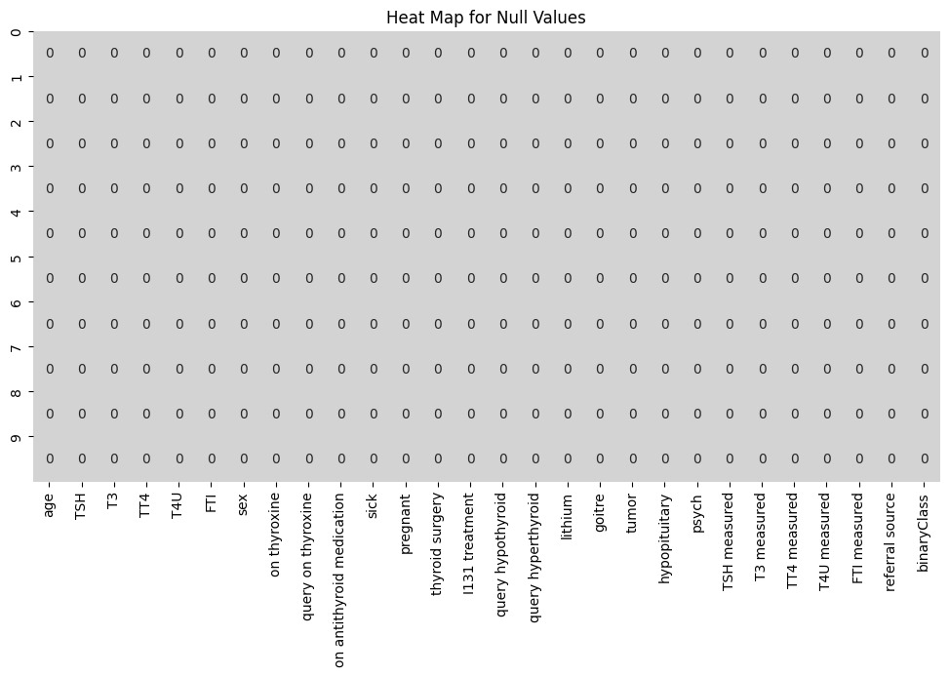
Fig. 6. Null Values
Fig.6.demonstrates the heatmap for null values achieves the same result but in a more concise manner. It selects the features of the Data Frame, creates a heatmap to visualize the missing values, and annotates the cells with the missing value indicator (1 for missing, 0 for not missing). Finally, it sets the y-axis tick labels to represent the rows and displays the heatmap.
2.Outliers Removal:
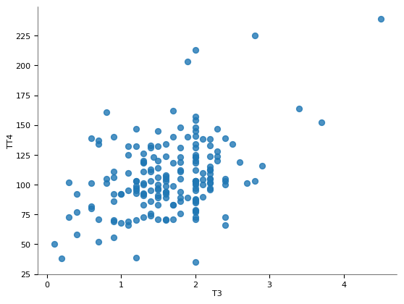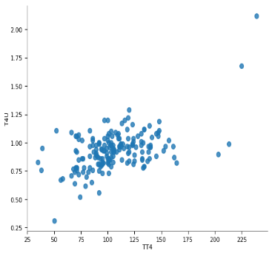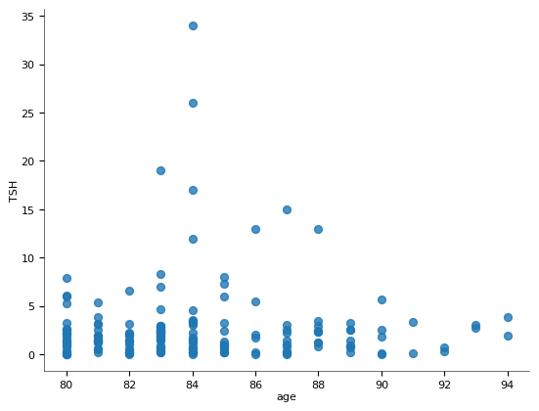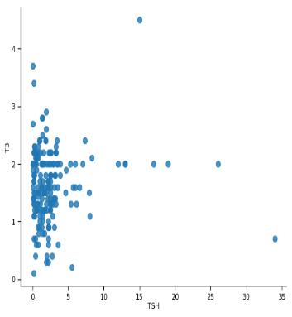
Fig. 7. Outliers Removal
The function outlier’s removal is designed to identify outliers in the numerical columns of a Data Frame represented in the Fig.7. It iterates through each numerical column, sorts the values, and calculates the lower and upper limits using the 0th and 95th percentiles, respectively. Any values falling outside these limits are considered outliers and stored in the detected outliers Data Frame.
2.Correlation Matrix
A straightforward method for summarizing the correlations between every variable in a dataset is to represent the correlation matrix in Figure.8.[17]. The key characteristics of the dataset are selected for this investigation using a correlation matrix. The link between dependent and independent qualities, namely their correlation, whether advantageous or detrimental, with one another—is established by the correlation matrix. To lessen the overfitting issue, features with weak correlations might be removed from the dataset. The correlation matrix's diagonal elements are those that show how closely related attributes are to one another [18]. Assume that if two features have a correlation value of more than1, we can only take into account one of them, and one measure might be removed out of the collection.
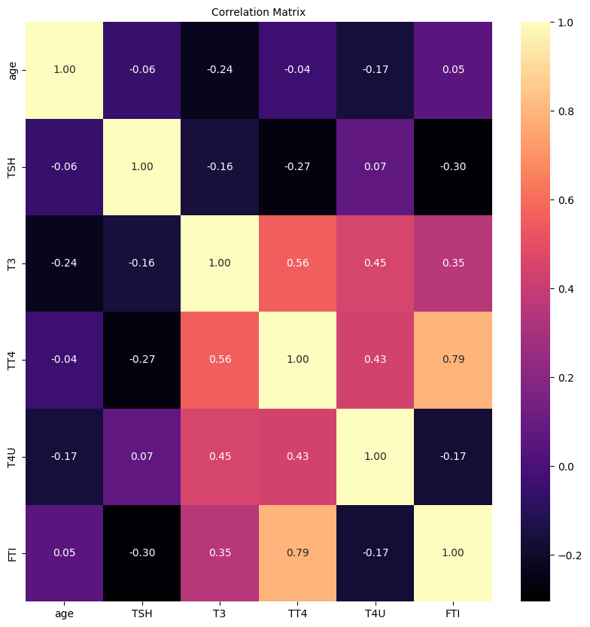

Fig. 8. Correlation Matrix
C. Feature Selection:
Feature selection phase will be to enhance the dataset in order to boost the performance of our models as shown in Fig.9. Feature selection is performed using Sequential Feature Selector (SFS) from the mlxtend library. SFS selects the best subset of features based on a specified evaluation metric.
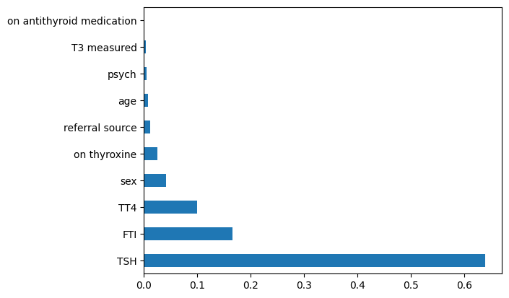
Fig. 9. Feature Selection

D. Model Selection:
Machine learning frameworks of the classification kind are used to divide information among various classes and it is a supervised learning and it will produce unseen to known category. [11] There are different types of classification models like Binary Classification which predict outcomes as yes or no, true or false, positive or negative. Another one is multi-label classification this predicts multiple categories and labels for the input given by user. Another two are Imbalanced and Hierarchical used for complex outcomes [19].
As prediction uses Binary Classification model. In Classification model, there are different models like Logistic Regression it is a statically model that draw relationship between input and output classes. Decision Tree Classifier is another best model and it is tree-based structure and produce decision-based outcomes. Random Forest this model combines multiple decision trees and it produce best accuracy.
E. Model Evaluation:
Standard assessment techniques are used to assess the predictive models following their instruction applying a variety of methods, including Random Forest, Logistic Regression, Naive Bayes, K-Nearest Neighbours, and Decision Tree. These indicators include the confusion matrix, which shows a breakdown of the model's predictions in relation to the actual class labels, and the predictability score, which quantifies the percentage of correctly categorized occurrences. In addition, reports on categorization are produced, which include measures like recall, precision, and F1-score for each category, providing information about how well the algorithm performs in various sessions [15].

V. THE RESEARCH INCLUDED MACHINE LEARNING ALGORITHMS

A.KNN
K-Nearest Neighbors (KNN) is a machine learning approach that supervises solve regression and classification issues. It is a versatile option for a range of dataset types in classification and regression applications because it can handle both numerical and categorical data. Using a metric for separation, like the distance determined by Euclid, it locates K closest neighbours to a given data point.

Euclidean Distance:
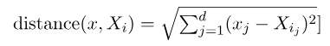 (1)
B. DECISION TREE
The choice tree is one type of algorithmic learning method that can be used for both categorization and regression issues. It builds a tree-like structure based on the input features to generate choices. While nodes in the tree represent decisions or tests on the feature values, leaf nodes in the tree show the final outcomes.
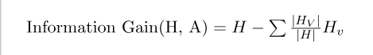 (2)
C.FOREST RANDOMIZATION
Random Forest is a popular supervised learning method that may be used for either regression or classification applications. It leverages ensemble learning, which combines multiple individual classifiers to improve model performance. Random Forest's strength lies in its ability to effectively handle complex datasets, provide robust predictions.

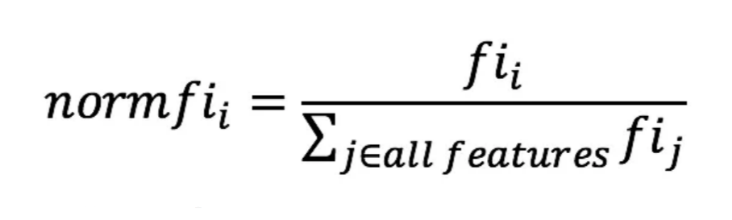
(3)
D.LOGISTICAL REGRESSION
A supervised machine learning technique called logistical regression is used for identifying issues is to estimate the likelihood that an individual case will belong to a group or not. The logistical regression approach transforms the constant-value output of the linear equation function into a categorical value outcome through the application of a sigmoid regression function to any actual values collection of input variables that are autonomous.

Logistic Regression Equation:
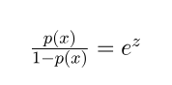 (4)
E. GUASSIANNB
In Gaussian Naive Bayes, continuous attributes are taken into account and the data features are distributed Guassian over the dataset. The word "naive" in the algorithm's name refers to the presumption that the algorithm takes into account when determining the features' labels. The underlying presumption is that each feature functions independently of the others, yet in practical applications, this may not hold true.
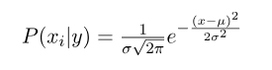 (5)

F. MULTI LAYER PERCEPTRON:
Multi-layer perceptron (MLPs), also known as multi-layer neural networks, utilize dense layers that fully connect input dimensions to the required dimensions. In MLPs, each node typically employs a sigmoid activation function to transform real data into meaningful outputs.

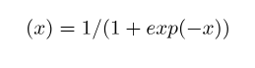
(6)
VI.RESULT AND ANALYSIS
For thyroid disease prediction we use six models namely knn, decision tree, random forest, logistic regression, guassiannb, multilayer perceptron. The precision of each of these methods' results is being estimated, as shown in table 2, It demonstrates strongly that the decision tree method 99.83 % of cases correctly forecast thyroid illness. Random forest of 99.65, KNN of accuracy 98.20, logistic regression of 97.26, gaussian of 60.20, multilayer perceptron of 75.15 are acquired in order to predict thyroid disease.

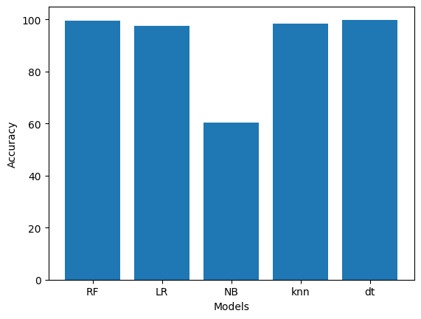
Fig.9.Acuuracy of models
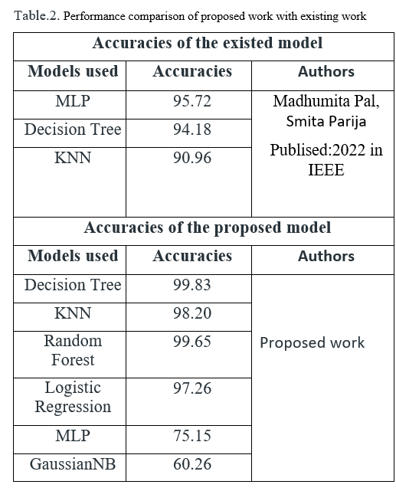

Table.2. examines the performance of the presented work with the current work. Madhumita Pal & Smita Para use KNN, Choice tree, and MLP machine learning classification techniques, respectively, to predict thyroid illness with accuracy scores of 90.96, 94.18, and 95.72[17]. Where proposed model having higher accuracy rate compared to existed model.

- BEFORE AND AFTER APPLYING K-FOLD:

Table.3. Before and After K-Fold
Algorithm | After K-Fold | Before K-Fold
Decision Tree | 0.99698 | 0.995997
Random Forest | 0.987734 | 0.986522
Knn | 0.978855 | 0.95643
Logistic Regression | 0.980363 | 0.976345
GaussianNB | 0.40677 | 0.40554
MLP | 0.90545 | 0.89065

Table.3. represents K-fold cross-validation is a resampling technique used to assess the performance of a machine learning model. The basic idea is to divide the dataset into k subsets of equal size, often referred to as "folds." The model is trained k times, each time using k-1 folds as training data and the remaining fold as validation data. This process ensures that each data point is used for validation exactly once.
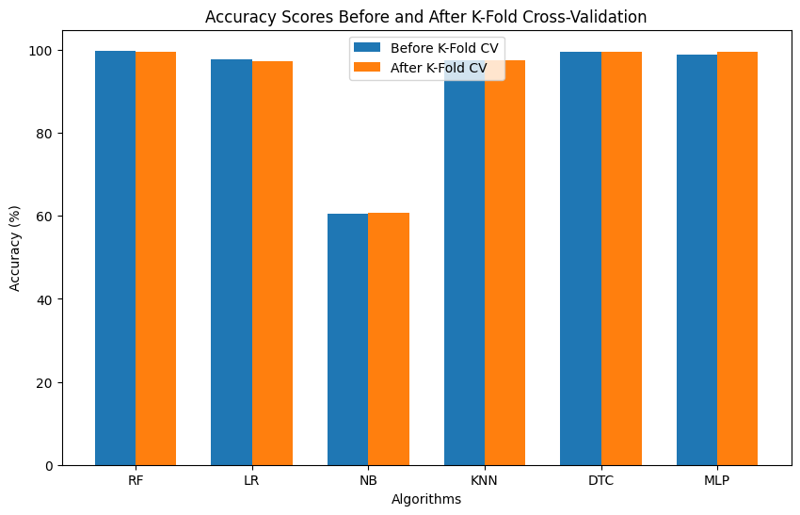

Fig.10.Before and After K-fold cross validation

- CLASSIFICATION REPORT:

Table. 3. Classification Report
Algorithm | F1 Score | Precision | Recall
Decision Tree | 0.996979 | 0.996997 | 0.996979
Random Forest | 0.987734 | 0.988744 | 0.997734
Knn | 0.978855 | 0.979398 | 0.978852
Logistic Regression | 0.980364 | 0.980383 | 0.980363
GuassainNb | 0.536780 | 0.768390 | 0.602719
MLP | 0.503674 | 0.503456 | 0.507453

Table.3. generate a classification report for predicting thyroid disease using machine learning, you'll need a trained model and a dataset with labelled instances (samples with features and corresponding target labels indicating presence or absence of thyroid disease). The classification report provides key metrics such as precision, recall, F1-score, and support for each class.
VII.CONCLUSION
Thyroid disease prediction encompasses multiple stages, such as blood testing and sample analysis. These processes can be carried out effectively using Machine Learning algorithms, which guarantee accurate results. The outcomes of Machine Learning models depend on the quality and quantity of data they are trained on. Clean and well-structured datasets generally produce higher accuracy and better results. Machine Learning is now being utilized in healthcare decisions to reduce mistakes made by people and let experts do deeper examination of medical information. Choice trees, forest randomization, knn, logistical regression, multilayer perceptron, along with guassianNb were predictive modelling methods that produced outcomes of 99.83, 99.65, 98.20, 97.26, 75.15, and 60.25, respectively. Our findings suggest that the algorithm with the greatest efficiency is the choice graph one in classifying thyroid disease among the three algorithms tested.

VIII.USER INTERFACE:
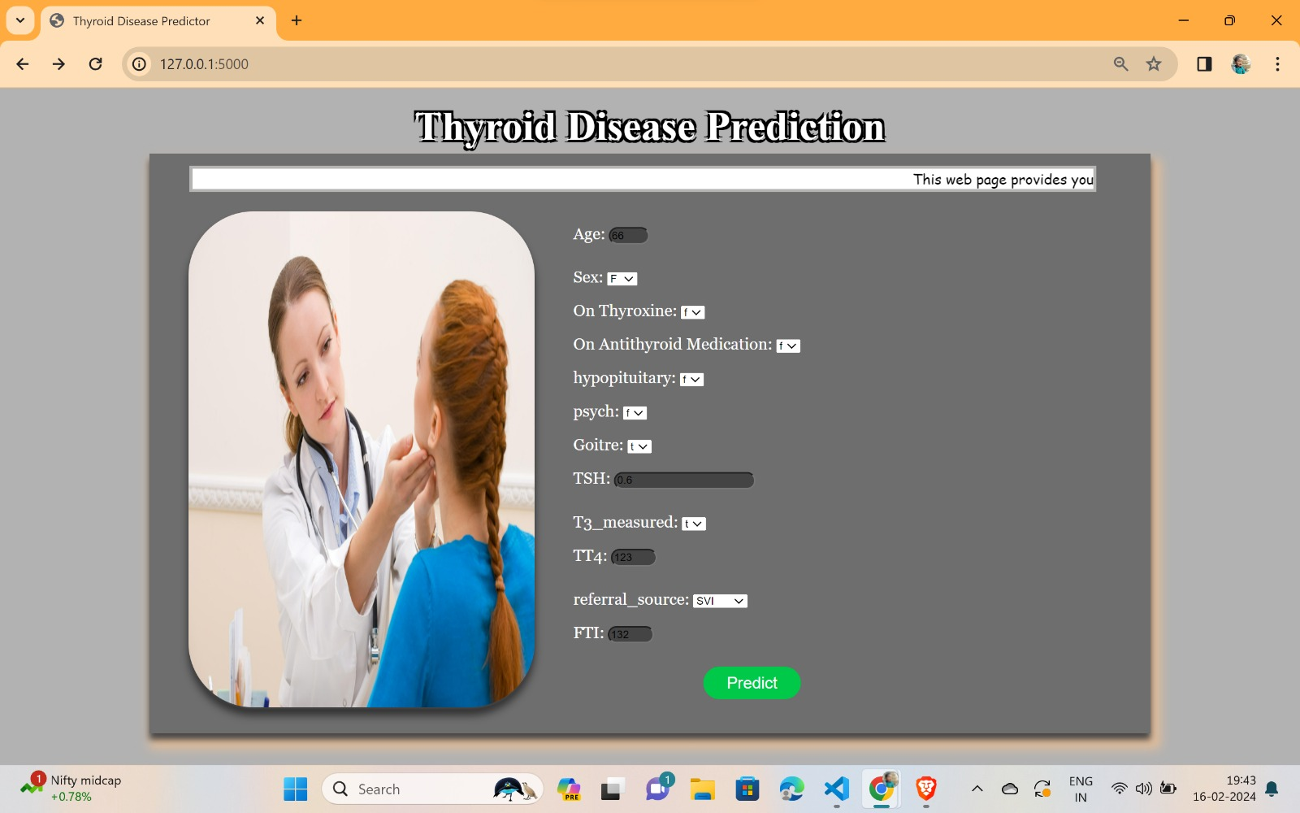
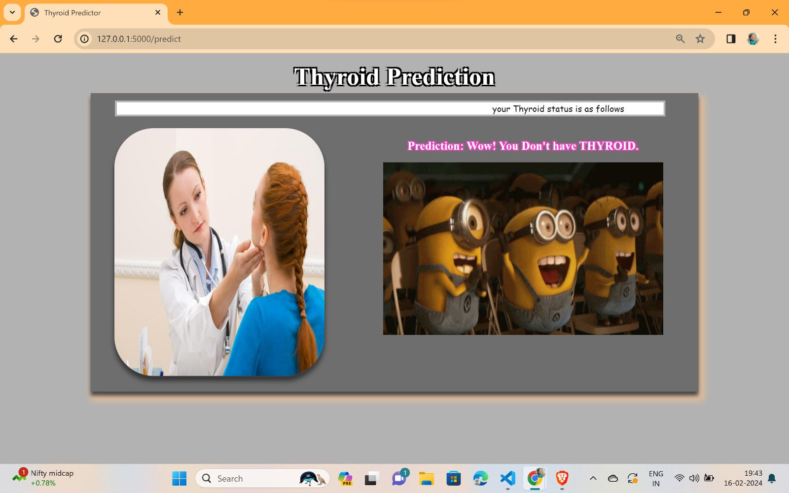

IX.REFERENCES
  - Chaubey, G., Bisen, D., Ajaria, S., & Yadav, V. Thyroid disease prediction using machine learning approaches. National Academy Science Letters, 44(3), 233-238. (2021).
  - Aversano, L., Bernardi, M. L., Cimitile, M., Iammarino, M., Macchia, P. E., Nettore, I. C., & Verdone, C. Thyroid disease treatment prediction with machine learning approaches. Procedia Computer Science, 192, 1031-1040. (2021)
  - Tyagi, A., Mehra, R., & Saxena, A. Interactive thyroid disease prediction system using machine learning technique. In 2018 Fifth international conference on parallel, distributed and grid computing (PDGC) (pp. 689-693). IEEE. (2018, December).
  - Aswathi, A. K., & Antony, A An intelligent system for thyroid disease classification and diagnosis. In 2018 second international conference on inventive communication and computational technologies (ICICCT) (pp. 1261-1264). IEEE. (2018, April).
  - Deepika, M., & Kalaiselvi, K. An empirical study on disease diagnosis using data mining techniques. In 2018 second international conference on inventive communication and computational technologies (ICICCT) (pp. 615-620). IEEE. (2018, April)
  - Sarangpure, N., Tamboli, S., & Kawadkar, An Early Determination and Prognosis of Thyroid Disease on Real-Time and Benchmarked Datasets with Comparative Analysis. In 2023 IEEE 8th International Conference for Convergence in Technology (I2CT) (pp. 1-5). IEEE. (2023, April).
  - May Sanjaya, I. M. D., Nugroho, H. A., & Setiawan, N. A. A comparison of classification methods on diagnosis of thyroid diseases. In 2015 International seminar on intelligent technology and its applications (ISITIA) (pp. 89-92). IEEE. (2015, May).
  - Ammulu, K., & Venugopal, T. Thyroid data prediction using data classification algorithm. Int. J. Innov. Res. Sci. Techno, 4(2), 208-212. | Volume 4 | Issue 2 | July 2020.
  - R. Banu, K.C. Sharmi “A Study of Data Mining Techniques to Detect Thyroid Disease” International Journal of Innovative Research in Science, Engineering and Technology |Vol. 6, Special
|Issue 11, September (2020)
  - Srinivasan, B., & Pavya, K Diagnosis of thyroid disease using data mining techniques: a study. International Research Journal of Engineering and Technology, 3(11), 1191-1194. (2016).
  - Yadav, D. C., & Pal, S Prediction of thyroid disease using decision tree ensemble method. Human-Intelligent Systems Integration, 2, 89-95. (2020).
  - Colubri, A., Silver, T., Fradet, T., Redzepi, K., Fry, B., & Sabeti, P Transforming clinical data into actionable prognosis models: machine-learning framework and field-deployable app to predict outcome of Ebola patients. PLoS neglected tropical diseases, 10(3), e0004549, (2016).
  - Kaggle website url:
https://www.kaggle.com/code/yasserhessein/thyroid-disease- detection-using-deep-learning
  - Yadav, D. C., & Pal, S. Prediction of thyroid disease using decision tree ensemble method. Human-Intelligent Systems Integration, 2, 89-95. (2020).
  - Vasan, C. R. C., DSU, B., MS, C., & Devikarani, H. S. (2018). Thyroid detection using machine learning. Computing (PDGC-2018), 2022
  - Chandhan.R, Chatan Vasan “Thyroid Disease Prediction with Machine Learning Algorithms” Research Gate International Conference on Parallel, article under the CC BY-NC-ND volume 16, issue 48, license, Dec.2021
  - Pal, M., Parija, S., & Panda, G. Enhanced prediction of thyroid disease using machine learning method. In 2022 IEEE VLSI Device Circuit and System (VLSI DCS) (pp. 199-204). IEEE. (2022, February).
  - Jahan Tigh, F. F. Kidney diseases diagnosis by using fuzzy logic. In International conference on industrial engineering and operations management. (2015, March)
  - Turanoglu-Bekar, E., Ulutagay, G., & Kantarcı-Savas, S. Classification of thyroid disease by using data mining models: comparison of decision tree algorithms. Oxford Journal of Intelligent Decision and Data Sciences, 2, 13-28. (2016).
  - Wang, Y., Yue, W., Li, X., Liu, S., Guo, L., Xu, H.,. Yang, G. Comparison study of radiomics and deep learning-based methods for thyroid nodules classification using ultrasound images. IEEE Access, 8, 52010-52017. (2020)

