Machine Learning: Bone Fracture Detection

Venkata Reddy Dodda

Associate Professor

*Computer Science and Engineering*

*Narasaraopeta Engineering College (Autonomous)*

Narasaraopet, Andhra Pradesh

[doddavenkatareddy@gmail.com](mailto:doddavenkatareddy@gmail.com)

Venkata Durga Praveen Badri

Student

*Computer Science and Engineering*

*Narasaraopeta Engineering College (Autonomous)*

Narasaraopet, Andhra Pradesh

[badrivdpraveen5@gmail.com](mailto:badrivdpraveen5@gmail.com)

Sumanth Thota

Student

*Computer Science and Engineering*

*Narasaraopeta Engineering College (Autonomous)*

Narasaraopet, Andhra Pradesh

[sumanththota2003@gmail.com](mailto:sumanththota2003@gmail.com)

Rushi Naga Manikanta Elchuri

Student

*Computer Science and Engineering*

*Narasaraopeta Engineering College (Autonomous)*

Narasaraopet, Andhra Pradesh [elchurirushi@gmail.com](mailto:elchurirushi@gmail.com)

*Abstract*— In today's interconnected world, computers play a pivotal role across diverse domains, revolutionizing aspects such as banking, online commerce, communication, education, research, and healthcare. To enhance medical practices and patient care, innovative technological solutions have emerged. Traditional X-ray scanners often produce indistinct images, posing a risk of misdiagnosis for bone fractures. A comprehensive approach that includes steps like pre-processing the x-ray image, bone edge finding, feature extraction, and machine learning classifiers has been designed to handle this difficulty. The algorithms accuracy evaluations range from 0.62 to 0.94. Remarkably, SVM stands out with the highest accuracy, surpassing most comparable studies. This statistical finding underscores the potential of SVM in fracture detection, reflecting advancements in medical imaging analysis.

Keywords— Computers, Interconnected world, medical practices, Technological solutions, X-ray scanners, Bone fractures, Diagnostic process, Machine learning classifiers, Accuracy assessment, medical imaging analysis.

# Introduction

The 206 bones that make up the human body vary in size, complexity, and form, with wrist fractures being common [1]. Machine learning in medical imaging has gained attention for aiding accurate diagnosis and treatment planning [2], especially given the rising global incidence of bone fractures [3].

X-rays, supported by the DICOM standard, are widely used for diagnosing bone fractures due to their speed and simplicity [4-5], with advancements in digital imaging enhancing their accessibility [4]. Machine learning algorithms play a crucial role in analysing medical images to identify abnormalities, particularly in skeletal imaging [5].

Computer vision systems offer efficient screening of X-ray images for potential fractures, mitigating errors associated with manual inspection [7]. Various methods, including preprocessing and fracture identification, have been proposed to enhance fracture detection accuracy [8-9].

Accurate classification of fractures, especially common ones like tibia fractures, is vital for determining optimal treatment strategies [10]. The reliance on X-ray technology for diagnosis, despite its longevity, underscores the need for advanced diagnostic tools [11], such as computer-aided diagnosis (CAD) systems driven by machine learning algorithms [14].

To achieve accurate fracture classification, noise reduction, feature extraction, and machine learning classification algorithms are employed, highlighting the iterative process of image analysis in medical diagnostics..

# Related works

This section presents a synthesis of existing literature, encompassing both conventional and cutting-edge methodologies for bone fracture detection and classification.

A meta filter that combined neural network and decision tree methodologies was exhibited by E. Mysuru et al. [6] and showed enhanced accuracy, reaching 85%. Pre-processing, segmentation, edge detection, and feature extraction are some of the distinct steps in the process that result in the classification of bone into fractured and non-fractured categories.

Support Vector Machine (SVM) learning approach by , D. Prakash et al. [11] presented a method for long bone fracture classification that achieved a 78% detection rate for transverse and oblique fractures.

An approach by A. Rajput et al. [14] employs preprocessing, feature extraction, and SVM classification, achieving an accuracy of 84.7% in fracture detection.

The effectiveness of the Canny Edge Detection algorithm for edge detection in X-ray images was demonstrated by N. Singh et al. [15], providing enhanced image analysis through intensity discontinuities.

A CNN technique using Spatial Fuzzy C-Means (SFCM) was presented by Y. Prathyusha et al. [16]. To reach a 78% accuracy and preprocessing stages.

A hybrid approach presented by E. Sorantin et al. [17] effectively identifies paediatric ulna and radius fractures using local Shannon entropy computation, achieving a remarkable 91% accuracy.

J.D. Obando et al. [18] proposed an X-ray image processing technique, with preprocessing enhancements such as CLAHE, achieving an 80% accuracy.

S. Rathor et al. [19] developed a deep learning model for distinguishing between fractured and healthy bone, achieving a classification accuracy of 92.44% after addressing overfitting through data augmentation.

Finally, R. Madupu et al. [20] compared their proposed method with Harris corner detection, demonstrating the superior accuracy (91%) of BPNN paired with cautious smoothing and perceptive edge detection for automated bone fracture identification.

# Methods

Dataset collection, preprocessing, edge detection, key feature finding, and lastly classification are the five primary modules that make up the bone fracture detection system.

Figure 1 outlines the stages of the suggested procedure for locating fractured bones in X - ray scans.

Fig*.* 1*.* Architecture

## Pre-processing

By addressing noise, inconsistencies, and incompleteness, preprocessing is essential to improving the image's accuracy. The initial step involves converting the image from RGB to shades of grey format and then Gaussian filter used for cancellation of noise.

1. Noise Cancellation:

Noise is the word for extraneous pixels that degrade the general quality of the picture. Noise can manifest in various forms, with "salt and pepper" noise being common in X-ray images. This kind of noise shows up in the image as sporadic bright and dark patches, typically resulting from capture or transmission malfunctions.

Pixels that are significantly different from their neighbors are replaced with the median value, enhancing image quality.

This noise cancellation step is crucial for improving the accuracy of subsequent analysis in the bone fracture detection system.

2. Enhancement of Contrast:

A digital image processing method called adaptive histogram equalization is used to improve image contrast. This method has demonstrated success in improving the contrast of medical X-ray images.

## Canny Edge Detection

A popular method for obtaining useful structural information from a variety of objects in vision systems is called "canny edge detection," which significantly lowers the volume of images that needs to be examine. This technique examines the image's fluctuating intensity over time. A few examples of the variables that affect edge detection quality are noise levels, edge density, and the presence of objects with similar intensities.

It has been found in this study that Canny edge detection technique can be modified to get the best results by adding an enhancement to improve contrast of image.

## Feature Extraction

A crucial step in image processing, especially when it comes to bone fracture identification, is feature extraction. For the purpose of extracting textural qualities like contrast, correlation, homogeneity, energy, and dissimilarity, the GLCM technique is a useful tool.

These characteristics play a significant role in discerning subtle differences in bone structures, aiding in fracture identification. Below are the formulas for calculating each of these textural properties using the GLCM approach:

1. Contrast:

Contrast is a metric used to quantify the variation in strength between pixels next to each other in an image.

$Contrast=\sum_{i,j}{P\left(ⅈ,j\right)}⋅{ \left|i-j\right|}^{2}$ (1)

Higher contrast values indicate larger differences in intensity levels between adjacent pixels, suggesting a more pronounced variation in the image.

2. Correlation:

Correlation assesses the degree of linear dependence between pixel intensities in the image.

$Correlation=\sum_{i,j}{\frac{\left(i-μ_{i}\right)⋅\left(j-μ_{j}\right)⋅p\left(i,j\right)}{σ_{i}⋅σ_{j}}}$ (2)

A strong linear relationship between pixel intensities is shown by a correlation value near 1, which points to a more equal distribution of intensities in the image.

3. Homogeneity:

Homogeneity measures the closeness of pixel intensities to the diagonal of the GLCM.

$Homogeneity=\sum_{i,j}{\frac{p\left(i,j\right)}{1+\left|i-j\right|}}$ (3)

Higher homogeneity values indicate that pixel pairs with similar intensities are more likely to occur, suggesting a smoother texture in the image.

4. Energy:

Energy (also known as uniformity or angular second moment) quantifies the uniformity of pixel intensities in the image.

$Energy=\sum_{i,j}{p{\left(i,j\right)}^{2}}$ (4)

Higher energy values indicate a more uniform distribution of pixel intensities in the image, suggesting a homogeneous texture.

5. Dissimilarity:

Dissimilarity measures the average intensity difference between pixel pairs in the image.

$Dissimilarity=\sum_{i,j}{p\left(i,j\right)}⋅\left|i-j\right|$ (5)

Higher dissimilarity values indicate greater intensity differences between neighboring pixels, suggesting a more heterogeneous texture in the image.

These textural properties provide valuable insights into the spatial relationships between pixel intensities, allowing for effective characterization of bone structures and helping to identify fractures in X-ray pictures.

# Results

The bone fractured dataset consisted of X-ray scans obtained from the Kaggle containing 120 broken and 70 normal images of wrist bones. The methodology outlined in the previous sections was applied to the dataset, yielding the following results:

## Pre-processing

Fig. 2 depicts the initial X - ray image prior to preprocessing.

The X-ray image after a Gaussian filter is applied to remove noise is shown in Fig. 3.

Fig. 4 showcases the X-ray image after enhancement and adaptive histogram equalization.

Fig. 5 showcases the detection of bone structures and edges using the Canny edge detection algorithm.

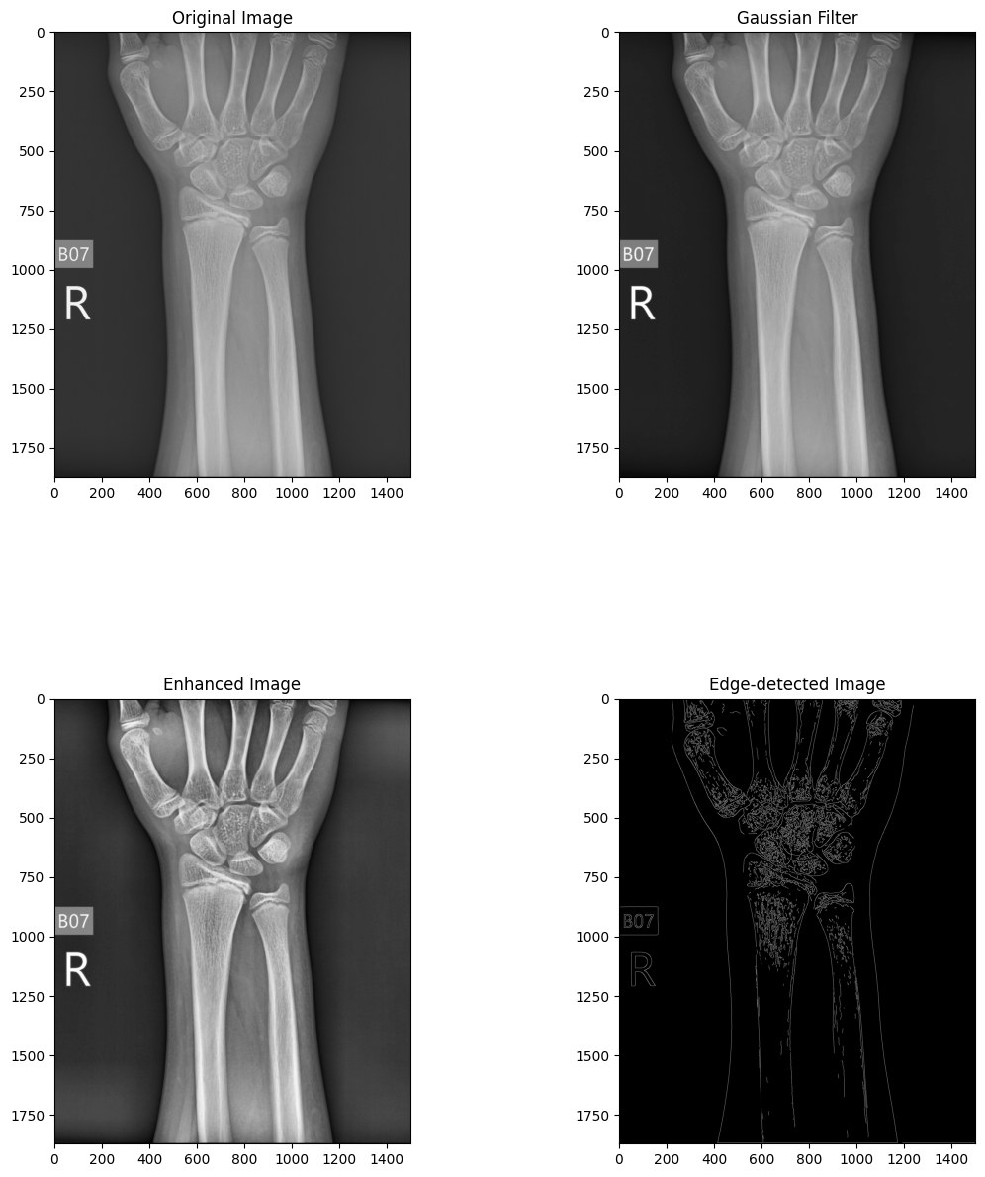

Fig. 2. X - ray image original



Fig. 3. X - ray after gaussian filter



Fig. 4. X - ray after enhancing



Fig. 5. X - ray after edge detection.

## Feature Extraction

140 characteristics were extracted per image using GLCM, which produced five attributes for four distances and seven angles. To maximize accuracy, several combinations of characteristics, distances, and angles were tried while using Python programs to extract GLCM features.

Fig. 6 displays an example of extracted GLCM features for five photos with angle = 90° and distance = 1.

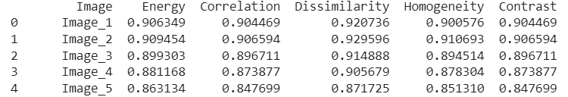

Fig. ***6***. GLCM features for 5 random images

## Classification

Using random selection, 80% of the dataset was implemented to learn and 20% for validation. The model was trained and tested using a variety of machine learning methods, such as Support Vector Machine (SVM), Naive Bayes, KNN, Random Forest, and Decision Tree. Preciseness, recall, and accuracy were assessed together with False Positive (FP), and False Negative (FN), True Positive (TP), True Negative (TN) results.

$Precision=\frac{TP}{TP+FP}$ (6)

$Recall=\frac{TP}{TP+FN}$ (7)

$Accuracy=\frac{TP+TN}{TP+TN+FN+FP}$ (8)

Table 1 displays a comparison of the efficacy of various machine learning methods. Accuracy of Naïve bayes is 0.88, Decision tree is 0.76, Random Forest is 0.62, KNN is 0.78, and SVM is 0.94 were attained.

Table 2 provides a comparison with other studies reviewed in this research, showcasing the effectiveness of the proposed system.

Table 1: Accuracy, Precision and Recall

|  |  |  |  |
| --- | --- | --- | --- |
| **Model** | **Precision** | **Recall** | **Accuracy** |
| SVM | 0.85 | 1.0 | 0.94 |
| Random Forest | 0.88 | 0.61 | 0.78 |
| Decision Tree | 0.87 | 0.57 | 0.76 |
| Gaussian NB | 0.79 | 1.0 | 0.88 |
| KNN | 0.83 | 0.22 | 0.62 |

Table 2: Comparing this paper to others

|  |  |  |  |
| --- | --- | --- | --- |
| **Citation** | **Year** | **Strategy** | **Accuracy** |
| [6] | 2015 | Decision Tree | 0.85 |
| [11] | 2017 | SVM | 0.78 |
| [14] | 2017 | SVM | 0.84 |
| [16] | 2019 | CNN with SFCM | 0.78 |
| [18] | 2019 | SVM with CLACHE | 0.80 |
| [19] | 2020 | CNN | 0.92 |
| [20] | 2020 | Back propagation Neural Network | 0.91 |
| Existing | 2024 | SVM | 0.94 |

# Conclusion

The main target of this study was to produce a tool that would assist medical professionals quickly and effectively diagnose whether or not a patient had a fractured wrist bone. This study describes an automated method for classifying and identifying bone fractures from X-ray images using machine learning.

Both fractured and intact bones, along with their corresponding X-ray images, were utilized in the experiment. With the increasing prevalence of bone fractures globally, the ability to detect even minor fractures holds significant value in medical practice. Thus, the proposed technique offers the capability to distinguish broken bones versus whole ones.

The GLCM is utilized for obtaining various characteristics from X-ray scans in order to machine learning algorithms can use them for classification, however the Canny edge detection is an asset for edge detection. A multitude of machine learning techniques and methods for analyzing images are included into the system with the express purpose of identifying lower wrist bone fractures.

Throughout the research, various machine learning strategies including Decision Tree, Naive Bayes, KNN, SVM, and Random Forest demonstrated accuracies ranging from 0.66 to 0.94. Notably, SVM exhibited its effectiveness in fracture detection and classification more accurate.

In conclusion, the developed system represents a promising approach to enhance the efficiency and accuracy of diagnosing wrist bone fractures, ultimately contributing to improved patient care and outcomes in medical practice.

##### References

1. F. Majeed, S. Adnan W. Abbas & M. Javid,” Lower Leg Bone Fracture Detection and Classification Using Faster RCNN for X-Rays Images”, IEEE (2020).
2. A. Al-Ghaithi & S. Al Maskari,” Artificial intelligence application in bone fracture detection”, Journal of Musculoskeletal Surgery and Research (2021).
3. C. McCollough, J. Bushberg, G. Fletcher & L. Eckel, "Answers to common questions about the use and safety of CT scans", Elsevier(2015).
4. P. Cephas & H. Hepzibah, "A robust approach for detection of the type of fracture from X-ray images", International Journal of Advanced Research in Computer and Communication Engineering (2015).
5. Sami H. Ismael, Shahab W. Kareem & Firas H. Almukhta, "Medical Image Classification Using Different Machine Learning Algorithms", AL-Rafidain Journal of Computer Sciences and Mathematics (2020).
6. S. College, E. Mysuru & R. Raman, "Detection of bone fracture using image processing methods", International Journal of Computer Applications (2015).
7. S.W. Kareem, "An evaluation of algorithms for classifying Leukocytes images", IEEE(2021).
8. B. Czerniak, "Dorfman and Czerniak’s Bone Tumors E-Book", Elsevier(2015).
9. Shahab Wahhab, Kareemab Roojwan ScHawezia & Farah Sami Khoshabaa, "A Comparison of Automated Classification Techniques for Image Processing in Video Internet of Things", Elsevier (2022).
10. N. Umadevi & D. GeethaJakshmi, "Multiple classification system for fracture detection in human bone x-ray images", IEEE (2012).
11. A. Vishnu, D. Prakash & S. Sharmila, "Detection and classification of long bone fractures", International Journal of Applied Engineering Research (2017).
12. L. Tanzi, E. Vezzetti, R. Moreno & S. Moos, "X-Ray Bone Fracture Classification Using Deep Learning: A Baseline for Designing a Reliable Approach", MDPI (2020).
13. Hersh A. Muhamad, Shahab Wahhab Kareem & Amin Salih Mohammed, "A deep learning method for detecting Leukemia in real images", MDPI (2022).
14. A. Tripathi, A. Upadhyay & A. Rajput, "Automatic detection of fracture in femur bones using image processing", Elsevier (2017).
15. N. Johari & N. Singh, "Bone fracture detection using edge detection technique", Springer Link(2017).
16. S.S. Sinthura, Y. Prathyusha, K. Harini, Y. Pranusha & B. Poojitha, "Bone fracture detection system using CNN algorithm", IEEE (2019).
17. F. Hrzic, I. Stajduhar, S. Tschauner, E. Sorantin & J. Lerga, "Local-entropy based approach for X-ray image segmentation and fracture detection", MDPI (2019).
18. E. Castro-Gutierrez, L. Estacio-Cerquin, J. Gallegos-Guillen & J.D. Obando, "Detection of Acetabulum Fractures Using X-Ray Imaging and Processing Methods Focused on Noisy Images", IEEE (2019).
19. D. Yadav & S. Rathor, "Bone fracture detection and classification using deep learning approach", IEEE(2020).
20. S. Karimunnisa, R. Madupu & P. Savarapu, "Detection of Bone Fractures Automatically with Enhanced Performance with Better Combination of Filtering and Neural Networks", IEEE(2020).