Web-Based Book Recommendation System Using Collaborative Filtering

Y.Chandana 1 Gajula Chenna Kesavulu 2, Bandela Mark Nicholas3, Shaik Mustak 4

1 Asst.Professor, 2, 3 & 4 Student

1[nagatirumalarao@gmail.com](mailto:cusb.atif@gmail.com), 2chennakesavulugajula@gmail.com, 3 marknicholasbandela@gmail.com, 4 mustakshaik@gmail.com

Department of Computer Science and Engineering,

Narasaraopeta Engineering College, Narasaraopet, Andhra Pradesh, India

***ABSTRACT- Recommender systems play a pivotal role in assisting users in suggesting products and gathering insights into their preferences online. In the competitive landscape of contemporary online bookstores, attracting customers and boosting revenue efficiently is crucial. Among various strategies, implementing a referral system stands out as a potent method. This research provides a comprehensible and straightforward approach to book recommendations, aiding readers in the optimal selection of books. The proposed methodology operates through training a database and gathering feedback to offer valuable insights for user decision-making. The recommendation system, outlined in this paper, is constructed using the collaborative filtering method. The system suggests and employs the machine learning (ML) model KNN (k-nearest neighbors) to categorize books based on user preferences. The architecture of the proposed system is introduced, emphasizing its overall structure, and the implementation is showcased, highlighting the practical application of the collaborative filtering approach in book recommendation.***

***KEYWORDS: Recommendation System, KNN, Django, collaborative filtering, Book Recommendation System***

# INTRODUCTION

# Platforms Like Spotify and Netflix provide person personalized movie suggestions, while YouTube tailors video recommendations based on user searches and interests. For avid readers, the availability of a specific book holds paramount importance, prompting them to explore various platforms to locate their desired titles. In the process of searching, reading, and eventually purchasing a book, individuals invest a significant amount of time. Preferences for book genres vary among readers, and new users may find it challenging to pinpoint their interests [1]. To streamline this process, a machine learning model comes into play to alleviate the user's efforts. The primary goal of the Bok platforms is that personalized recommendation systems have become indispensable tools for guiding users toward content that aligns with their tastes and preferences. Platforms like Spotify, Netflix, and YouTube have set the standard for leveraging machine learning algorithms to curate tailor recommendations[2] enhancing user satisfaction and engagement.

# The recommendation System (BRS) is to offer readers a user-friendly interface where they can input their required books and search for the most favorite books.

# However, while these platforms cater to the audiovisual and multimedia preferences of users, bibliophiles often find themselves navigating a fragmented landscape when seeking out their next literary adventure. The quest for the perfect book involves scouring various online retailers, libraries, and book recommendation websites, consuming valuable time and effort in the process. Furthermore, newcomers to the world of literature may feel overwhelmed by the sheer diversity of genres and titles, making it challenging to pinpoint their interests.[3]

# The Book Recommendation System (BRS), is a revolutionary application of machine learning technology designed to streamline the discovery and selection of books across a multitude of genres. The primary objective of the BRS is to provide readers with a user-friendly interface where they can input their preferences and receive personalized recommendations tailored to their tastes. By analyzing user behavior[4], reading history, and genre preferences, the BRS leverages sophisticated algorithms to suggest books that are likely to resonate with each user.

# The BRS not only simplifies the exploration and selection of books but also fosters serendipitous discovery by introducing users to titles they may not have encountered otherwise. By offering a unified platform aggregating book recommendations from multiple sources, the BRS creates a seamless and immersive experience for users in their literary pursuits. preferences, facilitating the discovery of their favorite books and similar titles across various genres on a unified platform. The BRS aims to simplify the exploration and selection of books, providing a seamless experience for users in their literary pursuits In today's digital age, where entertainment and information are increasingly consumed online[5]

# A book recommendation system is a sophisticated technology designed to suggest books to users based on their individual preferences, past reading history, and various other relevant factors. These systems utilize intricate algorithms that analyze user data alongside book metadata to generate personalized recommendations tailored to each user's tastes and interests. One of the most prevalent techniques employed in these systems is collaborative filtering, which identifies patterns and similarities among users to make recommendations. Collaborative filtering can be implemented in two primary ways: user-based and item-based. User-based collaborative filtering suggests books to a user based on the preferences and ratings of similar users.

# Additionally, content-based filtering is another common approach used in book recommendation systems. This technique suggests books to users based on the attributes and features of the books themselves, such as genre, author, and plot summary, in conjunction with the user's past behavior and preferences. Hybrid approaches, which combine collaborative filtering and content-based filtering techniques, are often employed to enhance recommendation accuracy by leveraging both user behavior and book attributes. Matrix factorization techniques like Singular Value Decomposition (SVD) and Alternating Least Squares (ALS) are utilized to analyze user-item interaction matrices and extract latent features representing user preferences and item characteristics.

# Moreover, advancements in deep learning have led to the application of neural networks in recommendation systems. Deep learning models can capture intricate patterns and representations from user-item interactions and metadata, enabling more accurate recommendations by accounting for nonlinear relationships between users and books. Evaluation metrics such as precision, recall, F1-score, and Mean Average Precision (MAP) are commonly used to assess the relevance and accuracy of recommendations provided by the system. In essence, book recommendation systems play a pivotal role in enhancing the reading experience by helping users discover new books that align with their interests and preferences.

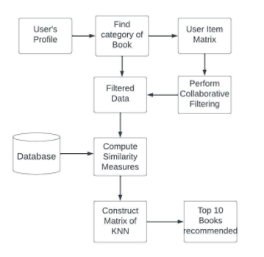

Fig 1. System Design

# II.Related Work

T. Adi Lakshmi et al. discuss the effectiveness of recommender systems in filtering and delivering [6] relevant information, particularly in the context of audiobooks. A hybrid recommender system, combining content-based and collaborative filtering, is proposed for driving recommendations. Various techniques, including clustering and evaluation metrics, are employed to enhance the precision and effectiveness of the recommendation system.

Sarma Dhiman et al. discuss the importance of user-specific recommendations is highlighted, with a focus on book-related preferences and interests. Different algorithms, such as User-based collaborative filtering and ECLAT, are utilized for efficient book recommendations. Additionally, the paper introduces a hybrid algorithm called HYRED, [7] which addresses adaptability and sparsity issues in handling vast data volumes.

In the healthcare domain, Choi Song Huin and Young Suin Jeiong et al discuss the use of machine learning models like boost, max voting, and KNN explored for predicting various diseases[4] based on shared health records. The broader scope of recommender systems in information retrieval and business improvement is acknowledged.

S.S.Sohail et al. The future of recommender systems is envisioned to leverage personal, implicit, and local information from the internet. The paper also emphasizes the use of collaborative filtering, content-based filtering, and hybrid approaches, with a specific focus on precision and optimization techniques such as KNN metrics and SVD.[6]

In the context of publication recommendations, user abstracts are analyzed to suggest suitable publications based on content similarity, achieving significant precision scores [7]. The paper concludes by highlighting the implementation of Collaborative Filtering and the KNN model, alongside a Chatbot function, for personalized book recommendations on a website.

III. PROPOSED METHODOLOGY

A Book Recommendation System (BRS) web application, featuring an interactive chatbot, has been developed using machine learning. The website allows users to discover books based on their preferences,[8] leveraging anticipated user ratings and popular searches. The tech stack includes HTML, CSS, JS, Bootstrap for the front end, and Django for the back end, utilizing SQLite for the database. Google's APIs are integrated for functionalities like login, account creation, and book searches.

*A. Dataset:*

In this paper, the dataset was obtained from Kaggle, and it consists of the three tables Books.csv, Ratings.csv, andUsers.csv. The dataset for the book recommendation system in use consists of information about books, including their titles, authors, and ratings[10]. the dataset contains 271362 rows and 6 columns these are the international book standard, book name, book author, publisher name, year of publishing image of book.

­­­

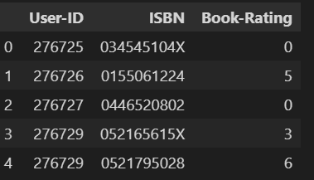

Fig 2. Rating Dataset

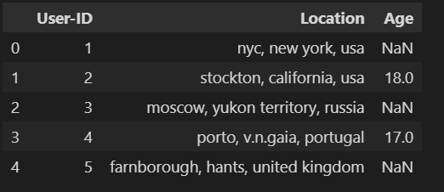

Fig 3. User Dataset

*B. Preprocessing Features:*

To enhance computational efficiency and avoid encountering "memory error," a preprocessing step is implemented, involving the selection of only 1 percent of the entire dataset for subsequent K-nearest neighbors (KNN) algorithm processing. This smaller subset of data is then transformed into a 2-dimensional matrix [11]. To handle missing values in the table, they are replaced with zeros. Additionally, the rating values within the matrix data frame are converted into a SciPy sparse matrix, ensuring more precise and resource-efficient calculations.[11]

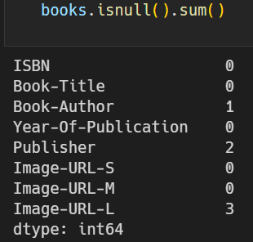

Fig 4. Dealing Null Values for the Books Dataset

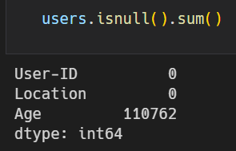

Fig 5. Dealing Null Values for the user's dataset

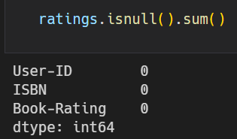

Fig 6. Dealing Null Values for the Ratings Dataset

*C. Model of the Architecture:*

This book recommendation system utilizes a hybrid approach, combining both collaborative filtering (CF) and K-Nearest Neighbors (KNN) techniques to provide personalized book suggestions to users.

*1. User Interaction*:

Users can interact with the system through various means, such as searching for books, browsing genres, and rating books. [12] This interaction generates data that is stored in a central database.

*2. Data Preprocessing:*

The collected data undergoes preprocessing to ensure its quality and consistency. This may involve handling missing values, converting data to numerical formats, and removing irrelevant information.

*3. Architecture:*

Hybrid Approach: Combining KNN and CF leverages the strengths of both techniques, providing flexibility and adaptability to different user profiles and data sparsity.

*4. Personalization:*

The system personalizes recommendations based on individual user preferences and historical interactions.

*5. Scalability:*

The architecture can be scaled to accommodate a growing user base and book collection

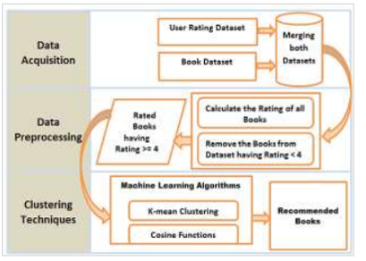

Fig 7. Proposed Technique for Book Recommendation

*D. Optimizer & Learn rate of the model:*

In this project, we use the Adam optimizer with the rate 0.001 modern networks network weights and make results fast to beginning learning levels. [14] The learning rate we used in this model is 0.001 at starting which means in the freezing state of weights. After the model is created the learning rate is changed to 0.0001 [7] because of model needs to learn the process and all the weights are unfreezed..

*E. Machine Learning Algorithm – KNN:*

Implementation of the K-nearest neighbors (KNN) algorithm for categorizing books by genre.[9] Utilization of user ratings for personalized book recommendations.

*F. Visualization*

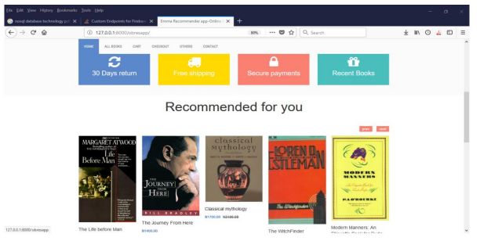

Fig 8..User Interface for the Customer

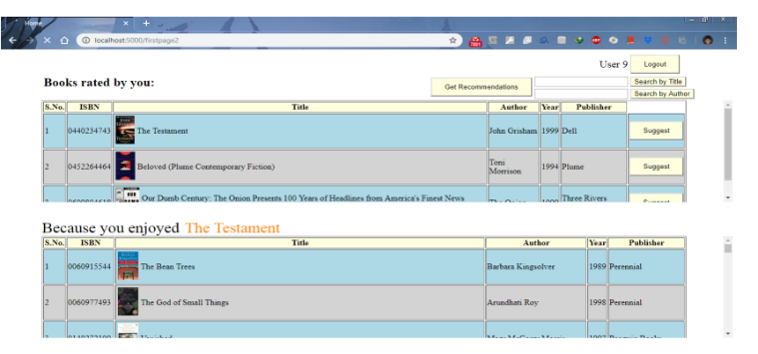

Fig 9. User Suggest books to others

*IV. PROPOSED MODEL PERFORMANCE*

*A. Dataset Distribution***:**

Here we separate the dataset into train, valid & test information from the given pictures. The whole picture is 89885. Here 84635 information of pictures are utilized for train reasons & for test reasons 2625 information of pictures are utilized [13]. After train and testing the information, a few pieces of information will be utilized for validation. CNN is a profound learning calculation. Here CNN and Xception are utilized for identifying the input picture. Here we utilized the three colors of rgb and the categorical mode and at long last the measure of clump is 64 for preparing and testing information. We delivered the information demonstrated which gave us way better execution [14].

*B. Proposed Model Efficiency:*

Here we prepared the model for 10 books and we got the precision for preparing information is 99.93% and for the approval information is 99.27% [14].In the wake of completing the preparation and testing the result acquired great exactness.

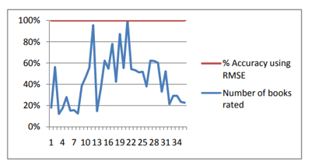

Fig 10. Graph of the number of books rated against the percentage accuracy of recommendation

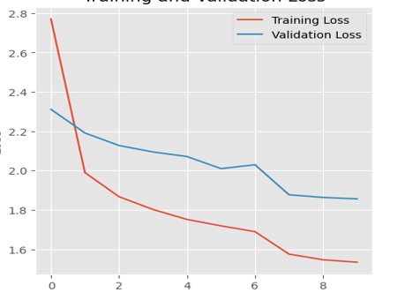

Fig 11. Train and validation loss

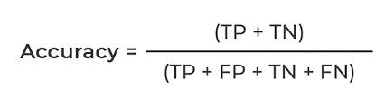

TN=” True positive”

TP=” True Negative”

FP=” False Positive”

FN=” False Negative”

Here we also calculated loss, and precision which all are evaluation metrics. [15]

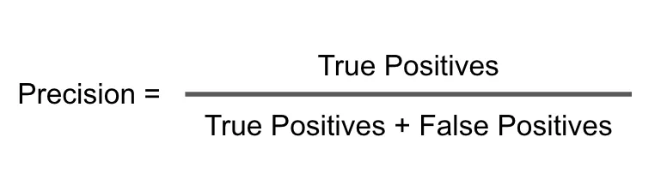

Precision is a metric that measures how often a machine learning model correctly predicts the positive class.

*C.Accuracy Comparisions:*

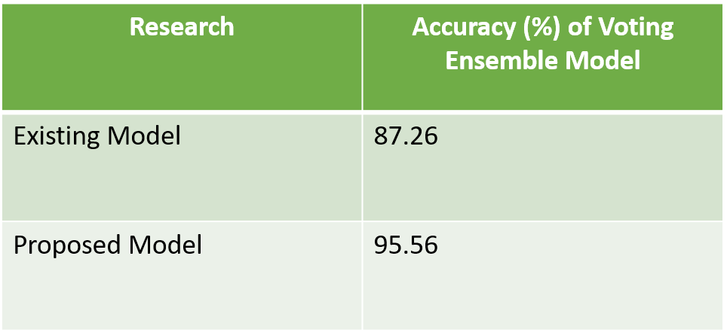

Fig 12. Overall accuracy

When we are using the existing model that is in the original base paper the accuracy becomes 87.26% and we are using the another model the accurate becomes the 95.56 % finally we conclude that we are changing the accuracy of the output from 87.26 to 95.26

*V. RESULT AND ANALYSIS*

The website interface includes features like Popular Searches, Explore, Login/Signup, Book Search, and a Chatbot.

The system uses a pre-processed dataset from Kaggle, and a sparse matrix is created for efficient computation. Collaborative Filtering and KNN algorithms are used to recommend books based on user preferences.

A chatbot enhances user interaction, providing recommendations and assisting with book searches. Matrix Factorization, specifically SVD, is used to derive latent factors for book recommendations.

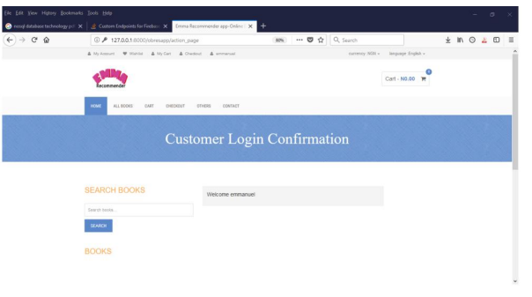

Fig 13. Login Page for the User

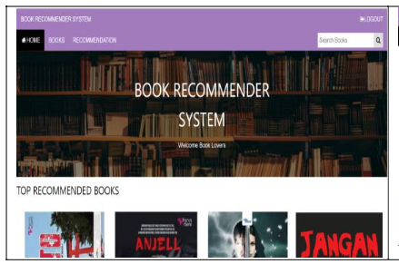

Fig 14. User Interface

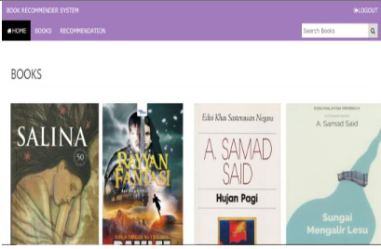

Fig 15.Recommended Books

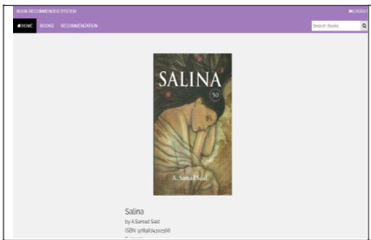

Fig 16.Detailed Book View

Table 1

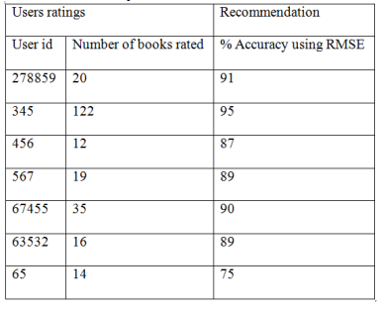

Table for user ratings and recommendations

*VI. CONCLUSION*

In this study, we have crafted a website dedicated to the implementation of a book recommendation system. The primary goal is to provide users with personalized book suggestions, utilizing the collaborative filtering approach. Furthermore, a K-nearest neighbors (KNN) algorithm has been devised to classify books based on various attributes such as genre, narrative, and authorship. To enhance user interaction, a chatbot has been integrated into the website using Google Cloud Platform's Dialogflow service. As part of our future endeavors, we aim to integrate our website with bookstore data, facilitating a seamless experience for readers. This integration would enable users to effortlessly discover and inquire about the availability of any desired book from vendors, streamlining the book-buying process.

*VII. REFERENCES*

[1] Phorasim, Phongsavanh, and Lasheng Yu, "Movies recommendation system using collaborative filtering and k-means.”, International Journal of Advanced Computer Research 7, no. 29 (2017): 52.

[2] Kommineni, Madhuri, P. Alekhya, T. Mohana Vyshnavi, V. Aparna, K.

Swetha, and V. Mounika, ”Machine learning based efficient recommendation system for book selection using user-based collaborative filtering algorithm.”, In 2020 Fourth International Conference on Inventive Systems and Control (ICISC), pp. 66-71. IEEE, 2020.

[3] Mathew, Praveena, Bincy Kuriakose, and Vinayak Hegde, ”Book Recommendation System through Content-based and Collaborative Filtering Methods 2016 International Conference on Data Mining and Advanced Computing (SAPIENCE), pp. 47-52. IEEE, 2016.

[4] Choi, Sang Hyun, Young-Seon Jeong, and Myong K. Jeong, ”A hybrid recommendation method with reduced data for large-scale application.”,

IEEE Transactions on Systems, Man, and Cybernetics, Part C (Applications and Reviews) 40, no. 5 (2010): 557-566.

[5] Arulmozhivarman, M., and Gerard Deepak, ”OWLW: ontology focused user-centric architecture for web service recommendations based on LSTM and whale optimization.”, In European, Asian, Middle Eastern, North African Conference on Management Information Systems, pp.

[6] Lakshmi, Soanpet Sree, and T. Adi Lakshmi, ”Recommendation systems: Issues and challenges.”, International Journal of Computer Science and Information Technologies 5, no. 4 (2014): 5771-5772.

[7] Sarma, Dhiman, Tanni Mittra, and Mohammad Shahadat Hossain, ”Personalized Book Recommendation System using Machine Learning Algorithm.", "Personalized Book Recommendation System Using Machine

Learning Algorithm.”

[8] Kanetkar, Salil, Akshay Nayak, Sridhar Swamy, and Gresha Bhatia,” Web-based personalized hybrid book recommendation system.”, In 2014 International Conference on Advances in Engineering Technology

Research (ICAETR-2014), pp. 1-5. IEEE, 2014.

[9] Thorat, B., P., Goudar, RM Barve, S.(2015). Survey on Collaborative Filtering and Content-Based Recommending. International Journal of Computer Application, 110(4), pp.31-36.

[10] Bagul, D.V. and Barve, S., 2021, January. A novel content-based recommendation approach based on LDA topic modeling for literature recommendation. In 2021 6th International Conference on Inventive Computation Technologies (ICICT) (pp. 954-961). IEEE.

[11] S. S. Sohail, J. Siddiqui, and R. Ali, "Book recommendation system

using opinion mining technique," 2013 International Conference on Advances in Computing, Communications, and Informatics (ICACCI),

[12] A. S. Tewari, A. Kumar, and A. G. Barman, "Book recommendation system based on combine features of content-based filtering, collaborative filtering, and association rule mining," 2014 IEEE

International Advance Computing Conference (IACC), Gurgaon, 2014

[13] P. Mathew, B. Kuriakose and V. Hegde, "Book Recommendation System through content-based and collaborative filtering method," 2016 International Conference on Data Mining and Advanced Computing

(SAPIENCE), Ernakulam, 2016,

[14] Chih-Ming Chen "An intelligent mobile location-aware book recommendation system that enhances problem-based learning in libraries, Interactive Learning Environments", Journal Interactive Learning Environments, 2013,

[15] R. Rahutomo, A. S. Perbangsa, H. Soeparno, and B. Pardamean, "Embedding Model Design for Producing Book Recommendation," 2019 International Conference on Information Management and

Technology (ICIMTech), Jakarta/Bali, Indonesia, 2019

[16] S. B. Shirude and S. R. Kolhe, "Improved Hybrid Approach of Filtering Using Classified Library Resources in Recommender System," in Intelligent Computing Paradigm: Recent Trends: Springer, 2020[17] I. H. Sarker, A. Colman, and J. J. J. o. B. D. Han, "Recencyminer: mining recency-based personalized behavior from contextual smartphone data

[18] M. N. Alam, D. Sarma, F. F. Lima, I. Saha, R. -E. -. Ulfath and S. Hossain, "Phishing Attacks Detection using Machine Learning Approach," 2020 Third International Conference on Smart Systems and

Inventive Technology (ICSSIT), Tirunelveli, India

[19] I. Saha, D. Sarma, R. J. Chakma, M. N. Alam, A. Sultana and S.Hossain, "Phishing Attacks Detection using Deep Learning Approach," 2020 Third International Conference on Smart Systems and Inventive Technology (ICSSIT), Tirunelveli, India, 2020,