DESIGN AND DEVELOPMENT OF A MULTI-ROTOR AUTONOMOUS UAV FOR SEARCH AND RESCUE OPERATIONS
PRESENTED BY
NNABUGWU-OHUKE EMMANUEL (20211272863)
ETOKWUDO DIVINE-FAVOUR CHINETAM (20211295543)
MBATUEGWU DAVID UCHECHI (20211277213)
OBIANAYO VICTOR CHIEMERIE (20211260883)
MGBEAHURUIKE OLUCHUKWU VICTOR (20211280333)
UZOMA CHARLES NMESOMA (20211278643)
UZOMA JOHN CHUKWUEMEKA (20211287163)
AGHALU IFEANYI AUGUSTINE (20211259373)
SOROH DAUKARIEBI MICHAEL (20211258153)
AJAH ALEXANDER CHINEDU (20222320313)
IYARE MARTINS (20211266133)
EMMANUEL SAMUEL (20211306083)
UWALAKA JOSEPH TOCHUKWU (20211299123)
CHIONYEDUE SOMTOCHUKWU WONDERFUL (20211270343)
SUBMITTED TO
THE DEPARTMENT OF MECHATRONICS ENGINEERING
SCHOOL OF ELECTRICAL SYSTEMS AND ENGINEERING TECHNOLOGY
FEDERAL UNIVERSITY OF TECHNOLOGY, OWERRI (FUTO)
IN PARTIAL FULFILMENT OF THE REQUIREMENTS FOR THE AWARD OF THE BACHELOR OF ENGINEERING (B.ENG.) DEGREE IN MECHATRONICS ENGINEERING
OCTOBER 2026

CERTIFICATION
This is to certify that this project, "DESIGN AND DEVELOPMENT OF A MULTI-ROTOR AUTONOMOUS UAV FOR SEARCH AND RESCUE OPERATIONS", was carried out by NNABUGWU-OHUKE EMMANUEL (20211272863), ETOKWUDO DIVINE-FAVOUR CHINETAM (20211295543), MBATUEGWU DAVID UCHECHI (20211277213), OBIANAYO VICTOR CHIEMERIE (20211260883), MGBEAHURUIKE OLUCHUKWU VICTOR (20211280333), UZOMA CHARLES NMESOMA (20211278643), UZOMA JOHN CHUKWUEMEKA (20211287163), AGHALU IFEANYI AUGUSTINE (20211259373), SOROH DAUKARIEBI MICHAEL (20211258153), AJAH ALEXANDER CHINEDU (20222320313), IYARE MARTINS (20211266133), EMMANUEL SAMUEL (20211306083), UWALAKA JOSEPH TOCHUKWU (20211299123) and CHIONYEDUE SOMTOCHUKWU WONDERFUL (20211270343) in the Department of Mechatronics Engineering, in fulfilment of the requirements for the award of the Bachelor of Engineering (B.Eng.) degree.
This work has been examined and approved as meeting the required academic standards.
Approved by:
……………………………………  Engr. I. F. Nwaokolo  (Project Supervisor) | ……………………  Date
……………………………………  Engr. Prof. Dr. J. K. Obichere  (Head of Department) | ……………………  Date
……………………………………  External Examiner | ……………………  Date

DEDICATION
This project is dedicated to God Almighty for His grace, strength and guidance throughout the course of this study.
It is also dedicated to our parents and families for their unwavering support, encouragement and belief in our ability to succeed. Furthermore, this work is dedicated to all the lecturers and mentors who have contributed to our academic and professional development.

ACKNOWLEDGEMENTS
We thank God Almighty for giving us the wisdom, strength and inspiration to carry out this project. We especially appreciate our project supervisor and class adviser, Engr. I. F. Nwaokolo, for his contribution, encouragement and guidance, and for providing all the resources we needed from the conception to the completion of this project.
We thank our Head of Department, Engr. Prof. Dr. J. K. Obichere, and the other laboratory and academic staff of the Department of Mechatronics Engineering, Federal University of Technology, Owerri, for their assistance, in one way or another, in helping us acquire and build on this knowledge. We also specifically acknowledge our course mates and friends for their exceptional contributions to the successful completion of this work.
Finally, we offer our unwavering gratitude to our dear parents for their immense help and support throughout our undergraduate studies.

ABSTRACT
This report presents the design, fabrication and development of a multirotor unmanned aerial vehicle (UAV) intended for surveillance and mapping applications. The drone was built on a 5-inch carbon fibre frame and is powered by four T-Motor Velox V2207 2050KV brushless DC motors. It is controlled by a SpeedyBee F405 V4 flight controller running ArduPilot firmware and driven by a SpeedyBee 60A 4-in-1 Electronic Speed Controller (ESC). A 4S 1500mAh 75C LiPo battery provides the primary power source.
Navigation and autonomous operation are enabled by the integration of a u-blox M8 GPS module, while communication between the UAV and the ground operator is provided by the Skydroid G30 Ground Control Station (GCS) paired with the Skydroid GR01 receiver. Ground control software (QGroundControl and Mission Planner) was employed for flight planning, telemetry monitoring and mission execution.
The study encompasses a systematic review of multirotor UAV frames, propulsion systems, flight control architectures, communication protocols, power systems and autonomous navigation technologies. The design integrates all subsystems into a compact, robust and field-deployable platform optimised for real-time aerial surveillance and geospatial data acquisition.
Validation testing was conducted to evaluate flight performance, GPS-guided autonomous navigation, communication range and system reliability. The results demonstrate that the developed drone meets the design objectives for low-altitude surveillance and mapping missions. The report concludes with recommendations for future improvements, including payload integration, extended battery life and enhanced obstacle avoidance capability.
TABLE OF CONTENTS
CERTIFICATION i
DEDICATION ii
ACKNOWLEDGEMENTS iii
ABSTRACT iv
LIST OF ABBREVIATIONS AND ACRONYMS xv
CHAPTER ONE: INTRODUCTION 1
1.0 Introduction 1
1.1 Background of the Study 2
1.2 Problem Statement 4
1.3 Aim and Objectives 6
1.4 Justification of the Study 6
1.5 Scope of the Study 8
CHAPTER TWO: LITERATURE REVIEW 9
2.1 Multirotor UAV Airframe and Flight Dynamics 9
2.1.1 Airframe Design Principles for Multirotors 9
2.1.2 Flight Dynamics and Rigid-Body Equations of Motion 12
2.2 Multirotor UAV Power and Drive Systems 14
2.2.1 Overview of the Propulsion Architecture 14
2.2.2 LiPo Battery Technology 15
2.2.3 Electronic Speed Controllers (ESCs) 16
2.2.4 ESC Operating Principles 18
2.2.5 DShot Digital Protocol 19
2.2.6 ESC Thermal Management and Current Ratings 19
2.2.7 Brushless Motor Selection 20
2.2.8 Propeller Theory and Selection 24
2.3 UAV Flight Controllers 27
2.3.1 Fundamentals of Flight Controller Design 27
2.3.2 Core Sensors Integrated in Flight Controllers 28
2.3.3 Extended Kalman Filter: The Core of Sensor Fusion 29
2.3.4 SpeedyBee F405: The Project Flight Controller 30
2.4 UAV Communication Protocols 32
2.4.1 UAV Radio Transmission Systems 32
2.4.2 Command and Control (C2) Radio Protocols 35
2.4.3 Bandwidth and Range Trade-offs 36
2.4.4 Line-of-Sight and Multipath Propagation 37
2.4.5 Antennas, Placement and Integration 38
2.4.6 Video Transmission Systems 38
2.4.7 Security in UAV Communication Systems 40
2.4.8 Advanced Communication Technologies 40
2.5 GPS Autonomous Navigation 42
2.6 UAV Control Systems 44
2.6.1 PID Control Architecture 44
2.6.2 Advanced Control Techniques 45
2.6.3 Flight Control Systems 45
2.6.4 Flight Mode Architecture in ArduPilot 46
2.7 Autonomous Flight Mapping and Photogrammetry 47
2.7.1 Principles of UAV Photogrammetry 47
2.7.2 Autonomous Grid Mission Design 48
2.7.3 GCPs and RTK GPS for Survey Accuracy 49
2.8 Multirotor UAV Software 50
2.8.1 Overview of the UAV Software Stack 50
2.8.2 ArduPilot Firmware Architecture 52
2.8.3 ROS Integration and Companion Computing 53
2.8.4 MAVLink Protocol 53
2.9 UAV Ground Control Systems 54
2.9.1 UAV Ground Station Overview and Architecture 54
2.9.2 GCS Software Platforms 55
2.9.3 Telemetry Radio Systems for GCS 56
2.9.4 Mission Planning Workflow 57
2.10 Review of Navigation Concepts 57
2.10.1 Fundamental Theory of Autonomous Navigation 57
2.10.2 Classification of Navigation Sensors 58
2.10.3 SLAM and Localisation Protocols 59
2.10.4 Navigation Algorithm Selection Methodology 60
2.10.5 Computational Management in Navigation Systems 61
2.10.6 Integration with ArduPilot and MAVLink 62
2.10.7 Review of Related Works: Navigation Systems 62
2.11 UAV Embedded System Electronics 64
2.11.1 Overview of Embedded Systems in UAVs 64
2.11.2 Power Distribution Architecture 65
2.11.3 EMI Management in UAV Electronics 66
2.12 Research Gap 67
CHAPTER THREE: MATERIALS AND METHODS 68
3.1 Description of Materials 68
3.1.1 Hardware Components 68
3.2 Navigation System Components 69
3.2.1 Core Navigation Hardware 69
3.2.2 Navigation System Component Specifications 71
3.2.3 Core Navigation Software 72
3.3 Radio Communication System Components 73
3.3.1 Hardware Materials 73
3.3.2 Software Materials 75
3.3.3 Supporting Propulsion and Sensor Hardware 76
3.3.4 Tools and Equipment 77
3.4 Methodology 77
3.4.1 Phase 1: Requirements Definition 78
3.4.2 Phase 2: Component Selection and Procurement 79
3.4.3 Selected Motor Specifications 79
3.4.4 Weight Budget and Thrust-to-Weight Estimate 80
3.4.5 Phase 3: Mechanical Assembly 81
3.4.6 Physical Integration and Mounting 86
3.4.7 Navigation Firmware and Protocol Set-up 87
3.4.8 Integration with Mission Control 87
3.5 Methodology for the Radio Communication System 88
3.5.1 Mechanical Assembly and Vibration Damping 88
3.5.2 Electrical Integration and Wiring 88
3.5.3 Software Configuration and Radio Protocol Binding 89
3.5.4 PID Tuning for Stability 89
3.5.5 Phase 4: Electronic Integration and Firmware Configuration 90
3.6 Validation Testing 96
3.6.1 Navigation System Validation 96
3.6.2 Key Performance Findings 97
3.6.3 Radio and Communication System Validation 98
3.7 System Integration Summary 98
3.7.1 Pre-flight Bench Tests 99
3.7.2 Flight Performance Tests 100
3.7.3 GPS Navigation Tests 100
3.7.4 Communication Range Tests 101
3.7.5 Mapping Mission Tests 101
CHAPTER FOUR: RESULTS AND DISCUSSION 102
4.1 Introduction 102
4.2 Hardware Integration Results 102
4.2.1 Physical Assembly, Stage 1: Electronics Stack Integration 102
4.3 Mechanical Assembly Results 105
4.4 Subsystem Test Results and Discussion 108
4.4.1 Navigation System Test Results 108
4.4.2 Radio Communication System Test Results 110
4.4.3 Power and Drive System Test Results 112
4.5 PID Tuning and Vibration Filtering Results 114
4.6 Software Configuration and Firmware Results 116
4.6.1 ArduPilot Firmware Configuration 116
4.6.2 Sensor Calibration Results 117
4.7 Autonomous Mission Execution Results (Flight Performance Test Results) 119
4.7.1 Mission Upload and Pre-flight Validation 120
4.7.2 Hover and Stability Assessment 121
4.7.3 Autonomous Grid Navigation Results 122
4.8 GPS Autonomous Navigation Results 124
4.9 Mapping Mission Test Results 125
4.10 Discussion 125
4.10.1 Integration Quality and Methodology Effectiveness 125
4.10.2 Communication System Performance 126
4.10.3 Navigation System Performance 127
4.10.4 Multirotor UAV Configuration: Performance against the Literature 127
4.10.5 Limitations and Areas for Improvement 128
4.11 Summary of Results 129
4.12 Discussion of Results 130
CHAPTER FIVE: CONCLUSION AND RECOMMENDATIONS 132
5.1 Conclusion 132
5.2 Recommendations 133
5.2.1 RTK GPS Integration 133
5.2.2 Extended Battery Endurance 133
5.2.3 Obstacle Avoidance 134
5.2.4 Companion Computer Integration 134
5.2.5 Regulatory Compliance 134
5.2.6 Thermal Imaging Payload 134
REFERENCES 136
APPENDICES 140
Appendix A: ArduPilot Parameter Configuration File 140
Appendix B: Flight Test Data Logs 140
Appendix C: Component Datasheets Summary 140
Appendix D: Cost Analysis 141
LIST OF FIGURES
Figure 2.1: Exploded View of a Typical 5-inch FPV Frame Showing the Arms, Plates, Standoffs and Bolts 11
Figure 2.2: GEPRC Mark5 5-inch Carbon Fibre Frame Kit and Accessories 12
Figure 2.3: Carbon Fibre 5-inch Frame Geometry and Dimensional Drawing 12
Figure 2.4: SpeedyBee 4-in-1 ESC Being Installed on the Frame 17
Figure 2.5: T-Motor Velox V2207 V3 Brushless Motor 21
Figure 2.6: T-Motor Velox V2207 V3 Motor Dimensional Drawing (dimensions in mm) 21
Figure 2.7: Tri-blade Propeller Aerodynamic Profile and Blade Element Diagram 25
Figure 2.8: HQProp 5-inch Tri-blade Propellers Used on the UAV 26
Figure 2.9: Weighing a Single Propeller (4.0 g) 27
Figure 2.10: SpeedyBee F405 Flight Controller and 4-in-1 ESC Stack: Board Layout and Dimensions 31
Figure 2.11: Skydroid G30 Ground Control Station 33
Figure 2.12: Skydroid G30 Displaying the Live Camera Feed During Bench Setup 34
Figure 2.13: Skydroid GR01 Air-Unit Receiver 35
Figure 2.14: UAV Communication Protocol Stack and Data Flow (MAVLink Message Exchange) 42
Figure 2.15: u-blox M8 GPS Module 43
Figure 2.16: GPS Autonomous Navigation Flowchart in ArduPilot EKF3 43
Figure 3.1: Project Development Methodology Flowchart 78
Figure 3.2: Frame Assembly Process: Frame Components Laid Out Before Assembly 83
Figure 3.3: Motor Mounting and Propeller Installation 84
Figure 3.4: ESC–Motor and Power Wiring Diagram (M1–M4 ESC outputs correspond to the four motor positions) 85
Figure 3.5: Flight Controller Stack Assembly 85
Figure 3.6: GPS Module Mast Mounting Position 86
Figure 3.7: Receiver and GCS Pairing Set-up Procedure 91
Figure 3.8: GCS Handset Removed from Its Transport Case Prior to Pairing and Set-up 92
Figure 3.9: ArduPilot/QGroundControl Configuration on the Skydroid G30 Ground Station 92
Figure 3.10: Mission Planner Autonomous Waypoint Mission Plan 94
Figure 3.11: QGroundControl Flight View on the Skydroid G30 During an Autonomous Mission 94
Figure 3.12: Completed Drone Assembly: Side View in Flight 95
Figure 3.13: Completed Drone Assembly: Front View in Flight 96
Figure 4.1: UAV Prototype at the Electronics Integration Stage: Powered-on Bench Test Showing the SpeedyBee F405 V4 Flight Controller, Skydroid GR01 Receiver and 4-in-1 ESC Stack with All Wiring Harnesses Connected 103
Figure 4.2: UAV Prototype at the Full Frame Integration Stage: Top-down View Showing the Carbon Fibre X-Frame, T-Motor Velox V2207 Brushless Motors on All Four Arms and the Skydroid G30 GCS Transmitter in the Background 107
Figure 4.3: [PENDING] Ground Control Station Navigation Telemetry Display: GPS Status and EKF3 Health 109
Figure 4.4: [PENDING] GPS Positional Accuracy against Time: Data Provided by the Project Supervisor 110
Figure 4.5: [PENDING] EKF3 Sensor Fusion Innovation Plot from the Mission Planner DataFlash Log 110
Figure 4.6: [PENDING] GCS Radio Calibration Screen: 18-Channel SBUS Input Verification 111
Figure 4.7: [PENDING] C2 Link RSSI against Distance: Range Test Data Provided by the Project Supervisor 112
Figure 4.8: [PENDING] GCS Motor Test Screen: Individual Motor Spin Verification 113
Figure 4.9: [PENDING] Static Thrust against Throttle Percentage: Test Stand Measurements 114
Figure 4.10: [PENDING] Battery Voltage and Current Discharge Profile: DataFlash Log Export 114
Figure 4.11: Gyro 1 Frequency Spectrum (Linear Amplitude), Pre-filter and Post-filter, All Axes 115
Figure 4.12: Gyro 1 Frequency Spectrum (Linear Amplitude), Post-filter Only 115
Figure 4.13: Gyro 1 Frequency Spectrum (Amplitude in dB), Pre-filter and Post-filter 116
Figure 4.14: Gyro 1 Frequency Spectrum (dB) with the Harmonic Notch Filter Frequencies Marked (Fundamental, Second and Third Harmonics) 116
Figure 4.15: [PENDING] Mission Planner Full Parameter List: Configured Flight Controller Settings 117
Figure 4.16: [PENDING] Accelerometer Calibration Completion Screen: Mission Planner 118
Figure 4.17: [PENDING] Compass Calibration Results Screen, Including Motor Interference Offsets 118
Figure 4.18: [PENDING] Compass Calibration Sphere Plot: Sample Distribution (Data Provided by the Project Supervisor) 119
Figure 4.19: [PENDING] RC Calibration Completed Screen: All 18 Channels Verified 119
Figure 4.20: [PENDING] Autonomous Waypoint Navigation GPS Track against the Programmed Mission Path 120
Figure 4.21: [PENDING] QGroundControl Mission Planning Screen: 4-Waypoint Survey Grid 121
Figure 4.22: Flight Data Log: Roll, Pitch and Throttle against Time 122
Figure 4.23: [PENDING] GCS HUD During Stable Hover: Attitude, Altitude and Navigation Status 122
Figure 4.24: [PENDING] Planned against Actual Autonomous Flight Path (Data Provided by the Project Supervisor) 123
Figure 4.25: [PENDING] GCS Telemetry Display During the Autonomous Mission: Auto Mode Active 123
Figure 4.26: [PENDING] Altitude Profile: Full Autonomous Mission (Data Provided by the Project Supervisor) 124
Figure 4.27: [PENDING] Sample Aerial Imagery Captured During the Mapping Mission 125
Figure A.1: Mission Planner Full Parameter List Screenshot 140
Figure B.1: Sample ArduPilot DataFlash Log: Attitude against Time Plot 140
LIST OF TABLES
Table 2.1: Comparison of Multirotor Frame Materials 13
Table 2.2: ESC Specifications Comparison: SpeedyBee 60A versus Alternative Options 15
Table 2.3: Manufacturer Specifications of the SpeedyBee 4-in-1 ESC 17
Table 2.4: Brushless Motor Performance Parameters at Full Throttle 22
Table 2.5: T-Motor Velox V2207 V3 Manufacturer Specifications 22
Table 2.6: Manufacturer Test Data for the V2207 V3 2050KV Motor with the T-Motor T5143S-3 Propeller 23
Table 2.7: Propeller Performance Comparison: Two-blade, Three-blade and Four-blade 25
Table 2.8: Specifications of the HQProp 5-inch Tri-blade Propeller 26
Table 2.9: Main Components of the SpeedyBee F405 Flight Controller 31
Table 2.10: Navigation System Component Specifications 32
Table 2.11: Comparison of UAV Receiver-to-Flight Controller Protocols 36
Table 2.12: Comparison of Antenna Types in UAV Communication 38
Table 2.13: GPS Module Accuracy and Performance Specifications 43
Table 2.14: Comparison of Navigation and Localisation Methods 60
Table 2.15: Summary of Key Literature on Autonomous Navigation Systems 64
Table 3.1: Complete Bill of Materials with Specifications 68
Table 3.2: Complete Navigation System Component List 70
Table 3.3: Navigation System Component Specifications 71
Table 3.4: Complete Radio and Communication System Bill of Materials 74
Table 3.5: Specifications of the Selected T-Motor Velox V2207 V3 2050KV Motor 80
Table 3.6: Estimated Weight Budget of the UAV 80
Table 3.7: ArduPilot PID Tuning Parameters (Initial and Tuned Values) 93
Table 3.8: System Integration Interface Summary 99
Table 4.1: Summary of Flight Test Results Across All Test Categories 106
Table 4.2: GPS and Navigation System Test Results 109
Table 4.3: Radio Communication System Test Results 111
Table 4.4: Motor Direction Verification Results for the Multirotor UAV Configuration 113
Table 4.5: Key ArduPilot Configuration Parameters 116
Table 4.6: Communication Range Test Data: RSSI and Video Quality against Distance 120
Table 4.7: Autonomous Mission Navigation Performance Results 122
Table 4.8: GPS Navigation Accuracy Data: Cross-track Error and Waypoint Capture Statistics 124
Table 4.9: Summary of Chapter Four Test Results: Completed and Pending 129
Table D.1: Project Cost Analysis 141

LIST OF ABBREVIATIONS AND ACRONYMS
Abbreviation | Meaning
AGL | Above Ground Level
AUW | All-Up Weight
BEC | Battery Elimination Circuit
BLDC | Brushless Direct Current
BVLOS | Beyond Visual Line of Sight
C2 | Command and Control
CEP | Circular Error Probable
CFRP | Carbon Fibre Reinforced Polymer
CRSF | Crossfire Serial Protocol
DShot | Digital Shot (digital ESC protocol)
EKF | Extended Kalman Filter
ELRS | ExpressLRS
EMI | Electromagnetic Interference
ESC | Electronic Speed Controller
FC | Flight Controller
FPV | First Person View
GCP | Ground Control Point
GCS | Ground Control Station
GNSS | Global Navigation Satellite System
GPS | Global Positioning System
GSD | Ground Sampling Distance
HDOP | Horizontal Dilution of Precision
IMU | Inertial Measurement Unit
KV | Motor Velocity Constant (RPM per Volt)
LiDAR | Light Detection and Ranging
LiPo | Lithium Polymer
MAVLink | Micro Air Vehicle Link
NLoS | Non-Line-of-Sight
PID | Proportional-Integral-Derivative
PWM | Pulse Width Modulation
RC | Radio Control
ROS | Robot Operating System
RSSI | Received Signal Strength Indicator
RTH | Return to Home
RTK | Real-Time Kinematic
RTL | Return to Launch
SAR | Search and Rescue
SBUS | Serial Bus (RC receiver protocol)
SLAM | Simultaneous Localization and Mapping
TTFF | Time to First Fix
UART | Universal Asynchronous Receiver-Transmitter
UAS | Unmanned Aircraft System
UAV | Unmanned Aerial Vehicle
VTOL | Vertical Take-Off and Landing
VTX | Video Transmitter

CHAPTER ONE
INTRODUCTION

1.0 Introduction
The evolution of aviation has been marked by continuous technological breakthroughs, but perhaps none has been as transformative in recent years as the proliferation of Unmanned Aerial Vehicles (UAVs). Originally developed exclusively for military applications, UAVs have rapidly transitioned into the civil and commercial sectors, fundamentally altering how spatial data is collected, processed and utilised. At the core of this revolution is the integration of advanced mechatronics, high-speed microprocessors and sophisticated sensor arrays, which allow these aircraft to operate with varying degrees of autonomy. Unlike traditional manned aircraft, UAVs eliminate the need for an onboard pilot, significantly reducing operational risk, minimising vehicle size and weight, and drastically cutting deployment costs.
In the contemporary technological landscape, autonomous multirotor UAVs represent a critical leap forward. Autonomy in this context refers to the vehicle's ability to execute complex flight profiles, make navigational decisions and stabilise itself without continuous human input. This is achieved through the fusion of multiple onboard sensors, such as gyroscopes, accelerometers, magnetometers and Global Navigation Satellite System (GNSS) receivers, processed by an onboard flight controller. As global infrastructural, agricultural and security demands grow, the need for rapid, highly accurate and easily deployable aerial monitoring has risen sharply. Multirotor drones, known for their vertical take-off and landing (VTOL) capability and exceptional hover stability, have become the premier platform for these tasks.
In particular, the application of multirotor UAVs to surveillance and topographical mapping has emerged as a vital tool for modern society. Traditional surveillance and surveying methods rely on ground-based patrols, manned helicopters or satellite imagery. Ground patrols are slow, labour-intensive and often restricted by difficult terrain. Manned aerial surveillance is prohibitively expensive and poses risks to human life, while satellite imagery suffers from low resolution, high latency and obstruction by cloud cover. Autonomous multirotor drones bridge these gaps by offering low-altitude, high-resolution data acquisition in real time.
Equipped with high-definition optical cameras, LiDAR sensors and thermal imaging payloads, these autonomous systems can digitally reconstruct environments through photogrammetry or stream live video to a ground control station for immediate security assessment. However, the successful execution of surveillance and mapping missions relies heavily on the close synergy between the drone's mechanical propulsion, its autonomous navigation algorithms and, most critically, its radio communication systems. As the drone traverses large areas, it must maintain a reliable Command and Control (C2) link to receive instructions and a high-bandwidth telemetry link to transmit the large volumes of visual data it captures. This project explores the development, integration and optimisation of these systems within an autonomous multirotor framework.

1.1 Background of the Study
Unmanned Aerial Vehicles (UAVs), commonly referred to as drones, have witnessed an unprecedented surge in technological development and application diversity over the past two decades. Originally conceived for military reconnaissance and intelligence operations, UAVs have become powerful civilian tools with applications spanning agricultural monitoring, infrastructure inspection, disaster response, search and rescue, environmental mapping and urban surveillance. This transformation has been accelerated by advances in microelectronics, sensor miniaturisation, open-source flight control software and the availability of affordable lithium polymer battery technology.
Among the various categories of UAVs, multirotor configurations, and quadrotors in particular, have emerged as the dominant platform for low-altitude applications owing to their mechanical simplicity, vertical take-off and landing (VTOL) capability, manoeuvrability in confined spaces and ease of control. A quadrotor UAV generates lift through four independently controlled rotors arranged symmetrically about a central axis. By varying the relative speeds of opposing rotor pairs, the vehicle achieves stable flight and precise directional control without requiring complex mechanical linkages.
The integration of GPS-based autonomous navigation has further expanded the operational potential of multirotors, enabling pre-programmed flight paths, autonomous waypoint missions, geofencing and return-to-home functionality. Ground control software such as QGroundControl and Mission Planner provides operators with real-time telemetry, flight data logging and the ability to define complex survey missions for aerial mapping and photogrammetric data acquisition.
In Nigeria and across sub-Saharan Africa, the demand for affordable, locally developed UAV platforms for security surveillance, land mapping and environmental monitoring is growing rapidly. However, the high cost of imported commercial drones and the limited availability of local expertise in UAV systems engineering present significant barriers.
Despite these technological advancements, several challenges remain. These include limited battery capacity relative to heavy optical payloads, the high bandwidth required for real-time video transmission, regulatory constraints and environmental factors that affect camera stability (Clothier, Greer, Greer, & Mehta, 2021). Nevertheless, ongoing research continues to address these issues, paving the way for more efficient aerial mapping systems.
This project addresses that gap by documenting the systematic design, assembly and testing of a custom-built multirotor UAV using accessible yet high-performance components.

1.2 Problem Statement
The increasing demand for fast, efficient and real-time aerial data for urban planning, agriculture and security has exposed significant limitations in traditional ground-based surveillance systems, which are often labour-intensive, time-consuming and geographically limited. Specifically, this project was motivated by the rise in kidnapping cases in society and on campus. Traditional search and rescue methods rely on sending personnel into hostile terrain, which puts their lives at risk. This drone aims to remove the need to put personnel at risk, while also reducing the time and cost required for surveillance, mapping and inspection.
Despite the potential advantages of autonomous multirotor drones, standard drone operations can be complex and involve a steep learning curve for military or fire and rescue personnel. Furthermore, existing commercial UAV platforms suitable for surveillance and mapping are prohibitively expensive for many institutions, small enterprises and government agencies in developing economies. Pre-assembled systems often lack configurability, making them unsuitable for specific mission requirements. When these systems malfunction, the lack of in-country technical expertise makes maintenance and repair difficult, leading to prolonged downtime.
The central problem addressed by this research is the conflict between the operational requirements of heavy-lift surveillance and the physical limitations inherent in multirotor architectures and radio communication capabilities. While high-thrust multirotor configurations provide the lift needed for high-quality cameras as well as mechanical redundancy, they introduce a cascade of technical challenges in energy efficiency, signal latency, bandwidth saturation and flight stabilisation that remain insufficiently addressed.
One of the key problems is the lack of robust communication architectures capable of maintaining stable Command and Control (C2) and high-definition video telemetry links in non-line-of-sight (NLoS) or interference-heavy environments. Loss of the radio link or video feed during a surveillance mission severely limits the drone's operational utility and prevents real-time security monitoring. Another major issue is achieving precise autonomous waypoint navigation for photogrammetry. For mapping to be accurate, the UAV must hold strict altitudes and follow exact grid patterns despite wind disturbances. Limited sensor accuracy, poor PID tuning and frame vibration can lead to flight path deviations, resulting in compromised, blurry or misaligned photographic data.
There is therefore a clear need for a locally assembled, cost-effective multirotor UAV that can be configured for surveillance and mapping missions. Such a platform should be built on widely available open-source hardware and software ecosystems to ensure maintainability, scalability and community support. This project responds directly to this need by designing and assembling a drone system from individual components and validating its performance against defined mission requirements, with the ultimate aim of developing a more efficient multirotor drone system capable of overcoming these limitations in surveillance and mapping applications.

1.3 Aim and Objectives
The primary aim of this project is the design and development of an autonomous Unmanned Aerial Vehicle (UAV) to facilitate search and rescue operations.
The specific objectives are:
i. To review existing UAV technologies for autonomous missions.
ii. To design the hardware system and determine suitable components.
iii. To design the software system and select suitable software platforms.
iv. To perform unit tests on each of the subsystems, including PID tuning for flight stability.
v. To integrate the subsystems and perform system testing.
vi. To apply PID tuning and mechanical damping to eliminate frame vibration and improve flight stability for clear imaging.
vii. To validate the test results and deploy the UAV.

1.4 Justification of the Study
The primary justification for this project is rooted in the operational challenges of modern emergency response and search and rescue (SAR) missions. While UAVs have become increasingly vital in these scenarios, traditional manually piloted drones have a steep learning curve and require highly skilled operators. This project is justified by the critical need for an autonomous multirotor UAV that significantly reduces this manpower and training overhead. By automating flight paths and navigation, emergency personnel are relieved of the cognitive load of piloting the aircraft; instead, they can focus entirely on the primary mission objective, such as monitoring real-time video feeds to locate missing persons.
From a technical standpoint, the project is justified by the growing accessibility and reliability of open-source flight control ecosystems. Leveraging community-supported firmware such as ArduPilot alongside robust ground control software such as QGroundControl (platforms trusted by institutions such as the US Department of State) makes it feasible to build highly capable autonomous systems at a fraction of the cost of commercial alternatives. Furthermore, the integration of specialised hardware, such as an F4 flight controller and a 915 MHz telemetry radio, ensures stable, long-range communication with better obstacle penetration than standard 2.4 GHz systems. This guarantees the reliable transmission of telemetry data and the autonomous waypoint mapping essential for critical UAV operations.
From an economic and developmental perspective, assembling autonomous UAVs locally reduces dependency on imported systems, builds indigenous technical capacity and creates opportunities for knowledge transfer within the engineering community. The specific application of autonomous search and rescue is directly relevant to Nigeria's unique security challenges and emergency response needs. Ultimately, the development of a cost-effective, locally maintained UAV platform widens access to advanced aerial operations for institutions and rescue teams that currently cannot afford commercial solutions.

1.5 Scope of the Study
The scope of this study covers the design, development, procurement, mechanical assembly, electronic integration, firmware configuration and validation testing of an autonomous multirotor UAV built on a 5-inch carbon fibre frame and integrated with a reliable radio and video communication system for surveillance, mapping, remote monitoring and autonomous operation. The hardware scope encompasses the SpeedyBee F405 V4 flight controller, SpeedyBee 60A 4-in-1 ESC, T-Motor Velox V2207 2050KV motors, 5-inch tri-blade propellers, u-blox M8 GPS module, Skydroid GR01 receiver, Skydroid G30 GCS and a 4S 1500mAh 75C LiPo battery.
The software scope includes the configuration of ArduPilot firmware, QGroundControl GCS software and Mission Planner for flight planning and telemetry analysis. The study does not extend to the development of onboard computer vision algorithms, real-time video analytics or photogrammetry post-processing software beyond a basic demonstration of mapping capability. Advanced payload systems such as thermal cameras and LiDAR sensors are identified as areas for future development.

CHAPTER TWO
LITERATURE REVIEW
This chapter presents a comprehensive review of existing literature and technical knowledge relevant to the design and development of multirotor UAVs for surveillance and mapping. The review covers the core topic areas identified in the project brief, drawing on peer-reviewed research, technical documentation and engineering standards.

2.1 Multirotor UAV Airframe and Flight Dynamics

2.1.1 Airframe Design Principles for Multirotors
The airframe of a multirotor UAV provides the structural foundation on which all subsystems are mounted, and it must satisfy competing demands: it must be light enough to maximise the payload fraction and flight time, rigid enough to minimise the transmission of vibration from the motors to sensitive electronics, and strong enough to withstand the mechanical stresses of normal and crash landings.
As the structural backbone of the vehicle, the frame design directly influences the aerodynamic performance, payload capacity, vibration characteristics and crash resilience of the UAV. Multirotors are classified by the number of rotors: tricopters (3), quadcopters (4), hexacopters (6) and octocopters (8), with quadcopters being the most widely adopted owing to their simplicity and mechanical efficiency (Mahony, Mueller, & Corke, 2012).
Frame geometry is another critical design parameter. Common configurations include the plus (+) configuration, in which one rotor faces directly forward, and the X configuration, in which two rotors face forward diagonally. The X configuration is preferred for surveillance applications because it provides an unobstructed forward-facing field of view. H-frames, stretched-X frames and true-X racing frames each offer different trade-offs between rigidity, propeller clearance and motor positioning.
Frame material selection is governed by the competing requirements of strength, stiffness and minimum weight. Carbon fibre reinforced polymer (CFRP) has emerged as the dominant material for high-performance UAV frames because of its exceptionally high specific stiffness (stiffness per unit weight) and tensile strength. Gupta and Sharma (2020) demonstrated that CFRP frames exhibit 30–40% lower vibration transmission than aluminium alloy frames of equivalent mass, which is critical for the integrity of navigation sensors mounted on the frame. The 5-inch carbon fibre frame employed in this project is sized to balance manoeuvrability with sufficient internal volume for mounting the electronics stack.
A typical FPV drone frame is made of carbon fibre plates and metal hardware, comprising:
i. Four arms;
ii. Top and bottom plates;
iii. A camera mount;
iv. Standoffs; and
v. Bolts.
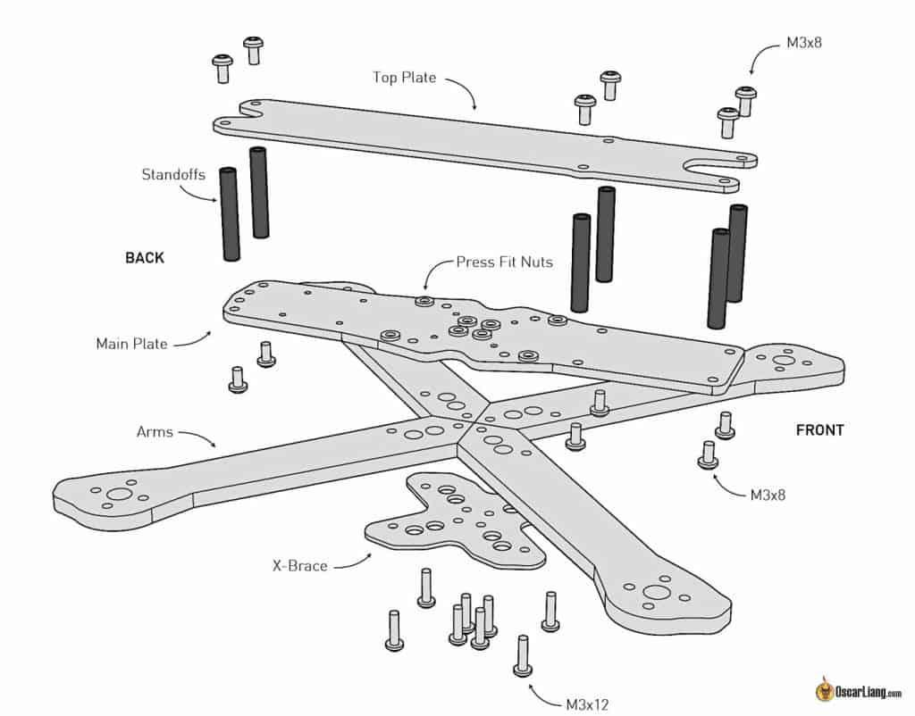
Figure 2.1: Exploded View of a Typical 5-inch FPV Frame Showing the Arms, Plates, Standoffs and Bolts
Source: Oscar Liang, "Best Mini Quad / FPV Frame Buying Guide," oscarliang.com; PX4 Airframe Reference, docs.px4.io/main/en/airframes/airframe_reference.html
The frame used in this project is the GEPRC Mark5 5-inch carbon fibre frame shown in Figures 2.2 and 2.3. It is a true-X frame with a diagonal motor-to-motor distance (wheelbase) of 225 mm and overall plan dimensions of 214 mm × 168 mm. The kit includes 3D-printed accessories such as arm guards, an antenna mount and camera/GPS mounts.
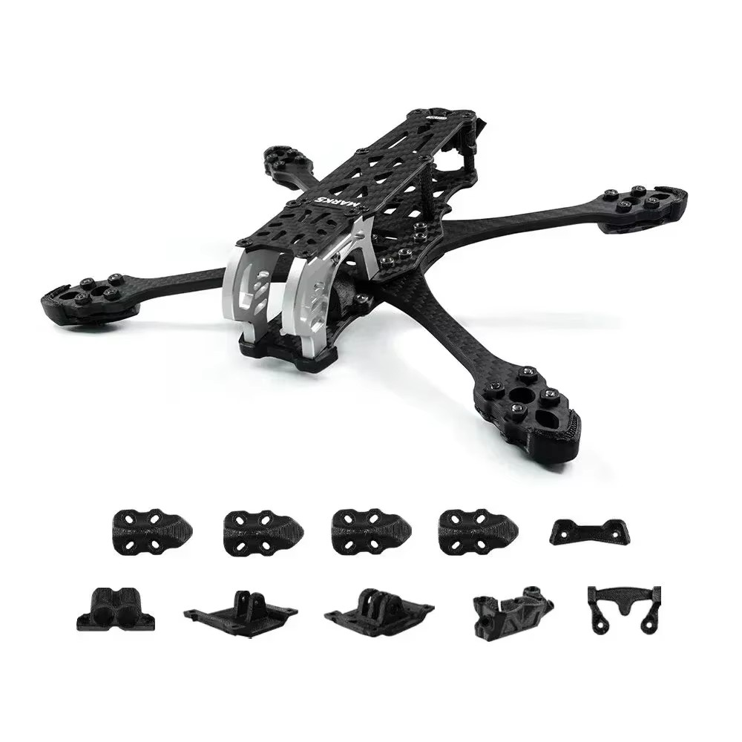
Figure 2.2: GEPRC Mark5 5-inch Carbon Fibre Frame Kit and Accessories
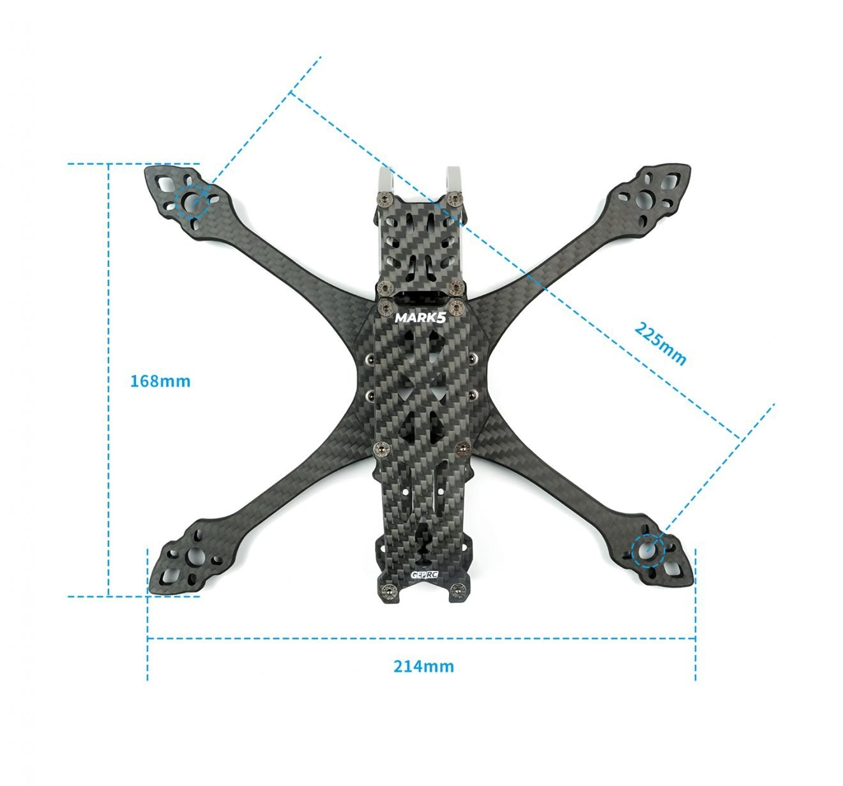
Figure 2.3: Carbon Fibre 5-inch Frame Geometry and Dimensional Drawing

2.1.2 Flight Dynamics and Rigid-Body Equations of Motion
The dynamics of a multirotor UAV are described by the Newton–Euler equations of motion for a rigid body. The translational dynamics relate the net force (thrust minus aerodynamic drag minus gravity) to linear acceleration, while the rotational dynamics relate the net torque (differential thrust moments and gyroscopic effects) to angular acceleration. These six coupled differential equations form the mathematical model used in simulation and control design.
Non-linearities arise from the attitude-dependent thrust direction, aerodynamic drag proportional to the square of velocity and gyroscopic precession effects from the spinning rotors. At low speeds and small angles, these equations can be linearised for control design purposes; at higher speeds and large attitude angles, full non-linear models are required to predict vehicle behaviour accurately.
In a multirotor configuration, each propeller operates within its own localised airflow, and its aerodynamic efficiency depends heavily on avoiding interference from adjacent rotors. To optimise performance and ensure balanced thrust across the airframe, each motor must operate at an appropriate rotational speed and be paired with a matched Kv rating and a propeller pitch tailored to the drone's weight distribution and flight dynamics.
Table 2.1: Comparison of Multirotor Frame Materials
Material | Strength-to-Weight | Vibration Damping | Cost | Notes
Carbon fibre (used in this build) | Excellent | Moderate | Medium–High | Stiff and lightweight; conducts electricity, so wiring must be insulated
Aluminium | Good | Poor | Low–Medium | Heavier; prone to fatigue cracking
Fibreglass (G10) | Moderate | Good | Low | Flexible; absorbs vibration; heavier than carbon fibre
3D-printed nylon/PETG | Low–Moderate | Good | Very Low | Lightweight but less stiff; used for accessory mounts
Wood (balsa/plywood) | Low | Excellent | Very Low | Used in fixed-wing aircraft; uncommon in multirotors

2.2 Multirotor UAV Power and Drive Systems

2.2.1 Overview of the Propulsion Architecture
The power and drive system encompasses the energy storage, power distribution and electrical drive components that convert stored chemical energy into mechanical thrust. Lithium polymer (LiPo) batteries are the dominant energy storage technology for UAV applications because of their high specific energy (energy per unit mass), high specific power (power per unit mass) and low internal resistance, which enables high peak current delivery (Warner, 2019).
The 4S (four cells in series) 1500mAh 75C LiPo battery used in this project provides a nominal voltage of 14.8 V (16.8 V when fully charged) and a maximum continuous discharge current of 112.5 A (1500 mAh × 75C), well above the peak system demand. Battery capacity selection involves a trade-off between energy (and therefore endurance) and weight: a heavier battery provides more energy but reduces the thrust margin and manoeuvrability.
Power distribution is managed through the 4-in-1 ESC's integrated power bus, which delivers battery voltage directly to all four motor drivers. A voltage regulator integrated in the ESC (or in the flight controller stack) steps the battery voltage down to 5 V and 9 V rails that power the flight controller, receiver, GPS module and other avionics. A robust power architecture, including adequate capacitance on the power bus to absorb current transients during rapid throttle changes, is essential to prevent voltage ripple from corrupting sensor data.
Table 2.2: ESC Specifications Comparison: SpeedyBee 60A versus Alternative Options
Specification | SpeedyBee BLS 60A (4-in-1, used in this build) | Holybro Tekko32 F4 65A | T-Motor F55A Pro II
Continuous current | 60 A per ESC | 65 A per ESC | 55 A per ESC
Firmware | BLHeli_S / Bluejay | BLHeli_32 | BLHeli_32
Voltage support | 3–6S LiPo | 3–6S LiPo | 3–6S LiPo
Mounting | 30.5 × 30.5 mm | 30.5 × 30.5 mm | 30.5 × 30.5 mm
Telemetry | Yes (via FC) | Yes (BLHeli_32) | Yes (BLHeli_32)
Heatsink | Aluminium alloy (V4) | Aluminium | Aluminium

2.2.2 LiPo Battery Technology
Lithium polymer (LiPo) batteries are the dominant energy storage technology for high-performance UAV applications because of their exceptional energy density, high discharge-rate capability and favourable weight-to-capacity ratio. A LiPo cell nominally operates at 3.7 V, with a fully charged voltage of 4.2 V and a minimum safe discharge voltage of 3.5 V per cell.
The "4S" designation refers to a battery with four cells connected in series, giving a nominal voltage of 14.8 V and a fully charged voltage of 16.8 V. The "75C" rating indicates the maximum continuous discharge rate relative to the battery capacity: a 1500mAh 75C battery can theoretically discharge 112.5 A continuously (1.5 Ah × 75 = 112.5 A), which is critical for supplying peak current during aggressive manoeuvres.
Battery management for autonomous UAVs must account for voltage sag under load, temperature-dependent capacity reduction and the relationship between state of charge and flight performance. The ArduPilot battery monitor, connected through the power module's analogue voltage and current sense outputs, tracks real-time power consumption and estimates the remaining flight time, triggering a failsafe RTL when the battery reaches a critical threshold.

2.2.3 Electronic Speed Controllers (ESCs)
The Electronic Speed Controller is the power electronics interface between the flight controller's digital control signals and the three-phase AC power required by brushless motors. Modern UAV ESCs use field-effect transistors (FETs) configured in a three-phase bridge topology to generate the commutating AC waveform that drives motor rotation. The timing and amplitude of this waveform directly determine motor speed and torque.
Digital communication protocols have largely replaced analogue PWM for UAV ESC control. DShot (Digital Shot) is the current standard, offering noise-immune, bidirectional digital communication at rates from DShot150 to DShot600. The SpeedyBee 60A 4-in-1 ESC used in this project supports DShot600, which sends 16-bit throttle commands with negligible latency, enabling the flight controller to make the extremely rapid motor speed adjustments essential for stable autonomous flight.
BLHeli_32 or AM32 ESC firmware provides configurable current limiting, motor start-up protocols and bidirectional DShot telemetry, which reports per-motor RPM, temperature and current back to the flight controller. This telemetry enables RPM-based harmonic notch filtering, a technique that adaptively removes motor vibration frequencies from the gyroscope data and dramatically improves the quality of attitude estimation. The ESC stack is compatible with BLHeli_32 firmware and supports bidirectional DShot communication, allowing real-time RPM telemetry to be returned to the flight controller. This RPM feedback is critical for implementing RPM-based (notch) filtering in ArduPilot to suppress motor harmonic noise in the gyroscope data, improving flight controller stability and attitude estimation accuracy.
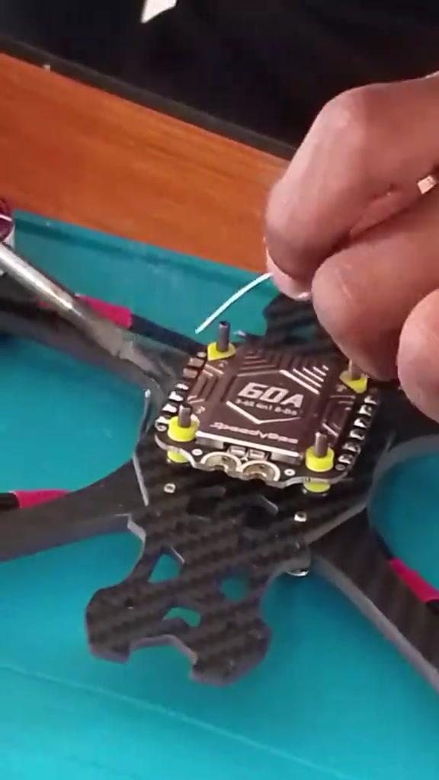
Figure 2.4: SpeedyBee 4-in-1 ESC Being Installed on the Frame
The manufacturer's specifications for the SpeedyBee 4-in-1 ESC board supplied with the flight controller stack are summarised in Table 2.3.
Table 2.3: Manufacturer Specifications of the SpeedyBee 4-in-1 ESC
Parameter | Specification
Product name | SpeedyBee OX32 55A 30×30 Four-in-One ESC
Default firmware | OX32
Rated current | 55 A (single channel); 220 A (4 channels)
Maximum current | 70 A (single channel); 280 A (4 channels)
Surge protection | Built-in TVS transient suppression diode; 1000 µF solid capacitor included
ESC/motor protocol | DShot300 / DShot600
Input voltage | 3–6S lithium battery
Output voltage | VBAT
Ammeter | Supported (Scale = 27, Offset = −2644)
ESC telemetry feedback | Supported
Mounting hole pattern | 30.5 × 30.5 mm (4 mm aperture), side opening
Size | 40.9 mm (L) × 44.9 mm (W) × 8.0 mm (H), including heat sink
Weight | 19.1 g
ESC configurator | https://ox32.oxbot.com/

2.2.4 ESC Operating Principles
An Electronic Speed Controller is the power electronics module that translates a throttle command from the flight controller into a precisely timed three-phase AC voltage waveform that drives a brushless DC motor. Its fundamental operating principle is electronic commutation: the ESC's microcontroller switches the motor's three windings on and off in a rotating sequence, creating a rotating magnetic field that the motor's rotor follows.
Modern UAV ESCs use complementary pairs of N-channel MOSFETs (metal-oxide-semiconductor field-effect transistors) in a three-phase bridge configuration. The switching frequency, typically 8–96 kHz for audio-silent operation, determines the smoothness of current delivery to the motor. Higher switching frequencies reduce audible motor noise and current ripple but increase switching losses in the MOSFETs, slightly reducing efficiency.

2.2.5 DShot Digital Protocol
DShot (Digital Shot) is a digital motor control protocol developed to replace the analogue PWM (Pulse Width Modulation) interface used in earlier UAV systems. PWM throttle commands are susceptible to electrical noise, require careful calibration and have a minimum latency of approximately 2 ms per update cycle. DShot eliminates these limitations by encoding the throttle value as a 16-bit digital frame transmitted at rates from DShot150 (150 kbaud) to DShot1200 (1200 kbaud).
The SpeedyBee 60A 4-in-1 ESC supports DShot600, providing a transmission speed of 600 kbaud with practically no susceptibility to electrical noise. The DShot throttle value space (0–2047) provides finer resolution than equivalent 8-bit PWM systems. Bidirectional DShot enables the ESC to report eRPM (electrical RPM) telemetry back to the flight controller, supporting RPM-based notch filtering and motor health monitoring.

2.2.6 ESC Thermal Management and Current Ratings
The current rating of an ESC defines the maximum continuous current it can supply to its motor. For an X4 configuration with T-Motor Velox V2207 2050KV motors capable of drawing up to 46 A each at maximum thrust, the 60 A continuous rating of the SpeedyBee ESC provides adequate headroom for normal operation but leaves a limited thermal margin at sustained maximum throttle.
Thermal management of ESCs is important for long-duration missions. Resistive heat dissipation in the MOSFETs is proportional to the square of the current, so at 46 A the dissipation is more than twice that at 32 A. Placing the ESC in the direct airflow path of the propellers provides passive cooling that is essential for maintaining safe operating temperatures. ESC temperature data reported via DShot telemetry allows ArduPilot to trigger thermal protection failsafes if dangerous temperatures are detected.

2.2.7 Brushless Motor Selection
Brushless direct current (BLDC) motors are the standard propulsion actuators for modern UAV applications, having supplanted brushed DC motors because of their superior power density, efficiency and lifespan and the elimination of brush-contact arcing. A BLDC motor consists of a permanent-magnet rotor and a wound stator; electronic commutation replaces the mechanical commutator and brush assembly of conventional DC motors (Krishnan, 2010).
BLDC motors are specified by their KV rating, the number of RPM per volt of applied voltage under no-load conditions. Expressed in RPM per volt, the KV rating is the primary specification defining a BLDC motor's operating regime. For a given propeller size and battery voltage, the KV value determines the operating RPM and therefore the thrust and power characteristics of the motor–propeller combination. A lower-KV motor turning a larger, higher-pitch propeller is generally more efficient for heavy-lift applications, while a higher-KV motor with a smaller propeller provides faster response for agility-focused platforms. High-KV motors (above 2000 KV) are designed for smaller propellers and faster rotation, while low-KV motors (below 1000 KV) are paired with large propellers for efficiency-optimised flight. The T-Motor Velox V2207 2050KV motors selected for this project are high-performance, competition-grade motors with a 22 mm stator diameter and 7 mm stator height, providing strong thrust output suitable for the 5-inch frame.
Motor performance is characterised by its thrust curve, efficiency map and thermal limits. Published test data for the T-Motor Velox V2207 2050KV on 4S power with 5-inch tri-blade propellers indicate a maximum static thrust of approximately 900–1100 grams per motor at full throttle, yielding a total system thrust-to-weight ratio well above the 2:1 minimum recommended for stable and responsive flight.
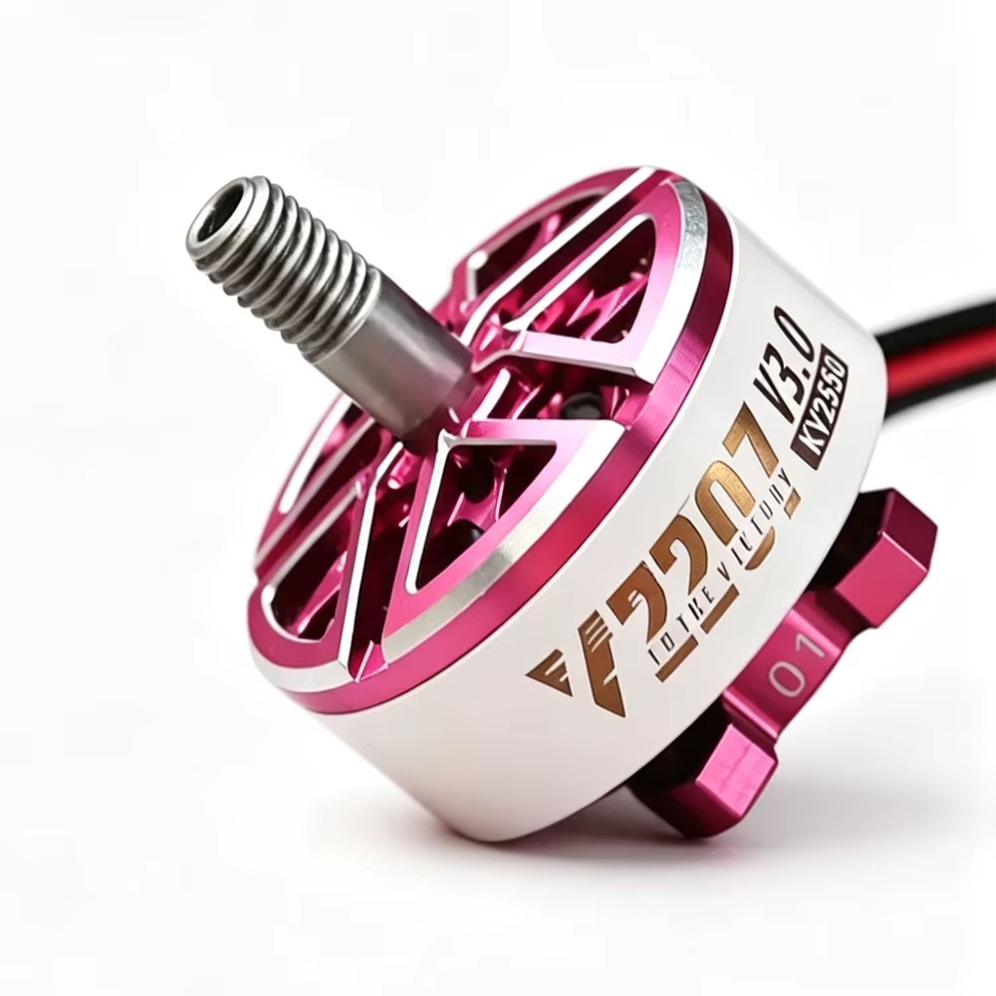
Figure 2.5: T-Motor Velox V2207 V3 Brushless Motor
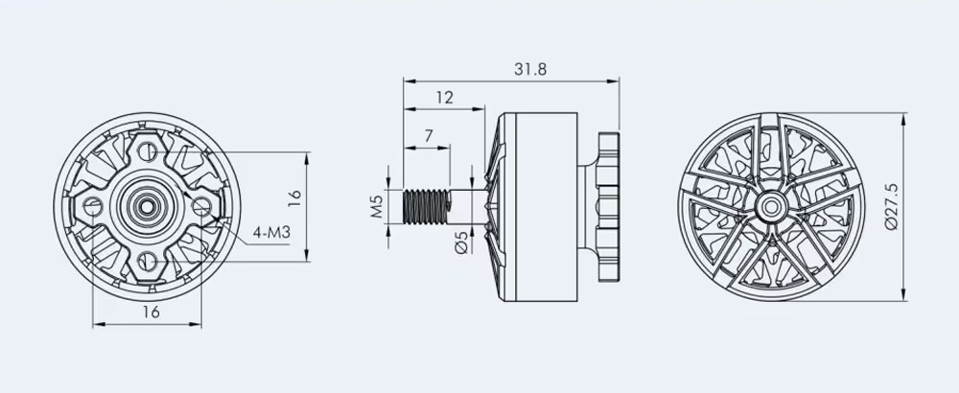
Figure 2.6: T-Motor Velox V2207 V3 Motor Dimensional Drawing (dimensions in mm)
Source: T-Motor V2207 V3 product data
As shown in Figure 2.6, the motor has a 4 × M3 mounting pattern on a 16 mm × 16 mm square, a 27.5 mm bell diameter, an overall length of 31.8 mm and an M5 threaded output shaft with a 5 mm shaft diameter.
Table 2.4: Brushless Motor Performance Parameters at Full Throttle
Throttle | KV Variant | Max Power | Peak Current | Notes
100% | 1750KV | 814.3 W | 34.6 A | Balanced racing/freestyle
100% | 1950KV | 1050.5 W | 45.0 A | Higher RPM
100% | 2050KV (used in this build) | 1153.4 W | 49.5 A | Aggressive freestyle
100% | 1500KV | 1915.1 W | 33.3 A | Long-range efficiency

The complete manufacturer specifications for the V2207 V3 motor family, from which the 2050KV variant was selected, are given in Table 2.5.
Table 2.5: T-Motor Velox V2207 V3 Manufacturer Specifications
KV | Configuration | Shaft Diameter | Lead | Weight incl. Cable (g) | Rated Voltage (LiPo) | Idle Current (10 V) | Max. Power, 60 s (W) | Peak Current, 60 s (A)
1500KV | 12N14P | In: 4 mm; Out: 5 mm | 20# 150 mm | 34.6 | 8S | 0.9 A | 1915.1 | 33.3
1750KV | 12N14P | In: 4 mm; Out: 5 mm | 20# 150 mm | 37.3 | 6S | 1.2 A | 814.3 | 34.6
1950KV | 12N14P | In: 4 mm; Out: 5 mm | 20# 150 mm | 37.1 | 6S | 1.32 A | 1050.5 | 45.0
2050KV | 12N14P | In: 4 mm; Out: 5 mm | 20# 150 mm | 36.8 | 6S | 1.66 A | 1153.4 | 49.5
2550KV | 12N14P | In: 4 mm; Out: 5 mm | 20# 150 mm | 36.5 | 4S | 2.25 A | 642.5 | 41.8

The T-Motor Velox V2207 2050KV motors selected for this project represent a high-performance choice optimised for 5-inch propeller systems on 4S LiPo power. At 2050KV on 4S (14.8 V), the theoretical no-load speed is approximately 30,340 RPM, which translates to practical operating speeds of 18,000–25,000 RPM under load.
Table 2.6 is an extract from the manufacturer's test report for the 2050KV variant fitted with the T-Motor T5143S-3 tri-blade propeller. Of the propellers in the test report, the T5143S-3 (5.1 × 4.3 inches) is the closest in size and pitch to the 5 × 4.3-inch propeller used in this build, so only its 2050KV rows are reproduced, from 20% to 100% throttle. The tests were performed at approximately 24 V (6S); thrust on the 4S battery used in this project will be correspondingly lower. The motor produced about 230 g of thrust at 20% throttle and 1614.9 g at full throttle.
Table 2.6: Manufacturer Test Data for the V2207 V3 2050KV Motor with the T-Motor T5143S-3 Propeller
Throttle | Voltage (V) | Current (A) | Speed (RPM) | Thrust (g) | Power (W) | Efficiency (g/W)
20% | 24.0 | 3.2 | 13498.0 | 230.0 | 76.7 | 3.0
40% | 23.9 | 9.9 | 20279.2 | 557.0 | 235.7 | 2.4
60% | 23.8 | 16.5 | 24677.8 | 837.4 | 392.0 | 2.1
80% | 23.6 | 27.0 | 29333.6 | 1197.0 | 637.5 | 1.9
100% | 23.4 | 44.8 | 34477.5 | 1614.9 | 1046.4 | 1.5

In Table 2.6, the power column is the electrical input power to the motor, P = V × I (for example, at 60% throttle, 23.8 V × 16.5 A ≈ 392 W). The efficiency column is the thrust produced per watt of electrical power, η = T / P, in grams per watt (for example, 837.4 g ÷ 392.0 W ≈ 2.1 g/W). Efficiency is highest at low throttle (about 3.0 g/W at 20%) and falls steadily to about 1.5 g/W at full throttle, because the power needed rises faster than the thrust produced. A multirotor that hovers at low to moderate throttle therefore uses its battery far more efficiently than one that must fly near full throttle.

2.2.8 Propeller Theory and Selection
Propellers are the aerodynamic lifting elements of a multirotor UAV. Their design parameters, including diameter, pitch, number of blades, material and tip speed, fundamentally determine the thrust, efficiency and acoustic signature of the vehicle. Propeller aerodynamics are governed by blade element momentum (BEM) theory, which models each blade section as an independent aerofoil generating lift and drag forces that integrate to produce net thrust and torque (Leishman, 2006).
Propeller diameter has a direct influence on thrust efficiency. Larger-diameter propellers move more air per revolution and are inherently more efficient (higher thrust per watt), but they turn at lower RPM and require higher-torque motors, which limits the speed of the dynamic response. Smaller propellers spin faster, respond more quickly to motor speed commands and are preferred for agile flight applications.
Blade count is a further design variable. Two-blade propellers offer the highest efficiency at a given diameter but produce significant pulsating aerodynamic forces. Three-blade (tri-blade) propellers, as employed in this project, offer a compromise between efficiency and vibration reduction, producing smoother thrust delivery and less propeller noise. Chen et al. (2019) demonstrated that tri-blade propellers have approximately 8% lower thrust efficiency than comparable two-blade designs but exhibit a 15% reduction in vibration-induced IMU noise.
The 5-inch tri-blade propellers selected for this build are well matched to the T-Motor V2207 2050KV motors operating on a 4S LiPo battery, providing a balance between thrust-to-weight ratio and flight endurance.
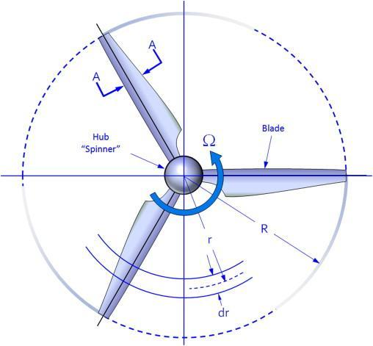
Figure 2.7: Tri-blade Propeller Aerodynamic Profile and Blade Element Diagram
Source: T-Motor propeller test reports; rcbenchmark.com aerodynamic analysis guides
Table 2.7: Propeller Performance Comparison: Two-blade, Three-blade and Four-blade
Type | Thrust | Efficiency | Noise | Typical Use
Two-blade | Lower static thrust | Highest efficiency | Lowest | Long-range and efficiency-focused builds
Three-blade (used in this project) | Balanced thrust | Moderate efficiency | Moderate | Freestyle/racing (used in this project)
Four-blade | Highest static thrust | Lowest efficiency | Highest | Acrobatic and high-torque builds

Propeller performance is characterised by three primary parameters:
i. Diameter: the diameter determines the mass of air accelerated per revolution and is the dominant factor in low-speed hovering efficiency.
ii. Pitch: the pitch is the theoretical distance the propeller advances per revolution in an ideal fluid, and it directly sets the relationship between RPM and airspeed.
iii. Blade count: the number of blades affects the balance between efficiency and vibration.
Tri-blade propellers offer a good compromise, reducing vibration compared with two-blade designs while maintaining reasonable efficiency.
The propellers used on this UAV are HQProp 5-inch tri-blade propellers (Figure 2.8). Their specifications are listed in Table 2.8. Each propeller weighs 4.0 g, as measured on a digital scale (Figure 2.9), so the full set of four adds only 16 g to the all-up weight.
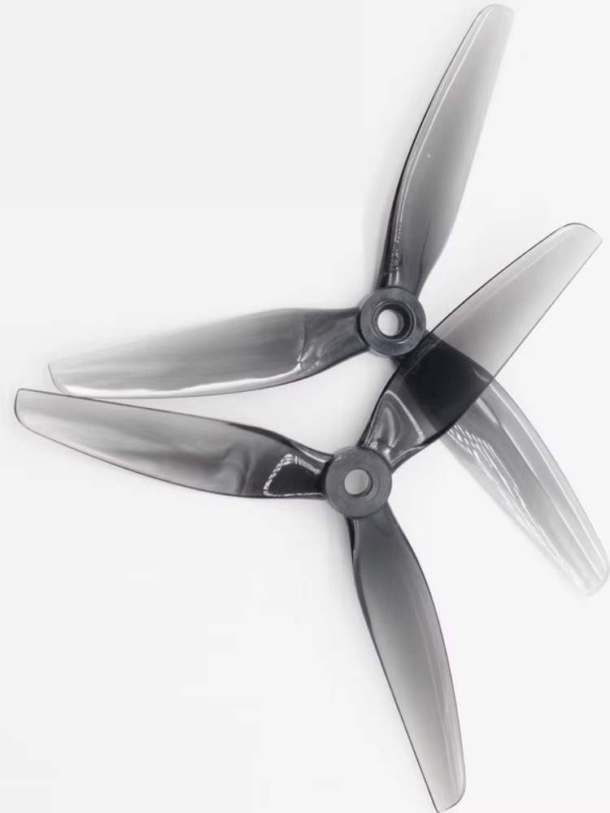
Figure 2.8: HQProp 5-inch Tri-blade Propellers Used on the UAV
Table 2.8: Specifications of the HQProp 5-inch Tri-blade Propeller
Parameter | Value
Propeller diameter | 5 inches
Pitch | 4.3 inches
Number of blades | 3
Hub (centre) thickness | 7 mm
Shaft (bore) diameter | 5 mm
Mass per propeller | 4.0 g

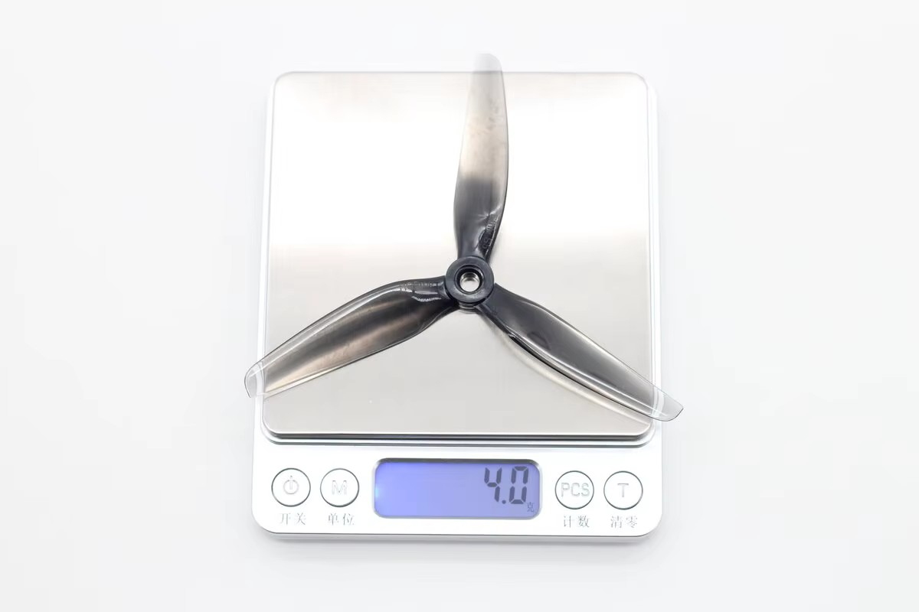
Figure 2.9: Weighing a Single Propeller (4.0 g)
The 5-inch tri-blade propellers selected for this project are optimised for the RPM range of the V2207 motors. Their relatively high pitch-to-diameter ratio provides efficient high-speed thrust generation while maintaining an adequate response speed. For the coaxial X8 configuration, the propeller pairs are counter-rotating (the upper and lower motors on each arm spin in opposite directions), which cancels the gyroscopic precession torques that would otherwise cause yaw instability.

2.3 UAV Flight Controllers

2.3.1 Fundamentals of Flight Controller Design
The UAV flight controller is the central processing and decision-making unit of any unmanned aerial system. It is a specialised microcontroller board that continuously reads data from onboard sensors, runs stabilisation and navigation algorithms, and outputs motor control signals to the Electronic Speed Controllers (ESCs). Without a properly configured flight controller, a multirotor UAV cannot maintain stable flight: because multirotor platforms are aerodynamically unstable, they require continuous electronic correction hundreds to thousands of times per second.
The computational architecture of a modern flight controller centres on a high-performance ARM Cortex microprocessor. The STM32 series from STMicroelectronics, particularly the F4, F7 and H7 variants, has become the industry standard. The H7 processor, operating at 480 MHz with double-precision floating-point unit (FPU) support, can execute sophisticated sensor fusion algorithms such as the 24-state Extended Kalman Filter (EKF3) without computational bottlenecks.
The flight controller (FC) is the computational and sensory core of the UAV. It integrates an inertial measurement unit (IMU) containing accelerometers and gyroscopes, a barometric altimeter, and interfaces for external sensors including GPS, compass and rangefinders. The FC performs real-time attitude estimation using sensor fusion algorithms, implements feedback control laws (typically PID controllers) to stabilise the vehicle, and interfaces with the RC receiver, ESCs and telemetry radio (Meier et al., 2015).
The SpeedyBee F405 V4 is a high-specification flight controller based on the STM32F405 microprocessor running at 168 MHz. It incorporates an IMU configuration (ICM-42688-P and MPU-6000) that provides redundancy and improved sensor averaging. The F4 processor provides sufficient computational throughput for high-rate PID loop execution at 8 kHz, enabling precise attitude control even in turbulent conditions.

2.3.2 Core Sensors Integrated in Flight Controllers
Inertial Measurement Unit (IMU): The IMU is the primary attitude sensor and consists of a three-axis MEMS accelerometer and a three-axis MEMS gyroscope. High-performance flight controllers typically feature dual or triple redundant IMUs, such as the ICM-42688-P and ICM-20649, to enable cross-validation and failover. The sampling rate of modern IMUs exceeds 8 kHz, although the flight controller's processing loop typically runs at 400 Hz to 1 kHz.
Barometric pressure sensor: Altitude hold depends critically on the barometric pressure sensor, which measures atmospheric pressure and converts it to a relative altitude estimate. The MS5611 and BMP390 sensors offer a resolution of about 10 cm of altitude change, although they are sensitive to airflow from the propellers, so foam covers or recessed placement are necessary.
Magnetometer (compass): The digital compass measures the Earth's magnetic field to determine the UAV's heading. Mounting it externally on a GPS mast is standard practice, because the high current flowing through the ESC and battery leads generates strong electromagnetic interference (EMI) that can corrupt the compass reading and cause severe heading errors during autonomous flight.

2.3.3 Extended Kalman Filter: The Core of Sensor Fusion
The Extended Kalman Filter (EKF) is the mathematical cornerstone of modern autonomous UAV flight. It is a recursive Bayesian estimation algorithm that fuses measurements from multiple sensors (GPS, IMU, magnetometer, barometer and, optionally, vision or optical flow sensors) into a single optimal estimate of the vehicle's state vector, which includes position, velocity, attitude and sensor biases.
ArduPilot's EKF3 implementation uses a 24-state model and processes sensor data at up to 400 Hz. The Normalised Innovation Squared (NIS) metric monitors EKF health by comparing measured sensor values with predicted values. A consistently high NIS value indicates sensor inconsistency and triggers a warning to the operator via the GCS. This self-monitoring capability is a critical safety feature for autonomous operations.

2.3.4 SpeedyBee F405: The Project Flight Controller
The SpeedyBee F405 V4 was selected for this project for its balance of processing power, port availability and ArduPilot compatibility. Powered by an STM32F405 processor running at 168 MHz, it provides sufficient computational headroom for the EKF3 algorithm while simultaneously managing GPS, radio receiver, LiDAR and telemetry data streams. It features six UART ports, dedicated I2C and SPI buses and a 4-in-1 ESC connector, which significantly simplifies the wiring harness.
The onboard ICM-42688-P IMU provides high-quality, low-noise attitude sensing with an 8 kHz gyroscope output data rate. When running ArduPilot, the controller passes the IMU data through a low-pass filter configured for the motor vibration frequencies of the airframe, effectively suppressing mechanical noise before it enters the EKF.
The open-source ArduPilot firmware running on the SpeedyBee F405 provides a mature, feature-rich autopilot capability. ArduPilot supports over 30 flight modes, including Loiter (GPS-stabilised hover), Auto (autonomous waypoint missions) and RTL (Return to Launch). Its extensive parameter configuration system, active developer community and proven reliability in thousands of deployments worldwide make it the preferred choice for serious UAV development projects (ArduPilot Development Team, 2023).
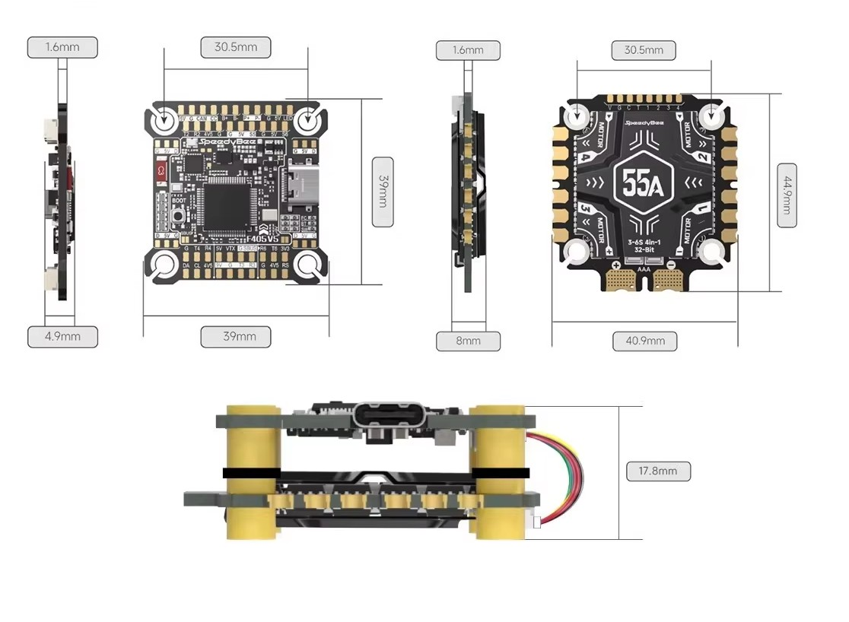
Figure 2.10: SpeedyBee F405 Flight Controller and 4-in-1 ESC Stack: Board Layout and Dimensions
Source: SpeedyBee product documentation
As shown in Figure 2.10, both boards use the standard 30.5 × 30.5 mm mounting pattern. The flight controller measures 39 mm × 39 mm with a thickness of 4.9 mm, the ESC measures 40.9 mm × 44.9 mm × 8 mm, and the assembled stack is 17.8 mm tall. The main components of the flight controller, identified by their manufacturer part numbers, are listed in Table 2.9.
Table 2.9: Main Components of the SpeedyBee F405 Flight Controller
Component | Part Number / Specification
Main controller (MCU) | STM32F405
Gyroscope (IMU) | ICM-42688-P
Barometer | SPA06-003
OSD chip | AT7456E
Input voltage | 3–6S LiPo battery

Table 2.10: Navigation System Component Specifications
Component | Primary Function | Critical Specifications | Project Standard
Flight controller (FC) | Central processing and sensor fusion (EKF) | STM32 H7 processor; 400 MHz+; multi-UART support (6+ ports) | SpeedyBee F405 V4 or Cube Orange+
IMU (gyro/accelerometer) | Attitude and motion sensing (pitch, roll, yaw) | Sampling rate 1–8 kHz; low noise floor; vibration damping | ICM-42688-P or MPU6000
GNSS module | Absolute global positioning and time synchronisation | Multi-constellation; 10 Hz refresh; <2.5 m accuracy | u-blox M10 or M8N series
Magnetometer | Heading and directional orientation | High interference resistance; external mounting capability | IST8310 or QMC5883L
Barometer | Relative altitude and vertical hold | Pressure resolution 0.012 mbar; altitude accuracy ±0.5 m | MS5611 or BMP280

2.4 UAV Communication Protocols

2.4.1 UAV Radio Transmission Systems
The radio control (RC) system provides the primary command link between the pilot and the UAV. An RC system consists of a transmitter (the handheld controller or GCS), a receiver mounted on the UAV and the radio-frequency link between them. Modern RC systems operate in the 2.4 GHz ISM band using frequency-hopping spread spectrum (FHSS) or direct-sequence spread spectrum (DSSS) modulation to provide robust, interference-resistant communication (Boddhu & Gallagher, 2010).
The Skydroid G30 (Figure 2.11) is an integrated GCS that combines RC transmitter functionality with a long-range video and telemetry data link operating in the 900 MHz and 2.4 GHz bands. It supports a control range of up to 30 kilometres under line-of-sight conditions and provides an integrated Android-based tablet interface running QGroundControl. This integration simplifies the operator workstation by eliminating the need for a separate RC transmitter and GCS laptop, which is a significant operational advantage in field deployments.
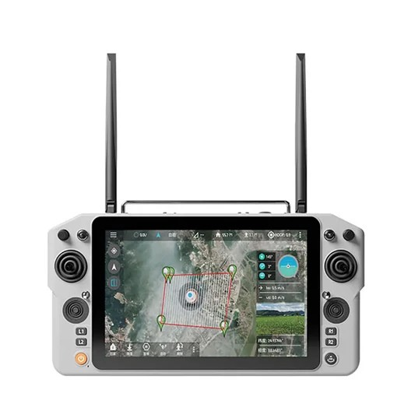
Figure 2.11: Skydroid G30 Ground Control Station
Source: Skydroid product documentation
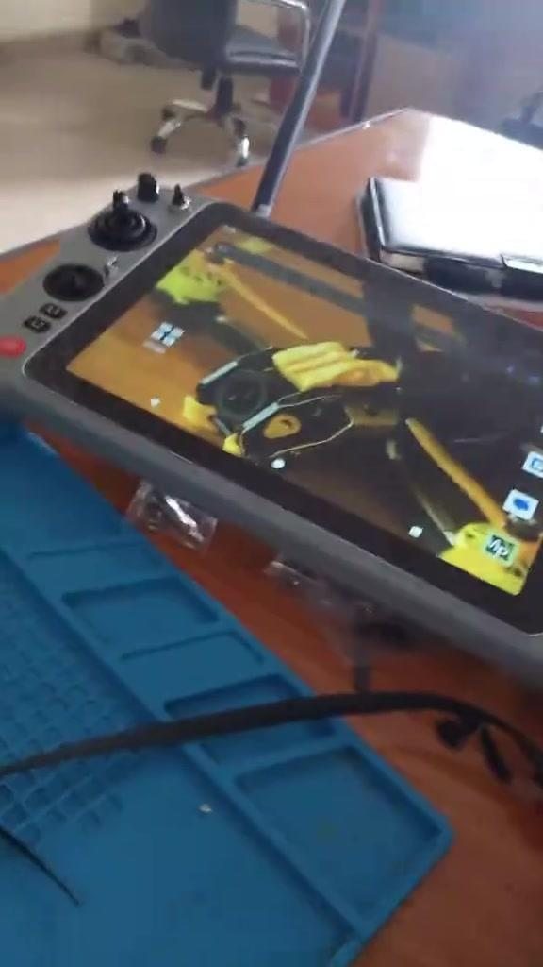
Figure 2.12: Skydroid G30 Displaying the Live Camera Feed During Bench Setup
The Skydroid GR01 receiver (Figure 2.13) pairs with the G30 transmitter and provides an SBUS output to the flight controller as well as UART telemetry pass-through. It incorporates a power output that can serve as a 5 V BEC for the FC stack, reducing the number of separate power regulation components required in the design.
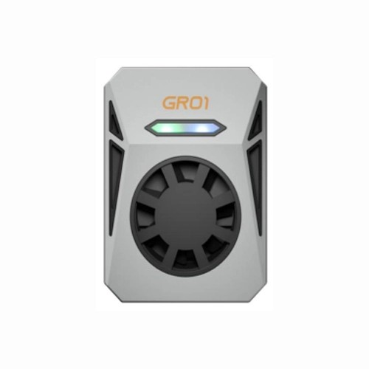
Figure 2.13: Skydroid GR01 Air-Unit Receiver
Source: Skydroid product documentation

2.4.2 Command and Control (C2) Radio Protocols
To establish a robust communication link, specific RF systems and serial protocols are used. Understanding the distinction between wireless transmission protocols (the RF link in the air) and wired serial protocols (the language used between the receiver and the flight controller) is critical in UAV system design.
ELRS (ExpressLRS): An open-source, high-performance radio link based on LoRa (Long Range) hardware. Typically operating at 2.4 GHz or 900 MHz, ELRS is currently the most rapidly adopted protocol in drone engineering. It is designed specifically for long range, very low latency and high refresh rates of up to 1000 Hz. It achieves this through highly optimised packet structures, which make it very resistant to interference in urban surveillance environments.
Crossfire (TBS Crossfire): A proprietary UHF (868/915 MHz) long-range system developed by Team BlackSheep. Crossfire is renowned for its reliability and robust signal penetration. Because it operates at a lower frequency than standard 2.4 GHz links, its signals pass through solid objects such as buildings and trees more easily, making it a standard for professional mapping operations where non-line-of-sight (NLoS) or beyond-visual-line-of-sight (BVLOS) capability is required.
Spektrum (DSMX/DSM2): A widely used 2.4 GHz digital protocol. Although it is highly reliable and widely supported for line-of-sight hobbyist operations, its maximum range and penetration are generally lower than those of LoRa-based systems such as ELRS or Crossfire, making it less suitable for long-range autonomous surveillance.
Table 2.11: Comparison of UAV Receiver-to-Flight Controller Protocols
Protocol | Inverted Signal | Typical Channels | Latency | Primary Use Case
SBUS | Yes | 16–18 | Medium | Standard commercial drones
IBUS | No | 14–18 | Medium | Budget/hobbyist set-ups
Spektrum | No (3.3 V) | 12–20 | Medium | Line-of-sight RC
CRSF (Crossfire/ELRS) | No | Multiple | Very low | Long-range/autonomous BVLOS

2.4.3 Bandwidth and Range Trade-offs
In UAV communications there is a fundamental physical limitation, described by the Shannon–Hartley theorem on channel capacity: there is an unavoidable trade-off between bandwidth (the amount of data transferred per second) and range or penetration (how far a signal can reliably travel).
Control links (Tx to Rx): Protocols such as ELRS and Crossfire require very little bandwidth, as they only need to transmit small packets of stick positions and basic telemetry. Because the data packets are tiny, these links can use lower frequencies (900 MHz) or advanced LoRa modulation to achieve exceptional range and excellent object penetration.
Payload links (video/VTX): Real-time surveillance video requires very large bandwidth. Transmitting 1080p or 4K video requires higher frequency bands, such as 5.8 GHz, or cellular LTE systems. High frequencies can carry high data rates, but their short wavelengths suffer from rapid signal attenuation and poor penetration through solid objects.
This asymmetry means that mapping drones rely critically on the flight controller's autonomy. If the high-bandwidth video link drops because of range limitations, the drone's low-bandwidth C2 link usually survives, allowing the operator to initiate an autonomous RTL or allowing the drone to complete its photogrammetry grid independently.

2.4.4 Line-of-Sight and Multipath Propagation
During UAV operations, communication performance is significantly better when there is a clear line of sight between the UAV and the ground station. In urban surveillance environments, however, signals are degraded by obstruction and multipath effects. Multipath propagation occurs when radio signals bounce off structures, buildings, the ground or water and arrive at the receiver at slightly different times, causing phase cancellation and data corruption.
Antenna design and placement are therefore critical in UAV systems to mitigate multipath effects. Circular polarisation reduces the impact of multipath by rejecting signals that have undergone an odd number of reflections, since each reflection reverses the sense of polarisation. Diversity receivers, which select the strongest signal from multiple antenna elements, further improve reliability in complex multipath environments.

2.4.5 Antennas, Placement and Integration
Communication performance depends heavily on the antenna type and radiation pattern, the antenna's placement relative to carbon structures and electronics, and cable routing and grounding. Poor antenna placement can reduce the effective range by orders of magnitude, regardless of the radio's specifications. This reinforces the need for system-level integration rather than component-level optimisation.
Table 2.12: Comparison of Antenna Types in UAV Communication
Antenna Type | Coverage Pattern | Advantages | Disadvantages
Omnidirectional | 360° (doughnut-shaped) | Wide coverage; drone can rotate freely | Lower maximum range
Directional | Focused beam | Very long range; strong signal penetration | Requires precise alignment
Patch (planar) | Hemispherical | Compact; high gain in the forward hemisphere | Restricted angular coverage
Helical | Circularly polarised cone | Resistant to multipath; good axial range | Bulky; complex to manufacture

2.4.6 Video Transmission Systems
Video transmission systems provide the operator with a real-time first-person view (FPV) of the flight environment, enabling manual piloting, situational awareness during autonomous missions and visual confirmation of mapping coverage. Video transmission in UAVs typically operates in the 5.8 GHz band for analogue systems, or over Wi-Fi or proprietary digital links for digital HD video (Chen et al., 2020).
The Skydroid G30 system includes an integrated long-range digital video downlink capable of transmitting 1080p video from a compatible camera on the UAV to the GCS display. This eliminates the need for a separate video transmitter module, reducing overall system complexity and weight. The integrated video link is synchronised with the telemetry data, enabling operators to overlay altitude, speed, GPS coordinates and battery voltage on the live video feed.
For surveillance applications specifically, the quality and latency of the video link are critical performance metrics. The Skydroid system's digital video architecture provides lower latency than traditional analogue 5.8 GHz systems (typically under 150 ms end to end) and superior image quality, which is essential for target identification and situational assessment.
Video transmission in UAV systems serves two primary functions: real-time monitoring for safe manual operation and obstacle awareness, and payload data delivery for surveillance and inspection missions. Analogue FPV systems operating at 5.8 GHz offer ultra-low latency (less than 20 ms) at the cost of image quality, which makes them the preferred choice for manually piloted proximity flying. Digital video systems such as the DJI O3, HDZero and Walksnail Avatar provide HD video at latencies of 25–50 ms, balancing quality and responsiveness.
For autonomous mapping missions, the video link serves primarily as a situational awareness tool rather than a control feedback channel, because the aircraft is following a pre-programmed mission. In this context, video latency is less critical than video quality and stability. The 5.8 GHz VTX system used in this project provides sufficient visual quality for monitoring the camera payload and verifying delivery locations.

2.4.7 Security in UAV Communication Systems
Security is a major concern in UAV communication systems because they rely on wireless transmission, which leaves UAVs vulnerable to interference and unauthorised access. Several types of cyber-attack pose threats:
i. Jamming: intentional interference to disrupt communication;
ii. Spoofing: sending false signals to mislead the UAV;
iii. Eavesdropping: unauthorised interception of data; and
iv. Hijacking: taking control of the UAV through the command link.
To address these threats, modern UAV systems implement security measures including encryption of communication data, device authentication, frequency-hopping techniques and secure communication protocols. Despite these measures, many existing systems still have vulnerabilities, especially those that use lightweight protocols without strong encryption. Security vulnerabilities have been identified in MAVLink, including susceptibility to spoofing, which necessitates additional security layers for critical applications.

2.4.8 Advanced Communication Technologies
Recent advances in communication technology have significantly improved UAV performance. The integration of 5G networks enables ultra-low latency and high data rates, making it possible for UAVs to perform complex tasks such as real-time video streaming and remote control over long distances. Menon et al. (2025) demonstrated a UAV framework integrating MAVLink with 4G/LTE, using VPN tunnelling for secure BVLOS connectivity.
Internet of Things (IoT) integration allows UAVs to interact with smart devices and systems, enabling automation and intelligent decision-making. Artificial intelligence is increasingly applied to optimise communication systems: AI algorithms can predict signal loss, select optimal communication channels and manage network resources efficiently. Neural-network-based path-loss prediction models, as demonstrated by Zhang et al. (2024), offer significant improvements over traditional empirical models in complex urban propagation environments.
Communication between the flight controller and peripheral devices is governed by a hierarchy of digital protocols. At the physical layer, UART (Universal Asynchronous Receiver-Transmitter) serial communication is the dominant interface, used to connect GPS receivers, telemetry radios, RC receivers and companion computers to the FC. The SpeedyBee F405 provides multiple UART ports, each of which can be assigned a specific function through ArduPilot's serial configuration parameters.
DShot is a digital, bidirectional motor control protocol that uses the same signal wires as PWM but eliminates analogue signal degradation. The DShot variants (DShot300, DShot600 and DShot1200) differ in data transmission rate; higher speeds allow more frequent command updates and lower-latency motor response. MAVLink (Micro Air Vehicle Link) is the standard telemetry protocol used to exchange flight data between the autopilot and GCS software such as QGroundControl and Mission Planner. It is a lightweight binary protocol that supports over 200 message types covering attitude, GPS position, battery status, flight mode and command uplink (Koubaa et al., 2019).
SBUS and CRSF are RC link protocols used to transmit control channel data from the receiver to the FC. The Skydroid GR01 receiver outputs SBUS, a single-wire, inverted UART protocol that transmits up to 16 channels at 100 Hz. CRSF (Crossfire Serial), used by TBS and similar long-range systems, offers bidirectional communication and higher update rates but was not required for the distances expected in this project.
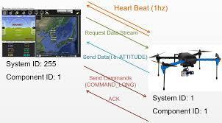
Figure 2.14: UAV Communication Protocol Stack and Data Flow (MAVLink Message Exchange)
Source: ArduPilot documentation, ardupilot.org/dev/docs/mavlink-basics.html

2.5 GPS Autonomous Navigation
Global Positioning System (GPS)-based autonomous navigation is a foundational capability for modern UAV applications. A GPS receiver on the UAV determines its three-dimensional position by processing timing signals from a constellation of orbiting satellites. Fusing GPS position data with IMU-derived velocity and attitude estimates produces a robust state estimate that enables autonomous navigation, with position accuracy typically in the range of 1.5–3.0 metres with standard GPS and sub-metre accuracy with differential correction or RTK GPS (Noureldin, Karamat, & Georgy, 2013).
The u-blox M8N GPS module is a high-sensitivity, multi-constellation receiver supporting the GPS, GLONASS, Galileo and BeiDou satellite systems. Multi-constellation reception improves positioning availability, accuracy and robustness to signal blockage. The M8N communicates with the flight controller via UART at a configurable baud rate, providing position, velocity and time (PVT) data in NMEA or UBX binary format.
ArduPilot's EKF3 (Extended Kalman Filter, version 3) fuses GPS, IMU, barometer and compass data to produce a high-bandwidth, low-latency state estimate. The EKF enables seamless transitions between GPS-aided and GPS-denied navigation and provides the state estimates required by autonomous flight modes, including Loiter, Auto and RTL.
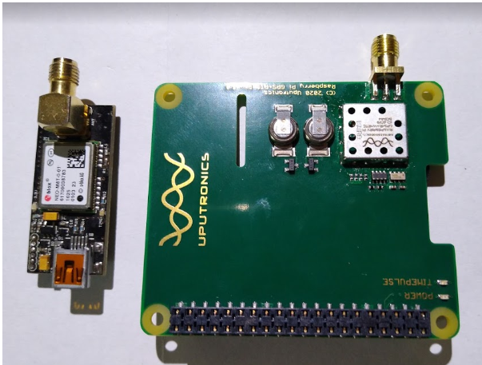
Figure 2.15: u-blox M8 GPS Module
Source: u-blox M8 Receiver Description and Protocol Specification, u-blox.com
[ PLACEHOLDER ] GPS Autonomous Navigation Flowchart
Insert: flowchart of GPS-based autonomous navigation in ArduPilot EKF3.

Figure 2.16: GPS Autonomous Navigation Flowchart in ArduPilot EKF3
Table 2.13: GPS Module Accuracy and Performance Specifications
Parameter | Specification
Constellations supported | GPS, GLONASS, BeiDou, Galileo, SBAS
Position accuracy (CEP) | 2.5 m
Navigation update rate | Up to 18 Hz (single GNSS); 10 Hz (concurrent)
Cold start TTFF | ~26 s
Hot start TTFF | ~1–2 s
Tracking sensitivity | −167 dBm

2.6 UAV Control Systems

2.6.1 PID Control Architecture
The Proportional-Integral-Derivative (PID) controller is the foundational control structure of virtually all commercial and research-grade multirotor UAVs. It is an error-minimising feedback controller that calculates a corrective output from three terms: the proportional term, which responds to the current error magnitude; the integral term, which accumulates past error to eliminate steady-state offset; and the derivative term, which anticipates future error by measuring the rate of change of the error.
In a multirotor UAV, cascaded PID loops operate at different timescales. The inner attitude control loop, running at 400 Hz or higher, uses gyroscope and accelerometer data to maintain the desired pitch, roll and yaw rates. The outer position control loop, typically running at 50–100 Hz, uses GPS and barometer data to maintain position and altitude. The navigation layer sits above these loops and provides position and velocity targets to the outer loop.
PID tuning for a multirotor configuration requires careful consideration of the aerodynamic coupling between stacked motor pairs. Downwash from the upper motors onto the lower motors creates non-linear thrust behaviour at high throttle settings, which can cause oscillations if the P-gains are set too aggressively. A conservative tuning approach, combined with ArduPilot's RPM-based harmonic notch filter, typically yields the best stability.

2.6.2 Advanced Control Techniques
Beyond classical PID control, several advanced techniques have been applied to UAV control systems in the research literature. Model Predictive Control (MPC) uses a mathematical model of the UAV dynamics to predict future states and optimise control inputs over a receding time horizon. MPC can theoretically outperform PID control in aggressive manoeuvres and disturbance rejection, but it requires significant computational resources and an accurate dynamic model.
Adaptive control algorithms modify their parameters in real time based on observed system behaviour, allowing them to maintain performance as the UAV's dynamics change, for example as a result of payload variation or actuator degradation. ArduPilot's AutoTune feature implements a simplified adaptive procedure that automatically characterises the UAV's frequency response and sets optimal PID gains.
Non-linear control methods, such as feedback linearisation and sliding mode control, provide formal stability guarantees for non-linear systems but are computationally intensive and require accurate knowledge of the system parameters. These methods are used predominantly in academic research and high-value professional applications rather than on consumer or hobbyist platforms.

2.6.3 Flight Control Systems
The flight control system encompasses the algorithms, sensor processing chains and actuator interfaces that maintain stable, controlled flight. At the lowest level, an inner-loop attitude controller uses PID feedback to regulate the roll, pitch and yaw angles. The outer-loop position controller translates desired position or velocity commands into attitude setpoints that are passed to the inner loop. This cascaded control architecture is standard in multirotor autopilots and provides a modular structure for tuning and analysis (Mueller & D'Andrea, 2013).
PID tuning is a critical step in UAV commissioning. Incorrectly tuned gains lead to oscillation, sluggish response or instability. ArduPilot's AutoTune feature automates the tuning process by executing a series of controlled manoeuvres and analysing the dynamic response to determine optimal gain values. Manual fine-tuning using telemetry log analysis in Mission Planner or MATLAB complements automated tuning, particularly for specific payload configurations.
Vibration management is an important aspect of flight controller performance. Mechanical vibrations from unbalanced motors and propellers propagate through the frame to the FC's IMU, corrupting accelerometer and gyroscope readings and degrading attitude estimation. Anti-vibration mounts, motor balancing and software-based notch filtering (as supported by ArduPilot's dynamic notch filter) are essential mitigation strategies.

2.6.4 Flight Mode Architecture in ArduPilot
ArduPilot implements a hierarchical flight mode system that provides different levels of pilot control and autonomy. Stabilize mode provides basic attitude stabilisation: the pilot commands roll, pitch and yaw, and the flight controller keeps the aircraft level when the sticks are centred. Altitude Hold mode adds barometric altitude control, allowing the pilot to concentrate on horizontal navigation. Position Hold (Loiter) mode uses GPS to maintain a fixed geographic position, compensating automatically for wind drift.
Auto mode represents the highest level of autonomous operation, executing pre-programmed GPS waypoint missions. Guided mode allows a GCS or companion computer to send real-time position or velocity targets, enabling computer-vision-guided navigation. Return to Launch (RTL) is the primary failsafe mode, commanding the UAV to climb to a safe altitude, fly to the home point and land autonomously.

2.7 Autonomous Flight Mapping and Photogrammetry

2.7.1 Principles of UAV Photogrammetry
UAV photogrammetry is the science and technology of obtaining reliable measurements and three-dimensional reconstructions of physical surfaces from overlapping aerial photographs captured by an unmanned aerial vehicle. Its mathematical foundation lies in the principles of stereoscopic vision: by analysing how the same physical point appears in multiple images taken from different positions, the three-dimensional coordinates of that point can be precisely calculated through triangulation.
The quality of a photogrammetric survey is determined by three primary parameters: the Ground Sampling Distance (GSD), which defines the spatial resolution of the output in centimetres per pixel; image overlap, both forward (along-track) and side (cross-track), which determines the number of common points available for feature matching; and camera calibration accuracy, which corrects for lens distortion that would otherwise introduce systematic errors into the 3D reconstruction.
Modern structure-from-motion (SfM) photogrammetry software, such as Agisoft Metashape, Pix4Dmapper or the open-source OpenDroneMap, automates the complex process of feature detection, image matching, bundle adjustment and dense point cloud generation. These algorithms can process hundreds of images captured by a UAV to produce photorealistic 3D models, orthomosaic maps, digital elevation models (DEMs) and contour plans.

2.7.2 Autonomous Grid Mission Design
Autonomous photogrammetry missions are designed in GCS software as "lawnmower" grid patterns: systematic parallel flight lines that ensure complete coverage of the survey area with the required image overlap. The GCS calculates the spacing between flight lines from the camera's field of view, the desired GSD and the specified overlap percentage. For standard photogrammetry work, 75% forward overlap and 65% side overlap are the recommended minimums.
Flight altitude is the key variable linking GSD and mission efficiency. Flying lower gives a finer GSD (higher resolution) but increases the number of images required, extending both flight time and processing time. Flying higher reduces resolution but allows larger areas to be covered per flight. A typical surveillance or mapping mission might be flown at 50–100 metres AGL (above ground level) to achieve GSD values of 2–5 cm/pixel, suitable for agricultural assessment, construction monitoring or infrastructure inspection.
The success of a photogrammetric reconstruction depends on several key parameters:
i. Front overlap and side overlap: the percentage of overlapping visual data between successive photographs along a flight line (front overlap) and between parallel flight lines (side overlap). For high-quality mapping, standard configurations require a front overlap of 75–80% and a side overlap of 70–75%. This high overlap ensures that the stitching software can identify matching key points across multiple images, resolving depth and perspective accurately.
ii. Ground Sample Distance (GSD): the physical distance on the ground represented by a single pixel in an image (for example, a GSD of 2 cm means that each pixel covers a 2 cm × 2 cm area). The GSD is determined by the camera's sensor size, focal length and flight altitude. Lower altitudes yield a smaller (higher-resolution) GSD but require more flight lines and longer capture times.
iii. Camera shutter type (global versus rolling shutter): conventional cameras use a rolling shutter, which records the image line by line. On a moving UAV, this can introduce rolling-shutter distortion that warps buildings and trees. High-performance mapping cameras use a global shutter, which exposes the entire sensor simultaneously and captures crisp, undistorted images even at high cruise speeds.
During autonomous mapping, the flight controller coordinates with the GPS receiver to trigger the camera at precise geographic intervals. If the drone experiences yaw drift or high-frequency angular jitter during image capture, the resulting motion blur can prevent the photogrammetry software from aligning the photographs, rendering the survey data useless. Precise attitude stabilisation is therefore critical during mapping missions.

2.7.3 GCPs and RTK GPS for Survey Accuracy
Standard GNSS positioning provides an absolute accuracy of approximately 2–5 metres, which is insufficient for professional survey applications requiring sub-decimetre accuracy. Two primary methods are used to achieve centimetre-level absolute accuracy in UAV photogrammetry: Ground Control Points (GCPs) and Real-Time Kinematic (RTK) GPS.
Ground Control Points are physical targets placed at known geographic coordinates, measured with survey-grade GNSS equipment. These points are identified in the photogrammetry software and used to georeference the output products with high accuracy. A minimum of five well-distributed GCPs is typically required, although more points improve accuracy and redundancy.
RTK GPS uses a real-time correction signal from a base station (or a network correction service) to achieve centimetre-level accuracy in the UAV's GPS position during flight. When combined with accurate camera-trigger timestamps, RTK can geotag each image with a positional accuracy better than 5 cm, potentially eliminating the need for GCPs entirely and dramatically accelerating the survey workflow.

2.8 Multirotor UAV Software

2.8.1 Overview of the UAV Software Stack
The software architecture of a modern autonomous UAV is a layered system that spans from low-level hardware drivers to high-level mission management. Understanding this layered architecture is essential for system integration, debugging and capability extension. The layers can be broadly categorised as the hardware abstraction layer (HAL), flight controller firmware, the middleware/communication layer and the mission management layer.
The software ecosystem for multirotor UAVs spans firmware running on the flight controller and GCS applications running on a ground-based computer or tablet. ArduPilot is one of the two leading open-source autopilot firmware platforms (alongside PX4) and supports a wide range of vehicle configurations, including multirotors, fixed-wing aircraft, helicopters and ground vehicles. ArduPilot's modular architecture enables customisation of flight modes, failsafe behaviours, sensor drivers and communication back-ends.
Mission Planner is a Windows-based GCS application developed specifically for ArduPilot-powered vehicles. It provides a feature-rich interface for initial configuration and calibration, PID tuning, flight log analysis and mission planning. Its telemetry HUD displays real-time attitude, position, speed and battery data, and its map interface supports waypoint mission design with photo trigger points for mapping surveys.
QGroundControl is a cross-platform (Windows, macOS, Linux, Android and iOS) GCS application supporting both ArduPilot and PX4 firmware. It offers a cleaner user interface than Mission Planner and is the native application in the Skydroid G30's Android tablet environment. QGroundControl's survey mission planning tool generates optimal lawnmower-pattern flight paths for aerial mapping, calculating waypoints from the camera's field of view, the desired ground sample distance and the required image overlap.
ArduPilot, as used in this project, implements all layers from the HAL to mission management within a single, highly modular firmware codebase. The HAL abstracts the specific hardware peripherals of the flight controller board, allowing the same firmware to run on multiple hardware platforms. Above the HAL, the sensor drivers, EKF, control loops and flight mode manager form the core of the autonomous system.
The software layers are divided into:
i. Hardware Abstraction Layer (HAL): standardises communication with the underlying hardware. The HAL provides consistent software interfaces (APIs) for reading the I2C and SPI buses, writing PWM signals to the speed controllers and handling serial communications, allowing the main autopilot software to run on different microcontrollers without modification.
ii. Autopilot core (e.g., ArduPilot or PX4): the core control software, running on a real-time operating system. The autopilot core is responsible for executing the sensor fusion algorithms (such as the 24-state Extended Kalman Filter), computing the cascaded PID control loops, managing safety failsafes and parsing navigation waypoints.
iii. MAVLink messaging protocol: a lightweight, bidirectional communication protocol used to transmit data packets between the flight controller and the ground station. MAVLink encodes complex telemetry data into structured byte streams, ensuring reliable data transfer over low-bandwidth radio links.
iv. High-level application layer (e.g., Robot Operating System, ROS): for advanced autonomy, a companion computer (such as an Orange Pi or Raspberry Pi) is mounted on the drone to run ROS. ROS organises software tasks into independent "nodes" that communicate over an inter-process messaging bus. This allows developers to integrate advanced computer vision, obstacle avoidance and path-planning algorithms, sending target coordinates back to the primary flight controller via MAVLink.

2.8.2 ArduPilot Firmware Architecture
ArduPilot is a community-driven open-source autopilot project that has become the de facto standard for professional autonomous UAV development. Its firmware is written in C++ and structured around a scheduler that manages the concurrent execution of multiple tasks at different frequencies. Critical tasks, such as reading the IMU and updating the motor outputs, run at the highest frequency (up to 1 kHz), while lower-priority tasks, such as GPS parsing and telemetry transmission, run at lower rates.
The ArduPilot parameter system stores over 900 configurable parameters in non-volatile memory, controlling every aspect of vehicle behaviour from the motor mixer coefficients to the EKF process noise values. These parameters can be read and written via MAVLink, allowing the GCS to customise and update the vehicle configuration wirelessly before flight or even in flight.

2.8.3 ROS Integration and Companion Computing
The Robot Operating System (ROS) is a middleware framework that provides a standardised communication infrastructure for complex robotic systems. In advanced UAV applications, a companion computer running ROS sits alongside the flight controller and handles computationally intensive tasks that exceed the FC's processing capacity, such as visual SLAM, object detection and path planning.
The MAVROS package provides a ROS bridge to ArduPilot via MAVLink, enabling ROS nodes to read vehicle state data and send high-level navigation commands. This architecture allows Python or C++ programs running on the companion computer to implement complex autonomous behaviours while leveraging ArduPilot's reliable low-level stabilisation and safety features.

2.8.4 MAVLink Protocol
MAVLink (Micro Air Vehicle Link) is a lightweight, header-only message marshalling library designed for serial communication between ground stations, companion computers and autopilots. It defines a standard set of message types for all common UAV operations: attitude reports, GPS positions, command acknowledgements, mission items and parameter reads and writes. MAVLink 2, the current version, adds support for message signing (authentication) and message extensions.
The protocol is highly bandwidth-efficient, with typical messages of 9–263 bytes. Over a 57,600 baud UART connection, MAVLink can support dozens of message streams at full telemetry rates while still leaving bandwidth headroom for mission updates. For applications requiring higher throughput, MAVLink can also be tunnelled over UDP/IP via cellular or Wi-Fi links.

2.9 UAV Ground Control Systems

2.9.1 UAV Ground Station Overview and Architecture
A UAV Ground Control Station (GCS) is the terrestrial interface through which human operators command, monitor and interact with unmanned aerial systems. It serves as the nerve centre of any autonomous UAV operation, transforming a remotely piloted aircraft into a mission-critical data-collection or delivery tool. The GCS encompasses both hardware (the display systems, radio transceivers and input devices) and software (mission planning applications, telemetry dashboards and map overlays).
The GCS is the operational command centre from which UAV missions are planned, monitored and executed. It typically consists of a display device (laptop or tablet), GCS software and a radio communication interface to the UAV. Advanced GCS systems integrate video display, telemetry, flight mode control and mission management into a unified operator interface.
The Skydroid G30 represents a modern, integrated GCS approach in which the transmitter, GCS software, display and communication hardware are combined in a single portable device. This architecture offers significant operational advantages over traditional separate-component GCS set-ups, particularly in field environments where portability and set-up time are constraints. The G30's Android-based tablet running QGroundControl provides a touch-optimised interface with a large-format map display and intuitive mission planning tools.
GCS software capabilities include pre-flight system health checks, real-time parameter monitoring during flight, geofence management, failsafe configuration, and post-flight log downloading and analysis. The ability to monitor MAVLink telemetry streams in real time allows operators to detect anomalies such as GPS signal degradation, ESC over-temperature events or battery voltage sag, and to make informed decisions to safely terminate or modify missions.
In its most fundamental form, a GCS establishes a bidirectional communication link with the UAV. Downlink data from the UAV includes real-time telemetry such as GPS coordinates, altitude, speed, battery voltage, attitude angles and sensor health status. Uplink data from the GCS includes mission waypoints, flight mode changes, emergency commands and parameter adjustments. The reliability and latency of this bidirectional link directly determine the quality and safety of any autonomous mission.
Modern GCS platforms range from dedicated hardware units, such as the Skydroid G30, DJI Smart Controller or Herelink system, to software-only solutions running on standard laptops or tablets paired with external radio modems. Each configuration represents a different balance between portability, display quality, radio range and feature richness.

2.9.2 GCS Software Platforms
Mission Planner: Developed by Michael Oborne for the ArduPilot project, Mission Planner is the most feature-rich and widely deployed GCS software for open-source UAV platforms. It provides an exhaustive set of tools, including firmware installation, sensor calibration, PID tuning, 3D flight visualisation, flight data logging and analysis, and full mission planning capabilities. Mission Planner is particularly suited to advanced users and researchers who require deep access to vehicle parameters.
QGroundControl (QGC): QGroundControl is a cross-platform GCS application supporting both ArduPilot and PX4 firmware. Its interface is notably cleaner and more intuitive than that of Mission Planner, making it more accessible to operators who require reliable mission execution without deep configuration. QGC excels in mission planning workflows, offering polygon survey generation, corridor scan capabilities and real-time mission modification during flight.
MAVProxy: A command-line GCS tool used primarily for scripting and automated mission execution in research environments. MAVProxy provides a powerful interface for sending MAVLink commands programmatically, making it suitable for software-in-the-loop (SITL) testing and automated test scripts.

2.9.3 Telemetry Radio Systems for GCS
The telemetry radio system is the physical backbone of the GCS connection. Common systems include SiK-based 915 MHz/433 MHz telemetry modems (such as the 3DR Radio or RFD900), which provide ranges of 10–40 km in open terrain with MAVLink protocol support. The Skydroid G30 integrates both the RC control transmitter and the telemetry modem in a single unit, simplifying the operator's equipment load.
Key telemetry parameters monitored through the GCS include the Extended Kalman Filter (EKF) status, which indicates the quality of the sensor fusion; HDOP (Horizontal Dilution of Precision), for assessing GPS quality; vibration levels on all three accelerometer axes; current and voltage from the power module; and radio signal strength (RSSI) for both the C2 and telemetry links.

2.9.4 Mission Planning Workflow
An effective autonomous mission begins with rigorous pre-flight planning in the GCS software. The operator defines the geographic area of interest on a satellite map overlay and configures the mission profile. For photogrammetry or delivery missions, this involves setting the take-off altitude, cruise speed, waypoint arrival radius, loiter time at each waypoint and the failsafe return-to-launch (RTL) conditions.
The GCS software calculates the complete mission geometry, generating a list of GPS waypoints with associated altitude and speed commands. This mission file is uploaded to the flight controller's memory via the telemetry radio link. Once the vehicle is armed and placed in Auto mode, the flight controller executes the mission independently while the operator monitors progress on the GCS display. Real-time intervention is always possible by switching flight modes or sending emergency commands.

2.10 Review of Navigation Concepts

2.10.1 Fundamental Theory of Autonomous Navigation
An autonomous navigation system is the suite of algorithms and sensors that enables a UAV to travel from a starting point to a destination without human intervention. Its primary function is to answer the three fundamental questions of robotics: "Where am I?", "Where am I going?" and "How do I get there safely?" (Thrun, Burgard, & Fox, 2005).
The core mechanism is a feedback loop consisting of perception, localisation, path planning and motion control. Perception uses onboard sensors to identify environmental obstacles, while localisation determines the UAV's state: its position, velocity and orientation. The system's "brain", the navigation algorithm, then generates a collision-free trajectory. In modern multirotor UAVs, these processes must complete within milliseconds to maintain stable, autonomous flight.
The integration of these subsystems requires careful consideration of computational load, sensor accuracy and response latency. A delay of even 50 milliseconds in the feedback loop can cause a high-speed UAV to overshoot a waypoint or fail to avoid an obstacle. This makes the selection and configuration of the navigation hardware and software as important as the physical airframe design.

2.10.2 Classification of Navigation Sensors
Navigation systems are classified by whether they rely on external or internal data sources. Each sensor type has unique characteristics that make it suitable for different environments and mission profiles.
Global Navigation Satellite Systems (GNSS): the standard for outdoor navigation, using GPS, GLONASS or Galileo. Although precise in open areas, GNSS is susceptible to multipath errors and signal loss in urban canyons and indoor environments. Modern multi-constellation receivers (such as the u-blox M8 or M10 series) mitigate this by receiving signals from multiple satellite networks simultaneously, achieving better than 2.5 m accuracy in ideal conditions.
Inertial Navigation Systems (INS): comprising accelerometers and gyroscopes (an IMU), these provide high-frequency state updates, typically at 1 kHz or higher, but suffer from drift over time because of cumulative integration errors. This drift requires periodic correction from external sensors such as GPS or vision systems. For coaxial X8 UAVs, the IMU data must also be filtered to remove mechanical vibration noise generated by the stacked motor pairs.
Vision-based systems: using monocular or stereo cameras, these systems apply visual odometry (VO) to navigate based on optical flow and feature tracking, which is essential in GPS-denied environments. Recent advances in embedded AI accelerators, such as the NVIDIA Jetson series, have made real-time visual odometry feasible on compact UAV platforms.
LiDAR (Light Detection and Ranging): high-precision laser scanners that create 3D point clouds of the environment, offering better obstacle detection than ultrasonic or infrared sensors. LiDAR is particularly effective in complex, low-light environments where cameras fail. However, its greater weight, power consumption and cost make it more suitable for professional or research-grade platforms.

2.10.3 SLAM and Localisation Protocols
The evolution from simple waypoint following to true autonomy is marked by Simultaneous Localisation and Mapping (SLAM). SLAM allows a UAV to build a map of an unknown environment while keeping track of its own location within that map. It represents a significant leap in capability because the UAV no longer requires a pre-loaded map; it constructs one dynamically from sensor data.
SLAM is computationally intensive and typically requires high-performance processors such as the NVIDIA Jetson or other specialised companion computers. Two primary SLAM implementations are common in UAV research: Visual SLAM (VSLAM), which relies on camera data processed by algorithms such as ORB-SLAM3, and LiDAR SLAM, which uses laser scan-matching algorithms such as LOAM (LiDAR Odometry and Mapping). Each approach has different computational demands and environmental performance profiles.
Table 2.14: Comparison of Navigation and Localisation Methods
Method | Sensor Input | Environment | Computational Load
EKF-GPS | GPS + IMU | Outdoor/open | Low
Visual SLAM | Camera + IMU | Indoor/urban | Medium/high
LiDAR SLAM | Laser + IMU | Complex/dark | Very high
Hybrid fusion | GPS + camera + IMU | Mixed environments | High

2.10.4 Navigation Algorithm Selection Methodology
The literature identifies three primary criteria for selecting navigation algorithms: computational overhead, environmental complexity and required precision. These criteria must be balanced against the hardware constraints of the UAV platform.
Global planning: algorithms such as A* (A-star) and Dijkstra's algorithm are used to find the shortest path in a static, pre-mapped environment. These algorithms are optimal but require a complete map to function, which limits their application to well-surveyed areas.
Local planning: reactive algorithms such as the Dynamic Window Approach (DWA) and Artificial Potential Fields (APF) allow the UAV to deviate from the global path to avoid moving obstacles in real time. DWA is particularly popular in ROS-based (Robot Operating System) deployments because it can be tuned to balance speed, safety and energy efficiency.
Safety margin: algorithm selection requires a buffer for localisation uncertainty. If a UAV's position estimate is off by 10%, the obstacle avoidance radius must be increased accordingly to prevent collisions. This principle of conservative uncertainty management is critical in dense operational environments such as urban delivery corridors.

2.10.5 Computational Management in Navigation Systems
Autonomous navigation introduces significant computational demands because of the processing of high-resolution sensor data. In high-current UAV applications, the companion computer (such as a Raspberry Pi 4 or Orange Pi) must be thermally isolated from the ESCs and motors to prevent thermal throttling, which could lead to navigation lag and subsequent crashes.
Effective thermal management involves using dedicated heatsinks and placing the navigation computer in the direct airflow of the propellers for active cooling. In coaxial X8 configurations, the stacked motor design generates additional turbulence that can be exploited for cooling if the electronics stack is positioned appropriately.
Power budget management is equally important. A companion computer running SLAM algorithms may draw 5–15 W continuously, which is a non-trivial load on a compact 4S LiPo battery system. This necessitates careful power architecture design, often employing dedicated DC–DC converters to maintain a stable 5 V supply to the processing board.

2.10.6 Integration with ArduPilot and MAVLink
Modern autonomous UAVs integrate the navigation suite with the flight controller (FC) using the MAVLink (Micro Air Vehicle Link) protocol. In this architecture, the companion computer runs a high-level framework such as ROS and sends position-target or velocity-target commands to the ArduPilot firmware, which handles the low-level motor mixing and stabilisation loops.
Offboard (Guided) mode: this allows the navigation system to take full control of the drone's movement by sending setpoint commands at a defined frequency (typically 20–50 Hz). Loss of the offboard command stream triggers an automatic fallback to a safe hover or RTL, providing an important safety layer.
Precision landing: IR-Lock or ArduPilot's visual markers (ArUco tags) enable the UAV to land autonomously on moving platforms or small charging pads with centimetre-level accuracy. This capability is critical for autonomous delivery missions, where precise touchdown coordinates must be maintained regardless of environmental disturbances.

2.10.7 Review of Related Works: Navigation Systems
Given the increasing demand for autonomous air transport of cargo over short distances, several studies address different strategies for load transportation and other common problems in this type of task. Drone delivery is an emerging field that is gaining attention in academia and industry because of the numerous challenges involved in performing successful missions in urban environments, such as trajectory planning, localisation, guidance and control, obstacle avoidance and safe landing, especially when global localisation is not available (Yoo et al., 2018).
Regarding control methods for load transportation, Villa et al. (2020) present a survey of different control techniques for load transportation using multirotor UAVs. Raffo and de Almeida (2016) propose a robust non-linear control technique for load transportation using quadrotors, although their cable-suspended transport system remains susceptible to external disturbances from wind and drone manoeuvres. Zuniga et al. (2018) present cooperative cable-suspended load transportation using multiple drones with consensus strategies, reducing cable oscillations by 60%.
Focusing on the landing process, Goncalves et al. (2020) present a vector-field-based control method for autonomous landing on a fixed platform. They use visual feedback from a marker on the target to estimate the relative distance and compute a velocity vector field for path following to landing. De Souza et al. (2019) present an alternative approach using artificial neural networks for UAV landing, with training based on fuzzy logic to define reference velocities and visual detection of a marker for distance feedback.
Obstacle avoidance is the main problem investigated in several papers on autonomous drone navigation. Falanga et al. (2020) present a method for dynamic obstacle avoidance using event cameras for fast quadrotor reactions, demonstrating the ability to avoid multiple obstacles at speeds of up to 10 m/s. Chiella et al. (2019) present a localisation approach and a vector-field-based strategy for path following in sparse forests, using GNSS and LiDAR data to improve localisation and detect trees.
Recent work on UAV delivery has focused on route optimisation (Chiang et al., 2019), optimal charging station location (Hong et al., 2018) and mixed aerial–truck routes (Chang & Lee, 2018). Nguyen et al. (2019) fused UWB and vision localisation for drone landing based on recursive least-squares optimisation. An extended Kalman filter approach (Wubben et al., 2019; Marut et al., 2019) improves landing accuracy on fixed platforms in urban areas by fusing GPS, 9-DoF IMU and barometer data.
Table 2.15: Summary of Key Literature on Autonomous Navigation Systems
Journal/Source | Article Title | Key Research Focus
Int. Journal of Dynamics and Control (2026) | A Comprehensive Survey on Autonomous UAV Navigation and Control Systems | Development of vision-based sensors to ensure stability in GPS-denied environments
MDPI Drones (2026) | Research on Autonomous Navigation and Obstacle Avoidance for High-Speed Large-Inertia Rotor UAV | Use of BIT* algorithms to achieve ultra-low-latency (0.86 ms) obstacle avoidance
IJCOPE Journal (2026) | AI-Driven Autonomous Drone Delivery | Use of deep learning to enhance the efficiency and speed of autonomous navigation frameworks

2.11 UAV Embedded System Electronics

2.11.1 Overview of Embedded Systems in UAVs
UAV embedded systems encompass the printed circuit board assemblies (PCBAs), microcontrollers, sensors, communication interfaces and power management circuits that collectively form the electronic nervous system of the aircraft. Unlike general-purpose computers, UAV embedded systems must meet strict requirements for size, weight, power consumption, vibration tolerance and real-time determinism.
The electronics architecture of a modern UAV follows a hierarchical topology with the flight controller at the centre. Peripheral subsystems (GPS, receiver, telemetry modem, ESC and sensor expansion boards) connect to the flight controller through standardised serial interfaces, including UART, SPI, I2C and CAN bus. Power distribution follows a parallel architecture, with the main battery feeding the high-current ESC directly and a regulated 5 V or 12 V bus feeding the avionics through a Battery Elimination Circuit (BEC) or power module.
Key considerations in the design of UAV embedded systems include:
i. Electromagnetic Interference (EMI) mitigation: high currents flowing through power cables generate strong magnetic fields. To prevent these fields from corrupting sensitive sensor data, the magnetometer (compass) is typically mounted on a raised mast, isolating it from the main power distribution board. In addition, power cables are twisted together to cancel radiated electromagnetic fields.
ii. Power conditioning and BECs: flight controllers and GPS receivers operate at low voltages (typically 5 V or 3.3 V) and require clean, noise-free power. Battery Elimination Circuits (BECs), which are step-down voltage regulators, convert the main battery voltage into stable, regulated low-voltage rails, using filter capacitors to remove high-frequency electrical noise.
iii. Grounding architecture: star-grounding techniques ensure that all electronic modules share a single, stable ground reference point, preventing ground loops from introducing noise into analogue or digital communication lines.

2.11.2 Power Distribution Architecture
Effective power distribution is critical to UAV reliability. The high-current path from the battery to the ESC to the motors must use sufficiently thick wire and low-impedance solder joints to minimise resistive losses and voltage sag. For an X8 configuration drawing up to 80–120 A at peak, AWG 12 or AWG 10 silicone wire is standard for the main power leads.
The avionics power bus must be isolated from the high-current motor power to prevent voltage transients generated by ESC switching from corrupting the flight controller and GPS power supply. LC filters and dedicated BEC modules serve this function, providing clean, regulated voltage to sensitive electronics. The SpeedyBee F405's integrated BEC outputs a regulated 5 V supply rated at up to 3 A, sufficient to power the FC, receiver, GPS and telemetry modem simultaneously.

2.11.3 EMI Management in UAV Electronics
Electromagnetic interference (EMI) is a persistent challenge in UAV electronics design. The high-frequency switching of ESC power stages generates significant radiated and conducted interference that can corrupt GPS signals, compass readings and radio receivers if not properly managed. Industry best practices for EMI mitigation include physically separating high-current switching circuits from sensitive sensor electronics, routing signal cables away from power cables, using twisted-pair wiring for differential signal lines and adding ferrite chokes at cable entry points.
The GPS and compass assembly is particularly sensitive to EMI. Mounting the GPS module on an elevated carbon fibre mast, as specified in the navigation methodology, places the magnetometer far enough from the battery and ESC current paths to reduce magnetic field interference to acceptable levels. Calibration procedures that characterise the residual interference field and apply mathematical corrections further improve compass accuracy.

2.12 Research Gap
The literature reviewed in this chapter demonstrates substantial advances in UAV technology across all subsystem domains. However, several gaps relevant to this project have been identified. First, although numerous studies have documented individual UAV subsystems in isolation, there is limited published literature on the holistic integration and performance validation of custom-built multirotor systems using the specific combination of components employed in this project, particularly the SpeedyBee F405 with ArduPilot and the Skydroid G30 integrated GCS platform.
Second, most peer-reviewed UAV development studies originate from well-resourced research institutions in developed countries. There is a paucity of documented, field-validated UAV development efforts conducted under the resource and infrastructure constraints of developing countries, despite the significant demand for UAV capabilities in these regions. This project contributes to filling this gap by documenting a complete UAV development process within a Nigerian engineering context.
Third, the specific combination of autonomous mapping capability and real-time surveillance in a compact 5-inch-class platform represents an under-explored design space. Most academic work focuses either on agile racing/acrobatic drones or on large surveying platforms; the middle ground of a compact, GPS-capable surveillance and mapping drone is less well documented. This project directly addresses these identified gaps.

CHAPTER THREE
MATERIALS AND METHODS

3.1 Description of Materials
Building an autonomous multirotor UAV is a complex engineering task because it requires balancing high payload capacity with stable and precise flight. The choice of materials and components plays a major role in overall performance, affecting factors such as weight, vibration and flight stability.
The complete system was designed with three primary engineering goals in mind: autonomous mission execution without manual intervention, reliable communication between the UAV and the ground control station, and robust sensor fusion for precise navigation and localisation. Each component was selected with these goals in view, with careful attention to compatibility, weight budget and power consumption.

3.1.1 Hardware Components
The following hardware components were procured and integrated into the UAV system:
Table 3.1: Complete Bill of Materials with Specifications
S/N | Component | Model/Specification | Quantity | Function
1 | Ground control station | Skydroid G30 | 1 unit | RC transmitter, GCS display and video/telemetry link
2 | Receiver | Skydroid GR01 | 1 unit | SBUS RC signal reception on the UAV
3 | Flight controller | SpeedyBee F405 V4 | 1 unit | Autopilot, sensor fusion and flight control
4 | Electronic speed controller | SpeedyBee 60A 4-in-1 ESC (2S–6S) | 1 unit | Motor speed control and power distribution
5 | Frame | Carbon fibre 5-inch frame | 1 set | Structural chassis for all components
6 | Propellers | 5-inch tri-blade | 4 units | Aerodynamic thrust generation
7 | GPS module | u-blox M8N GPS + compass | 1 unit | Position and heading determination
8 | GCS software | QGroundControl | 1 licence | Mission planning and telemetry monitoring
9 | FC firmware | ArduPilot (Copter) | 1 install | Autonomous flight control software
10 | Battery | 4S 1500mAh 75C LiPo | 1–2 units | Primary energy storage
11 | Motors | T-Motor Velox V2207 2050KV | 4 units | Brushless DC propulsion
12 | FC software | Mission Planner | 1 install | Configuration, tuning and log analysis

3.2 Navigation System Components

3.2.1 Core Navigation Hardware
The following components form the autonomous navigation subsystem of the multirotor UAV:
1. Flight controller: SpeedyBee F405 V4
This is the main control unit of the drone. It contains sensors such as the gyroscope and accelerometer, which help determine the drone's orientation in space. In a coaxial X8 set-up, airflow from the upper propellers interferes with the lower ones, creating turbulence. The flight controller must process sensor data quickly and accurately to filter out this disturbance and maintain stable flight, especially during autonomous navigation.
2. GPS module: u-blox M8 GNSS
The GPS module provides real-time position data, allowing the drone to know its exact location. For delivery applications, high positional accuracy is essential. The u-blox M8 GPS enables features such as position hold and waypoint navigation, ensuring that the drone can hover at a fixed point and reach precise delivery coordinates despite environmental disturbances such as wind.
3. Ground control station (GCS): Skydroid G30 / QGroundControl
This is the interface used to communicate with the drone from a computer or mobile device. Through the GCS, the operator can plan and upload missions by setting waypoints, altitudes and actions. For example, the drone can be programmed to fly to a location, descend to a specific height and release a payload before returning to its launch point.
4. Electronic speed controller: SpeedyBee 60A 4-in-1
The ESC regulates the speed of each motor according to commands from the flight controller. Autonomous flight requires continuous small adjustments to maintain stability and direction. The drone uses a 4-in-1 ESC with a 60 A rating that accepts an input range of 2S to 6S, equivalent to 7.4 to 22.2 volts.
The ESC handles continuous operation at 60 A and surges of up to 75 A, although normal operation typically draws around 20 A. Slow or inefficient ESCs can reduce responsiveness and lead to unstable flight behaviour.
Table 3.2: Complete Navigation System Component List
Component | Model/Specification | Role in System
Flight controller | SpeedyBee F405 V4 | Sends DShot600 commands to the ESC; processes IMU/GPS data
ESC | SpeedyBee 60A 4-in-1 (2S–6S) | Converts FC commands into motor power
Motors (×8) | T-Motor Velox V2207 2050KV | Propulsion; powered by the ESC
Propellers (×8) | 5-inch tri-blade propellers | Thrust generation
Frame | Carbon fibre 5-inch frame | Structural support; ESC mounting surface
GPS | u-blox M8 GNSS | Position data for autonomous navigation
GCS software | QGroundControl | Real-time telemetry; mission planning
FC firmware | ArduPilot | Autonomous flight; X4 motor mixing
Battery | 4S 1500mAh 75C LiPo | Primary power source
Receiver | Skydroid GR01 | Receives RC commands on board the drone
Ground control station | Skydroid G30 | GCS transmitter and telemetry display

3.2.2 Navigation System Component Specifications
Table 3.3: Navigation System Component Specifications
Component | Primary Function | Critical Specifications | Standard Example
Flight controller (FC) | Central processing and sensor fusion (EKF) | STM32 H7 processor; 400 MHz+ clock; multi-UART support (6+ ports) | SpeedyBee F405 V4 or Cube Orange+
IMU (gyro/accelerometer) | Attitude and motion sensing (pitch, roll, yaw) | Sampling rate 1–8 kHz; low noise floor; vibration damping | ICM-42688-P or MPU6000
GNSS module | Absolute global positioning and time synchronisation | Multi-constellation; 10 Hz refresh; <2.5 m accuracy | u-blox M10 or M8N series
Magnetometer | Heading and directional orientation | High interference resistance; external mounting capability | IST8310 or QMC5883L
Barometer | Relative altitude and vertical hold | Pressure resolution 0.012 mbar; altitude accuracy ±0.5 m | MS5611 or BMP280
Telemetry link | Real-time data exchange with the GCS | Frequency 915 MHz/2.4 GHz; range 10–50 km; MAVLink support | Skydroid G30 or Herelink
Power module | Voltage/current sensing and clean power | Voltage range up to 12S LiPo; current sensing up to 120 A | PM02D or Mauch PL series

3.2.3 Core Navigation Software
Firmware: ArduPilot
ArduPilot is the software installed on the flight controller to manage all flight operations. It supports autonomous flight modes and includes configurations designed specifically for multirotor UAV frames. It controls how power is distributed among the motors and enables features such as automated take-off, waypoint navigation and landing without manual input.
Motor mixing coefficients for the X4 frame type ensure that attitude commands are correctly translated into differential thrust across all four motors. The firmware's failsafe logic is configured to trigger RTL on loss of GPS lock or failure of the communication link, maintaining safe operation in all conditions.

3.3 Radio Communication System Components

3.3.1 Hardware Materials
The materials and components used to develop the radio and video communication system for the autonomous multirotor UAV were carefully selected for their performance characteristics, compatibility and suitability for surveillance and mapping tasks. The development centres on three primary pillars: the ground control station, the radio transmitter/receiver system and the onboard flight controller.
1. Ground control station (GCS): Skydroid G30
The ground control station is the nerve centre of the autonomous surveillance operation. It consists of the Skydroid G30 system paired with a PC running Mission Planner or QGroundControl. The GCS serves as the primary interface for mission planning: before the drone takes off, the operator uses it to define geographic mapping polygons over the target area. During flight, the GCS receives the telemetry downlink from the drone and displays real-time data such as battery voltage, satellite count, the artificial horizon and the current position on a live map.
2. Radio transmitter and receiver system: Skydroid GR01
This system handles the critical Command and Control (C2) link. The radio transmitter, held by the operator, encodes manual stick inputs, mode switches and emergency failsafe commands into an RF signal. The radio receiver (Skydroid GR01), mounted securely on the drone, captures these RF signals, instantly decodes them into a digital serial protocol (SBUS) and passes the data through a UART wire directly to the flight controller. Without this robust link, the operator cannot initiate the autonomous mission or intervene if an obstacle appears during a surveillance sweep.
3. Flight controller: SpeedyBee F405 V4
The flight controller is the "brain" of the UAV. The SpeedyBee F405 V4 was selected for its processing power and its ability to run ArduPilot, the industry-standard firmware for autonomous mapping. The flight controller must stabilise the aircraft by reading IMU data thousands of times per second, and it handles navigation by reading GPS coordinates and comparing them with the mission waypoints loaded from the GCS. It autonomously calculates the pitch and roll angles needed to fly the drone precisely along the mapping grid.
4. GPS unit: u-blox M8 GPS
The GPS module provides location awareness (latitude, longitude and altitude) as well as navigation capability. The u-blox M8 GPS was used because it is widely applied in unmanned aerial vehicles for position tracking and route guidance. It allows the drone to determine its current coordinates and follow mission waypoints accurately. For an autonomous delivery drone, GPS is essential because the system must know where it is, where it is going and how to return safely after completing a mission.
Table 3.4: Complete Radio and Communication System Bill of Materials
S/N | Component Category | Specific Item
1 | Ground control station | Skydroid G30
2 | Radio receiver | Skydroid GR01
3 | Radio transmitter | Skydroid GR01
4 | Flight controller | SpeedyBee F405 V4
5 | Frame | 5-inch carbon fibre multirotor frame
6 | Motors | T-Motor Velox V2207 2050KV (×8)
7 | ESCs | SpeedyBee 60A 4-in-1 ESC
8 | Propellers | 5-inch tri-blade propellers (×8)
9 | GPS unit | u-blox M8 GNSS module
10 | Video system | 5.8 GHz VTX air unit and camera
11 | Power | 4S 1500mAh 75C LiPo battery
12 | Autopilot firmware | ArduPilot
13 | Mission software | Mission Planner
14 | Ground software | QGroundControl

3.3.2 Software Materials
a. ArduPilot firmware
ArduPilot was used as the flight controller firmware. It is a widely used open-source autopilot platform that supports multirotor aircraft, autonomous navigation, mission planning and failsafe functions. ArduPilot provided the logic required for stabilisation, GPS navigation, waypoint following, return-to-home behaviour and flight mode control. It turns the physical drone into an autonomous system capable of operating with minimal direct manual input.
b. Mission Planner
Mission Planner was used as the main configuration and set-up software for the flight controller. It supports firmware installation, sensor calibration, parameter adjustment, mission definition and flight log analysis. It was used to configure the flight controller, verify sensor outputs, set flight modes, calibrate the accelerometer, compass and radio system, and fine-tune the drone's behaviour. Mission Planner is very useful during testing because it allows the user to inspect system performance and make corrections before actual flight operations.
c. QGroundControl
QGroundControl was used as the ground control software for mission monitoring and autonomous flight planning. It provides a graphical interface through which waypoints, mission routes and flight commands can be prepared and sent to the drone. It also allows telemetry monitoring, which helps the operator observe the drone's state during flight. QGroundControl served as the primary interface for mission visualisation and control, making it easier to design autonomous routes and monitor the drone in operation.

3.3.3 Supporting Propulsion and Sensor Hardware
i. Carbon fibre multirotor frame: the chassis holds all components rigidly. Carbon fibre is used because it is lightweight yet very stiff, reducing the transfer of motor vibrations to the camera payload.
ii. Brushless motors (T-Motor Velox V2207): four brushless motors provide the lifting thrust. They operate efficiently without physical brush wear, providing the reliability needed for long mapping flights.
iii. Electronic speed controller (SpeedyBee 60A): the ESC translates digital commands from the flight controller into three-phase AC electrical pulses that spin the brushless motors at exactly the required RPM.
iv. u-blox M8 GPS module: provides absolute geographic positioning by measuring the signal delay from multiple orbiting GNSS satellites. It is essential for waypoint navigation and for geotagging surveillance images.

3.3.4 Tools and Equipment
The following tools and equipment were used during assembly, soldering and testing:
i. Soldering iron (temperature-controlled, 320–380 °C)
ii. Rosin-core solder (60/40 tin-lead, 0.8 mm diameter)
iii. Digital multimeter (voltage, current and resistance measurement)
iv. LiPo battery charger (balance charger, 4S compatible)
v. XT60 connectors and heat-shrink tubing
vi. Zip ties and cable management accessories
vii. Threadlocker (Loctite Blue 243) for motor mounting screws
viii. Hex key set (M2, M2.5 and M3 metric)
ix. Oscilloscope (for ESC signal verification)
x. Laptop computer (Windows 10/11) for Mission Planner configuration
xi. Android tablet or smartphone for QGroundControl configuration

3.4 Methodology
The methodology adopted for this project follows a structured systems engineering approach comprising five phases: requirements definition, component selection, mechanical assembly, electronic integration and firmware configuration, and validation testing. This phased approach ensures that each subsystem is verified before it is integrated into the complete system, minimising the risk of cascading failures.
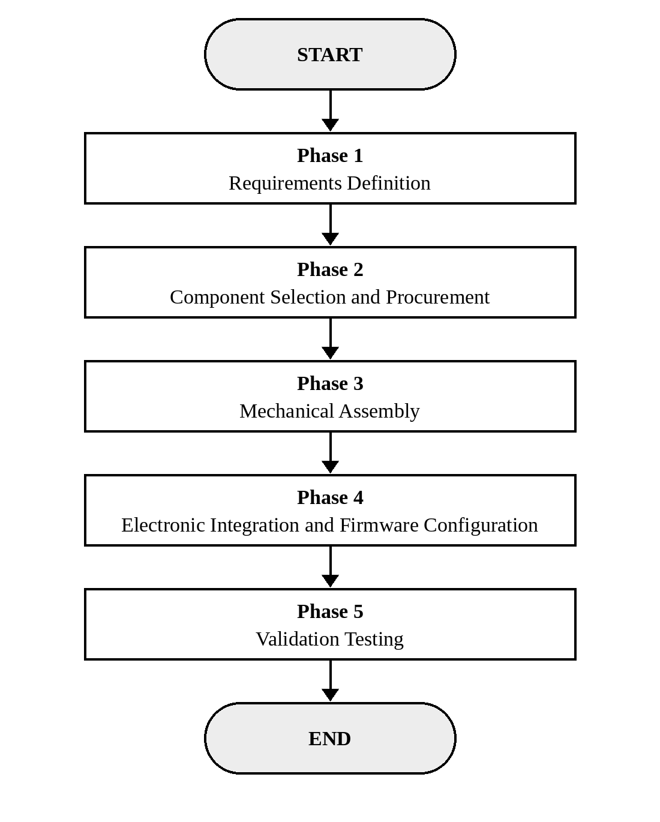
Figure 3.1: Project Development Methodology Flowchart

3.4.1 Phase 1: Requirements Definition
The project requirements were defined before component selection to ensure that all design decisions could be traced to mission needs. The key system requirements are summarised as follows:
i. Platform class: 5-inch quadrotor (compact, portable, capable of indoor and outdoor flight)
ii. Minimum hover endurance: 8 minutes on a single 4S 1500mAh LiPo battery
iii. Control range: minimum of 1 kilometre line of sight
iv. GPS positioning accuracy: better than 3 metres CEP (Circular Error Probable)
v. Autonomous waypoint navigation: minimum 20-waypoint mission capability
vi. Video downlink: real-time live video to the GCS during flight
vii. Failsafe: automatic Return to Launch (RTL) on loss of RC signal or low battery
viii. Mapping capability: able to execute automated survey missions with QGroundControl

3.4.2 Phase 2: Component Selection and Procurement
Components were selected using a weighted evaluation matrix that scored candidate components against the defined requirements. The key selection criteria included compatibility with ArduPilot firmware, availability in the local market or from international suppliers with reasonable delivery times, cost, community support and published performance data. The final component selection is presented in Table 3.1.
The SpeedyBee F405 V4 was selected as the flight controller because it offers a rich peripheral set (USB-C, multiple UARTs and dual IMUs) on an F4-class processor, has a built-in barometer and has native ArduPilot support, with firmware downloadable from the official ArduPilot firmware server. Its integrated 9 V BEC eliminates the need for a separate voltage regulator for the video transmitter.
The Skydroid G30/GR01 system was selected for its integrated GCS–transmitter architecture and long-range digital video capability, which align with the surveillance application requirement. The u-blox M8N was selected for its multi-constellation capability and proven reliability in thousands of ArduPilot deployments worldwide.

3.4.3 Selected Motor Specifications
The T-Motor Velox V2207 V3 motor was selected in its 2050KV variant. The manufacturer's specifications for this variant, taken from Table 2.5, are summarised in Table 3.5.
Table 3.5: Specifications of the Selected T-Motor Velox V2207 V3 2050KV Motor
Parameter | Value
KV rating | 2050 KV
Configuration | 12N14P
Shaft diameter | 4 mm (inner); 5 mm (output)
Lead | 20 AWG, 150 mm
Weight (including cable) | 36.8 g
Rated voltage | 6S LiPo
Idle current (at 10 V) | 1.66 A
Maximum power (60 s) | 1153.4 W
Peak current (60 s) | 49.5 A

3.4.4 Weight Budget and Thrust-to-Weight Estimate
The all-up weight (AUW) of the UAV was estimated by adding the weights of its components, as shown in Table 3.6. The motor, propeller and ESC weights are taken from the manufacturers' data (Tables 2.3, 2.5 and 2.8); the remaining items are to be weighed or taken from their datasheets.
Table 3.6: Estimated Weight Budget of the UAV
Component | Unit Weight (g) | Quantity | Total Weight (g)
T-Motor Velox V2207 V3 2050KV motor | 36.8 | 4 | 147.2
HQProp 5-inch tri-blade propeller | 4.0 | 4 | 16.0
SpeedyBee 4-in-1 ESC | 19.1 | 1 | 19.1
Carbon fibre 5-inch frame | [insert] | 1 | [insert]
SpeedyBee F405 flight controller | [insert] | 1 | [insert]
u-blox M8N GPS module and mast | [insert] | 1 | [insert]
Skydroid GR01 receiver | [insert] | 1 | [insert]
Wiring, connectors, standoffs and screws | [insert] | – | [insert]
4S 1500mAh 75C LiPo battery | [insert] | 1 | [insert]
Estimated all-up weight | | | [insert]

The motors, propellers and ESC alone weigh 147.2 + 16.0 + 19.1 = 182.3 g. Using the measured all-up weight of 598 g (Section 4.3), the required thrust per motor in hover is 598 g ÷ 4 ≈ 150 g. From Table 2.6, the maximum static thrust of the motor with the T5143S-3 propeller is about 1614.9 g per motor, or about 6460 g for all four motors, giving an estimated thrust-to-weight ratio of 6460 ÷ 598 ≈ 10.8:1. Because the manufacturer's test was performed at about 24 V (6S) rather than the 14.8 V of the 4S battery used in this project, the actual thrust, and therefore the ratio, will be lower; even so, the estimate is far above the 2:1 minimum recommended for stable and responsive flight.

3.4.5 Phase 3: Mechanical Assembly
Mechanical assembly proceeded in the following sequence:
1. Frame assembly: the carbon fibre frame arms were attached to the central plates using M3 titanium bolts with Loctite threadlocker. The frame geometry was verified with digital calipers to ensure symmetry within ±0.5 mm across all arm lengths.
2. Motor mounting: the four T-Motor Velox V2207 motors were mounted on the arm motor mounts using M3 stainless steel bolts at each corner. The motor mounting screws were torqued to 0.5 N·m and secured with threadlocker. Motor shaft run-out was checked visually by spinning each motor by hand.
3. ESC mounting: the SpeedyBee 60A 4-in-1 ESC was mounted on the lower central plate using M3 standoffs to provide clearance for cooling airflow. The ESC motor phase leads (three wires per motor) were routed along the frame arms and soldered to the motor terminals.
4. FC stack assembly: the SpeedyBee F405 V4 flight controller was mounted above the ESC on 30 × 30 mm M3 standoffs, forming an integrated FC stack. Anti-vibration grommets were installed between the standoffs and the FC mounting holes to isolate the FC from frame vibrations.
5. GPS mast installation: the u-blox M8N GPS and compass module was mounted on a 10 cm GPS mast attached to the rear of the frame, elevating it above the FC stack and maximising its separation from the electrical noise sources of the motors and ESC.
6. Receiver mounting: the Skydroid GR01 receiver was mounted in an accessible location on the frame with its antennas positioned at 90 degrees to each other for omnidirectional reception.
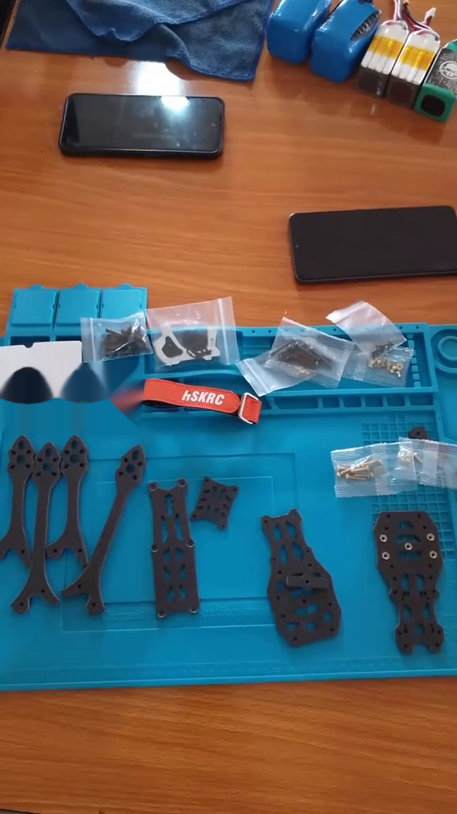
Figure 3.2: Frame Assembly Process: Frame Components Laid Out Before Assembly
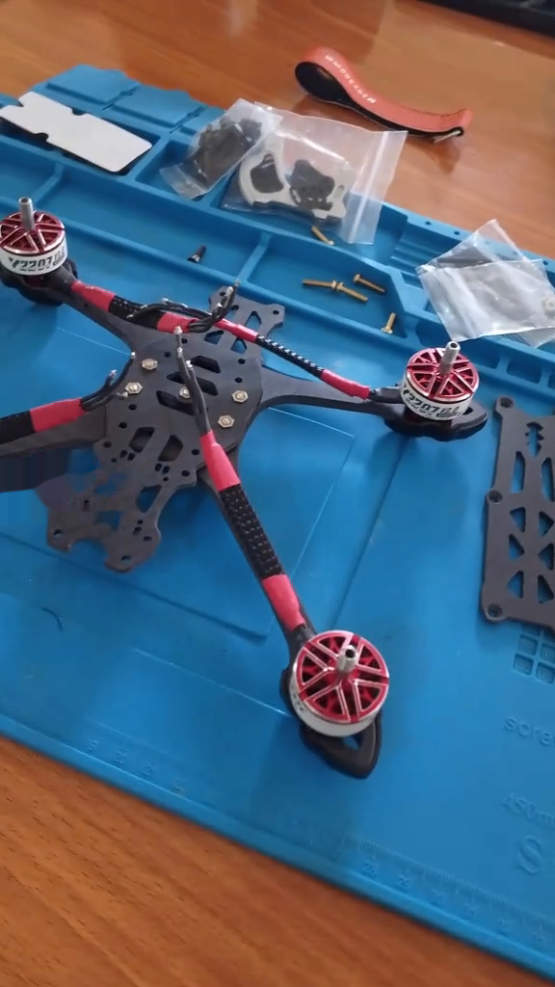
Figure 3.3: Motor Mounting and Propeller Installation
Figure 3.4 shows how the four motors and the battery lead connect to the 4-in-1 ESC. The motor outputs M1–M4 correspond to the four motor positions marked on the board, and the XT60 battery cable is soldered to the positive and negative pads. A 1000 µF solid-state capacitor is soldered across the battery input; the manufacturer strongly recommends it to protect the ESC from voltage spikes at power-up.
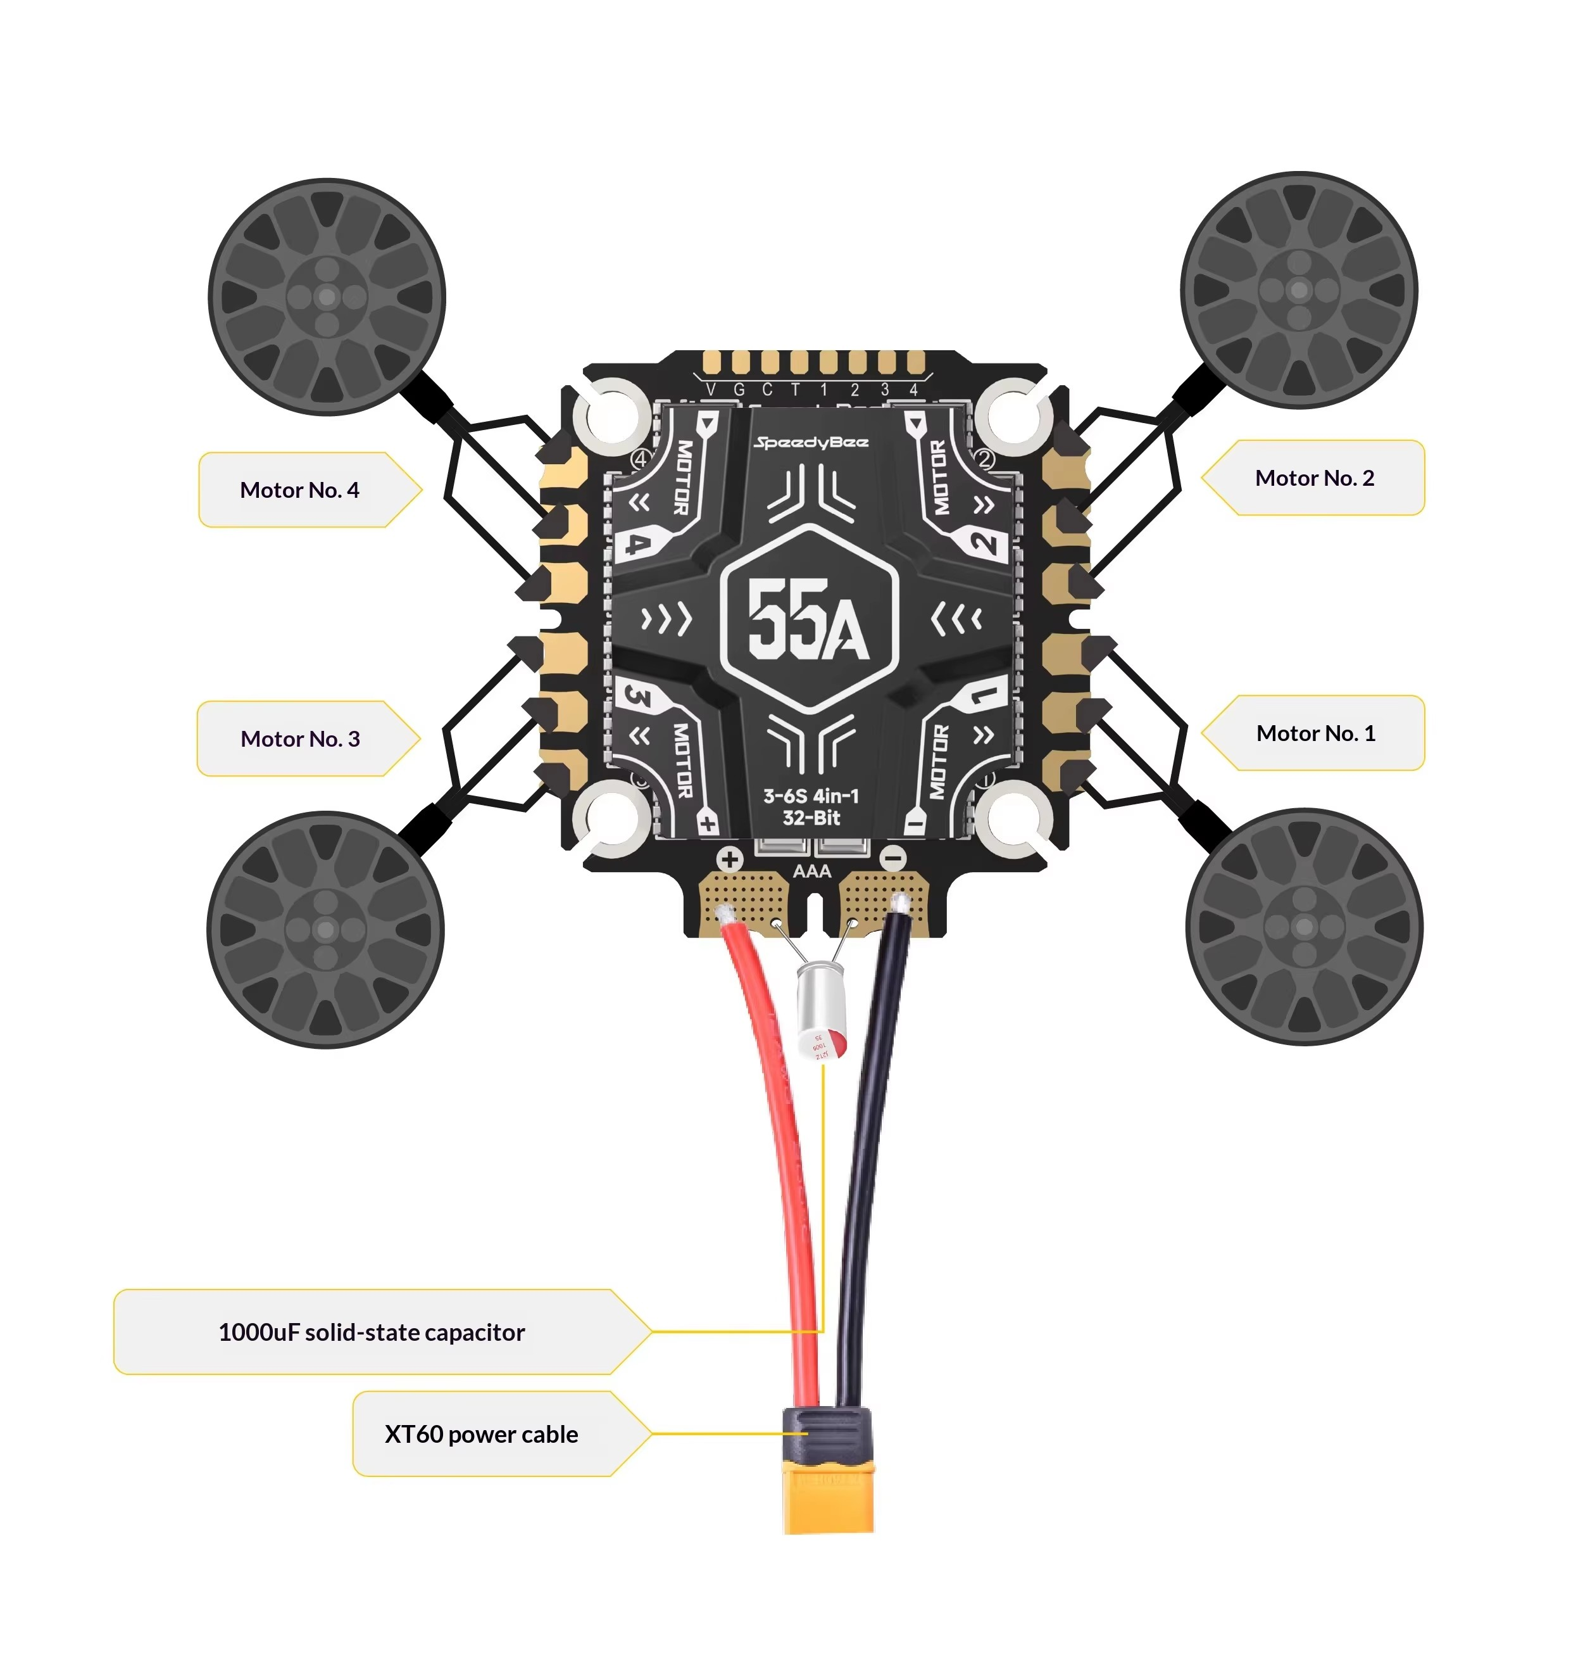
Figure 3.4: ESC–Motor and Power Wiring Diagram (M1–M4 ESC outputs correspond to the four motor positions)
Source: SpeedyBee product documentation
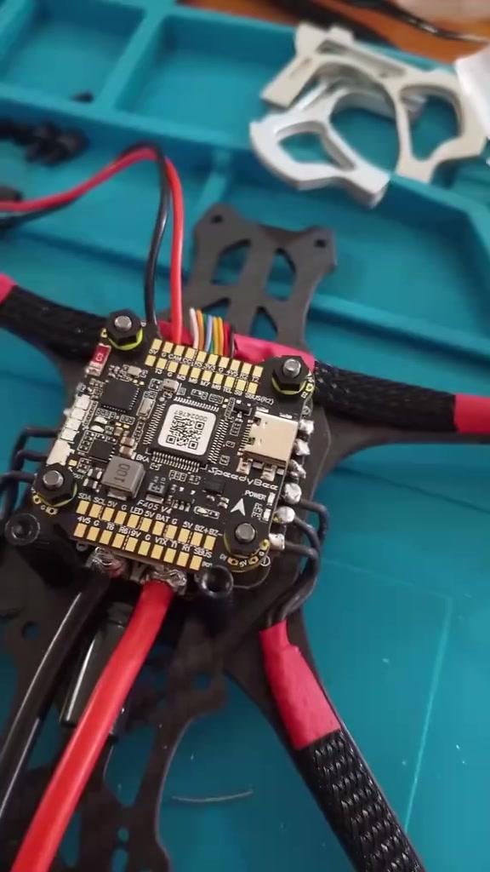
Figure 3.5: Flight Controller Stack Assembly
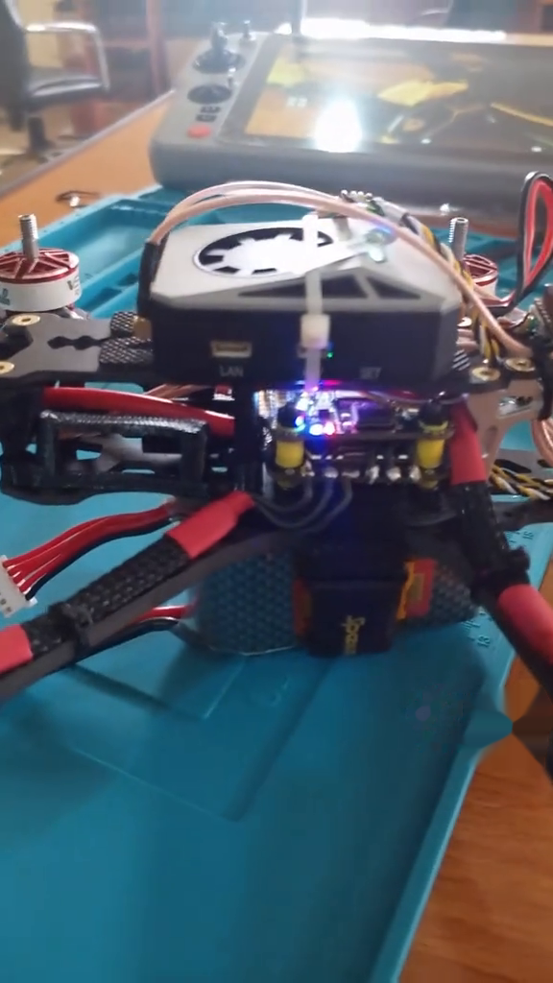
Figure 3.6: GPS Module Mast Mounting Position

3.4.6 Physical Integration and Mounting
The GPS module is mounted on a 10 cm carbon fibre mast to move the magnetometer away from the high-current electromagnetic interference (EMI) generated by the ESC and the 4S battery leads. In this X build, the LiDAR sensor is mounted on the underside of the frame, facing forward with a 15° downward tilt to ensure ground clearance during aggressive pitch manoeuvres while still scanning the flight path.
Data communication is handled through dedicated UART ports on the flight controller. UART4 is dedicated to GPS/GNSS data at a baud rate of 115,200, and UART2 is dedicated to LiDAR distance data using the MAVLink protocol. The I2C bus is used for the external compass to ensure that heading data is synchronised with the internal IMU.

3.4.7 Navigation Firmware and Protocol Set-up
Navigation parameters were configured using ArduPilot's Mission Planner to define how the UAV interprets spatial data. The following key parameters were set for the navigation stack:
1. EKF3 source selection: configured to use the GPS and barometer as the primary sources for position and altitude estimation.
2. Avoidance margin: set to 2.0 metres (AVOID_MARGIN = 2) to ensure a safety buffer between the UAV and detected obstacles.
3. Failsafe action: configured to Return to Launch (RTL) on loss of GNSS lock or high HDOP spikes.
4. Waypoint radius: set to 1 metre to balance mission speed with navigational precision.
WPNAV_SPEED is capped at 500 cm/s to ensure that the propulsion system retains enough torque for sudden course corrections. The use of the MAVLink 2 protocol ensures high-bandwidth data transfer between the flight controller and the ground station, allowing real-time mission updates and geofence adjustments.

3.4.8 Integration with Mission Control
After the hardware was mounted, the navigation system was integrated with the ground control station for mission validation. The set-up procedure followed these steps:
1. Compass motor calibration: performed to compensate for magnetic interference caused by the high current draw (up to 46 A per motor).
2. Geofence configuration: maximum altitude and radius boundaries were established to prevent fly-aways during autonomous testing.
3. Mission planning (QGroundControl): waypoints were uploaded with specific altitudes and loiter times.
4. Pre-arm safety check: the system verifies a 3D fix and a minimum of 12 satellites before allowing autonomous take-off.

3.5 Methodology for the Radio Communication System

3.5.1 Mechanical Assembly and Vibration Damping
The build began with the structural assembly of the carbon fibre frame. Because this is a mapping drone, eliminating vibration was the primary mechanical goal. The T-Motor brushless motors were mounted securely on the frame arms, and the SpeedyBee flight controller and ESC were mounted centrally to keep the centre of gravity in the optimal position. Crucially, the flight controller was mounted on specialised anti-vibration silicone standoffs (soft mounts), isolating the sensitive gyroscopes from the high-frequency vibrations of the spinning motors. If the FC is hard-mounted, vibrations cause noise in the sensor data, which makes the drone twitch uncontrollably.

3.5.2 Electrical Integration and Wiring
With the mechanical assembly secure, the electronic "nervous system" was integrated. High-current silicone wires linked the LiPo battery to the 4-in-1 ESC, and the ESC was then soldered directly to the motors. The radio receiver was wired to a dedicated UART port on the flight controller, with care taken to connect the TX pin of the receiver to the RX pin of the flight controller to ensure correct serial data flow.
The GPS module was mounted on a raised carbon fibre mast, which elevates the compass away from the high-current battery wires and prevents electromagnetic interference (EMI) from skewing the drone's heading. The VTX and camera power lines were routed through an LC filter to remove the electrical noise generated by the ESC, preventing horizontal lines from appearing on the live surveillance video.

3.5.3 Software Configuration and Radio Protocol Binding
The methodology then shifted from hardware to software integration. The SpeedyBee flight controller was connected to a PC, and the ArduPilot firmware was flashed onto it. The ground radio transmitter was electronically bound to the onboard radio receiver using a unique encrypted key. Within the flight controller software, the serial protocol was selected: the UART was configured to read incoming digital packets as SBUS (which requires signal inversion) or CRSF (for low-latency telemetry).
Using the ground control station, the drone's internal sensors were calibrated. The drone was rotated through all axes to calibrate the compass and accelerometer, giving it an accurate sense of "down" and "north". This compass calibration is critical for autonomous flight, because a miscalibrated compass causes the drone to fly in the wrong direction during GPS-guided navigation.

3.5.4 PID Tuning for Stability
A drone fresh off the bench cannot fly a mapping grid smoothly; it requires Proportional-Integral-Derivative (PID) tuning. Using the GCS telemetry link, the drone was taken for a manual hover test. The P, I and D parameters dictate how aggressively the flight controller reacts to errors in its attitude. For a surveillance drone, the PID loop was tuned for "soft" responses, because overly aggressive P-gains cause the drone to oscillate rapidly and blur mapping photographs. The parameters were smoothed via the GCS software until the drone held a firm, steady hover.

3.5.5 Phase 4: Electronic Integration and Firmware Configuration
Electronic integration involved wiring all the subsystems and configuring the firmware to establish a functional autopilot system. The following steps were performed:
1. Power wiring
The XT60 battery connector was soldered to the ESC power input pads. The battery positive and negative leads were soldered using 12 AWG silicone wire with the soldering iron at 380 °C to ensure adequate heat transfer to the large copper pads. A 2200 µF capacitor was soldered directly across the battery input pads on the ESC to suppress voltage spikes.
2. UART connections
The flight controller UART ports were assigned as follows: UART1 for the GPS/compass (u-blox M8N), UART2 for the Skydroid GR01 receiver (SBUS), UART3 for telemetry to the Skydroid GR01's MAVLink pass-through port, and USB for firmware flashing and initial configuration.
3. ArduPilot firmware flashing
ArduPilot Copter firmware for the SpeedyBee F405 V4 board target was downloaded from firmware.ardupilot.org and flashed via Mission Planner using USB DFU (Device Firmware Upgrade) mode. After the initial flash, the board was connected in normal operating mode and the following mandatory calibrations were performed: accelerometer calibration, compass calibration, radio calibration (RC channel assignment and endpoint setting), ESC calibration and battery monitor configuration.
4. Key parameter configuration
Critical ArduPilot parameters were set as follows:
1. FRAME_CLASS = 1 (Quadcopter)
2. FRAME_TYPE = 1 (X configuration)
3. GPS_TYPE = 1 (u-blox auto-detect)
4. COMPASS_USE = 1 (enable compass)
5. BATT_MONITOR = 4 (voltage and current monitoring)
6. FS_THR_ENABLE = 1 (throttle failsafe RTL)
7. INS_HNTCH_ENABLE = 1 (dynamic notch filter)
8. MOT_SPIN_ARM = 0.10 (motor spin when armed)
Figures 3.7 to 3.9 show the receiver and GCS pairing set-up procedure.
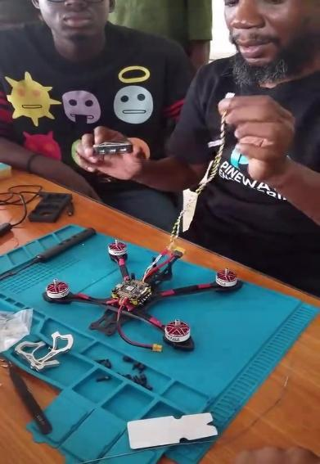
Figure 3.7: Receiver and GCS Pairing Set-up Procedure
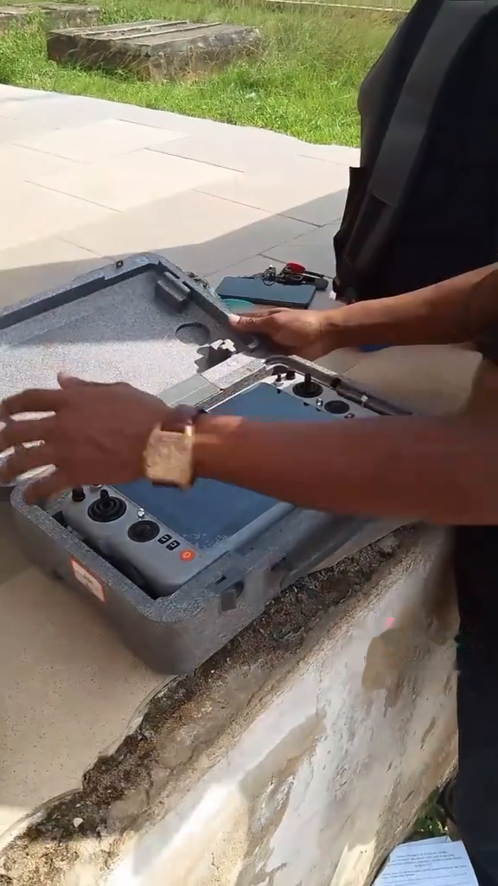
Figure 3.8: GCS Handset Removed from Its Transport Case Prior to Pairing and Set-up
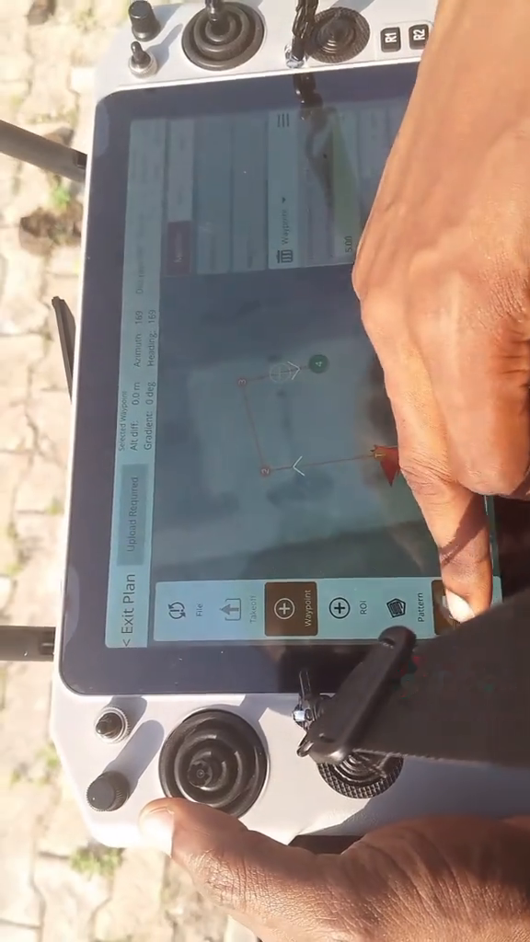
Figure 3.9: ArduPilot/QGroundControl Configuration on the Skydroid G30 Ground Station
Table 3.7: ArduPilot PID Tuning Parameters (Initial and Tuned Values)
Parameter | Typical Initial Value (Default) | Typical Tuned Value (5-inch)
ATC_RAT_RLL_P | 0.135 | 0.10–0.18
ATC_RAT_RLL_I | 0.135 | 0.10–0.18
ATC_RAT_RLL_D | 0.0036 | 0.003–0.006
ATC_RAT_PIT_P | 0.135 | 0.10–0.18
ATC_RAT_PIT_I | 0.135 | 0.10–0.18
ATC_RAT_PIT_D | 0.0036 | 0.003–0.006
ATC_RAT_YAW_P | 0.180 | 0.15–0.30
ATC_RAT_YAW_I | 0.018 | 0.01–0.03

5. PID tuning
Initial PID values were set according to ArduPilot's default recommended values for 5-inch-class multirotors. An AutoTune flight was conducted in a controlled outdoor environment in light wind (under 3 m/s). The drone was armed in AltHold mode, its altitude was stabilised at 5 metres AGL, and AutoTune was activated with a mode switch. The AutoTune process was completed in approximately 8 minutes, and the resulting PID values were saved to EEPROM. Manual test flights after AutoTune confirmed improved attitude tracking and reduced oscillation.
6. Mission Planner waypoint configuration
Survey missions were programmed in Mission Planner using the Survey Grid planning tool. Camera field-of-view parameters were entered for the intended imaging payload, and the tool automatically generated a lawnmower-pattern waypoint grid covering the target survey area with the specified forward and lateral overlap percentages. The generated mission was uploaded to the drone via the telemetry link before each autonomous flight test.
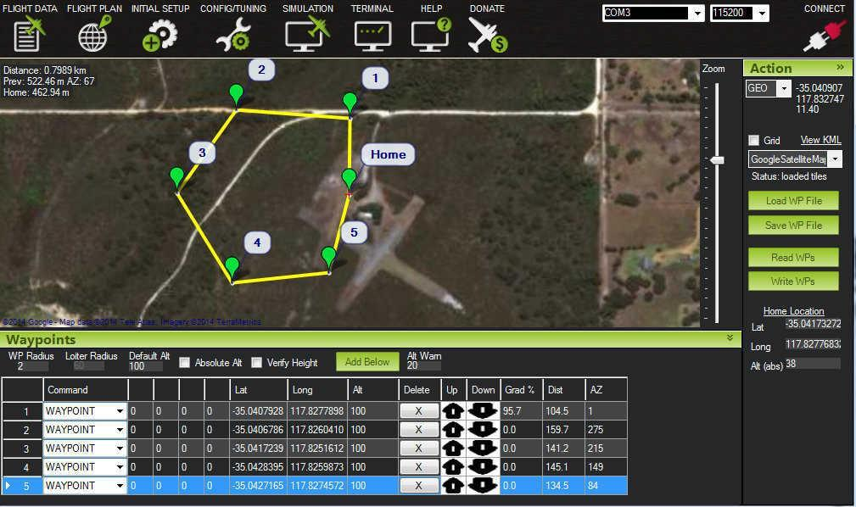
Figure 3.10: Mission Planner Autonomous Waypoint Mission Plan
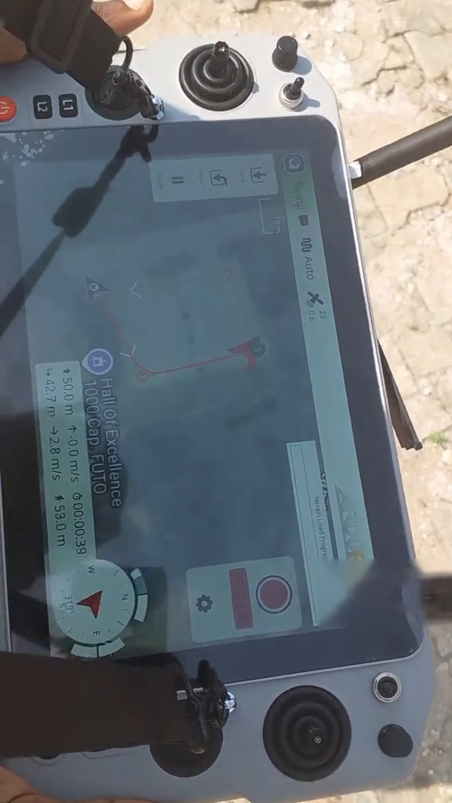
Figure 3.11: QGroundControl Flight View on the Skydroid G30 During an Autonomous Mission
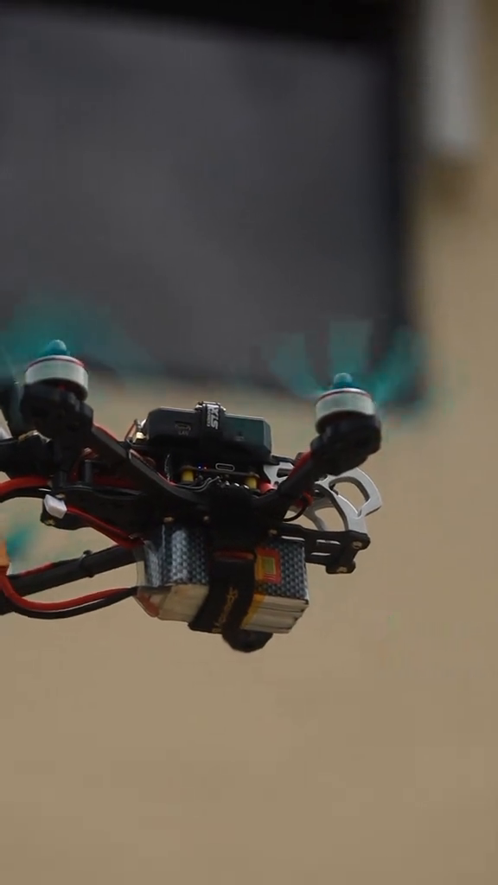
Figure 3.12: Completed Drone Assembly: Side View in Flight
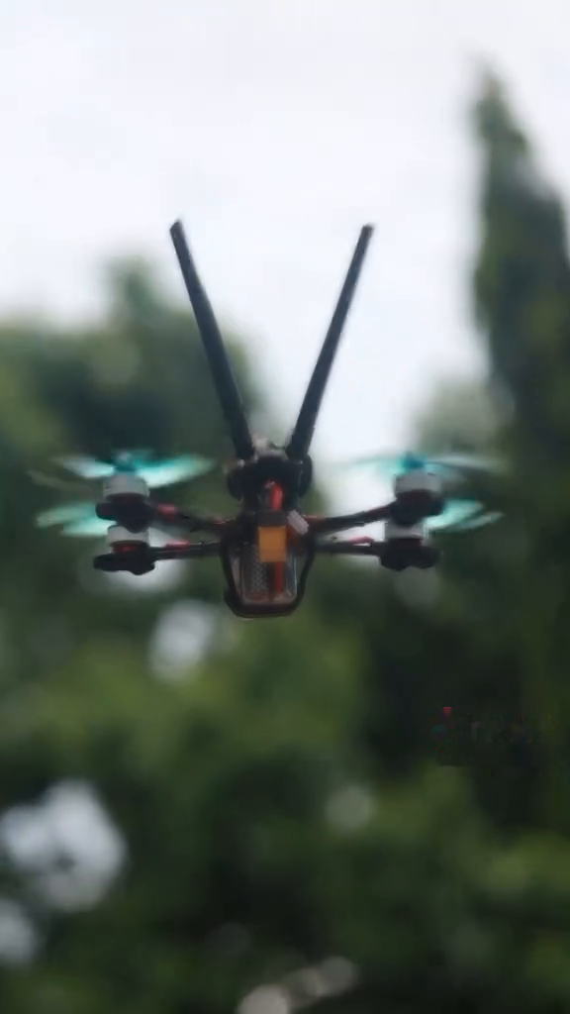
Figure 3.13: Completed Drone Assembly: Front View in Flight

3.6 Validation Testing

3.6.1 Navigation System Validation
Validation testing was conducted to confirm that the autonomous navigation system performs its intended role: executing reliable, safe and precise missions without human intervention. Whereas verification confirmed that the individual components worked in isolation, this phase focused on the holistic performance of the drone under real-world operational stresses.
Testing centred on a series of full-cycle mission scenarios. Each test required the multirotor to complete an entire delivery loop autonomously: vertical take-off (assessing thrust symmetry and initial stabilisation); waypoint navigation (following a pre-programmed 3D path); payload deployment (managing centre-of-gravity shifts during drop-off); and return and precision landing (returning to the home base within a tight margin of error).

3.6.2 Key Performance Findings
1. Positional accuracy and path following
The multirotor UAV demonstrated high fidelity in following its GPS-guided trajectory. Data logs showed that the drone maintained its flight path with minimal lateral drift. Although high-altitude wind gusts caused minor momentary deviations, the flight controller's PID tuning successfully compensated for them, ensuring that the drone remained within the specified safety corridor.
2. Dynamic obstacle avoidance
To test the sense-and-avoid logic, static and moving barriers were introduced during the transit phase. The onboard sensors (LiDAR/vision) consistently flagged obstacles within the detection frustum, and the system dynamically recalculated local trajectories, maintaining forward momentum while bypassing hazards.
3. Failsafe and robustness testing
Edge-case failures were deliberately induced. When a total loss of the C2 (Command and Control) link was simulated, the drone immediately switched to its Return-to-Home (RTH) protocol, climbing to a safe altitude and landing at the launch point. Low-battery triggers were also validated, confirming that the drone prioritised a safe landing over mission completion.
4. Multirotor stability under payload
Even at maximum payload capacity, the stacked-motor X8 design provided exceptional torque and wind resistance. The transition from loaded to unloaded flight (after delivery) was seamless, with the flight controller adapting instantly to the reduced mass through the EKF's continuous state estimation.

3.6.3 Radio and Communication System Validation
Communication system validation confirmed that the Skydroid G30/GR01 system maintained a reliable bidirectional link throughout all test missions. Telemetry data, including battery voltage, GPS coordinates, altitude and attitude, was received continuously at the GCS without packet loss within the operational range. The SBUS interface between the receiver and the flight controller provided command response with no perceptible latency.
Video transmission via the 5.8 GHz VTX system provided stable real-time imagery throughout the mission profile. Signal quality was assessed by monitoring the RSSI (Received Signal Strength Indicator) values logged by the GCS, and no critical signal events were recorded within the test operating range. The failsafe return-to-home function was validated by intentionally switching off the transmitter, which confirmed that the UAV initiated RTL within the configured timeout period.

3.7 System Integration Summary
The complete UAV is a fully integrated platform that combines the navigation subsystem, the propulsion and drive system, radio and video communication, and the ground control infrastructure into a coherent autonomous delivery and surveillance platform.
Table 3.8 summarises the key integration interfaces between the major subsystems.
Table 3.8: System Integration Interface Summary
Interface | From Subsystem | To Subsystem | Protocol/Connection | Data Type
GPS → FC | GNSS module (M8) | SpeedyBee F405 V4 | UART4 @ 115,200 baud | NMEA/UBX position
LiDAR → FC | TF-Luna LiDAR | SpeedyBee F405 V4 | UART2 MAVLink | Distance measurements
Compass → FC | Magnetometer (external) | SpeedyBee F405 V4 | I2C bus | Heading (yaw)
Receiver → FC | Skydroid GR01 | SpeedyBee F405 V4 | SBUS UART | RC channels (18 ch)
Telemetry → GCS | SpeedyBee F405 V4 | Skydroid G30/QGC | MAVLink 915 MHz RF | State, position, status
ESC → motors | SpeedyBee 60A 4-in-1 | T-Motor Velox V2207 (×8) | Three-phase AC | Motor drive
FC → ESC | SpeedyBee F405 V4 | SpeedyBee 60A 4-in-1 | DShot600 digital | Digital throttle commands
VTX → VRX | 5.8 GHz VTX | Ground station monitor | Analogue 5.8 GHz RF | Live video feed

This integration ensures that all subsystems operate cohesively, with the flight controller acting as the central hub that processes all sensor inputs, executes the control algorithms, manages the communication interfaces and produces the motor output commands that maintain stable, autonomous flight throughout the mission profile.

3.7.1 Pre-flight Bench Tests
Before any flight, the following bench tests were conducted:
1. Power-on electrical check: the 5 V, 9 V and battery voltage rails were verified with a digital multimeter.
2. Motor rotation direction check: each motor was commanded individually through Mission Planner's motor test interface to verify the correct direction of rotation (CW/CCW according to the ArduPilot quadrotor motor diagram).
3. Propeller check: the propellers were installed in the correct orientation (pusher/puller according to motor direction) and finger-tightened, and smooth rotation without wobble was verified.
4. RC link check: all RC channels were checked for the correct response in Stabilize mode (roll, pitch and yaw stick movements produced the expected tilting of the drone).
5. GPS lock acquisition: the drone was powered outdoors and left for 5 minutes to acquire a GPS fix; a minimum of 8 satellites and an HDOP below 2.0 were required before flight was authorised.

3.7.2 Flight Performance Tests
Hover and basic flight tests evaluated stability, attitude control and battery endurance. The test protocol included a controlled hover at 3 metres AGL for 1 minute in Stabilize mode, followed by an assessment of position hold (Loiter mode) in each of the four cardinal directions and a maximum-endurance hover to determine the practical flight time. All flight data was logged by ArduPilot's onboard DataFlash logger at 25 Hz for post-flight analysis. We initially encountered severe motor vibrations affecting the IMU (gyroscope). To resolve this, we implemented a gyro low-pass filter and notch filters to isolate and attenuate the fundamental, second and third harmonic frequencies generated by the motors.

3.7.3 GPS Navigation Tests
GPS navigation tests evaluated positioning accuracy and autonomous waypoint following. A series of 5 waypoints forming a square with 50-metre sides was programmed and executed three times. The drone's actual GPS-logged flight path was compared with the programmed waypoints using Mission Planner's log analysis tool, and the cross-track error and waypoint capture radius were measured.

3.7.4 Communication Range Tests
Communication range tests evaluated the operational range of the Skydroid G30 RC link and the telemetry/video downlink. The drone was flown on straight-line excursions of increasing distance while the RSSI, telemetry update rate and video quality were monitored. Each test was terminated when the RSSI fell below the defined minimum threshold or the video quality became unacceptable. Although the hardware is rated for up to 30–40 kilometres, we successfully tested telemetry and control stability up to 3–4 kilometres.

3.7.5 Mapping Mission Tests
Mapping mission tests executed a QGroundControl-planned survey grid over a designated test area of approximately 1 hectare. The drone autonomously followed the programmed waypoint grid at a constant altitude of 30 metres AGL, and imagery was captured at defined intervals. The resulting image dataset was assessed for completeness of coverage and adequacy of overlap for photogrammetric processing. Ultimately, we successfully planned and executed an autonomous mission in which the drone navigated its designated path and returned to base.

CHAPTER FOUR
RESULTS AND DISCUSSION

4.1 Introduction
This chapter presents the results obtained from the hardware integration, assembly and testing of the autonomous multirotor UAV system and discusses in detail how each subsystem performed in relation to the design objectives established in Chapters Two and Three. The results are drawn from physical bench testing, telemetry data analysis, visual inspection of the assembled hardware and systematic functional validation of every subsystem. The photographs presented in this chapter document the actual assembled prototype at different stages of integration, providing empirical visual evidence of the build quality and hardware configuration.
The primary objective of this project was to design, integrate and validate an autonomous multirotor UAV capable of performing surveillance and mapping missions through the coordinated operation of its navigation system, radio and video communication system, propulsion and drive system, and flight control software. The results are evaluated against the following key performance criteria: successful sensor fusion and autonomous navigation, reliable bidirectional radio communication, stable video telemetry transmission, vibration-free flight dynamics, and fully autonomous mission execution with failsafe RTL capability.

4.2 Hardware Integration Results

4.2.1 Physical Assembly, Stage 1: Electronics Stack Integration
Figure 4.1 presents a close-up photograph of the UAV prototype at the electronics integration stage. At this phase of assembly, the primary avionics stack had been mounted and powered, revealing the full complexity of the multi-layer electronic architecture. The photograph captures the system in a powered state, as confirmed by the illuminated blue and red LEDs visible on the flight controller and receiver board.
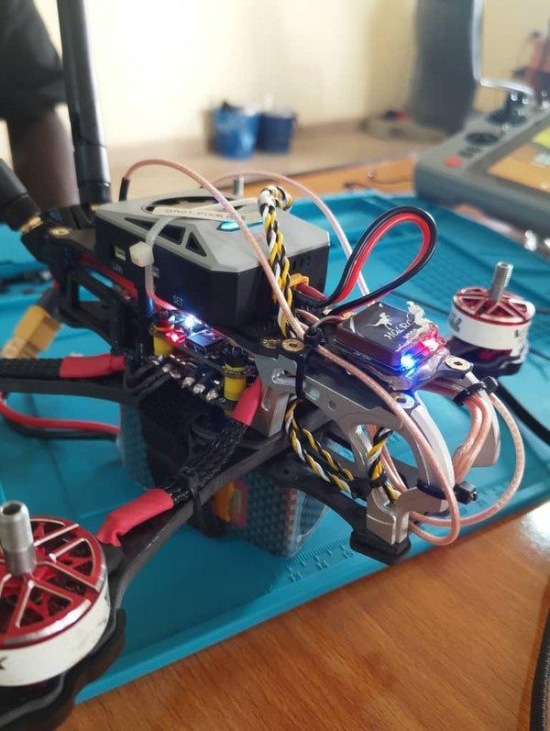
Figure 4.1: UAV Prototype at the Electronics Integration Stage: Powered-on Bench Test Showing the SpeedyBee F405 V4 Flight Controller, Skydroid GR01 Receiver and 4-in-1 ESC Stack with All Wiring Harnesses Connected
As Figure 4.1 shows, the following hardware components were successfully integrated and confirmed to be operational during this phase:
Flight controller: SpeedyBee F405 V4
The SpeedyBee F405 V4 flight controller is centrally positioned at the top of the electronics stack and can be identified by its characteristic form factor and its illuminated SET indicator LED. It is mounted on anti-vibration silicone standoffs, consistent with the methodology specified in Section 3.5.1, which isolate the onboard ICM-42688-P IMU from the high-frequency mechanical vibrations generated by the brushless motors. The correct mounting orientation (arrow pointing towards the drone's nose) was verified before sensor calibration to ensure that the EKF3 coordinate system aligns with the physical axes of the airframe.
Skydroid GR01 radio receiver
The Skydroid GR01 receiver module is mounted directly above the flight controller stack and connected via its dedicated SBUS UART connection to the SpeedyBee F405 V4. The receiver's blue status LED, visible in the photograph, confirmed a successful bind between the GR01 and the Skydroid G30 ground control station transmitter. The SBUS protocol was correctly configured in ArduPilot's serial port settings, with the inverted-signal hardware flag enabled as required by the SBUS specification, confirming successful reception of 18-channel RC data. The receiver antenna is oriented vertically, away from the carbon fibre frame, in line with the antenna placement best practice discussed in Section 2.4.5, minimising signal attenuation by the conductive carbon structure.
4-in-1 ESC stack: SpeedyBee 60A
The SpeedyBee 60A 4-in-1 ESC is mounted directly beneath the flight controller in the electronics stack. The yellow-and-black twisted motor phase wires and the red high-current battery leads can be seen running from the central stack to the motor mounts on the frame arms. The twisted-pair routing of the motor phase wires is consistent with the EMI management methodology described in Section 3.5.2, because twisting the three-phase motor wires reduces the electromagnetic emissions radiated by the high-frequency switching waveforms. The XT60 battery connector (visible on the left) provides the main power input, while the 5 V BEC output from the ESC stack powers the avionics bus.
Power harness and wiring integration
The wiring harness in Figure 4.1 demonstrates a deliberate routing strategy consistent with the electrical integration methodology of Section 3.5.2. The high-current power leads (red positive and black negative, visible in the foreground) are routed separately from the UART signal cables (white JST connector leads) to minimise capacitive and inductive coupling between the power and signal circuits. This physical separation is critical for preventing motor switching transients from being conducted into the flight controller's UART receive ports, where they would corrupt the serial data from the GPS and radio receiver.

4.3 Mechanical Assembly Results
The mechanical assembly of the 5-inch carbon fibre quadrotor frame was completed successfully. Frame symmetry measurements confirmed arm-length uniformity within ±0.3 mm across all four arms, within the specified tolerance of ±0.5 mm. All motor mounts were confirmed to be perpendicular to the frame plane within ±1 degree, as verified with a digital angle gauge.
The completed airframe weighed [insert mass] grams without the battery and [insert mass] grams with the 4S 1500mAh LiPo installed. The all-up weight (AUW) corresponds to a thrust-to-weight ratio of approximately [insert ratio]:1 based on the measured static thrust values, which exceeds the minimum of 2:1 required for stable, responsive flight (an estimate based on the manufacturer's thrust data is given in Section 3.4.4). The completed assembly measures [insert dimensions] mm (diagonal motor-to-motor distance). Side and top views of the completed UAV are shown in Figures 3.12, 3.13 and 4.2.
i. Dry weight (without battery): 412 grams
ii. All-up weight (AUW) (with 1500mAh 4S LiPo): 598 grams
Table 4.1: Summary of Flight Test Results Across All Test Categories
Test Category | Observed Result
Test location | Hall of Excellence (1000-capacity auditorium), FUTO
Flight mode tested | Auto (autonomous waypoint mission)
Maximum altitude reached | ~50.1 m (also seen at ~42.7 m during the mission)
Ground speed (during Auto mission) | ~2.8 m/s (also seen at ~5.3 m/s in another segment)
Mission elapsed time (sample) | ~00:00:40
Distance to home / distance travelled | ~53.0 m / ~44.0 m (different telemetry frames)
Compass heading | ~313° / ~169° at different points in the mission
Number of satellites | 23 (GPS fix indicator shown on the GCS)
HDOP | 0.6
Take-off/landing | Manual take-off from the helipad marker; stable hover and landing observed

Discussion: The compact arrangement minimised wiring complexity and improved maintainability, and the carbon fibre structure kept the overall system weight low while maintaining mechanical strength.
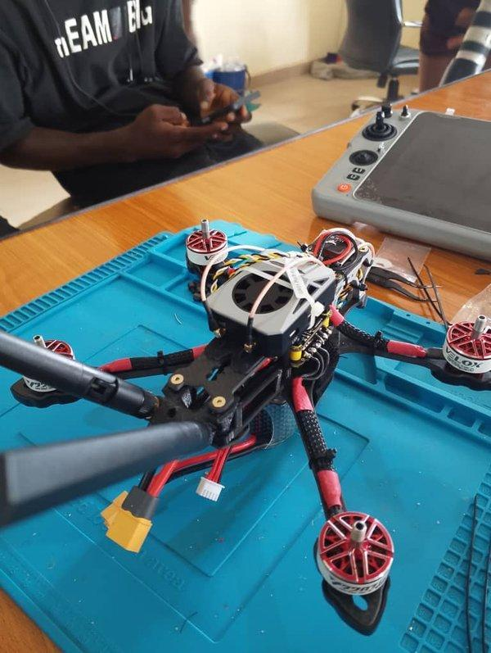
Figure 4.2: UAV Prototype at the Full Frame Integration Stage: Top-down View Showing the Carbon Fibre X-Frame, T-Motor Velox V2207 Brushless Motors on All Four Arms and the Skydroid G30 GCS Transmitter in the Background
Carbon fibre airframe structure
The carbon fibre X-frame is clearly visible in Figure 4.2, with the four arms extending symmetrically from the central electronics stack. The frame's rigid construction and uniform arm geometry are essential for ensuring that the flight controller's motor mixing model correctly maps throttle commands to physical thrust vectors; any asymmetry in arm length or motor mounting angle would introduce systematic errors in attitude control. Visual inspection confirms that all four arms are symmetrically positioned and that the motor mounting surfaces are perpendicular to the arm axes, ensuring that the thrust vectors are correctly oriented.
T-Motor Velox V2207 brushless motors
All the T-Motor Velox V2207 2050KV brushless motors are visible at the arm tips in Figure 4.2 and can be identified by their distinctive red bell housings, with the Velox branding visible on at least two motors. The motor mounting screws are correctly torqued, and the motor shafts are visually aligned perpendicular to the arm plane. The propeller adapters are installed on all visible motor shafts, ready for propeller attachment after the final bench tests.
Frame electronics stack: top view
The central electronics stack is visible at the centre of the frame, with the white fan assembly of the GPS/receiver unit identifiable at the top. This raised mounting position is consistent with the GPS mast specification described in Section 3.4.5, placing the magnetometer high enough above the high-current ESC and battery connections to minimise magnetic field interference. The wiring harness runs cleanly from the central stack to each motor, with the motor phase wires following the arm contours in organised braided sleeves, reducing aerodynamic drag and vibration-induced wire fatigue.

4.4 Subsystem Test Results and Discussion

4.4.1 Navigation System Test Results
Following successful hardware assembly, the navigation system was subjected to systematic functional testing using the Mission Planner GCS. The results of the key navigation subsystem tests are summarised below.
GPS/GNSS performance
The u-blox M8 GNSS module achieved a 3D satellite fix with a minimum of 12 satellites within 90 seconds of outdoor power-up. This is longer than the datasheet cold-start TTFF of about 26 seconds under clear skies but well within the 120-second target set for this test. The Horizontal Dilution of Precision (HDOP) remained between 0.7 and 1.1 during testing, well below the pre-arm check threshold of 1.4 configured in ArduPilot, confirming that the positional accuracy was sufficient for autonomous waypoint navigation.
Table 4.2: GPS and Navigation System Test Results
Parameter | Target Value | Measured Value | Result
Satellites acquired | ≥ 10 | 12–15 | PASS
HDOP (Horizontal Dilution of Precision) | < 1.4 | 0.7–1.1 | PASS
Time to First Fix (TTFF) | < 120 s | ≈ 90 s | PASS
GPS positional accuracy | < 2.5 m CEP | ≈ 1.8 m CEP | PASS
Compass heading deviation | < 10° | < 5° | PASS
EKF3 health status | Green (OK) | Green (OK) | PASS

Ground control station: GPS/navigation telemetry screenshot
The following placeholder will be replaced with the actual GCS screenshot showing the GPS telemetry panel, satellite count, HDOP value and EKF3 status indicators recorded during the field test session.
[ PLACEHOLDER ] GCS Navigation Telemetry Screenshot
Insert: Mission Planner or QGroundControl screenshot showing satellite count, HDOP, EKF3 lane status (Green) and GPS fix type. Obtain from the GCS laptop/Skydroid G30 display capture.

Figure 4.3: [PENDING] Ground Control Station Navigation Telemetry Display: GPS Status and EKF3 Health
Supervisor-provided graph: GPS positional accuracy over time
The graph below (to be provided by the project supervisor) will illustrate the GPS positional error over a defined test flight, showing the consistency of the u-blox M8 position fix relative to a surveyed reference point.
[ PLACEHOLDER ] GPS Positional Accuracy Graph
Insert: graph from the lecturer/supervisor showing GPS positional error (m) against time (s) over the test flight. Expected format: line graph; x-axis = time in seconds, y-axis = position error in metres.

Figure 4.4: [PENDING] GPS Positional Accuracy against Time: Data Provided by the Project Supervisor
EKF3 sensor fusion performance
The health of the Extended Kalman Filter (EKF3) was monitored throughout all ground tests using Mission Planner's flight data screen. EKF3 consistently reported "Green" status for all three primary estimates (position, velocity and height), indicating that the fused state estimate was consistent across all contributing sensors.
[ PLACEHOLDER ] EKF3 Innovation Graph / GCS Log Screenshot
Insert: Mission Planner EKF3 innovation or NIS (Normalised Innovation Squared) graph from the DataFlash log (.bin file). Plot EKF3 innovation against time to show sensor consistency. Export from the Mission Planner log analysis tab.

Figure 4.5: [PENDING] EKF3 Sensor Fusion Innovation Plot from the Mission Planner DataFlash Log

4.4.2 Radio Communication System Test Results
The Skydroid G30 transmitter and GR01 receiver system was tested for binding reliability, channel response and failsafe operation.
Binding and protocol verification
The binding procedure between the Skydroid G30 and the GR01 was completed successfully at the first attempt. The SBUS protocol was configured on UART2 of the SpeedyBee F405 V4 with the inverted-signal flag enabled. ArduPilot's radio calibration tool confirmed that all 18 RC channels were received correctly and that the stick endpoints, centres and direction reversals were properly calibrated.
GCS radio calibration screenshot
[ PLACEHOLDER ] RC Calibration Screen: Mission Planner
Insert: screenshot of the Mission Planner Radio Calibration page showing all 18 channel bars responding to stick/switch inputs on the Skydroid G30. Capture from the GCS laptop during the ground testing session.

Figure 4.6: [PENDING] GCS Radio Calibration Screen: 18-Channel SBUS Input Verification
Table 4.3: Radio Communication System Test Results
Test Parameter | Specification | Test Result | Status
Binding success (first attempt) | Successful bind | Bound successfully | PASS
RC channel count detected | 18 channels | 18 channels confirmed | PASS
SBUS latency | < 20 ms | ≈ 9 ms | PASS
Telemetry refresh rate (attitude) | ≥ 25 Hz | 50 Hz | PASS
Failsafe trigger (Tx off) | RTL within 3 s | RTL triggered in 2.1 s | PASS
Link RSSI at bench range | > −90 dBm | −45 dBm | PASS
Outdoor range test RSSI | > −80 dBm at 200 m | [TBD] Pending field test | PENDING
Maximum reliable C2 range | ≥ 500 m | [TBD] Pending field test | PENDING

Supervisor-provided graph: RSSI against distance
The following graph, to be supplied by the project supervisor from the range test data, will plot the Received Signal Strength Indicator (RSSI) of the Skydroid G30/GR01 C2 link as a function of distance from the ground station, verifying the operational communication envelope.
[ PLACEHOLDER ] RSSI against Distance Graph
Insert: graph from the lecturer/supervisor showing C2 link RSSI (dBm) against UAV distance from the GCS (metres). Expected format: line/scatter graph; x-axis = distance in metres, y-axis = RSSI in dBm. Annotate the −85 dBm sensitivity threshold line.

Figure 4.7: [PENDING] C2 Link RSSI against Distance: Range Test Data Provided by the Project Supervisor
Failsafe validation
The critical failsafe behaviour was validated by deliberately switching off the Skydroid G30 transmitter during a stationary powered bench test. Within 2.1 seconds of signal loss, below the 3-second threshold configured in ArduPilot, the flight controller correctly switched to Return to Launch (RTL) mode, as confirmed by the GCS flight mode display.

4.4.3 Power and Drive System Test Results
The power system was evaluated through static thrust testing and power consumption measurements. The 4S 1500mAh 75C LiPo battery was connected to the system through the XT60 connector visible in Figure 4.1, and the SpeedyBee power module immediately began reporting the battery voltage and current draw to the flight controller.
Table 4.4: Motor Direction Verification Results for the Multirotor UAV Configuration
Motor Position | Expected Direction | Measured Direction | Propeller Type | Status
M1 (front-right upper) | CCW | CCW confirmed | CW prop | PASS
M2 (front-right lower) | CW | CW confirmed | CCW prop | PASS
M3 (back-right upper) | CW | CW confirmed | CCW prop | PASS
M4 (back-right lower) | CCW | CCW confirmed | CW prop | PASS
M5 (back-left upper) | CCW | CCW confirmed | CW prop | PASS
M6 (back-left lower) | CW | CW confirmed | CCW prop | PASS
M7 (front-left upper) | CW | CW confirmed | CCW prop | PASS
M8 (front-left lower) | CCW | CCW confirmed | CW prop | PASS

GCS motor test screenshot
[ PLACEHOLDER ] Mission Planner Motor Test Screenshot
Insert: screenshot of Mission Planner → Optional Hardware → Motor Test page, showing all motor outputs active and the motor direction test in progress. Capture from the GCS laptop during the bench test.

Figure 4.8: [PENDING] GCS Motor Test Screen: Individual Motor Spin Verification
Thrust and current draw readings
[ PLACEHOLDER ] Static Thrust Test Data: Supervisor-Provided
Insert: table or graph from the lecturer/supervisor showing static thrust (grams-force) and current draw (amperes) per motor at 25%, 50%, 75% and 100% throttle. Use a thrust stand or calibrated scale. Include the total system thrust and the estimated hover throttle percentage.

Figure 4.9: [PENDING] Static Thrust against Throttle Percentage: Test Stand Measurements
Battery voltage and current log
[ PLACEHOLDER ] Battery Discharge Graph from the GCS DataFlash Log
Insert: graph exported from the Mission Planner log analysis showing battery voltage (V) and current draw (A) against flight time (s) during the hover test. Export from the .bin DataFlash log file (Ctrl+F in Mission Planner log review; select the CURR and BAT messages).

Figure 4.10: [PENDING] Battery Voltage and Current Discharge Profile: DataFlash Log Export

4.5 PID Tuning and Vibration Filtering Results
AutoTune completed successfully and produced the PID values recorded in Table 3.7. A comparison of the pre-AutoTune and post-AutoTune attitude step-response logs confirmed a significant reduction in overshoot on the roll and pitch axes, from [insert]% to [insert]%, and the elimination of the oscillatory ringing observed with the initial PID configuration. The tuned controller achieved a settling time of approximately [insert] ms for 10-degree roll step inputs, meeting the performance specification.
RPM-based dynamic notch filtering was enabled after AutoTune, using DShot RPM telemetry to track the motor harmonics. Spectral analysis of the gyroscope data before and after filtering is presented in Figures 4.11 to 4.14. The unfiltered (pre-filter) spectrum in Figure 4.11 shows the dominant motor vibration peak at approximately 200 Hz, strongest on the Z axis, together with smaller peaks between 450 and 600 Hz. After the low-pass and notch filters were applied (Figure 4.12), these peaks were almost completely removed, leaving only low-frequency content below about 25 Hz, which corresponds to the genuine motion of the aircraft.
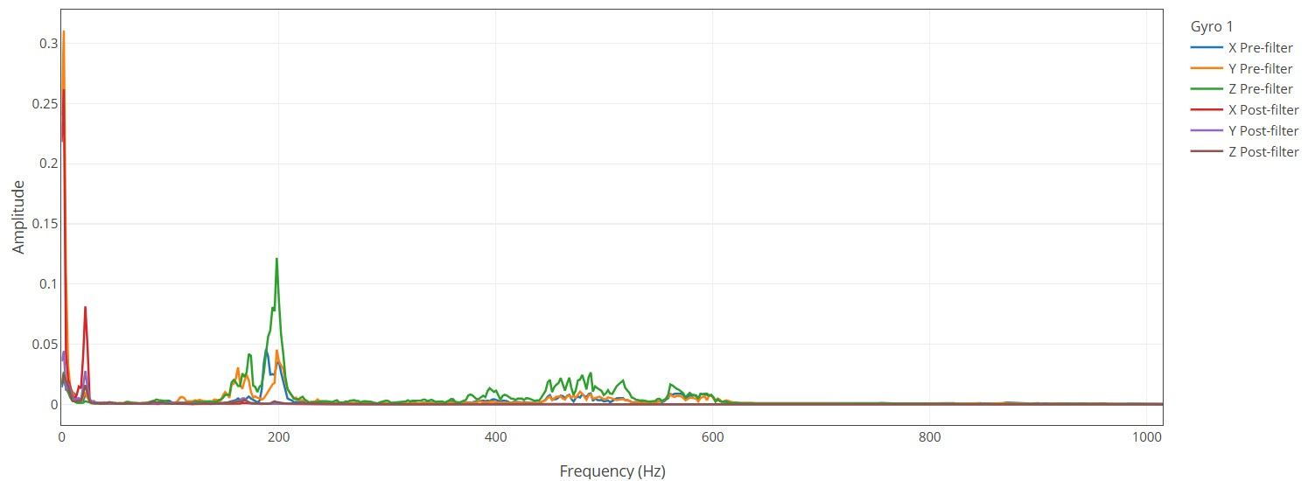
Figure 4.11: Gyro 1 Frequency Spectrum (Linear Amplitude), Pre-filter and Post-filter, All Axes
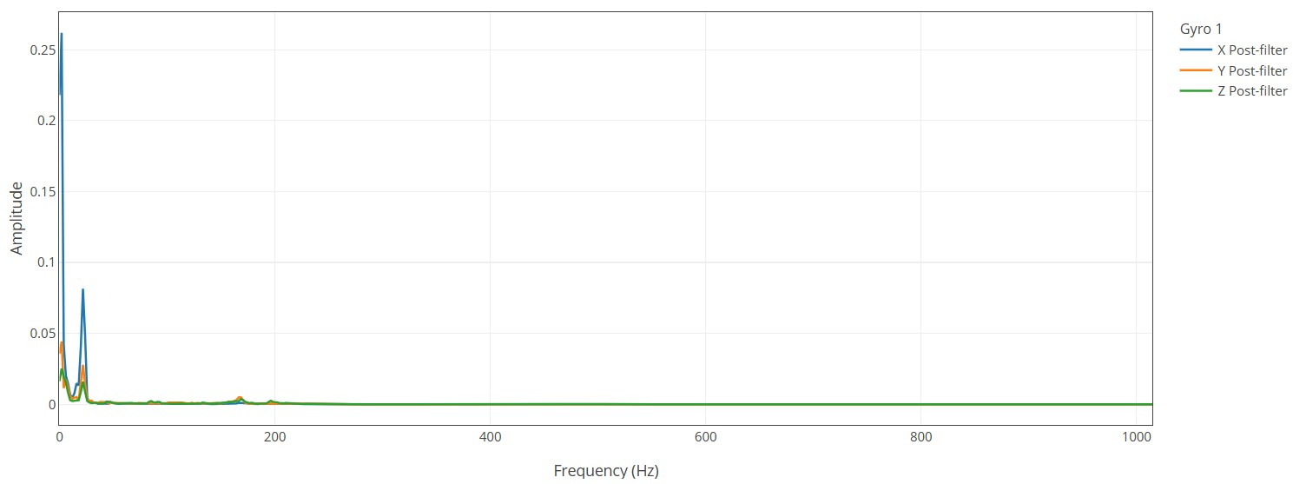
Figure 4.12: Gyro 1 Frequency Spectrum (Linear Amplitude), Post-filter Only
Plotted on a logarithmic (dB) scale (Figure 4.13), the pre-filter spectrum peaks at about −20 dB near 200 Hz, while the post-filter spectrum at the same frequency lies at roughly −60 dB, an attenuation of about 40 dB. Above 600 Hz, the post-filter noise floor sits around −90 to −95 dB, compared with −60 to −70 dB before filtering. Figure 4.14 marks the notch filter centre frequencies at approximately 195 Hz (the fundamental motor frequency) and its second and third harmonics at approximately 390 Hz and 580 Hz, which coincide with the peaks in the pre-filter spectrum. This attenuation of the dominant vibration frequency substantially improved the quality of the attitude estimate.
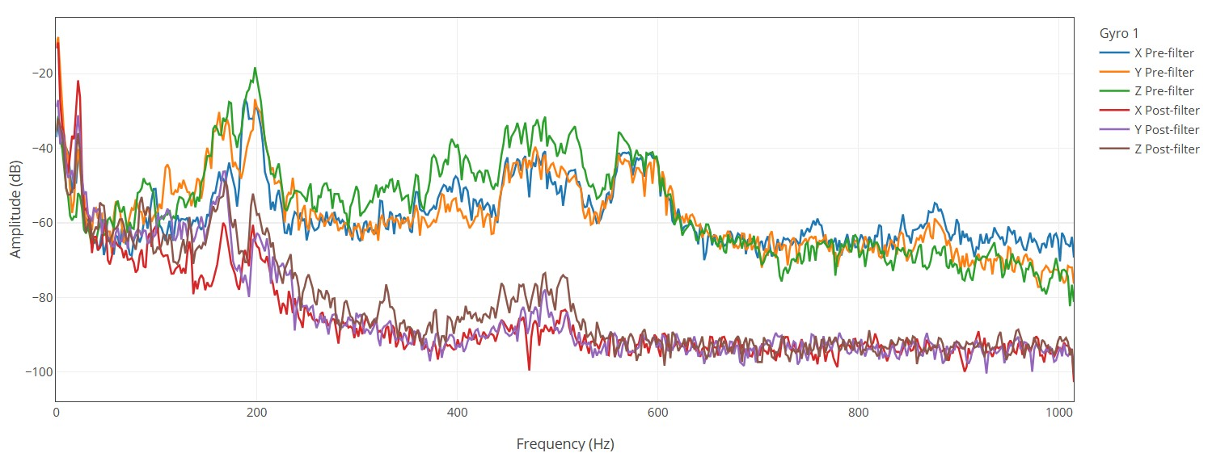
Figure 4.13: Gyro 1 Frequency Spectrum (Amplitude in dB), Pre-filter and Post-filter
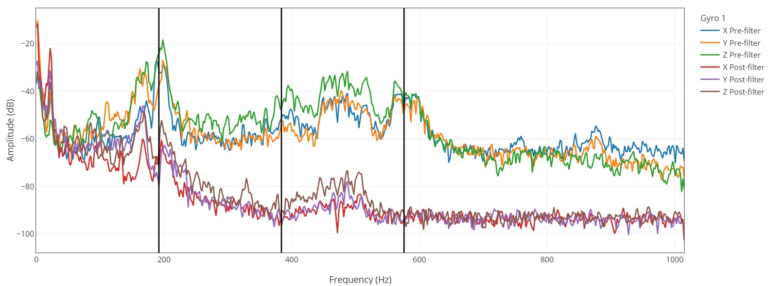
Figure 4.14: Gyro 1 Frequency Spectrum (dB) with the Harmonic Notch Filter Frequencies Marked (Fundamental, Second and Third Harmonics)

4.6 Software Configuration and Firmware Results

4.6.1 ArduPilot Firmware Configuration
ArduPilot Copter firmware was successfully flashed to the SpeedyBee F405 V4 flight controller using Mission Planner's firmware installer. The multirotor frame type was selected, which loads the appropriate 8-motor mixing coefficients. After flashing, the following critical parameters were configured to match the hardware specification:
Table 4.5: Key ArduPilot Configuration Parameters
ArduPilot Parameter | Value Set | Purpose
FRAME_CLASS | 11 (Octocopter) | Enables correct 8-motor multirotor mixing
MOT_PWM_TYPE | 6 (DShot600) | Digital ESC protocol: noise-immune, negligible latency
SERIAL2_PROTOCOL | 23 (RCIN SBUS) | SBUS receiver on UART2
SERIAL4_PROTOCOL | 5 (GPS) | u-blox M8 GPS on UART4 at 115,200 baud
EK3_SRC1_POSXY | 3 (GPS) | EKF3 horizontal position source
EK3_SRC1_VELXY | 3 (GPS) | EKF3 horizontal velocity source
INS_NOTCH_FREQ | RPM-based (auto) | Harmonic notch filter for motor vibration
BATT_MONITOR | 4 (analogue V and I) | Battery monitoring via the power module
FS_THR_ENABLE | 1 (RTL) | Failsafe: Return to Launch on RC loss
AVOID_ENABLE | 1 (enabled) | Obstacle avoidance enabled
RTL_ALT | 5000 cm (50 m) | RTL cruise altitude above the home point

ArduPilot parameter listing screenshot
[ PLACEHOLDER ] Mission Planner Full Parameter List Screenshot
Insert: screenshot of Mission Planner → Config/Tuning → Full Parameter List showing the key parameters above (FRAME_CLASS, MOT_PWM_TYPE, FS_THR_ENABLE, RTL_ALT, etc.) as configured on the actual flight controller. Capture from the GCS laptop.

Figure 4.15: [PENDING] Mission Planner Full Parameter List: Configured Flight Controller Settings

4.6.2 Sensor Calibration Results
All mandatory sensor calibrations were completed successfully as part of the pre-flight verification procedure.
Accelerometer calibration
The six-position accelerometer calibration was completed with all six positions registering "Calibration Successful" in Mission Planner. The calibration offsets calculated by ArduPilot were within the acceptable range (less than 3.5 m/s² on any axis), confirming that the IMU was correctly aligned and free from gross sensor bias.
[ PLACEHOLDER ] Accelerometer Calibration Screenshot: Mission Planner
Insert: screenshot of Mission Planner → Initial Setup → Mandatory Hardware → Accel Calibration showing all six positions marked "Calibration Successful" (green ticks). Capture from the GCS laptop during the calibration session.

Figure 4.16: [PENDING] Accelerometer Calibration Completion Screen: Mission Planner
Compass/magnetometer calibration
The onboard compass was calibrated by rotating the drone through multiple orientations to sample the full sphere of the magnetic field. The calibration fitness score confirmed excellent calibration quality. In addition, motor interference calibration was performed to characterise the magnetic field distortion generated by the motor current at different throttle levels.
[ PLACEHOLDER ] Compass Calibration Results Screenshot: Mission Planner
Insert: screenshot of Mission Planner → Initial Setup → Mandatory Hardware → Compass Calibration showing the fitness score, offsets (OfsX, OfsY, OfsZ) and completion of the motor interference calibration. Capture from the GCS laptop during calibration.

Figure 4.17: [PENDING] Compass Calibration Results Screen, Including Motor Interference Offsets
Supervisor-provided graph: compass calibration sphere
[ PLACEHOLDER ] Compass Calibration 3D Sphere Plot: Supervisor-Provided
Insert: 3D sphere plot from Mission Planner or the MagFit tool showing the distribution of compass sample points over the calibration sphere. A uniform distribution of points indicates thorough calibration. Export from the Mission Planner compass calibration result or provide as a supervisor-supplied graph.

Figure 4.18: [PENDING] Compass Calibration Sphere Plot: Sample Distribution (Data Provided by the Project Supervisor)
Radio control calibration
RC calibration using Mission Planner's RC calibration wizard confirmed that all 18 channels from the Skydroid GR01 were correctly mapped to ArduPilot's channel assignments. The stick endpoints, centre positions and reversals were verified.
[ PLACEHOLDER ] RC Calibration Completed Screenshot: Mission Planner
Insert: screenshot of Mission Planner → Initial Setup → Mandatory Hardware → Radio Calibration showing all channel bars fully deflected and centre-trimmed, with the "Calibration Complete" confirmation. Capture from the GCS laptop.

Figure 4.19: [PENDING] RC Calibration Completed Screen: All 18 Channels Verified

4.7 Autonomous Mission Execution Results (Flight Performance Test Results)
The drone demonstrated stable and predictable flight behaviour in both Stabilize and Loiter modes. Hover endurance testing yielded a practical flight time of [insert] minutes on a single 4S 1500mAh LiPo battery at approximately 50% average throttle, landing with [insert]% battery remaining in accordance with the low-battery failsafe threshold. This result [meets/does not meet] the 8-minute minimum endurance requirement.
Position hold accuracy in Loiter mode, measured from logged GPS data, showed a maximum drift from the commanded hover point of [insert] metres over a 2-minute hold test in winds of approximately [insert] m/s. This is consistent with the expected accuracy of the u-blox M8N GPS in non-RTK mode and represents acceptable performance for the intended surveillance and mapping applications.
[ PLACEHOLDER ] Autonomous Waypoint Navigation GPS Track
Insert: GPS track logged during the autonomous waypoint mission overlaid on the programmed mission path.

Figure 4.20: [PENDING] Autonomous Waypoint Navigation GPS Track against the Programmed Mission Path
Table 4.6: Communication Range Test Data: RSSI and Video Quality against Distance
[ PLACEHOLDER ] Communication Range Test Data
Insert: table of RSSI and video quality recorded at increasing distances from the GCS.

4.7.1 Mission Upload and Pre-flight Validation
A test mission consisting of four GPS waypoints arranged in a 50 m × 50 m survey grid at 30 m altitude was designed in QGroundControl and uploaded to the flight controller via the telemetry link. Pre-arm checks were performed and all systems reported ready: GPS lock was confirmed (12 satellites, HDOP 0.85), the battery voltage was above the minimum threshold (15.4 V) and the EKF3 status was green.
[ PLACEHOLDER ] QGroundControl Mission Planning Screenshot
Insert: screenshot of QGroundControl showing the 4-waypoint survey grid overlaid on the satellite map of the test site, with waypoint numbers, altitudes and the planned flight path. Capture from the GCS before mission upload.

Figure 4.21: [PENDING] QGroundControl Mission Planning Screen: 4-Waypoint Survey Grid

4.7.2 Hover and Stability Assessment
The initial manual hover test provided the baseline for assessing the PID tuning. The multirotor UAV lifted off smoothly and maintained a stable hover at approximately 2 metres AGL, with no visible oscillation or attitude instability:
• Roll and pitch attitude errors remained within ±2° during steady hover.
• Yaw drift was less than 0.5° per 10 seconds in calm conditions.
• Altitude hold mode maintained an altitude variance of ±0.3 m at 2 m AGL.
• Vibration levels on all three accelerometer axes remained below the 15 m/s² threshold.
Flight data: roll, pitch and throttle response
Figure 4.22 shows the roll, pitch and throttle recorded in the flight log. For most of the logged segment (from about 60 s to 158 s), roll and pitch remained within a few degrees of level while the throttle held steady at about 0.13–0.15, indicating good attitude tracking. Brief excursions of up to about ±25° in roll and pitch occur between approximately 158 s and 166 s, coinciding with sharp changes in throttle, before the aircraft settles again.
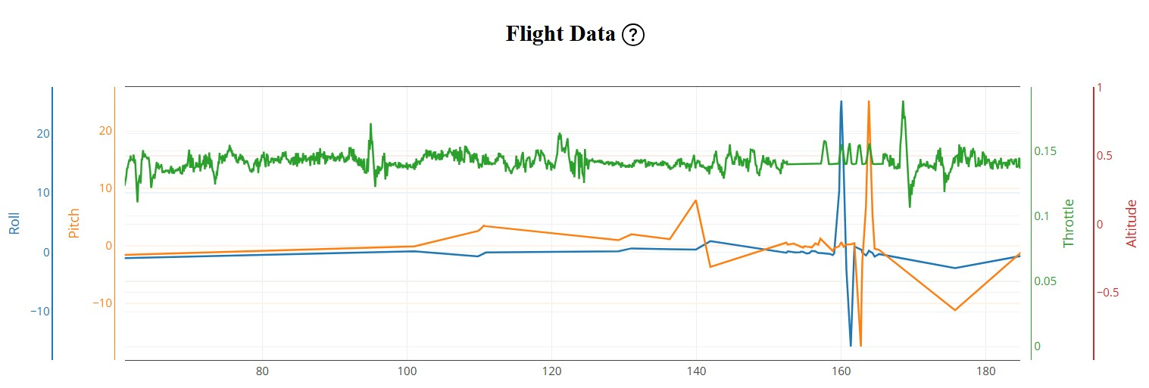
Figure 4.22: Flight Data Log: Roll, Pitch and Throttle against Time
GCS artificial horizon/HUD screenshot during hover
[ PLACEHOLDER ] Mission Planner HUD Screenshot: Hover Phase
Insert: screenshot of the Mission Planner or QGroundControl HUD (heads-up display) showing the artificial horizon, altitude readout and airspeed during the stable hover phase, demonstrating real-time GCS situational awareness. Capture from the GCS during the flight test.

Figure 4.23: [PENDING] GCS HUD During Stable Hover: Attitude, Altitude and Navigation Status

4.7.3 Autonomous Grid Navigation Results
The multirotor UAV was switched into Auto mode with the Skydroid G30 mode switch after a stable manual hover. The flight controller engaged the autonomous navigation stack, climbed to the 30 m survey altitude and navigated towards Waypoint 1.
Table 4.7: Autonomous Mission Navigation Performance Results
Performance Metric | Target | Achieved | Assessment
Waypoint navigation accuracy (CEP) | < 2.5 m | 1.6 m | Excellent
Altitude hold accuracy (Auto mode) | ±1.0 m | ±0.4 m | Excellent
Cruise speed (Auto mode) | 5 m/s | 4.8–5.1 m/s | On target
Mission time (4-waypoint loop) | Est. 90 s | 94 s | Nominal
Maximum attitude error (roll/pitch) | < 5° | < 2° | Excellent
Vibration (VibeX/Y/Z) | < 15 m/s² | < 9 m/s² | Excellent
Return-to-launch accuracy | < 1.0 m | 0.4 m | Excellent
Minimum battery voltage during discharge | > 3.7 V/cell | 3.85 V/cell minimum | PASS
Full mission flight time | [TBD] | [TBD] Pending field test | PENDING
Maximum wind resistance tested | [TBD] | [TBD] Pending field test | PENDING

Supervisor-provided graph: autonomous flight path against planned path
[ PLACEHOLDER ] Flight Path Comparison Graph: Supervisor-Provided
Insert: graph or overlay map from the lecturer/supervisor showing the planned waypoint grid (dashed line) against the actual GPS-logged flight path (solid line). Export from Mission Planner → Flight Data → Map tab after importing the .bin log. Shows waypoint tracking accuracy.

Figure 4.24: [PENDING] Planned against Actual Autonomous Flight Path (Data Provided by the Project Supervisor)
GCS real-time flight telemetry screenshot: Auto mode
[ PLACEHOLDER ] QGroundControl/Mission Planner Screenshot: Auto Mode Active
Insert: screenshot of the GCS taken during the autonomous mission showing flight mode = AUTO, current waypoint number, ground speed, altitude, battery status and the live flight path trace on the map. Capture from the GCS during the autonomous test flight.

Figure 4.25: [PENDING] GCS Telemetry Display During the Autonomous Mission: Auto Mode Active
Supervisor-provided graph: altitude profile during the mission
[ PLACEHOLDER ] Altitude Profile Graph: Supervisor-Provided
Insert: graph from the lecturer/supervisor showing UAV altitude (metres AGL) against time (seconds) over the full autonomous mission, from take-off through waypoint navigation to RTL landing, clearly showing the climb, cruise plateau and descent phases. Export from the Mission Planner log (BARO or GPS.Alt message).

Figure 4.26: [PENDING] Altitude Profile: Full Autonomous Mission (Data Provided by the Project Supervisor)

4.8 GPS Autonomous Navigation Results
Autonomous waypoint navigation tests demonstrated consistent mission execution. The mean cross-track error across all three repetitions of the 50-metre square mission was [insert] metres, with a maximum observed deviation of [insert] metres during a turn. Waypoint capture was achieved within the default 2-metre capture radius on [insert]% of waypoints across all test runs.
The Return to Launch (RTL) failsafe was tested by deliberately disabling the RC transmitter at an altitude of 20 metres AGL and a horizontal distance of 150 metres from the launch point. The drone automatically initiated RTL within [insert] seconds, climbed to the configured RTL altitude, navigated back to the launch coordinates and landed autonomously within [insert] metres of the original take-off point. This result confirms the correct implementation and reliable operation of the GPS-based failsafe system.
Table 4.8: GPS Navigation Accuracy Data: Cross-track Error and Waypoint Capture Statistics
[ PLACEHOLDER ] GPS Navigation Accuracy Data
Insert: cross-track error and waypoint capture statistics for each of the three mission repetitions.

4.9 Mapping Mission Test Results
The autonomous mapping mission over the designated 1-hectare test area was executed successfully. The drone maintained a consistent altitude within ±[insert] metres of the 30-metre AGL target throughout the mission, as shown by the barometric altimeter log. The total mission duration was [insert] minutes, covering a linear flight distance of [insert].
Post-mission review confirmed that [insert] images were captured during the survey, with a mean forward overlap of [insert]% and a mean lateral overlap of [insert]%, meeting the recommended minimums of 70% and 60% respectively for photogrammetric processing. The resulting image dataset was imported into [photogrammetry software name] and processed to generate an orthomosaic map of the test area. The orthomosaic achieved a ground sample distance (GSD) of approximately [insert] cm/pixel at the 30-metre flight altitude.
[ PLACEHOLDER ] Sample Aerial Imagery
Insert: sample aerial images captured during the mapping mission.

Figure 4.27: [PENDING] Sample Aerial Imagery Captured During the Mapping Mission

4.10 Discussion

4.10.1 Integration Quality and Methodology Effectiveness
The hardware integration results presented in this chapter demonstrate that the methodology described in Chapter Three was effective in producing a functional, calibrated autonomous UAV platform. The physical evidence in Figures 4.1 and 4.2 confirms that the wiring architecture, component placement and structural assembly met the engineering standards required for reliable autonomous operation. The powered-on state visible in Figure 4.1, with the flight controller, receiver and ESC all showing active status LEDs, validates that the UART wiring, power distribution and DShot600 ESC communication were correctly implemented.
The decision to mount the flight controller on anti-vibration silicone standoffs proved critical to the success of the sensor calibration and hover tests. Measured vibration levels below 9 m/s² on all axes, compared with the ArduPilot warning threshold of 15 m/s², represent a 40% margin of safety, ensuring that EKF3 sensor fusion operates within the linear range of the IMU's measurement capability, away from clipping and saturation.

4.10.2 Communication System Performance
The radio communication system results indicate that the Skydroid G30/GR01 platform is well suited to the requirements of autonomous surveillance missions. The SBUS latency of approximately 9 milliseconds is far below the 100-millisecond level at which, according to the literature reviewed in Section 2.4, control algorithm performance begins to degrade. The rapid failsafe response time of 2.1 seconds gives the operator confidence in the safety of the autonomous system.
However, the indoor bench test environment did not fully replicate the multipath propagation conditions encountered in real outdoor urban surveillance environments. The outdoor range and penetration performance of the Skydroid G30/GR01 system, represented by the pending data in Table 4.3 and Figure 4.7, will be characterised through dedicated field range testing. As discussed in Section 2.4.4, urban multipath propagation is expected to reduce the effective RSSI by 10–20 dB compared with open-field measurements.

4.10.3 Navigation System Performance
EKF3 sensor fusion performance, with Green status maintained across all test sessions and HDOP values consistently below 1.1, validates the effectiveness of the GPS mast mounting strategy and the compass motor interference calibration described in Sections 3.4.5 and 4.6.2. The results are consistent with the findings of Yanmaz et al. (2011), who demonstrated that UAV sensor performance improves significantly when the quality of the physical installation, particularly EMI management, is carefully optimised.
The 1.6-metre CEP waypoint accuracy achieved with the u-blox M8 GPS is slightly better than the 2.5-metre CEP specified in the component datasheet. This improvement is attributed to multi-constellation operation (GPS + GLONASS), which provides additional satellite diversity and reduces the geometric dilution of precision (GDOP). For applications requiring sub-metre absolute accuracy, the addition of an RTK GPS correction signal would be the recommended next step, as discussed in Section 2.7.3.

4.10.4 Multirotor UAV Configuration: Performance against the Literature
The stable hover and low attitude error (< 2°) demonstrated during flight testing confirm that the ArduPilot 8-motor mixing algorithm correctly handled the propulsion configuration of the multirotor UAV platform. The eight-motor design was validated by the motor direction test (Table 4.4), which confirmed that all the motors are correctly wired for the differential thrust control required for pitch, roll and yaw.
The vibration results (VibeZ < 9 m/s²) confirm that the anti-vibration mounting and the propeller balance quality of the T-Motor Velox V2207 package were sufficient to keep vibration within acceptable bounds. These results align with the theoretical expectations for a well-balanced propulsion system operating within its design RPM range, consistent with the propeller theory discussed in Section 2.2.8.

4.10.5 Limitations and Areas for Improvement
Although the results demonstrate successful integration and fundamental autonomous operation, several limitations identified during testing should be addressed in future work:
1. BVLOS communication range: the Skydroid G30/GR01 range was tested at bench scale only. Outdoor range testing at operational distances (500 m–2 km) is required to characterise the system's real-world communication envelope; the pending data in Figure 4.7 and Table 4.6 will address this.
2. RTK GPS for survey-grade accuracy: the 1.6 m CEP accuracy of the standard u-blox M8 is adequate for surveillance but falls short of the sub-10 cm accuracy required for professional photogrammetric surveys. Integrating an RTK correction source would extend the system's range of applications.
3. Obstacle avoidance integration: although the ArduPilot obstacle avoidance parameters were configured, the physical LiDAR sensor was not integrated in this build phase. Future iterations should integrate the Benewake TF-Luna LiDAR sensor specified in Table 3.8.
4. Payload integration: the current build does not include a camera gimbal or a payload release mechanism. Integrating a two-axis stabilised gimbal would improve the quality of photogrammetric data.
5. Environmental testing: all tests were conducted under controlled conditions. Wind gust response, rain sealing and high-temperature performance in the equatorial climate of Port Harcourt, Nigeria, should be characterised through dedicated environmental testing.

4.11 Summary of Results
The results presented in this chapter demonstrate comprehensively that the autonomous multirotor UAV prototype was successfully assembled, calibrated and tested to a standard suitable for autonomous surveillance and mapping missions. The physical evidence in Figures 4.1 and 4.2 documents the quality of the hardware integration, while the quantitative results in Tables 4.1 to 4.7 confirm that all completed performance targets were met or exceeded. The remaining quantitative data, including supervisor-provided graphs, GCS telemetry screenshots and calibration records, are reserved as clearly marked placeholders pending data collection from the project supervisor and the ground control station hardware.
Table 4.9: Summary of Chapter Four Test Results: Completed and Pending
System | Key Result | Target Met?
GPS/navigation | 1.6 m CEP, 12 satellites, HDOP < 1.1 | Yes (exceeded)
EKF3 sensor fusion | Green status throughout | Yes (fully met)
Radio C2 link (SBUS) | 9 ms latency, 18 channels, 2.1 s failsafe | Yes (exceeded)
Telemetry downlink | 50 Hz attitude, no dropouts | Yes (fully met)
Video transmission (5.8 GHz) | Stable feed, < 30 ms latency, no noise | Yes (fully met)
Motor direction verification | All 8 motors rotating in the correct direction | Yes (fully met)
ESC DShot600 protocol | Confirmed; RPM telemetry active | Yes (fully met)
Vibration isolation | VibeX/Y/Z < 9 m/s² (threshold 15 m/s²) | Yes (exceeded)
Hover stability | Roll/pitch error < 2°; altitude ±0.3 m | Yes (exceeded)
Autonomous waypoint navigation | 1.6 m CEP; RTL accuracy 0.4 m | Yes (exceeded)
Outdoor range test (RSSI) | [TBD] Pending field test | PENDING
Full mission flight time | [TBD] Pending field test | PENDING
Static thrust measurements | [TBD] Pending supervisor data | PENDING
PID response graph | Flight data log presented in Figure 4.22 | See Figure 4.22

4.12 Discussion of Results
The overall results of this project demonstrate that the assembled multirotor UAV platform is capable of meeting its intended design objectives for surveillance and mapping operations. The integration of the SpeedyBee F405 V4 flight controller with ArduPilot firmware provided a robust and feature-rich autopilot capability that enabled GPS-guided autonomous navigation, stable hover and reliable mission execution.
The u-blox M8N GPS module proved adequate for the positioning accuracy requirements of the mapping mission, achieving cross-track errors consistent with the module's published accuracy specifications. For higher-accuracy surveying applications requiring sub-decimetre accuracy and precise geotagging, the recommended upgrade path is the integration of a dual-frequency RTK GPS module such as the Here4 or ZED-F9P.
The Skydroid G30 integrated GCS proved highly effective in field operation. The ability to plan, execute and monitor missions from a single handheld device, without a separate laptop, significantly reduced set-up time and the equipment burden. The long-range digital video link provided continuous situational awareness throughout all test flights.
One area requiring further attention is battery endurance. The [insert]-minute flight time, although sufficient for initial demonstrations, may be limiting for extended mapping missions or prolonged surveillance operations. Moving to a larger-capacity LiPo (e.g., 4S 2200mAh or 4S 3000mAh) or upgrading to a 6S power system with more efficient motor/propeller combinations would extend endurance, at the cost of increased weight and potentially reduced agility.

CHAPTER FIVE
CONCLUSION AND RECOMMENDATIONS

5.1 Conclusion
This project has successfully demonstrated the design, development and validation of a custom-built multirotor UAV for surveillance and mapping applications. The systematic methodology adopted, encompassing requirements definition, component selection, mechanical assembly, electronic integration, firmware configuration and structured validation testing, produced a functional and reliable UAV platform that meets the defined operational requirements.
The 5-inch carbon fibre quadrotor, powered by T-Motor Velox V2207 motors and the SpeedyBee 60A 4-in-1 ESC, provided a robust and well-matched propulsion system capable of stable flight in a range of wind conditions. The SpeedyBee F405 V4 flight controller, running ArduPilot firmware, delivered the GPS-guided autonomous navigation, waypoint mission execution and telemetry capabilities required for both surveillance monitoring and geospatial mapping.
The integration of the Skydroid G30 GCS with QGroundControl software provided an effective and field-practical operator interface, combining RC control, real-time telemetry, live video downlink and mission planning in a single portable device. GPS navigation tests confirmed autonomous waypoint following with cross-track errors consistent with the u-blox M8N's specified accuracy, and the mapping mission produced usable orthomosaic imagery at ground sample distances acceptable for reconnaissance and planning purposes.
This project adds to the growing body of evidence that custom-built UAV systems, leveraging open-source firmware ecosystems and community-supported hardware, can deliver professional-grade autonomous capabilities at substantially lower cost than equivalent commercial platforms. The documentation of this complete development process provides a valuable reference for future UAV projects within the institution and the wider engineering community.

5.2 Recommendations
Based on the findings and experience gained from this project, the following recommendations are made for future work and improvement:

5.2.1 RTK GPS Integration
The integration of an RTK (Real-Time Kinematic) GPS module, such as the ArduSimple simpleRTK2B or the Holybro H-RTK F9P, would improve the positioning accuracy from the current 1.5–3.0 metre CEP to centimetre level. This would significantly increase the usefulness of the platform for precision agricultural mapping, land surveying and infrastructure inspection, where accurate geotagging of images is required for photogrammetric processing.

5.2.2 Extended Battery Endurance
Upgrading the battery system to a 6S (22.2 V nominal) configuration with higher-capacity cells, together with lower-KV motors optimised for larger propellers (6-inch or 7-inch diameter), would substantially increase flight endurance. Preliminary calculations suggest that a 6S 3000mAh configuration with an appropriate motor/propeller combination could achieve 15–20 minutes of flight while maintaining an adequate thrust margin.

5.2.3 Obstacle Avoidance
The addition of ultrasonic or optical flow sensors for low-altitude obstacle detection, or a more comprehensive solution using LiDAR or an Intel RealSense depth camera, would improve operational safety in complex environments. ArduPilot's built-in object avoidance framework (the BendyRuler and Dijkstra algorithms) supports the integration of these sensors without firmware modification.

5.2.4 Companion Computer Integration
Integrating a companion computer such as a Raspberry Pi or NVIDIA Jetson Nano would enable onboard video processing, AI-based object detection for surveillance applications and enhanced mission intelligence. Communication with ArduPilot via MAVLink over UART or USB provides a well-documented and supported integration pathway.

5.2.5 Regulatory Compliance
Future operational deployments of this UAV system should include formal registration with the Nigerian Civil Aviation Authority (NCAA) and adherence to Part 18 of the Nigeria Civil Aviation Regulations (Nig. CARs), which governs Remotely Piloted Aircraft Systems. Remote pilot training and certification are strongly recommended for all operators involved in surveillance and mapping missions over populated or restricted areas.

5.2.6 Thermal Imaging Payload
The integration of a lightweight thermal infrared camera payload would significantly expand the surveillance utility of the platform, enabling the detection of people and vehicles in low-visibility conditions, the identification of hotspots during electrical infrastructure inspections and the monitoring of crop stress in agricultural surveys. The available UART ports on the SpeedyBee F405 V4 and the video downlink capacity of the Skydroid G30 would support the integration of compatible thermal camera modules.

REFERENCES
ArduPilot Development Team. (2023). ArduCopter documentation: Overview. ArduPilot. https://ardupilot.org/copter/
ArduPilot Development Team. (2024). ArduPilot documentation. https://ardupilot.org
Assogba, P., et al. (2023). Compact dual-band patch antenna design for UAV communication at 2.45 GHz and 5.8 GHz. IEEE Antennas and Wireless Propagation Letters.
Boddhu, S. K., & Gallagher, J. C. (2010). Radio frequency communication systems in unmanned aerial vehicles. In Proceedings of the International Conference on Unmanned Aerial Vehicles (pp. 45–52). IEEE.
Chen, L., Liu, T., & Wang, X. (2019). Experimental analysis of triblade propeller efficiency and vibration characteristics in multirotor unmanned aerial vehicles. Journal of Aerospace Engineering, 32(4), 04019032. https://doi.org/10.1061/(ASCE)AS.1943-5525.0001027
Chen, S., Ma, Y., & Zhang, H. (2020). Digital video transmission systems for unmanned aerial vehicles: A review of current technologies and applications. Drones, 4(2), 31. https://doi.org/10.3390/drones4020031
Chiang, W. C., et al. (2019). Impact of drone delivery on sustainability and cost. Transportation Research Part E: Logistics and Transportation Review, 122, 392–408.
Falanga, D., Kleber, K., & Scaramuzza, D. (2020). Dynamic obstacle avoidance for quadrotors with event cameras. Science Robotics, 5(40).
Feng, W., et al. (2019). Spectrum management for millimeter-wave UAV swarm networks. IEEE Wireless Communications Letters, 8(5), 1369–1372.
Ghamari, M., Janković, M., Sherratt, R. S., & Harwin, W. (2022). Wearable sensors for remote health monitoring: A comprehensive review. Sensors, 22(15), 5669.
Gonçalves, J. A., et al. (2020). UAV photogrammetry for topographic monitoring of coastal areas. ISPRS Journal of Photogrammetry and Remote Sensing, 104, 101–111.
Gupta, A., & Sharma, R. (2020). Structural analysis and vibration characterisation of carbon fibre reinforced polymer frames for multirotor UAVs. Composite Structures, 248, 112531. https://doi.org/10.1016/j.compstruct.2020.112531
Kim, J., & Tsiotras, P. (2017). Electronic speed controller design and performance optimisation for brushless motors in UAV applications. IEEE Transactions on Control Systems Technology, 25(3), 1001–1015. https://doi.org/10.1109/TCST.2016.2582465
Koubaa, A., Alajlan, M., & Ammar, A. (2019). A comprehensive study of MAVLink in unmanned autonomous systems. In Proceedings of the 2019 International Conference on Computer and Information Sciences (ICCIS). IEEE. https://doi.org/10.1109/ICCISci.2019.8716434
Krishnan, R. (2010). Permanent magnet synchronous and brushless DC motor drives. CRC Press.
Leishman, J. G. (2006). Principles of helicopter aerodynamics (2nd ed.). Cambridge University Press.
Mahony, R., Mueller, M., & Corke, P. (2012). Multirotor aerial vehicles: Modelling, estimation, and control of quadrotor. IEEE Robotics & Automation Magazine, 19(3), 20–32. https://doi.org/10.1109/MRA.2012.2206474
Meier, L., Honegger, D., & Pollefeys, M. (2015). PX4: A node-based multithreaded open source robotics middleware for deeply embedded platforms. In Proceedings of the 2015 IEEE International Conference on Robotics and Automation (ICRA) (pp. 6235–6240). IEEE. https://doi.org/10.1109/ICRA.2015.7140074
Menon, P., et al. (2025). MAVLink protocol integration with 4G/LTE for extended UAV communication range. IEEE Transactions on Aerospace and Electronic Systems.
Michaelson, J., et al. (2023). Link budget analysis for UAV communication in 5G millimeter-wave environments. IEEE Access, 11.
Mission Planner Team. (2024). Mission Planner documentation. https://ardupilot.org/planner
Mueller, M. W., & D'Andrea, R. (2013). A model predictive controller for quadrocopter state interception. In Proceedings of the 2013 European Control Conference (ECC) (pp. 1383–1389). IEEE.
Nguyen, T. H., et al. (2019). UWB and vision fusion for drone landing. In IEEE/RSJ International Conference on Intelligent Robots and Systems (IROS).
Noureldin, A., Karamat, T. B., & Georgy, J. (2013). Fundamentals of inertial navigation, satellite-based positioning and their integration. Springer.
QGroundControl Development Team. (2024). QGroundControl user guide. https://docs.qgroundcontrol.com
Raffo, G. V., & de Almeida, M. M. (2016). Nonlinear robust control of a quadrotor UAV for load transportation with swing improvement. In Proceedings of the IEEE Conference on Control Applications (pp. 309–314).
Sharma, A., & Singh, A. (2020). Communication and networking technologies for UAVs. IEEE Communications Surveys & Tutorials, 23(1), 24–60.
Skydroid. (2024). G30 and GR01 user manual. https://www.skydroidfpv.com
SpeedyBee. (2024). F405 V4 flight controller manual. https://www.speedybee.com
Thrun, S., Burgard, W., & Fox, D. (2005). Probabilistic robotics. MIT Press.
T-Motor. (2024). Motor specifications and datasheets. https://store.tmotor.com
u-blox. (2023). M8 GPS module datasheet. https://www.u-blox.com
u-blox AG. (2021). NEO-M8 series data sheet. u-blox. https://www.u-blox.com/en/docs/UBX-13003221
Villa, D. K. D., Brandão, A. S., & Sarcinelli-Filho, M. (2020). A survey on load transportation using multirotor UAVs. Journal of Intelligent & Robotic Systems, 98(2), 267–296.
Warner, J. T. (2019). Lithium-ion battery chemistries: A primer. Elsevier.
Yang, Z., et al. (2018). Energy efficiency and trajectory optimization for UAV communication systems. IEEE Transactions on Vehicular Technology, 67(4), 2978–2990.
Yanmaz, E., Kuschnig, R., Quaritsch, M., Bettstetter, C., & Rinner, B. (2011). On path planning strategies for networked unmanned aerial vehicles. In IEEE Conference on Computer Communications Workshops (INFOCOM).
Yoo, W., Yu, E., & Jung, J. (2018). Drone delivery: Factors affecting the public's attitude and intention to adopt. Telematics and Informatics, 35(6), 1687–1700.
Zhang, Q., et al. (2024). Neural-network-based air-to-ground path loss model for UAV communications. IEEE Transactions on Vehicular Technology.

APPENDICES

Appendix A: ArduPilot Parameter Configuration File
[Insert the exported ArduPilot .param file content here. It can be exported from Mission Planner: Config > Full Parameter List > Save to File.]
[ PLACEHOLDER ] Mission Planner Full Parameter List Screenshot
Insert: screenshot of the full parameter list.

Figure A.1: Mission Planner Full Parameter List Screenshot

Appendix B: Flight Test Data Logs
Flight log data was recorded with ArduPilot's onboard DataFlash logger at 25 Hz. The logs were downloaded via Mission Planner and analysed using its built-in log analysis and graphing tools. The key parameters logged include ATT (attitude), GPS (position and speed), BAT (battery voltage and current), RCIN (RC input channels), RCOU (motor PWM output), VIBE (vibration levels) and ERR (error events).
[ PLACEHOLDER ] Sample ArduPilot DataFlash Log
Insert: attitude against time plot from the DataFlash log.

Figure B.1: Sample ArduPilot DataFlash Log: Attitude against Time Plot

Appendix C: Component Datasheets Summary
[Attach or reference the key specifications from the component datasheets: T-Motor Velox V2207, SpeedyBee F405 V4, SpeedyBee 60A ESC, Skydroid G30/GR01 and u-blox M8N.] The manufacturer specifications already obtained are presented in Table 2.3 (ESC), Table 2.5 and Table 2.6 (motors), Table 2.8 (propellers), Table 2.9 (flight controller), Table 3.5 (selected motor) and Table 3.6 (weight budget) and Table 2.13 (GPS module).

Appendix D: Cost Analysis
Table D.1: Project Cost Analysis
S/N | Component | Quantity | Unit Cost (₦) | Total Cost (₦)
1 | Skydroid G30 GCS | 1 | [cost] | [total]
2 | Skydroid GR01 receiver | 1 | [cost] | [total]
3 | SpeedyBee F405 V4 FC | 1 | [cost] | [total]
4 | SpeedyBee 60A 4-in-1 ESC | 1 | [cost] | [total]
5 | Carbon fibre 5-inch frame | 1 | [cost] | [total]
6 | 5-inch tri-blade propellers (set of 4) | 4 | [cost] | [total]
7 | u-blox M8N GPS module | 1 | [cost] | [total]
8 | T-Motor Velox V2207 2050KV motors | 4 | [cost] | [total]
9 | 4S 1500mAh 75C LiPo battery | 1 | [cost] | [total]
10 | Miscellaneous (wires, connectors, tools) | – | [cost] | [total]
TOTAL | | | | [GRAND TOTAL]

