**PRACTICAL-5**

**Experiments on Packet Capture tool:Wireshark**

**CAPTURING PACKETS**

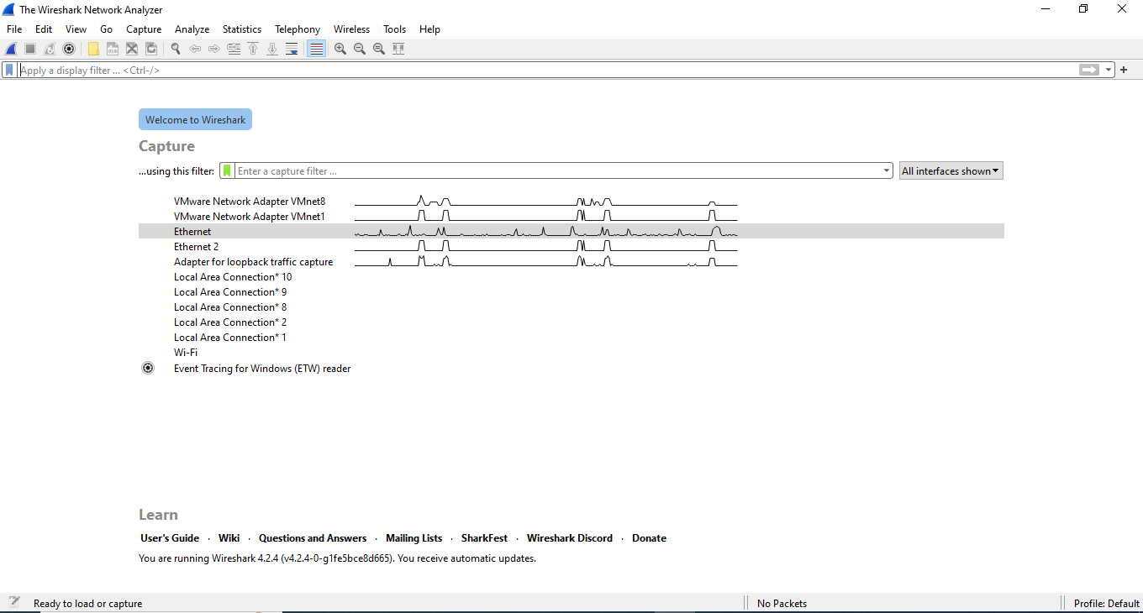

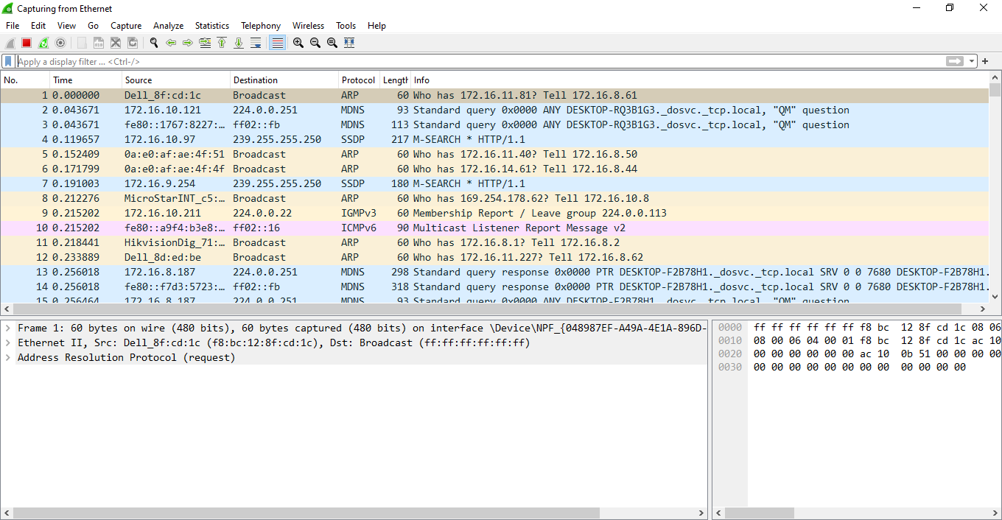

Packet

Bytes

Packet

Details

Packet

List

**Coloring Rules**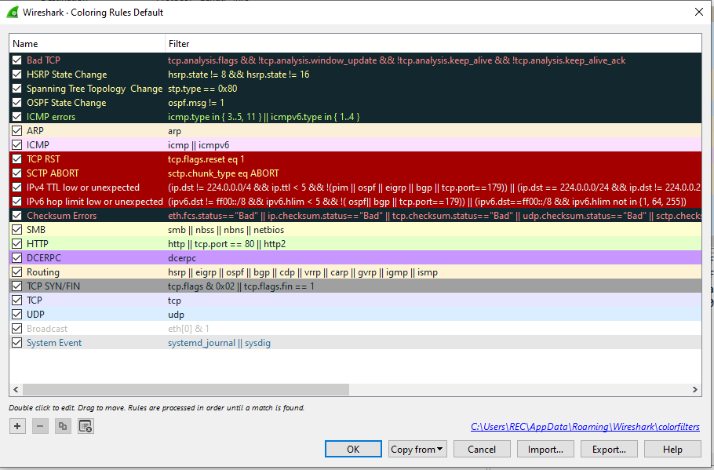

**Filtering packets**

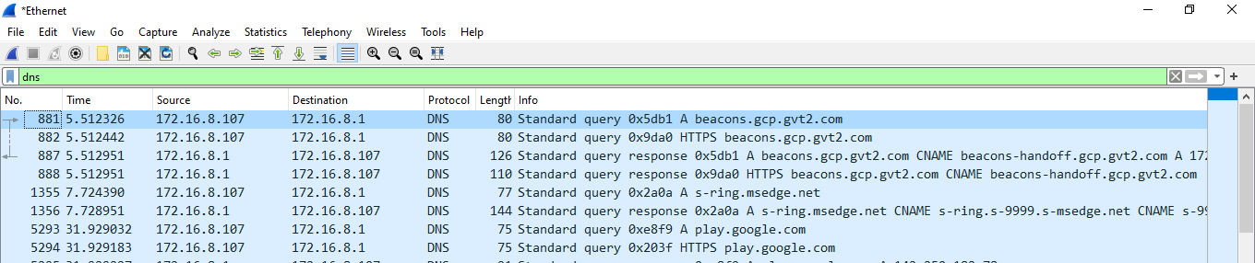

**Display Filters**

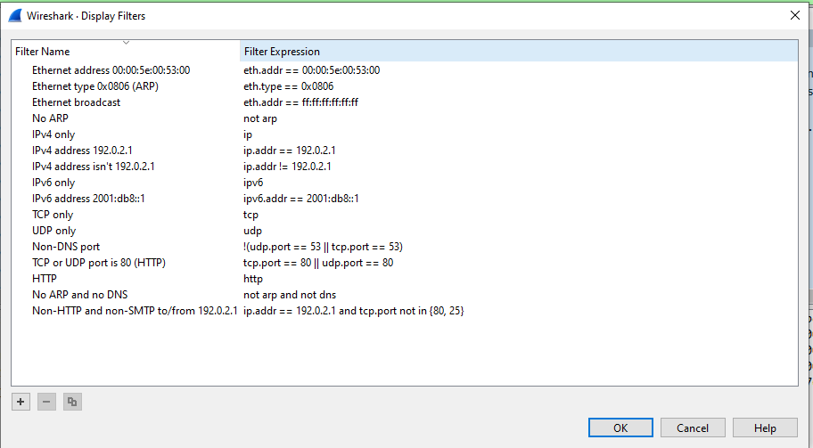

**TCP Stream**

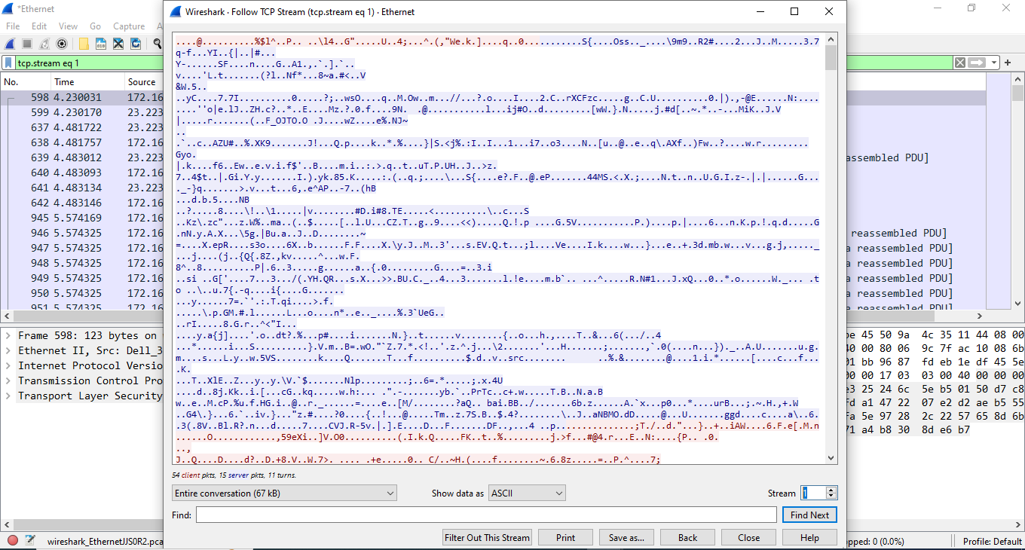

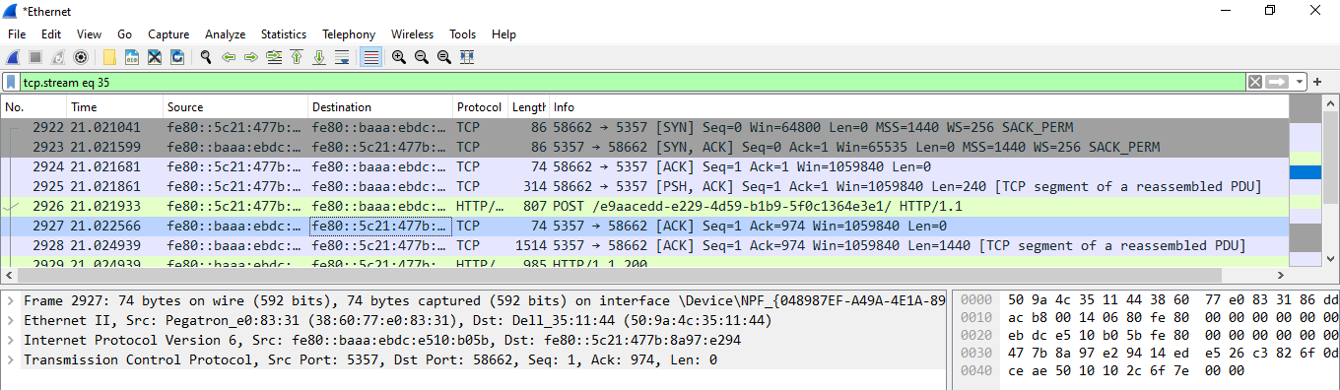

**Inspecting Packets**

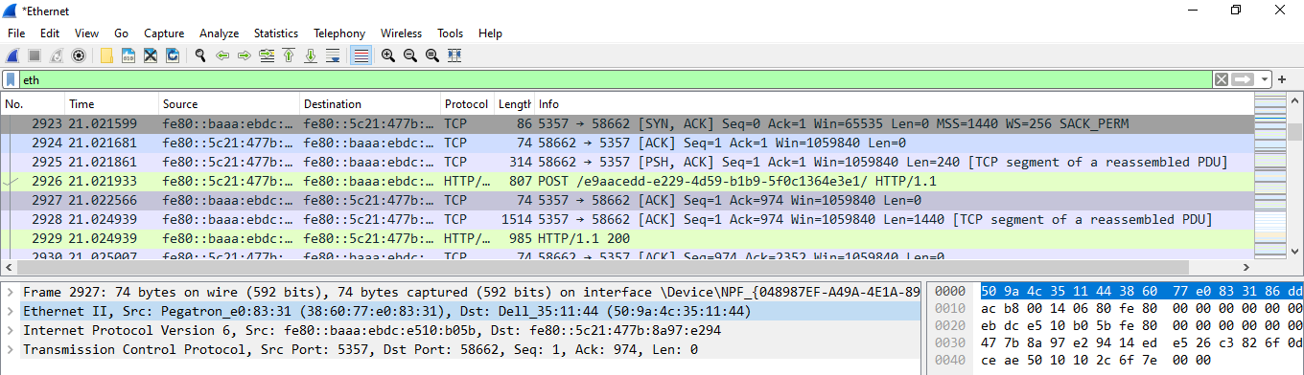

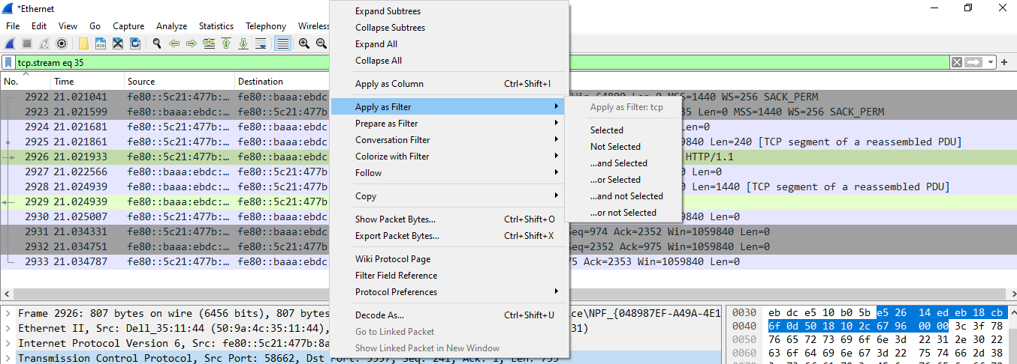

**Flow Graph**



