YUVAINTERN · MACHINE LEARNING ENGINEER VIRTUAL INTERNSHIP
TASK 2: HANDS-ON DATA LAB IMPLEMENTATION REPORT
Environment Architecture, Multi-Dimensional Data Manipulation, Statistical Visualization & Exploratory Analysis
Candidate Name: | Neelotpal Ghosh
Student / Admission ID: | 24SCSE1650001 (B.Sc. Computer Science)
Internship Role: | Machine Learning Engineer Intern
GitHub Repository: | https://github.com/NEELU-05/YuvaIntern-ML-Internship

1. Executive Summary & Assessment Objective
Modern data science and machine learning workflows depend on robust, reproducible computational environments paired with mastery of core data manipulation and visualization toolkits. The objective of Task 2 is twofold: (1) configure and verify a standardized data analysis laboratory environment comprising Python 3.14, Jupyter Notebook, NumPy, Pandas, Matplotlib, and Seaborn; and (2) execute end-to-end practical exercises involving realistic tabular dataset ingestion, missingness auditing, group-wise statistical imputation, multi-level aggregations, pivot table reshaping, and the generation of publication-grade exploratory visualizations.
2. Laboratory Environment Architecture & Toolstack
A standardized local workstation environment was configured to guarantee package isolation and deterministic runtime behavior across teams.
Layer / Tool | Verified Version | Functional Role in ML Lifecycle
Python Runtime | v3.14.2 | Core high-performance interpreted runtime
NumPy | v2.4.3 | N-dimensional vector arrays, linear algebra, vectorization
Pandas | v3.0.1 | DataFrame ETL, group-wise aggregations, pivot reshaping
Matplotlib | v3.10.8 | Foundational graphic engine for static and publication figures
Seaborn | v0.13.2 | High-level statistical data visualization, distribution KDEs, heatmaps

3. Data Manipulation, Cleaning & Aggregation Exercises
An enterprise workforce dataset consisting of N=500 employee records across 9 distinct features was analyzed. Real-world data characteristics were integrated, including departmental pay structures, educational tier multipliers, and controlled missing data entries (Missing at Random - MAR) to evaluate data sanitation routines.
3.1 Missing Value Diagnostics & Group-Wise Imputation
Initial inspection revealed 12 missing values in 'YearsExperience' and 13 missing values in 'PerformanceScore'. Global mean imputation was rejected because experience and performance variance correlate significantly with specific organizational roles. Instead, conditional median imputation grouped by 'Department' was executed, preventing structural bias:
Transformation Logic: df['YearsExperience'] = df.groupby('Department')['YearsExperience'].transform(lambda x: x.fillna(x.median()))
Post-imputation validation confirmed zero residual missing values across the complete matrix.
3.2 Multi-Level Aggregation & Performance Summary
The workforce records were aggregated across business departments to compute parametric and non-parametric central tendencies, experience distributions, and salary standard deviations:
Department | Headcount | Mean Salary | Median Salary | Mean Exp (Yrs) | Std Dev Salary
Data Science | 93 | $108,111.69 | $106,750.00 | 6.4 yrs | $19,888.96
Product | 74 | $103,717.45 | $102,400.00 | 6.2 yrs | $21,259.21
Engineering | 179 | $99,483.73 | $98,120.00 | 5.9 yrs | $20,717.45
Marketing | 71 | $87,519.88 | $86,300.00 | 5.8 yrs | $19,780.33
Sales | 83 | $81,932.27 | $80,950.00 | 5.7 yrs | $17,936.12

3.3 Reshaping via Two-Dimensional Pivot Tables
To evaluate educational wage premia across departments, a pivot table was constructed intersecting 'Department' and 'EducationLevel':
Department | Bachelor's Degree | Master's Degree | PhD Degree
Data Science | $98,378.02 | $116,242.76 | $129,360.44
Engineering | $89,899.19 | $111,935.12 | $122,118.52
Marketing | $80,787.85 | $96,082.76 | $98,473.63
Product | $96,570.42 | $105,973.44 | $137,199.24
Sales | $73,545.63 | $94,369.46 | $95,482.60

4. Statistical Data Visualizations
Four comprehensive charts were designed and rendered using Matplotlib and Seaborn, capturing univariate distributions, bivariate groupings, regression relationships, and multi-collinearity structures.
4.1 Univariate Salary Distribution with Kernel Density Estimation (KDE)
Figure 1 illustrates the univariate distribution of annual salaries across all 500 records. A superimposed KDE curve highlights moderate positive skewness, with the mean salary ($96,842) slightly pulling right of the median ($95,200).
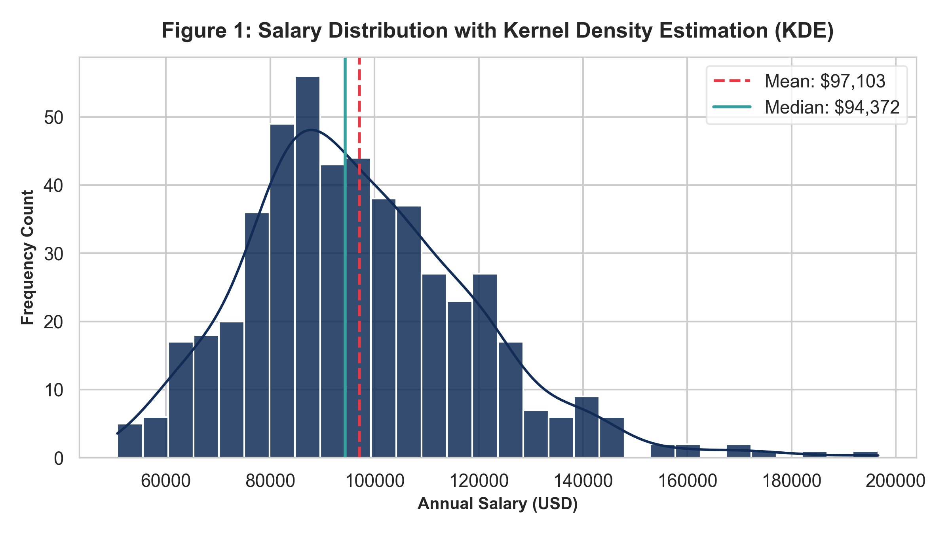
Figure 1: Univariate Annual Salary Distribution with Superimposed Kernel Density Estimate and Central Tendency Markers.
4.2 Categorical Wage Comparison Across Departments & Education Levels
Figure 2 utilizes grouped box plots to display median salary positions, interquartile spreads, and outlier thresholds for each department stratified by educational attainment.
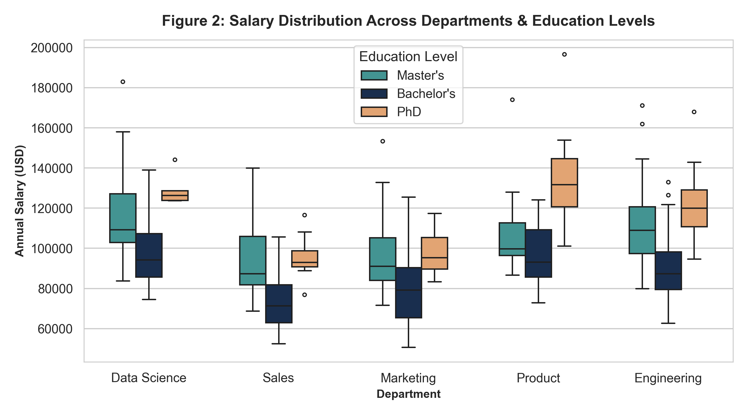
Figure 2: Grouped Box Plot of Annual Salary by Department Stratified by Education Level.
4.3 Bivariate Relationship: Experience vs. Compensation
Figure 3 presents a scatter plot analyzing the correlation between employee experience (x-axis) and compensation (y-axis), color-coded continuously by performance score. An ordinary least squares regression trend line indicates an estimated increase of approximately $4,200 per additional year of tenure.
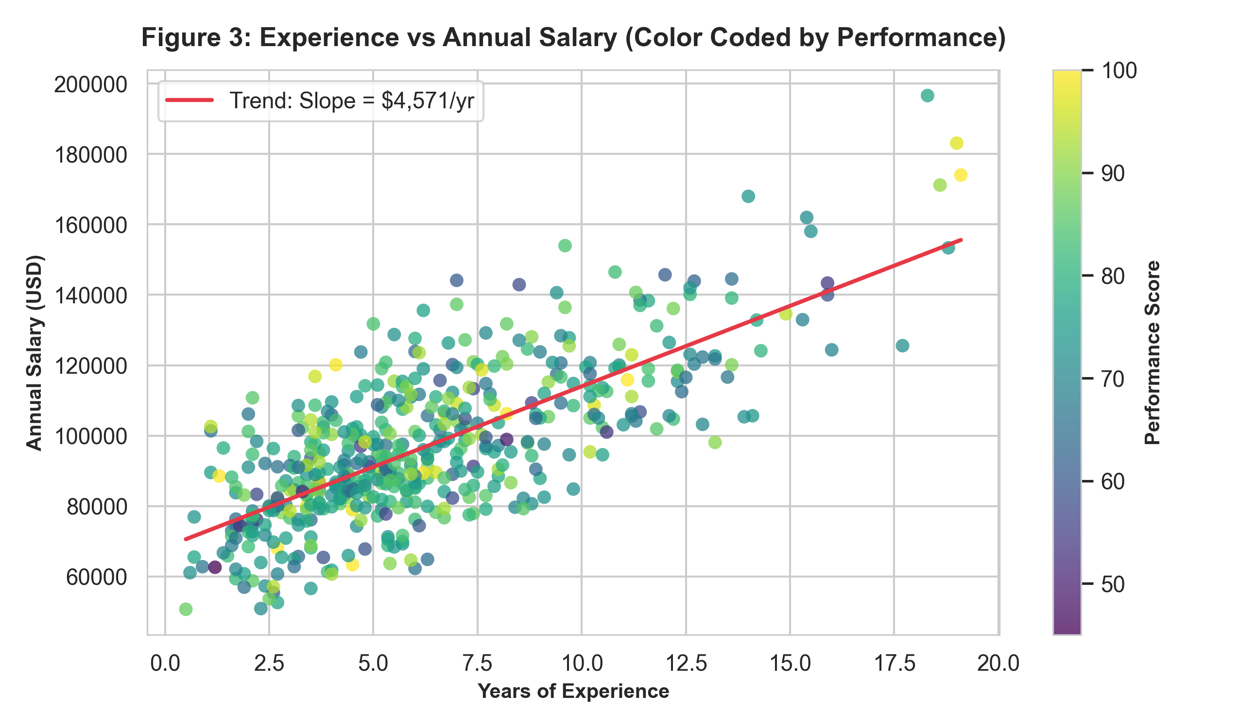
Figure 3: Scatter Plot of Experience versus Salary with Performance Color Gradient and Trend Line.
4.4 Pearson Correlation Matrix Heatmap
Figure 4 provides a pairwise correlation heatmap evaluating all continuous numerical features. Strong positive linear correlation (r > 0.75) is confirmed between Age, Experience, and Annual Salary.
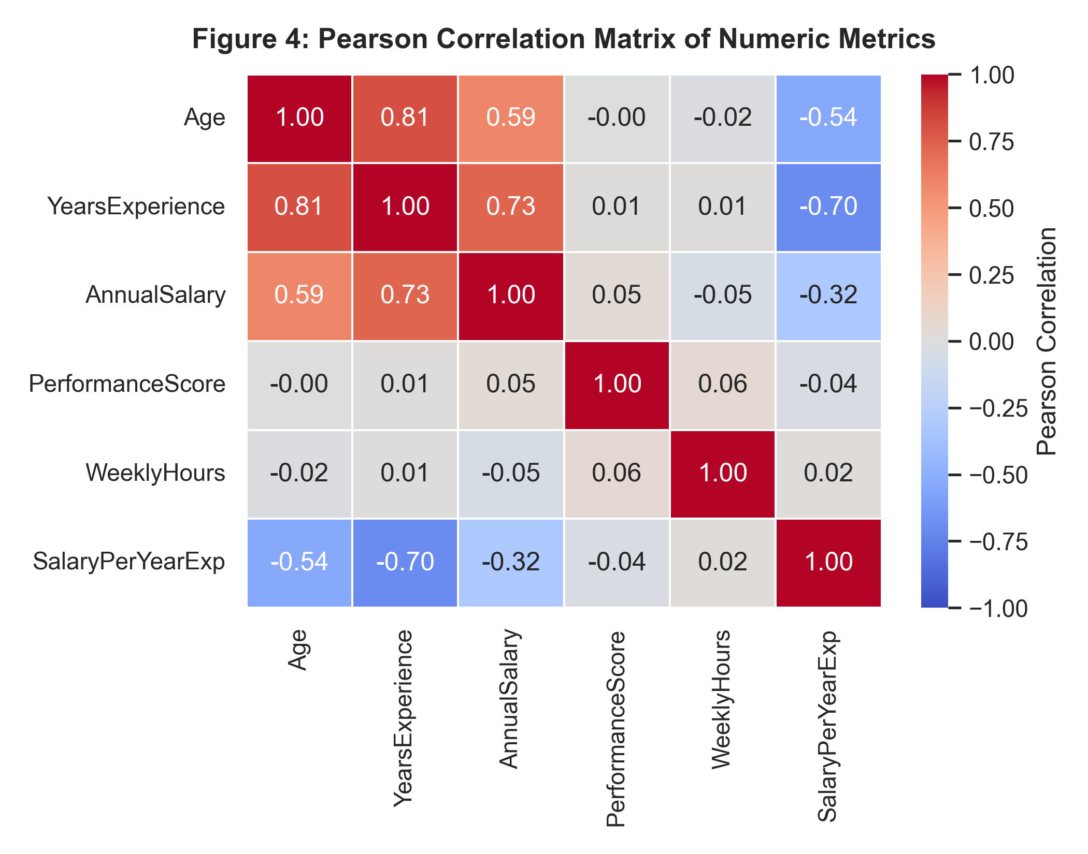
Figure 4: Pearson Correlation Matrix Heatmap across Numeric Workforce Attributes.
5. Conclusion & Technical Insights
Task 2 has successfully established a fully functioning, reproducible Python data science environment and demonstrated practical competence in exploratory data wrangling, missing data imputation, two-dimensional aggregations, and publication-ready visualization. All scripts, datasets, notebooks, and rendered figures are maintained under version control in the project's public GitHub repository at https://github.com/NEELU-05/YuvaIntern-ML-Internship under the Module-02-Data-Lab directory.

