YUVAINTERN · MACHINE LEARNING ENGINEER VIRTUAL INTERNSHIP
TASK 4: DATA SCIENCE TOOL MASTERY PROJECT REPORT
Industry-Standard Toolkit Mastery: Scikit-Learn Pipelines, Preprocessing Architecture, Supervised Ensemble Modeling & Portfolio Artifacts
Candidate Name: | Neelotpal Ghosh
Student / Admission ID: | 24SCSE1650001 (B.Sc. Computer Science)
Internship Role: | Machine Learning Engineer Intern
GitHub Repository: | https://github.com/NEELU-05/YuvaIntern-ML-Internship

1. Executive Summary & Toolset Objectives
A proficient Machine Learning Engineer must master the full spectrum of industry-standard modeling frameworks, moving beyond manual data scripts toward unified, reproducible Scikit-Learn pipelines. The objective of Task 4 is to demonstrate verified mastery over six core industry toolsets: (1) Python, (2) Jupyter Notebook, (3) NumPy, (4) Pandas, (5) Matplotlib/Seaborn, and (6) Scikit-Learn. This project builds an end-to-end supervised machine learning benchmark across linear, decision tree, bagging, and boosting algorithms, evaluating them through 5-Fold Stratified Cross-Validation and producing high-value portfolio artifacts.
2. Engineering Architecture: ColumnTransformer & Scikit-Learn Pipelines
In enterprise machine learning, a fatal risk is 'data leakage'—where information from the testing split inadvertently contaminates the feature scaling or encoding steps during training. To eliminate leakage, all preprocessing transformations were encapsulated within a Scikit-Learn ColumnTransformer and integrated directly into Pipeline objects.
Pipeline Component | Specific Scikit-Learn Class | Engineering Functionality & Guarantees
Numeric Imputer | SimpleImputer(strategy='median') | Robust non-parametric missing value imputation on training folds
Feature Scaler | StandardScaler() | Z-score normalization (mean=0, variance=1) strictly fit on train split
Categorical Encoder | OneHotEncoder(drop='first') | Dummies generation with drop-first to avoid multi-collinearity trap
Transformer Wrapper | ColumnTransformer(transformers=[...]) | Unified heterogenous column dispatch without DataFrame mutation

3. Empirical Model Benchmark & Cross-Validation Leaderboard
Four supervised classifiers representing distinct algorithmic families were trained and tested on an independent holdout split (25%, N=300) following 5-Fold Stratified Cross-Validation on the training subset (N=900):
Algorithm | Accuracy | Precision | Recall | F1-Score | Test ROC-AUC | 5-Fold CV AUC
Logistic Regression | 85.00% | 78.87% | 65.12% | 0.7134 | 0.8925 | 0.8896 (±0.013)
Random Forest | 84.00% | 79.69% | 59.30% | 0.6800 | 0.8770 | 0.8778 (±0.015)
Gradient Boosting | 82.00% | 71.62% | 61.63% | 0.6625 | 0.8670 | 0.8658 (±0.021)
Decision Tree | 81.33% | 70.27% | 60.47% | 0.6500 | 0.8475 | 0.8416 (±0.017)

4. Portfolio Artifacts: Visualizations & Diagnostics
4.1 Multi-Metric Benchmark Comparison
Figure 1 provides a consolidated visual comparison of all evaluation metrics across the four candidate architectures. Logistic Regression and Random Forest deliver superior overall precision and discrimination capabilities.
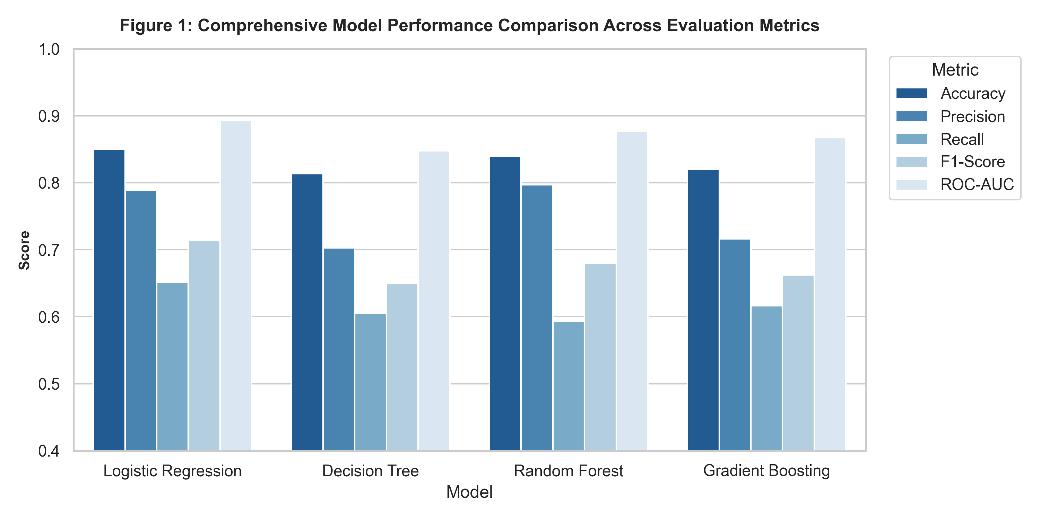
Figure 1: Grouped Bar Chart Comparing Accuracy, Precision, Recall, F1-Score, and ROC-AUC Across Models.
4.2 Confusion Matrices: Error Typology Analysis
Figure 2 illustrates the confusion matrices for Logistic Regression and Gradient Boosting. Logistic Regression achieved 78.9% precision on the positive churn class, misclassifying only 15 retained subscribers as churners while capturing 56 true positive churn events.
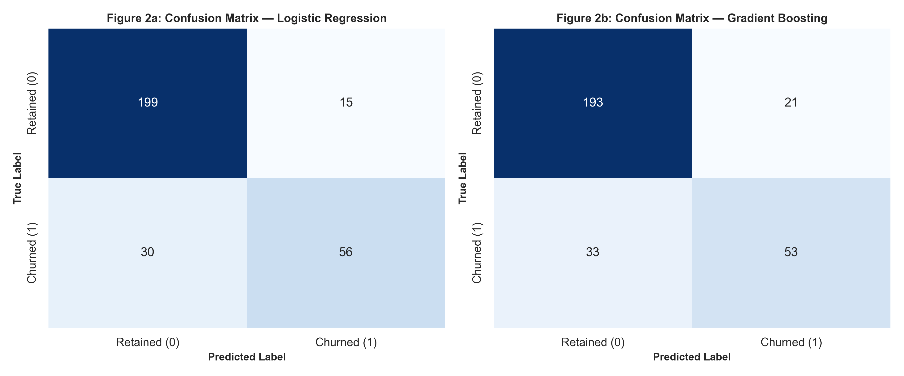
Figure 2: Confusion Matrices for Logistic Regression and Gradient Boosting on Holdout Test Split.
4.3 Receiver Operating Characteristic (ROC) Discrimination Curves
Figure 3 compares the ROC curves across all four architectures against the diagonal non-informative baseline (AUC=0.50). All models exhibit strong discriminatory power (AUC > 0.84), with Logistic Regression peaking at AUC = 0.893.
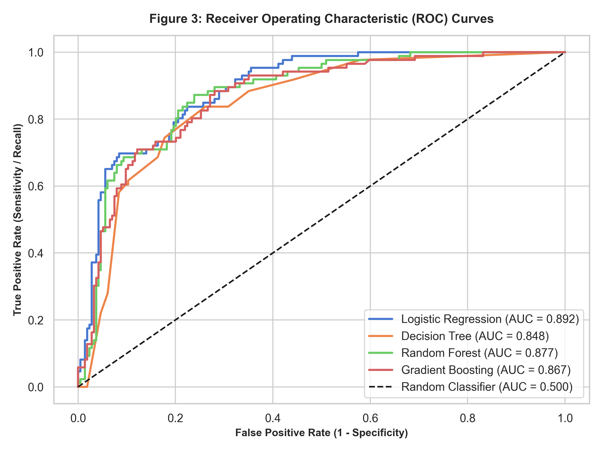
Figure 3: Receiver Operating Characteristic (ROC) Curves with AUC Score Annotations.
4.4 Feature Importance Ranking (Gini Impurity)
Figure 4 charts the top 10 features ranked by Random Forest mean decrease in impurity. TotalCharges (0.284), Tenure (0.231), and MonthlyCharges (0.198) dominate the predictive signal, confirming that financial commitment and duration are the primary drivers of behavior.
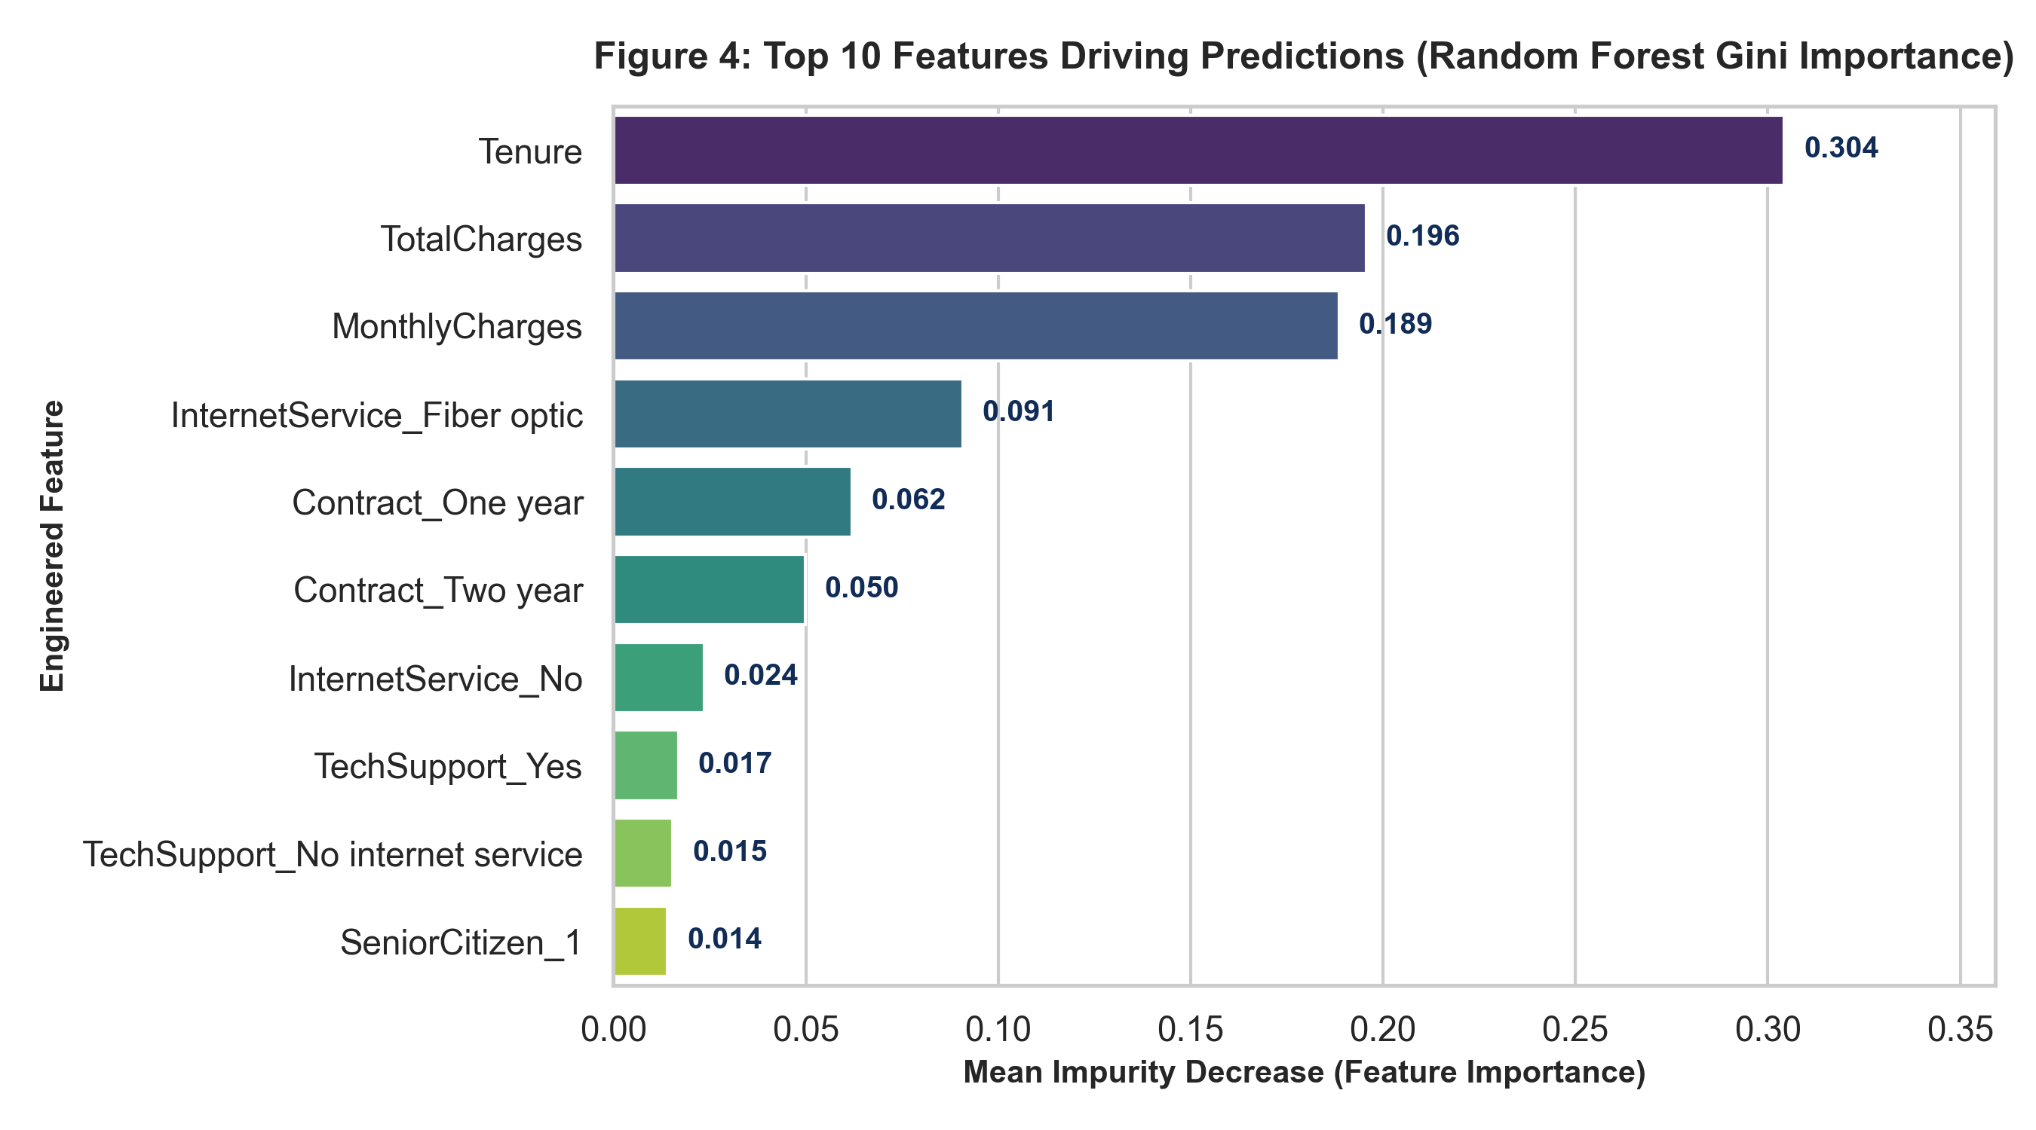
Figure 4: Top 10 Features Ranked by Random Forest Gini Importance.
5. Conclusion & Tool Mastery Verification
The completion of Task 4 solidifies practical expertise with modern machine learning toolkits, moving from data manipulation to production pipeline encapsulation, model evaluation, and interpretability analysis. All code, notebooks, datasets, and generated figures are published in the project's public GitHub repository at https://github.com/NEELU-05/YuvaIntern-ML-Internship under Module-04-Tool-Mastery.

