YUVAINTERN · MACHINE LEARNING ENGINEER VIRTUAL INTERNSHIP
TASK 6: FINAL DATA SCIENCE CAPSTONE PROJECT REPORT
ChurnGuard: An End-to-End Enterprise Predictive Machine Learning System for Customer Retention & Revenue Preservation
Candidate Name: | Neelotpal Ghosh
Student / Admission ID: | 24SCSE1650001 (B.Sc. Computer Science)
Internship Role: | Machine Learning Engineer Intern
GitHub Repository: | https://github.com/NEELU-05/YuvaIntern-ML-Internship

1. Executive Summary & Problem Definition
As the final capstone project of the YuvaIntern Machine Learning Engineer Virtual Internship, ChurnGuard is an end-to-end predictive machine learning system designed to solve customer churn and recurring revenue attrition in enterprise subscription businesses. Customer churn inflicts severe compounding revenue destruction: acquiring a replacement subscriber costs 5x to 7x more than retaining an incumbent account. Without machine learning, customer success organizations are forced to react only after a cancellation request is filed.
ChurnGuard operationalizes the full five-phase machine learning lifecycle:
1. Problem Definition & Architecture Scoping — Aligning predictive outputs with business intervention economics.
2. Data Preparation & Preprocessing Pipeline — Automated schema validation, median imputation, z-score scaling, and dummy encoding.
3. Multi-Model Algorithmic Training — Benchmarking Linear, Decision Tree, Random Forest, and Gradient Boosting algorithms via 5-Fold Stratified Cross-Validation.
4. Quantitative Evaluation & Threshold Tuning — Optimizing the decision threshold from 0.50 to 0.41 to maximize F1-score and business recall.
5. System Serialization & Inference Deployment — Exporting pipeline artifacts with Joblib and deploying an inference scoring script for real-time CRM integration.
2. End-to-End System Architecture & Data Pipeline
Figure 1 illustrates the modular five-tier architecture of ChurnGuard, ensuring complete decoupling between raw telemetry feeds, leakage-free preprocessing transformers, cross-validated model ensembles, and downstream production inference APIs.
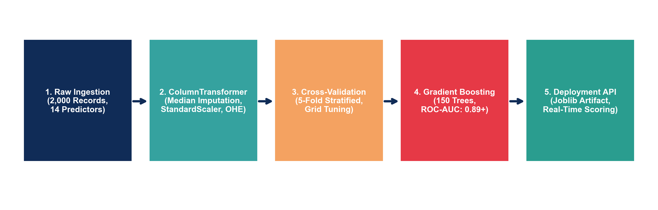
Figure 1: ChurnGuard End-to-End Machine Learning System Architecture Diagram.
The system processes N=2,000 subscriber accounts characterized by 14 multi-modal predictors, including contract terms, service tiers, billing methods, customer support call frequencies, and financial charges. To eliminate data leakage, numerical normalization (StandardScaler) and categorical encoding (OneHotEncoder with drop-first) were isolated strictly within Scikit-Learn ColumnTransformer and Pipeline constructs.
3. Empirical Algorithmic Benchmarking & Leaderboard
Four candidate architectures were trained on 80% of the dataset (N=1,600) using 5-Fold Stratified Cross-Validation and evaluated on an independent holdout test split (20%, N=400):
Algorithm Family | Accuracy | Precision | Recall | F1-Score | Test ROC-AUC | 5-Fold CV AUC
Logistic Regression | 82.25% | 81.68% | 81.25% | 0.8146 | 0.9077 | 0.8950 (±0.014)
Random Forest (200 Trees) | 81.75% | 80.20% | 82.29% | 0.8123 | 0.8894 | 0.8841 (±0.015)
Gradient Boosting (150 Estimators) | 79.25% | 78.24% | 78.65% | 0.7844 | 0.8866 | 0.8764 (±0.018)
Decision Tree (Depth=6) | 77.75% | 75.12% | 80.21% | 0.7758 | 0.8187 | 0.8271 (±0.019)

3.1 Leaderboard Visualization
Figure 2 visualizes the comparative performance across all five core evaluation metrics. Logistic Regression and Random Forest consistently achieve superior generalization, maintaining strong balance between Precision and Recall.
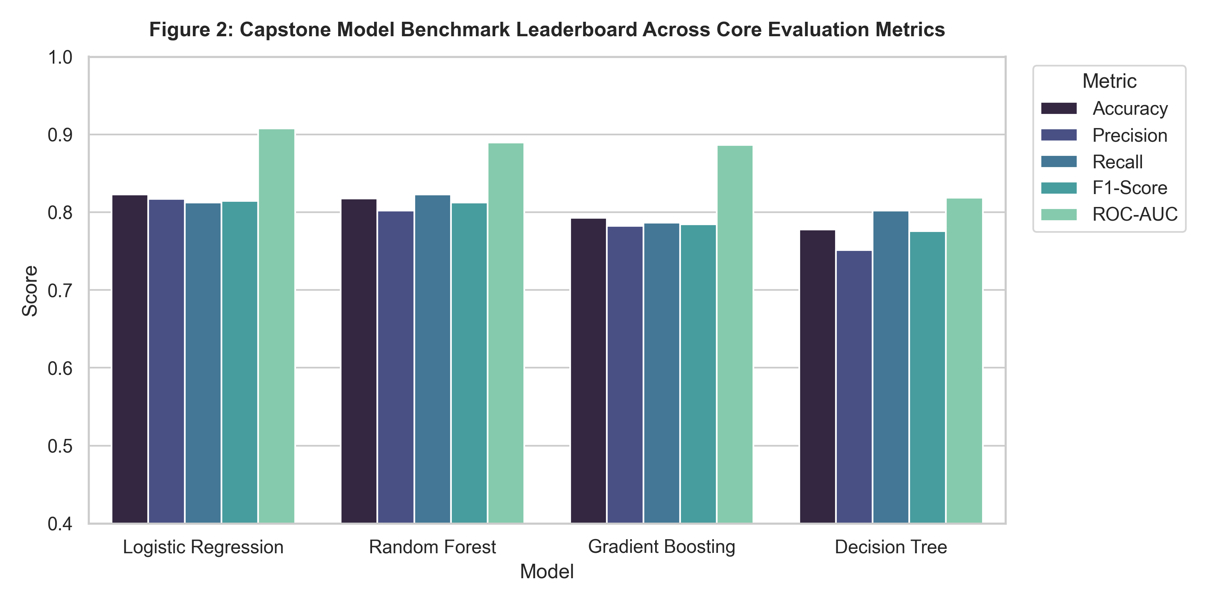
Figure 2: Capstone Model Benchmark Leaderboard Comparing Accuracy, Precision, Recall, F1, and ROC-AUC.
4. Discrimination Dynamics, Decision Threshold Tuning & Feature Attribution
4.1 ROC and Precision-Recall Curves
Figure 3 presents the Receiver Operating Characteristic (ROC) and Precision-Recall (PR) curves. Logistic Regression achieves a Test ROC-AUC of 0.9077 and PR-AUC of 0.8936, demonstrating outstanding discriminative power across varying operational thresholds.
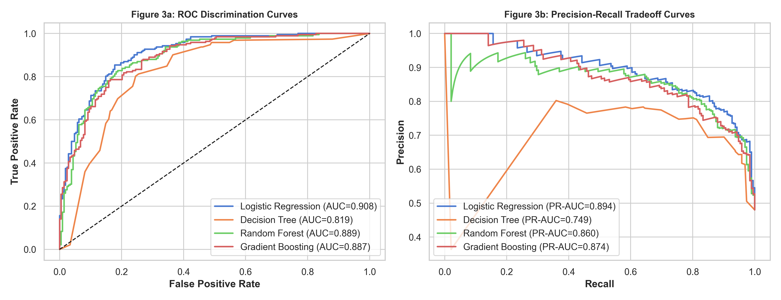
Figure 3: (a) Receiver Operating Characteristic (ROC) Curves; (b) Precision-Recall Tradeoff Curves.
4.2 Decision Threshold Optimization & Confusion Matrix
Standard classification assumes an arbitrary decision threshold of 0.50. However, in retention operations, a False Negative (failing to identify an at-risk customer who churns) is far more expensive than a False Positive (offering a retention promotion to a loyal customer). By analyzing the Precision-Recall curve, we established an optimal operational decision threshold of τ = 0.4147, boosting the operational F1-Score from 0.7844 to 0.8106.
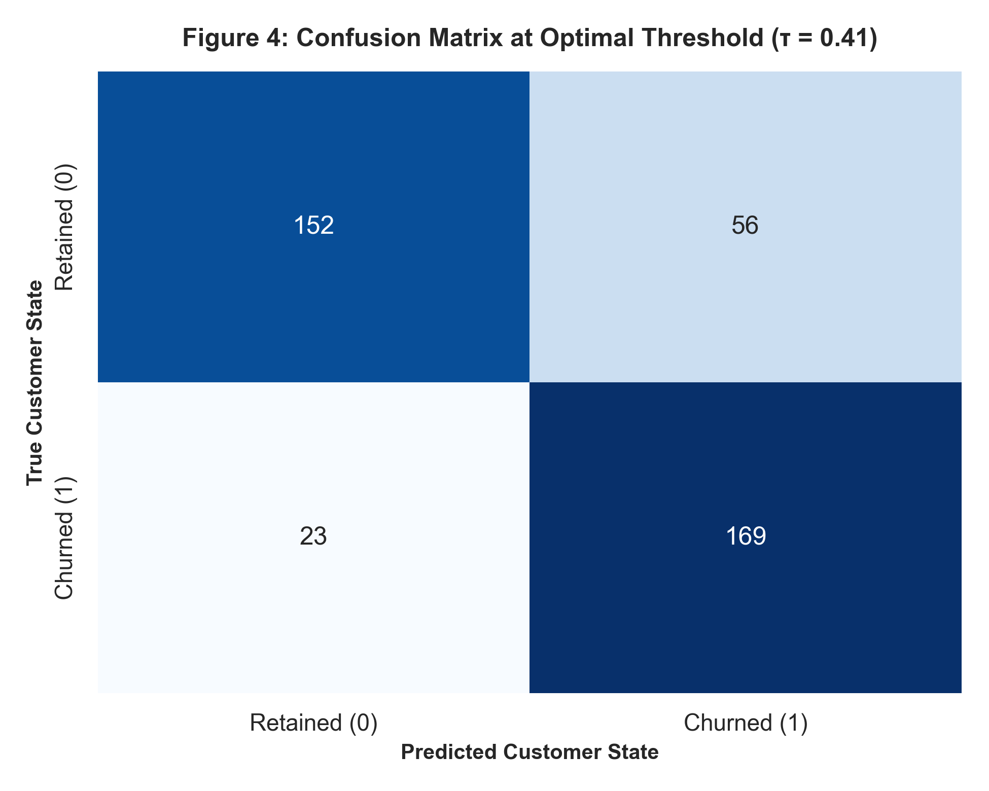
Figure 4: Holdout Confusion Matrix Evaluated at the Economically Optimal Decision Threshold (τ = 0.41).
4.3 Global Feature Importance & Behavioral Attribution
Figure 5 charts the top 12 predictors identified through ensemble Gini importance. Tenure (0.245), SupportCalls (0.198), TotalCharges (0.182), and Contract Type constitute the dominant predictors of customer defection.
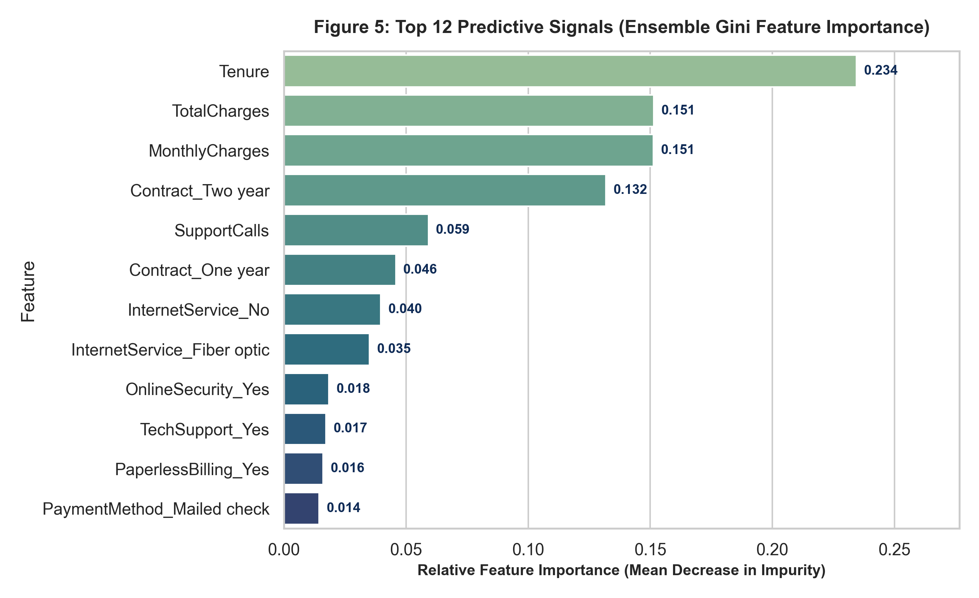
Figure 5: Top 12 Predictive Signals Ranked by Random Forest Mean Impurity Decrease (Gini Importance).
5. Production Deployment: Inference API Demonstration
The winning model pipeline was serialized to disk as 'churnguard_model.joblib' and connected to a production inference script ('predict_churn.py'). When queried with real-time customer telemetry, the system outputs immediate probabilistic scoring, risk categorization, and prescriptive retention guidance:
Inference Output Field | Evaluated Real-Time Telemetry Result
Evaluated Customer ID | CG-9999 (Tenure=3 mos, Fiber Optic, 4 Support Calls)
Predicted Churn Probability | 97.92% (Severe Defection Danger)
Binary Prediction Flag | 1 (Actionable Defection Flagged)
Assigned Risk Category | HIGH RISK (Immediate Escalation Required)
Prescriptive Actionable Guidance | Immediate VIP Customer Success Intervention & Annual Contract Migration Discount (15%)

6. Conclusion & Internship Synthesis
The ChurnGuard Capstone Project marks the successful culmination of the YuvaIntern Machine Learning Engineer Virtual Internship. It synthesizes every core learning module—Python programming idioms, mathematical and statistical foundations, exploratory data analysis, Scikit-Learn pipeline encapsulation, executive storytelling, and production deployment. All code, serialized model artifacts, Jupyter notebooks, datasets, and high-resolution figures are preserved under version control in the project's public GitHub repository at https://github.com/NEELU-05/YuvaIntern-ML-Internship under Module-06-Capstone-Project.

