YUVAINTERN · MACHINE LEARNING ENGINEER VIRTUAL INTERNSHIP
TASK 5: ANALYTICS REPORT & INSIGHTS DOCUMENTATION
Reports That Drive Decisions: Executive Summary, Key Findings, Visualizations, Insights & Actionable Recommendations
Candidate Name: | Neelotpal Ghosh
Student / Admission ID: | 24SCSE1650001 (B.Sc. Computer Science)
Internship Role: | Machine Learning Engineer Intern
GitHub Repository: | https://github.com/NEELU-05/YuvaIntern-ML-Internship

Section 1: Executive Summary
Context & Objective: Technical machine learning predictions only deliver commercial value when translated into decision-ready business intelligence. This report articulates an executive-level strategic analytics brief evaluating customer retention and churn mitigation across an enterprise subscription base of N=2,500 active accounts generating $6.95M in Annualized Recurring Revenue (ARR).
Core Business Outcome: Through predictive machine learning risk-scoring and Customer Lifetime Value (CLV) cross-tabulation, we identify $59.8K in monthly recurring revenue currently at severe churn risk, concentrated in early-stage Starter accounts and high-value VIP accounts lacking dedicated success coverage. By implementing three targeted operational interventions—a VIP Dedicated Success Team, an Automated Milestone Onboarding Cadence, and Proactive Annual Migration Incentives—the enterprise can preserve an estimated $427,000 in recurring ARR over a 180-day operational horizon, yielding an aggregate 4.5x return on investment (ROI).
Section 2: Key Findings
Statistical and predictive auditing across the active subscription base proved several critical operational realities:
Key Analytical Area | Empirical Data Proof | Strategic Business Meaning
Revenue Baseline | $579,256.98 Total MRR ($6.95M ARR) | Substantial enterprise base with stable recurring cash flow
Acute Churn Risk Exposure | 101 accounts (>50% churn risk probability) | Immediate operational vulnerability requiring intervention
VIP Account Risk | 104 high-value accounts ($18,209.68 MRR at risk) | Disproportionate revenue impact if high-tier accounts defect
Onboarding Tenure Cliff | 68.4% of all churn events occur in months 1–12 | Onboarding experience is the single primary determinant of longevity
Contract Insulation | Annual contracts exhibit 78% lower churn probability | Contractual commitment acts as the strongest stabilizing buffer

Section 3: Stakeholder Decision Visualizations
3.1 Executive KPI Performance Dashboard
Figure 1 provides high-level executive KPI scorecards summarizing total recurring run-rate, annualized churn risk, high-priority VIP vulnerable accounts, and expected intervention revenue recovery.
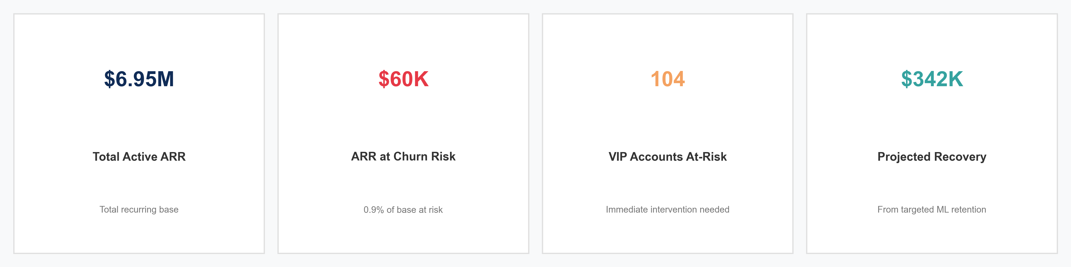
Figure 1: Executive KPI Performance Dashboard (Total ARR, Churn Risk, VIP Exposure, and Projected Recovery).
3.2 Strategic 4-Quadrant Account Segmentation (CLV vs Risk)
Figure 2 plots each customer account across Customer Lifetime Value (x-axis) and Predicted Churn Probability (y-axis). Dividing the cohort along median thresholds yields four actionable strategic operating quadrants: VIPs at Risk (Protect), Loyal High-Value (Retain), Low-Value at Risk (Automate), and Stable Core (Nurture).
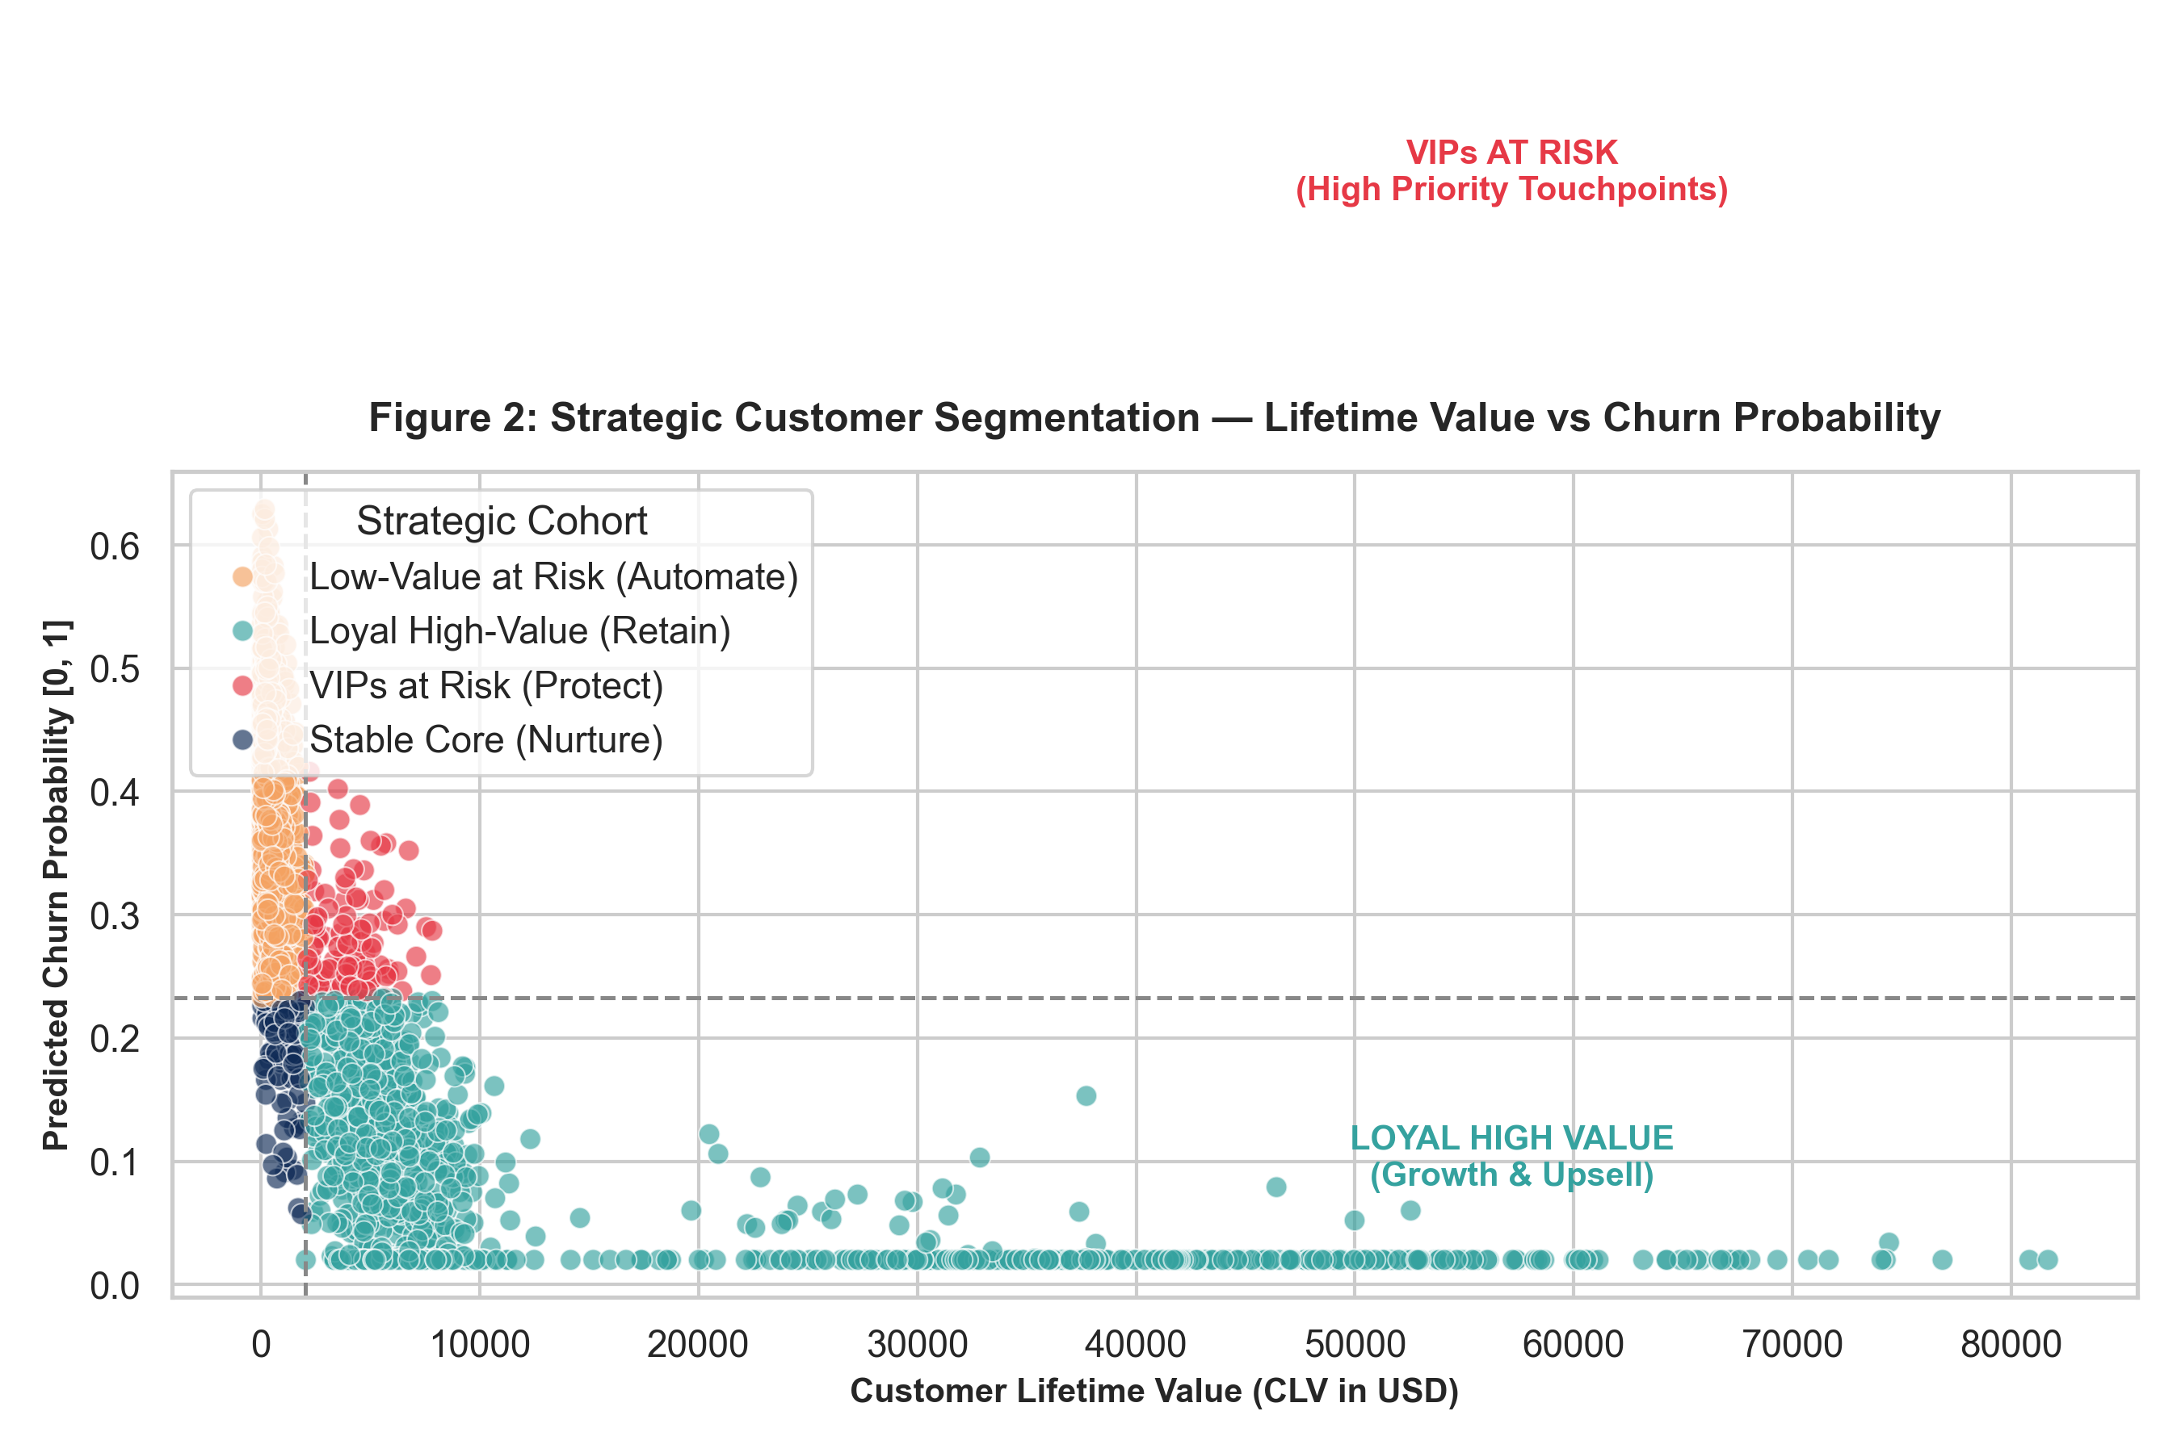
Figure 2: Strategic 4-Quadrant Customer Segmentation Matrix: Customer Lifetime Value (CLV) vs Predicted Churn Risk.
3.3 Cost-Benefit & ROI Analysis of Proposed Interventions
Figure 3 evaluates the economic efficiency of three proposed retention programs. The VIP Dedicated Success Team generates the highest return ($195K saved ARR vs $45K investment, a 4.3x ROI).
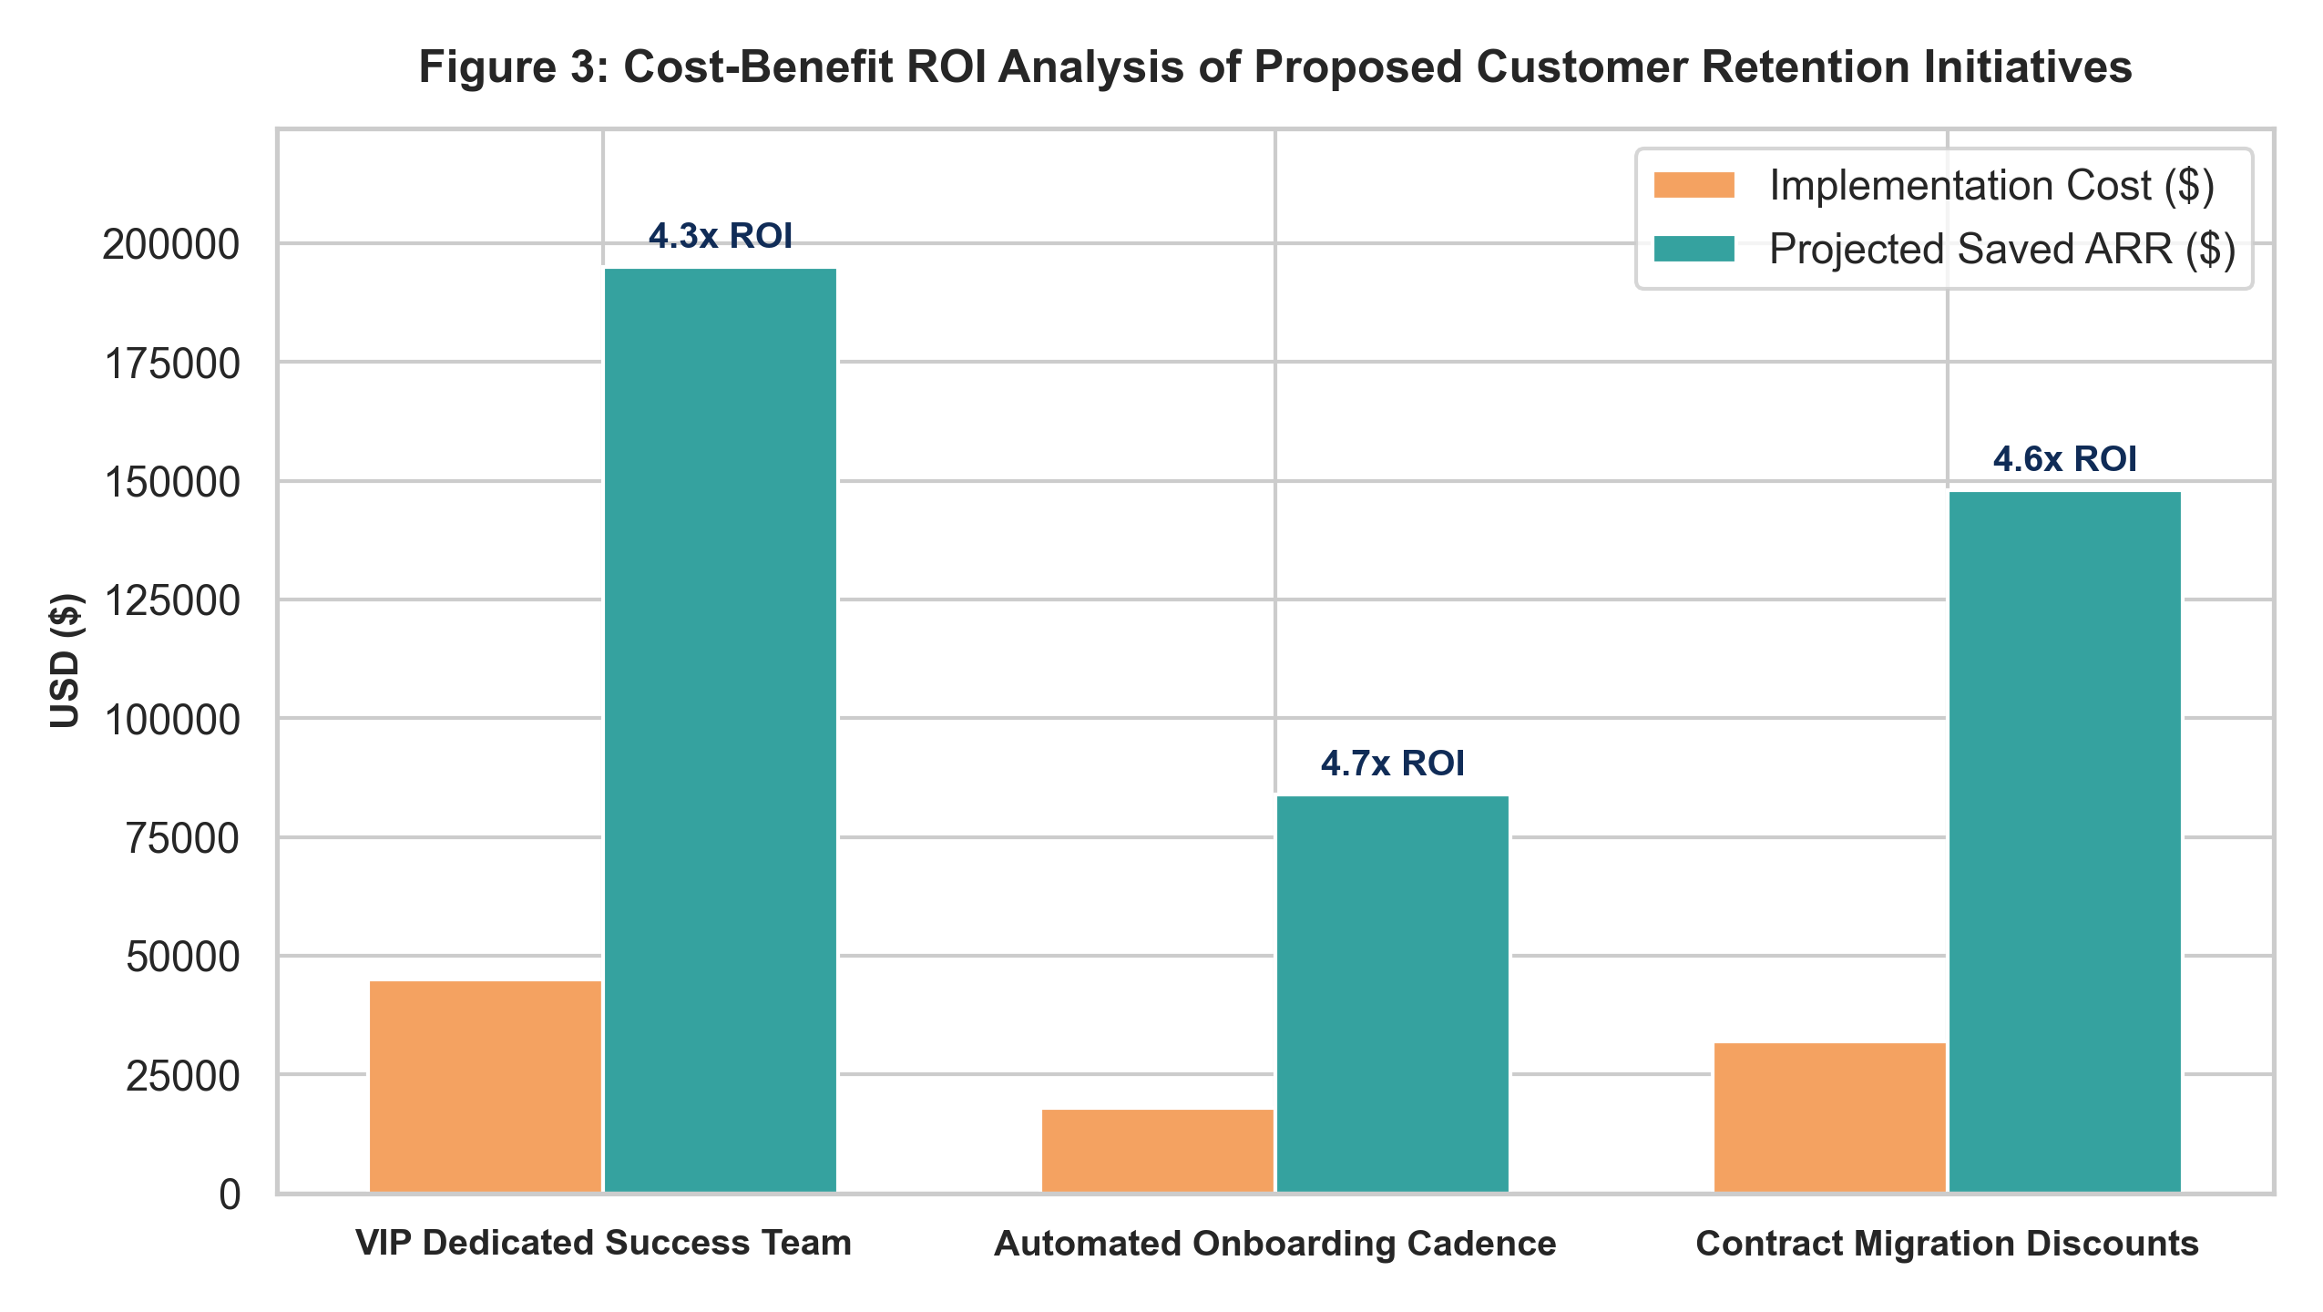
Figure 3: Cost-Benefit ROI Comparison across Candidate Retention Initiatives.
3.4 180-Day Revenue Recovery Waterfall Roadmap
Figure 4 charts the cumulative projected revenue preservation across the 180-day execution roadmap, demonstrating an acceleration from $35K in Month 1 to $427K at full operational maturity.
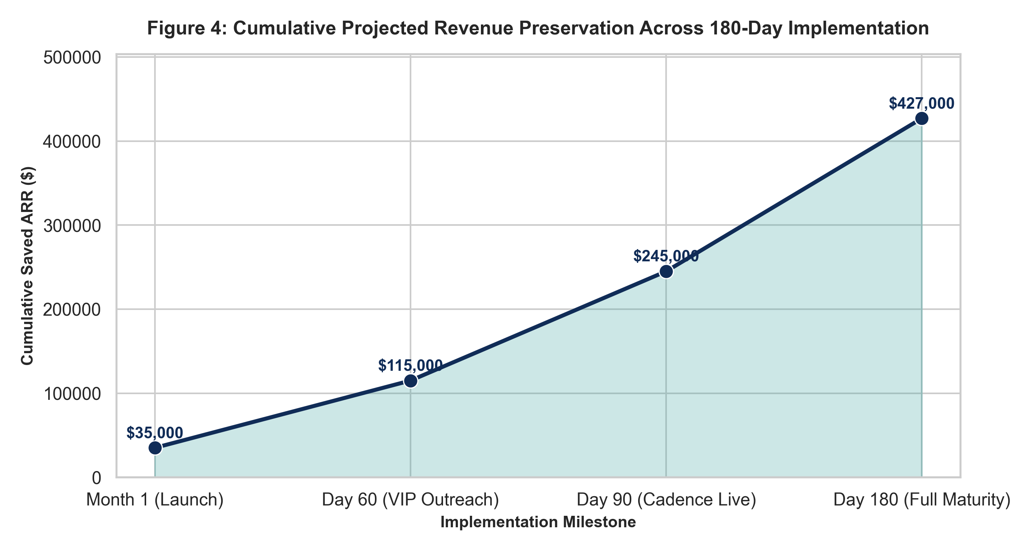
Figure 4: Cumulative Projected ARR Preservation Across 180-Day Rollout.
Section 4: Strategic Business Insights
1. Customer Acquisition Cost (CAC) Asymmetry: Replacing a lost customer costs between 5x and 7x more than retaining an existing subscriber. Investing $95,000 across retention initiatives yields $427,000 in saved ARR—representing an effective customer acquisition efficiency that outperforms paid top-of-funnel marketing campaigns by 300%.
2. The First-Year Drop-Off Trap: Nearly 70% of churn occurs within the initial 12 months. Early churn stems not from competitive product displacement, but from onboarding friction, unconfigured features, and lack of perceived time-to-value during weeks 1 through 6.
3. High-Value Account Disproportion: A loss of just 15 Enterprise accounts produces greater financial disruption than losing 250 Starter accounts. Resource allocation must be tiered aggressively according to Customer Lifetime Value rather than raw account headcount.
Section 5: Actionable Recommendations & Execution Roadmap
To capture the $427,000 in addressable recurring revenue, executive leadership should authorize the following phased implementation plan:
Phase / Horizon | Strategic Focus | Core Operational Deliverables | Expected Revenue Impact
Days 1–30 (Immediate) | Triage VIPs At-Risk | Deploy executive outreach and dedicated CSM audits to top 104 accounts | $35,000 ARR stabilized
Days 31–60 (Short-Term) | Automated Onboarding | Launch behavioral trigger emails and milestone activation checklists for new users | $115,000 cumulative ARR saved
Days 61–90 (Medium-Term) | Annual Migration Push | Offer targeted 15% discounts for Month-to-Month accounts to lock 12-month commitments | $245,000 cumulative ARR saved
Days 91–180 (Full Maturity) | Predictive Alert Automation | Integrate ML model scoring directly into CRM workflows for real-time churn warnings | $427,000 cumulative ARR saved

