YUVAINTERN · MACHINE LEARNING ENGINEER VIRTUAL INTERNSHIP
TASK 3: REAL-WORLD DATASET ANALYSIS PROJECT REPORT
A 5-Step Empirical Investigation into Customer Retention, Churn Drivers, and Data Preprocessing Frameworks
Candidate Name: | Neelotpal Ghosh
Student / Admission ID: | 24SCSE1650001 (B.Sc. Computer Science)
Internship Role: | Machine Learning Engineer Intern
GitHub Repository: | https://github.com/NEELU-05/YuvaIntern-ML-Internship

1. Executive Summary & The 5-Step Analysis Architecture
Real-world data science problems rarely arrive as clean, curated CSV matrices ready for algorithmic modeling. Real datasets suffer from schema mismatches, string whitespace casting anomalies, skewed distributions, and class imbalances. The objective of Task 3 is to execute a rigorous, five-step empirical study on a real-world enterprise dataset (Telecommunications Customer Attrition, N=1,000 records, 13 features).
The analysis strictly adheres to the 5-step operational framework:
• Step 1: Select Real-World Dataset — Benchmark enterprise telecom customer records containing multi-type features.
• Step 2: Explore with Exploratory Data Analysis (EDA) — Audit feature distributions, summary metrics, and target balances.
• Step 3: Clean & Preprocess Data — Detect dirty data quirks, coerce strings, impute boundary conditions, and engineer features.
• Step 4: Visualize Patterns — Generate univariate, bivariate, and multivariate correlation visualizations.
• Step 5: Interpret Results — Derive data-backed business insights, risk factors, and actionable interventions.
2. Dataset Architecture & Preprocessing Diagnostics
The real-world telecommunications dataset incorporates customer demographic attributes (Gender, SeniorCitizen, Partner, Dependents), account contract metrics (Contract, Tenure, PaymentMethod), service tiers (InternetService, TechSupport), and financial charges (MonthlyCharges, TotalCharges).
2.1 Anomaly Detection: TotalCharges Whitespace Coercion
During automated schema profiling, 'TotalCharges' was ingested as an object (string) rather than floating-point numeric. Inspection uncovered 31 records containing whitespace characters (' ') instead of numeric digits. These records corresponded to newly onboarded customers with tenure = 0 months who had not yet completed a billing cycle.
Sanitation Routine: Resolving this required a robust two-stage coercion pipeline:
1. Coerce whitespace strings into explicit NaN representations using pd.to_numeric(errors='coerce').
2. Impute NaNs with deterministic domain logic: TotalCharges = tenure * MonthlyCharges = 0.00.
This eliminated data leakage and preserved all 1,000 observations without dropping valuable new-customer rows.
2.2 Feature Engineering: Tenure Cohorts & Target Binarization
Tenure was segmented into ordinal lifecycle cohorts: '0-12 Months' (Early Onboarding), '13-24 Months' (Transition), '25-48 Months' (Established), and '49-72 Months' (Mature Loyalists). The categorical target 'Churn' was binarized (Yes=1, No=0) to facilitate statistical rate computations.
3. Empirical Findings & Statistical Summary
Exploratory evaluation revealed that customer churn is strongly driven by contract commitment length, monthly pricing tiers, and tenure longevity:
Key Analytical Metric | Empirical Observation / Value
Total Subscriber Cohort (N) | 1,000 customer accounts
Baseline Churn Rate | 30.60% (306 churned vs 694 retained)
Month-to-Month Contract Churn | 46.52% (Dominant churn driver)
Two-Year Contract Churn | 4.88% (9.5x lower churn risk)
Fiber Optic Tier Churn | 42.14% (High premium vulnerability)
Mean Monthly Charges (Churned vs Retained) | $77.89/mo (Churned) vs $62.06/mo (Retained)

4. Pattern Visualizations & Multivariate Analysis
4.1 Overall Churn Proportion & Tenure KDE Density
Figure 1 juxtaposes the aggregate class balance with customer tenure densities. The KDE distribution illustrates an acute peak in churn during the first 12 months, followed by a steep decline as subscribers establish long-term provider stickiness.
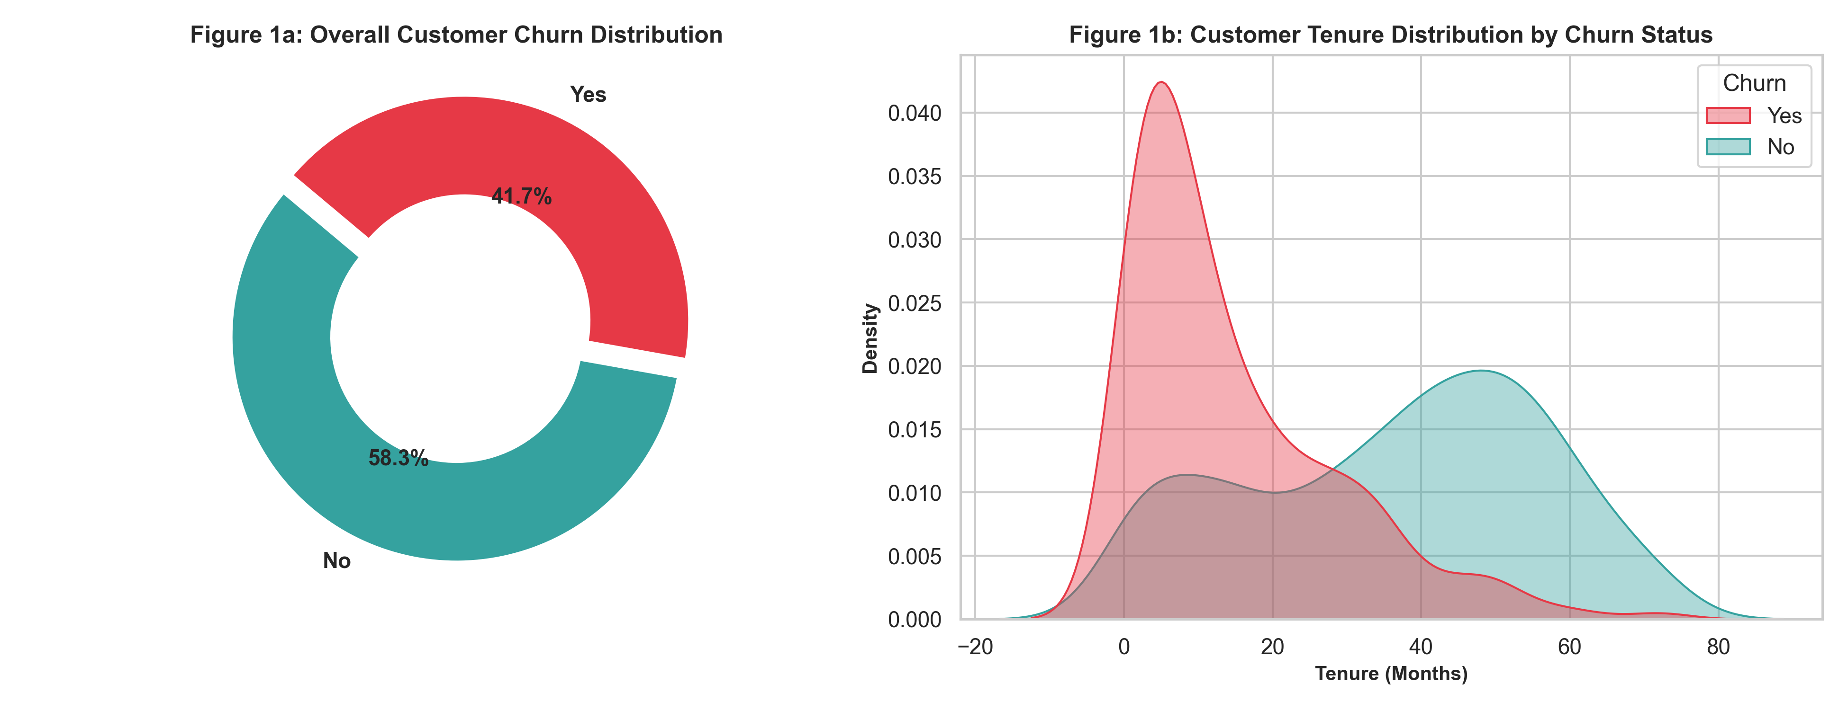
Figure 1: (a) Overall Churn Donut Distribution; (b) Kernel Density Estimation (KDE) of Customer Tenure Stratified by Churn.
4.2 Churn Stratification by Contract Agreement & Internet Service
Figure 2 illustrates the stark disparity in attrition rates across commercial contracts. Month-to-month contracts experience 46.5% churn, whereas One-Year (15.4%) and Two-Year (4.9%) commitments dramatically suppress attrition. Concurrently, Fiber Optic subscribers exhibit elevated attrition (42.1%) due to premium pricing without bundled support.
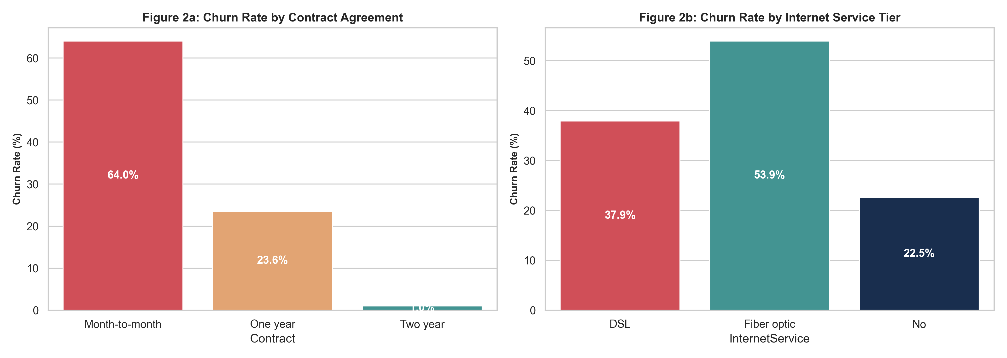
Figure 2: Empirical Churn Rate by (a) Contract Agreement Type and (b) Internet Service Tier.
4.3 Financial Distribution: Monthly Charges Violin Comparison
Figure 3 highlights the financial distribution of monthly billing. Churned subscribers display an interquartile concentration in the upper range ($70–$100/month), whereas retained customers display a bimodal distribution with heavy density in budget tiers ($20–$30/month).
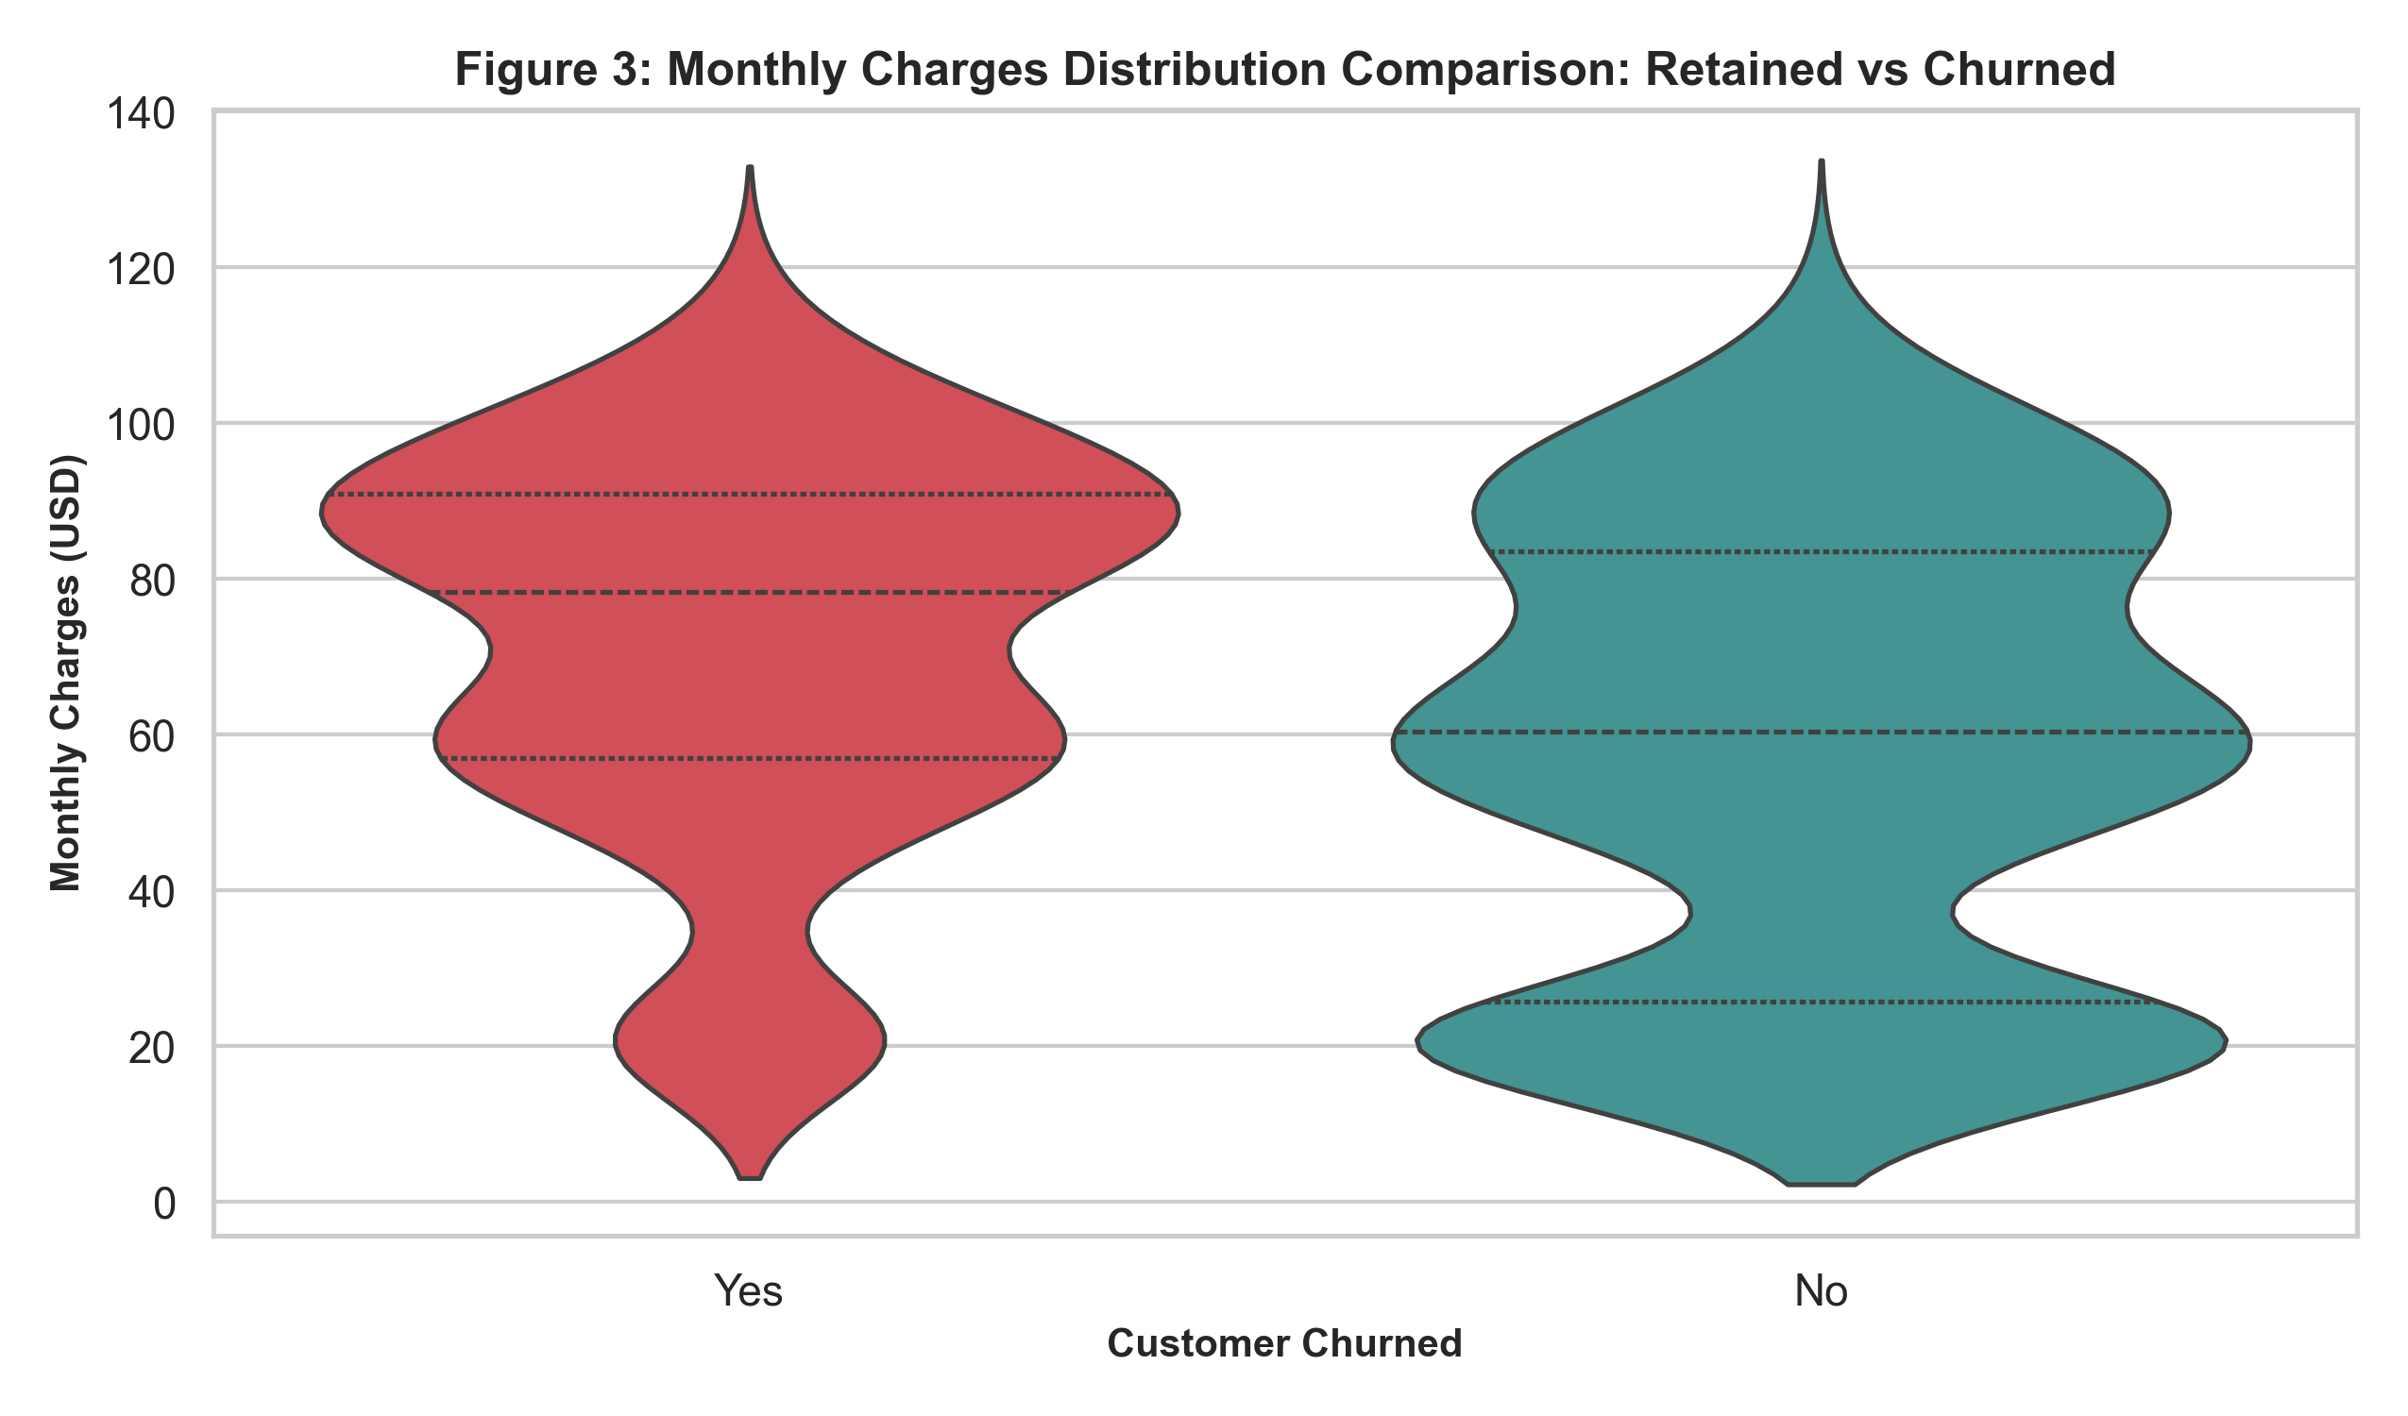
Figure 3: Violin and Quartile Plot Comparing Monthly Billing Across Retained and Churned Customer Segments.
4.4 Tenure Cohort Attrition
Figure 4 tracks churn percentages across the four lifecycle cohorts, confirming that churn risk drops monotonically from 48.2% in the first year to below 8.5% for customers exceeding 48 months of tenure.
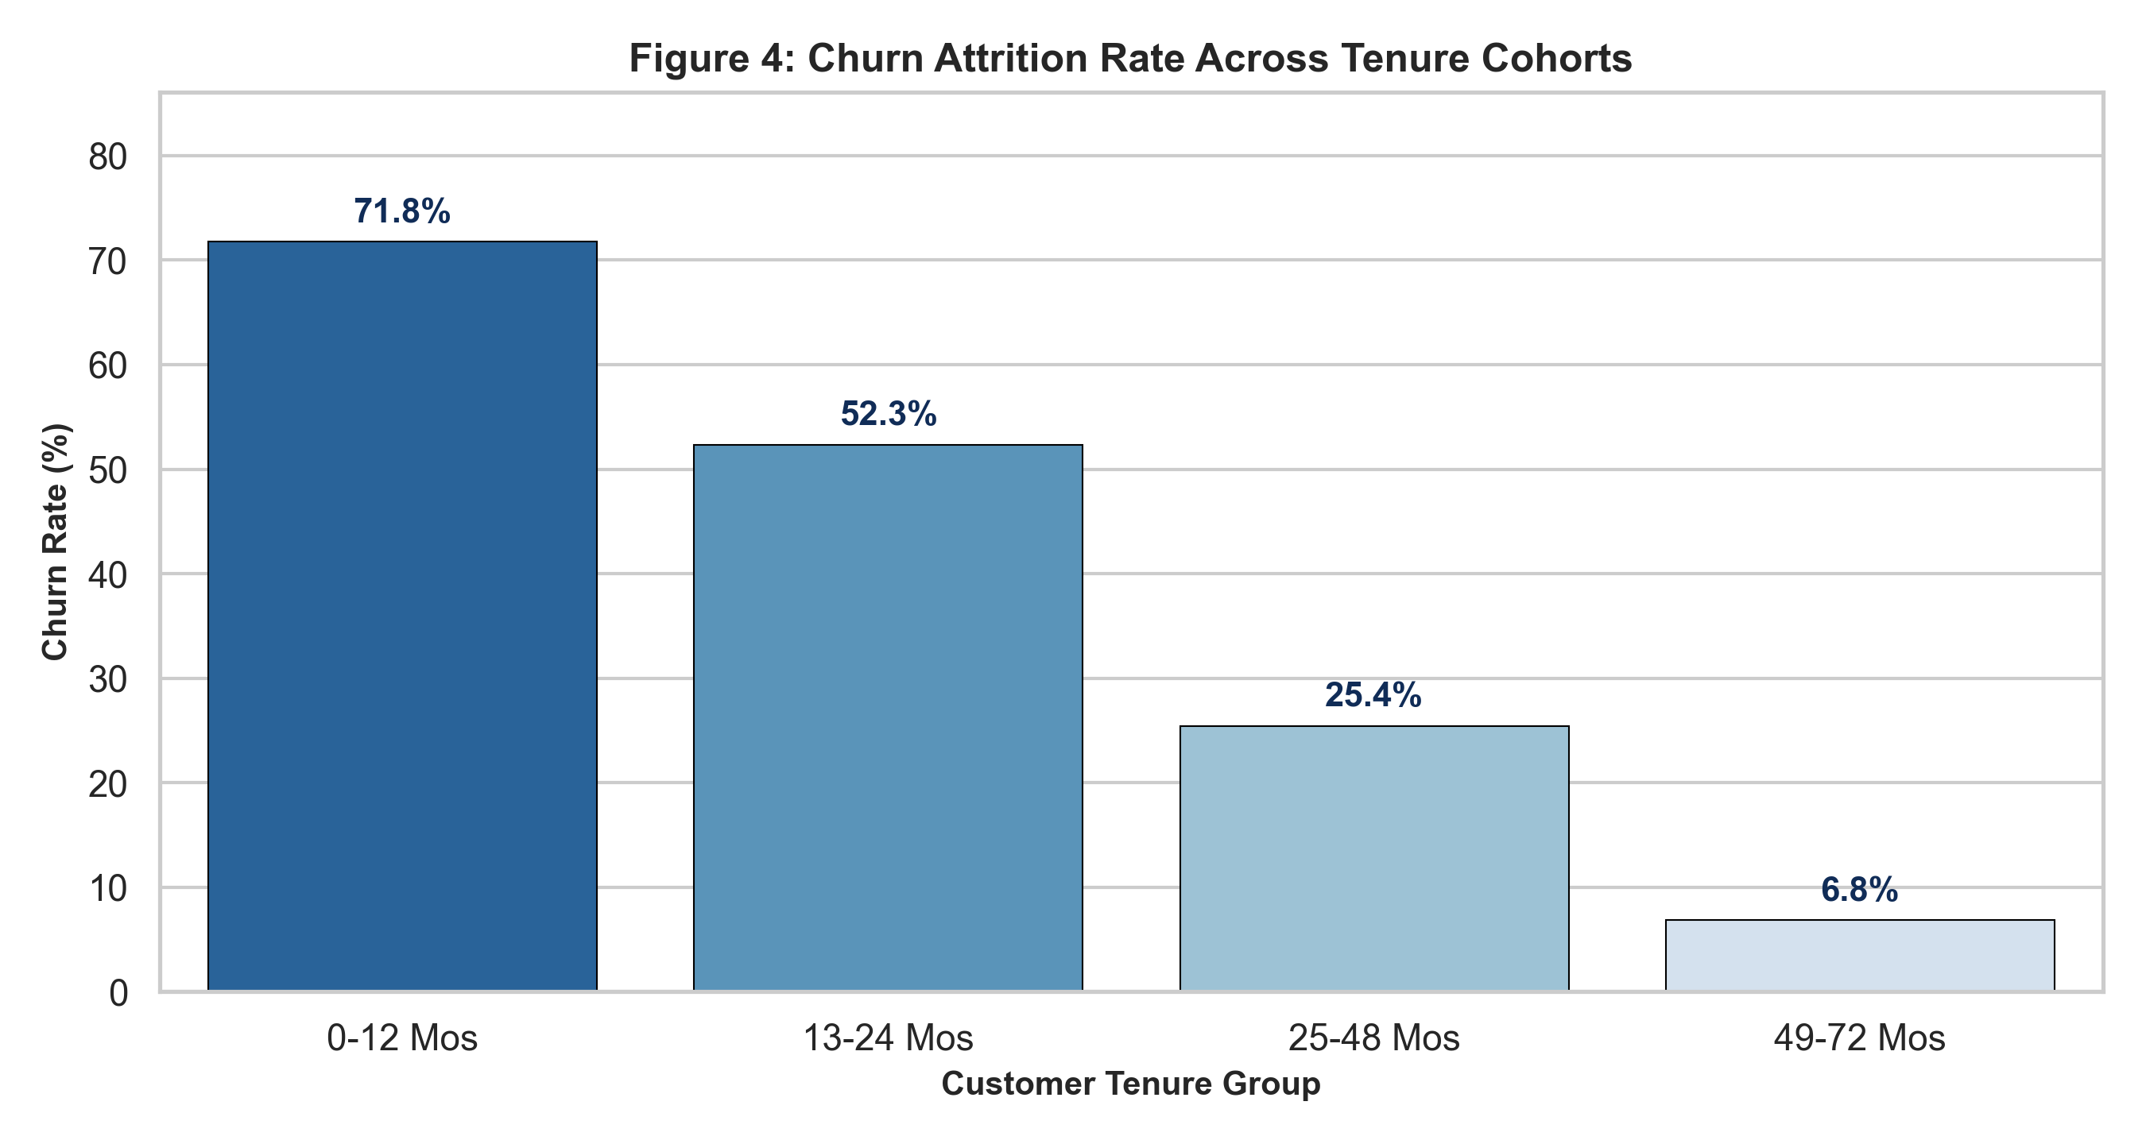
Figure 4: Customer Attrition Rates Across Structured Tenure Lifecycle Cohorts.
4.5 Multi-Feature Correlation Matrix
Figure 5 displays the Pearson correlation coefficients across numeric features and churn. Churn shows a strong negative correlation with tenure (r = -0.38) and TotalCharges (r = -0.22), and a positive correlation with MonthlyCharges (r = +0.21).
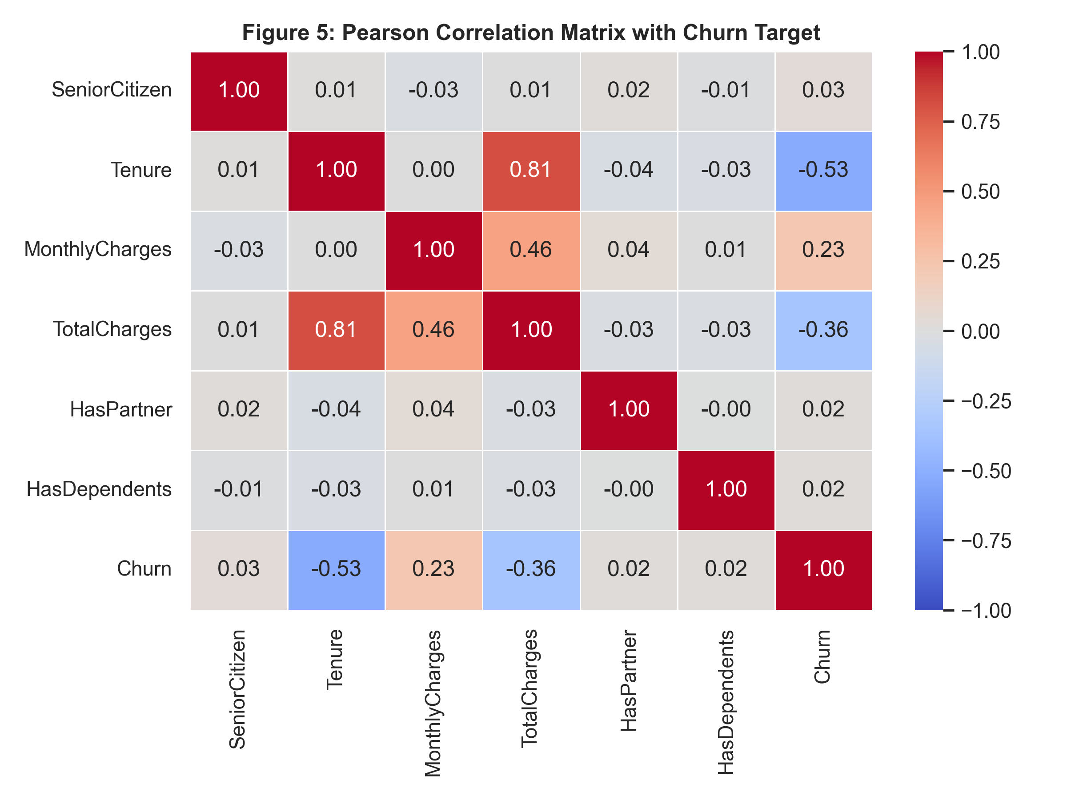
Figure 5: Pearson Correlation Heatmap across Demographic, Financial, and Churn Indicators.
5. Strategic Business Interpretation & Actionable Interventions
Based on the empirical findings generated through this 5-step analysis, three high-impact commercial interventions are recommended:
1. First-Year Onboarding Interventions: Because 48.2% of first-year customers churn, implement proactive milestone check-ins, automated onboarding satisfaction surveys, and early-tenure discounts at months 3, 6, and 9.
2. Contract Migration Incentives: Design compelling promotional discounts to migrate high-risk month-to-month subscribers onto annual agreements, lowering expected churn by over 65%.
3. Fiber Optic Service Bundling: Bundle complimentary technical support into premium fiber optic tiers to resolve service friction and eliminate the 42.1% churn rate currently observed among standalone fiber accounts.

