Hustle.ai
Complete Product Outline
MVP Edition → Scaled Edition
Project Breakout — 2026

1. Project Overview
Hustle.ai is a full-stack AI-powered job hunting platform. Users find jobs, generate tailored resumes and cover letters with one click, and auto-apply — all without leaving the platform.

Problem | Job hunting is fragmented, time-consuming, and generic. No single tool personalizes the process end-to-end.

Solution | Built-in job portal + one-click AI resume & cover letter generation + auto apply via email or API.

Target Users | Students, freshers, and early-career professionals actively applying for jobs.

Core Flow | Login → Profile → Browse Jobs → One Click → Generate → Review → Auto Apply → Track

⚡ PHASE 1 — MVP

2. MVP Overview
The MVP proves one thing: a user can go from zero to applied in under 2 minutes. Nothing else matters until this works.

MVP Goal | Complete working flow: Login → Profile → Find Job → Generate Resume + Cover Letter → Auto Apply via Email → Track

Stack | Next.js · Node.js/Express · FastAPI · MongoDB · Nodemailer · LLM API

Timeline | 4 weeks — 2-3 hours per night consistently

What's IN the MVP
- Auth — email/password + JWT
- User profile — basic info + resume upload
- Job listings — manually seeded with apply emails (10-15 jobs)
- LLM pipeline — JD analysis + resume tailoring + cover letter generation
- PDF generation — resume + cover letter
- Email apply — attach PDFs, send to job's apply email via Nodemailer
- Application tracker — status auto set to Applied
- Review UI — user sees generated content before applying

What's OUT of MVP
- OAuth, Redis, Kafka — scale solutions, zero users right now
- Job matching ML — not needed until job volume grows
- ATS scoring — post-MVP polish
- API apply — email apply covers 80% of cases
- External job scraping — manual seed data is enough to validate

MVP Architecture Diagram
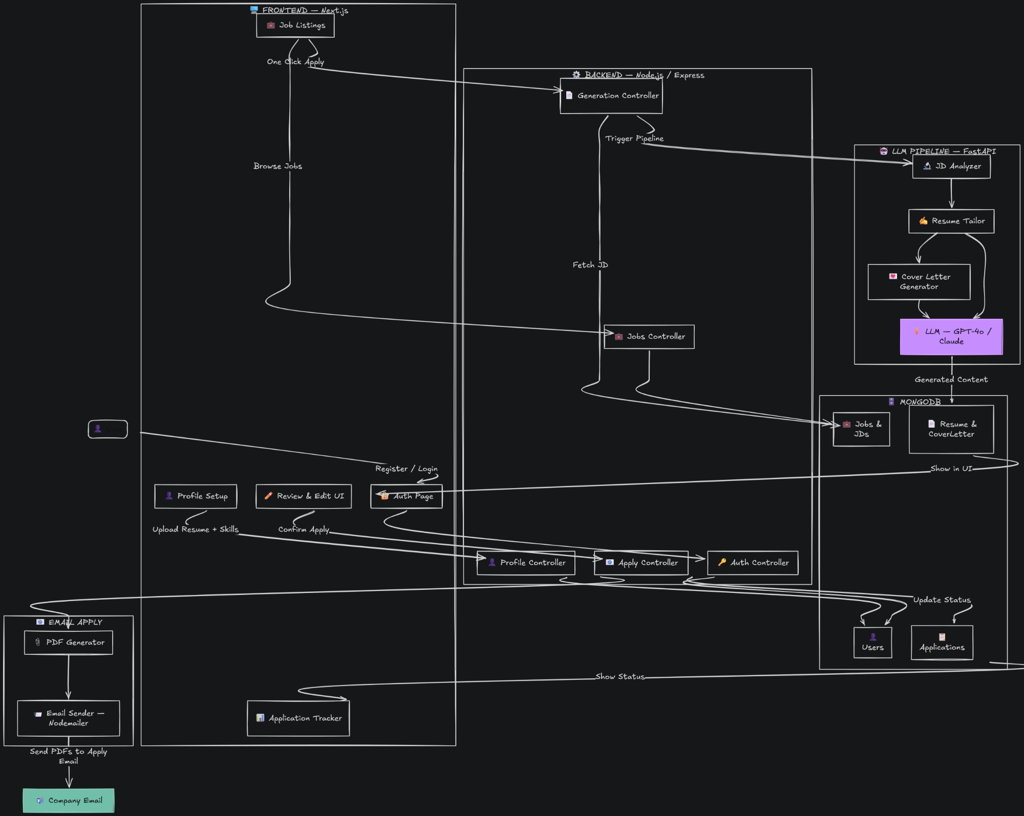
Figure 1 — Hustle.ai MVP Architecture

MVP Build Order
Week 1 — Foundation
- Auth — email/password + JWT
- User profile + resume upload
- Job listings — seed 10-15 jobs manually with apply emails

Week 2 — The Core
- LLM pipeline — JD analysis + resume tailoring
- LLM pipeline — cover letter generation
- PDF generation for both documents

Week 3 — The Magic
- One-click apply — attach PDFs, send via Nodemailer
- Application tracker — auto status update to Applied
- Review UI — side-by-side view before confirming apply

Week 4 — Polish & Ship
- Bug fixes and edge case handling
- Clean UI pass
- Deploy — Vercel (frontend) + Railway or Render (backend)
- Get 5 real users to test the flow

MVP Auto Apply Flow
- User clicks Apply on a job listing
- System fetches full JD from MongoDB using jobId — no manual paste
- LLM pipeline triggered synchronously (no Kafka at MVP stage)
- JD analyzed — keywords, tone, seniority extracted
- Resume tailored to JD
- Cover letter generated matching JD tone
- Both documents converted to PDF
- PDFs sent as email attachments to job's apply email via Nodemailer
- Application status auto-updated to Applied in tracker

MVP Success Metric
Can a user go from zero to applied in under 2 minutes? If yes — MVP is done. Ship it.

🚀 PHASE 2 — SCALED

3. Scaled Architecture Overview
Once MVP is validated with real users, scale the infrastructure. Add async processing, caching, ML matching, ATS scoring, and API-based apply. Each addition is justified by real usage, not speculation.

Stack | Next.js · Node.js/Express · FastAPI · MongoDB · Redis · Kafka · OAuth · Python ML

What Gets Added in Scale
- OAuth — Google/GitHub login replaces email/password
- Redis — 5 justified caching use cases
- Kafka — 2 justified async pipelines
- Job matching ML — FastAPI scores user profile against all jobs
- ATS scoring — resume scored against JD after generation
- API apply — support companies with application APIs
- External jobs — manual JD paste for LinkedIn/Naukri jobs

Scaled Architecture Diagram
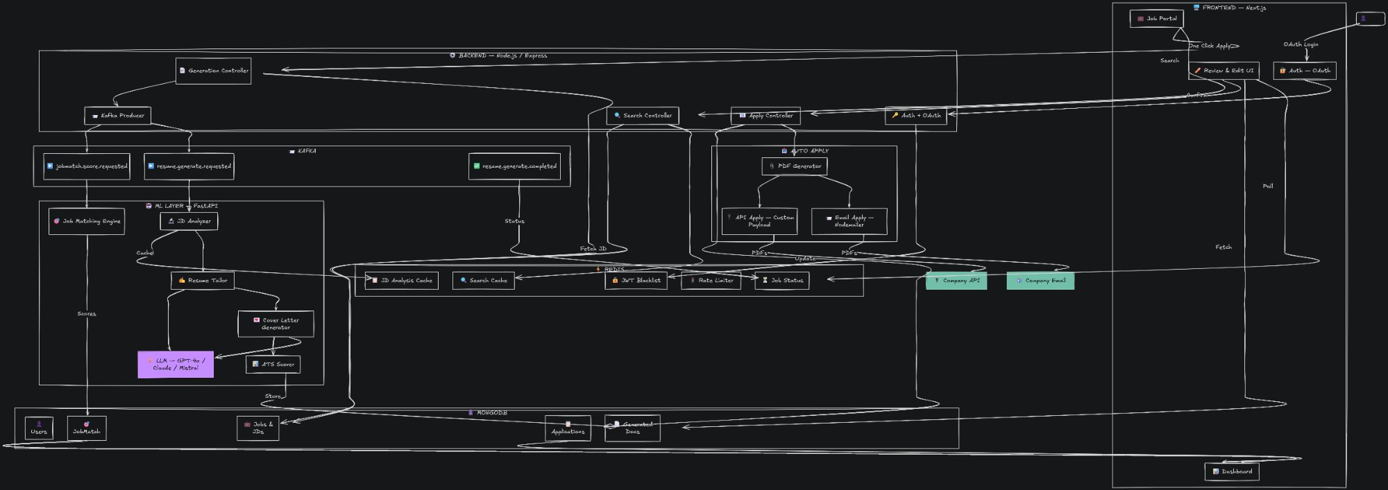
Figure 2 — Hustle.ai Scaled Architecture

Redis — 5 Justified Use Cases
- 1. Job Search Cache
Most frequent action. Same query never hits MongoDB twice. TTL 24hrs.

- 2. JD Analysis Cache
LLM analyzing a JD costs money. Hash JD → cache extracted keywords. Same JD never processed twice.

- 3. Generation Job Status
Kafka async processing status stored in Redis. Frontend polls here not MongoDB.

- 4. Rate Limiting — LLM Endpoint
Counter per user per hour. Prevents abuse and runaway LLM API bills.

- 5. JWT Blacklist
Logged out tokens invalidated instantly. TTL matches token expiry.

Kafka — 2 Justified Use Cases
- 1. Resume Processing Pipeline
ML scoring takes 5-10 seconds. Upload completes instantly, Kafka carries task to FastAPI async. Never blocks the API.

- 2. LLM Document Generation
LLM calls take 10-30 seconds. API returns jobId instantly, Kafka carries task, result published when done. Frontend polls Redis for status.

Scaled Auto Apply Flow
- User clicks Apply — JD fetched from MongoDB by jobId
- Kafka event fired: resume.generate.requested
- FastAPI runs full pipeline async — JD analysis, resume tailoring, cover letter, ATS scoring
- Generation status tracked in Redis — frontend polls
- User reviews in side-by-side UI, edits inline
- User confirms → Apply Controller triggered
- PDF Generator creates final documents
- Email Apply — PDFs sent via Nodemailer to apply email
- API Apply — PDFs sent via custom payload to company API
- Application status updated to Applied in MongoDB
- Dashboard reflects updated stats

Post-MVP Build Order
- OAuth — Google/GitHub
- Redis — search cache + JWT blacklist + rate limiting
- Job matching ML pipeline via FastAPI
- Kafka — resume processing async
- Kafka — LLM generation async
- Generation status polling via Redis
- ATS scoring layer
- API apply — custom payload builder
- External job support — manual JD paste
- Scale job listings — scraping or partnerships

4. Startup Pitch (When Shipped)
"I built a job hunting platform with a built-in job portal, one-click AI-generated ATS-optimized resumes and cover letters, and auto-apply via email and API — backed by an async ML pipeline using Kafka, Redis caching, and a FastAPI model layer."

Project Breakout 2026 — Slowly Steady Wins The Race

