HPING3 Documentation

1. Tool Overview

1.1. Description
HPING3 is a command-line-oriented, open-source tool for generating and analyzing custom TCP/IP packets. Unlike the traditional ping utility, which is limited to ICMP (Internet Control Message Protocol) echo requests, HPING3 provides a comprehensive suite of capabilities for manipulating and transmitting packets across various protocols, including TCP, UDP, and RAW-IP. This versatility allows a user to craft packets with granular control over headers and payloads, a crucial capability for network security auditing and diagnostics. The tool can be used to test firewall rules, perform sophisticated port scans, conduct traceroute-like actions with different protocols, and audit the behavior of TCP/IP stacks. Its functionality extends to handling fragmentation and arbitrary packet sizes, and it is also capable of file transfer over supported protocols.

1.2. Category
Within the cybersecurity landscape, HPING3 is a foundational tool in the red team arsenal and is a core component of Kali Linux. It is primarily categorized under Reconnaissance, Exploitation, and Post-Exploitation, reflecting its broad range of applications. For reconnaissance, HPING3 facilitates advanced host discovery, port scanning with custom flags, and remote operating system fingerprinting. In the exploitation phase, it is a powerful utility for simulating controlled denial-of-service (DoS) attacks, such as SYN floods, to test network and application resilience. During post-exploitation, its ability to craft custom packets allows for the creation of covert channels to transfer files without detection.

1.3. Developer/Maintainer
HPING3 was created by Salvatore Sanfilippo, a renowned figure in the cybersecurity community who is also known by his handle "Antirez". Although the tool is not under continuous development, its stability and effectiveness have cemented its status as a widely used utility. The creator's legacy is noteworthy as it extends beyond HPING3; he is also the inventor of the "idle scan" technique, which has been integrated into other leading network scanners like Nmap. This connection is significant because it illustrates the fundamental role of HPING3 and its author in the evolution of modern network security auditing. The theoretical work of a single developer on low-level packet manipulation has led to the creation of a powerful tool and the widespread adoption of a new scanning methodology, confirming the authoritative position of HPING3 in the field.

1.4. License
HPING3 is open-source and is licensed under the GNU General Public License version 2 (GPLv2). This license guarantees that the tool is free to use, inspect, modify, and distribute, which has contributed to its widespread adoption and the trust placed in it by the security community. The open-source nature of the tool allows security researchers to audit its code, ensuring there are no hidden backdoors or malicious functionalities.

1.5. Official Resources
The primary and most reliable resource for HPING3 is its GitHub repository at https://github.com/antirez/hping.

2. Installation Guide

2.1. System Requirements
HPING3 is a lightweight, command-line utility with minimal system requirements. Its core dependencies for Debian-based systems such as Kali Linux include libc6, libpcap0.8t64, and libtcl8.6. The installed package size is a compact 255 KB, which is a significant tactical advantage for a red teamer as it leaves a minimal footprint on a system. This small size makes the tool highly portable and less likely to be flagged by disk-based security solutions. To function correctly, HPING3 requires elevated privileges, which are necessary for sending and receiving raw network packets.

2.2. Installation Methods
HPING3 is a standard component of Kali Linux and is pre-installed in the distribution. This makes it immediately accessible to users without any initial setup. For other Debian-based systems, the installation is straightforward using the APT package manager.
Using APT (Kali Linux & Debian)
sudo apt update
sudo apt install hping3
The command updates the package list and then installs the HPING3 package, automatically resolving any dependencies.
Dependencies
libc6
libpcap0.8t64
libtcl8.6

Manual Installation from Source Although not typically necessary for Kali Linux, understanding the process for compiling from source is useful for other platforms. The general procedure involves cloning the official GitHub repository and then compiling the code using make commands. This process ensures the user has the latest version of the tool.

2.3. Verification
After installation, the functionality of HPING3 can be quickly verified.
Check Version:
hping3 --version
hping3 -v
Either of these commands will display the installed version of the tool, confirming a successful installation.
Access Manual Page: For a comprehensive and authoritative guide to all of the tool's options and features, the man hping3 command is the definitive resource on any Linux system.
The minimal system requirements and small installed size of HPING3 underscore its utility. This small footprint makes the tool easier to deploy and more portable, which is a key tactical advantage for red team operations. The ability to use it from a pre-installed Kali Linux environment or a Docker container further minimizes setup time and reduces the risk of detection.

3. Basic Configuration

3.1. Initial Setup
HPING3 does not require any initial setup or first-time configuration steps. All operational parameters are specified at the command line for each individual execution. The only preliminary requirement for use is that the user must possess the necessary administrative privileges ( sudo or root ) to access the raw network socket interface, which is a prerequisite for crafting and sending custom packets.

3.2. Configuration Files
The tool operates entirely from the command line and does not rely on configuration files to store its settings. This design choice is deliberate and aligns with its purpose as a low-level, on-the-fly packet crafting utility. The absence of persistent configuration files promotes stateless and highly flexible use, allowing a user to change parameters dynamically for each test without managing external files. This is a fundamental difference between HPING3 and more comprehensive scanners like Nmap, which often use configuration files for persistent settings or performance tuning. HPING3's simplicity means its power is directly tied to a user's expertise in command-line syntax and networking principles.

3.3. Environment Variables
HPING3 does not use any specific environment variables for its operation. However, a user may encounter a "command not found" error if the directory containing the HPING3 executable (/usr/sbin/) is not included in the system's $PATH environment variable. This issue can be resolved by either explicitly providing the full path to the executable or by running the command with sudo su to elevate to a root shell where the path is correctly configured.

3.4. Default Credentials
HPING3 is a client-side network tool and does not function as a service, therefore, it does not have any default credentials. It does not require authentication or operate with any form of user accounts or passwords.

4. Core Functionality

4.1. Key Features
The strength of HPING3 lies in its ability to provide a granular level of control over network packets that is not possible with traditional tools. Its key features enable a wide range of advanced network tests and security audits:
- Custom Packet Generation: HPING3 can send custom packets using a variety of protocols, including TCP, UDP, ICMP, and RAW-IP, allowing a user to test network behavior across different communication layers. This ability to craft packets with specific TCP flags, sequence numbers, and payloads enables detailed and precise testing that goes far beyond a simple ping utility.
- Fragmentation Control: The tool can split a single packet into multiple fragments using the -f flag. This is an advanced technique used to test the resilience of IP stacks and to attempt to bypass firewalls that may fail to properly reassemble the fragmented traffic. HPING3 also supports setting a "virtual MTU" with the --mtu option, which implies fragmentation if the packet size exceeds this value.
- File Transfer: HPING3 can transfer files over supported protocols, which is a key capability for red teamers who need to exfiltrate data from a target system. The tool can read data from a file and insert it directly into the packet's payload using the -E or --file flag.
- Firewall, IDS, and IPS Testing: HPING3 is a foundational tool for auditing network security devices. By sending customized packets, a user can test firewall rules, evaluate how a firewall handles different protocols and flags, and determine if it is stateful or stateless. Its ability to simulate high-volume packet floods also makes it effective for evaluating the behavior and resilience of Intrusion Detection and Prevention Systems (IDS/IPS).
- Traceroute using Multiple Protocols: Unlike the standard traceroute utility, which typically uses ICMP, HPING3 can perform traceroute-like actions using different protocols like TCP. This is a critical feature for mapping network paths when ICMP traffic is blocked by a firewall.
- Advanced Port Scanning: HPING3 provides granular control for performing both standard and spoofed port scans. A user can scan a range of ports using the --scan flag and can use various TCP flags (SYN, FIN, ACK, etc.) to conduct different types of stealthy scans.
- Path MTU Discovery: HPING3 is used to perform Path MTU (Maximum Transmission Unit) discovery. This technique involves sending packets with the "Don't Fragment" bit set to determine the maximum packet size that can be sent between two points without being broken into smaller fragments.
- TCP/IP Stack Auditing & OS Fingerprinting: HPING3 can be used to audit the behavior of TCP/IP stacks and to fingerprint remote operating systems. By analyzing the responses from a target, particularly by using options like --tcp-timestamp, a user can gain insights into the remote host's operating system and uptime. While powerful for this purpose, it is worth noting that more comprehensive tools like Nmap are often preferred for extensive OS fingerprinting.

4.2. Basic Usage and Command Structure
The foundational command structure for HPING3 is hping3 host [options]. The
host parameter can be either an IP address or a hostname. All functionality is controlled through the [options], which are various flags and arguments that define the packet's content and the tool's behavior. The true power of HPING3 is unlocked by combining these parameters. For example, a command for a SYN flood attack can be combined with a random source IP address (-S --flood --rand-source), making it extremely difficult for a target to identify the origin of the attack.

4.3. Common Parameters
The following table provides a comprehensive overview of the most frequently used HPING3 command-line parameters, categorized by function.
Parameter (Short/Long) | Description | Use Case(s)
-c, --count | Specifies the number of packets to send. | Limiting the number of probes for a precise scan.
-i, --interval | Sets the delay between packets (in seconds or microseconds). | Controlling the rate of a scan or flood.
--flood | Sends packets as fast as possible. | Stress testing and DoS attack simulations.
-a, --spoof | Spoofs the source IP address. | Hiding a user's true identity during a scan.
-t, --ttl | Sets the Time to Live (TTL) value. | Mapping network paths and bypassing low-level firewalls.
-f, --frag | Splits packets into multiple fragments. | Evading some firewalls that fail to reassemble fragmented packets.
-1, --icmp | Sets the tool to ICMP mode. | Performing a basic ping-like scan.
-2, --udp | Sets the tool to UDP mode. | Scanning for open UDP ports.
-8, --scan | Enables scan mode for a specified port range. | Efficiently scanning multiple ports with a single command.
-p, --destport | Sets the destination port for the packets. | Targeting a specific service on a host.
-S, --syn | Sets the SYN flag. | Initiating a TCP connection for port scanning.
-A, --ack | Sets the ACK flag. | Testing stateful firewalls to see how they handle out-of-state packets.
-F, --fin | Sets the FIN flag. | Conducting a stealthy FIN scan to detect open ports.
-d, --data | Sets the size of the packet body. | Creating custom-sized packets for various tests.
-E, --file | Loads a file's content into the packet's data section. | Transferring files over a covert channel.
-T, --traceroute | Enables traceroute mode. | Mapping the network path using custom protocols.

5. Test Scenarios & Commands
A deep understanding of HPING3 is not about memorizing commands, but about comprehending the network behavior they are designed to test. The following table provides a breakdown of common test scenarios, explaining the objective, the command, and the expected network response and its interpretation. This is a crucial step for a student to learn how to "read" network traffic and interpret the results of a security scan.

1. ICMP and Probe-Based Discovery

Standard ICMP ping
  - hping3 -1 target -c 1
  - This command sends a single ICMP echo request, similar to the standard ping utility, but with HPING3's ability to specify additional parameters. This is useful for checking if a host is alive and responding, particularly in environments where ICMP traffic might be blocked by a firewall.
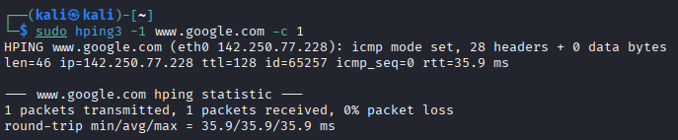

Subnet Discovery (Ping Sweep)
  - hping3 -1 10.0.1.x --rand-dest -I eth0
  - By using the --rand-dest flag, this command scans a subnet by sending ICMP packets to random destinations, which can make the scan less conspicuous. The -I flag specifies the network interface to use.
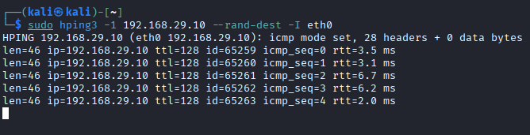

ICMP Type-Specific Testing
  - hping3 -1 -C 17 -c 1 target
  - This command sends an ICMP Address Mask Request (type 17) packet to the target. This type of specific probing can be used to test how a host or network device responds to a variety of ICMP packet types beyond a simple echo request.
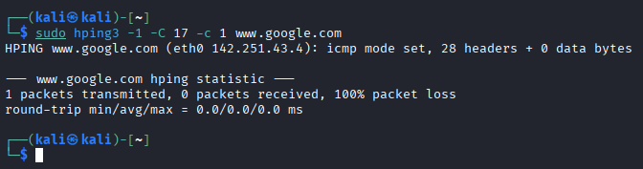

Traceroute Using ICMP
  - hping3 --traceroute -V -1 target
  - This command performs a traceroute-like function using ICMP packets. The -V flag enables verbose output, which provides detailed information about each hop, including round-trip time, making it useful for network troubleshooting and mapping.
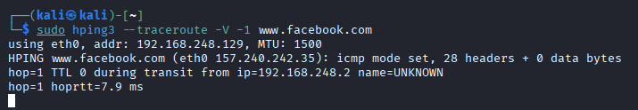

2. TCP Flag-Based Scans & Reconnaissance

SYN Scan (Port Checking)
  - hping3 -S -p 80 -c 1 target
  - This is a foundational command that sends a single TCP SYN packet to port 80. If the port is open, the target will respond with a SYN-ACK packet. If the port is closed, it will respond with a RST-ACK. If there is no response, it is likely that a firewall is filtering the traffic.
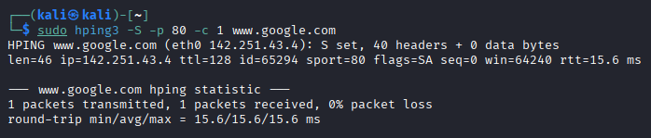

Range-Based SYN Scan
  - hping3 -8 50-60 -S target
  - The -8 or --scan flag allows for scanning a range of ports, in this case, ports 50 to 60, with a single command. This is an efficient way to check for multiple services on a target machine without running a separate command for each port.
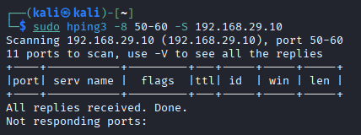

Sweep Scan
  - hping3 -8 1-1024 -S target
  - This command performs a wide-range SYN scan across a large number of common ports, from 1 to 1024. This type of sweep is effective for broad reconnaissance to discover a wide variety of running services.
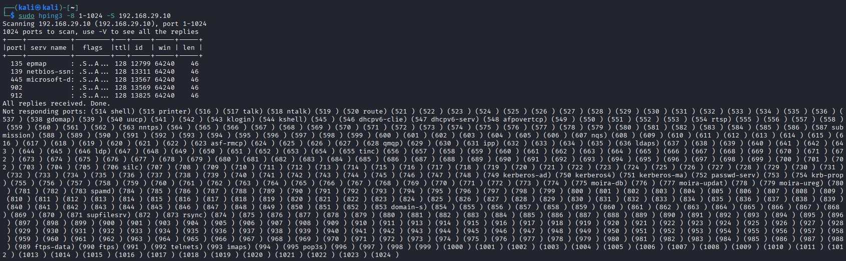

FIN, PUSH, URG (XMAS-style) Scan
  - hping3 -F -P -U -p 80 target
  - This command sets a combination of TCP flags (FIN, PUSH, URG). This is a type of stealth scan because, on an open port, a compliant system will typically ignore the packet and send no response. On a closed port, the system will respond with a RST-ACK. This can be used to bypass simple firewalls that only monitor SYN packets.
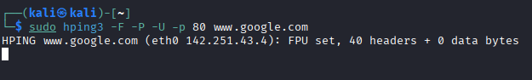

ACK Scan (Firewall Detection)
  - hping3 -A -p 80 target
  - By sending a packet with only the ACK flag set, this command tests whether a firewall is stateful or stateless. A stateful firewall, which tracks active connections, will likely drop the unexpected ACK packet and send no response, indicating a "filtered" port. A stateless firewall, which simply filters based on predefined rules, may send a RST response if the port is closed, indicating that the port is "unfiltered but closed".
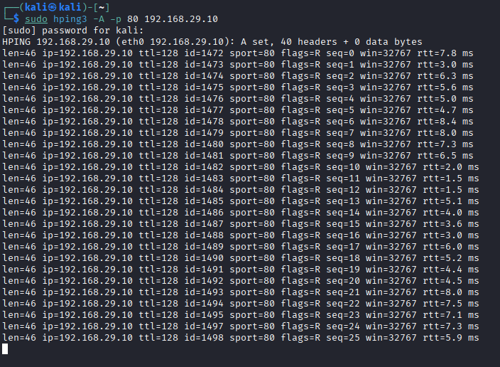

TCP Timestamp Option Testing
  - hping3 -S -p 80 --tcp-timestamp target
  - This command uses the --tcp-timestamp flag to include the TCP Timestamp option in the SYN packet . This is useful for auditing the TCP/IP stack of a remote host and can help a user infer the target's uptime, which is valuable for both offensive and defensive purposes .
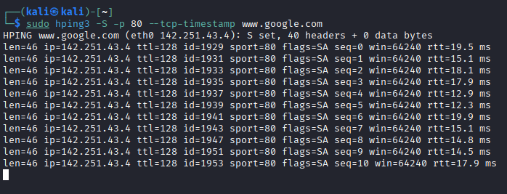

3. UDP & Raw IP Testing

UDP Scan
  - hping3 -2 -p 53 target
  - This command sends UDP packets to a specific port, in this case, port 53. Since UDP is a connectionless protocol, an open port may not send a response. If the port is closed, the target is expected to return an ICMP "port unreachable" message. No response indicates that the port is either open or that the packets are being filtered by a firewall.
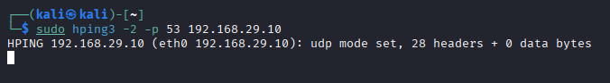

4. Traffic Control, Spoofing & Flooding

Random Source IP (Scan Evasion)
  - hping3 --rand-source -S -p 80 target
  - This command sends SYN packets to a target from random source IP addresses. This is a key evasion technique that makes it difficult for a target to identify the true origin of a scan or attack, though it prevents the user from receiving a response.
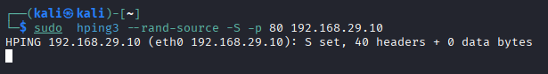

Flood Mode (DoS Simulation)
  - hping3 -S -p 80 --flood target
  - The --flood flag instructs HPING3 to send packets as fast as possible without waiting for a reply. This is the basis of a basic SYN flood attack, designed to overwhelm a target's resources and test its resilience to high-volume traffic.
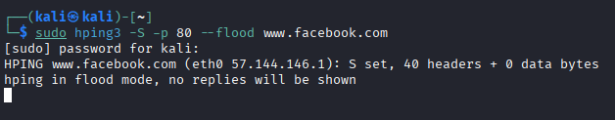

SYN Flood with Spoofed Source
  - hping3 -S -p 22 --flood -a spoofedIP target
  - This command combines the --flood flag with IP spoofing (-a), simulating a high-rate SYN flood from a fake source IP. This makes it more difficult for the target to block the attack by source IP address and can make the attack appear to originate from a completely different location.
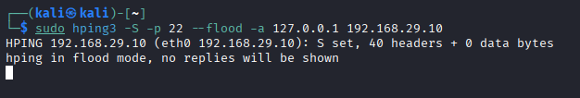

Smurf Attack Simulation
  - hping3 --icmp --flood target -a target
  - This is a classic DoS technique where HPING3 sends a high volume of ICMP packets to the target. The -a flag spoofs the source IP address to be the target's own IP address, which is a key component of a Smurf attack.
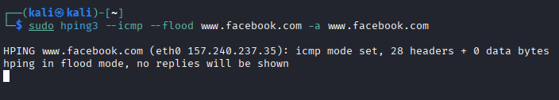

5. Advanced Tracing & Fragmentation

TCP-Based Traceroute
  - hping3 --traceroute -V -S -p 80 -s 5050 target
  - This command performs a traceroute to the target using TCP packets instead of the default ICMP protocol. This is especially useful when network devices are configured to block or filter ICMP, which is a common defensive measure.
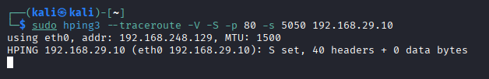

Load-Balancer Discovery via TTL
  - hping3 www.google.com -S -p 80 -T --ttl 13 --tr-keep-ttl -n
  - This advanced command attempts to discover load balancers and the multiple backend servers they manage. By sending packets with a fixed Time-to-Live (TTL) value (--tr-keep-ttl) and a specified TTL (-t 13), a user can force packets to a specific point in the network. If different responses are received, it can expose the use of multiple backend servers.
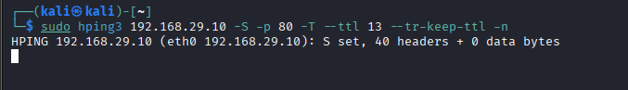

Packet Fragmentation for Firewall Evasion
  - hping3 -S -p 80 -f target
  - The -f flag splits a packet into multiple fragments. Some older or poorly configured firewalls may fail to properly reassemble and inspect these fragmented packets, allowing the traffic to bypass detection and reach the target. HPING3 supports various fragmentation flags like -f, --morefrag, and --fragoff.
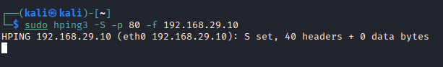

6. Miscellaneous & Niche Scenarios:

Idle/Zombie Scan
  - hping3 -S -p 80 -s 0 --spoof zombieIP target
  - This is a highly stealthy scanning method that spoofs the source IP address to that of a "zombie" host. By analyzing the IP ID of the zombie host, a user can infer if the target port is open or closed, without sending any packets from their own IP.
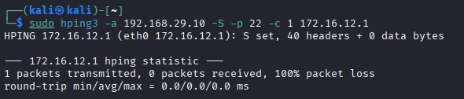

Banner Grabbing
  - hping3 -S -p 21 -c 1 target
  - While more advanced tools are typically used for this, a simple HPING3 command can sometimes be used to "poke" a port and check for a banner. This can provide a quick, high-level overview of the service running on a specific port, such as an FTP service on port 21.
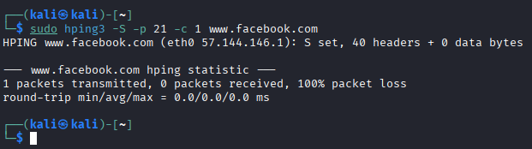

Custom Payload Injection
  - hping3 target --data 500 --udp -p 1234
  - The --data flag allows a user to specify a custom payload size in bytes. This is useful for testing a network's ability to handle custom-sized packets, a key part of auditing network resilience against various DoS and evasion techniques.
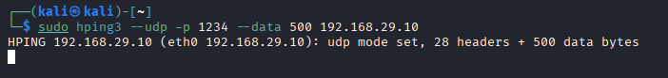

TTL-Based Rel (Packet Flow Estimation)
  - hping3 -r target
  - The -r or --rel flag displays the IP ID increments instead of the raw IP ID value. This can be used to monitor and estimate the traffic flow from a specific host, providing insights into the relative number of packets sent and received.

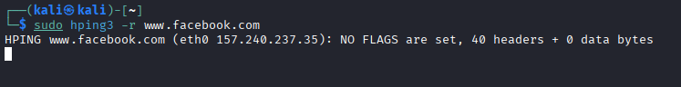

Summary Table of Test Scenarios:
Category | Scenario | Example Command
ICMP & Subnet Ping | Basic ping / sweep | -1, --rand-dest
TCP Scanning | SYN, FIN, ACK, ISN, Timestamp | -S, -F -P -U, -A, -Q, --tcp-timestamp
UDP Testing | UDP scan | -2 / --udp
Traffic & Spoofing | Flood, Smurf, LAND, random source | --flood, --rand-source, -a, --icmp, -S -a
Traceroute & Routing | ICMP, TCP traceroute, TTL probing | --traceroute, -t, --tr-keep-ttl
Fragmentation | Bypass rules | -f, --fragoff
Idle / Banner Scan | Stealth scanning, grabbing banners | --spoof, -p, --data

6. Troubleshooting

6.1. Common Errors and Solutions
- Error: Permission denied This is one of the most frequently encountered errors when using HPING3. The root cause is that the tool requires elevated privileges to access the network interface and craft raw packets, a capability that is restricted for standard user accounts.
  - Solution: The resolution is to run the command with sudo (sudo hping3...). If this still fails, a user may need to switch to the root user with
  - sudo su to ensure proper path and permissions.
- Error: Request timed out or Packet lost 100% This is a common issue when using the ICMP protocol (-1 flag). It does not necessarily mean the target host is down; rather, it often indicates that a firewall or network device is configured to drop ICMP packets.
  - Solution: A user should try using a different protocol, such as a TCP SYN scan (-S flag), which may be allowed through the firewall to a specific port.
- Error: no such device This error occurs when the specified network interface name (-I or --interface) is invalid or misspelled.
  - Solution: A user can list the available network interfaces using the ifconfig or ip a command and then specify the correct interface name with the -I flag.

6.2. Debugging
The most effective method for debugging HPING3 is to combine its native verbose and debug flags with a network protocol analyzer.
- HPING3 Flags: The -V or --verbose flag provides detailed output about the packets being sent and received. The -D or --debug flag can provide additional debugging information for complex issues.
- Wireshark Integration: For a definitive view of what is happening on the wire, a user can run a packet capture tool like Wireshark on the local machine while executing HPING3 commands. This allows the user to inspect the actual packet headers and flags to verify that their crafted packets are being sent correctly, which is invaluable for understanding how the tool works at a low level.

6.3. Support Resources
The official GitHub repository serves as the primary technical resource, though it is not heavily maintained. For user support, a user can rely on the comprehensive
man hping3 manual page on their Linux system. Additionally, community-driven platforms such as specialized forums and cybersecurity learning websites like Cybrary often feature tutorials and discussions about HPING3.

7. Security Considerations

7.1. OPSEC Concerns
HPING3 is not inherently a stealth tool. While it provides options for spoofing IP addresses, the packets it generates can still be easily detected by sophisticated network security devices. A critical operational security (OPSEC) consideration for any user is that the very act of running the HPING3 binary can be an indicator of compromise (IOC). Blue teams and network security solutions, such as the Elastic detection rules, are specifically configured to monitor for the execution of such tools on a system. This means a red teamer must consider not only the network traffic they generate but also their local footprint, as the HPING3 process itself can trigger an alert.

7.2. Detection Methods
Security professionals and blue teams employ various methods to detect malicious or unauthorized use of tools like HPING3.
- Intrusion Detection/Prevention Systems (IDS/IPS): The high volume of packets generated by HPING3's --flood flag is a textbook signature for an IDS/IPS. Similarly, unusual packet headers, a high rate of SYN packets from a single or random set of sources, or fragmented packets can trigger alerts.
- Firewall and Log Analysis: Firewalls are configured to drop traffic based on specific rules, but they also log rejected packets. Analyzing firewall logs can reveal anomalous behavior, such as repeated attempts to connect to closed ports or the presence of malformed packets.
- System Telemetry: On the local host, security tools can detect the HPING3 process itself, its command-line arguments, and the network connections it opens. This host-based detection is a vital layer of defense.

7.3. Mitigation Techniques
Defending against the capabilities of HPING3 requires a multi-layered approach that addresses both network and host-based vulnerabilities.
- Firewall Filtering: Implement granular firewall rules to block suspicious traffic. This can include filtering based on specific TCP flags, protocols, or a combination of both. For example, a firewall can be configured to drop all incoming packets with the -A (ACK) flag unless they belong to an established connection.
- Rate Limiting: Network devices and Web Application Firewalls (WAFs) can be configured with rate-limiting policies to restrict the number of connection attempts from a single source within a given time frame. This is a primary defense against flood attacks and resource exhaustion.
- SYN Cookies: As a direct countermeasure to SYN flood attacks, servers can use a technique called SYN cookies. The server responds to a SYN packet with a SYN-ACK that contains a special cookie in the sequence number field. It only allocates resources for the connection once the client responds with a valid ACK containing this cookie.
- Operating System and Firmware Updates: Regularly patching operating systems and network device firmware is crucial. Many historical attacks, such as the Ping of Death, were vulnerabilities in how older systems handled oversized or fragmented ICMP packets. Modern systems have been patched against these specific exploits, but new vulnerabilities can always be discovered.
- DDoS Protection Services: For high-value web services, using a cloud-based DDoS protection service (e.g., Cloudflare) is an effective strategy. These services absorb large-scale packet floods at the network edge, preventing the malicious traffic from ever reaching the origin server.
The offensive capabilities of HPING3 are directly proportional to the defensive measures developed to counter them. Understanding how an attack works from the perspective of HPING3 is a key step in developing robust defensive strategies. A student should recognize that the existence of tools like HPING3 drives the innovation of defenses such as SYN cookies and sophisticated firewalls. This dynamic relationship between offensive and defensive cybersecurity is a fundamental concept that a student must grasp to succeed in the field.

8. References and Additional Resources

8.1. Cheat Sheet
The following table provides a quick reference for the most common and powerful HPING3 commands.
Objective | Command
Ping a host with ICMP | hping3 --icmp -c 4 target_ip
TCP SYN scan on a specific port | hping3 -S -p 80 target_ip
Scan multiple TCP ports | hping3 --scan 80,443,8080 -S target_ip
SYN Flood attack | hping3 --flood -S -p 80 target_ip
Spoofed SYN attack | hping3 -S -p 80 -a fake_ip target_ip
Traceroute with TCP | hping3 --traceroute -V -S -p 80 target_ip
Scan with random source IP | hping3 --rand-source -S -p 80 target_ip
Check server uptime | hping3 --tcp-timestamp -p 80 target_ip

8.2. Related Tools
While HPING3 is a powerful tool, it is important to understand its role relative to other network security utilities. The following table compares HPING3 to two other widely used tools: Nmap and Scapy.
Feature | HPING3 | Nmap | Scapy
Type | Packet crafter & analyzer | Port scanner & host discovery | Packet generator library
Primary Use | Granular, low-level testing & DoS simulation | Broad, automated network mapping & vulnerability scanning | Programmatic packet manipulation & custom automation
Packet Customization | High (command-line) | Medium (pre-defined scans) | Extremely High (Python scripts)
OS Fingerprinting | Limited (relies on responses) | Yes (extensive database) | Yes (requires scripting)
Scripting Support | Yes (via Tcl) | Yes (via NSE) | Yes (Python library)
Learning Curve | Medium (requires network knowledge) | Low-Medium (intuitive syntax) | High (requires Python & deep network knowledge)

8.3. Further Reading
For a student who wishes to deepen their understanding of network security and the principles behind HPING3, the following resources are recommended:
- Official HPING3 Resources: The definitive source for the tool's code and documentation is its official GitHub repository at https://github.com/antirez/hping .
- Kali Tool Documentation: The Kali Website Tool Documentation on HPING3 https://www.kali.org/tools/hping3/

8.4. Community Resources
The cybersecurity community is a vital resource for learning and problem-solving. A student can find support and shared knowledge through:
- Cybersecurity Learning Platforms: Platforms like Cybrary provide comprehensive training, certification prep, and hands-on labs. Similarly, TryHackMe offers guided learning paths, tutorials, and practical security challenges.
- Professional Communities: Organizations like the Open Worldwide Application Security Project (OWASP) provide critical guidance on web application and API security, including best practices for input validation and access control.
- Online Forums and Groups: General-purpose forums like Reddit have communities dedicated to ethical hacking and cybersecurity. Additionally, Discord has numerous servers focused on cybersecurity, CTFs (Capture The Flag), and technical topics, such as the OwlSec server.

