Mongoose
Mongoose Introduction

What's mongoose?
Mongoose is an Object Data Modeling (ODM) library for MongoDB and Node.JS. It is responsible for:
- Managing data relationships.
- Providing schema validation.
- Implementing the translation between code objects and the representation of those objects in MongoDB.
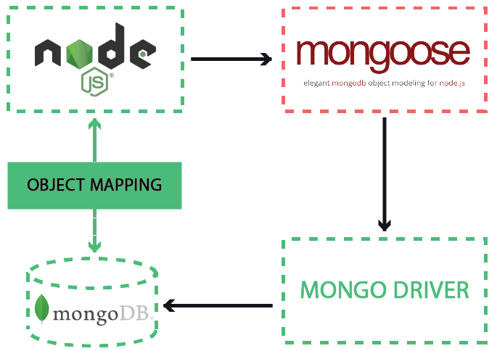
https://mongoosejs.com/

Mongodb vs SQL
You know by now that MongoDB is a schema-less NoSQL document database. It means you can store JSON documents on it. The structure of these documents can vary as it is not enforced like SQL databases. This is one of the advantages of using NoSQL as it speeds up application development and reduces the complexity of deployments.
The example below is a reminder of how data is stored in Mongo vs. SQL Database:
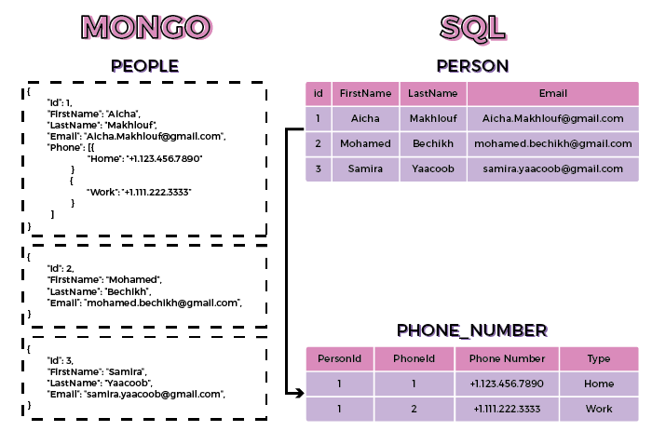
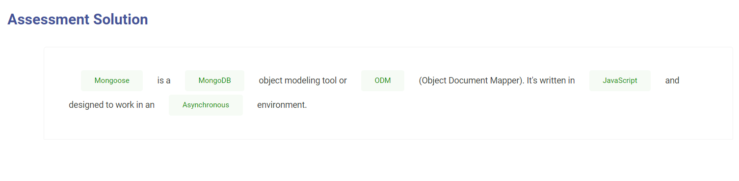

Terminologies

Terminologies
Just as a reminder, here are some terminologies used with the NoSQL database:
- Collections: Collections in Mongo are the equivalent of tables in relational databases. They can hold multiple JSON documents.
- Documents: Documents are the equivalent of records or data rows in SQL. While an SQL row can reference data in other tables, Mongo documents usually combine them in one document.
- Fields: Fields or attributes that are similar to columns in an SQL table.
- Schema: While Mongo is schema-less, SQL defines a schema via the table definition. A Mongoose ‘schema’ is a document data structure (or a shape of the document) that is enforced via the application layer.
- Models: Models are higher-order constructors that take a schema and create an instance of a document equivalent to records in a relational database.
- References: References are referred from one document to another using the value of the referenced (parent) document.
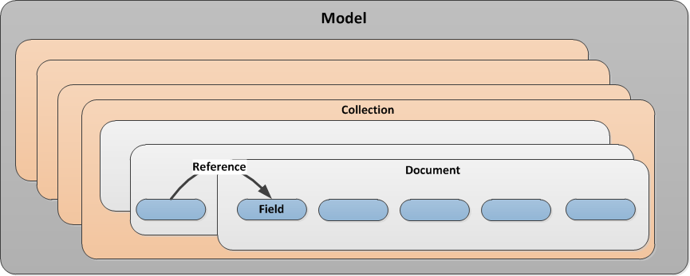

Additional Resources
#Terminologies
https://www.dummies.com/category/articles/big-data-33578/

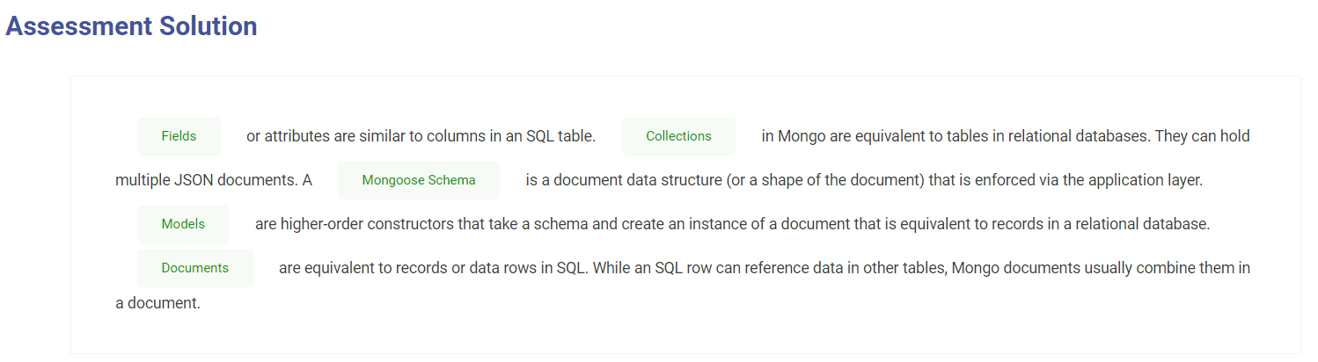

Getting Started

Getting Started
- Mongo Installation: First, we need MongoDB to be installed in our machine (check the MongoDB Super Skill if needed)
Let’s have a look at some of the basics of Mongoose by implementing a model that presents the data of a simplified address book.
Fire up your favorite IDE (ahem..VSCode), create a blank project, and let’s get started! We will be using the limited ES6 syntax in Node, (so we won’t be configuring Babel).
- Mongoose Installation
Let’s go to the project folder and initialize our project:
npm init -y
Let’s install Mongoose and a validation library with the following command:
npm install mongoose validator
The above install command will install the latest version of the libraries. The Mongoose syntax in this course is specific to Mongoose v5 and beyond.

Additional Resources
#Connecting a database

https://mongoosejs.com/docs/connections.html

Getting Started
- Database Connection
Create a file ./src/database.js under the project's root.
Next, we will add a simple class with a method that connects to the database.
Your connection string will vary based on your installation.
let mongoose = require('mongoose');const server = '127.0.0.1:27017'; // REPLACE WITH YOUR DB SERVERconst database = 'myDB'; // REPLACE WITH YOUR DB NAMEclass Database {
constructor() {
this._connect()
}
_connect() {
mongoose.connect(`mongodb://${server}/${database}`)
.then(() => {
console.log('Database connection successful')
})
.catch(err => {
console.error('Database connection error')
})
}
}module.exports = new Database()
The require(‘mongoose’) call above returns a Singleton object. It means that when you call require(‘mongoose’) for the first time, it creates an instance of the Mongoose class and returns it. On subsequent calls, it will return the same instance that was created and returned to you the first time because of how module import/export works in ES6.

About Module import/require work-flow:
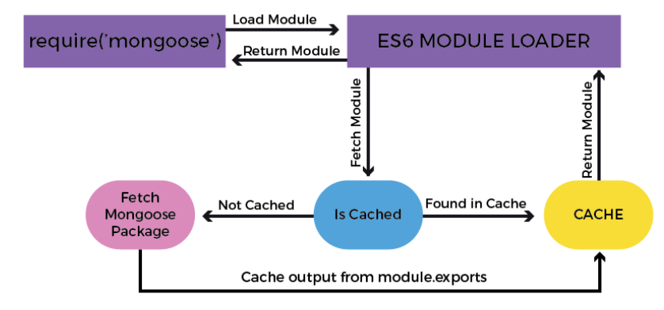
In the previous code, we have also turned our database class into a singleton by returning an instance of the class in the module.exports statement because we only need a single connection to the database.
ES6 makes it very easy for us to create a singleton (single instance) pattern because of how the module loader works by caching the response of a previously imported file.
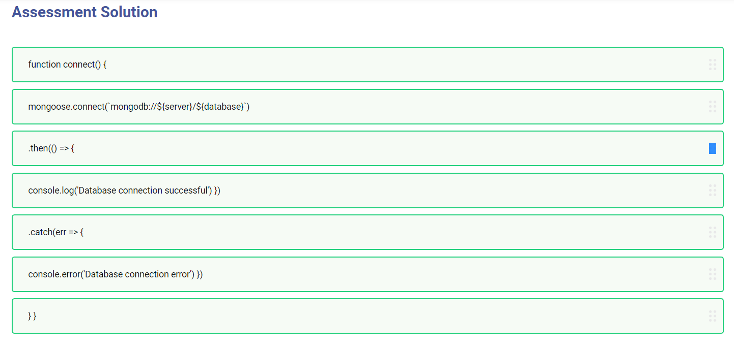

Mongoose Schema vs. Model

Mongoose Schema vs. Model
A Mongoose model is a wrapper on the Mongoose schema. A Mongoose schema defines the structure of the document, default values, validators, etc... whereas a Mongoose model provides an interface to the database for creating, querying, updating, deleting records, etc.
Creating a Mongoose model comprises primarily of three parts:

1. Referencing Mongoose
let mongoose = require('mongoose')
This reference will be the same as the one that was returned when we connected to the database, which means the schema and model definitions will not need to explicitly connect to the database.

Additional Resources
#Mongoose schema.
https://mongoosejs.com/docs/guide.html

Mongoose Schema vs. Model

2. Defining the Schema
A schema defines document properties through an object where the key name corresponds to the property name in the collection.
let emailSchema = new mongoose.Schema({
email: String
})
Here we define a property called email with a schema type String which maps to an internal validator that will be triggered when the model is saved to the database. It will fail if the data type of the value is not a string type.
The following Schema Types are permitted:
- Array
- Boolean
- Buffer
- Date
- Mixed (A generic / flexible data type)
- Number
- ObjectId
- String
Mixed and ObjectId are defined under require(‘mongoose’).Schema.Types.

Additional Resources
#Mongoose schema.

Mongoose Schema vs. Model

3. Exporting a Model
We need to call the model constructor on the Mongoose instance and pass it the name of the collection and a reference to the schema definition.
module.exports = mongoose.model('Email', emailSchema)
Let’s combine the code above into ./src/models/email.js to define the contents of a basic email model:
let mongoose = require('mongoose')let emailSchema = new mongoose.Schema({
email: String
})module.exports = mongoose.model('Email', emailSchema)

Additional Resources
#Mongoose schema.

Mongoose Schema vs. Model

3. Exporting a Model
A schema definition should be simple, but its complexity is usually based on application requirements. Schemas can be reused and they can contain several child-schemas too. In the example above, the value of the email property is a simple value type. However, it can also be an object type with additional properties on it.
We can also create an instance of the model we've defined above and populate it using the following syntax:
let EmailModel = require('./email')let msg = new EmailModel({
email: 'ada.lovelace@gmail.com'
})
Let’s enhance the email schema to make the email property a unique and required field. We can then convert the value to lowercase before saving it. We can also add a validation function that will ensure that the value is a valid email address. We will reference and use the validator library installed earlier.
let mongoose = require('mongoose')let validator = require('validator')let emailSchema = new mongoose.Schema({
email: {
type: String,
required: true,
unique: true,
lowercase: true,
validate: (value) => {
return validator.isEmail(value)
}
}
})module.exports = mongoose.model('Email', emailSchema)

Additional Resources
#Mongoose schema.

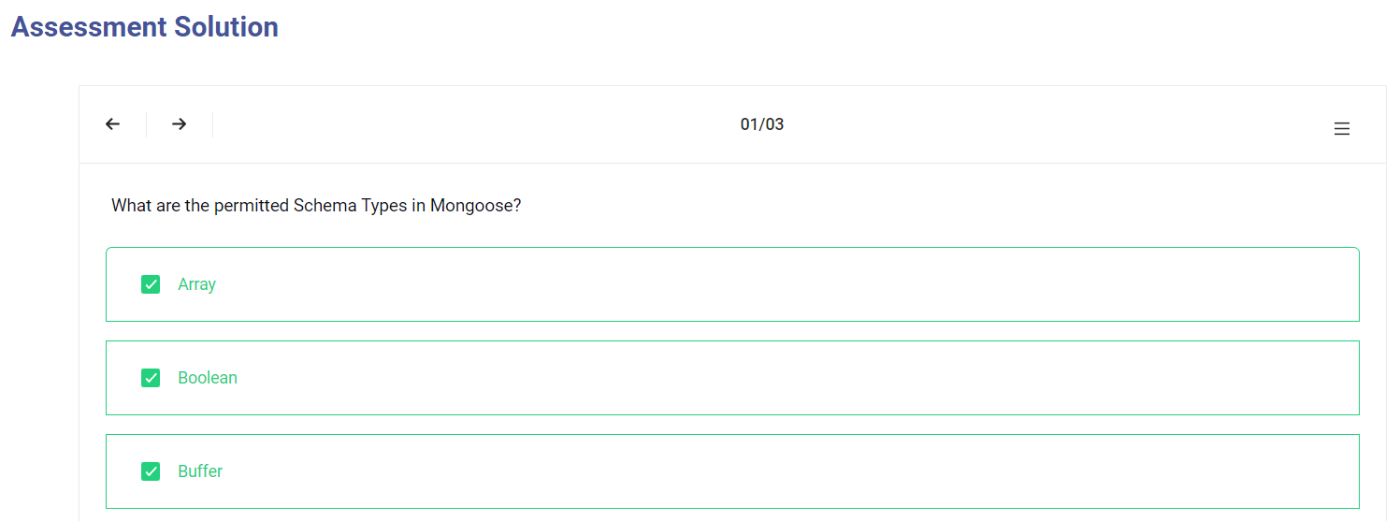
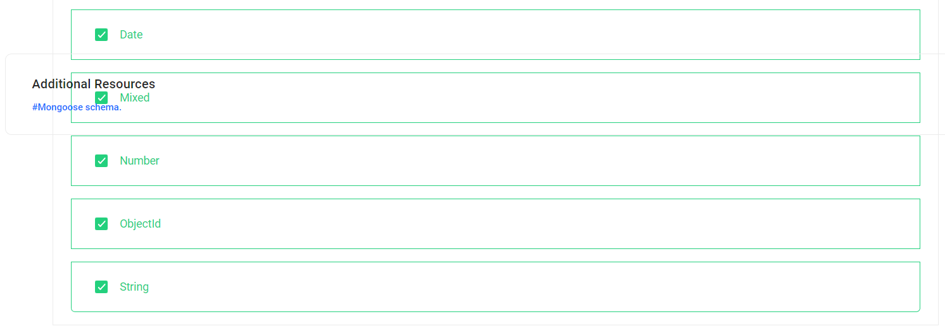

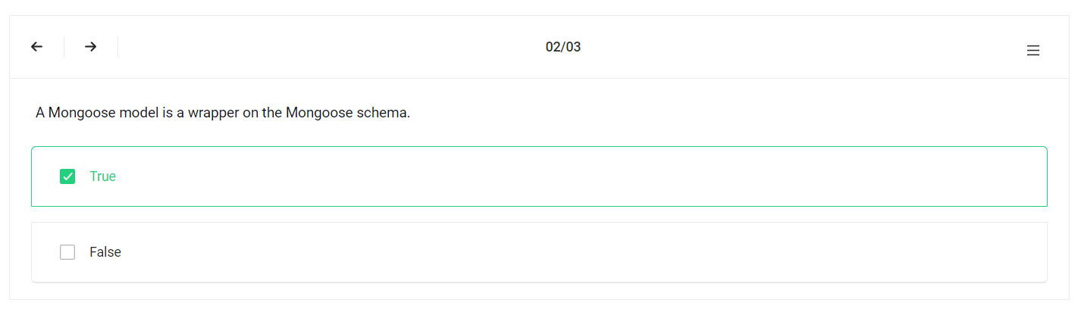

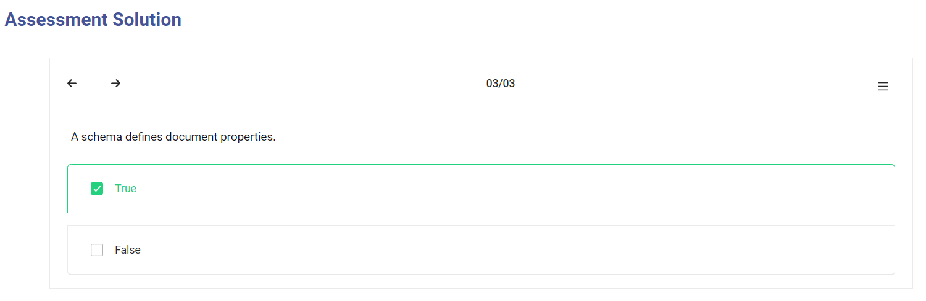

Basic Operations

Basic Operations

Mongoose has a flexible API and provides many ways to accomplish a task. We will not focus on the variations because that is out of the scope of this course. However, try to remember that most of the operations can be done in more than one way either syntactically or via the application's architecture.

Create Record
Let’s create an instance of the email model and save it to the database:
let EmailModel = require('./email')let msg = new EmailModel({
email: 'ADA.LOVELACE@GMAIL.COM'
})
msg.save()
.then(doc => {
console.log(doc)
})
.catch(err => {
console.error(err)
})
The result is a document that is returned upon a successful save:
{
_id: 5a78fe3e2f44ba8f85a2409a,
email: 'ada.lovelace@gmail.com',
__v: 0
}
​
The following fields are returned (internal fields are prefixed with an underscore):
- The _id field is auto-generated by Mongo and is a primary key of the collection. Its value is a unique identifier for the document.
- The value of the email field is returned. Notice that it is lower-case because we specified the lowercase:true attribute in the schema.
- __v is the versionKey property set on each document when first created by Mongoose. Its value contains the internal revision of the document.
​
If you try to repeat the save operation above, you will get an error because we have specified that the email field should be unique.
311790:0

Additional Resources
#Mongoose document

https://mongoosejs.com/docs/documents.html

Basic Operations

Fetch Record
Let’s try to retrieve the record we saved to the database earlier. The model class exposes several static and instance methods to perform operations on the database. We will now try to find the record that we have created previously using the find method and pass the email as the search term.
EmailModel
.find({
email: 'ada.lovelace@gmail.com' // search query
})
.then(doc => {
console.log(doc)
})
.catch(err => {
console.error(err)
})
The document returned will be similar to what was displayed when we created the record:
{
_id: 5a78fe3e2f44ba8f85a2409a,
email: 'ada.lovelace@gmail.com',
__v: 0
}

Additional Resources
#Mongoose document

Basic Operations

Update Record
Let’s modify the record above by changing the email address and adding another field to it, all in a single operation. For performance reasons, Mongoose won’t return the updated document so we need to pass an additional parameter to ask for it:
EmailModel
.findOneAndUpdate(
{
email: 'ada.lovelace@gmail.com' // search query
},
{
email: 'theoutlander@live.com' // field:values to update
},
{
new: true, // return updated doc
runValidators: true // validate before update
})
.then(doc => {
console.log(doc)
})
.catch(err => {
console.error(err)
})
The document returned will contain the updated email:
{
_id: 5a78fe3e2f44ba8f85a2409a,
email: 'theoutlander@live.com',
__v: 0
}

Additional Resources
#Mongoose document

Basic Operations

Delete Record
We will use the findOneAndRemove call to delete a record. It returns the original document that was removed:
EmailModel
.findOneAndRemove({
email: 'theoutlander@live.com'
})
.then(response => {
console.log(response)
})
.catch(err => {
console.error(err)
})

Additional Resources
#Mongoose document

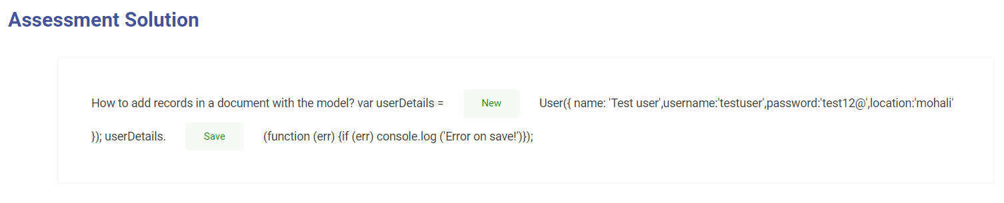

Helpers.
Helpers
So far, we have looked at some of the basic functionalities known as CRUD (Create, Read, Update, Delete) operations, but Mongoose also provides the ability to configure several types of helper methods and properties. These can be used to further simplify working with data.
Let’s create a user schema in ./src/models/user.js with the fields firstName and lastName:
let mongoose = require('mongoose')let userSchema = new mongoose.Schema({
firstName: String,
lastName: String
})module.exports = mongoose.model('User', userSchema)

Additional Resources
#mongoose static helper
https://mongoosejs.com/docs/queries.html#:~:text=Mongoose%20models%20provide%20several%20static,returns%20a%20mongoose%20Query%20object.&text=A%20mongoose%20query%20can%20be,the%20results%20to%20the%20callback%20.

Helpers

Virtual Property
A virtual property is not restricted the database. We can add it to our schema as a helper to get and set values.
Let’s create a virtual property called fullName which can be used to set values on firstName and lastName and retrieve them as a combined value when read:
userSchema.virtual('fullName').get(function() {
return this.firstName + ' ' + this.lastName
})
userSchema.virtual('fullName').set(function(name) {
let str = name.split(' ')

this.firstName = str[0]
this.lastName = str[1]
})
Callbacks for get and set must use the function keyword as we need to access the model via the this keyword. Using fat arrow functions will change what this refers to.
Now, we can set firstName and lastName by assigning a value to fullName:
let model = new UserModel()
model.fullName = 'Thomas Anderson'console.log(model.toJSON()) // Output model fields as JSONconsole.log()console.log(model.fullName) // Output the full name
The code above will output the following:
{ _id: 5a7a4248550ebb9fafd898cf,
firstName: 'Thomas',
lastName: 'Anderson' }
Thomas Anderson

Additional Resources
#mongoose static helper

Helpers

Instance Methods
We can create custom helper methods on the schema and access them via the model instance. These methods will have access to the model object and they can be used quite creatively. For instance, we could create a method to find all the people who have the same first name as the current instance.
In this example, let’s create a function to return the initials for the current user. Let’s add a custom helper method called getInitials to the schema:
userSchema.methods.getInitials = function() {
return this.firstName[0] + this.lastName[0]
}
This method will be accessible via a model instance:
let model = new UserModel({
firstName: 'Thomas',
lastName: 'Anderson'
})let initials = model.getInitials()console.log(initials) // This will output: TA

Additional Resources
#mongoose static helper

Helpers

Static Methods
Similar to instance methods, we can create static methods on the schema. Let’s create a method to retrieve all users in the database:
userSchema.statics.getUsers = function() {
return new Promise((resolve, reject) => {
this.find((err, docs) => {
if(err) {
console.error(err)
return reject(err)
}
resolve(docs)
})
})
}
Calling getUsers on the Model class will return all the users in the database:
UserModel.getUsers()
.then(docs => {
console.log(docs)
})
.catch(err => {
console.error(err)
})
Adding instance and static methods is a nice approach to implement an interface to database interactions on collections and records.

Additional Resources
#mongoose static helper

Helpers

Middleware
Middleware is a set of functions that run at specific stages of a pipeline. Mongoose supports middleware for the following operations:
- Aggregate
- Document
- Model
- Query
For instance, models have pre and post functions that take two parameters:
- Type of event (‘init’, ‘validate’, ‘save’, ‘remove’)
- A callback that is executed with this referencing the model instance
Example of Middleware (a.k.a. pre and post hooks):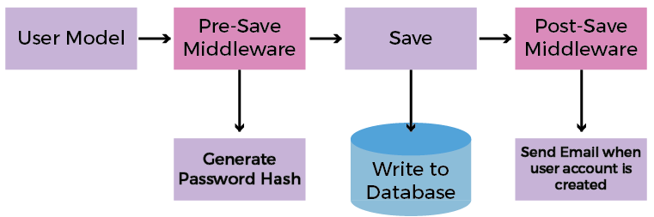

Additional Resources
#mongoose static helper

Helpers

Middleware
Let’s demonstrate this, as an example, by adding two fields called createdAt and updatedAt to our schema:
let mongoose = require('mongoose')let userSchema = new mongoose.Schema({
firstName: String,
lastName: String,
createdAt: Date,
updatedAt: Date
})module.exports = mongoose.model('User', userSchema)
When model.save() is called, there is a pre(‘save’, …) and post(‘save’, …) event that is triggered. For the second parameter, you can pass a function that is called when the event is triggered. These functions take a parameter to the next function in the middleware chain.
Let’s add a pre-save hook and set values for createdAt and updatedAt:
userSchema.pre('save', function (next) {
let now = Date.now()

this.updatedAt = now
// Set a value for createdAt only if it is null
if (!this.createdAt) {
this.createdAt = now
}
// Call the next function in the pre-save chain
next()
})
Let’s create and save our model:
let UserModel = require('./user')let model = new UserModel({
fullName: 'Thomas Anderson'
}
msg.save()
.then(doc => {
console.log(doc)
})
.catch(err => {
console.error(err)
})
You should see values for createdAt and updatedAt when the created record is printed:
{ _id: 5a7bbbeebc3b49cb919da675,
firstName: 'Thomas',
lastName: 'Anderson',
updatedAt: 2018-02-08T02:54:38.888Z,
createdAt: 2018-02-08T02:54:38.888Z,
__v: 0 }

Additional Resources
#mongoose static helper

Helpers

Plugins
Suppose that we want to track when a record was created and last updated on every collection in our database. Instead of repeating the above process, we can create a plugin and apply it to every schema.
Let’s create a file ./src/model/plugins/timestamp.js and replicate the above functionality as a reusable module:
module.exports = function timestamp(schema) {
// Add the two fields to the schema
schema.add({
createdAt: Date,
updatedAt: Date
})

// Create a pre-save hook
schema.pre('save', function (next) {
let now = Date.now()

this.updatedAt = now
// Set a value for createdAt only if it is null
if (!this.createdAt) {
this.createdAt = now
}
// Call the next function in the pre-save chain
next()
})
}
To use this plugin, we simply pass it to the schemas that should be given this functionality:
let timestampPlugin = require('./plugins/timestamp')

emailSchema.plugin(timestampPlugin)
userSchema.plugin(timestampPlugin)

Additional Resources
#mongoose static helper

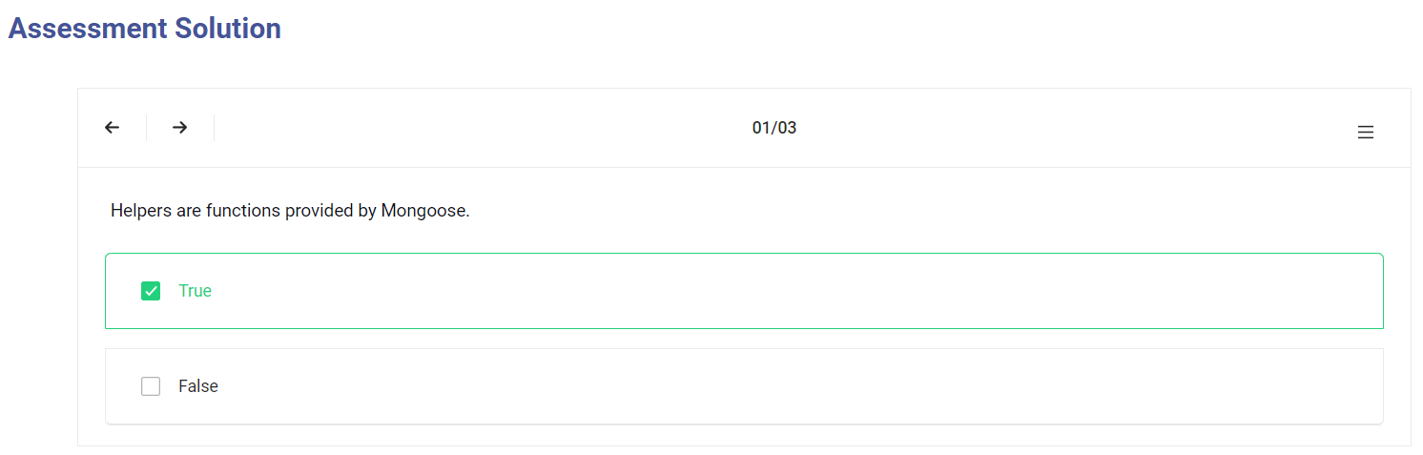
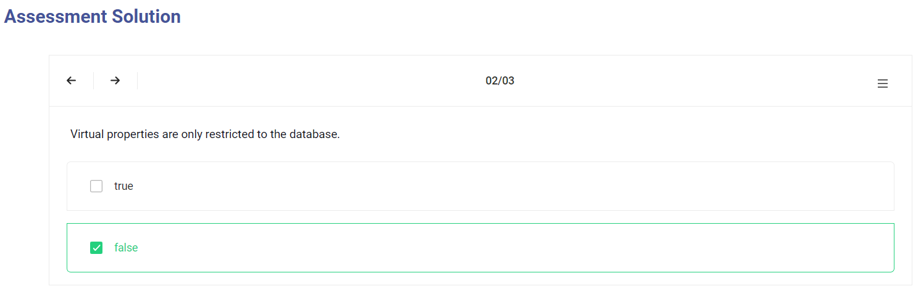
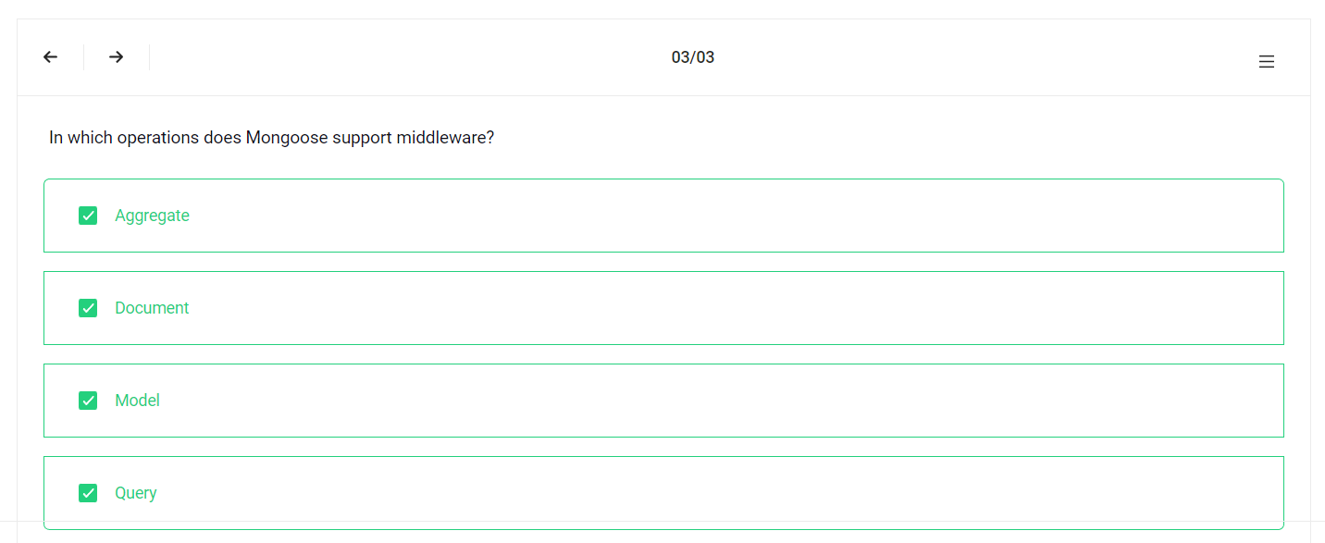

Query Building

Query Building

Mongoose has a very rich API that handles many complex operations supported by MongoDB. Let's take for example a query where we can incrementally build query components.
In this example, we are going to:
- Find all users.
- Skip the first 100 records.
- Limit the results to 10 records.
- Sort the results by the firstName field.
- Select the firstName.
- Execute that query.
UserModel.find() // find all users
.skip(100) // skip the first 100 items
.limit(10) // limit to 10 items
.sort({firstName: 1} // sort ascending by firstName
.select({firstName: true} // select firstName only
.exec() // execute the query
.then(docs => {
console.log(docs)
})
.catch(err => {
console.error(err)
})

Additional Resources
#Mongoose query

https://mongoosejs.com/docs/api/query.html

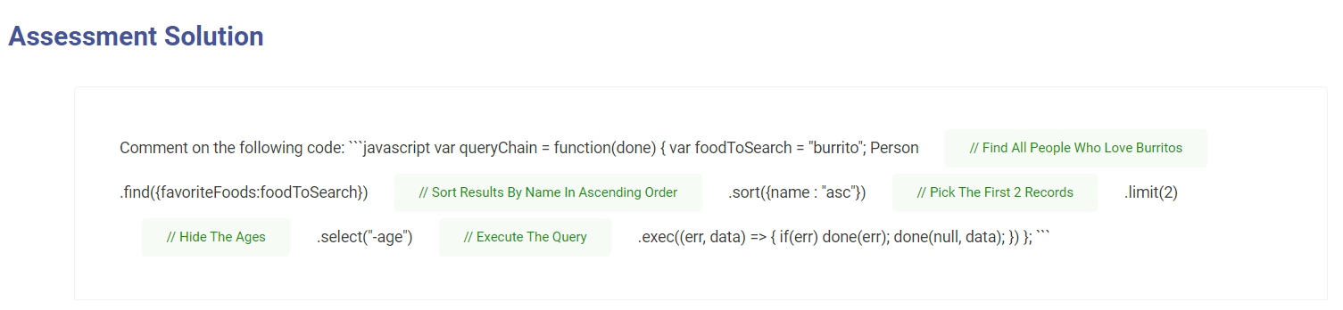

Conclusion
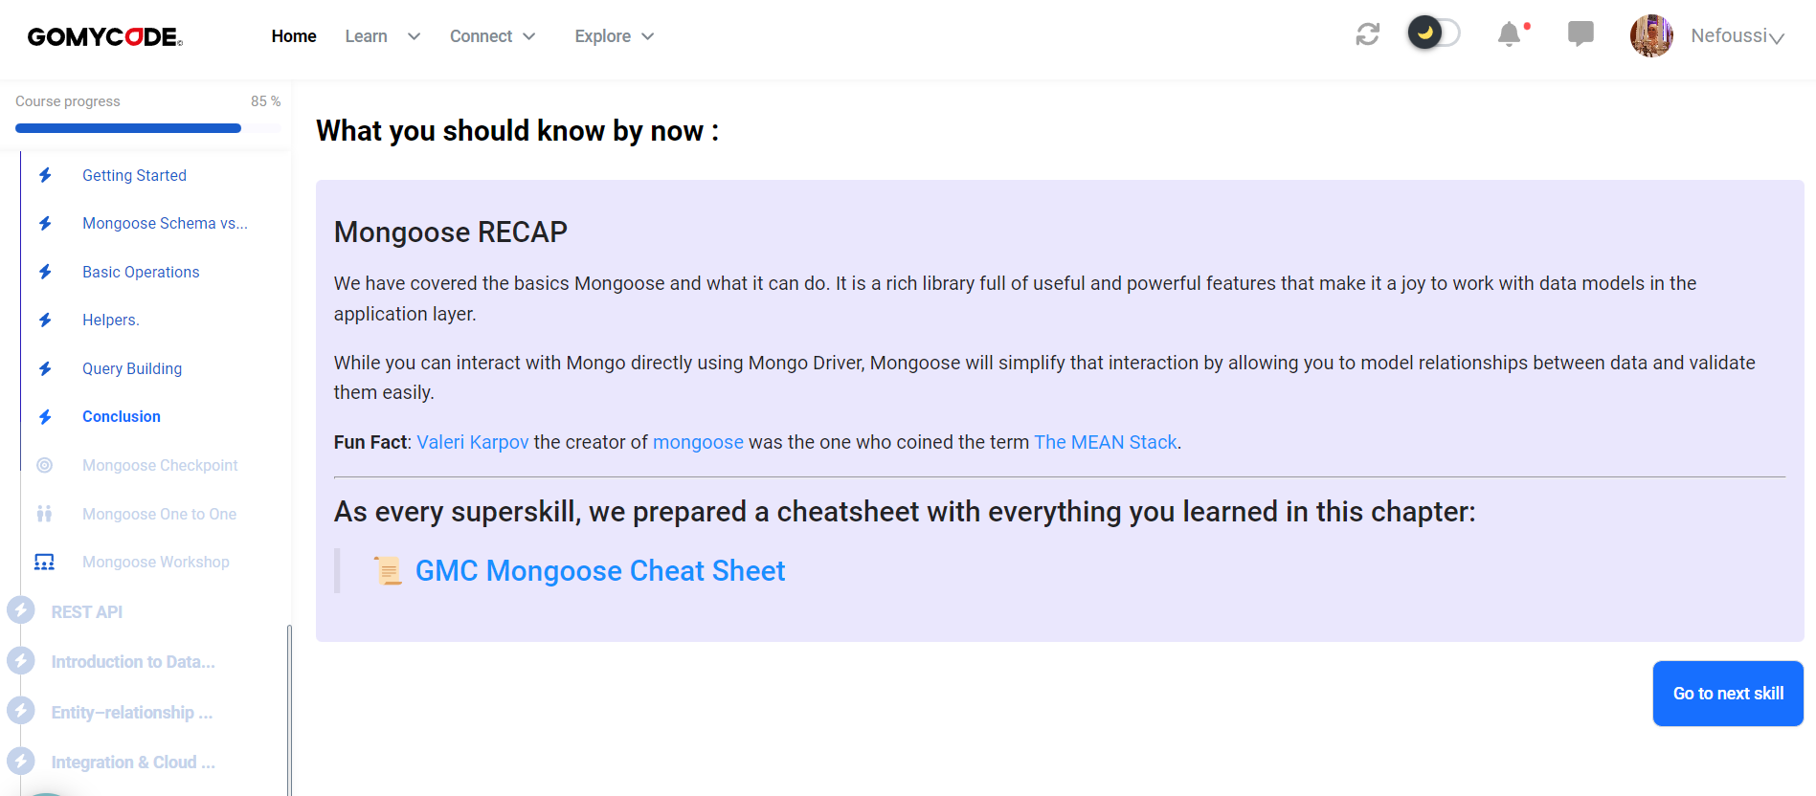

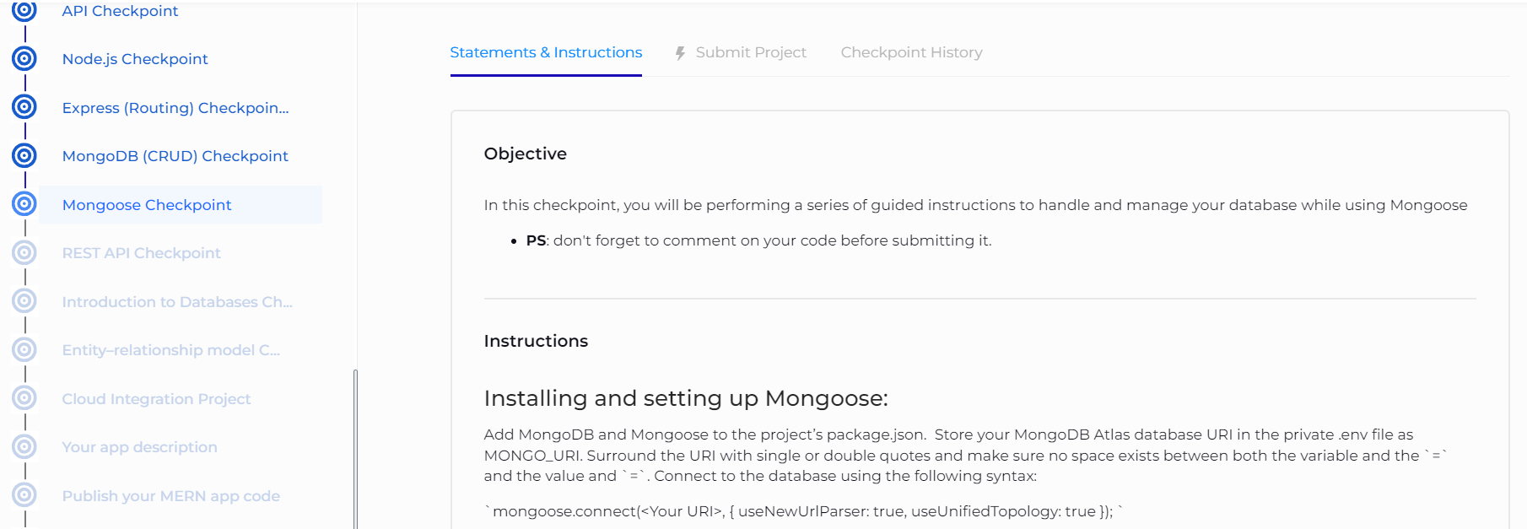
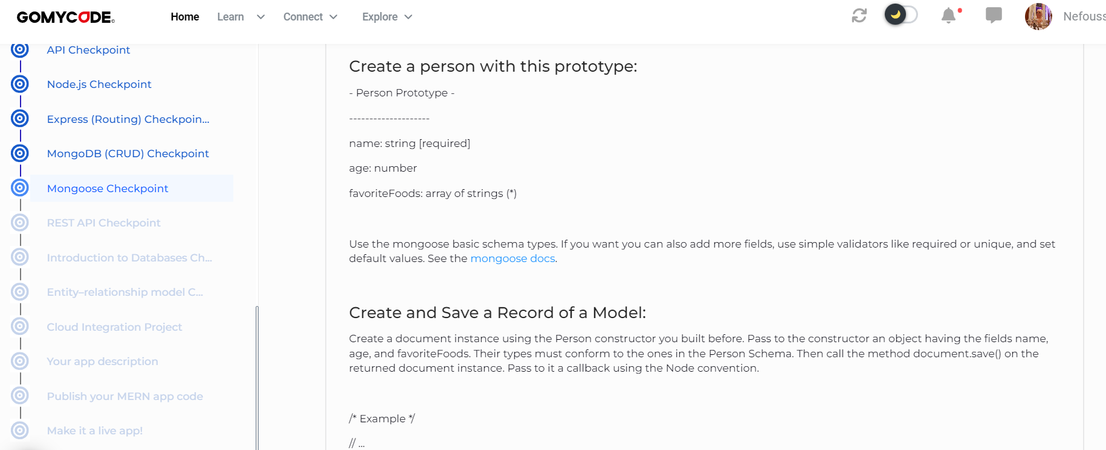
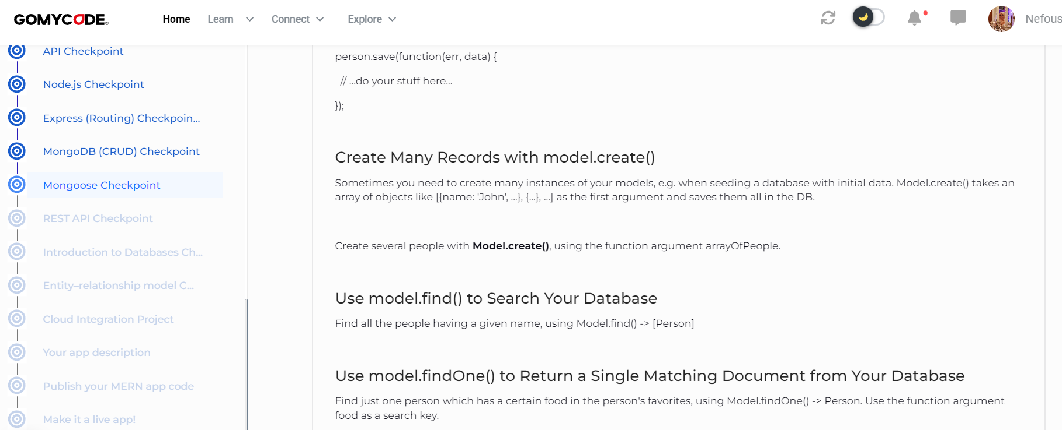

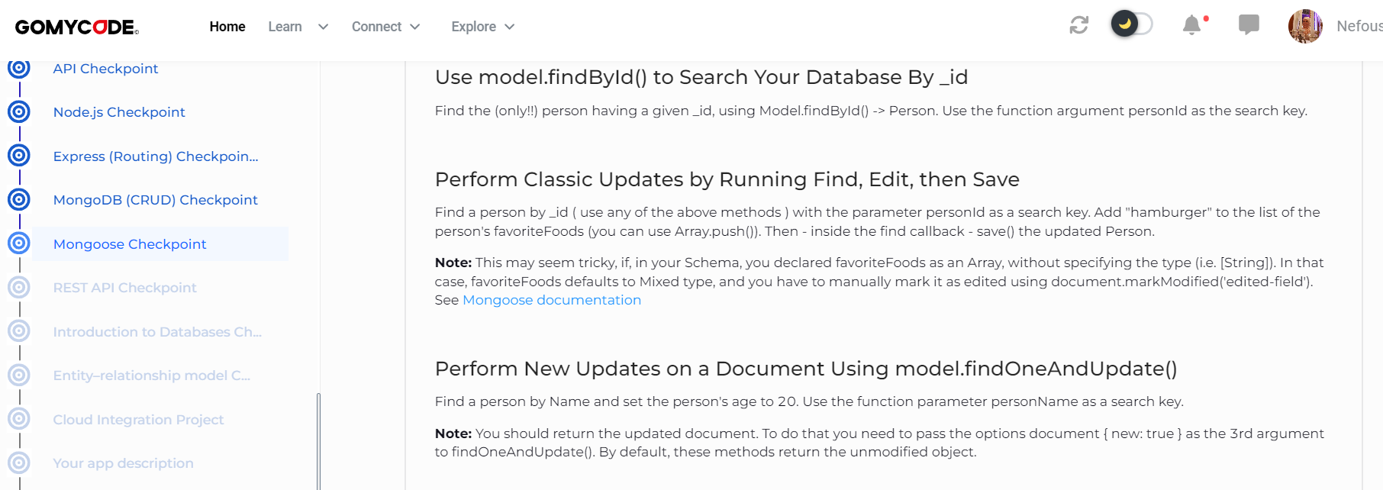

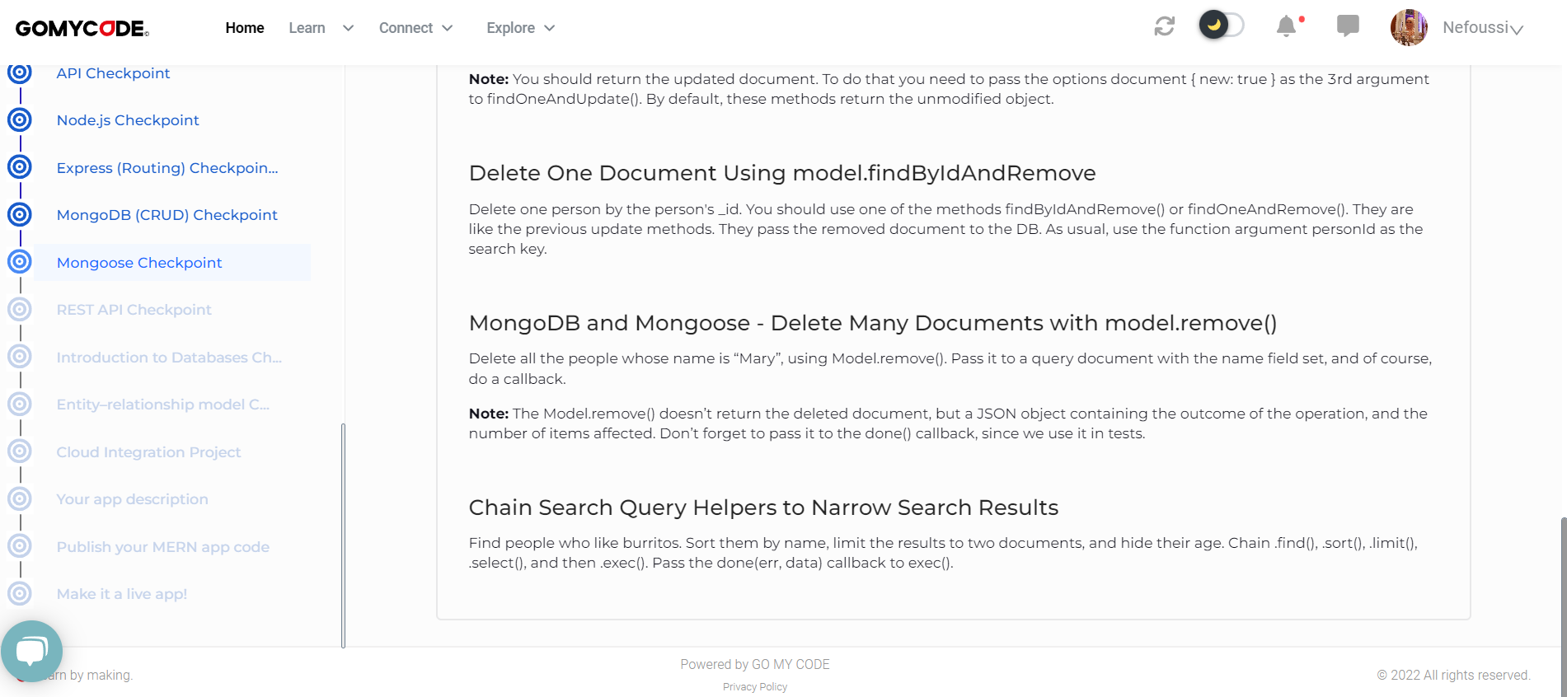

https://mongoosejs.com/docs/schematypes.html#Mixed

