**NEFSC *Ichthystick II* Electronic Fish Measuring Board**

**Sensor Case Manufacturing Manual**

**ver2.1**

**1.0 Getting Started:**

This manual was developed to aid in the construction of the *Ichthystick II* Electronic Fish Measuring Board sensor case. The case is manufactured from High Density Polyethylene Plastic (HDPE) that is cut to size to fit the required Temposonic Linear Sensor. A 1 ⅛ inch channel is routed out of the top of HDPE plastic to house the linear sensor. Excess material is taken out of the bottom of the HDPE plastic to reduce the weight of the finished case. A ⅛ inch clear plastic sheet is attached to the top of the HDPE case to provide a watertight covering for the linear sensor. See Appendix A for a view of the overall assembly of the Ichthystick II Case.

* + 1. **Tools Required:**

Router

Table Saw

Powered Jigsaw with 10 TPI blade for cutting plastics

Power Drill with assorted drill bits, 1/8”, 11/64, 11/32, 15/32”, 5/16”

4 - Workbench Clamps

Screw Driver – Slotted

Screw Driver – Phillips Head

½ inch Router Bit with ⅝ inch shank

1 inch Router Bit with ⅝ inch shank

Counter Sink Drill Bit

¼ ” Roundover Router Bit with ¼” shank

Specialty tool for threaded inserts, ¼”-20 and t-handle ¼” drive tool

10 x 24 NC Tap Bit

¼” x 18 NPT Tap Bit

¼” x 20 drive tool for stop plate inserts

* + 1. **List Of Materials:**

|  |  |  |  |  |
| --- | --- | --- | --- | --- |
| Description: | Part Number: | Quantity: | Vendor: | Notes: |
| Plywood sheet,  ½” thick x ? |  | 1 | Local Hardware Store | Use plywood to construct a template for the fishboard. Length depends on size of fishboard. |
| Polyethylene (HDPE) Sheet,  1-1/4” thick, 10”x48” | 8619K999 | 1 | McMaster-Carr | Use this size HDPE sheet for the 36” length sensor. |
| Polyethylene (HDPE) Sheet,  1-1/4” thick, 10”x60” | 8619K999 | 0 | McMaster-Carr | Use this size HDPE sheet for optional 42” length sensor. |
| Polycarbonate Sheet,  1/8” Thick, 10” x ? | 8574K73 | 1 | McMaster-Carr | “Top Cover” of fishboard.  Length should match size of board being built. |
| Nylon 82 Degree Flat Head Slotted Machine Screw, 10-24 thread, 3/4” Length | 94605A245 | 1 pack | McMaster-Carr | These screws secure the top cover to the base of the fishboard. |
| Type 316 Stainless Steel Flat Head Phillips Machine Screw, ¼”-20 Thread, 2-1/2” Length | 91500A552 | 1 pack | McMaster-Carr | These screws secure the stop plate to the base of the fishboard. |
| Self-Tapping Zinc-Plated Steel Insert, ¼”-20 Interior Thread, 3/8” Exterior Thread, 31/64” Length | 90240A001 | 1 pack | McMaster-Carr | Threaded insert which is used to secure the stop plate to the fishboard base. |
| Drive Tool for ¼”-20 Internal Thread insert | 90240A029 | 1 | McMaster-Carr | Tool for threaded inserts above. |
| Circular Connector, Female, 8-position Right Angle | MDC-8FP-FW07-R | 1 | Mencom | Right angle connector for new Temposonic’s Linear Sensor. |
| Receptacle, Micro-Change 6 Pin Male | 7R6A06A19A1201 | 1 | Brad-Harrison | This connector is supplied as part of the Display Assembly. |
| Terminal Strip, 6 place | 70077181 | 1 | Allied Electronics |  |
| 36” Linear-Position Sensor | EP20360UD841R3 | 1 | Process Control Solutions | 36 inch linear sensor. |
| 42” Linear Position Sensor | EP20420UD841R3 | 0 | Process Control Solutions | 42 inch linear sensor optional. Case size will need to be adjusted accordingly. |
| Rare Earth Magnet,  1” Long x 0.25” Wide x 0.1” Thick | NSN0834 | 1 pack | National Imports | Magnet mounted on linear sensor at far end of measurement stroke which compensates for changes in temp and humidity. |
| 3/8” x 3/8” x 3/8” Neodymium Block Magnet, N52, NI | B666-N52 | 1 pack | K&J Magnetics, Inc. | Use for measuring wand. |
| Plastic Square Tube, ½” x 6’ length | 3161T11 | 1 | McMaster-Carr | Use for measuring wand. Cut length to suit. |
| Double Sided Foam Tape, 1/16” x 1” x 36 yds, White | S-3792W | 2 | U-Line | Double Sided Foam tape for watertight integrity between plastic cover sheet and case |
| ¾” x 15’ Hook & Loop  Velcro | VEK90081 | 1 | OfficeSupplyInc | Fastener for sensor to board. |
| Crazy Glue |  | 1 | Local hardware Store | Fasten magnet to sensor |
| Millimeter Rules | 3/4MMr-W001L05GTC | TBD | Oregon Rule Co. | Visual Measuring Tape on top of sensor |
| Teflon Thread Seal Tape |  | 1 | Local Hardware Store | Use to seal Brad-Harrison connector on side of board |
| Dry Paks-Silica Gel Tyvek Desiccants | N/A | 1 | Veritemp.com | Use for absorbing condensation inside sealed board. |

**2.0 Ichthystick II Fishboard Sensor Case Construction (36 inch Length):**

The following is a detailed “Step-by-Step” process that can be used to construct a watertight HDPE case to house the Temposonic Linear-Position Sensor EP2D-36. Knowledge of proper power tool operation is recommended, but not required. If the operator is new to router operations, it is suggested that a practice piece of 1 ¼ inch HDPE plastic be used to get the feel of using a router to cut channels in the plastic.

**Step 1: Create the case template**

* Using a ½ inch thick sheet of plywood, create a template as per attached drawing (Appendix B).
* Using a ⅛ inch drill bit, drill pilot holes in the plywood template at the hole locations shown in the attached drawing (Appendix B).

**Step 2: Cut HDPE plastic to the correct length**

* The HDPE plastic comes from McMaster-Carr in lengths of 48 inches. Using a table saw, remove 2 inches of plastic from one end of the HDPE plastic. The fishboard case should have a length of 46 inches. The remaining 2 inches of plastic will be used as the fish stop plate.

**Step 3: Cut a channel in the top of the HDPE plastic which will house the Temposonic Linear Sensor**

* Carefully clamp the template to the 1 ¼ inch thick HDPE plastic sheet. (See Figure 1.)
* Securely clamp the template and plastic sheet to the work surface.
* Using a router with the ½ inch template router bit, route out the center channel and connector compartment area to a depth of ½ inch.
* Replace the ½ inch router bit with the 1 inch bit.
* Using the 1 inch router bit, carefully remove additional material from the center channel and connector compartment area to a depth of 1 ⅛ inch**. Caution: The thickness of the HDPE plastic sheet is 1 ¼ inch. Make sure that the depth of the cut into the plastic does not exceed 1 ⅛ inch.**

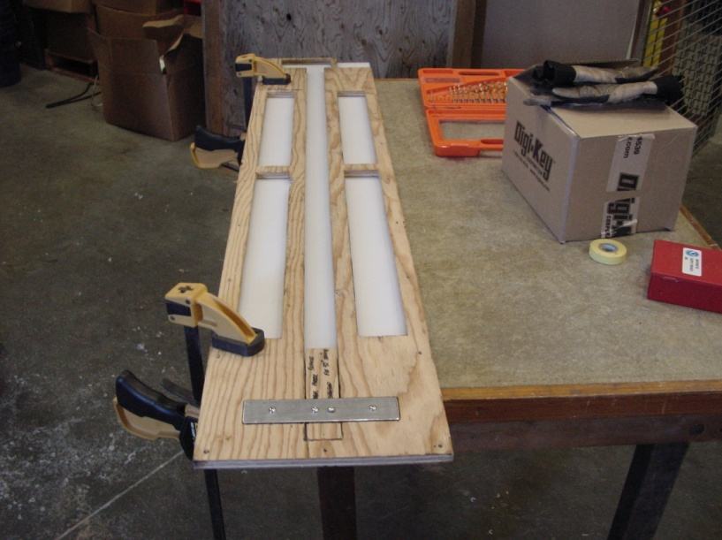

Figure 1. Template clamped to HDPE Case.

**Step 4: Cutout excess material on the bottom of the HDPE plastic to reduce weight of the board**

* Remove the template from the top of the HDPE plastic sheet.
* Flip the plastic sheet over to expose the bottom.
* Secure the template to the bottom of the HDPE plastic using clamps.
* Securely clamp the template and plastic sheet to the work surface.
* Using a router with the ½ inch template router bit, remove material from the four sections as shown on the diagram in Appendix B.
* Replace the ½ inch router bit with the 1 inch bit.
* Using the 1 inch router bit, carefully remove additional material from the four sections to a depth of 1 inch.
* Remove the template from the bottom of the HDPE plastic sheet.

**Step 5: Drill pilot holes in the clear plastic “Top Cover” and the top of the HDPE plastic sheet**

* Place the HDPE plastic sheet on the work surface with the top facing up.
* Carefully lay the ⅛ inch “Top Cover” clear plastic sheet on the top of the HDPE plastic sheet.
* Place the wooden template on the “Top Cover” and the HDPE plastic sheet and secure in place using clamps.
* Drill ⅛ inch pilot holes through the “Top Cover” and the HDPE plastic sheet to a depth of ¾ inch according to the hole pattern on the template. These holes will mark the location of the countersink plastic screws which will attach the “Top Cover” to the HDPE plastic case and the two locations for the Stop Plate mounting screws.

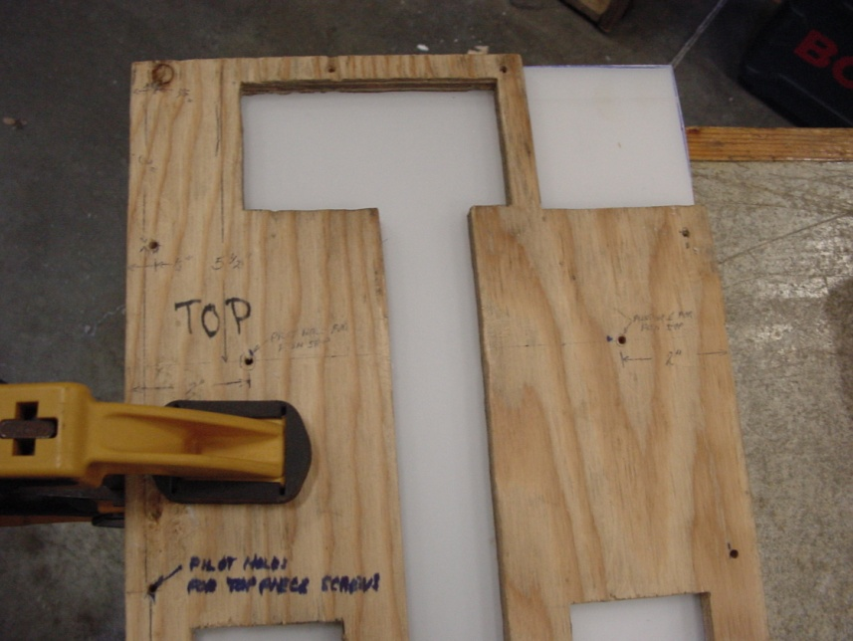

Figure 2. View of "Pilot Holes" in Template.

**Step 6: Drill 11⁄64 inch holes in both the “Top Cover” and the HDPE plastic case to prepare holes for thread taps**

* Remove wooden template from “Top Cover” and HDPE plastic case.
* Carefully line up pilot holes in “Top Cover” and HDPE plastic case, and secure “Top Cover” to the HDPE case using clamps.
* Drill **11⁄64** inch holes through the “Top Cover” and the HDPE plastic case at the pilot hole locations along the perimeter of the case to a depth of 1 inch.

**Step 7: Countersink holes in the “Top Cover”**

* Using the countersink bit, countersink the perimeter holes in the “Top Cover” plastic sheet so that the plastic slotted screw heads will sit flush into the “Top Cover”.

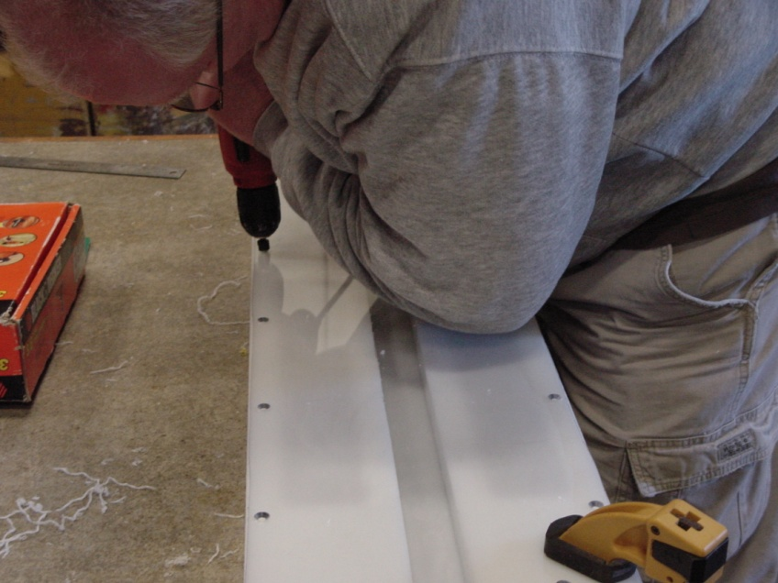

Figure 3. Countersink Screw Holes.

**Step 8: Drill 11⁄32** **inch mounting holes for the Stop Plate**

* Using an **11⁄32** inch drill bit, drill holes at the two locations for the Stop Plate mounting screws to a depth of 1 inch. These holes will be used for the self tapping threaded inserts for the Stop Plate mounting screws.

**Step 9: Thread holes in perimeter of HDPE case**

* Remove the “Top Cover” plastic sheet from the HDPE plastic case.
* Using a 10-24 threaded tap, thread the holes that were drilled in the perimeter of the HDPE plastic case. (See Figure 4.)
* These threaded holes should now accept the nylon flat head 10-24 screws that will secure the “Top Cover” to the HDPE case.

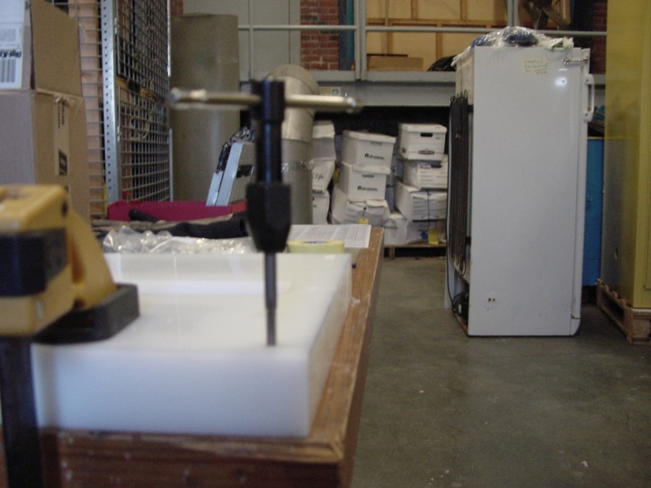

Figure 4. Creating threaded holes in HDPE case.

**Step 10: Install the self-tapping zinc-plated threaded inserts for the Stop Plate**

* Using the ¼” – 20 threaded insert tool (Figure 5), install two self-tapping zinc-plated threaded inserts at the locations shown in the diagram on Appendix B.

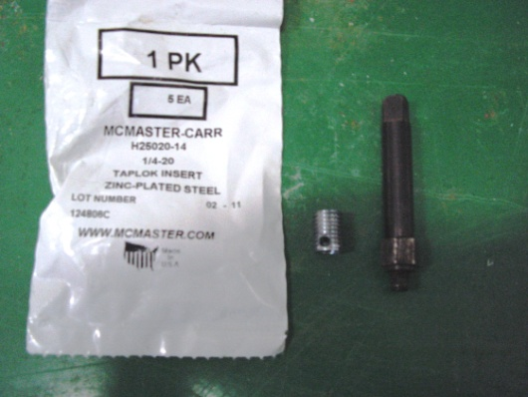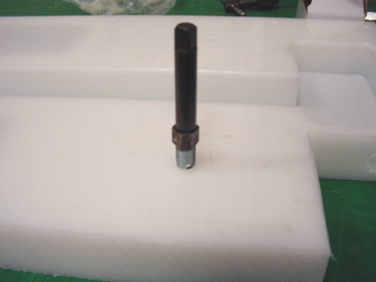

Figure 5. Stop Plate Screw Insert and Tool.

**Step 11: Remove extra material from corner of board**

* Secure the “Top Cover” to the HDPE case using the nylon screws.
* Using a Jigsaw with a 10 TPI blade for plastics, remove the corner of the “Top Cover” and the HDPE plastic case. (See Figure 5.) The Brad Harrison connector will be installed in the side of the HDPE plastic case adjacent to the connector compartment.
* Remove the “Top Cover” from the HDPE case.

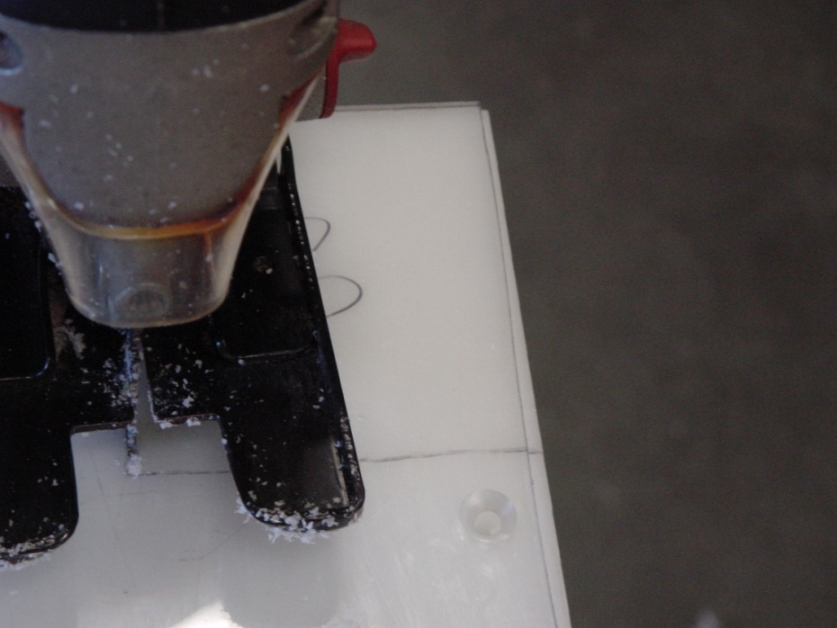

Figure 6. Removing corner of "Top Cover" and HDPE case.

**Step 12: Drill and tap the hole in the side of the HDPE plastic case for the Brad Harrison connector**

* Drill a 15/32 hole in the side of the HDPE plastic case at the location shown in the diagram on Appendix C.
* Cut threads into this hole using the ¼” – 18 NPT thread tap.

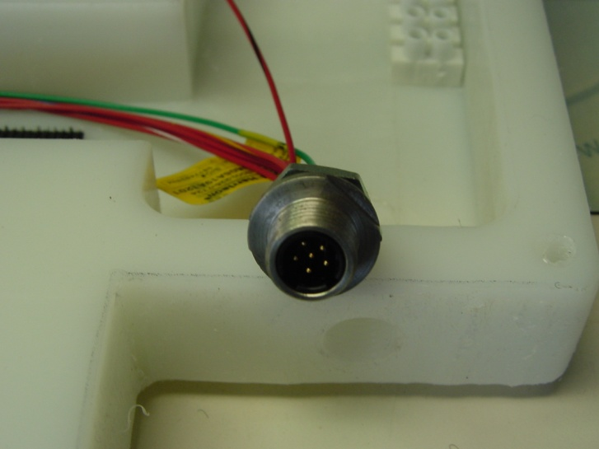

Figure 7. Brad-Harrison Connector Location

**Step 13: Round off all sharp edges on the “Top Cover” and the HDPE plastic case**

* Secure the “Top Cover” to the HDPE plastic case using the nylon flat head 10-24 screws.
* Secure the case and cover to the work surface using clamps.
* Using a router with a ¼” round-over bit, round off all of the edges on the fishboard case (top, bottom, and sides) to give it a more professional appearance. The smoothed edges will also protect the operator’s hands from inadvertent cuts from the sharp plastic corners.
* Remove the “Top Cover” from the HDPE plastic case.

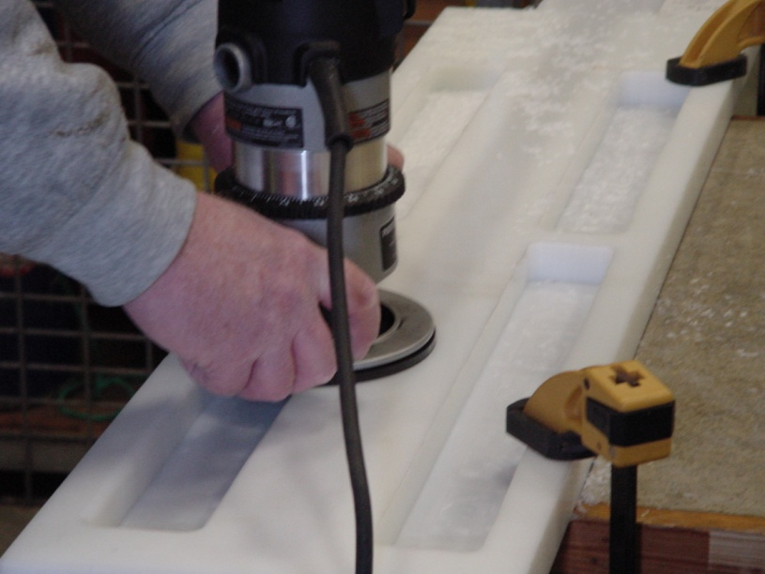

Figure 8. Rounding all edges on the board with "Round-Over" router bit.

**Step 14: Create the fishboard “Stop Plate”**

* The fishboard “Stop Plate” will be created using the leftover (2”L x 10”W x 1 ¼”T) piece of HDPE plastic that was trimmed from the original 10”W x 48”L x 1 ¼”T piece of HDPE plastic. (See Appendix D for details.)
* Using a ⁵⁄₁₆ inch drill bit, drill two holes through the length of the “Stop Plate” as shown in appendix D.
* Counter-sink the two holes so that the ¼” – 20 thread stainless steel screws will sit flush within the top of the “Stop Plate”.
* Using a router with a ¼” round-over bit, round off all edges of the “Stop Plate”, except the bottom.

**Step 15: Install connectors and wiring**

* Install the Brad Harrison connector P/N 7R6A19A1201 into the side of the HDPE plastic case where the threaded ¼” – 18 NPT hole is located. Put Teflon Thread Seal Tape on the threads of the connector and put silicone grease on the o-ring to help seal against water intrusion.
* Wire this connector to the terminal block as shown in the attached wiring diagram (Appendix E).
* Wire the Amphenol connector P/N C091-31F006-100-2 as shown in the attached wiring diagram (Appendix E). Connect the wires to the terminal block. This connector will mate to the Temposonic’s linear sensor. (See Figure 9.) (New Sensors have a Mencom Connector on end.)

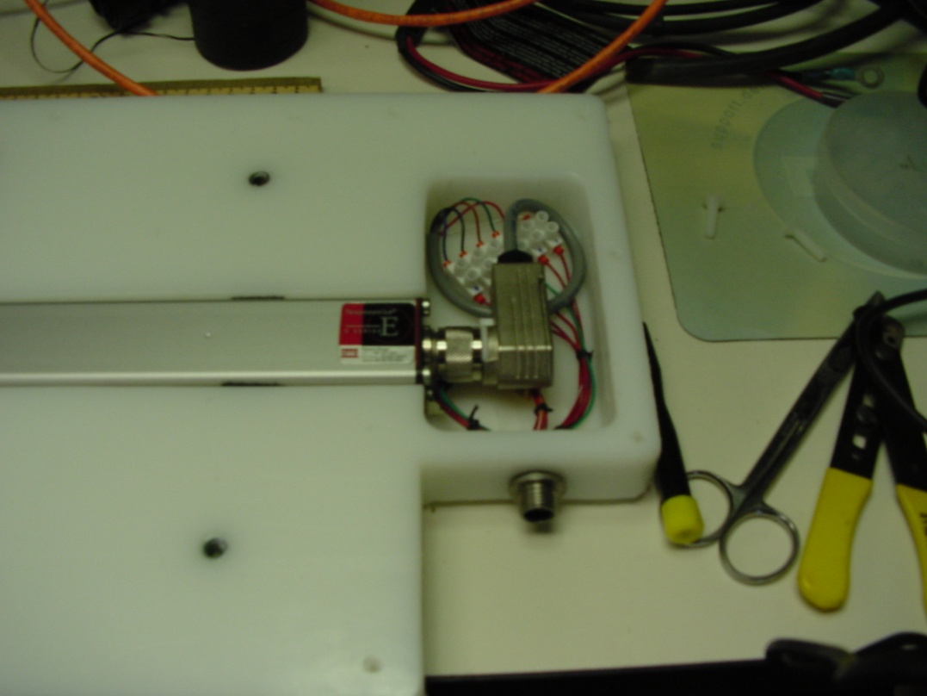

Figure 9. Installed Amphenol and Brad Harrison Connectors

**Step 16: Install the Temposonic’s EP2D-36 Linear-Position sensor**

* Using Velcro “Hook & Loop” fastener tape, install 3 inch piece of “Hook” portion of the tape on the bottom of the HDPE case channel as shown in Figure 10. This tape will help secure the sensor to the case.

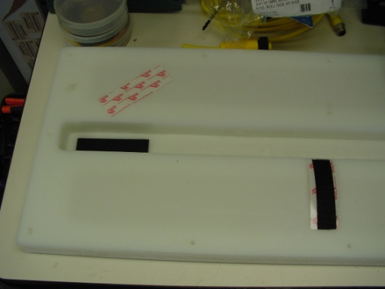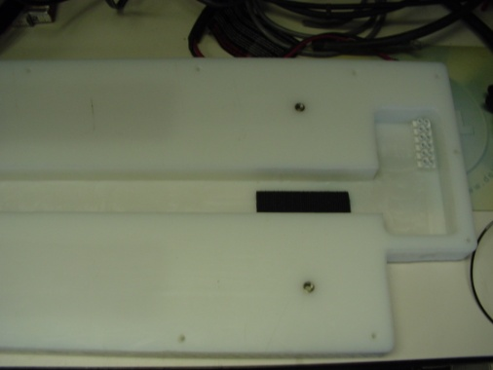

Figure 10. Locations of 3" pieces of "Hook" tape

* Place a small drop of super glue on the “South” face of the 1”L x 0.25”W Rare Earth Magnet and attach to the EP2D-36 sensor over the “dot” that represents the end of the measurement stroke. (See Figure 11.) The “North” face of the magnet should be facing up.
* When the glue dries, wrap some electrical tape around the magnet to further secure it to the EP2D-36 sensor. (See Figure 11.)

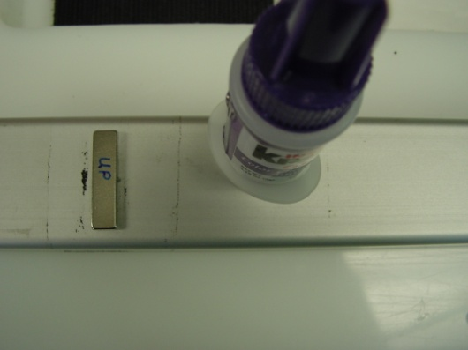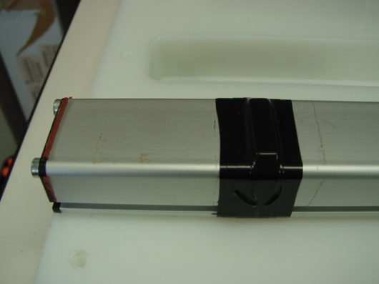

Figure 11. Location of 1"L x 1/4"W magnet

* Install 3 inch pieces of the “Loop” portion of the Velcro tape to each end of the EP2D-36 sensor as shown in Figure 12. This tape will help secure the sensor to the case.

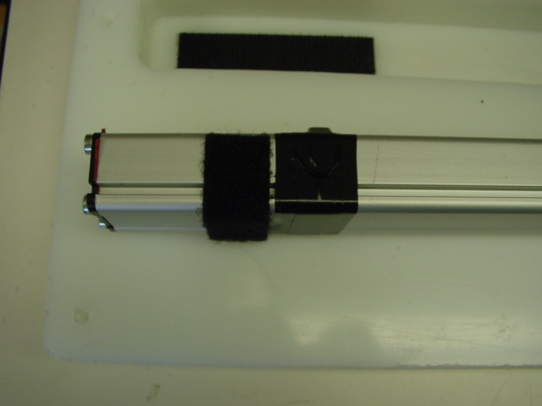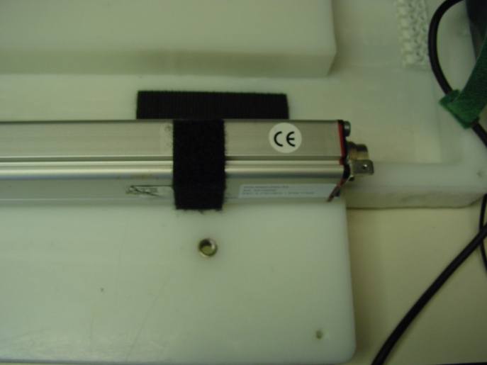

Figure 12. Location of "Loop" portion of Velcro Tape

* Connect the Amphenol connector to the EP2D-36 sensor, and secure the sensor to the HDPE case channel. (See Figure 9.)
* Apply a strip of measurement tape to the top center of the sensor strip aligning the beginning of the tape from the inside edge of the “Stop Plate” to the magnet at the end of the sensor as a visual guide to lengths. It is IMPORTANT to align the zero point of the tape to the inside edge of the “Stop Plate” as the measurement points on the tape will be used to calibrate the sensor.
* Put a Silica Gel Tyvek Dessicant (Dry Pak) in the compartment where the cable wires are connected to the sensor to absorb condensation from changes in temperature and humidity.

(Need Picture)

**Step 17: Finish assembling the fishboard case**

* With the EP2D-36 sensor securely fastened to the HDPE case, apply the U-Line double-sided foam tape to the top portion of the HDPE case, especially in the areas around the screw holes including the screw holes for the Stop Plate. (Need Picture)
* Carefully install the “Top Cover” onto the HDPE case and secure with the nylon 10-24 screws.
* Attach the “Stop Plate” to the HDPE case using the ¼”-20 Stainless Steel machine screws.

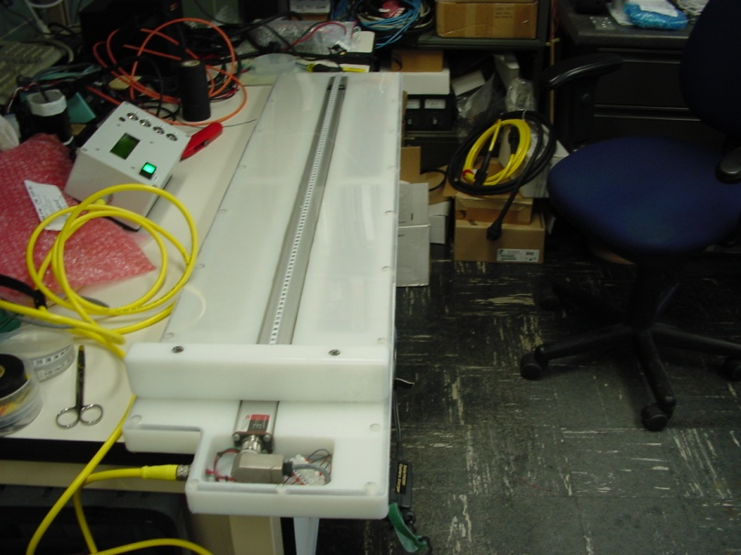

Figure 13. Picture of completed case with Display Assy P/N IFMB-10100

**Step 18: Create the Measurement Wand**

* Cut a 3.0 inch length of polycarbonate ½” square tubing. (See Appendix F for example. Need to update)
* At one end of the tube, apply a liberal amount of super glue to the inside wall of the tube.
* Slide the K&J Magnetics P/N B666-N52 block magnet into this end of the polycarbonate tubing. The “South Pole” face of the magnet should be facing into the tubing. The “North Pole” should be facing out, flush with the end of the tubing material.
* Apply a liberal amount of super glue to the exposed face of the magnet to provide a watertight seal to the magnet face.
* At the other end of the polycarbonate tubing, apply a liberal amount of silicon sealant to provide a watertight seal to the open end of the tubing. (See Figure 14 for the finished measurement wand. (Need to update)

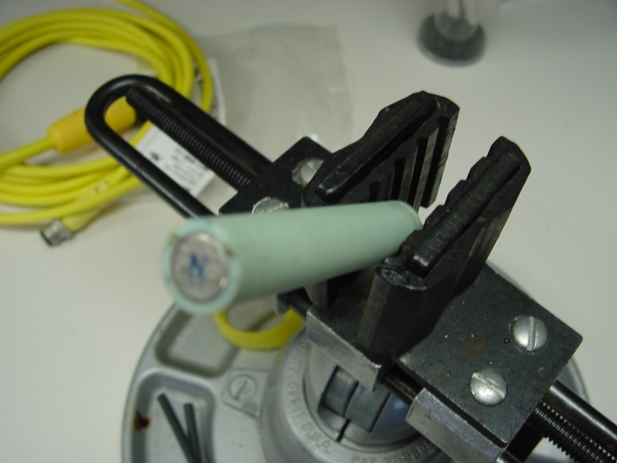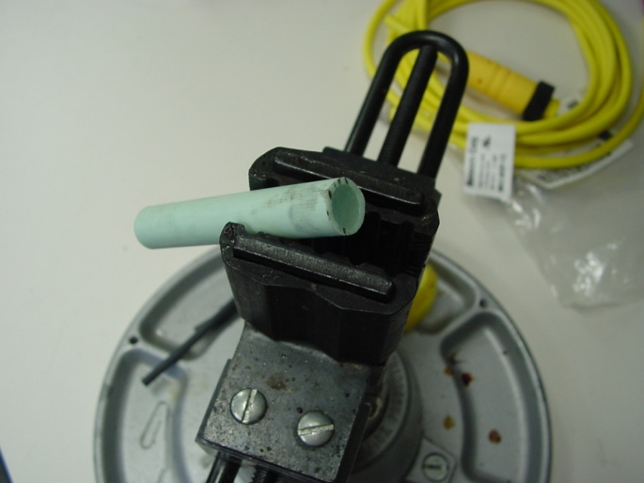

Figure 14. Completed Measurement Wand