***NOAA, NMFS, Northeast Fisheries Science Center***

***166 Water Street***

***Woods Hole, MA 02543***

**NEFSC *Ichthystick II* Electronic Fish Measuring Board**

**Sensor Case Manufacturing Manual**

**Ver3.0**

**5/10/2021**

**Marinna Martini**

**Joe Godlewski**

# Revisions:

Version 2.0: Joe Godlewski

Version 2.1: Joe Godlewski

Version 3.0: Updated by Marinna Martini, changes the order of the construction process, updates for the new MCBH sensor, the use of a gasket, and includes the 42” MTS sensor. Information from past versions are also included, as drawings and files for these still exist on NEFSC servers.

Contents

Revisions: 2

List of figures: 4

List of Appendices: 4

Acknowledgements 4

1.0 Introduction: 5

**1.0.1** **Tools Required:** 6

1.0.2 List Of Materials: 7

2.0 Ichthystick II Fishboard Sensor Case Construction: 9

Step 1: Create the case template 9

Step 2: Cut HDPE plastic to the correct size 9

Step 3: Remove extra material from the corner of the board 10

Step 4: Cut a channel in the top of the HDPE plastic for the Temposonic Sensor 12

Step 5: Cutout excess material on the bottom of the HDPE plastic 12

Step 6: Drill and tap the hole in the side of the HDPE plastic case for the Subconn bulkhead connector 13

Step 7: Create the gasket 13

Step 8: Drill, countersink and tap holes through the cover, gasket & bottom. 14

Step 9: Create the fishboard “Stop Plate” 15

Step 10: Drill the stop plate mounting holes 15

Step 11: Round off all sharp edges on the “Top Cover” and the HDPE plastic case 16

Step 12: Install the self-tapping zinc-plated threaded inserts for the Stop Plate 17

Step 13: Install connectors and wiring 18

Step 14: Install the Temposonic Linear-Position sensor 21

Step 15: Finish assembling the fishboard case 22

Gasket seal 23

Foam tape seal 25

Step 16: Create the Measurement Wand 26

3.0 Appendices 27

3.1 Assembly views of the *Ichthystick II* 27

3.1.1 Isometric view of 36” sensor version 27

3.1.2 3D Model of future version with 42” sensor 27

3.2 Template drawings 27

3.2.1 42” case 27

3.2.2 36” case (original) 27

3.2.3 Rough cut guide for 4 x 8 ft. sheet of material 27

3.3 Detail of Connector hole placement 27

3.3.1 Subconn MCBH 27

3.3.2 Brad Harrison (original) 27

3.4 Detail of Stop Plate and Screw Hole Locations 27

3.5 Wiring Diagrams 27

3.5.1 Schematic for wiring Mencom to Subconn (used today) 27

3.5.2 Schematic for wiring Mencom to Brad Harrison (used today) 27

3.5.3 Schematic for wiring to interface with Ichthystick II displays with Mencom sensors 27

3.5.4 Schematic for the first Ichthystic II with Amphenol and Brad Harrison connectors 27

3.6 Measurement Wand Diagrams 28

3.6.1 Circular Wand 28

3.6.2 Square Wand 28

# List of figures:

Figure 1: Guide for cutting with the jig saw. 10

Figure 2. Removing corner of "Top Cover" and HDPE case. 11

Figure 3. Template clamped to HDPE Case. 12

Figure 4: Finished gasket 13

Figure 5. Drilling cover holes using reference marks. 14

Figure 6: Locating and drilling holes in the stop plate 16

Figure 7. Rounding all edges on the board with "Round-Over" router bit. 16

Figure 8. Stop Plate Screw Insert and Tool. 17

Figure 9. Installed Amphenol and Brad Harrison Connectors 19

Figure 10: Version with Amphenol and SubConn connectors 19

Figure 11: Version with the newest Temposonics sensors, Mencom and SubConn connectors, in use in 2021. 20

Figure 12. Locations of 3" pieces of "Hook" tape 21

Figure 13. Location of 1" long by 1/4" wide magnet 21

Figure 14. Location of "Loop" portion of Velcro Tape 22

Figure 15: Wiring compartment with desiccant pack (older Amphenol sensor connector shown) 23

Figure 16: picture of case with a gasket seal showing how the grease flows to make the final seal. Normal compression from the screws with cause some extrusion of the silicone gasket material out the sides as well. 24

Figure 17: Detail of foam tape technique 25

Figure 18. Picture of completed case with Display Assembly 26

Figure 19. Completed Measurement Wand 26

# List of Appendices:

Appendix 3.1: Case assembly

Appendix 3.2: UFMB Case Templates & Rough Cut Guide

Appendix 3.3: Bulkhead Connector Location

Appendix 3.4: Fish Stop Plate

Appendix 3.5: Connector Wiring Schematics

Appendix 3.6: Measurement Wand Diagrams

# Acknowledgements

Thanks to Jon Doucette, Peter Chase, Dave McElroy and Vincent Manfredi for information, corrections and insight into the various flavors of Ichthystick II in current use and the history of its development.

# 1.0 Introduction:

This edition of the of the *Ichthystick II* Electronic Fish Measuring Board sensor case changes the order of manufacturing steps, preserves past manufacturing methods and provides an updated way to make the case with a gasket seal instead of foam tape, and includes the newer Subconn connector. The number of screws is increased for the 42” sensor version. It takes someone new to the build process about 80 hours to make two boards.

This manual was developed to aid in the construction of the *Ichthystick II* Electronic Fish Measuring Board sensor case. The case is manufactured from High Density Polyethylene Plastic (HDPE) that is cut to size to fit the required Temposonic Linear Sensor. A 1 ⅛” channel is routed out of the top of HDPE plastic to house the linear sensor. Excess material is taken out of the bottom of the HDPE plastic to reduce the weight of the finished case. A ⅛” clear plastic sheet is attached to the top of the HDPE case to provide a *water resistant* encapsulation for the linear sensor. These instructions add the option of using a silicone gasket instead of foam tape to attach the top to the bottom of the case. With the silicone gasket, the case is at least IP54 rated (dust and splash proof). See Appendix 1 for a view of the overall assembly of the *Ichthystick II* Case.

It is recommended that the reader review the whole manual first, and decide which elements (seal type, sensor length, screw spacing, wiring harness) is preferred, print this document and mark up what tools, materials, steps and information will and will not be used. A variety of wiring harnesses are provided in Appendix 3.5 to accommodate different Fisheries surveys’ needs for old and new board designs.

A note about High Density Polyethylene Plastic specified from McMaster Carr. This material is sold as water resistant, not water proof. It will, in time, allow air to diffuse through the material and this may explain past frustration in preventing corrosion of the MTS sensor channel. This was demonstrated in a newly constructed fish board sealed with a gasket and grease and the MCBH sensor with an O-ring. The board was moved from ~35% humid environment to ~50% humid and back, and within a day, the interior of the board reflected the outside humidity. If the grease does not fully flow to complete the seal, this is another way atmosphere can infiltrate into the sensor channel.

So far the gasket seal has been tested with direct and close stream of a garden hose jet and keeps water out. Thus the new gasket method will protect the sensor from water incursion at least as well or better than the foam tape, without having to glue the cover to the case. The cover can be easily removed to service the sensor and interior wiring if needed. Note that, the MTS sensor itself is protected against moisture incursion. The grease will initially flow and come out the sides of the case – this is normal. Simply wipe off the excess. Stainless screws are preferred over nylon with the caveat that it will be easier to strip the threads, so tighten carefully to hand tight; only enough so that you can see the grease flow and fill in gaps. It was observed that the nylon screws deformed over time and the slot was hard to access.

Neither seal method is ideal – the foam tape is not air tight and the gasket is only air tight if enough grease is used, dirt is kept at a minimum, and the grease flows enough to fill any gaps. With the HPDE being porous, until a new material is selected for the case, keeping moisture out completely is not possible. Luckily, the sensor itself is sealed, the connectors are reasonably moisture proof. The encapsulation of the terminal block and sensor is good enough for wash down.

## **Tools Required:**

Chip clearing bits and blades for plastics are recommended to prevent the HPDE from melting

* Router
  + ½” Router Bit with ⅝” shank
  + 1” Router Bit with ⅝” shank
  + ¼” Round over Router Bit with ¼” shank
* Table Saw or circular saw
  + blade for plastics (Diablo D0756N 7 1/4" x 56 tooth Alum/plastic saw blade)
* Powered Jigsaw
  + 10 TPI blade for cutting plastics
* Finishing sander with 80 and 180 grit sandpaper
* Drill press or dowel guide
* Coarse and fine flat files
* Power Drill (it is nice to have two)
  + assorted drill bits: 1/8”, 3/16”, 11/64”, ¼”, 15/32”, 5/16”
* Workbench Clamps, 4 large, 2 small
* Screw Driver – Slotted
* Screw Driver – Phillips Head
* Center punch
* Wire brush
* Exacto knife
* Counter Sink Drill Bit for ¼” screws, 82 degrees (McMaster 28145A46).
* Specialty tool for threaded inserts, ¼”-20 and t-handle ¼” drive tool
  + 11/32” drill bit
  + ¼” x 20 drive tool for stop plate inserts
  + 7/64” drill bit, 3/16” & ¼” drill bits ~4.5” long,
* For SubConn MCBH bulkhead connector:
  + 7/16-20 UNF-2A tap bit, Uncoated High-Speed Steel General Purpose Tap Taper Chamfer, 7/16"-20 Thread Size, 1-7/16" Thread Length
  + drill bit, 25/64, for 7/16-20 tap
* For Brad Harrison bulkhead connector:
  + ¼” x 18 NPT Tap Bit
* For cover screws:
  + 10 x 24 NC Tap Bit
* Trash bags, 30-40 gal
* Broom, hand broom and dust pan
* Shop vac
* Safety glasses, ear muffs, work gloves

## 1.0.2 List Of Materials:

|  |  |  |  |  |
| --- | --- | --- | --- | --- |
| Description: | Part Number: | Quantity: | Vendor: | Notes: |
| Plywood sheet,  ½” thick |  | 1 | Local Hardware Store | Use plywood to construct a template for the fishboard. Size depends on size of fishboard desired. |
| Neoprene Rubber Sheet, 1/16"" Thick, 36”x60” | 8616K72 | 1 | McMaster-Carr | To make a removable gasket instead of foam tape. |
| Moisture Resistant HDPE (Polyethylene) Sheet,  1-1/4” thick, 48”x96” | 8619K98 | 1 | McMaster-Carr | Cut to 10” x ~60” for 42” sensor or 10” x ~48” for 36” sensor |
| Polyethylene (HDPE) Sheet,  1-1/4” thick, custom | 8619K999 | 0 | McMaster-Carr | Needs special quote, no longer in catalog |
| Polycarbonate Sheet,  1/8” Thick, 10” x ? | 8574K73 | 1 | McMaster-Carr | “Top Cover” of fishboard.  Length should match size of board being built. |
| Nylon 82 Degree Flat Head Slotted Machine Screw, 10-24 thread, 3/4” Length | 94605A245 | 1 pack of 100 | McMaster-Carr | These screws secure the top cover to the base of the fishboard. Use with foam tape. |
| Type 316 Stainless Steel Flat Head Phillips Machine Screw, ¼”-20 Thread, 2-1/2” Length | 91500A552 | 1 pack of 10 | McMaster-Carr | These screws secure the stop plate to the base of the fishboard. Use with gasket. |
| Self-Tapping Zinc-Plated Steel Insert, ¼”-20 Interior Thread, 3/8” Exterior Thread, 31/64” Length | 90240A001 | 2 | McMaster-Carr | Threaded insert which is used to secure the stop plate to the fishboard base. |
| Drive Tool for ¼”-20 Internal Thread insert | 90240A029 | 1 | McMaster-Carr | Tool for threaded inserts above. |
| Circular Connector, Female, 8-position Right Angle | MDC-8FP-FW07-R | 1 | Mencom | Right angle connector for new Temposonic’s Linear Sensor. |
| Subconn connector, 6 Pin Male | MCBH6M | 1 | MacArtney | Comes with O-ring #014 |
| O-ring, nitrile, #014 | 9452K58 | 1 | McMaster-Carr |  |
| Terminal Strip, 6 place | 70077181 | 1 | Allied Electronics |  |
| 36” Linear-Position Sensor | EP20360UD841R3 | 1 | Process Control Solutions | 36” linear sensor. |
| 42” Linear Position Sensor | EP20420UD841R3 | 0 | Process Control Solutions | 42” linear sensor optional. Case size will need to be adjusted accordingly. |
| Rare Earth Magnet,  1” Long x 0.25” Wide x 0.1” Thick | NSN0834 | 1 pack | National Imports | Magnet mounted on linear sensor at far end of measurement stroke which compensates for changes in temp and humidity. |
| 3/8” x 3/8” x 3/8” Neodymium Block Magnet, N52, NI | B666-N52 | 1 pack | K&J Magnetics, Inc. | Use for measuring wand. |
| Plastic Square Tube, ½” x 6’ length | 3161T11 | 1 | McMaster-Carr | Use for measuring wand. Cut length to suit. |
| Double Sided Foam Tape, 1/16” x 1” x 36 yds., White | S-3792W | 2 | U-Line | Double Sided Foam tape for watertight integrity between plastic cover sheet and case |
| ¾” x 15’ Hook & Loop  Velcro | VEK90081 | 1 | Office Supply Inc. | Fastener for sensor to board. |
| Crazy Glue |  | 1 | Local hardware Store | Fasten magnet to sensor |
| Millimeter Rules | 3/4MMr-W001L05GTC | TBD | Oregon Rule Co. | Visual Measuring Tape on top of sensor |
| Teflon Thread Seal Tape |  | 1 | Local Hardware Store | Use to seal Brad-Harrison connector on side of board |
| Silica Gel 10 gram Tyvek Desiccants |  | 1 | Silicagelpackets.com | Use for absorbing condensation inside sealed board. |
| Molycote/Dow 111 silicone lubricant | 2275-111CMPD150GTUBE-ND | 1 | Digikey | Use to lubricate the gasket and any O-rings |
| Permatex Clear RTV Silicone Adhesive sealant | 80050 | 1 | Local hardware store, Tractor Supply | Used to seal the end of the magnetic wand |

# 2.0 Ichthystick II Fishboard Sensor Case Construction:

The following is a detailed “Step-by-Step” process that can be used to construct a water resistant HDPE case to house the MTS Temposonic Linear-Position Sensor EP2D-36 or EP2D-42 (36 and 42” Lengths). Knowledge of proper power tool operation is recommended, but not required. If the operator is new to router operations, it is recommended that a practice piece of 1 ¼” HDPE plastic be used to get the feel of using a router to cut channels in the plastic. When routing the plastic using the template as a guide, carefully adjust the router bit so that the cutting edge is above the surface of the HDPE, and still not cutting into the template. New router users may consider routing the underside of the case first.

## Step 1: Create the case template

Appendix 3.2 has templates for the 36” and 42” sensors. The new 42” version has 5” spacing between screws, preferred for a gasket seal, and the original 36” version has 6” spacing between screws. One option is to make the longer case, leaving the option to use either length sensor, using a piece of filler material to occupy any excess space in the sensor channel.

* Using a ½” thick sheet of plywood, create a template as per the drawing for the selected sensor length with openings to rout the sensor channel in the top and remove material from the bottom.
* Using a ⅛” drill bit, drill pilot holes in the plywood template at the hole locations shown.

## Step 2: Cut HDPE plastic to the correct size

* The HDPE plastic in the McMaster-Carr catalog is now only directly available in 4x8 ft. sheets. Other sizes may be special ordered. If you are making two or more fish boards, consider getting the full 4x8 sheet at the same price as pre-cut material. Rough cut the polycarbonate and HDPE to size, noting that the last 2” is for the stop plate. A rough cut guide is in Appendix 3.2.3.
* Using a table (preferred) or circular saw, remove 2” of plastic from one end of the HDPE plastic. Similarly trim the polycarbonate sheet. The fishboard case should have a length of 46 or 53.5”. The 2” of plastic off one end will be used as the fish stop plate. It can be easier to cut the HDPE and polycarbonate together to match, depending on the size of the rough materials.
* Do not remove the protective material on the polycarbonate until you are finished with construction.

## Step 3: Remove extra material from the corner of the board

The Subconn connector will be installed in the side of the HDPE plastic case adjacent to the connector compartment, this corner cut makes a protective indent for it. The lengthwise cut to remove the corner material here is likely the most important cut you will make. Getting a smooth, square cut here is important to achieving a good O-ring seal where the bulkhead connector will mate to the edge of the case. If you have access to a shop with a table saw, or some other tool that is better controlled than a jig saw, this is preferred.

* Continue with the polycarbonate sheet on top of the HDPE slab.
* With the template, or by hand, mark the corner to be removed, then set the template aside. Do not try to use the template as a guide or a fence for the jig saw. Set up a guide as shown in Figure 1 for the lengthwise cut. Then move the guide for the cross width cut.
* Clamp the polycarbonate securely to the HDPE and to the work bench.
* Using a Jigsaw with a 10 TPI blade for plastics, remove the corner of the polycarbonate and the HDPE plastic together, Figure 2.

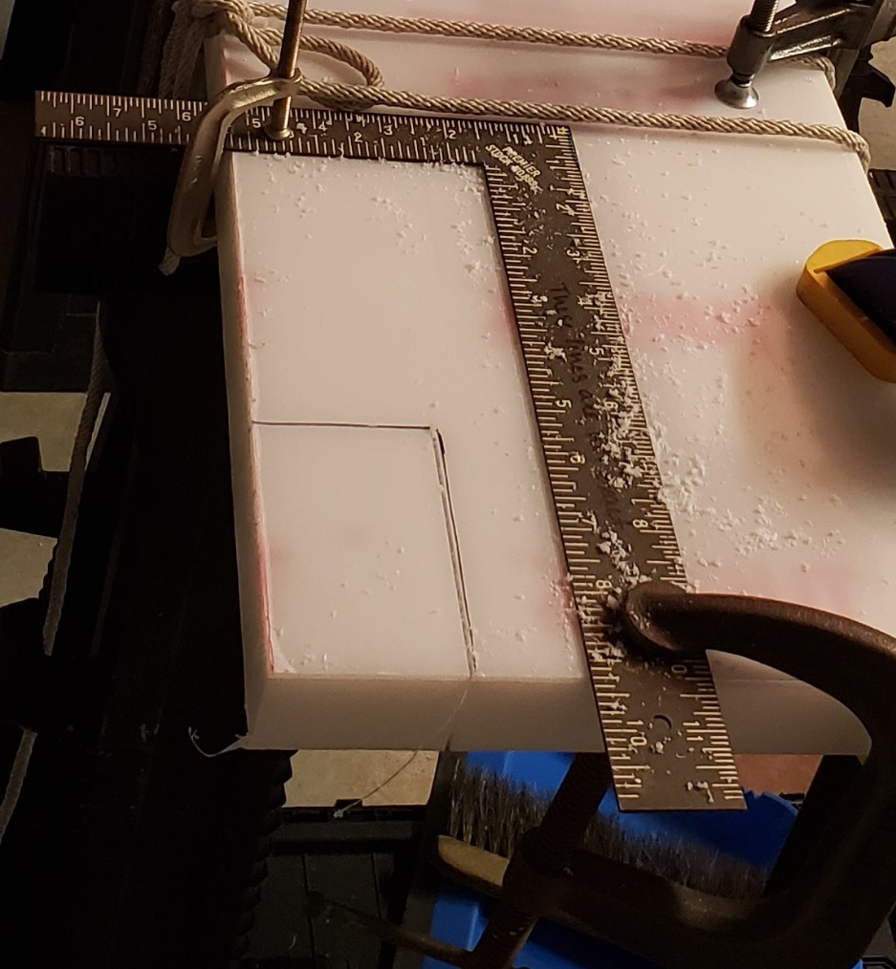

Figure : Guide for cutting with the jig saw.

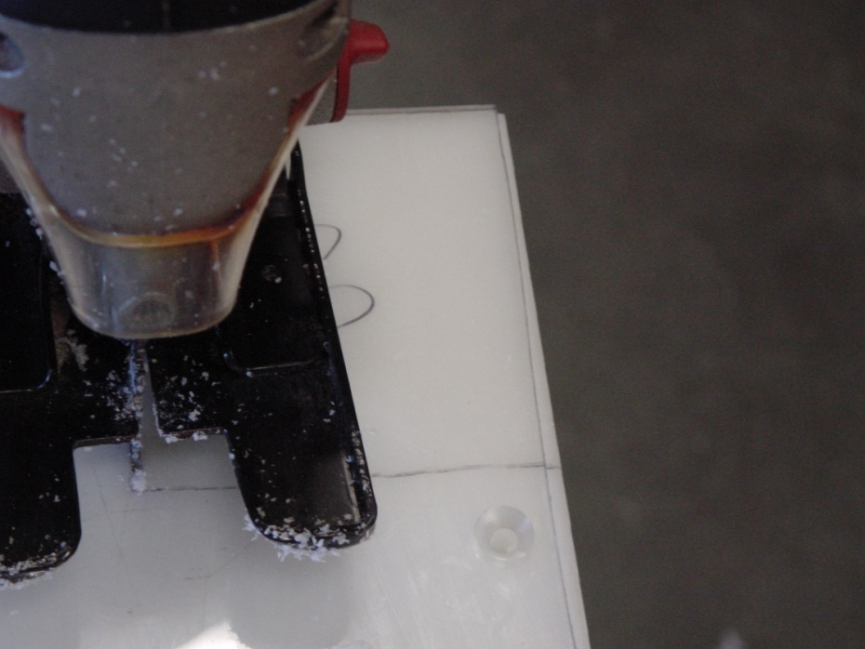

Figure . Removing corner of "Top Cover" and HDPE case.

* Remove the “Top Cover” from the HDPE case.
* If you are making more than one fish board, label the pieces of polycarbonate and HDPE that have been cut together so that they can remain together as you work.
* The material cut out from the corner will be handy to practice tapping and countersinking holes.

Inspect the lengthwise edge of the case where the Subconn connector will attach. This surface needs to be perpendicular to the top, flat and smooth to accept the O-ring seal. With very find grit sandpaper, the finishing sander, and by hand, sand the sides of the HDPE to remove the roughest marks from the cutting. Look for gouges, scrapes and cuts and smooth those.

## Step 4: Cut a channel in the top of the HDPE plastic for the Temposonic Sensor

* If you have cut the HDPE and polycarbonate together, remove the polycarbonate and set aside.
* Carefully clamp the template to the 1 ¼” thick HDPE slab (Figure 3).
* Securely clamp the template and plastic sheet to the work surface.
* Using a router with the ½” template router bit, rout out the center channel and connector compartment area to a depth of ½”.
* Replace the ½” router bit with the 1” bit.
* Using the 1” router bit, carefully remove additional material from the center channel and connector compartment area to a depth of 1 ⅛” in 2-3 passes.
* **Caution: The thickness of the HDPE plastic sheet is 1 ¼”. Make sure that the depth of the cut into the plastic does not exceed 1 ⅛”.**
* 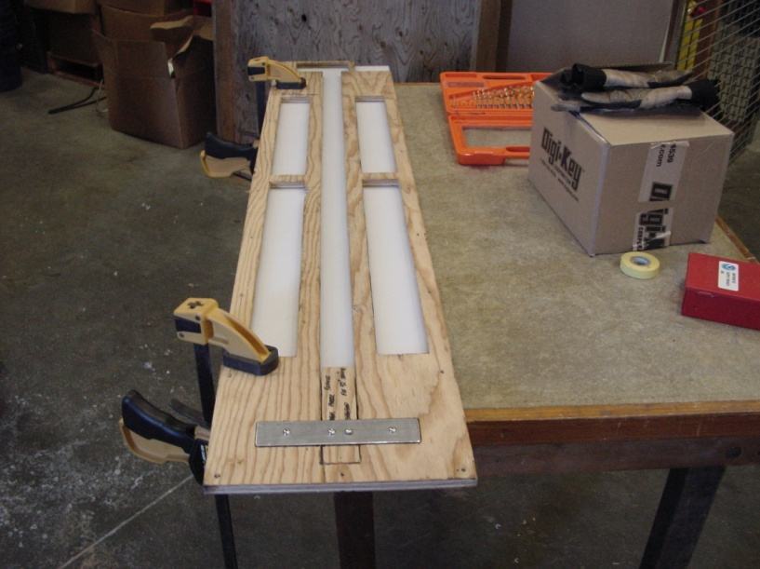Be careful to set the router bit correctly, if all of the cutting edge is below the top of the material (this is easy to do when trying to avoid routing the template), a skin of plastic will remain on top, trapping the removed material and heat, and will cause the HDPE to melt and reform behind the bit.

Figure . Template clamped to HDPE Case.

## Step 5: Cutout excess material on the bottom of the HDPE plastic

This is to reduce weight of the board.

* Remove the template from the top of the HDPE slab.
* Flip the HDPE plastic sheet over to expose the bottom.
* Secure the template to the bottom of the HDPE plastic using clamps.
* Securely clamp the template and plastic sheet to the work surface.
* Using a router with the ½” template router bit, remove material from the four sections as shown on the drawing you have chosen from Appendix 3.2.
* Replace the ½” router bit with the 1” bit.
* Using the 1” router bit, carefully remove additional material from the four sections to a depth of 1” in 2-3 passes.
* Remove the template from the bottom of the HDPE plastic sheet.

## Step 6: Drill and tap the hole in the side of the HDPE plastic case for the Subconn bulkhead connector

This is the least forgiving part of the whole process. It is best done using a drill press to get the axis of the hole perpendicular to the face of the HDPE, to insure that the connector’s O-ring face will seal properly against the HDPE. If a drill press is not available, try a dowel guide.

* Drill a 25/64” hole in the side of the HDPE plastic case at the location shown in the diagram in Appendix 3.3.1. Drawings for the older Brad Harrison connector are included in Appendix 3.3.2 for historical reference.
* Cut threads into this hole using the 7/16-20 UNF thread tap.
* Inspect the outer face where the hole penetrates through to the routed sensor channel. Make sure it is flat, smooth and square with the sides of the case. Make sure the face that will seal against the connector’s O-ring is smooth and even. Sand with a fine grit sandpaper or emery cloth if necessary.

## Step 7: Create the gasket

* With the HDPE sheet facing up (the sensor channel on top), lay the silicone sheet that is to become the gasket across the HDPE, make sure it is smooth and flat.
* Lay the template on top and clamp in place.
* With a sharp knife, trim the silicone sheet to the final outside dimensions of the HDPE. Cut out the center to the shape of the channel for the sensor and connector, following the template. Remove the template and set aside. Keep the silicone gasket you have made in place on the HDPE (Figure 4).

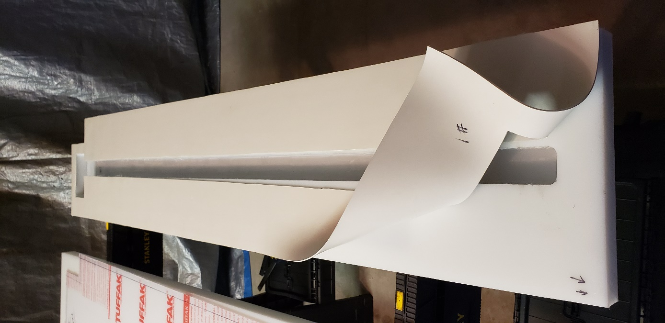

Figure : Finished gasket

## Step 8: Drill, countersink and tap holes through the cover, gasket & bottom.

The advantage here is that you do not have to worry about alignment of the holes through three pieces. Pilot holes can be drilled using the template or measured out. It is helpful to make some practice holes and tap them using excess material.

* With the silicone gasket you have cut in place, lay the polycarbonate top on with the silicone gasket so that the gasket is sandwiched between the polycarbonate top and HDPE bottom of the fish board case. Clamp in place. On the cover, mark out the locations of the holes according to Appendix 3.2. If you are using the template, clamp it on top of the polycarbonate.
* Drill the 1/8” pilot holes. If you are using the template, drill to a depth of 1 3/8” from the top of the template. If you are not using the template, see below. Do not drill all the way through the bottom of the case.
* Attach the countersink to the 11/64” tap drill, adjust the bottom of the countersink bit ¾” from the tip of the drill bit. This way you can drill and countersink at the same time, and check your countersink depth as you go along.
* For each hole you have marked or have a pilot hole:
  + Use two more small clamps, clamp on either side of the hole location (Fig. 4) to prevent the polycarbonate top from lifting as you drill.
  + If you did not drill pilot holes with the template and have marked the hole locations, drill a 1/8” pilot hole through the top, gasket and bottom to a depth of 7/8” overall. Do not drill all the way through the bottom of the case.
  + Drill and countersink with the 11/64” bit to a depth of 7/8”, or just to the top of the cutting part of the countersink bit. Check your depth and the size of the countersink carefully before tapping. Do not go too deep – the nylon screws will deform into a deep countersink.
  + Tap the hole through the top, gasket and into the bottom.
  + Insert a nylon screw. Inserting the screws as you go will help keep everything in place and give you feedback on the getting the depth of the countersink so that the tops of the screws are as flush with the top face of the polycarbonate, and not too deep.

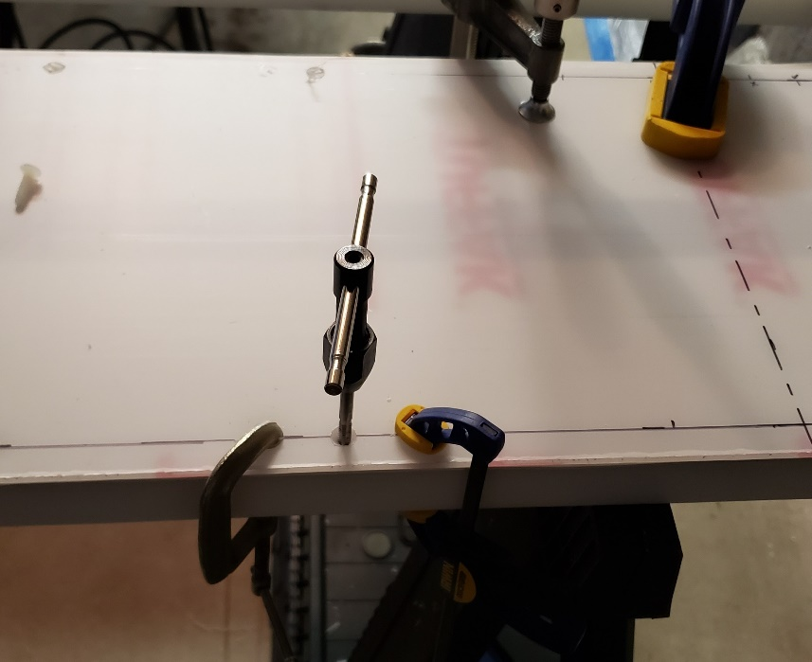

Figure . Drilling cover holes using reference marks.

## Step 9: Create the fishboard “Stop Plate”

The fishboard “Stop Plate” will be created using the leftover HDPE plastic cut to a size of 2” long x 10” wide x 1 ¼” high. Usually made the piece of HDPE plastic that was trimmed from the original 10” wide x 1 ¼” thick piece of HDPE plastic (Appendix 3.4).

## Step 10: Drill the stop plate mounting holes

This method drills through the stop plate and case together to quickly insure that the holes in the stop plate, through the cover and gasket are all aligned (Appendix 3.4). The holes in the stop plate will have a tight fit. It is better to drill the pilot holes before routing the edge of the top of the case and the stop plate as it will be easier to align the centerline marks. It can be difficult to drill a large, deep hole through the polycarbonate, as it will quickly heat and melt. This is where chip clearing bits are useful. The strategy here is to widen the hole gradually to avoid the bit getting stuck in the polycarbonate and to clear the soft HDPE material without melting. As with the small screws, do not drill all the way through the bottom of the case.

A key point in this step is to make sure that the zero point of the sensor lines up with the centerline of the stop plate (which is the centerline of the stop plate holes). This will insure that none of the “dead” area of the sensor is on the measurement side of the stop plate. In a later step we will align the zero point of the measurement tape to the edge of the stop plate. The calibration procedure will account for this positioning.

* Insure the polycarbonate top, silicone gasket and HDPE bottom pieces are securely clamped together and clamped to the workbench. If you have already installed all the screws for the top, then simply clamp the assembly to the workbench securely.
* Using measurements or the template, mark the centerline of the stop plate holes across the width of the case assembly.
* Identify and mark the centerline along the length of the stop plate piece.
* Align the centerlines and clamp the stop plate piece firmly to the case assembly.
* Check that the side of the stop plate facing towards the length of the sensor is within the stroke length of the sensor. This will be 2.85” from where the sensor channel ends at the connector space, for the model EP2D. Check the sensor specifications for other models.
* Drill pilot holes with the 7/64” bit. It is OK if this bit is too short to get entirely through the stop plate.
* Widen with the 3/16” bit, then the ¼” bit, all the way through into the case bottom. You now have pilot holes. For a tight fit, the ¼” holes in the stop plate are sufficient for the screws.
* Remove the stop plate.
* With the 5/16” bit widen the holes in the polycarbonate through to the HDPE to a depth of ½”.
* Finish with the 11/32” bit, the final diameter for the inserts.
* The countersink will be drilled later.

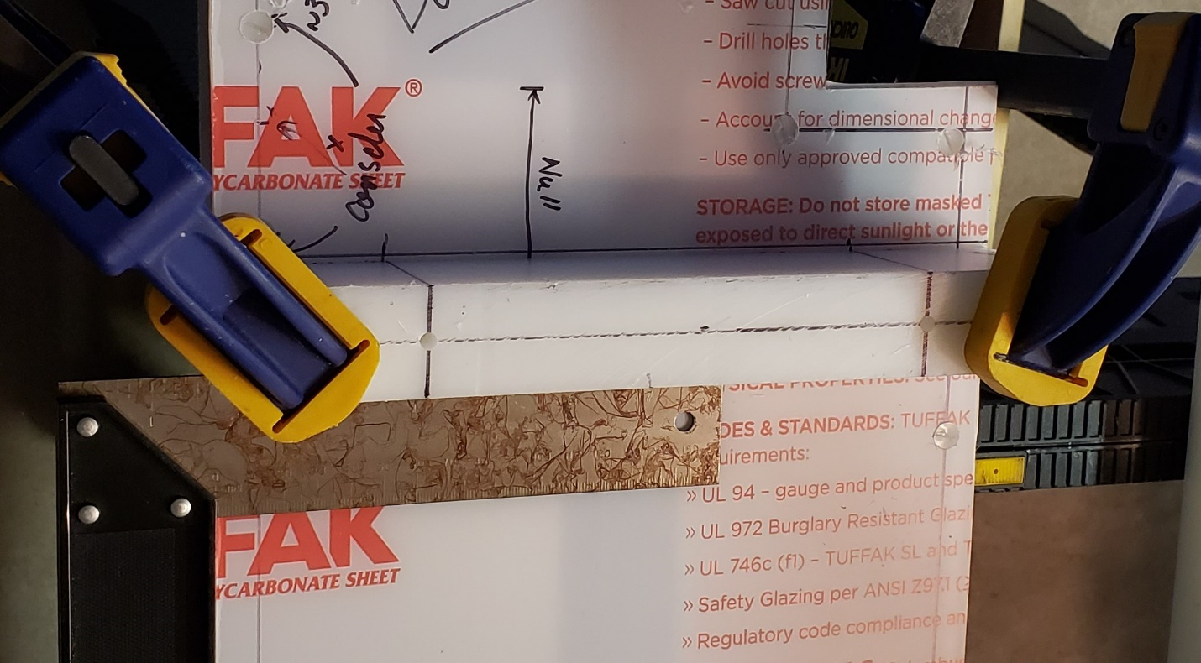Figure : Locating and drilling holes in the stop plate

## Step 11: Round off all sharp edges on the “Top Cover” and the HDPE plastic case

* If not already in place, secure the “Top Cover” to the HDPE plastic case using the nylon flat head 10-24 screws.
* Secure the case and cover to the work surface using clamps.
* Using a router with a ¼” round-over bit, round off all of the edges on the fishboard case (top, bottom, and sides) to give it a more professional appearance. The smoothed edges will also protect the operator’s hands from inadvertent cuts from the sharp plastic corners.
* Remove the “Top Cover” from the HDPE plastic case.
* Rout the edges of the stop plate.
* Any edges that are hard to get with the router, smooth with sandpaper and/or finish sander.

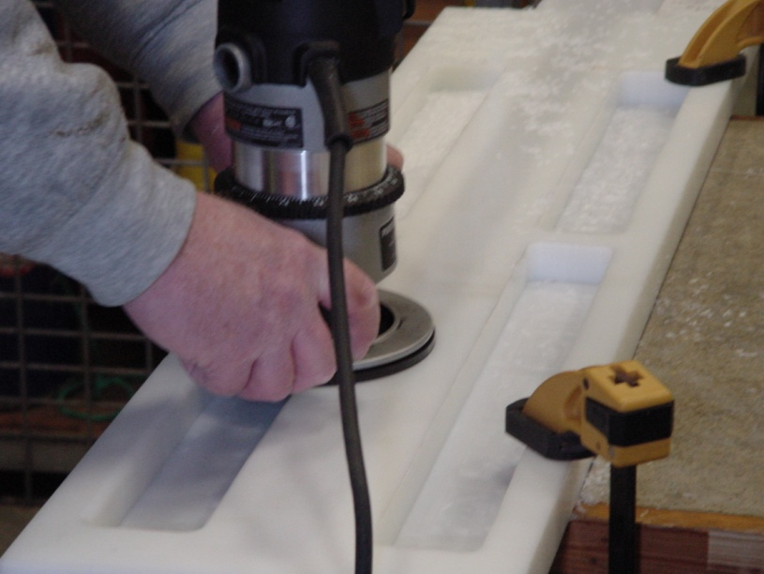

Figure . Rounding all edges on the board with "Round-Over" router bit.

## Step 12: Install the self-tapping zinc-plated threaded inserts for the Stop Plate

* Unscrew all the nylon screws, remove the polycarbonate top and gasket (if installed). Roll up the gasket carefully and store where it will not be ripped, scratched, gouged or nicked. Make sure it is marked to identify which case it was made with.
* Using the ¼” – 20 threaded insert tool (Figure 5), install two self-tapping zinc-plated threaded inserts at the locations shown in the diagram on Appendix 3.2. The holes in the sides of the inserts should be down, this is the tapered cutting end of the insert.
* The top of the insert should be flush with the top surface of the HDPE when done.
* Drill the countersink in the top of the stop plate
* Check the hole alignment and countersink by replacing the polycarbonate top and gasket (one does not have to re-install all the screws) and install the stop plate. If the fit is too tight or it is hard to align the holes and start the screw threads, widen the holes in the stop plate with the 11/32” bit.

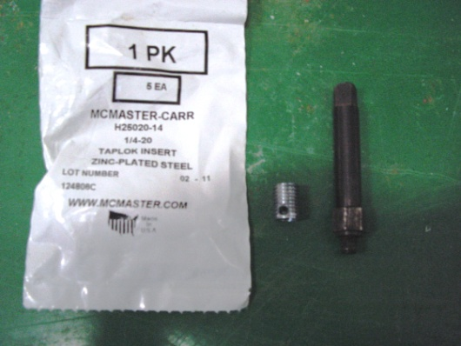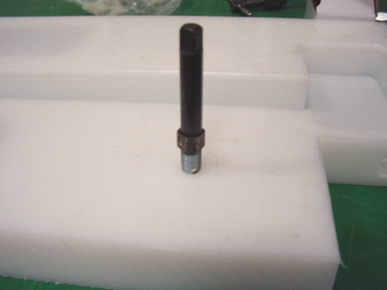

Figure . Stop Plate Screw Insert and Tool.

## Step 13: Install connectors and wiring

As of 2021, there are a number of variants of wiring harnesses for the Ichthystick II. They include harnesses to work with equipment used by colleagues at the Massachusetts Division of Marine Fisheries offices, older version of equipment still in use and test cables. These are included for completeness.

1. In current use at NEFSC by ESB on scallop surveys and cooperative research, is a Mencom connector to the Temposonics EP2 sensors and a Subconn MCBH6M through the side of the case. A Subconn to Subconn cable connects the case to the display. Data is transmitted from the display using Bluetooth. This arrangement is shown in Figure 11 and drawing IFMB-10407 Revision A in Appendix 3.5.1.
2. In current use at NEFSC by ESB on shrimp surveys and by the Massachusetts Division of Marine Fisheries on the F/V Gloria Michelle, is a version shown in drawing CableAssy_IFMB-10406RevA.pdf in Appendix 3.5.2. Still using a Brad Harrison connector through the side of the case, it uses the new Mencom connector to the Temposonics sensor.
3. The oldest version as adapted from the Alaska Fisheries Center board has an Amphenol connector. This exists because it was the original connector used by Temposonics to the EP2 sensor and may still be found in older fish board setups. Brad Harrison connectors were used in the side of the case, and were later retired because of leakage issues. This arrangement is shown in Figure 9, and the wiring diagram CableAssy_IFMB-10406.pdf in Appendix 3.5.4.
4. To address leakage of the Brad Harrison connector at the side of the fish board case, it was replaced by a Subconn MCBH. This version uses the Mencom connector at the sensor, and to the IFMB display. This is shown in drawing IFMB-10407 in Appendix 3.5.3. There are still some displays in use with Mencom connectors.
5. A hybrid of new and old exists to use old sensors requiring Amphenol connectors (P/N C091-31F006-100-2) and new displays and display cables requiring the Subconn MCBH6M connector. This arrangement is shown in Figure 10.

To install the bulkhead connector into the side of the case:

* Check that the surface of the HDPE around the connector hole is still smooth and free of abrasion, cuts or scores. This is where the O-ring will seal.
* Grease the Subconn connector O-ring lightly with the Molykote 111 grease. Install the O-ring on the connector.
* Install the connector. Screw it in carefully, tighten until the O-ring is compressed and the metal part flush with the HDPE. Do not overtighten, the metal could strip the soft plastic threads.
* Wire this connector to the terminal block as shown in the appropriate wiring diagram (Appendix 3.5).
* Wire the connector to the sensor as shown in the wiring diagram appropriate to your connector and sensor situation. Wiring diagrams are in Appendix 3.5.

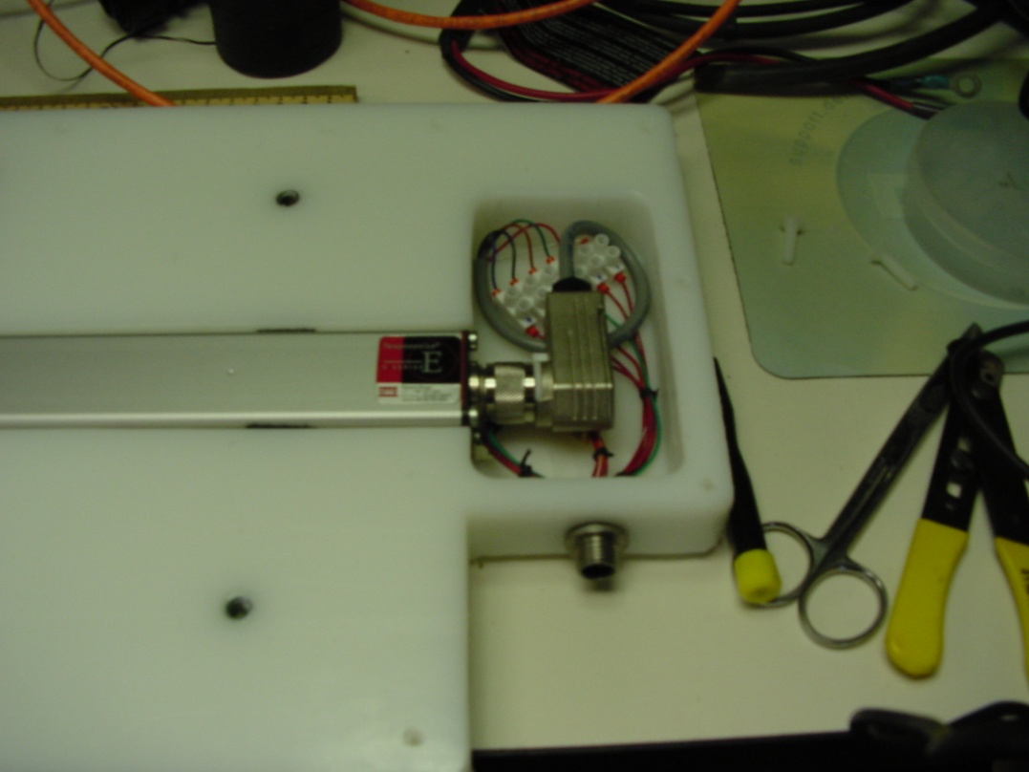

Figure 9. Installed Amphenol and Brad Harrison Connectors

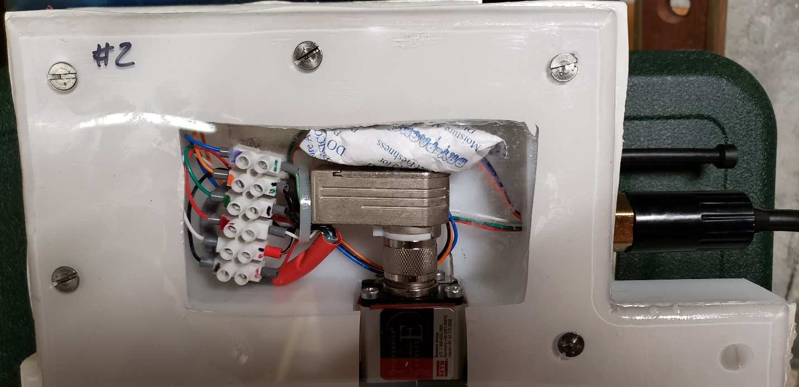

Figure : Version with Amphenol and SubConn connectors

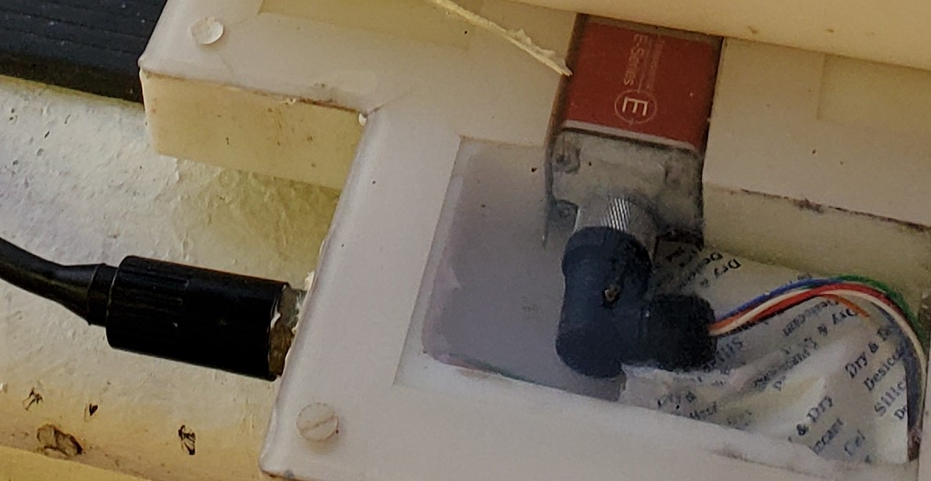

Figure : Version with the newest Temposonics sensors, Mencom and SubConn connectors, in use in 2021.

## Step 14: Install the Temposonic Linear-Position sensor

As in step 10, the zero point of the sensor should line up with the centerline of the stop plate (which is the centerline of the stop plate holes). This will insure that none of the “dead” area of the sensor is on the measurement side of the stop plate.

* Using Velcro “Hook & Loop” fastener tape, install a 3” piece of “Hook” portion of the tape on the bottom of the HDPE case channel as shown in Figure 12. This tape will help secure the sensor to the case.

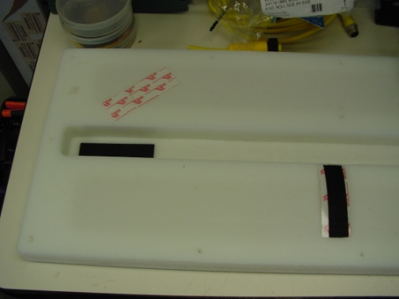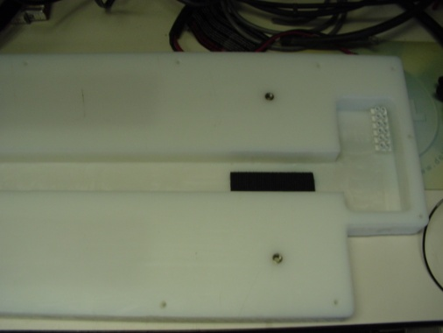

Figure 12. Locations of 3" pieces of "Hook" tape

* Place a small drop of super glue on the “South” face of the 1” long by 0.25” wide Rare Earth Magnet and attach to the sensor over the “dot” that represents the end of the measurement stroke (Figure 13). The “North” face of the magnet should be facing up. Not sure which is which? Use a compass.
* When the glue dries, wrap some electrical tape around the magnet to further secure it to the sensor (Figure 14).

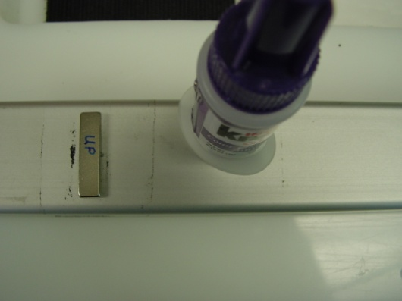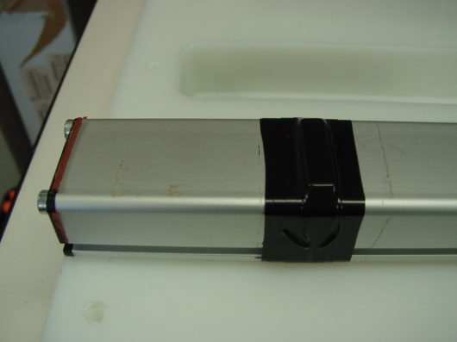

Figure 13. Location of 1" long by 1/4" wide magnet

* Install 3” pieces of the “Loop” portion of the Velcro tape to each end of the sensor as shown in Figure 14. This tape will help secure the sensor to the case.

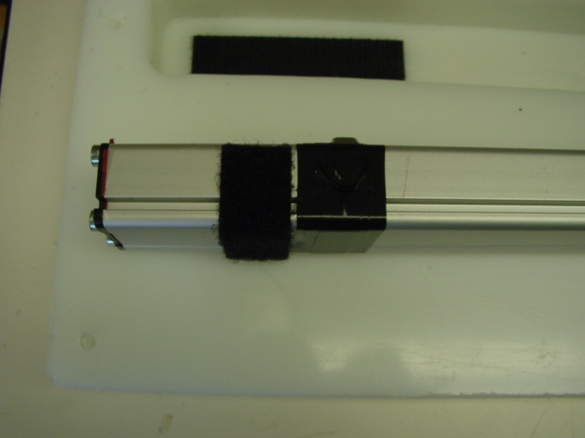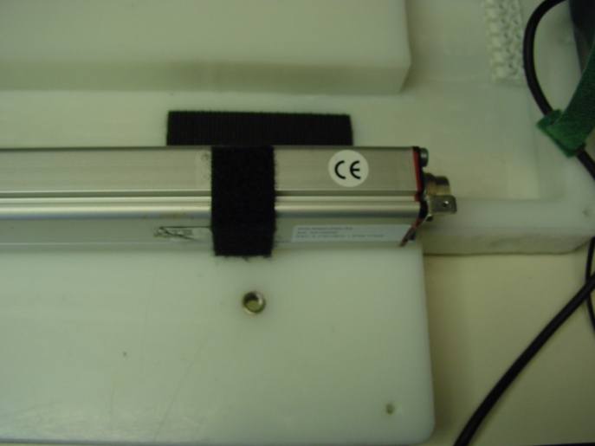

Figure 14. Location of "Loop" portion of Velcro Tape

* Connect the Amphenol or Mencom connector to the sensor, and secure the sensor to the HDPE case channel.
* Apply a strip of measurement tape to the top center of the sensor strip aligning the beginning of the tape from the inside edge of the “Stop Plate” to the magnet at the end of the sensor as a visual guide to lengths. It is IMPORTANT to align the zero point of the tape to the inside edge of the “Stop Plate” as the measurement points on the tape will be used to calibrate the sensor.

## Step 15: Finish assembling the fishboard case

The foam tape was the original method used to prevent water intrusion to the sensor channel. It glues the cover onto the case, so that re-opening the case requires laborious cleaning to remove the old tape and re-application of tape. Using the gasket, one can now open and close the case without destroying the seal.

Put a Silica Gel Tyvek Desiccant (Dry Pak) and humidity indicator strip in the compartment where the cable wires are connected to the sensor to absorb condensation from changes in temperature and humidity (Figure 15).

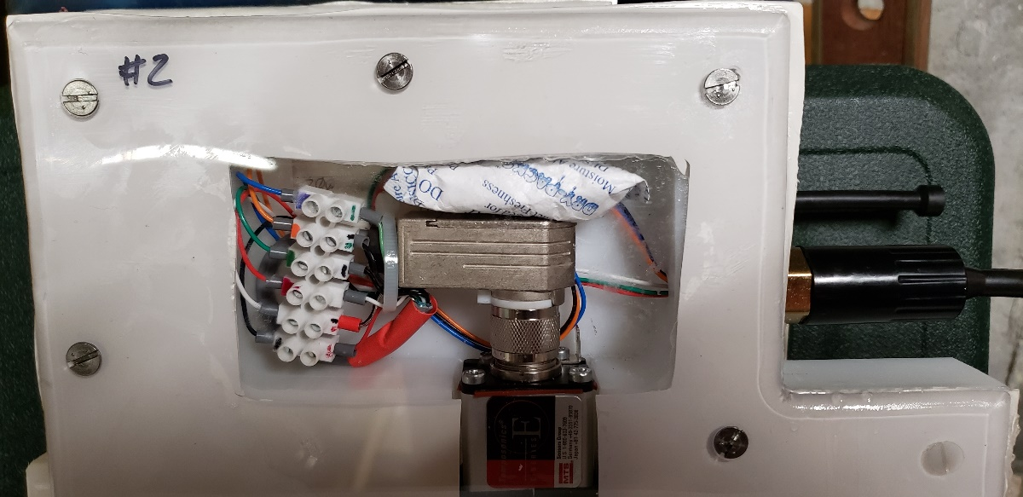

Figure : Wiring compartment with desiccant pack (older Amphenol sensor connector shown)

### Gasket seal

* Make sure the sensor securely fastened to the HDPE case, the wiring all connected.
* Apply a liberal and unbroken layer of Molykote 111 grease to the case, a width of 1” from the edge, all the way around. Apply grease around the stop plate holes.
* Unroll the gasket onto a clean surface, and clean both sides of the gasket of debris, dust, etc. from manufacturing and handling.
* Carefully lay the gasket on the case.
* Apply a liberal and unbroken layer of Molykote 111 grease to the top gasket, a width of 1” from the edge, all the way around. Apply grease around the stop plate holes. The gasket should now be greased on both sides. Make sure the holes all line up.
* Carefully install the “Top Cover” onto the HDPE case and secure with the nylon 10-24 screws.
* Attach the “Stop Plate” to the HDPE case using the ¼”-20 Stainless Steel machine screws.

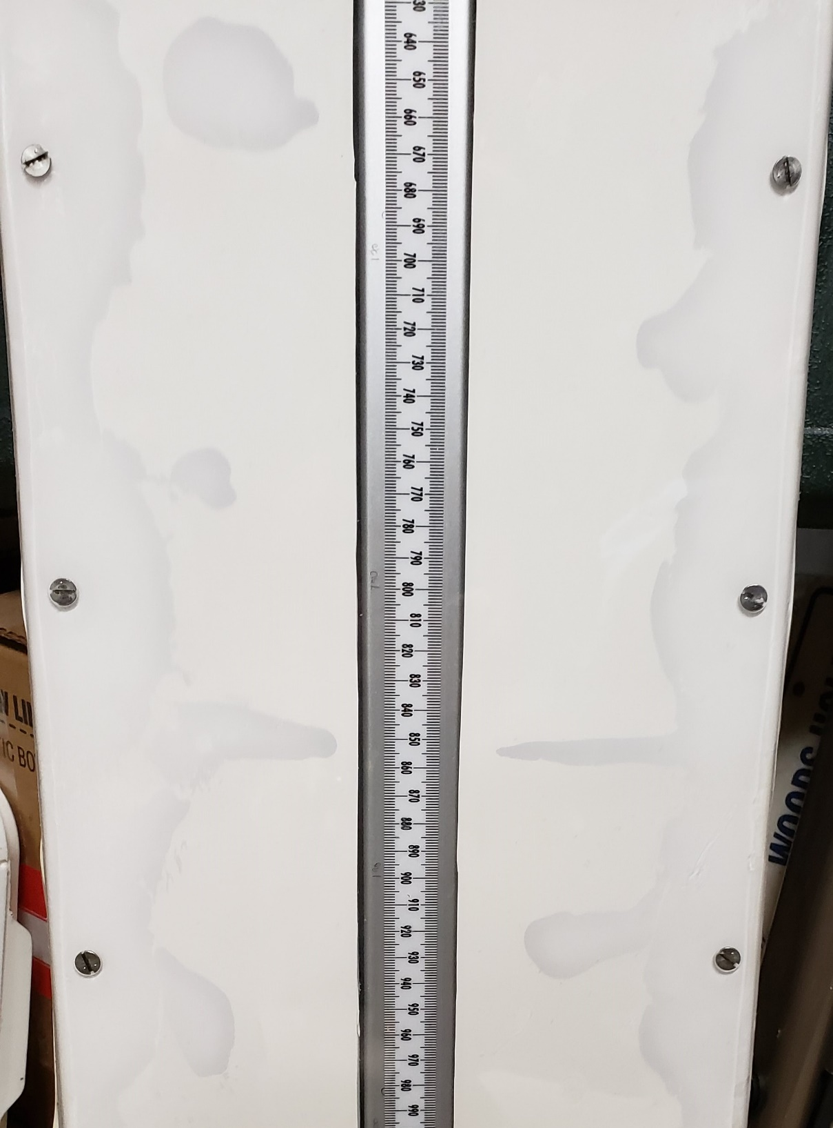

Figure : picture of case with a gasket seal showing how the grease flows to make the final seal. Normal compression from the screws with cause some extrusion of the silicone gasket material out the sides as well.

Notes: The grease will initially flow and come out the sides of the case – this is normal. Simply wipe off the excess. Stainless screws are preferred over nylon with the caveat that it will be easier to strip the threads, so tighten hand tight, only enough so that you can see the grease flow and fill in gaps. It was observed that the nylon screws deformed over time and the slot was hard to access.

### Foam tape seal

* With the sensor securely fastened to the HDPE case, apply the U-Line double-sided foam tape to the top portion of the HDPE case, especially in the areas around the screw holes including the screw holes for the Stop Plate. Use a zig-zag pattern to slow water from seeping in where ends of the tape butt together (Figure 17).
* 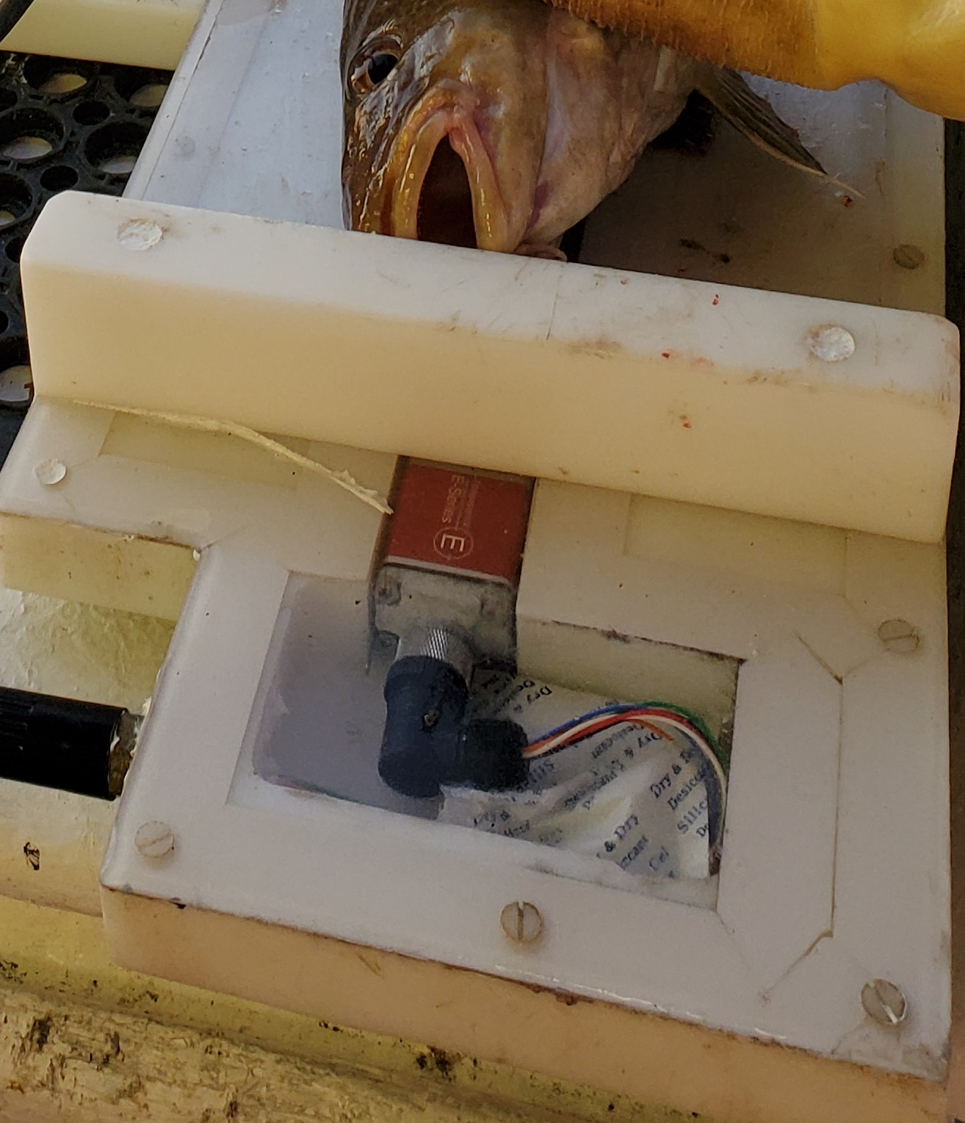

Figure : Detail of foam tape technique

* Carefully install the “Top Cover” onto the HDPE case and secure with the nylon 10-24 screws.
* Attach the “Stop Plate” to the HDPE case using the ¼”-20 Stainless Steel machine screws.

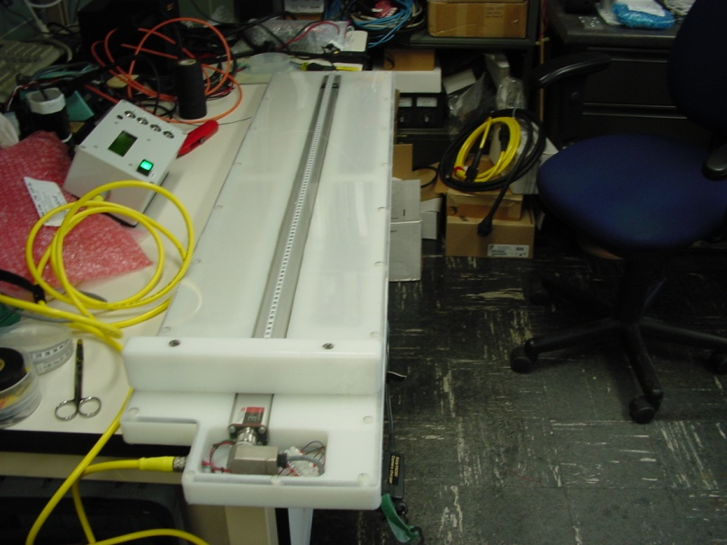

Figure 18. Picture of completed case with Display Assembly

## Step 16: Create the Measurement Wand

There are several varieties of magnetic wand used for fish boards, two are shown in Appendix 3.6.

* Cut a 3.0” length of polycarbonate tubing. (See Appendix 3.6)
* At one end of the tube, apply a liberal amount of super glue to the inside wall of the tube.
* Slide the K&J Magnetics P/N B666-N52 block magnet or circular magnet into this end of the polycarbonate tubing. The “South Pole” face of the magnet should be facing into the tubing. The “North Pole” should be facing out, flush with the end of the tubing material.
* Apply a liberal amount of super glue to the exposed face of the magnet to provide a watertight seal to the magnet face.
* At the other end of the polycarbonate tubing, apply a liberal amount of silicon sealant to provide a watertight seal to the open end of the tubing (Figure 19).

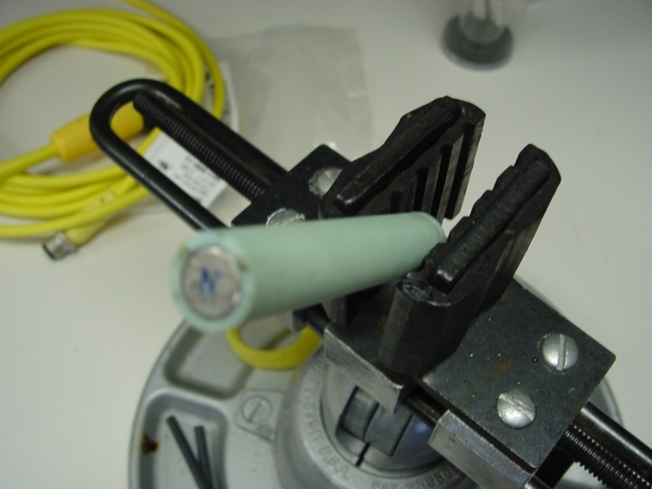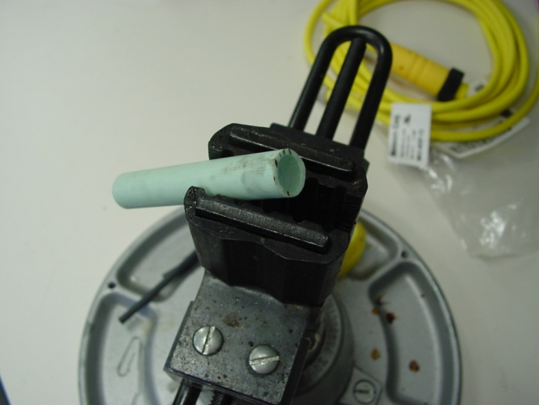

Figure 19. Completed Measurement Wand

# 3.0 Appendices

## 3.1 Assembly views of the *Ichthystick II*

### 3.1.1 Isometric view of 36” sensor version

Appendix 3.1.1 Fishboard_Case_withSensor.pdf

### 3.1.2 3D Model of future version with 42” sensor

Appendix 3.1.2 Assembly.pdf

## 3.2 Template drawings

### 3.2.1 42” case

Appendix 3.2.1 FB001-013Template-2021114.pdf

### 3.2.2 36” case (original)

Appendix 3.2.2 TemplateLayout.pdf

### 3.2.3 Rough cut guide for 4 x 8 ft. sheet of material

Appendix 3.2.3 FB001-012RoughCut-2021114.pdf

## 3.3 Detail of Connector hole placement

### 3.3.1 Subconn MCBH

Appendix 3.3.1 FB001-001Case-002-2021114.pdf

### 3.3.2 Brad Harrison (original)

Appendix 3.3.2 ConnectorHole.pdf

## 3.4 Detail of Stop Plate and Screw Hole Locations

Appendix 3.4 FB001-000Assy-001Stop-20210114.pdf

## 3.5 Wiring Diagrams

### 3.5.1 Schematic for wiring Mencom to Subconn (used today)

Appendix 3.5.1 FishboardSubconnMod_IFMB-10407RevA.pdf

### 3.5.2 Schematic for wiring Mencom to Brad Harrison (used today)

Appendix 3.5.2 CableAssy_IFMB-10406RevA.pdf

### 3.5.3 Schematic for wiring to interface with Ichthystick II displays with Mencom sensors

Appendix 3.5.3 FishboardSubconnMod_IFMB-10407.pdf

### 3.5.4 Schematic for the first Ichthystick II with Amphenol and Brad Harrison connectors

Appendix 3.5.4 CableAssy_IFMB-10406.pdf

## 3.6 Measurement Wand Diagrams

### 3.6.1 Circular Wand

Appendix 3.6.1 MeasuringWand_Circular.pdf

### 3.6.2 Square Wand

Appendix 3.6.1 MeasuringWand_Square.pdf