Black sea bass indicator analysis

Abigail Tyrell

10 May 2021

## Recruitment

### Winter SST anomaly

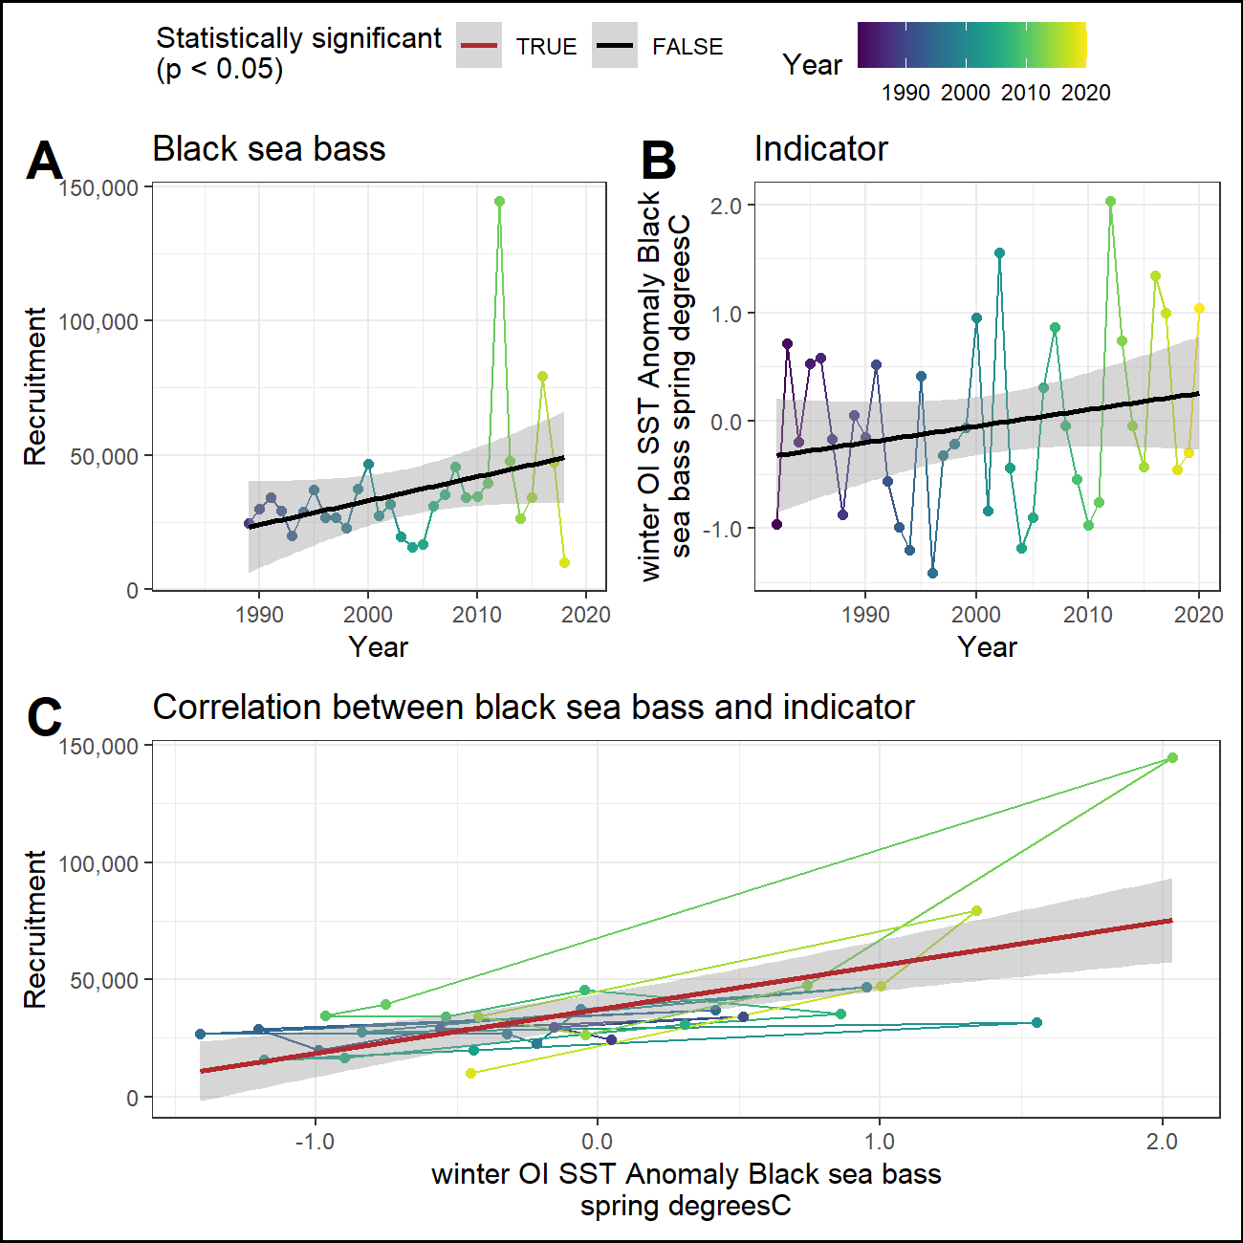

### Fall SST anomaly (prior year)

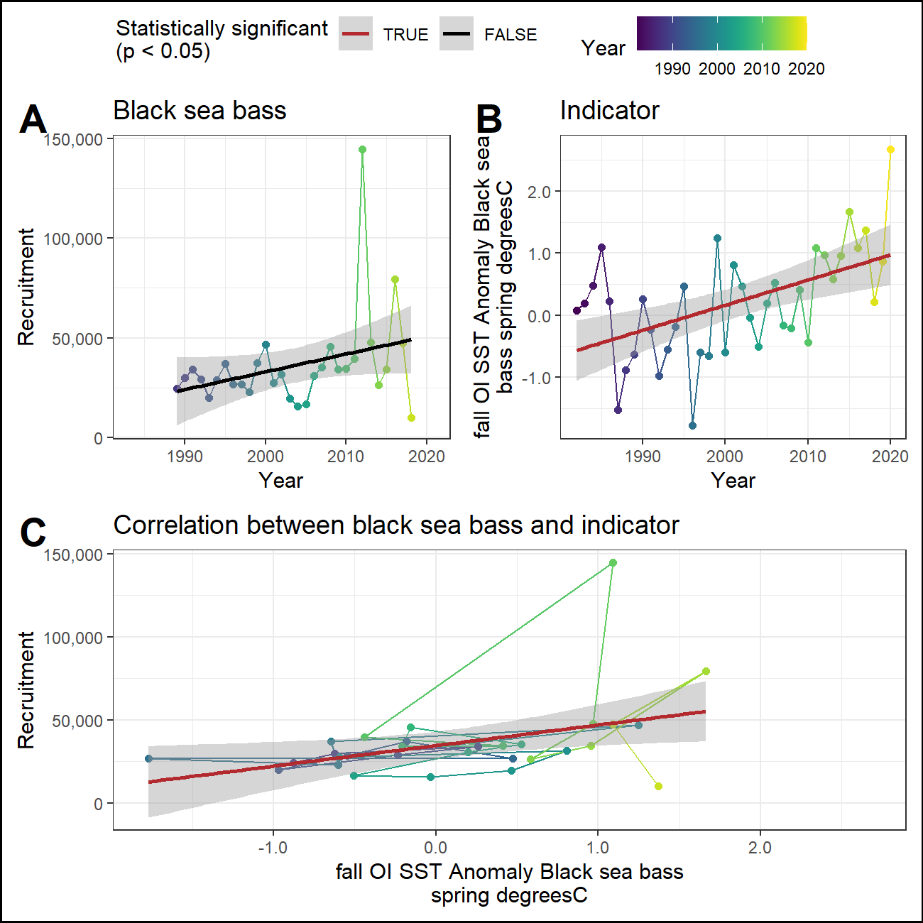

### Winter primary production

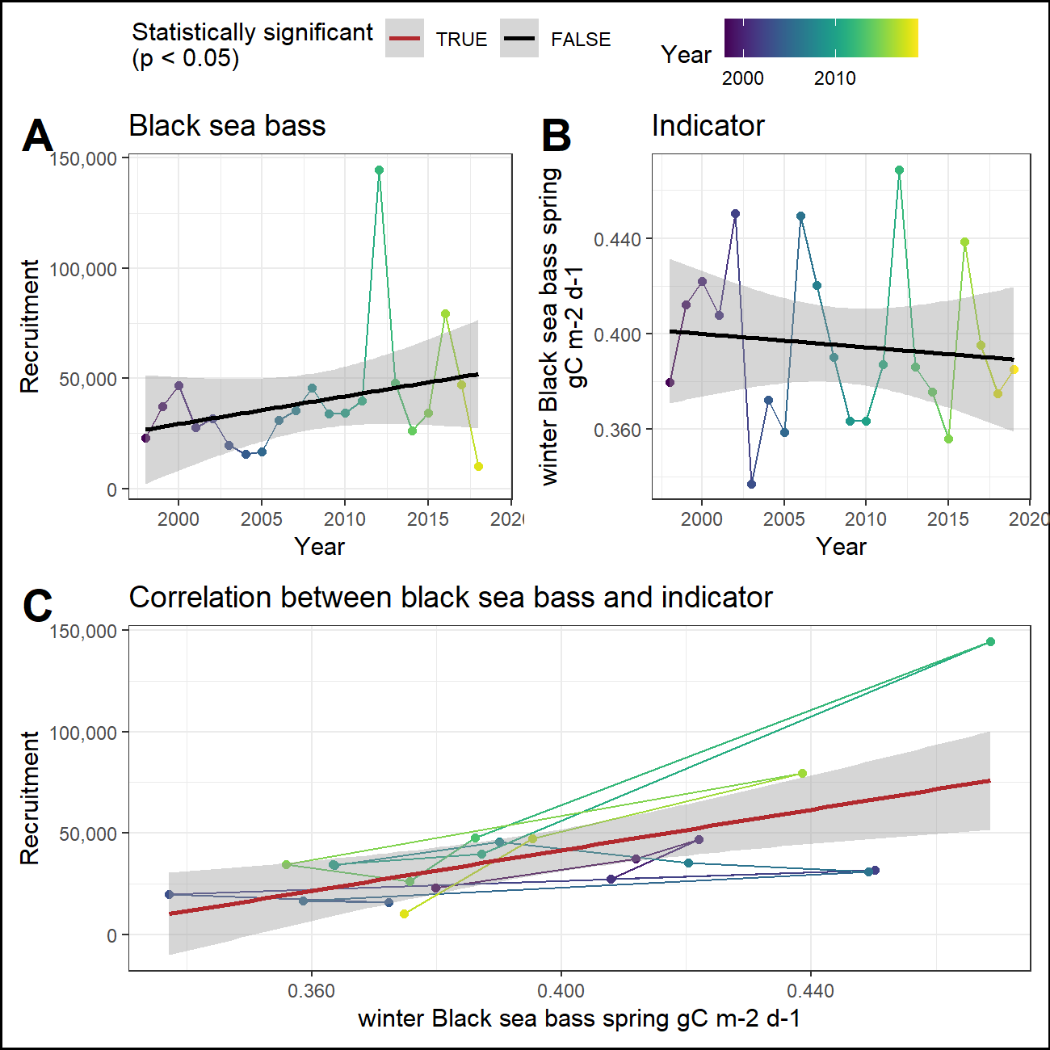

### Fall primary production (prior year)

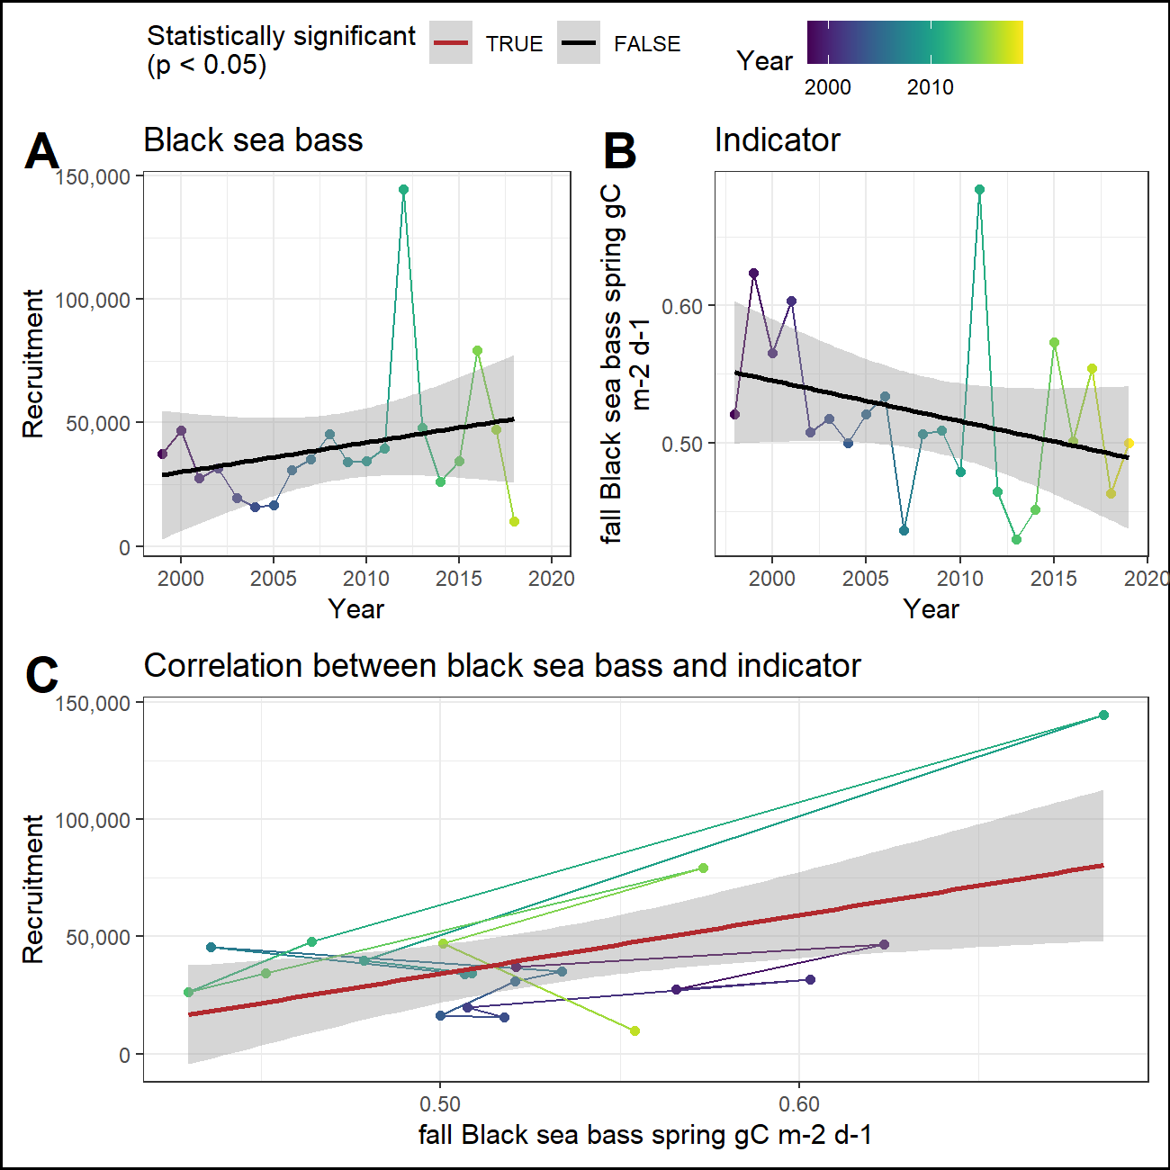

### Cold pool index (prior year)

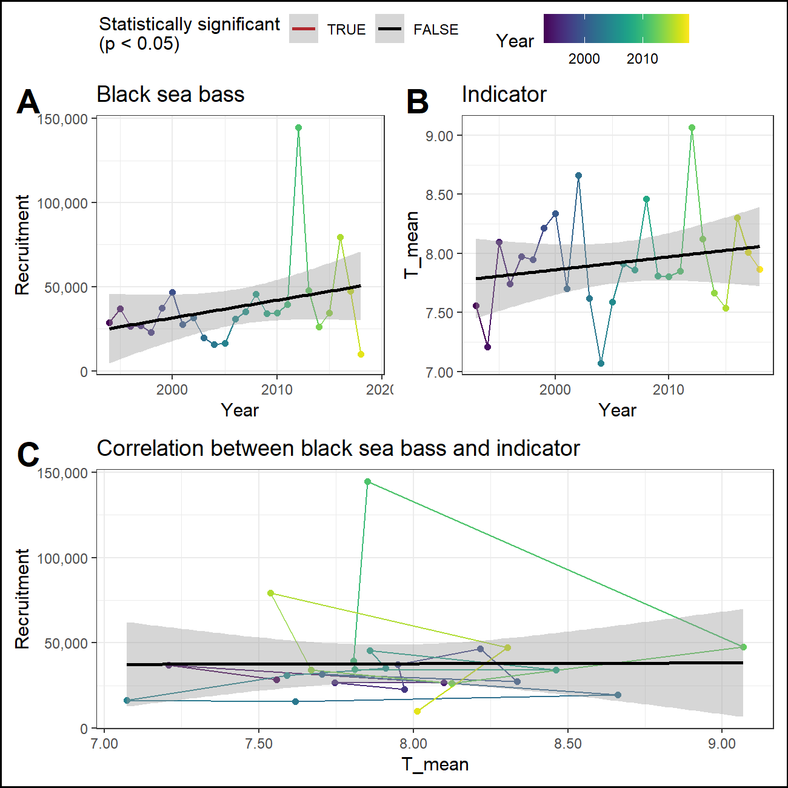

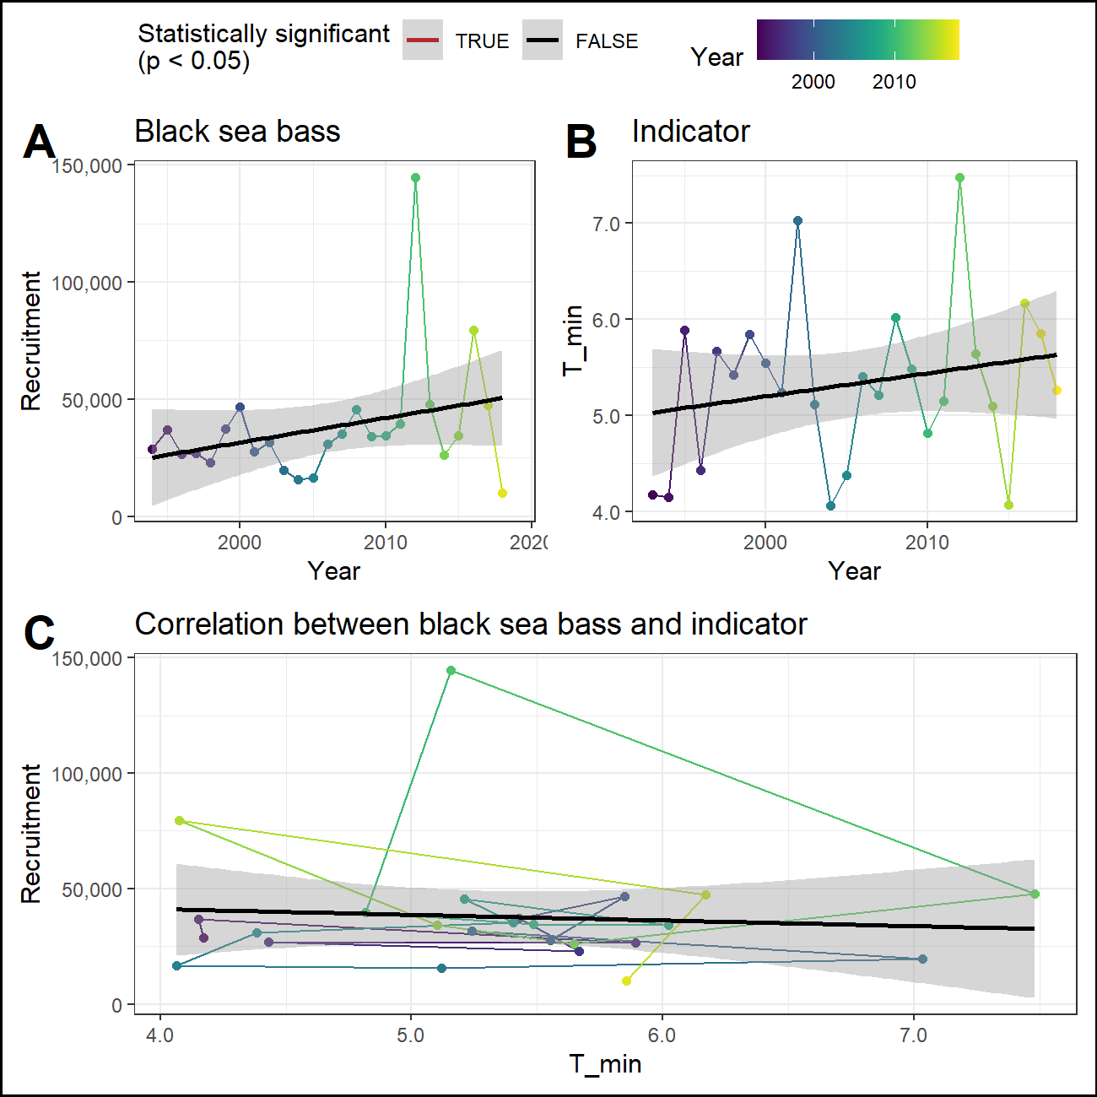

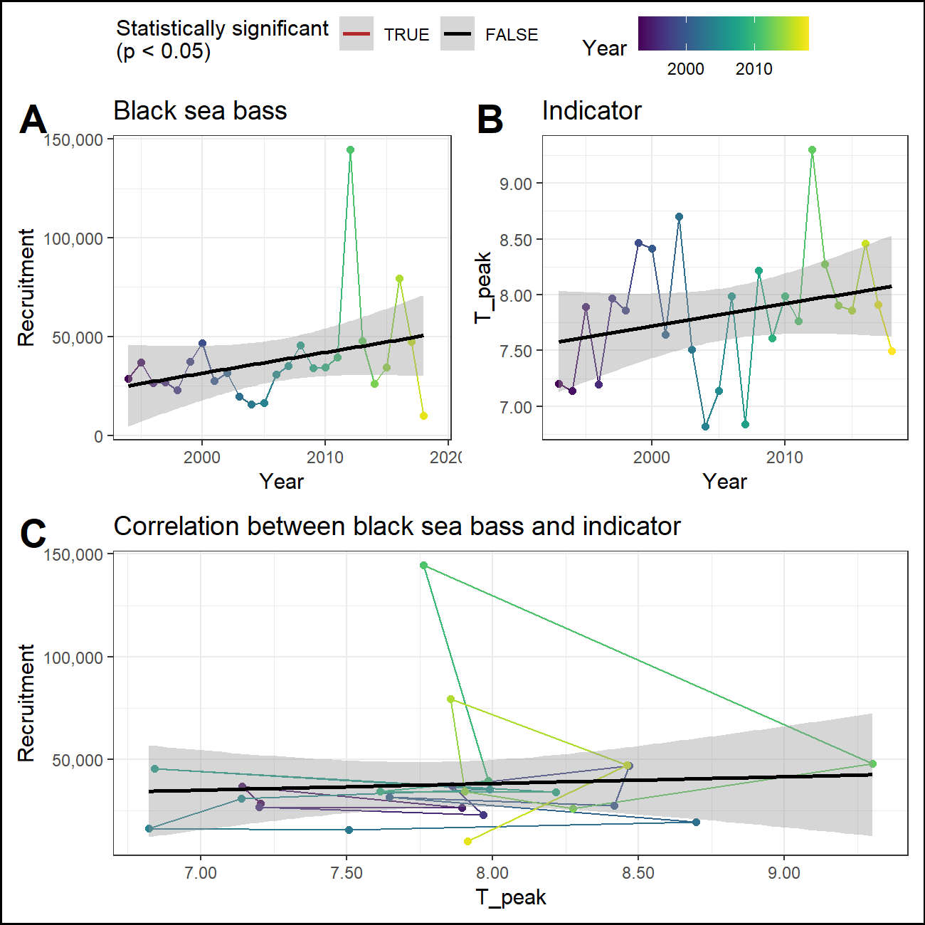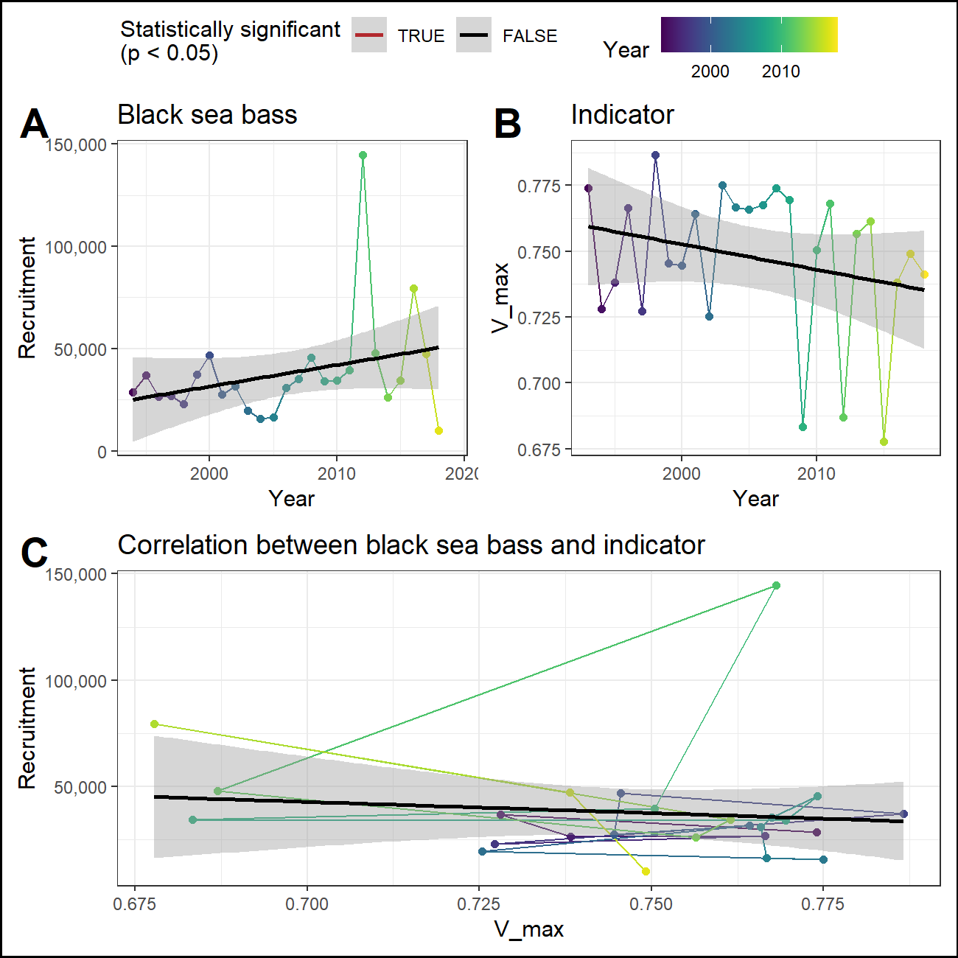

### Predator abundance

## Ecosystem

### Sea surface temperature

#### Recruitment

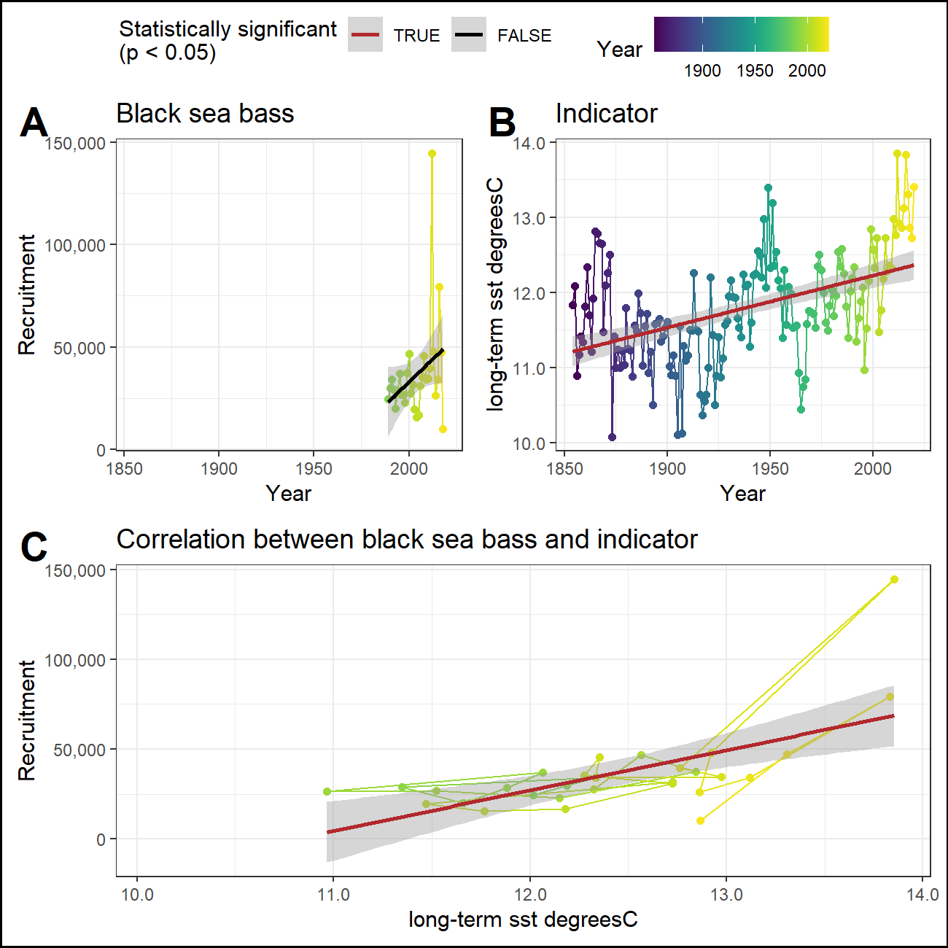

#### Abundance

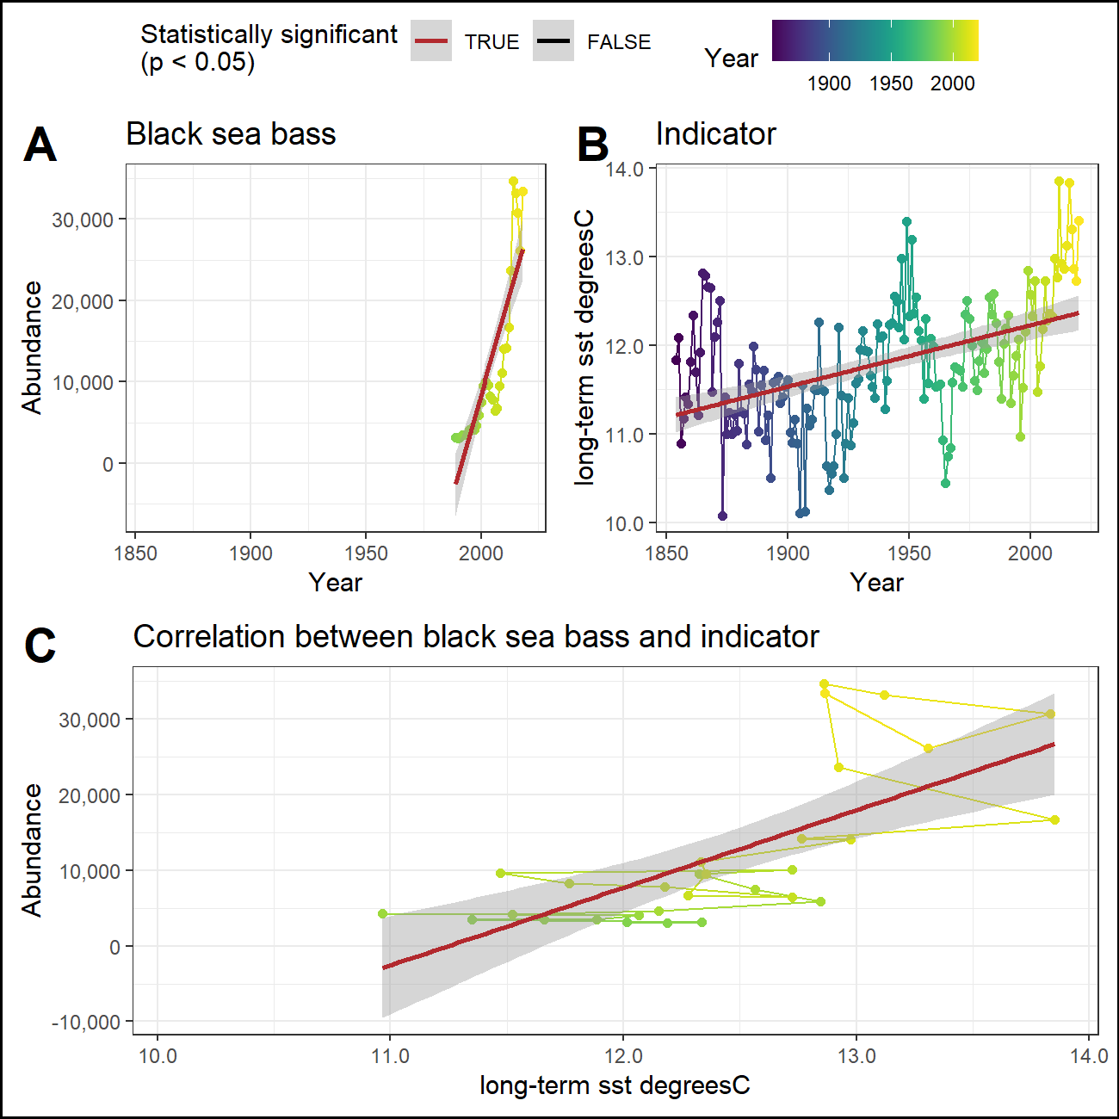

### Marine heatwaves

#### Recruitment

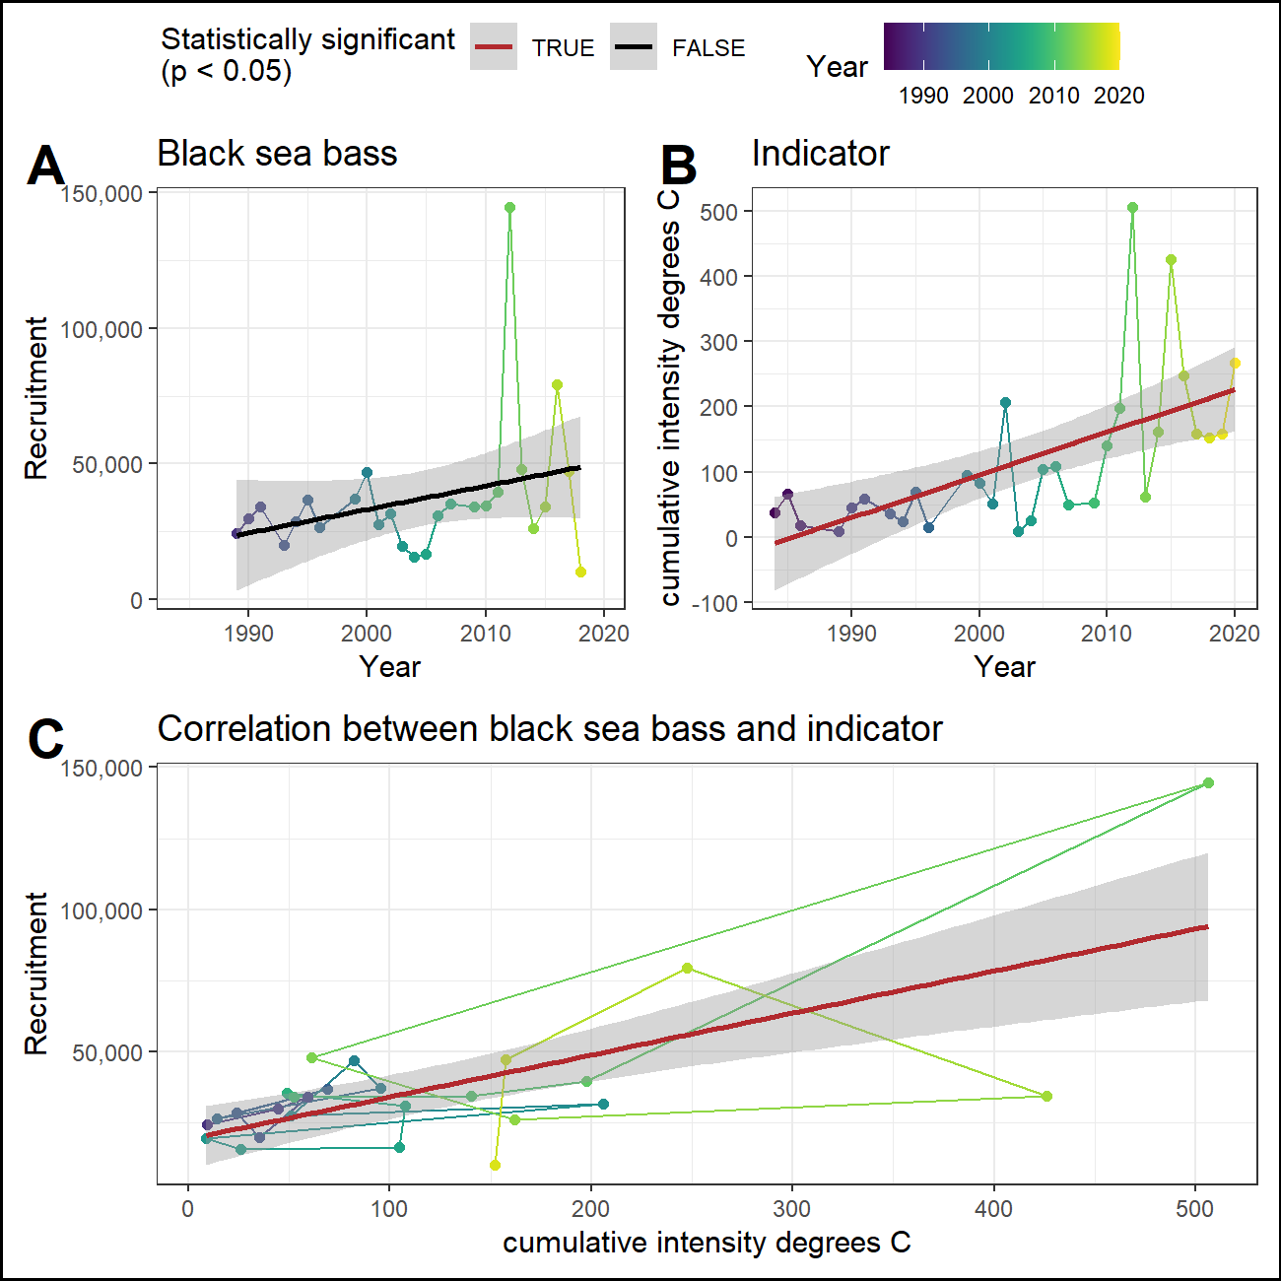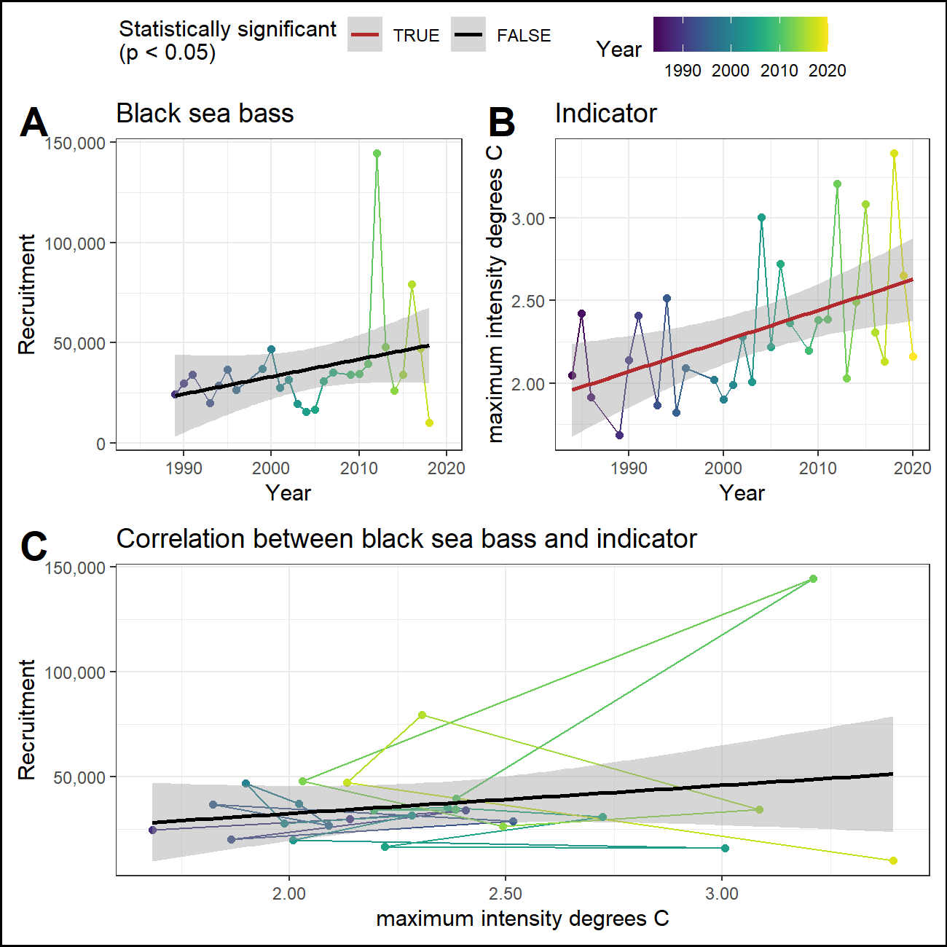

#### Abundance

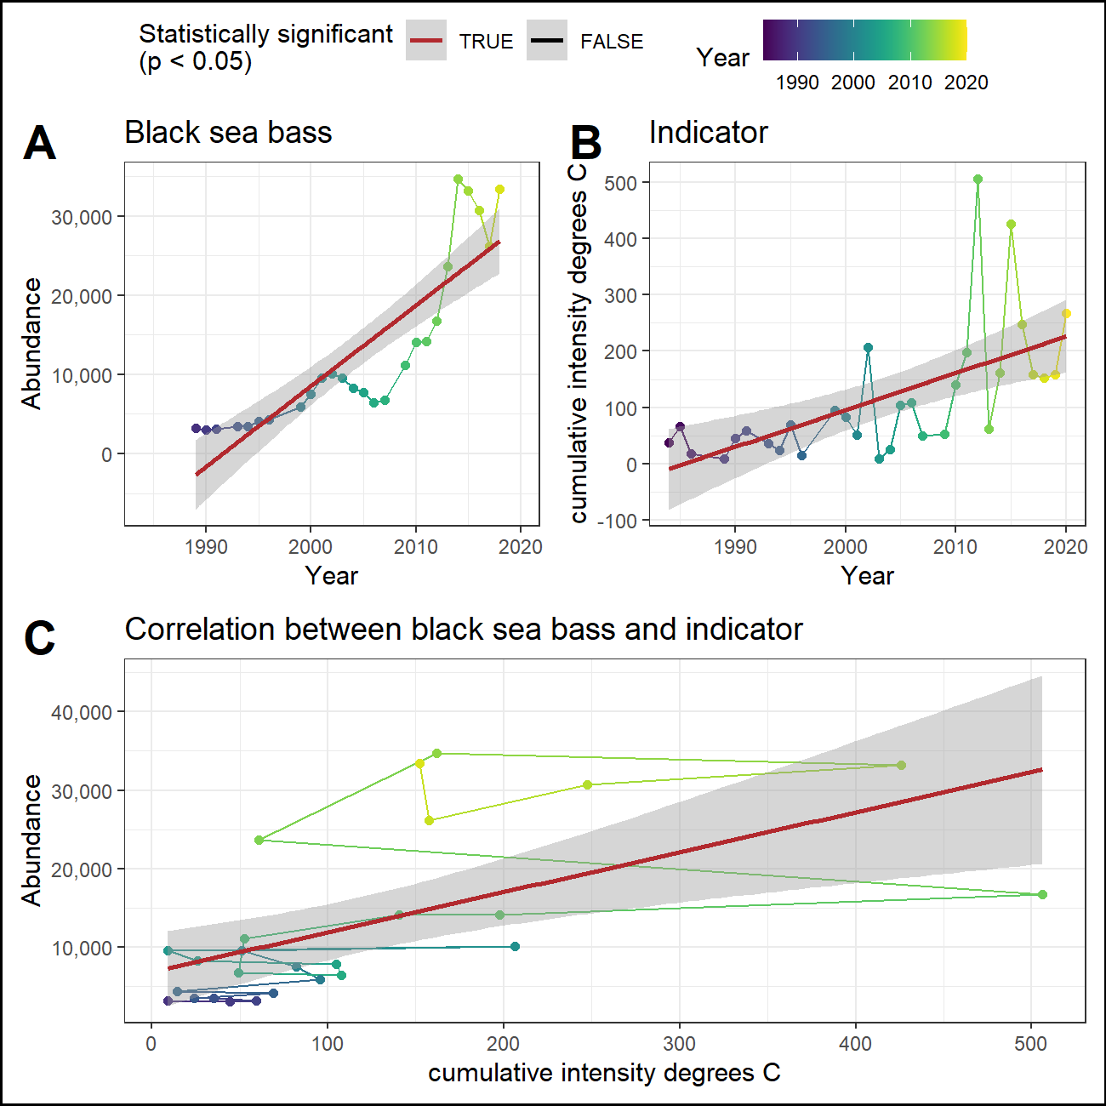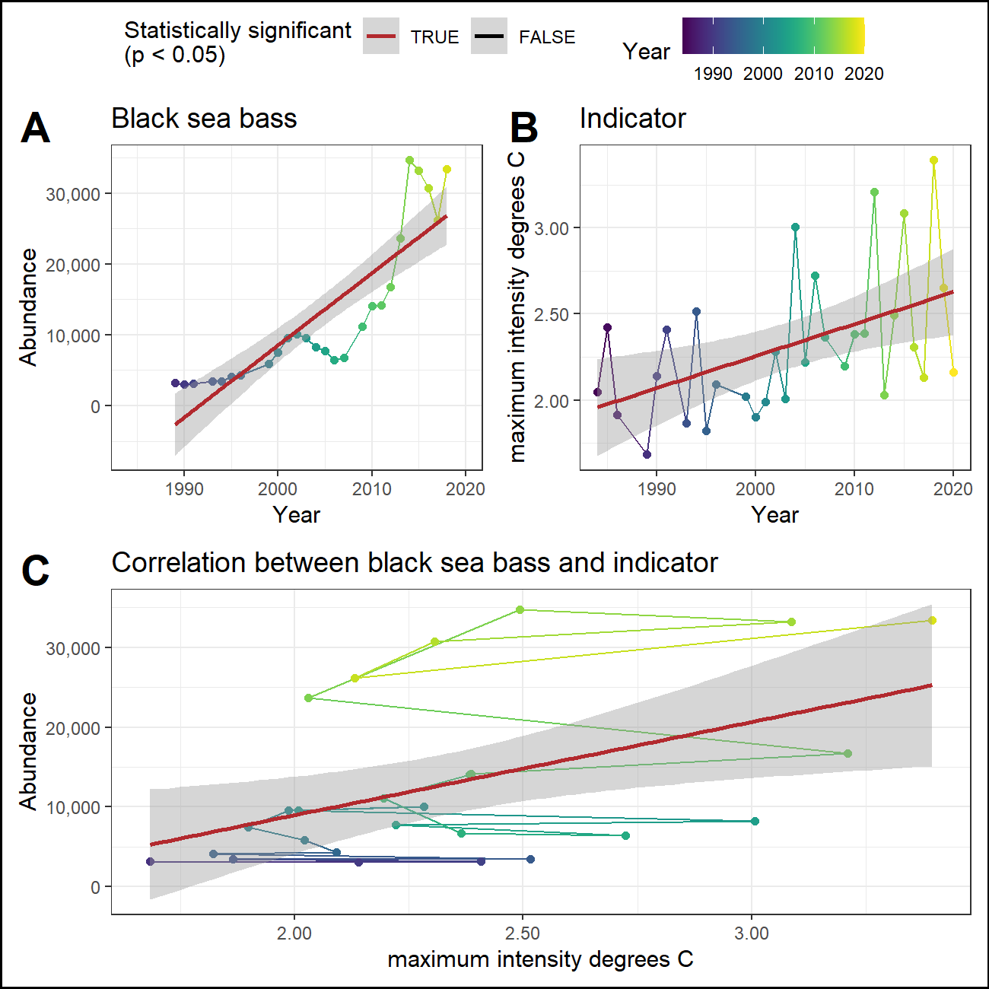

## Management

### Total catch

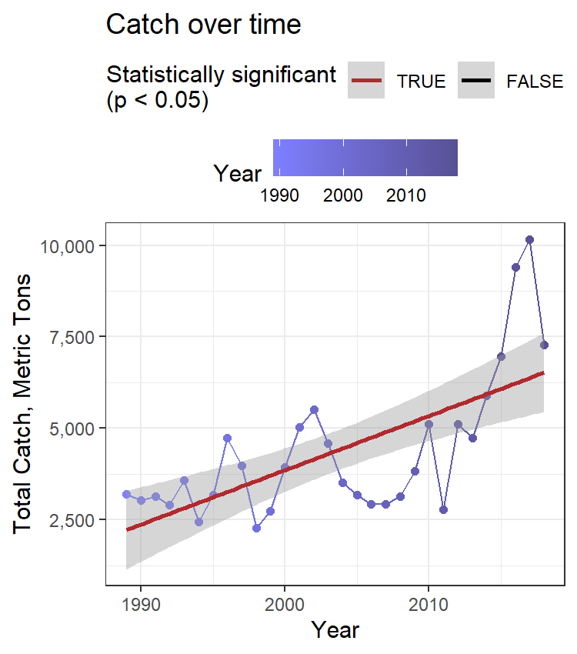

### CPUE

### Catch vs TAC

### Stock range

#### Northern range

Northernmost survey observation in each year.

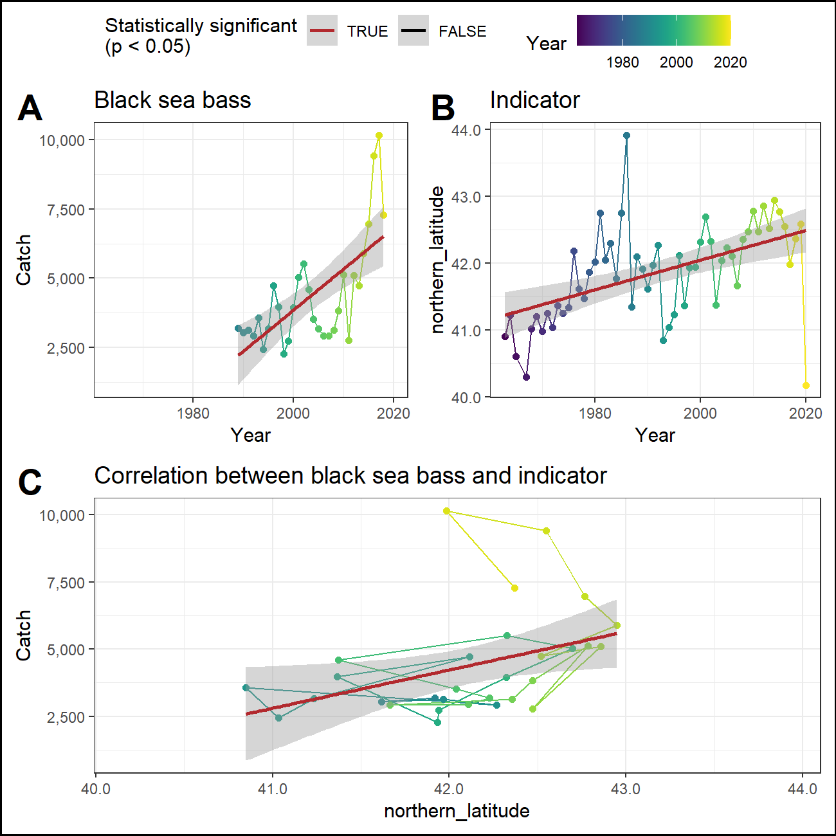

#### Southern range

Southernmost survey observation in each year.

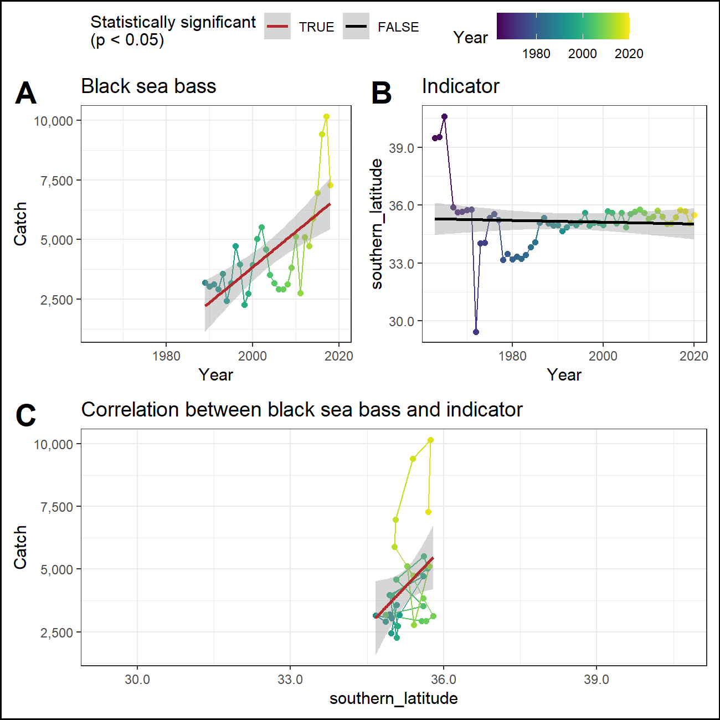

### Center of mass

## Report cards

### Indicator report card

| Indicator | Trend with time | Trend with recruitment | Trend with abundance | Trend with catch |
| --- | --- | --- | --- | --- |
| winter OI SST Anomaly Black sea bass spring degreesC | No | Yes, positive | Not tested | Not tested |
| fall OI SST Anomaly Black sea bass spring degreesC | Yes, positive | Yes, positive | Not tested | Not tested |
| winter Black sea bass spring gC m-2 d-1 | No | Yes, positive | Not tested | Not tested |
| fall Black sea bass spring gC m-2 d-1 | No | Yes, positive | Not tested | Not tested |
| T_mean | No | No | Not tested | Not tested |
| V_max | No | No | Not tested | Not tested |
| long-term sst degreesC | Yes, positive | Yes, positive | Yes, positive | Not tested |
| cumulative intensity degrees C | Yes, positive | Yes, positive | Yes, positive | Not tested |
| maximum intensity degrees C | Yes, positive | No | Yes, positive | Not tested |
| northern_latitude | Yes, positive | Not tested | Not tested | Yes, positive |
| southern_latitude | No | Not tested | Not tested | Yes, positive |

### Time series report card

| Time | winter OI SST Anomaly Black sea bass spring degreesC | fall OI SST Anomaly Black sea bass spring degreesC | winter Black sea bass spring gC m-2 d-1 | fall Black sea bass spring gC m-2 d-1 | long-term sst degreesC | cumulative intensity degrees C | maximum intensity degrees C | northern latitude | southern latitude |
| --- | --- | --- | --- | --- | --- | --- | --- | --- | --- |
| 2016 | 1.34 | 1.09 | 0.44 | 0.5 | 13.83 | 247.47 | 2.31 | 42.55 | 35.39 |
| 2017 | 1 | 1.37 | 0.4 | 0.55 | 13.31 | 157.72 | 2.13 | 41.99 | 35.74 |
| 2018 | -0.45 | 0.21 | 0.37 | 0.46 | 12.87 | 152.03 | 3.39 | 42.37 | 35.7 |
| 2019 | -0.3 | 0.87 | 0.39 | 0.5 | 12.73 | 157.86 | 2.65 | 42.59 | 35.05 |
| 2020 | 1.04 | 2.68 |  |  | 13.41 | 267.46 | 2.16 | 40.17 | 35.5 |
| recent mean | 0.53 ± 0.83 | 1.24 ± 0.91 | 0.4 ± 0.03 | 0.5 ± 0.04 | 13.23 ± 0.44 | 196.51 ± 56.14 | 2.53 ± 0.53 | 41.93 ± 1.01 | 35.48 ± 0.28 |
| long-term mean | -0.04 ± 0.83 | 0.21 ± 0.89 | 0.4 ± 0.03 | 0.52 ± 0.06 | 11.79 ± 0.72 | 117.35 ± 117.33 | 2.32 ± 0.42 | 41.87 ± 0.73 | 35.16 ± 1.53 |