
State of the Ecosystem 2026: DRAFT REPORT for New England and
the
Mid-Atlantic March 24, 2025

parent_report.Rmd
This is a draft report that presents all content from both New England and the Mid Atlantic. Several sections are shared between regions, and sections that differ for each region are marked with H1 headers. Some text is shown in square brackets to indicate that that text will differ in the New England and Mid Atlatnic reports (e.g., [Mid Atlantic text] or [New England text]). Most figures are shown only once when they are exactly the same in each region’s report, but in a few cases the figures are repeated and the figure numbers referenced in the text may refer the reader to the ‘wrong’ region. All of these editing quirks will be resolved in the final report.

Introduction

About This Report
[ This report is for the Mid-Atlantic Fishery Management Council (MAFMC). The purpose of this report is to synthesize ecosystem information to allow the MAFMC to better meet fishery management objectives, and to update the MAFMC’s Ecosystem Approach to Fishery Management (EAFM) risk assessment. The major messages of the report are synthesized on pages 1 and 2, with highlights of 2024 ecosystem events on page 3. ] or [ This report is for the New England Fishery Management Council (NEFMC). The purpose of this report is to synthesize ecosystem information to allow the NEFMC to better meet fishery management objectives. The major messages of the report are synthesized on pages 1-3, with highlights of 2024 ecosystem events on page 4. ]
The information in this report is organized into two main sections; performance measured against ecosystem-level management objectives (Table 1), and potential risks to meeting fishery management objectives (Table 2: climate change and other ocean uses). A final section highlights notable 2024 ecosystem observations.

Report structure
A glossary of terms1, detailed technical methods documentation2, indicator data3, and detailed indicator descriptions4 are available online. We recommend new readers first review the details of standard figure formatting (Fig. 98a), categorization of fish and invertebrate species into feeding guilds (Table 11), and definitions of ecological production units (EPUs, including the [Mid-Atlantic Bight, MAB] or [Gulf of Maine (GOM) and Georges Bank (GB)]; Fig. 98b) provided at the end of the document.
The two main sections contain subsections for each management objective or potential risk. Within each subsection, we first review observed trends for indicators representing each objective or risk, including the status of the most recent data year relative to a threshold (if available) or relative to the long-term average. Second, we identify potential drivers of observed trends, and synthesize results of indicators related to those drivers to outline potential implications for management. For example, if there are multiple drivers related to an indicator trend, do indicators associated with the drivers have similar trends, and can any drivers be affected by management action(s)? We emphasize that these implications are intended to represent testable hypotheses at present, rather than “answers,” because the science behind these indicators and syntheses continues to develop.
Table 1: Ecosystem-scale fishery management objectives in [the Mid-Atlantic Bight] *or* [New England]

Objective categories Indicators reported
Objectives: Provisioning and Cultural Services
Seafood Production Landings; commercial total and by feeding guild; recreational harvest Commercial Profits Revenue decomposed to price and volume
Recreational Opportunities Angler trips; recreational fleet diversity Stability Diversity indices (fishery and ecosystem)
Social & Cultural Community fishing engagement and social vulnerability status Protected Species Bycatch; population (adult and juvenile) numbers; mortalities

1https://noaa-edab.github.io/tech-doc/glossary.html 2https://noaa-edab.github.io/tech-doc/ 3https://noaa-edab.github.io/ecodata/ 4https://noaa-edab.github.io/catalog/index.html

Table 1: Ecosystem-scale fishery management objectives in [the Mid-Atlantic Bight] *or* [New England]

Objective categories Indicators reported
Potential Drivers: Supporting and Regulating Services
Management Stock status; catch compared with catch limits
Biomass Biomass or abundance by feeding guild from surveys
Environment Climate and ecosystem risk indicators listed in Table 2

Table 2: Risks to meeting fishery management objectives in [the Mid-Atlantic Bight] *or* [New England] Risk categories Observation indicators reported Potential driver indicators reported
Climate and Ecosystem Risks

Risks to Managing Spatially Risks to Managing Seasonally
Risks to Setting Catch Limits
Managed species (fish and cetacean) distribution shifts

Managed species spawning and migration timing changes
Managed species body condition and recruitment changes
Benthic and pelagic forage distribution; ocean temperature, changes in currents and cold pool

Habitat timing: Length of ocean summer, cold pool seasonal persistence
Benthic and pelagic forage quality & abundance: ocean temperature & acidification

Other Ocean Uses Risks
Offshore Wind Fishery revenue and landings from wind Wind development speed; Protected species

Risks
lease areas by species and port
presence and hotspots

Performance Relative to Fishery Management Objectives
In this section, we examine indicators related to broad, ecosystem-level fishery management objectives. We also provide hypotheses on the implications of these trends—why we are seeing them, what’s driving them, and potential or observed regime shifts or changes in ecosystem structure. Identifying multiple drivers, regime shifts, and potential changes to ecosystem structure, as well as identifying the most vulnerable resources, can help managers determine whether anything needs to be done differently to meet objectives and how to prioritize upcoming issues/risks.

Seafood Production

01_seafood_production_midatlantic.Rmd
Indicators: Landings; commercial and recreational
This year, we present updated indicators for total commercial landings, (includes seafood, bait, and industrial landings), U.S. seafood landings, and Council-managed U.S. seafood landings. Total commercial landings within the Mid-Atlantic have declined over the long term, and both total U.S. and Mid-Atlantic managed seafood landings are near their all time low (Fig. 1).

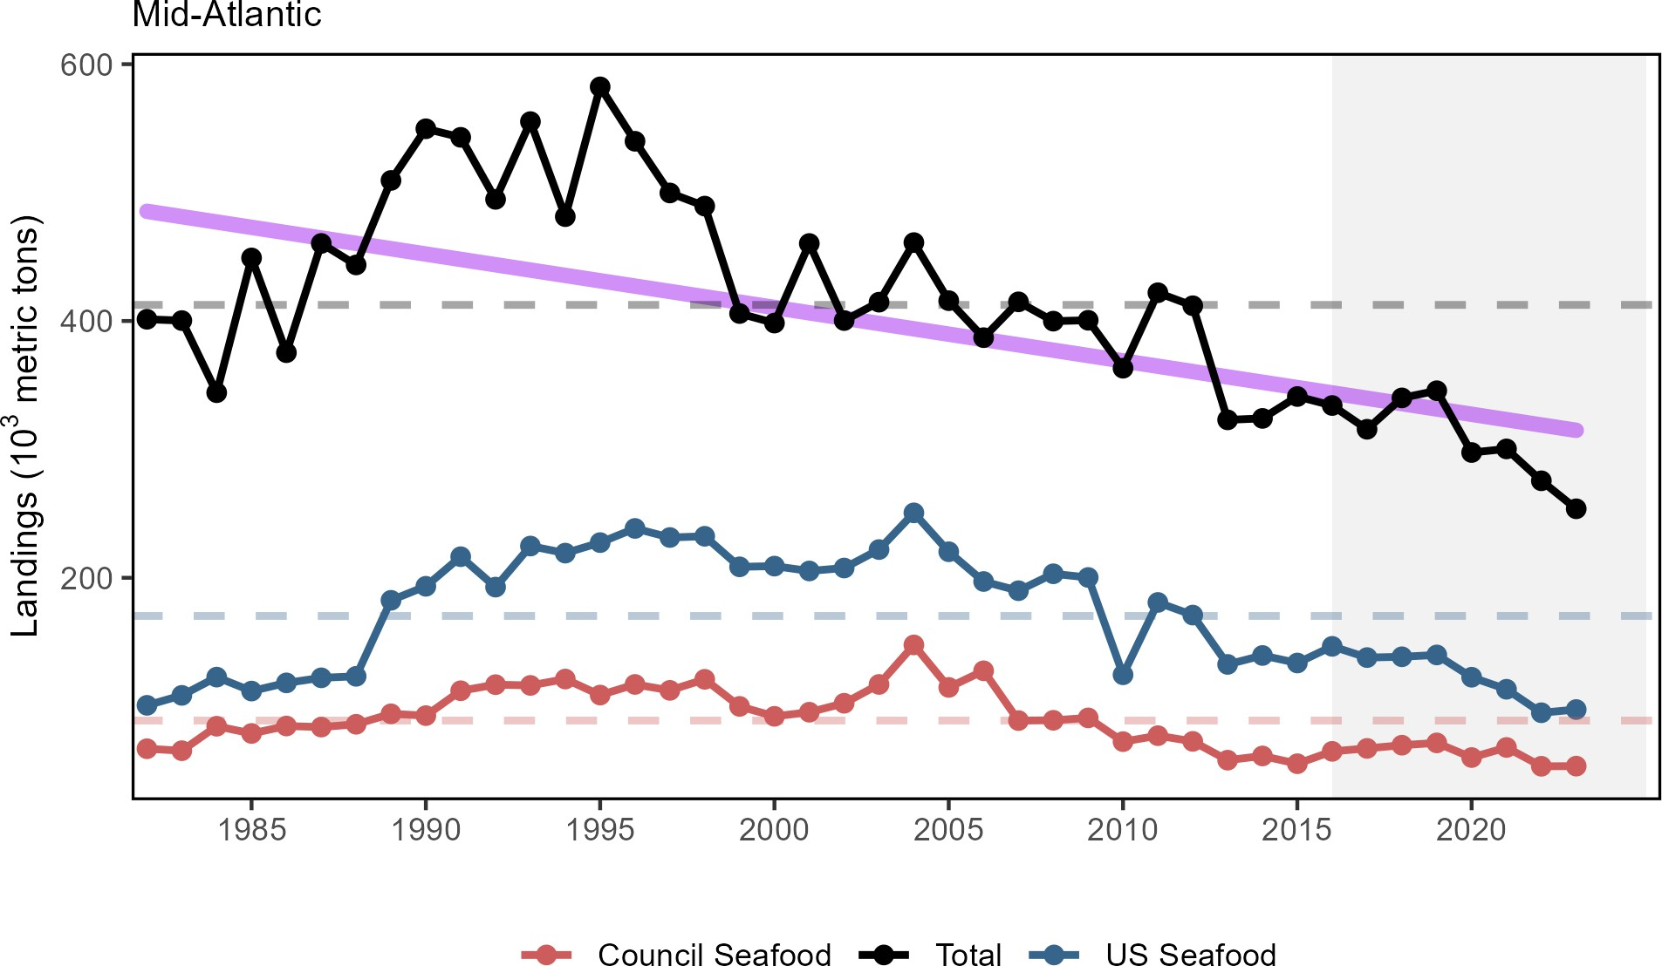

Figure 1: Total commercial landings (black), total U.S. seafood landings (blue), and Mid-Atlantic managed U.S. seafood landings (red), with significant decline (purple) in total landings.

Commercial landings by guild include all species and all uses, and are reported as total for the guild and the MAFMC managed species within the guild. Landings of benthos have been below the long term average since 2010, primarily driven by surf clam and ocean quahog, with scallops now contributing to the decline as well. Total landings of planktivores is presenting a significant downward trend, primarily due to decreases in species not managed by the MAFMC (Atlantic herring and Atlantic menhaden; Fig. 2).

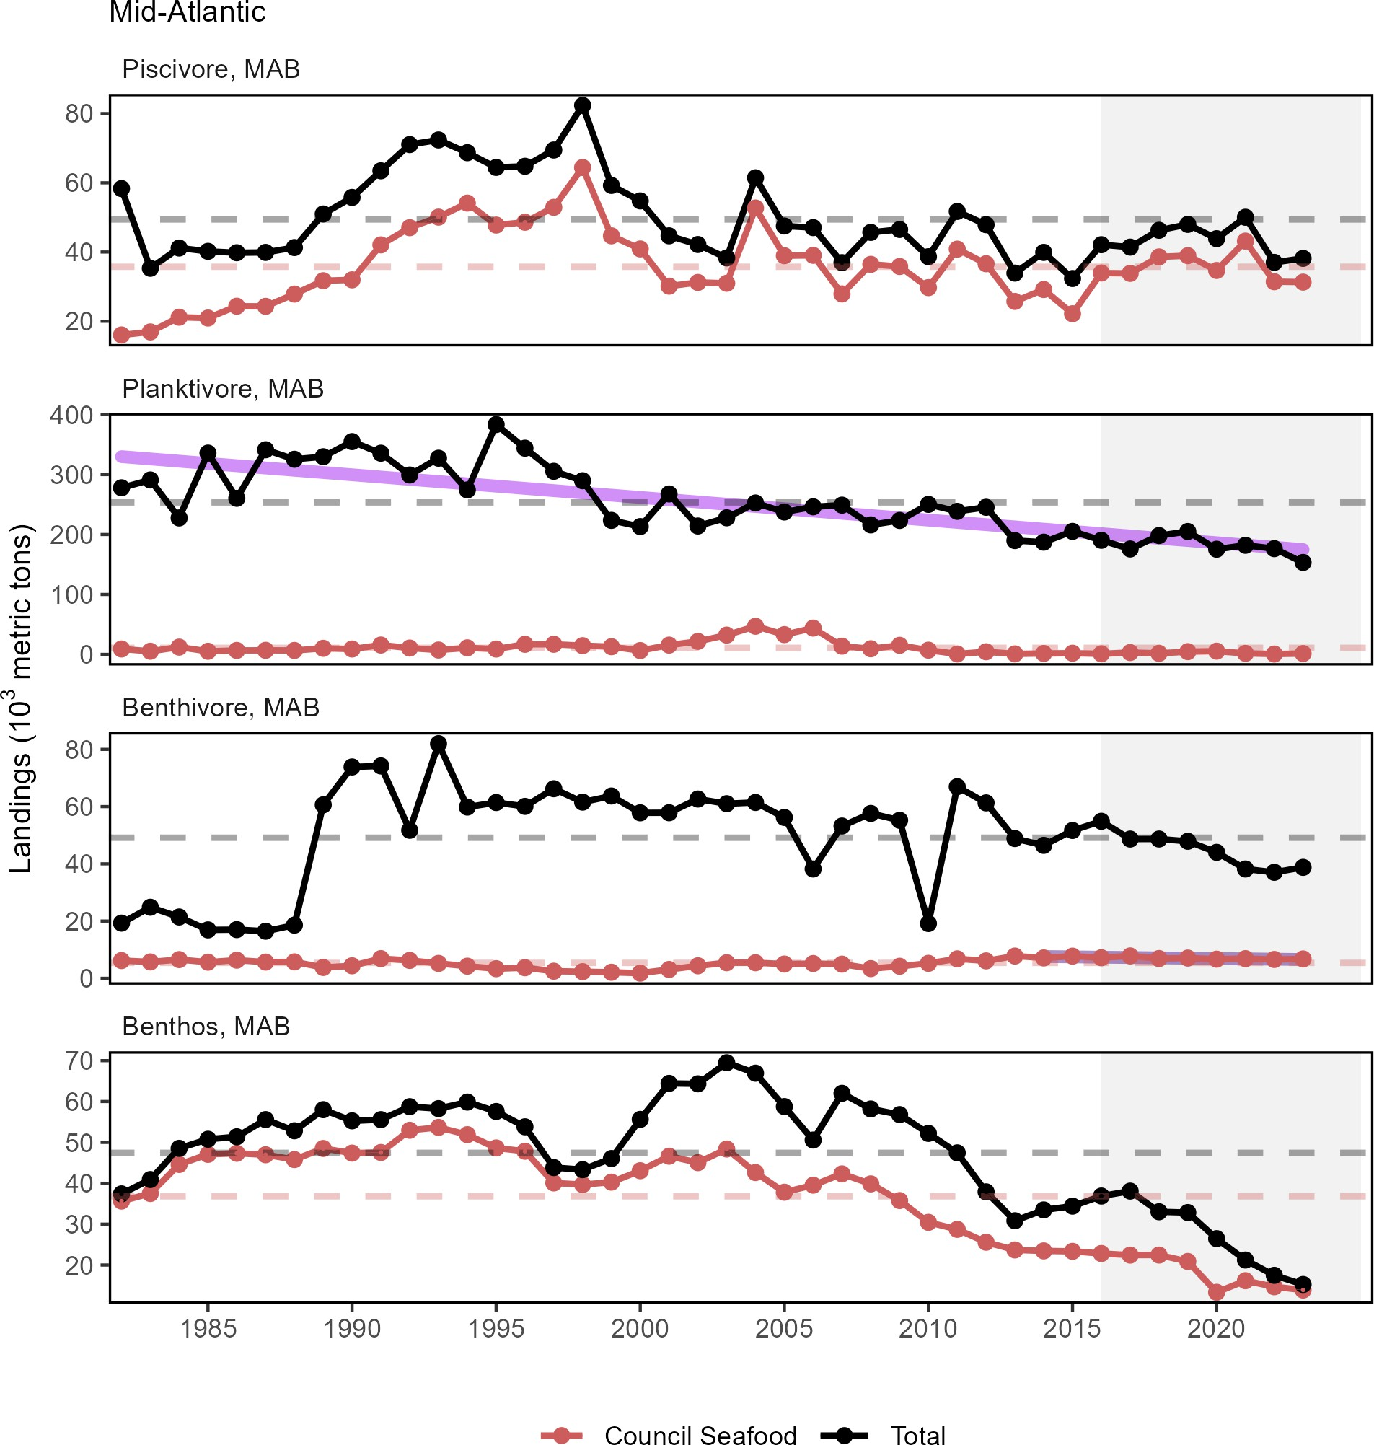

Figure 2: Total commercial landings in the Mid-Atlantic Bight (black) and MAFMC-managed U.S seafood landings (red) by feeding guild, with significant declines (purple) in total planktivore landings.

Community Climate Change Risk indicators have been developed to evaluate port specific landings and revenue risk in terms of commercial species climate vulnerability. The total climate vulnerability is a measure of to what degree a region’s landings (or revenue) is dependent on species sensitive to different climate and environmental change factors including temperature and acidification. For ports combined across Mid-Atlantic states, the total climate vulnerability of landings ranged between moderate and high with a long term increase from 2000-2021 (Fig. 3).

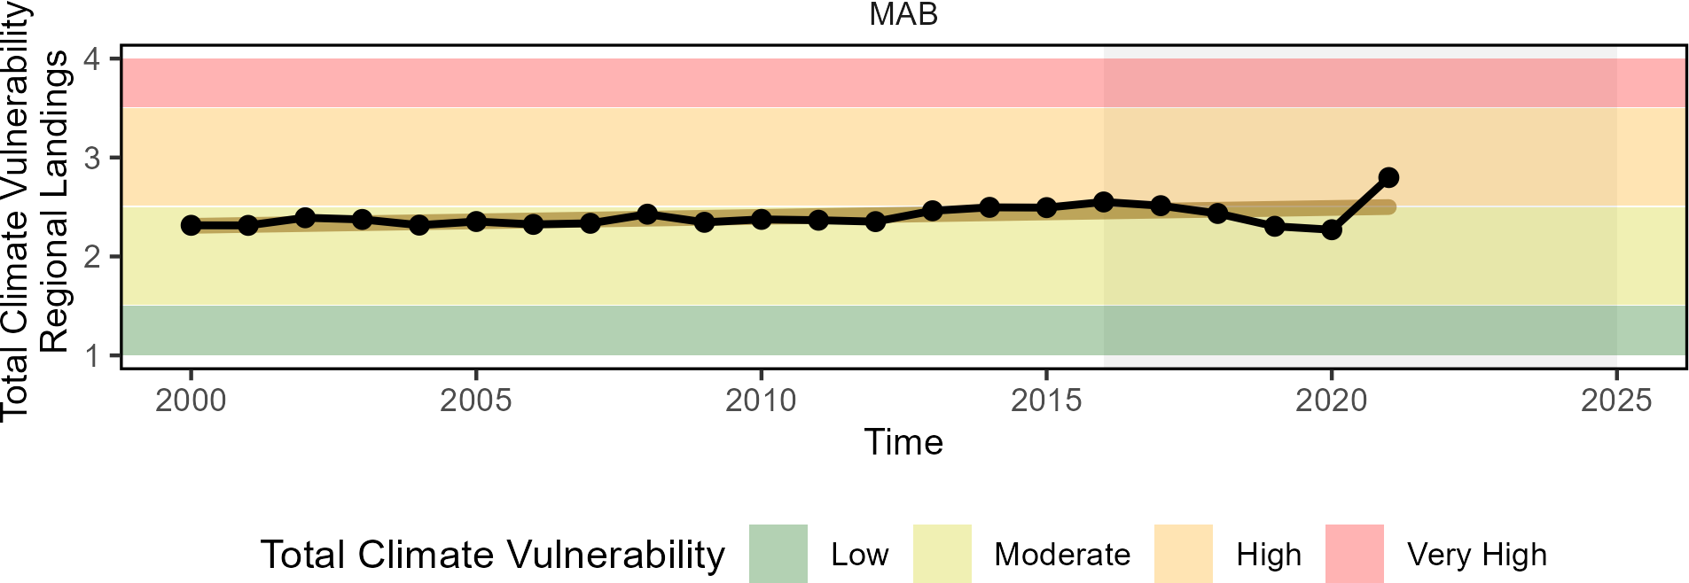

Figure 3: Mid-Atlantic region total climate vulnerability of commercial landings (sum of Mid-Atlantic port landings weighted by species climate vulnerability from Hare et al. 2016).

Although total recreational harvest (fish presumed to be eaten) has increased from a historic low in 2018, there is a long-term decline in the Mid-Atlantic (Fig. 4).
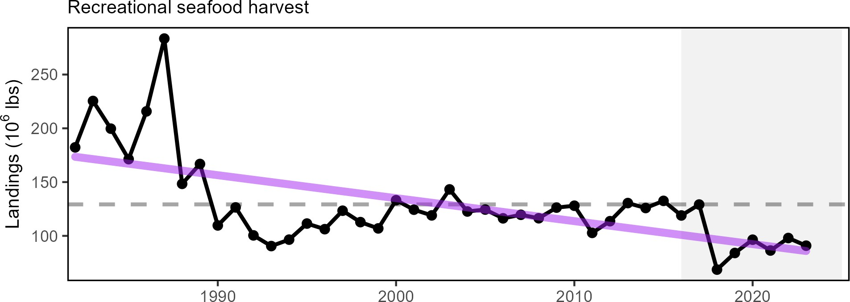

Figure 4: Total recreational seafood harvest (millions of pounds, black, significant decrease, purple) in the Mid-Atlantic region.

Recreational shark landings have generally decreased for most shark groups through 2023 (Fig 5). The recent low in pelagic shark landings is likely influenced by regulatory changes implemented in 2018 intended to rebuild shortfin mako stocks and comply with binding recommendations by the International Commission for the Conservation of Atlantic Tunas (ICCAT).

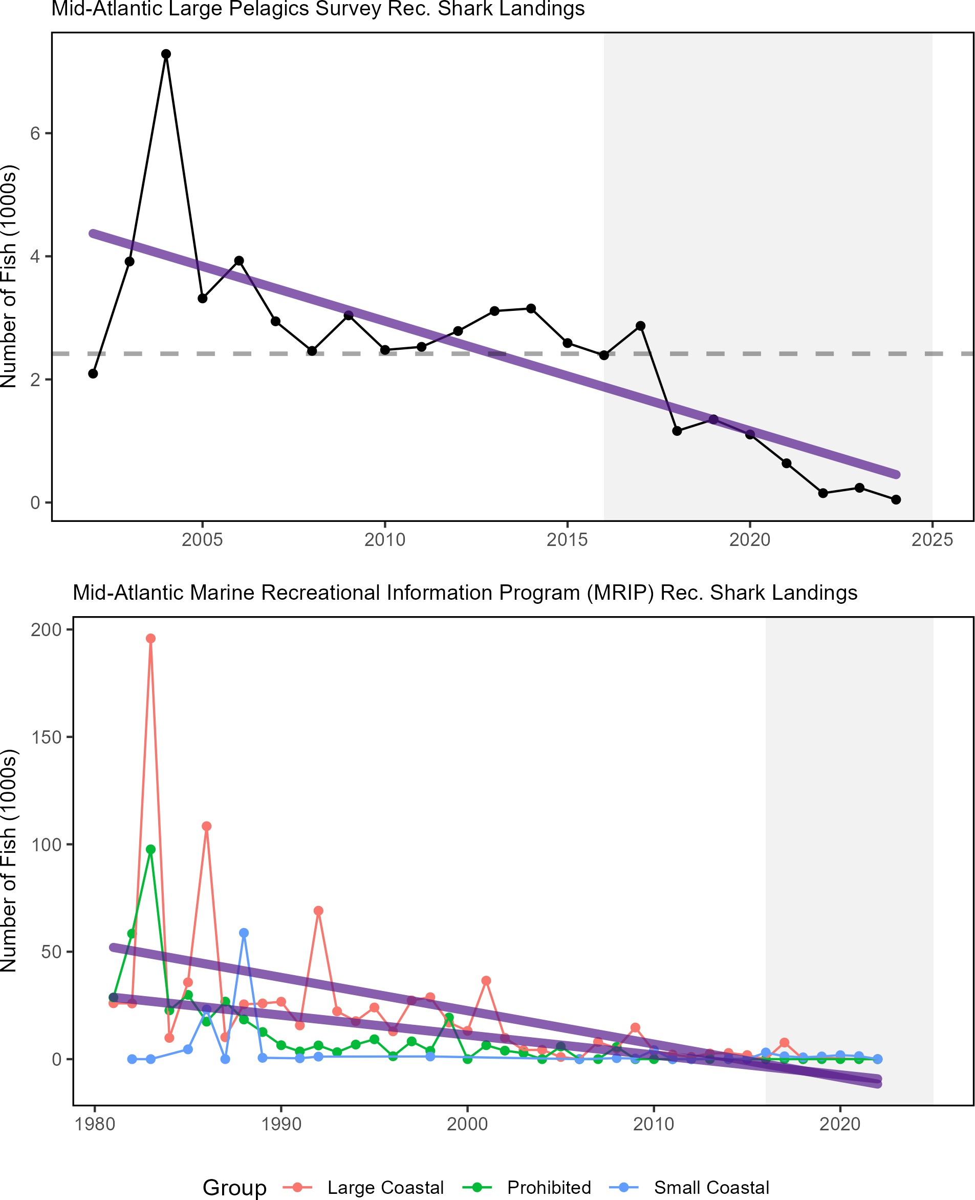

Figure 5: Recreational shark landings from Marine Recreational Information Program (top) and Large Pelagics Survey (bottom) with declining trends (purple).

Aquaculture production is not yet included in total seafood landings. Available aquaculture production of oysters for a subset of Mid-Atlantic states indicates a decline in recent years.

Implications
Declining commercial (total and seafood) landings and recreational harvest can be driven by many interacting factors, including combinations of ecosystem and stock production, management actions, market conditions, and environmental change. While we cannot evaluate all possible drivers at present, here we evaluate the extent to which stock status, management, and system biomass trends may play a role.

Stock Status and Catch Limits Single species management objectives (1. maintaining biomass above minimum thresholds and 2. maintaining fishing mortality below overfishing limits) are being met for all but three MAFMC- managed species (Fig. 6), though the status of six stocks is unknown (Table 3).

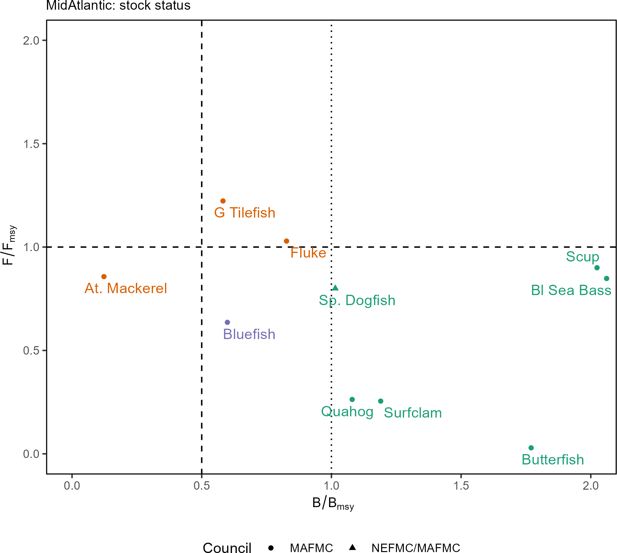

Figure 6: Summary of single species status for MAFMC and jointly federally managed stocks (Spiny dogfish and both Goosefish). The dotted vertical line is the target biomass reference point of BMSY . The dashed lines are the management thresholds of one half BMSY (vertical) or FMSY . (horizontal). Stocks in orange are below the biomass threshold (overfished) or have fishing mortality above the limit (subject to overfishing), so are not meeting objectives. Stocks in purple are above the biomass threshold but below the biomass target with fishing mortality within the limit. Stocks in green are above the biomass target, with fishing mortality within the limit.

Table 3: Unknown or partially known stock status for MAFMC and jointly managed species.

Stock | F/Fmsy | B/Bmsy
Longfin inshore squid - Georges Bank / Cape Hatteras | - | 2.873
Northern shortfin squid - Northwestern Atlantic Coast | - | -

Table 3: Unknown or partially known stock status for MAFMC and jointly managed species.

Stock | F/Fmsy | B/Bmsy
Goosefish - Gulf of Maine / Northern Georges Bank | - | -
Goosefish - Southern Georges Bank / Mid-Atlantic | - | -
Blueline tilefish - Mid-Atlantic Coast | - | -
Chub mackerel - Atlantic | - | -

Stock status affects catch limits established by the Council, which in turn may affect landings trends. Summed across all MAFMC managed species, total Acceptable Biological Catch or Annual Catch Limits (ABC or ACL) have been relatively stable 2012-2023 (Fig. 7). The recent total ABC or ACL is lower relative to 2012-2013, with much of that decrease due to declining Atlantic mackerel ABC. This is true even with the addition of blueline tilefish management contributing an additional ABC to the total post-2017, due to that fishery’s small relative size.
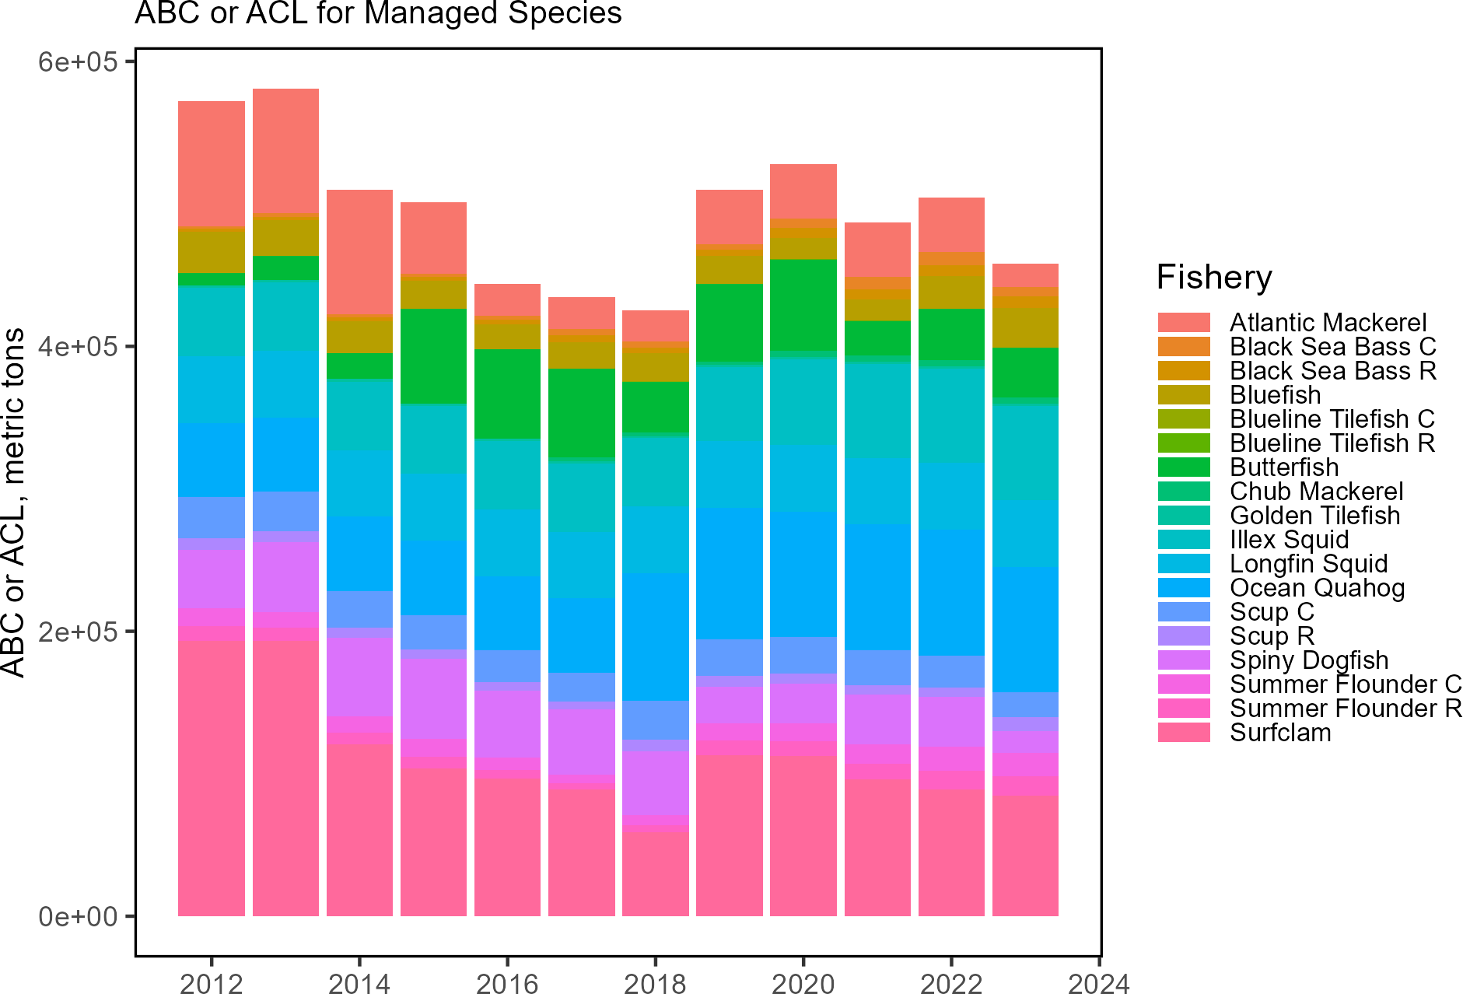

Figure 7: Top: Sum of catch limits across all MAFMC managed species. Bottom: Catch limits by species for MAFMC commercial (C) and recreational (R) fisheries.

Nevertheless, the percentage caught (landings and discards) for each stock’s ABC/ACL suggests that these catch limits are not generally constraining as most species are well below the 1/1 ratio (Fig. 8). Therefore, stock status and associated management constraints are unlikely to be driving decreased landings for the majority of species.

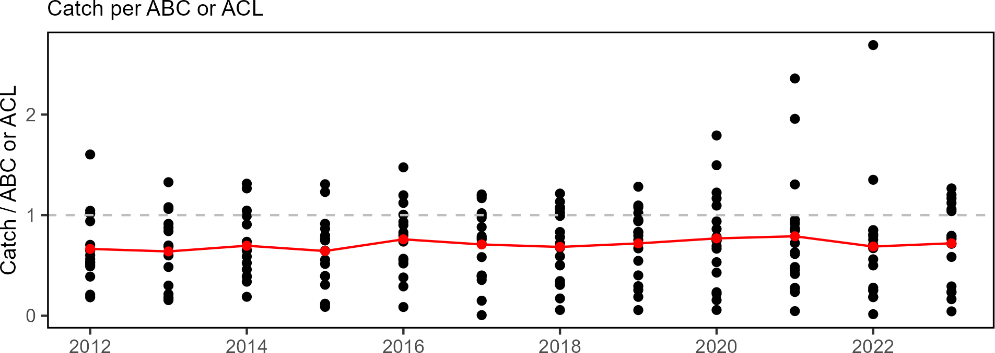

Figure 8: Catch divided by ABC/ACL for MAFMC managed fisheries. High points are recreational black sea bass (up to 2021) and scup (2022). Red line indicates the median ratio across all fisheries.

System Biomass Although aggregate biomass trends derived from scientific resource surveys are mostly stable in the MAB, spring piscivores, fall benthivores, and fall benthos show long-term increases (Fig. 9). While managed species make up varying proportions of aggregate biomass, trends in landings are not mirroring shifts in the overall trophic structure of survey-sampled fish and invertebrates. Therefore, major shifts in feeding guilds or ecosystem trophic structure are unlikely to be driving the decline in landings.

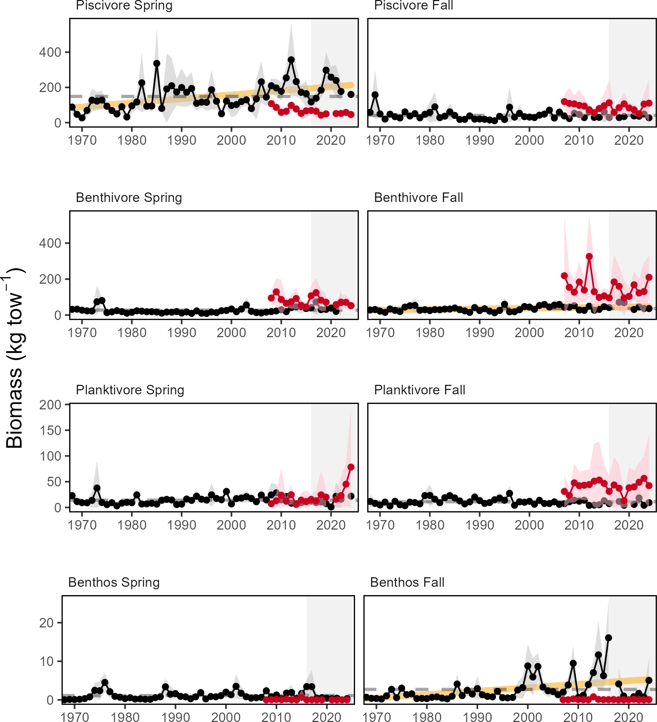

Figure 9: Spring (left) and fall (right) surveyed biomass in the Mid-Atlantic Bight. Data from the NEFSC Bottom Trawl Survey are shown in black, with the nearshore NEAMAP survey shown in red. Significant increases (orange lines) are present for spring piscivore and fall benthivore and benthos biomass. The shaded area around each annual mean represents 2 standard deviations from the mean.

Effect on Seafood Production Stock status is above the minimum threshold for all but one stock, and aggregate biomass trends appear stable or increasing, so the decline in managed commercial seafood landings is most likely driven by market dynamics affecting the landings of surfclams and ocean quahogs, as landings have been below

quotas for these species. In addition, regional availability of scallops has contributed to the decline of benthos landings not managed by the MAFMC, with some of the most productive grounds closed through 2023 due to rotational management. The long term decline in total planktivore landings, and total landings, is largely driven by Atlantic menhaden fishery dynamics, including a consolidation of processors leading to reduced fishing capacity between the 1990s and mid-2000s.
The distribution of surfclams and ocean quahogs is changing, resulting in areas with overlapping distributions and increased mixed landings. Given the regulations governing mixed landings, this could have become problematic and the Council recently took final action to address this issue.
The decline in recreational seafood harvest stems from other drivers. Some of the decline, such as that for recreational shark landings, is driven by management intended to reduce fishing mortality on mako sharks. However, NOAA Fisheries’ Marine Recreational Information Program survey methodology was updated in 2018, so it is unclear whether the lower than average landings for species other than sharks since 2018 are driven by changes in fishing behavior or the change in the survey methodology. Nevertheless, the recreational harvest appears to be stabilizing at a lower level than historical estimates.
Other environmental changes require monitoring as they may become important drivers of commercial and recreational landings in the future. Overall, landings from Mid-Atlantic ports depend on species with moderate climate vulnerability, and the proportion of landings with higher vulnerability has increased over time. We note that individual stocks will respond differently to these drivers, and fisheries and communities rely on different combinations of stocks:
- Climate is trending into uncharted territory. Globally, 2024 was the warmest year on record (see 2024 Highlights section).
- Stocks are shifting their distributions, moving towards the northeast and into deeper waters throughout the Northeast US Large Marine Ecosystem (see Climate Risks section).
- Some ecosystem composition and production changes have been observed (see Stability section).
- Some fishing communities are affected by socioeconomic vulnerabilities (see Community Social and Climate Vulnerability section).

parent_report.Rmd 01_seafood_production_newengland.Rmd
Indicators: Landings; commercial and recreational
This year, we present updated indicators for total commercial landings, U.S. seafood landings (includes seafood, bait, and industrial landings), and Council-managed U.S. seafood landings through 2023. There are long-term declines in all New England landings time series except for total commercial landings on GB (Fig. 1). There exist long-term declines in commercial seafood landings and NEFMC managed seafood landings for both the GOM and GB, but over the last decade there is no trend in managed seafood landings in the GOM.

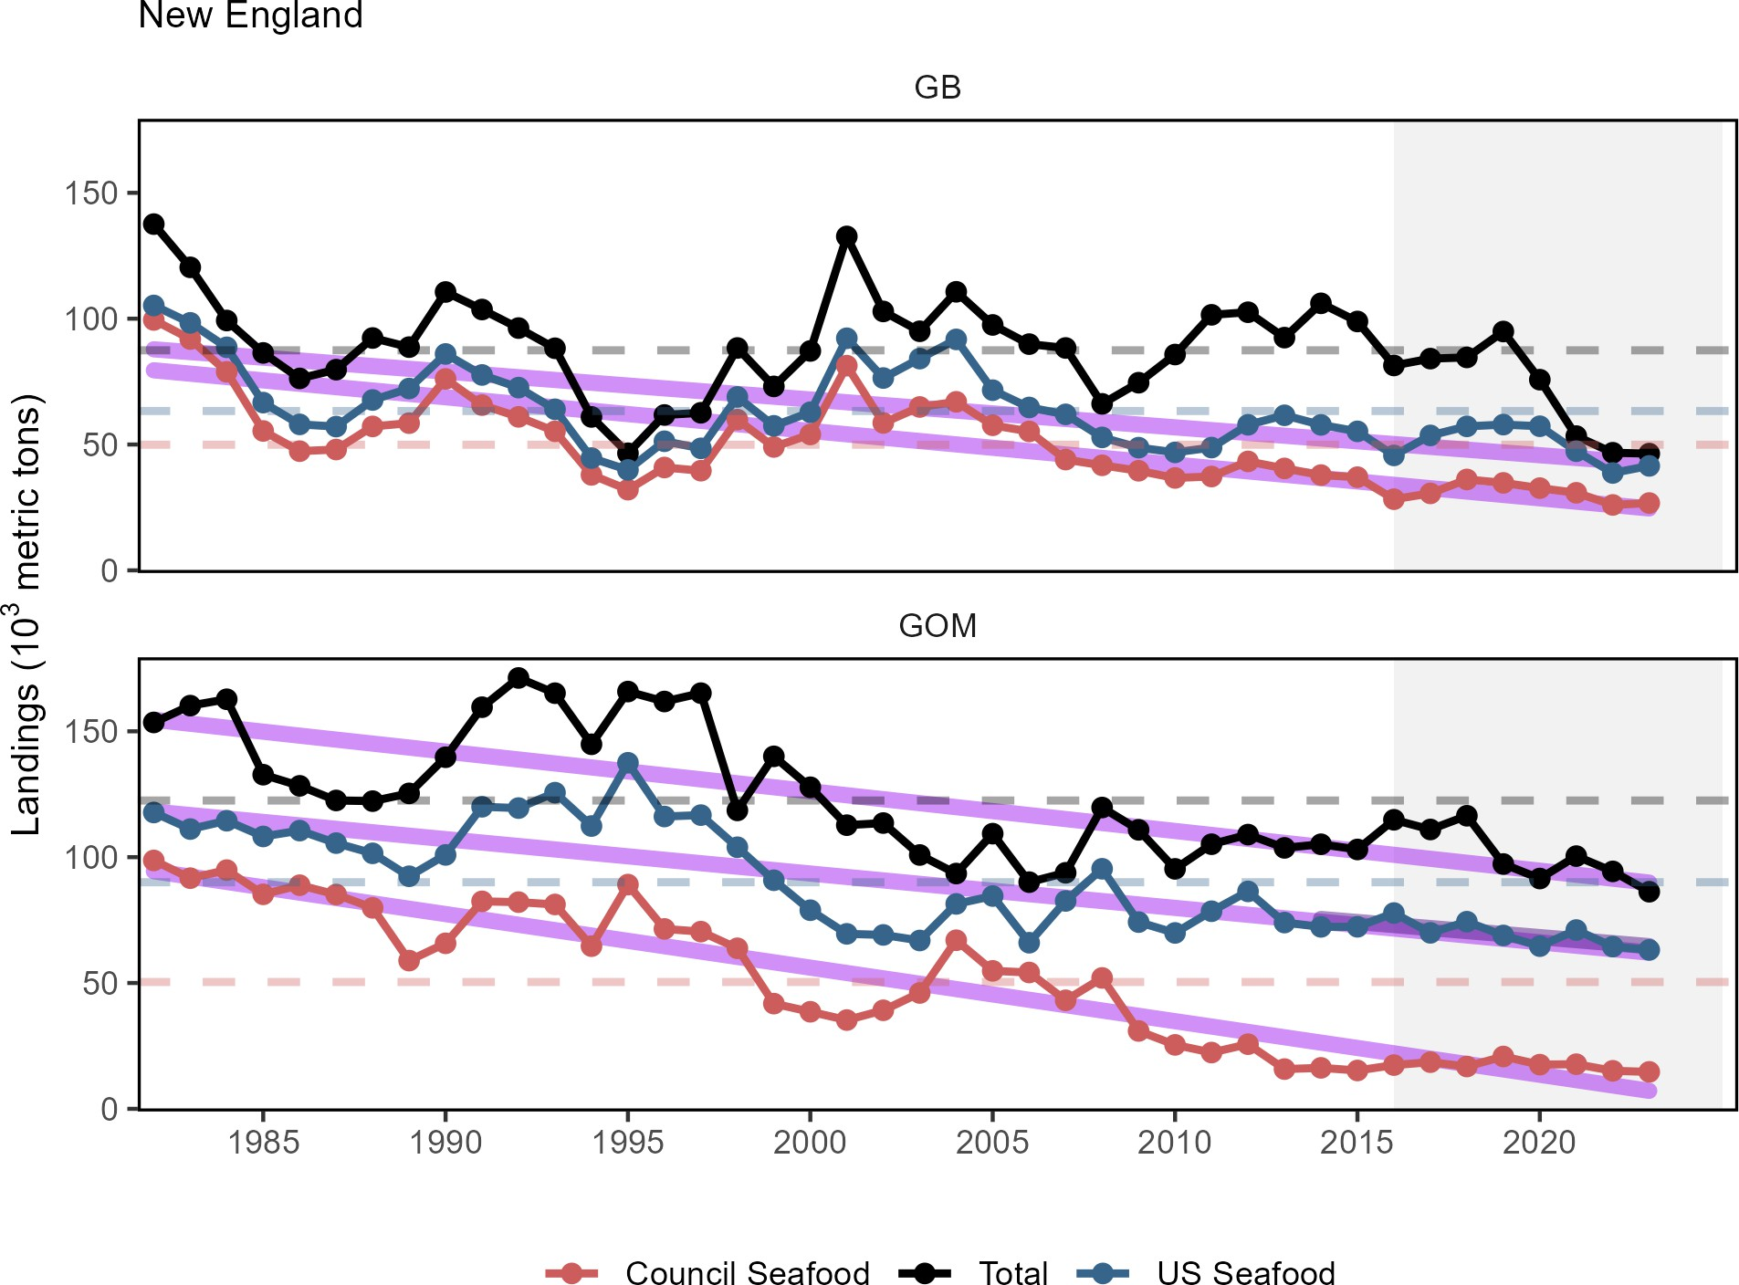

Figure 10: Total commercial landings (black), total U.S. seafood landings (blue), and New England managed U.S. seafood landings (red) for Georges Bank (GB) and the Gulf of Maine (GOM).

Commercial landings by guild include all species and all uses, and are reported as total for the guild and the NEFMC managed species within the guild. As reported in previous years, downward trends persist for a number of guilds in both regions. Current high total landings for benthivores (GOM) are attributable to American lobster, and a significant long term increase in benthos landings (GB) is attributable to clams and scallops (Fig. 2).Current landings of planktivores are still below the long term mean.
Aquaculture production is not yet included in total seafood landings.

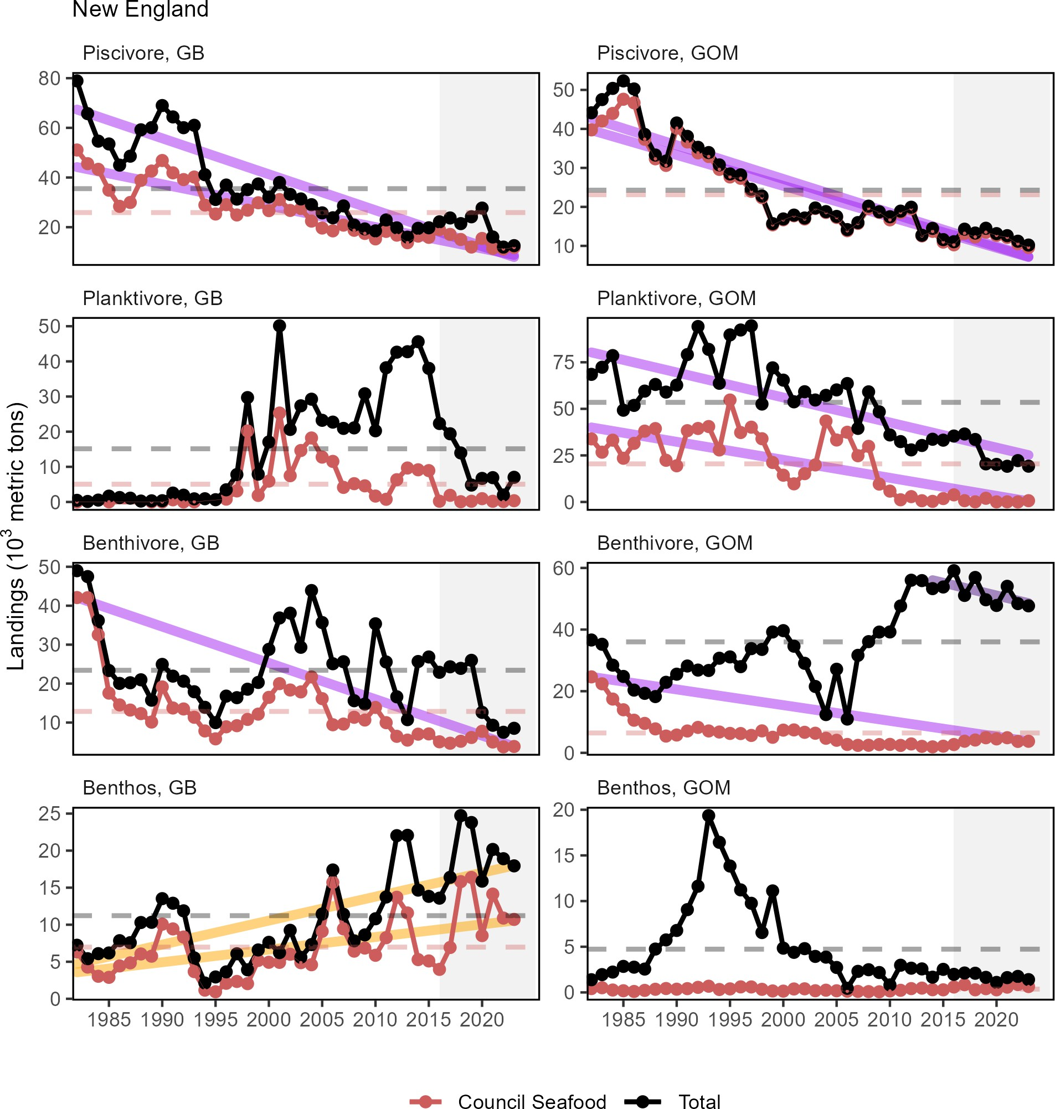

Figure 11: Total commercial landings (black) and NEFMC managed U.S seafood landings (red) by feeding guild for the Gulf of Maine (GOM, right) and Georges Bank (GB, left).

Total Community Climate Change Risk is a measure of to what degree a region’s landings (or revenue) is dependent on sensitivity and exposure factors that relate to species’ risk to temperature or ocean acidification changes as the result of future climate change. For New England, the total climate vulnerability of landings (Fig. 3) was moderate in 2022 with no long-term trend suggesting a moderate reliance on climate-sensitive species. This proportion has not significantly changed since 2000.

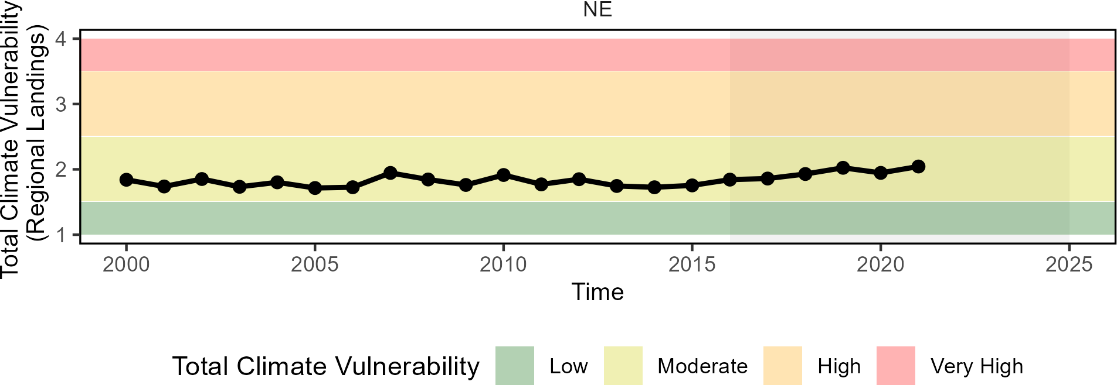

Figure 12: Total climate vulnerability on New England landings from 2000 to 2022. Horizontal colored bars show different climate risk levels.

Overall, recreational harvest (retained fish presumed to be eaten) has declined in New England (Fig. 4). However, recent harvest has remained above the historical low level in 2020. Recreational shark landings of pelagic and prohibited sharks have declined since 2018 (Fig 5), which is likely influenced by regulatory changes implemented in 2018 intended to rebuild shortfin mako stocks and comply with binding recommendations by the International Commission for the Conservation of Atlantic Tunas (ICCAT).
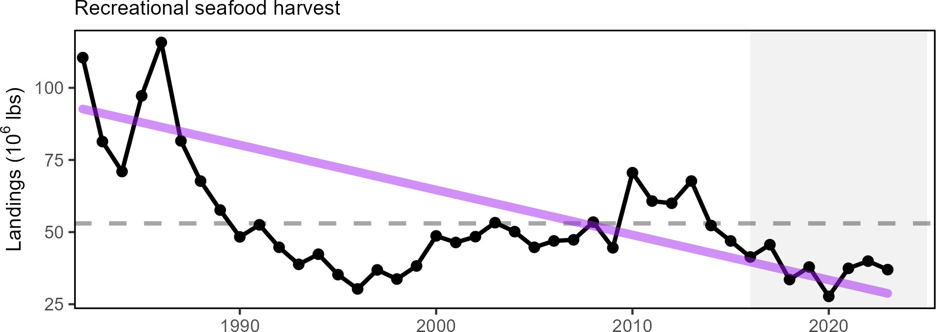

Figure 13: Total recreational seafood harvest (millions of pounds) in the New England region.

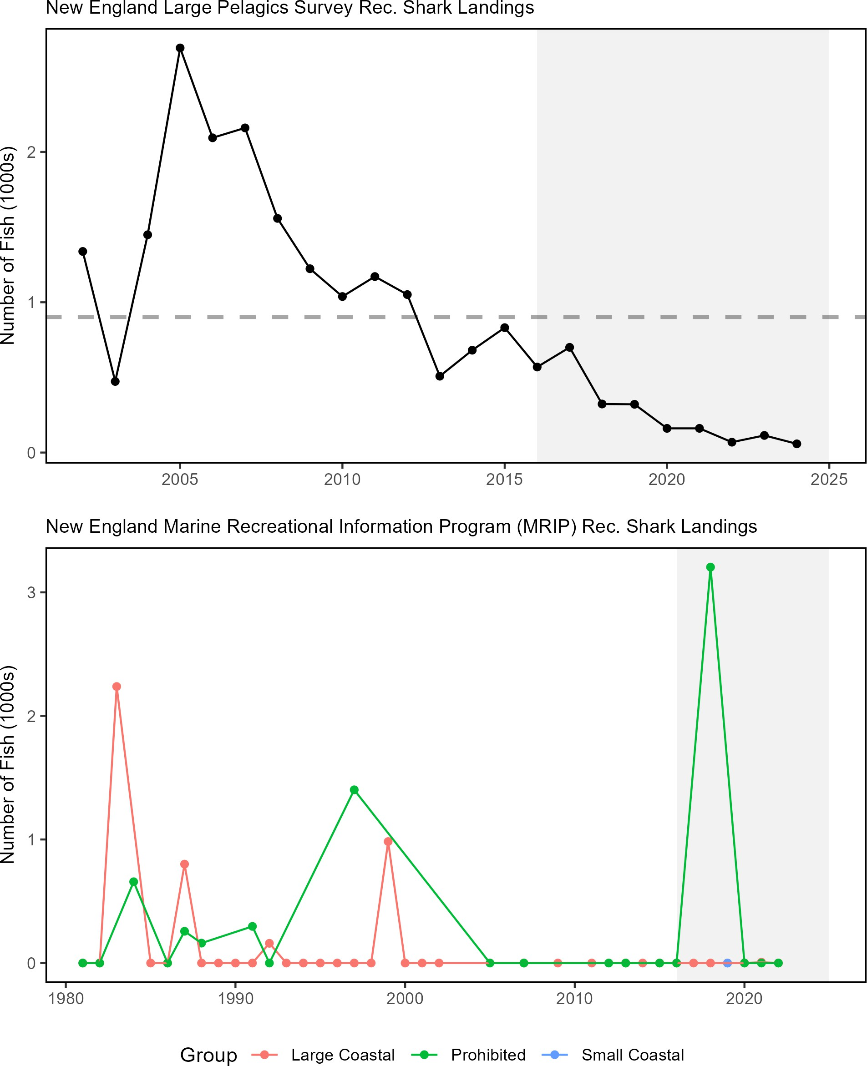

Figure 14: Recreational shark landings from Marine Recreational Information Program (top) and Large Pelagics Survey (bottom)

Implications
Declining commercial (total and seafood) landings and recreational harvest can be driven by many interacting factors, including combinations of ecosystem and stock production, management actions, market conditions, and environmental change. While we cannot evaluate all possible drivers at present, here we evaluate the extent to which stock status, management, and system biomass trends may play a role.

Stock Status Single species management objectives (1. maintaining biomass above minimum thresholds and 2. maintaining fishing mortality below overfishing limits) are not being met for some NEFMC managed species. Thirteen stocks are currently estimated to be below B_{MSY} (Fig. 6), while status relative to B_{MSY} could not be assessed for 13 additional stocks (Table 4). Therefore, stock status and associated management constraints are likely contributing to decreased landings. To better address the role of management in future reports, we could examine how the total allowable catch (TAC) and the percentage of the TAC taken for each species has changed through time.
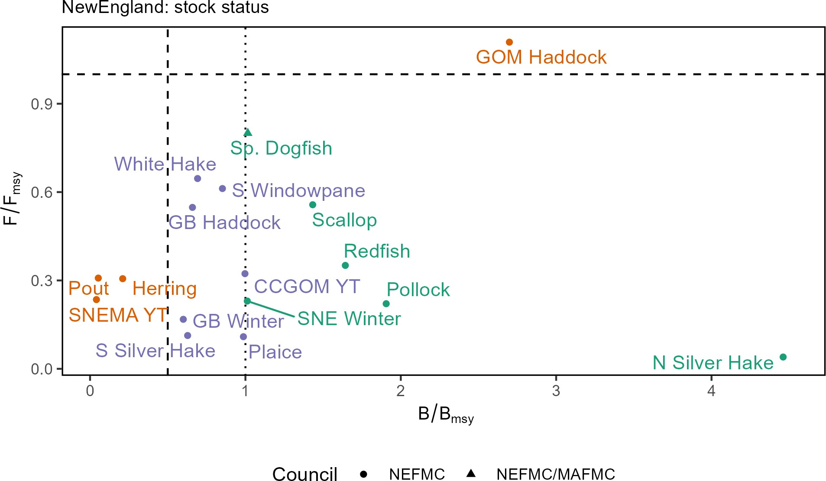

Figure 15: Summary of single species status for NEFMC and jointly federally managed stocks (goosefish and spiny dogfish). The dotted vertical line at one is the target biomass reference point of B. The dashed lines are the management thresholds of B (vertical) or F (horizontal). Colors denote stocks with B/BM SY < 0.5 or F/FMSY (orange), stocks 0.5<B/BM SY <1 (blue), and stocks B/BM SY >1 (green).CCGOM = Cape Cod Gulf of Maine, GOM = Gulf of Maine, GB = Georges Bank, SNEMA = Southern New England Mid Atlantic

Table 4: Unknown or partially known stock status for NEFMC and jointly managed species.

Stock | F/Fmsy | B/Bmsy
Atlantic cod - Georges Bank¹ | - | -
Atlantic cod - Gulf of Maine¹ | - | -
Atlantic halibut - Northwestern Atlantic Coast | - | -
Barndoor skate - Georges Bank / Southern New England | - | 1.070

Table 4: Unknown or partially known stock status for NEFMC and jointly managed species.

Stock | F/Fmsy | B/Bmsy
Clearnose skate - Southern New England / Mid-Atlantic | - | 0.802
Little skate - Georges Bank / Southern New England | - | 0.580
Offshore hake - Northwestern Atlantic Coast | - | -
Red deepsea crab - Northwestern Atlantic | - | -
Red hake - Gulf of Maine / Northern Georges Bank | - | -
Red hake - Southern Georges Bank / Mid-Atlantic | - | -
Rosette skate - Southern New England / Mid-Atlantic | - | 1.075
Smooth skate - Gulf of Maine | - | 0.696
Thorny skate - Gulf of Maine | - | 0.035
Windowpane - Gulf of Maine / Georges Bank | - | -
Winter flounder - Gulf of Maine | - | -
Winter skate - Georges Bank / Southern New England | - | 1.120
Witch flounder - Northwestern Atlantic Coast | - | -
Yellowtail flounder - Georges Bank | 0.09 | -
Goosefish - Gulf of Maine / Northern Georges Bank | - | -
Goosefish - Southern Georges Bank / Mid-Atlantic | - | -
1The most recent cod assessment made stock status recommendations for the four new stocks (Eastern Gulf of Maine, Western Gulf of Maine, Georges Bank, and Southern New England) but were not available yet for this report.

System Biomass Aggregate biomass trends derived from scientific resource surveys have been stable to increasing in both regions (Fig. 16 & Fig. 17).The benthivores group spiked during the last decade, due to a large haddock recruitment, but appears to be returning to average levels. Planktivore biomass on GB continues to rise with the highest fall biomass observed since 1968. There are mixed trends in piscivores on GB, and increasing trends for planktivores across both regions and seasons and benthos on GB in both seasons. The New Hampshire/Maine state survey time series is too short to estimate trends, while the Massachusetts state survey shows the increasing trend in planktivores in the fall but a decrease in piscivores in the spring and benthos in both seasons (Fig. 18). While managed species comprise varying proportions of aggregate biomass, trends in landings are not mirroring shifts in the overall trophic structure of survey-sampled fish and invertebrates. Therefore, major shifts in feeding guilds or ecosystem trophic structure are unlikely to be driving the decline in landings.

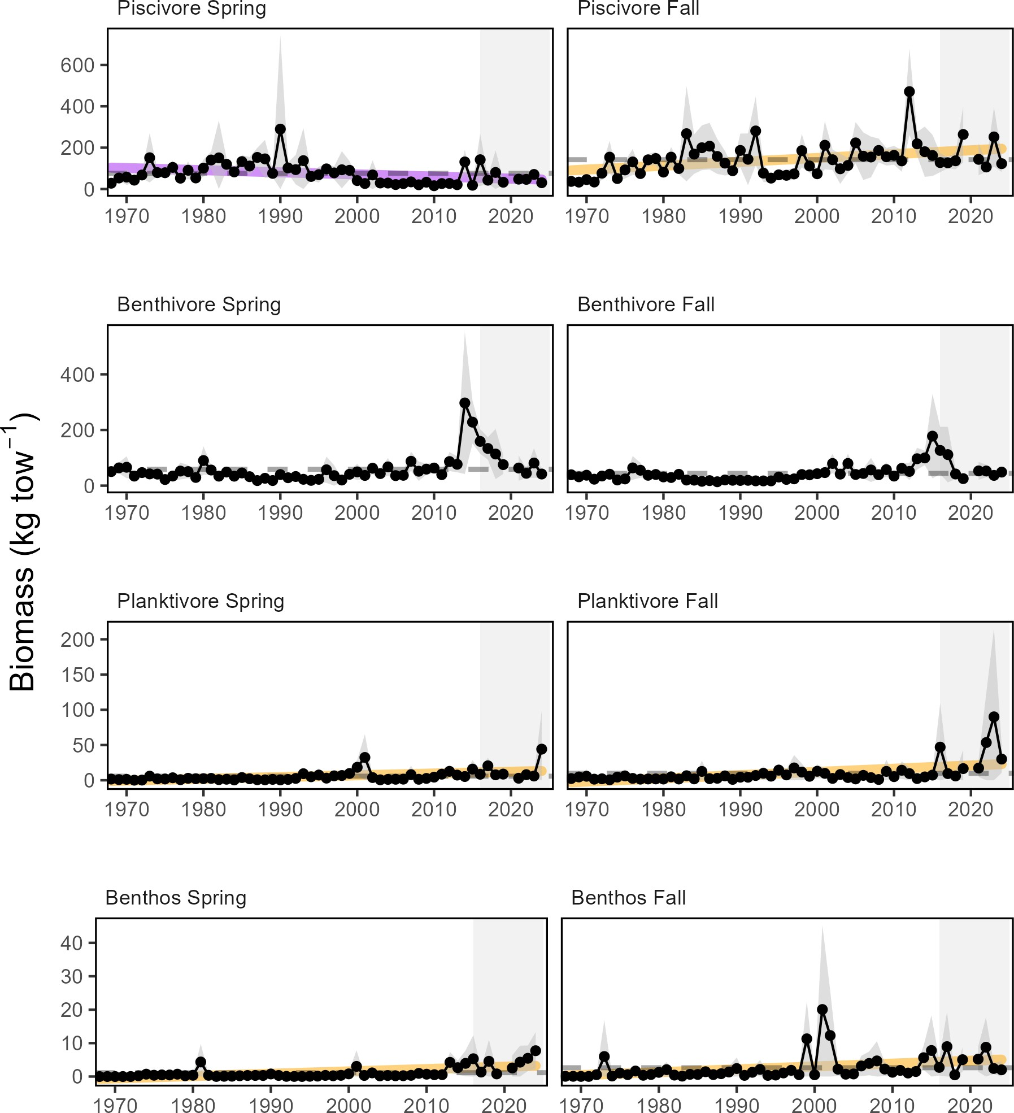

Figure 16: Spring (left) and fall (right) surveyed biomass on Georges Bank. The shaded area around each annual mean represents 2 standard deviations from the mean.

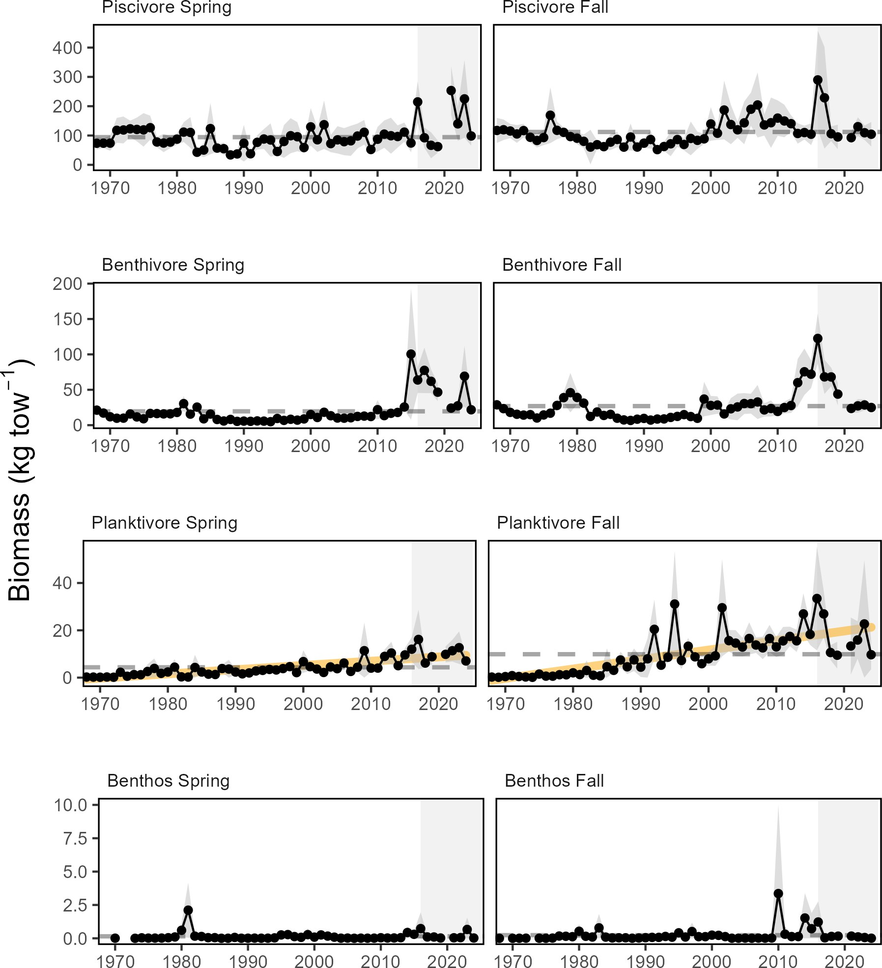

Figure 17: Spring (left) and fall (right) surveyed biomass in the Gulf of Maine. The shaded area around each annual mean represents 2 standard deviations from the mean.

Effect on Seafood Production With the poor or unknown stock status of many managed species, the decline in commercial seafood landings in the Gulf of Maine most likely reflects lower catch quotas implemented to rebuild overfished stocks, as well as market dynamics.
The decline in recreational seafood harvest stems from multiple drivers. Some of the decline, such as for recreational

shark landings, continues to be driven by tightening regulations. However, changes in demographics and preferences for recreational activities likely play a role in non-HMS (Highly Migratory Species) declines in recreational harvest, with current harvests well below the time series average.
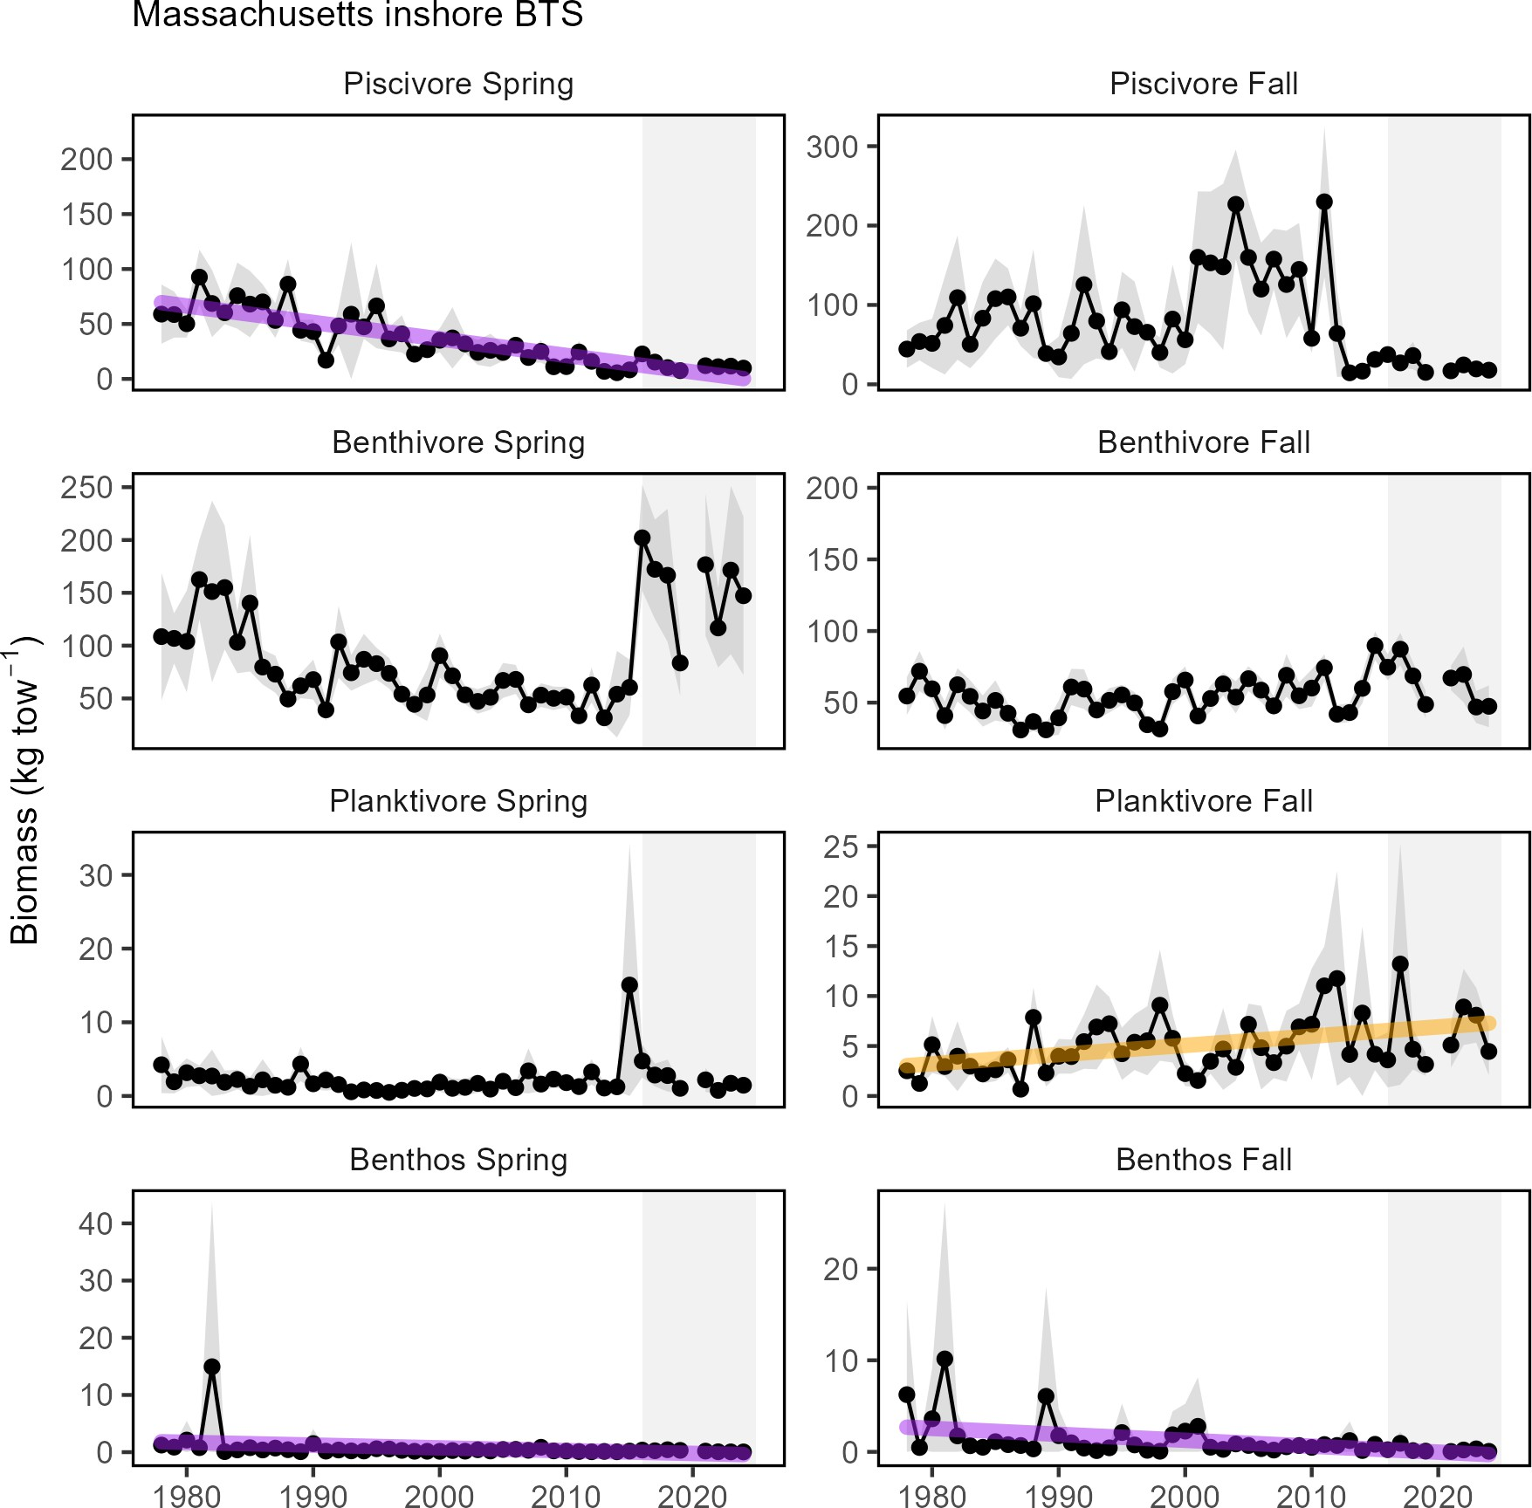

Figure 18: Spring (left) and fall (right) surveyed biomass from the state of Massachusetts inshore survey. The shaded area around each annual mean represents 2 standard deviations from the mean.

Other environmental changes require monitoring as they may become important drivers of future landings:
- Climate is trending into uncharted territory. Globally, 2024 was the warmest year on record5 (see 2024

5https://noaa-edab.github.io/catalog/observation_synthesis.html

Highlights section).
- Stocks are shifting their distribution, moving towards the northeast and into deeper waters throughout the Northeast US Large Marine Ecosystem (Fig. 54, Climate Risks section).
- Ecosystem composition and production changes have been observed (see Stability section).
- Some fishing communities are affected by social vulnerabilities (see Social Vulnerability section).

parent_report.Rmd
Commercial Profits

02_commercial_profits_midatlantic.Rmd
Indicators: revenue (a proxy for profits)
Total commercial revenue and MAFMC managed species revenue within the Mid-Atlantic Bight have declined over the past 20-30 years. In 2023, total revenue was at an all-time low, and revenue from MAFMC managed species was near an all-time low (Fig. 19).
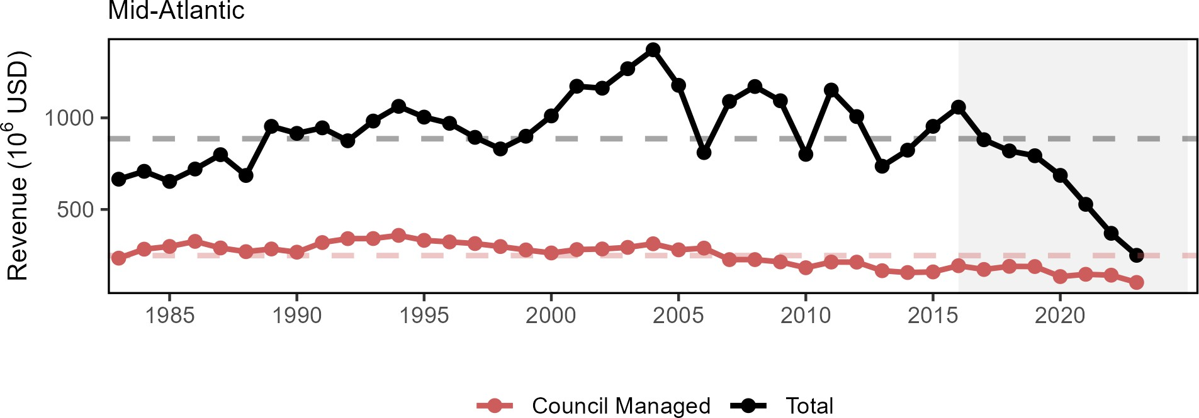

Figure 19: Revenue for the for the Mid-Atlantic region: total (black) and from MAFMC managed species (red).

Revenue earned by harvesting resources is a function of both the quantity landed of each species and the prices paid for landings. Beyond monitoring yearly changes in revenue, it is even more valuable to determine what drives these changes: harvest levels, the mix of species landed, price changes, or a combination of these. The Bennet Indicator decomposes revenue change into two parts, one driven by changing quantities (volumes), and a second driven by changing prices. All changes are in relation to a base year (1982). The 1982 base year was selected because that is the first year the relevant data is available and it also allows for an extended period of time in which to evaluate market trends and dynamics.
In the Mid-Atlantic region revenues were above the 1982 baseline for all years in the series until 2022 and 2023 (Fig. 20). In 2023, lower revenue was driven primarily by both lower quantities of benthos landed, and lower prices of benthos, benthivores, and planktivores. The lower benthos prices are a departure from past years, which saw benthos prices contributing positively to revenue changes since the early 2000’s. (Fig. 21).

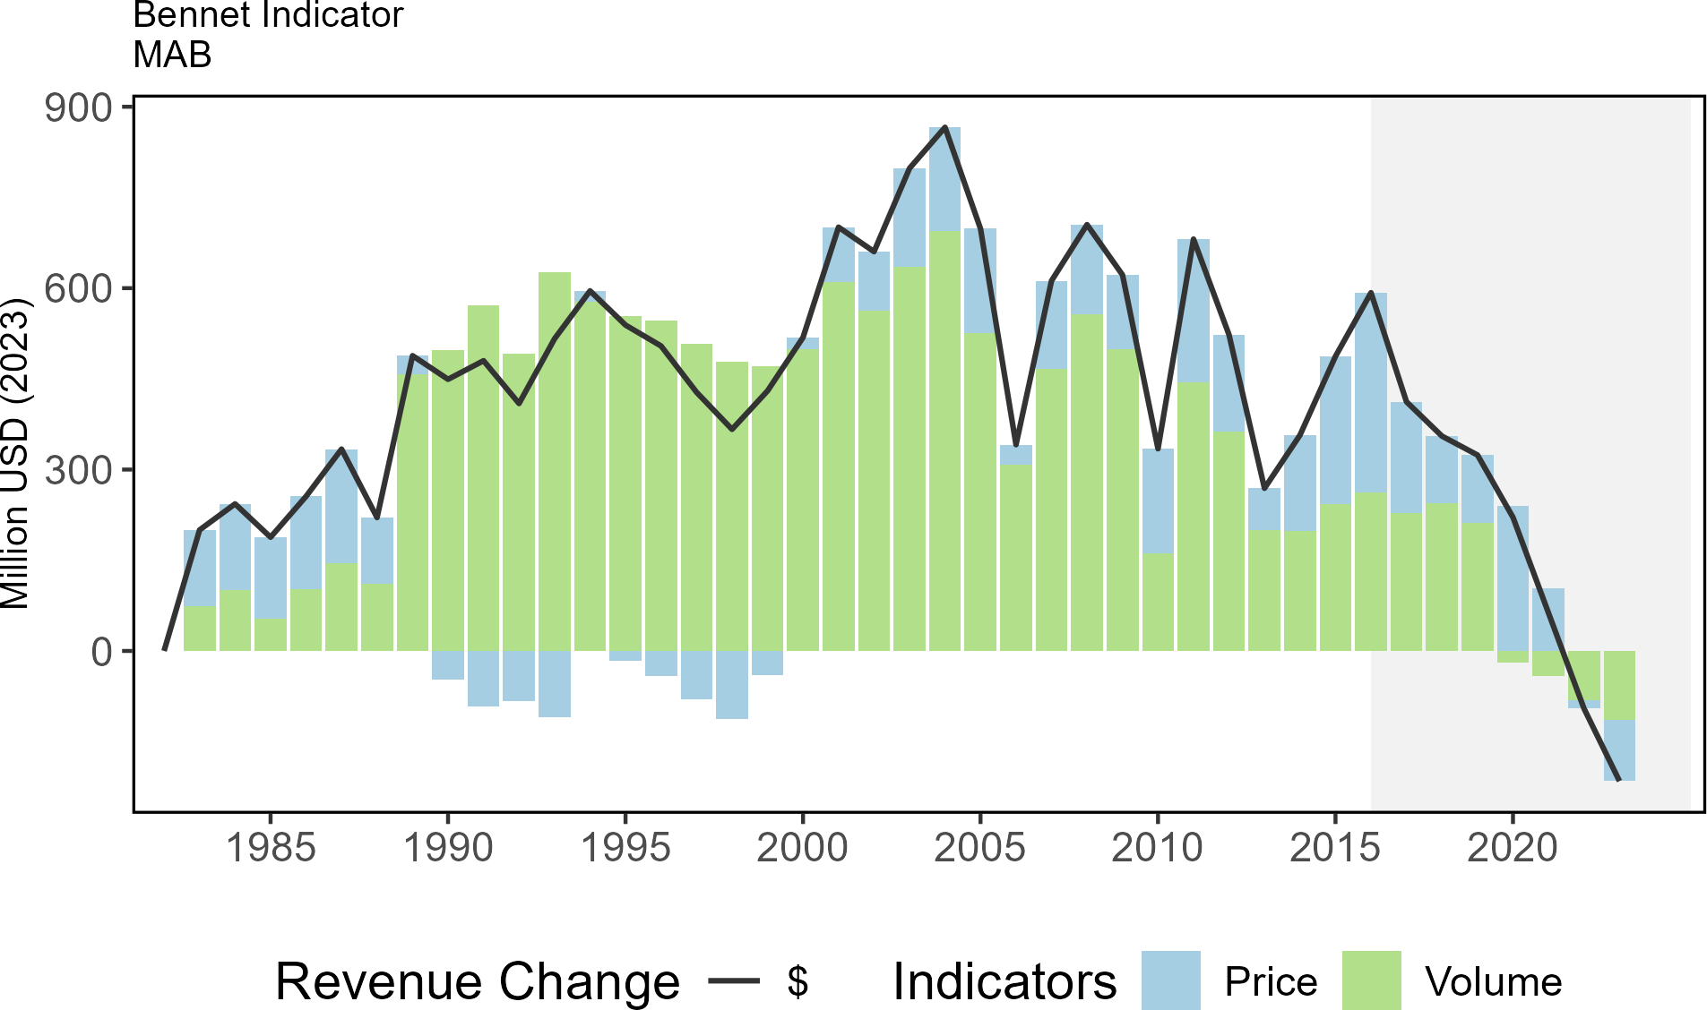

Figure 20: Revenue change from 1982 values in 2023 dollars (black); Price (blue), and Volume Indicators (green) for total commercial landings in the Mid-Atlantic Bight.

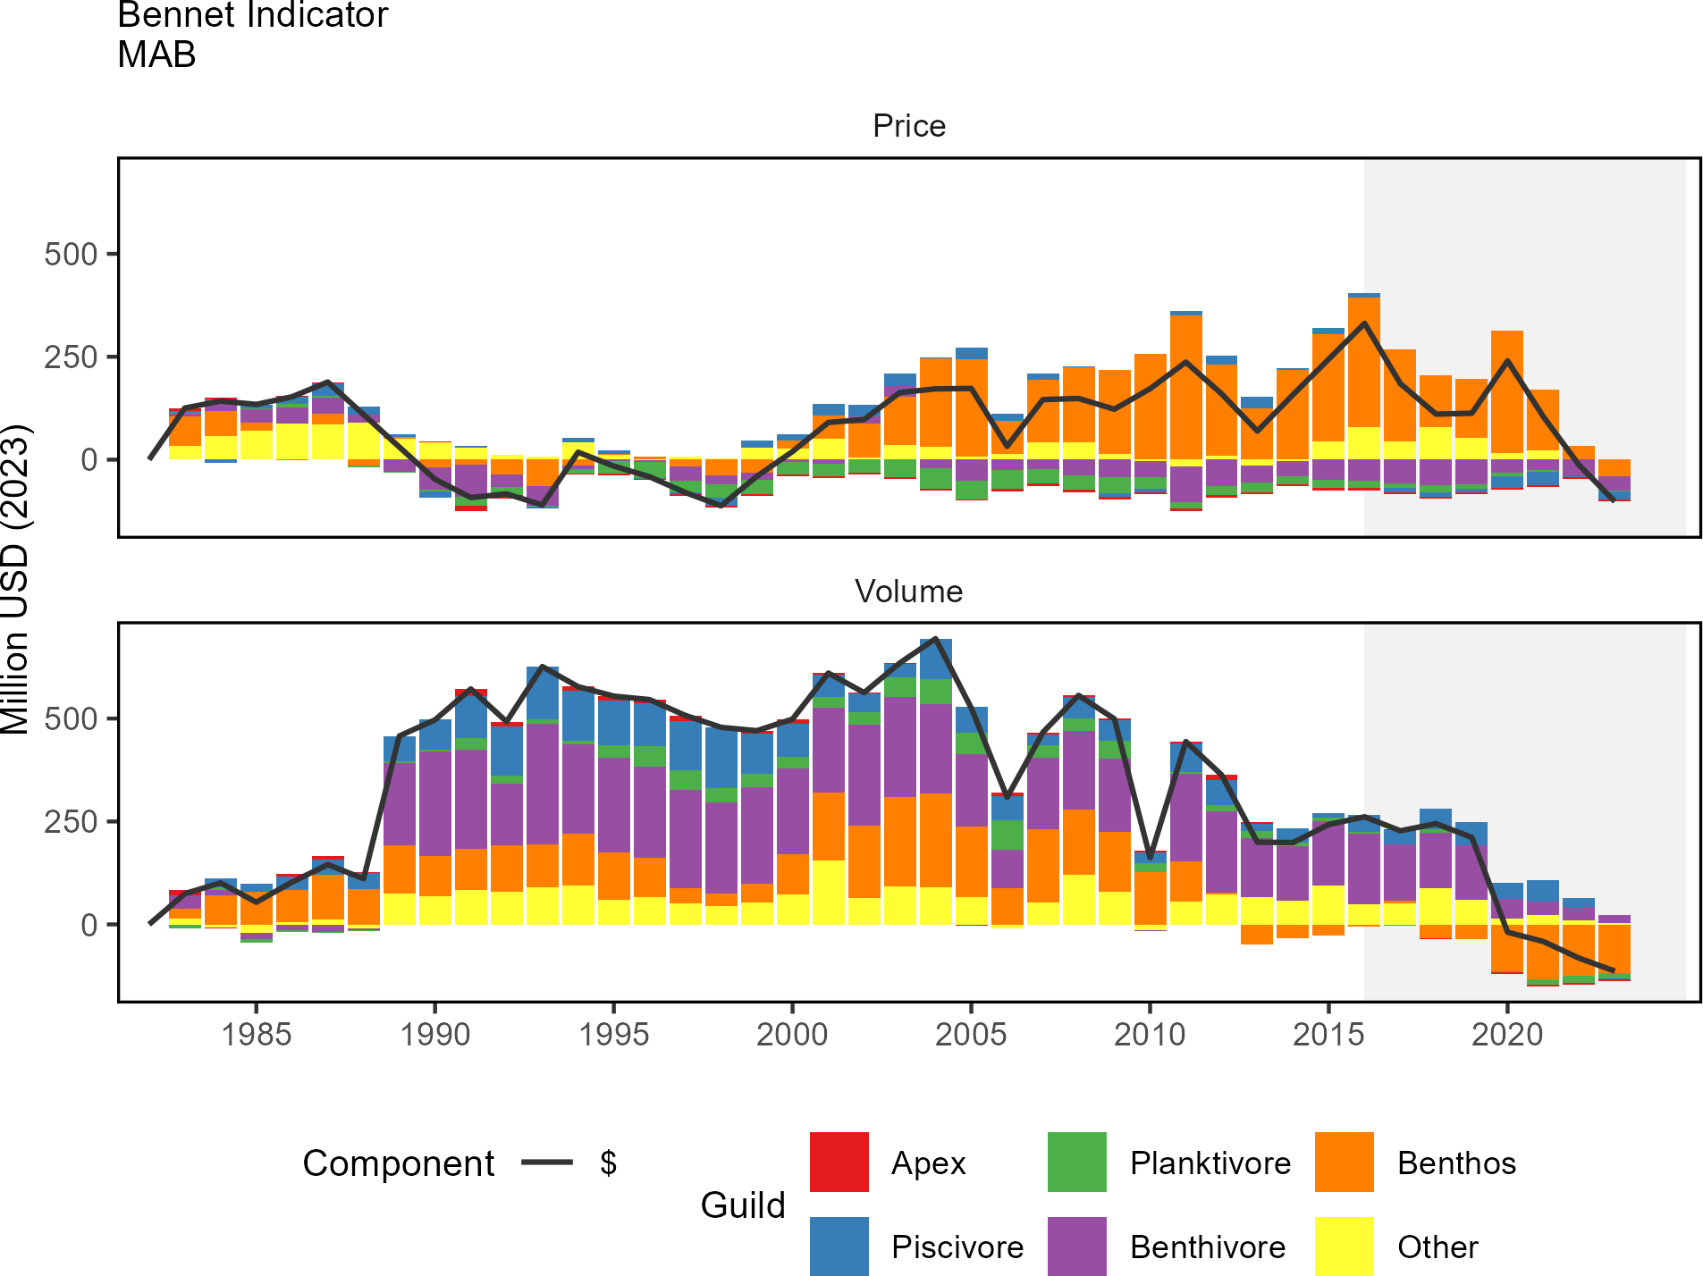

Figure 21: Total price and volume indicators in 2023 dollars (black) for commercial landings, and individual guild contributions to each indicator, in the Mid-Atlantic Bight.

For ports combined across Mid-Atlantic states, total climate vulnerability of revenue ranged from high to very high from 2000-2021, with no long-term trend. This suggests that Mid-Atlantic port commercial fishing revenue has been highly reliant on climate-sensitive species for most of the period since 2000 (Fig. 22).

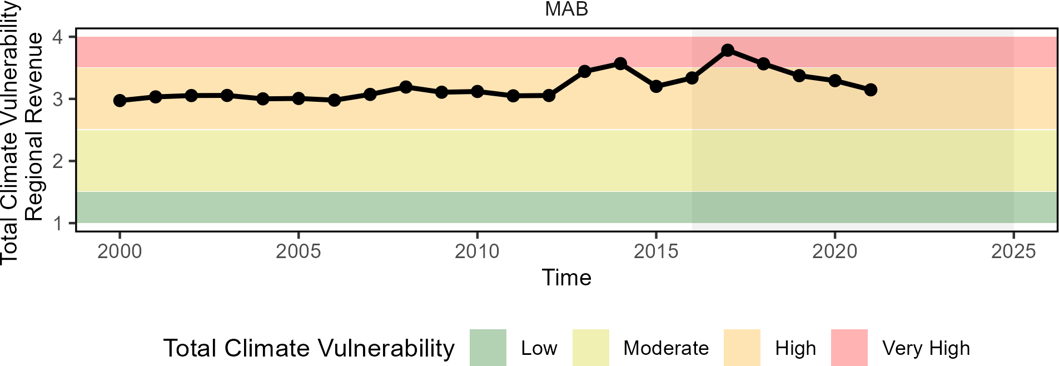

Figure 22: Mid-Atlantic region total climate vulnerability of commercial revenue (sum of Mid-Atlantic port revenue weighted by species climate vulnerability from Hare et al. 2016).

Implications
Although the Mid-Atlantic region shows declining revenue since 2016, inflation-adjusted revenue from harvested species was still greater than 1982 levels until the past two years. In a similar manner to seafood landings, the results here are driven in large part by market dynamics affecting the landings of surfclams and ocean quahogs, as landings have been below quotas for these species, as well as lower quotas and prices for Atlantic scallops. The declining benthos category since 2012 may be partially caused by decreases in surfclam and ocean quahogs in the southern part of their range as harvest have shifted northward. Changes in other indicators, particularly those driving landings and those related to climate change, require monitoring as they may become important drivers of revenue in the future; for example:
- Surfclams, ocean quahogs, and scallops are sensitive to warming ocean temperatures and ocean acidification, as reflected in the high climate vulnerability of total landings from from Mid-Atlantic ports.
- Multiple stressors including warming and ocean acidification are interacting in Mid-Atlantic shellfish habitats.

parent_report.Rmd 02_commercial_profits_newengland.Rmd
Indicators: revenue (a proxy for profits)
Total commercial revenues from all species is below the long-term mean for both the GB and GOM regions in 2023 (Fig. 23). In addition, revenue from NEFMC managed species shows a long-term decline in the GOM. GB continues to exhibit a cyclical nature with regards to revenue, largely driven by rotational management of Atlantic sea

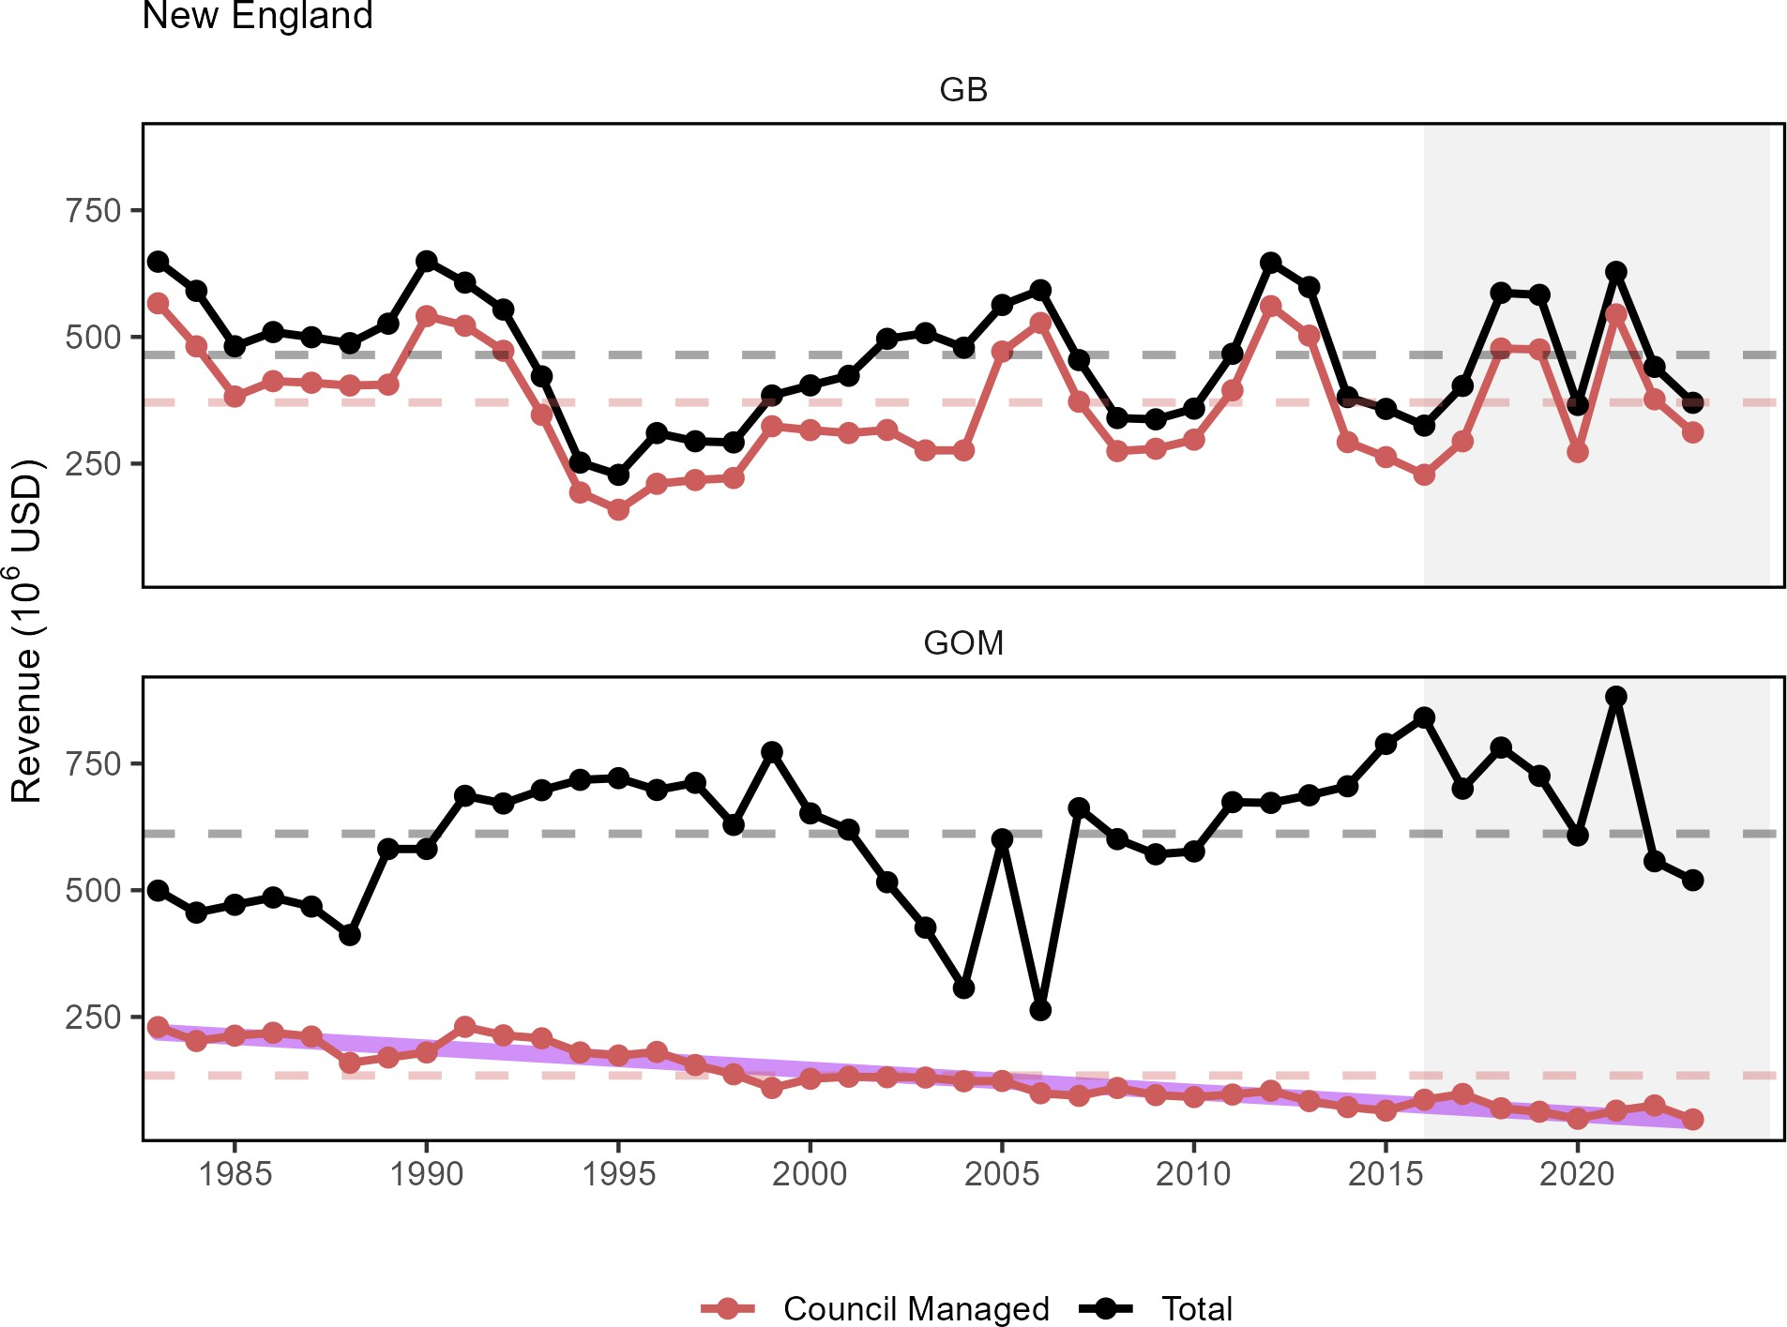

Figure 23: Revenue through 2023 for the New England region: total (black) and from NEFMC managed species (red).

Revenue earned by harvesting resources is a function of both the quantity landed of each species and the prices paid for landings. Beyond monitoring yearly changes in revenue, it is even more valuable to determine what drives these changes: harvest levels, the mix of species landed, price changes, or a combination of these. The Bennet Indicator decomposes revenue change into two parts, one driven by changing quantities (volumes), and a second driven by changing prices. All changes are in relation to a base year (1982).
In the GB region, revenues have been consistently lower than the 1982 baseline throughout the time series. The changes in total revenue in GB was primarily driven by volumes prior to 2010, and then by prices (Fig.24). In the GOM, revenues have been above the 1982 baseline in all but four years, largely due to changing prices in most years. Breaking down the revenue by guild (Fig. 25), or GB, both the volume and price trend have been largely driven by benthos (scallops, quahogs and surfclams). In the GOM region, increased prices for benthivores (lobster) drove the year-over-year increases in overall prices. Benthivores also had a large influence on the overall volume indicator in the GOM.

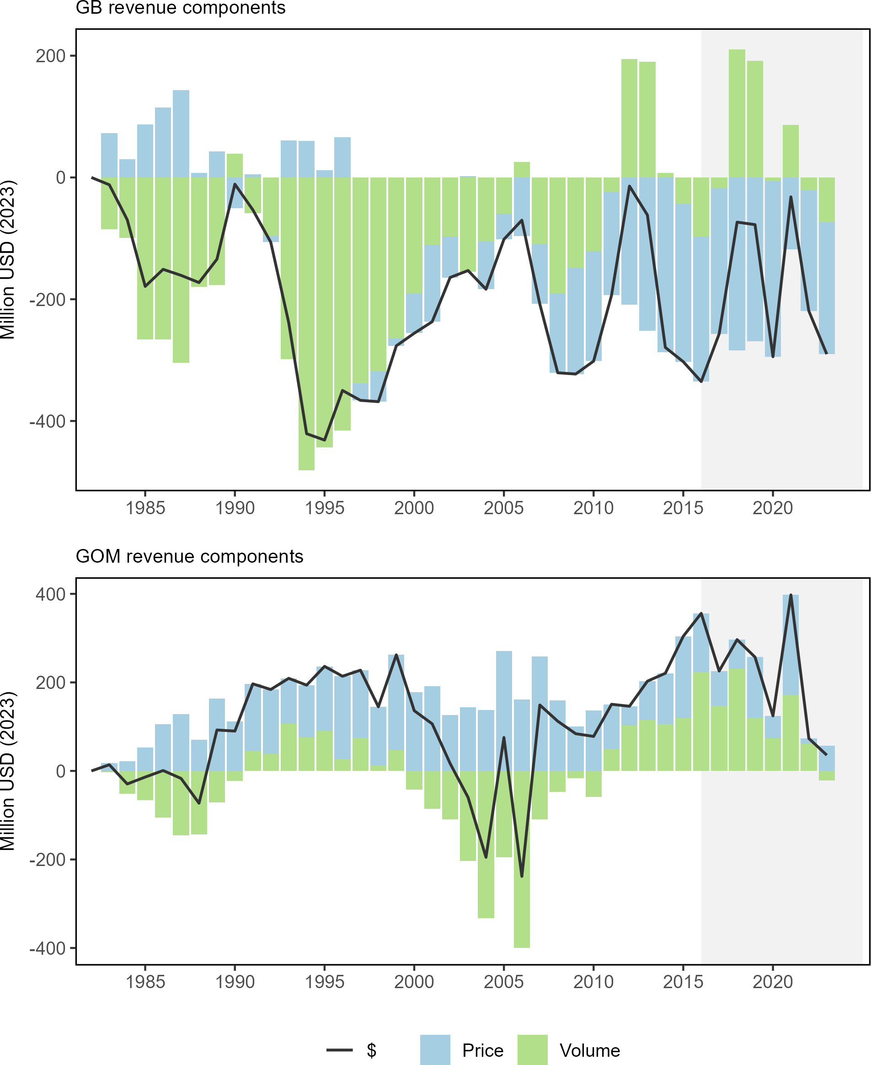

Figure 24: Revenue change from the 1982 baseline in 2023 dollars (black), price, and volume for commercial landings from Georges Bank (GB: top) and the Gulf of Maine (GOM: bottom)

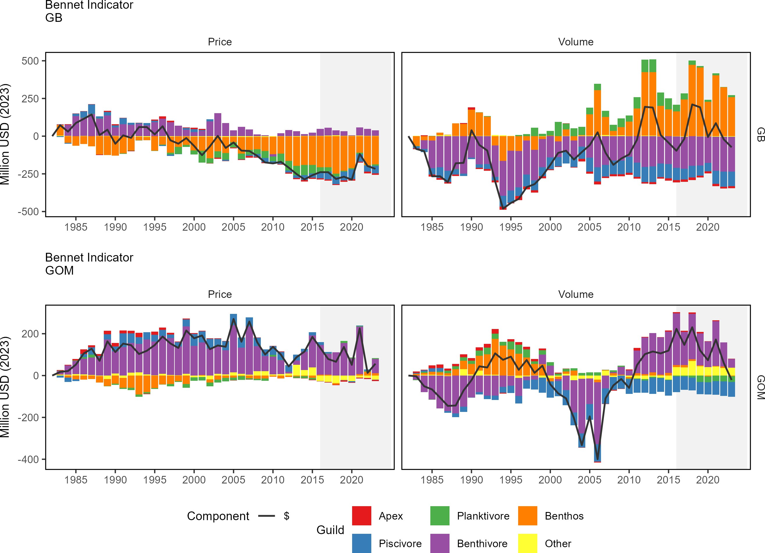
Figure 25: Revenue change from the long-term mean in 2023 dollars (black), price, and volume for commercial landings from Georges Bank (GB: top panels) and the Gulf of Maine (GOM: bottom panels)

For New England, total climate vulnerability of revenue was moderate in 2022 with no long-term trend (Fig. 26). This suggests that while New England commercial fishing is moderately reliant on climate-sensitive species, this proportion has not significantly changed since 2000.

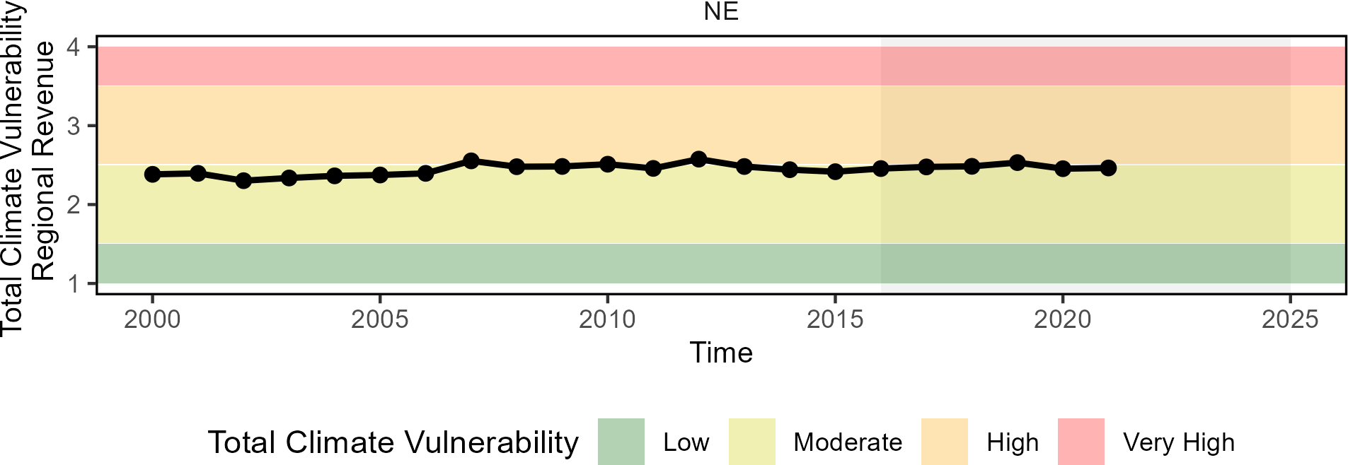

Figure 26: Total climate vulnerability on New England revenue from 2000 to 2022. Horizontal colored bars show different climate risk levels.

Implications
The continued dependence on lobster in the GOM and sea scallops on GB is affected by multiple drivers including resource availability and market conditions. As both species are sensitive to ocean warming and acidification, it is important to monitor these and other climate drivers.

parent_report.Rmd
Recreational Opportunities

03_recreational_opportunities_midatlantic.Rmd
Indicators: Angler trips, fleet diversity
Recreational effort (angler trips) in 2023 continues to be above the long-term average (Fig. 27). in the MAB. However, recreational fleet diversity (i.e., effort by shoreside, private boat, and for-hire anglers) has declined over the long term (Fig. 28).

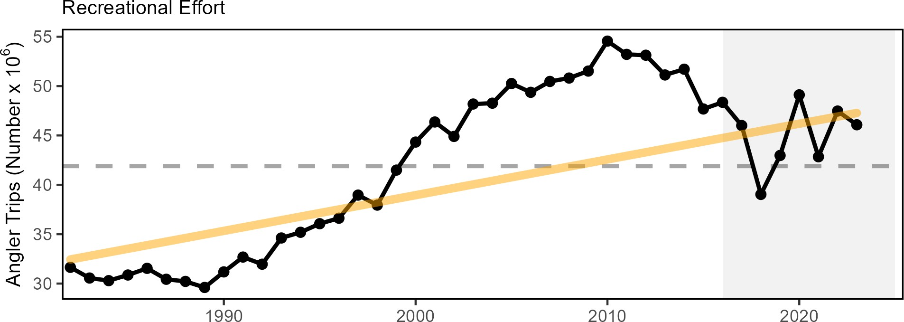

Figure 27: Recreational effort (number of trips, black) in the Mid-Atlantic, with significant increase (orange line).

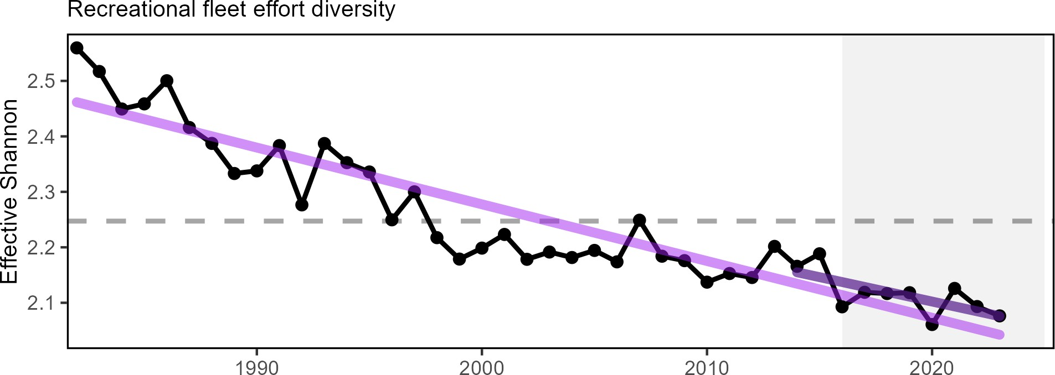

Figure 28: Recreational fleet effort diversity (black) in the Mid-Atlantic, with significant decrease (purple line).

Implications
While the overall number of recreational opportunities in the MAB is above the long-term average, the continuing decline in recreational fleet effort diversity suggests a potentially reduced range of recreational fishing options.
The downward effort diversity trend is driven by party/charter contraction (down from 2.2% in 2021 to 1.3% of trips in 2023), and a shift toward shorebased angling, which currently makes up 60% of all angler trips. Effort in private boats has remained relatively stable from 2022 values.
Changes in recreational fleet diversity can be considered when managers seek options to maintain recreational opportunities. Shore anglers will have access to different species than vessel-based anglers, and when the same species is accessible both from shore and from a vessel, shore anglers typically have access to smaller individuals. Many states have developed shore-based regulations where the minimum size is lower than in other areas and sectors to maintain opportunities in the shore angling sector. MAFMC is currently considering recreational sector separation which might establish different options for managing the for-hire sector from other modes.

03_recreational_opportunities_newengland.Rmd
Indicators: Angler trips, fleet diversity
Recreational effort (angler trips) increased during 1982-2010, but has since declined to the long-term average (Fig. 29). Recreational fleets are defined as private vessels, shore-based fishing, or party-charter vessels. Recreational fleet diversity, or the relative importance of each fleet type, has remained relatively stable over the latter half of the time series (Fig. 30).
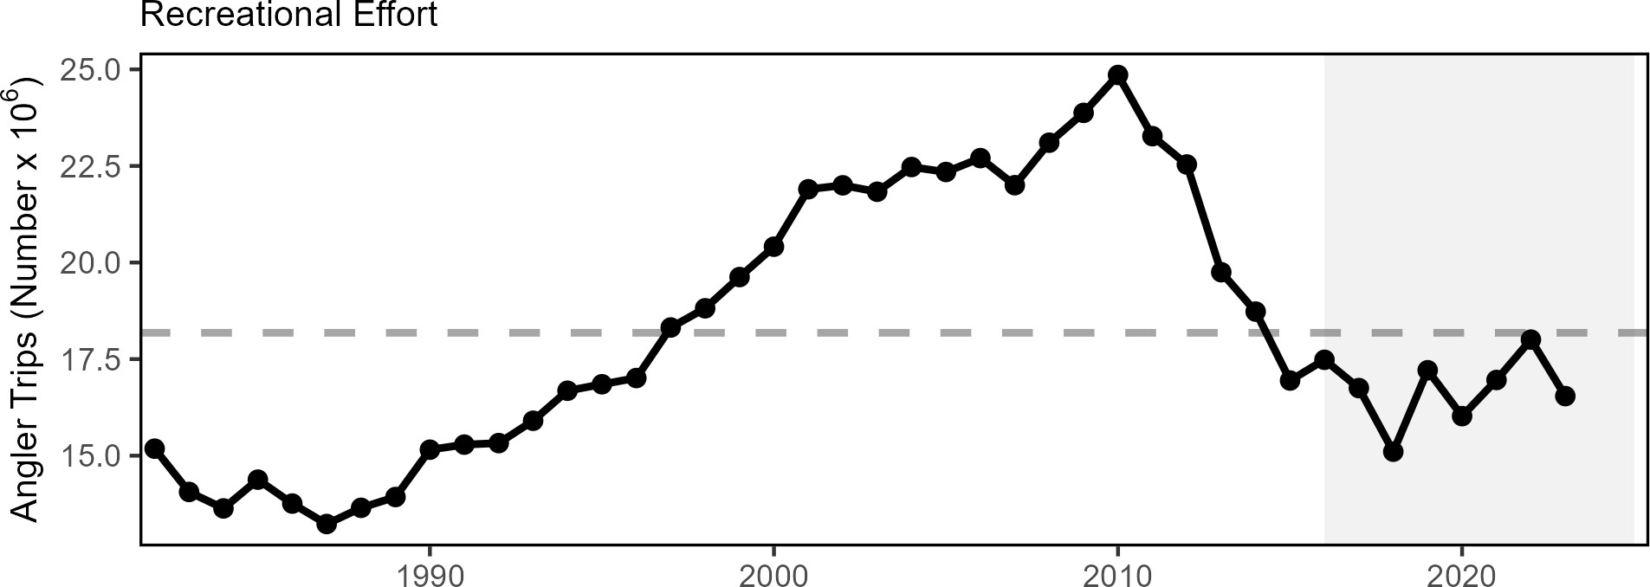

Figure 29: Recreational effort in New England.

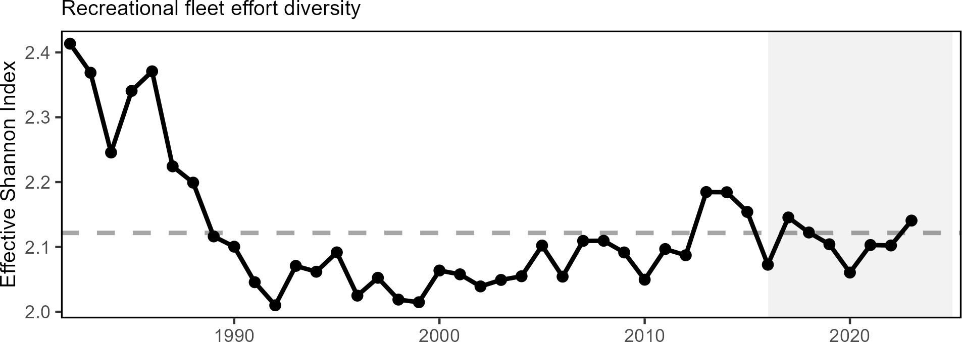

Figure 30: Recreational fleet effort diversity in New England.

Implications
The absence of a long term trend in recreational angler trips and fleet effort diversity suggests relative stability in the overall number of recreational opportunities in the region.

Stability

04_stability_midatlantic.Rmd
Indicators: fishery fleet and catch diversity, ecological component diversity
While there are many potential metrics of stability, we use diversity indices to evaluate overall stability in fisheries and ecosystems. In general, diversity that remains constant over time suggests a similar capacity to respond to change over time. A significant change in diversity over time does not necessarily indicate a problem or an improvement, but does indicate a need for further investigation. We examine diversity in commercial fleet and species catch, recreational species catch (with fleet effort diversity discussed above), zooplankton, adult fishes, and fish traits (e.g. size and fecundity).

Fishery Stability Several diversity estimates are used to evaluate stability for fleets landing federally managed species, and species landed by commercial vessels with Mid-Atlantic permits. Commercial fishery fleet count has declined while fleet revenue diversity has been stable over time in the MAB, with no trend identified, but current values are above the long-term average (Fig. 31).
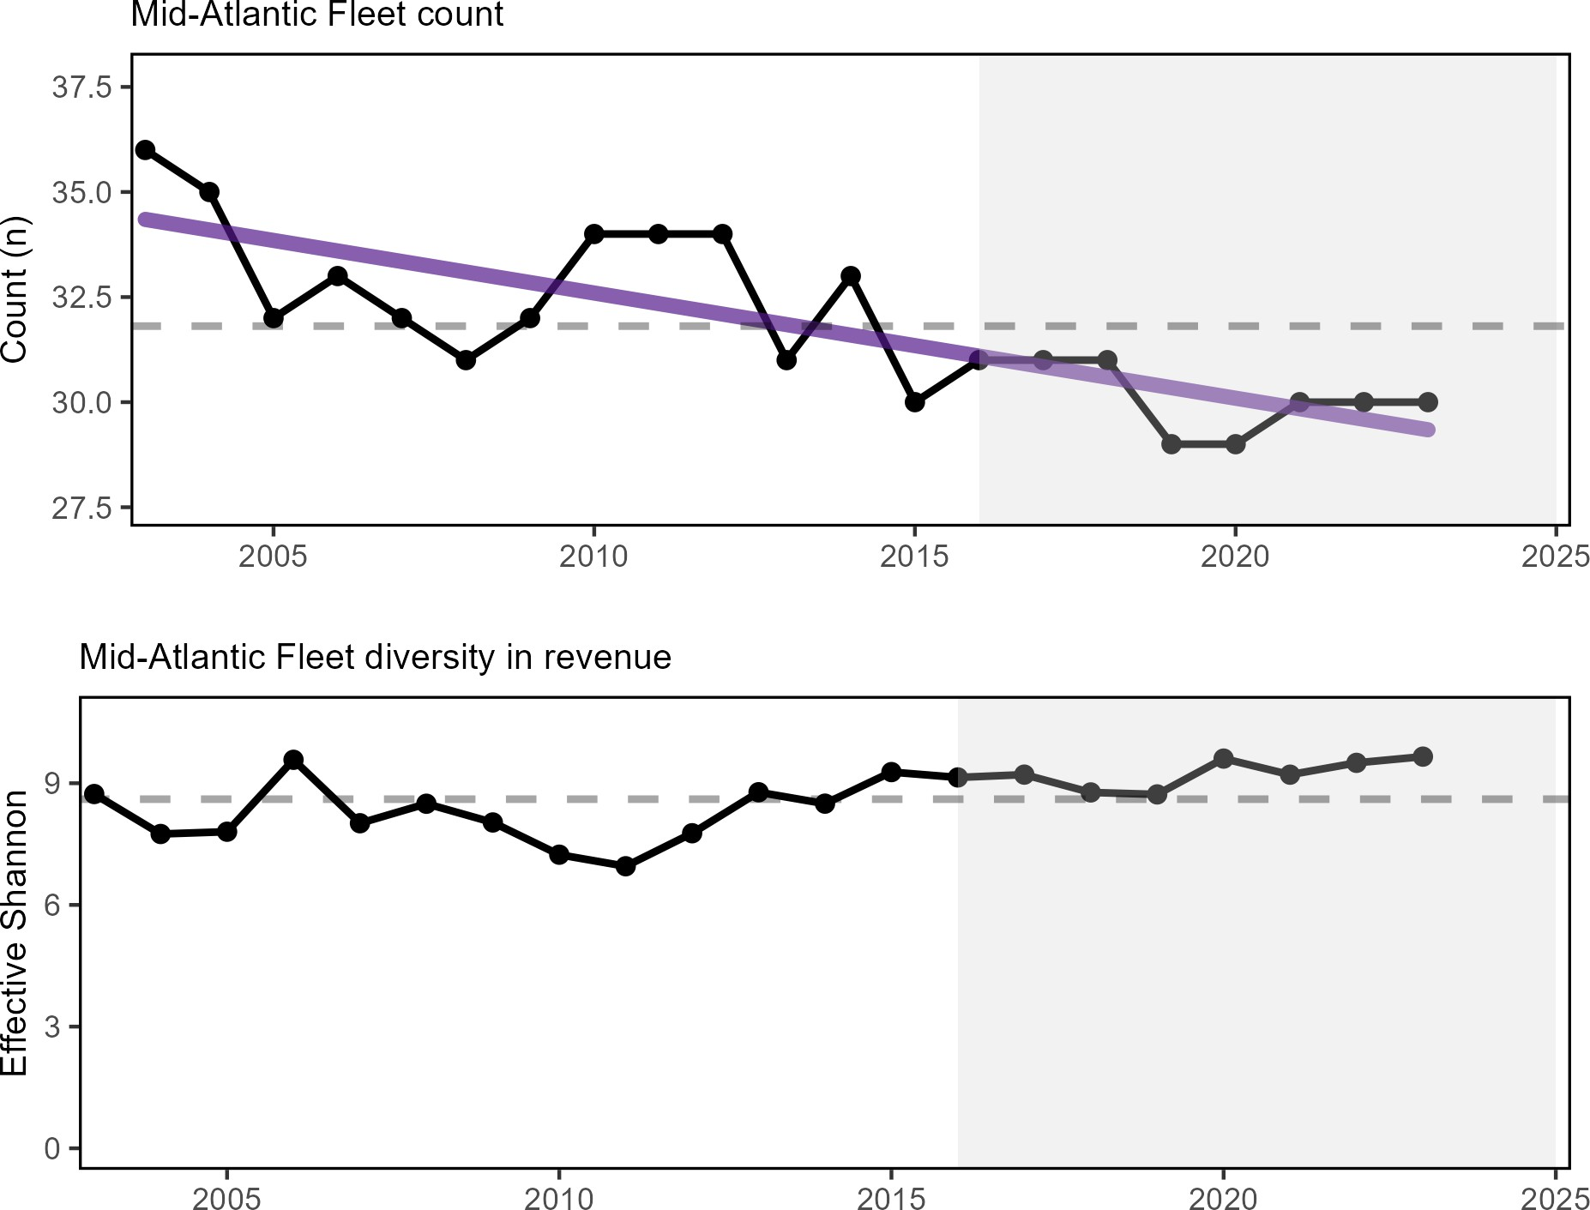

Figure 31: Commercial fleet count (top) and fleet diversity in revenue (bottom) in the Mid-Atlantic (black) with significant decline in fleet count (purple line).

This indicates different commercial fleet composition but similar diversity in species targeting opportunities over time, for those fleets continuing to fish (Fig. 32). Of note is that the current lack of vessel data available for surf clam and ocean quahog prior to 2003 precludes the assessment of longer term dynamics with these indicators.
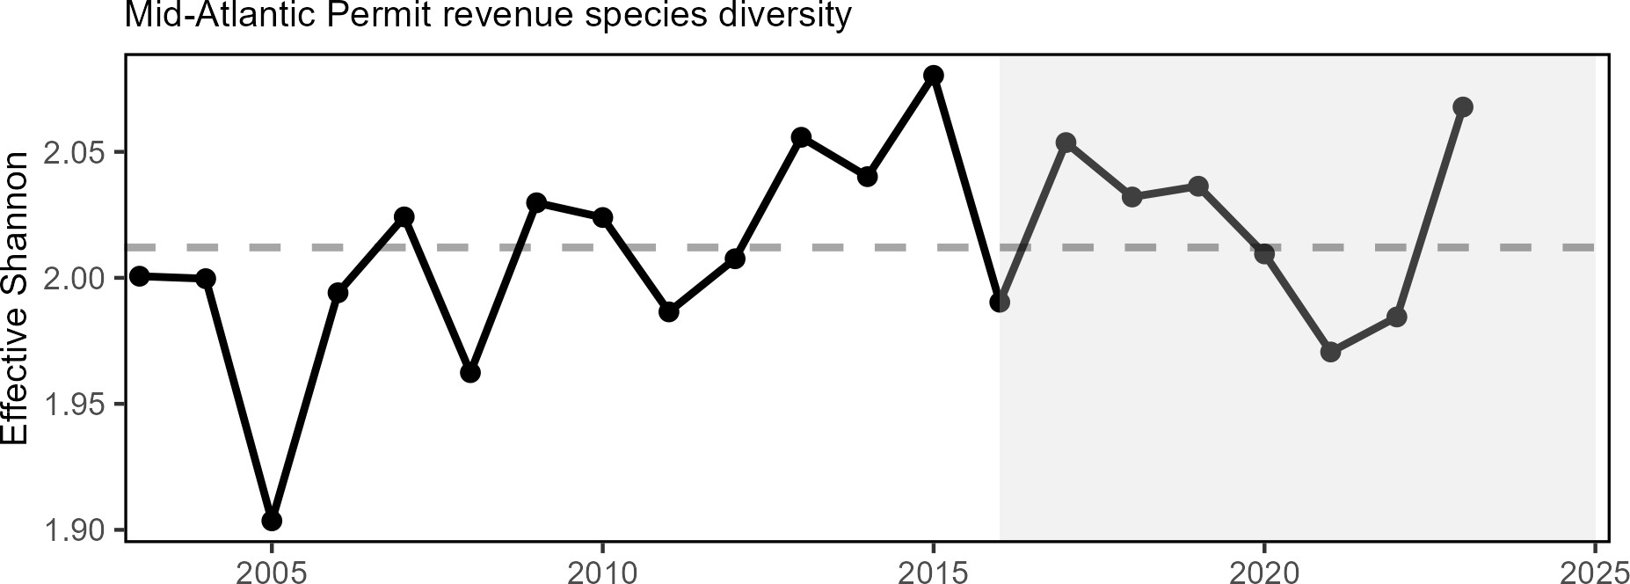

Figure 32: Species revenue diversity in the Mid Atlantic.

As noted above, recreational fleet effort diversity is declining (Fig. 28), suggesting a shift in recreational fishing opportunities. However, recreational species catch diversity has no long term trend so is considered stable, and has been at or above the long term average since 2016 (Fig. 33).
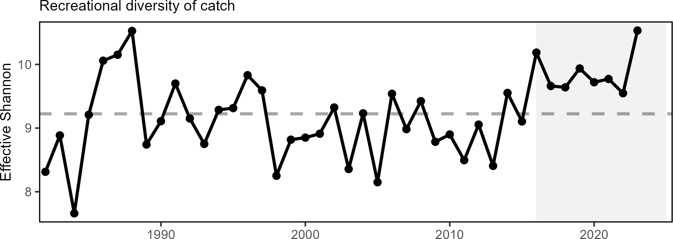

Figure 33: Diversity of recreational catch in the Mid Atlantic.

Ecological Stability Ecological diversity indices show mixed trends. Total annual primary production is a measure of the total amount of carbon (i.e. energy ) produced by phytoplankton per year. Total primary production in the Mid Atlantic Bight has no clear trend (Fig. 34), suggesting stability in energy at the base of the food web.

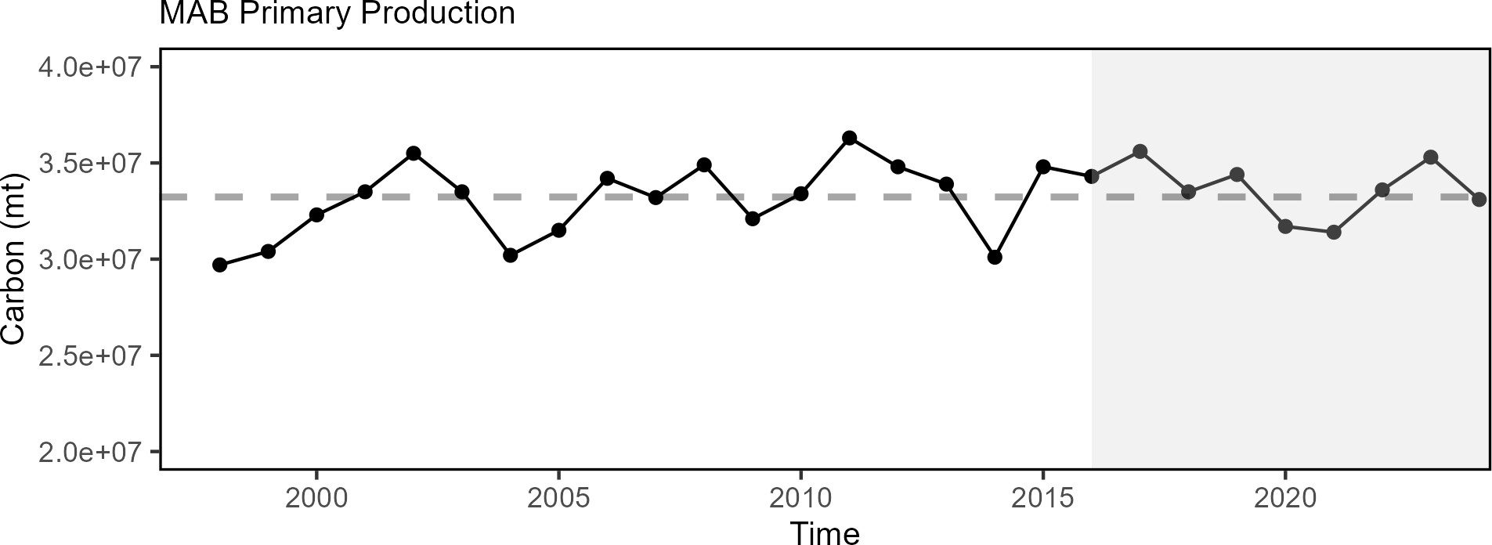

Figure 34: Total areal annual primary production for the MAB. The dashed line represents the long-term (1998-2024) annual mean.

Zooplankton diversity is increasing in the MAB (Fig. 35), while adult fish diversity, the expected number of species in a standard number of individuals sampled from the NEFSC bottom trawl survey, appears stable over time, with current values within one standard deviation from most historic estimates (Fig. 36).

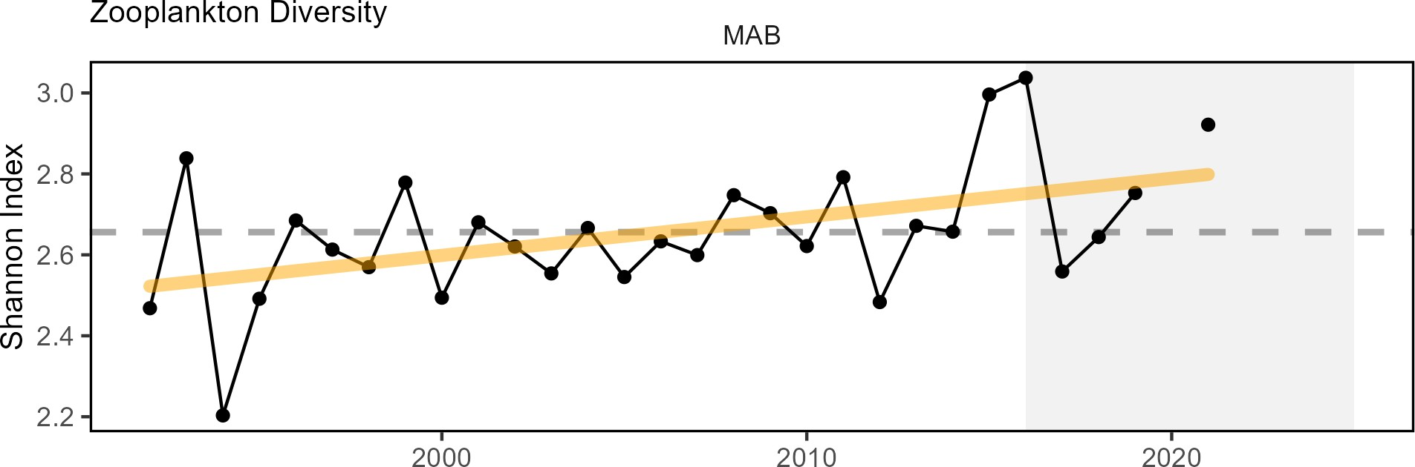

Figure 35: Zooplankton diversity in the Mid-Atlantic Bight, Shannon diversity index (black) with significant increase (orange line).

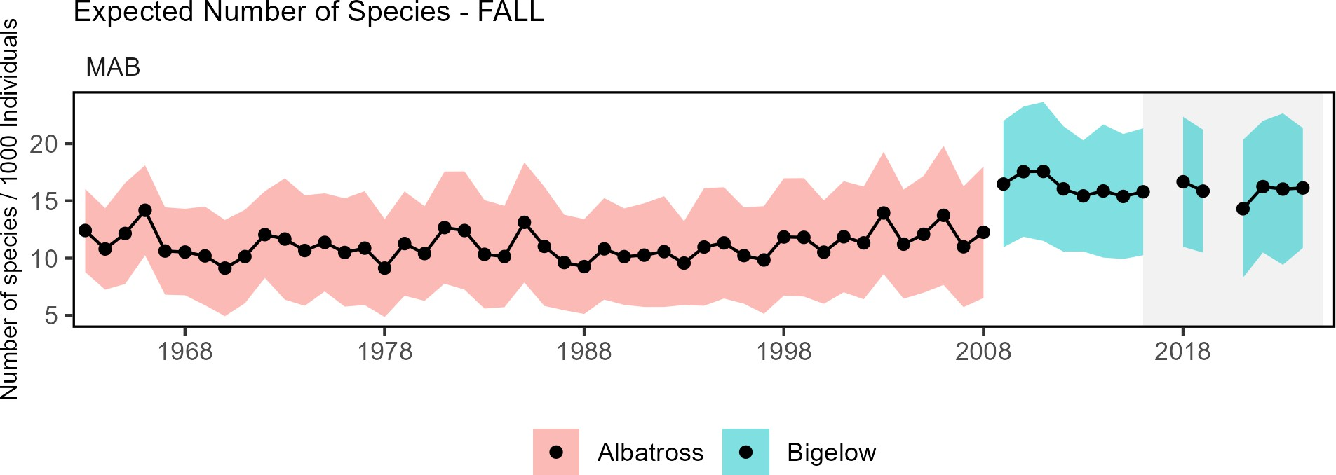

Figure 36: Adult fish diversity in the Mid-Atlantic Bight, based on expected number of species. Results from survey vessels Albatross and Bigelow are reported separately due to catchability differences.

Functional traits, such as length at maturity, maximum body size, or fecundity, can synthesize change across complex, diverse communities. Monitoring changes in functional trait distributions for the fish community can provide a means of assessing ecosystem-scale resilience. There is evidence of long term change in trait distributions in the MAB (Fig. 37). The spring finfish community in the MAB is showing long-term shifts towards slower life history strategies with higher length and maturity and lower fecundity. In contrast, the fall MAB finfish community has shifted towards decreased length at maturity, smaller offspring size, and lower trophic level indicative of faster life histories.
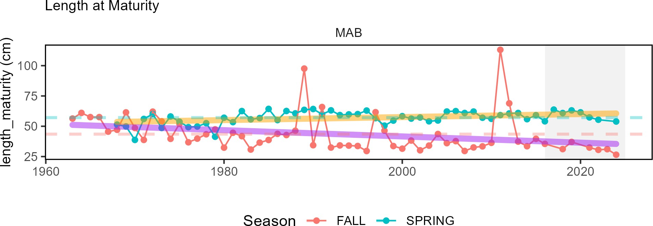

Figure 37: Fish community functional traits in the Mid Atlantic Bight based on Fall (red) and Spring (blue) survey data. Length at maturity for the full finfish community has increased in spring (orange line), but decreased in fall (purple lines)

Implications
Fleet diversity indices are used by the MAFMC in their EAFM risk assessment to evaluate stability objectives as well as risks to fishery resilience and maintaining equity in access to fishery resources. Instability in the commercial fleet count metric suggests potentially lower capacity to respond to the current range of fishing opportunities. Commercial species permit revenue diversity is relatively stable but comparisons are limited by missing clam fishery data prior to

2003.
Declining recreational fleet effort diversity, as noted above, indicates that the party/charter boat sector continues to contract, with shoreside angling becoming more important as a percentage of recreational angler trips. Stability in recreational species catch diversity has been maintained by a different set of species over time. A recent increase in Atlantic States Marine Fisheries Commission (ASMFC) and South Atlantic Fishery Management Council (SAFMC) managed species in recreational catch is helping to maintain diversity in the same range that MAFMC and New England Fishery Management Council (NEFMC) managed species supported in the 1990s. These changes in effort and species trends may necessitate new or changing management considerations to ensure effective tools and opportunities are in place to support recreational fisheries.
Production at the base of the food web is variable, but stable over time. Stable adult fish diversity indicates the same overall number and evenness over time, but doesn’t rule out species substitutions (e.g., warm-water replacing cold-water).
There was evidence for long term change in finfish trait distributions in the mid-Atlantic Bight, with spring and fall communities showing shifts in different directions. This suggests instability in seasonal dominance of fish with faster or slower life histories.
In the MAB, existing diversity indicators suggest some instability in the fisheries and ecosystem components examined. In addition, declining recreational fleet diversity suggests a potential loss in the range of recreational fishing opportunities. Increasing zooplankton diversity (due to increases in abundance of several taxa and stable or declining dominance of an important copepod species) suggests a shift in the zooplankton community that warrants continued monitoring to determine if managed species are affected. The species revenue diversity in commercial landings also warrants continued attention given its relatively low index value indicating average reliance on a small number of species for revenue.

parent_report.Rmd 04_stability_newengland.Rmd
Indicators: fishery fleet and catch diversity, ecological component diversity, total primary production
While there are many potential metrics of stability, we use diversity indices to evaluate overall stability in fisheries and ecosystems. In general, diversity that remains constant over time suggests a similar capacity to respond to change over time. A significant change in diversity over time does not necessarily indicate a problem or an improvement, but does indicate a need for further investigation. We examine diversity in commercial fleet and species catch, and recreational species catch (with fleet effort diversity discussed above), zooplankton, and adult fishes.

Fishery Stability Diversity estimates have been developed for species landed by commercial vessels with New England permits and fleets landing managed species. Although the effective number of species being landed in the commercial fleet rebounded slightly from the historical low of 2021, the diversity in catch is still well below the series average (Fig. 38). Commercial fishery fleet count is also below the time series average.

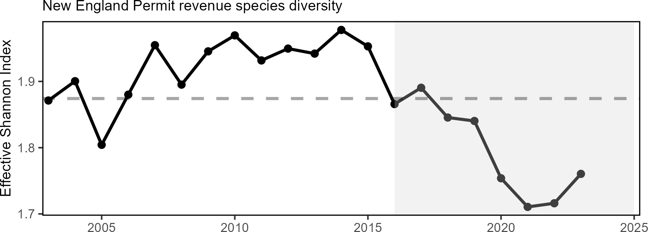

Figure 38: Species revenue diversity in New England.

As noted above, recreational fleet effort diversity is stable. However, recreational species catch diversity has been above the time series average since 2008 with a long-term positive trend (Fig. 39).
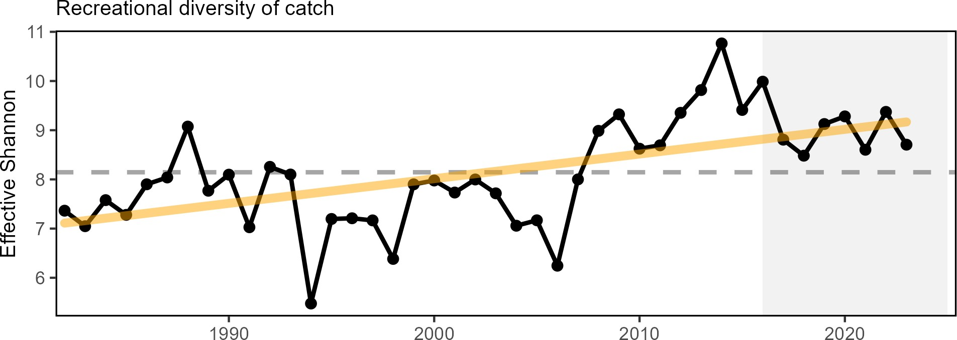

Figure 39: Diversity of recreational catch in New England.

Ecological Stability Ecological diversity indices show mixed trends. Total annual primary production (TPP) is a measure of the total amount of carbon (i.e. energy) produced by phytoplankton per year. 2023 saw record high TPP in the GOM due to a highly unusual phytoplankton bloom, but it is currently unknown how much of that primary production was incorporated into the upper trophic levels. Preliminary 2024 values were near the long-term average (Fig. 40).

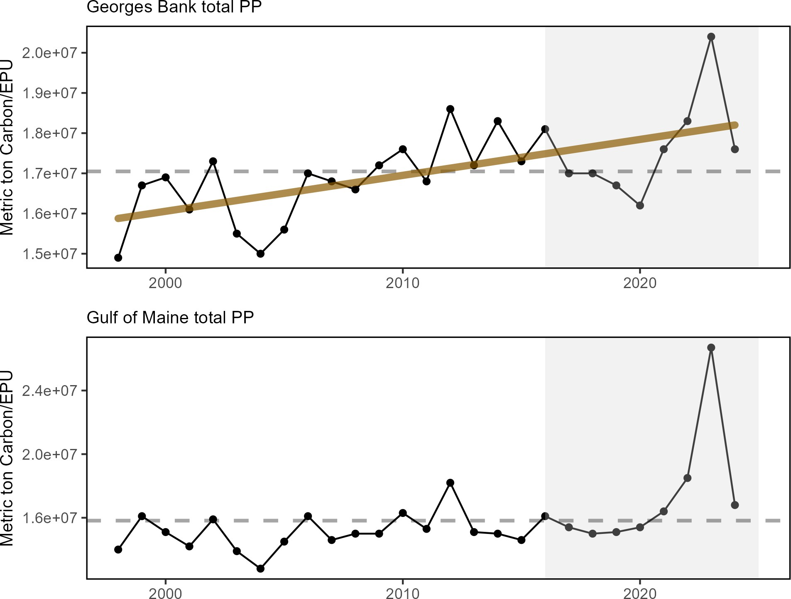

Figure 40: Total areal annual primary production by ecological production unit. The dashed line represents the long-term (1998-2023) annual mean.

Zooplankton diversity is increasing on GB, while no trend is evident in the GOM (Fig. 41). However, it is worth noting that the 2021 index for the GOM is the highest observed. Adult fish diversity shows an increasing trend in the GOM and no trend on GB (Fig. 42).

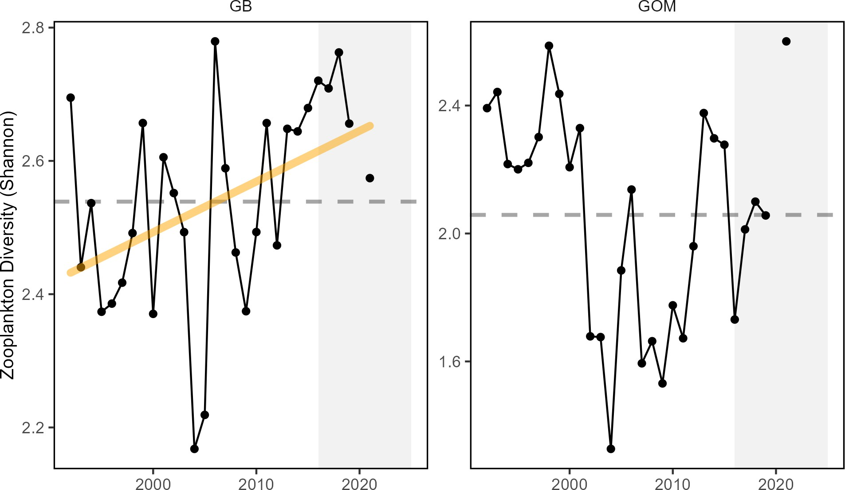

Figure 41: Zooplankton diversity on Georges Bank and in the Gulf of Maine, based on Shannon diversity index. 2020 surveys were incomplete due to COVID-19.

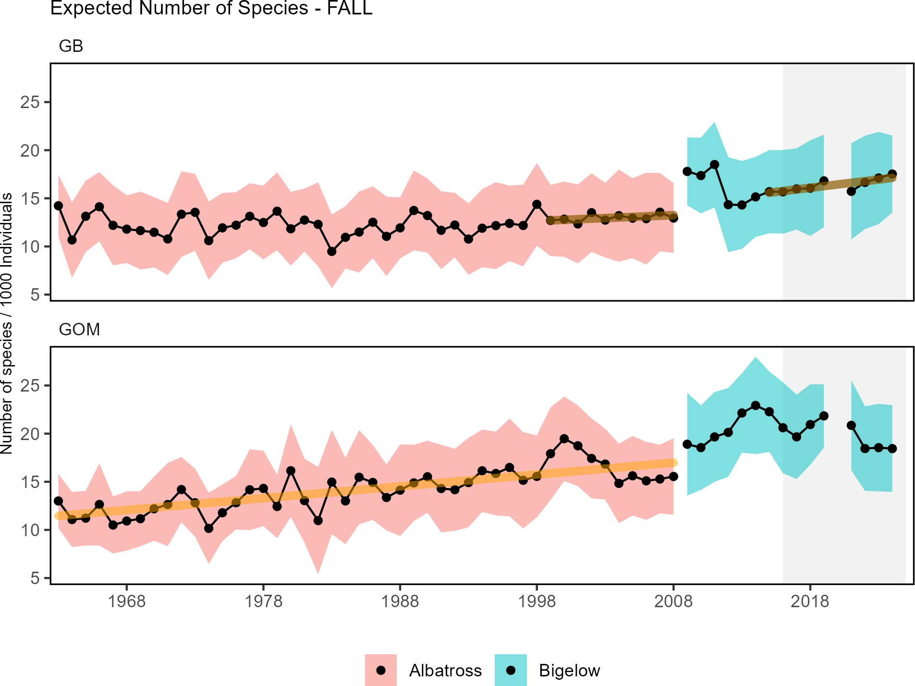

Figure 42: Adult fish diversity for Georges Bank and in the Gulf of Maine, based on expected number of species in a standard number of individuals. Results from survey vessels Albatross and Bigelow are reported separately due to catchability differences.

Functional traits, such as length at maturity, asymptotic body size, or fecundity, can synthesize change across complex, diverse communities. Monitoring changes in functional trait distributions can provide a means of assessing ecosystem-scale resilience. There is evidence of long term change in trait distributions in the GOM with an increase in pace of life . Both fall and spring finfish communities are showing declines in fecundity in GB and GOM (Fig. 43).

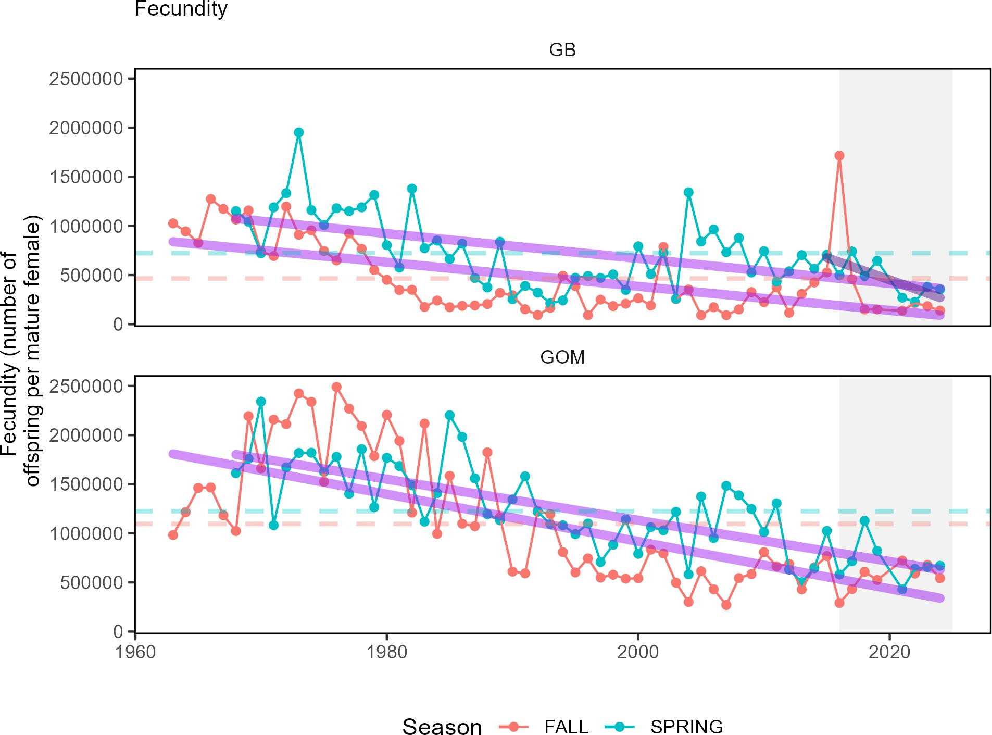

Figure 43: Fish community functional traits in New England based on Fall (red) and Spring (blue) survey data.

Implications
Fleet diversity indices can be used to evaluate stability objectives as well as risks to fishery resilience and to maintain equity in access to fishery resources. The relatively low diversity estimates for the commercial fishery are likely driven by the continued reliance on a few species, such as sea scallops and lobster. This trend could diminish the capacity to respond to future fishing opportunities. Meanwhile, the increase in recreational species catch diversity is due to recent increases in Atlantic States Fisheries Management Council (ASFMC) and MAFMC managed species within the region, offsetting decreased limits on more traditional regional species.
Ecological diversity indices can provide insight into ecosystem structure. Changes in ecological diversity over time may indicate altered ecosystem structure with implications for fishery productivity and management. Increasing zooplankton diversity in GB is attributed to an overall increase in zooplankton abundance and the declining dominance of the calanoid copepod Centropages typicus. Stable adult fish diversity on GB suggests the same overall number and evenness over time, but does not rule out species substitutions (e.g., warm-water species replacing cold-water ones). Increasing adult diversity in the GOM suggests an increase in warm-water species and should be closely monitored.
As a whole, the examined diversity indicators suggest changes in commercial and recreational fisheries, likely driven by changes in the mix of species landed. However, there seems to be overall stability in ecosystem components. Increasing diversity in the recreational catch, GB zooplankton, and GOM adult fish accompanied by lows in

commercial fleet diversity metrics, suggests warning signs of a potential regime shift or ecosystem restructuring and warrants continued monitoring to determine if managed species are affected.

parent_report.Rmd

Community Social and Climate Vulnerability
Providing for sustained participation of fishing communities, and avoiding adverse economic impacts to fishing communities are objectives of fishery management. We report the top communities most engaged in commercial and recreational fisheries and the degree to which these communities may be vulnerable to change based on their socioeconomic conditions using data for the most recent available year (2022).
Coastal fishing communities worldwide have or are likely to experience social, economic, and cultural impacts from climate change, both negative (e.g., loss of infrastructure, fish stock decline) and positive (e.g., increased abundance of valuable species). Changes in marine fisheries as a consequence of climate change will require adaptation by coastal fishing communities and fisheries managers alike. The Community Climate Change Risk Indicators were developed to help examine trends in climate change vulnerability in U.S. coastal fishing communities in the Northeast Region using indicators developed to understand fishing community level risk to climate change as based on species dependency.

05_csvi_midatlantic.Rmd
Indicators: Fishing Engagement and Community Social Vulnerability
The engagement indices demonstrate the importance of commercial and recreational fishing to a given community relative to other coastal communities in a region. Social vulnerability indicators measure social factors that shape a community’s ability to adapt to change. For this report, we focus on top communities with the highest engagement scores, the top communities with the highest population relative engagement scores, and on three socio-demographic indicators within the CSVI toolset (poverty, personal disruption, population composition).
In 2022, Cape May, NJ; Reedville, VA; and Montauk, NY were the most engaged commercial fishing communities. Barnegat Light, NJ is much more engaged in commercial fishing relative to its population size when compared to other communities in the Mid-Atlantic (Fig.44). Cape May, NJ also ranked medium on the population composition index (calculated based on proportions of non-white, non-English speaking, and younger populations) and Atlantic City, NJ ranked high for all socio-demographic indicators suggesting that this important commercial fishing community may be more vulnerable to change in the future (Table 5).
Manteo, Vandemere, and Hobuken, NC are no longer listed as top ten recreational communities, replaced by Cape May and Barnegat Light, NJ; Orient, NY; Topsail Beach, Avon and Rodanthe, NC (Fig.45).

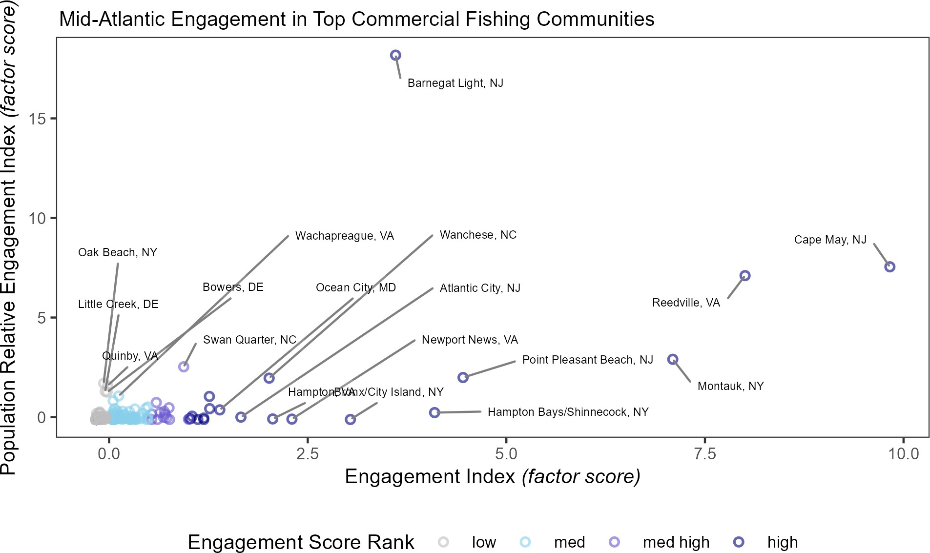

Figure 44: Commercial engagement and population relative engagement, with labels for the top commercially engaged fishing communities in the Mid-Atlantic. *Due to changes in data infrastructure, data from Reedville, VA was combined with data from ‘Other VA’ and ’Other Northumberland’.

Table 5: Socio-demographic indicator rankings (ranging from low = low vulnerability to high = high vulnerability) for [Mid-Atlantic] *or* [New England] communities most engaged in commercial fishing, 2022. Blank spaces indicate no data available.

Community | Personal Disruption | Population Composition | Poverty
Cape May, NJ | low | med | low
Reedville, VA | low | low | low
Montauk, NY | low | low | low
Point Pleasant Beach, NJ | med | low | low
Hampton Bays/Shinnecock, NY | low | high | low
Barnegat Light, NJ | low | low | low
Bronx/City Island, NY | high | high | high
Newport News, VA | med | low | med
Hampton, VA | med | low | med
Wanchese, NC | low | low | low
Atlantic City, NJ | high | high | high
Ocean City, MD | med | low | low

Table 5: Socio-demographic indicator rankings (ranging from low = low vulnerability to high = high vulnerability) for [Mid-Atlantic] *or* [New England] communities most engaged in commercial fishing, 2022. Blank spaces indicate no data available.

Community | Personal Disruption | Population Composition | Poverty
Swan Quarter, NC | low | low | low
Wachapreague, VA | low | low | low
Quinby, VA | med | low | low
Bowers, DE | low | low | low
Little Creek, DE | high | low | high
Oak Beach, NY | low | low

Several communities ranked in the top communities for both commercial and recreational indices; Montauk, NY, Cape May, NJ, Barnegat Light, NJ, Point Pleasant Beach, NJ, Ocean City, MD, and Wachapreague, VA (Fig. 45), meaning these communities may be impacted simultaneously (to a greater degree than others) by commercial and recreational regulatory changes. Of those included in the top-ranked recreational communities, both Bivalve, MD and Morehead City, NC had medium or higher ranks for two of three socio-demographic indicators examined here (Table 6). This suggests that future changes to recreational fishing conditions may disproportionately impact these places.
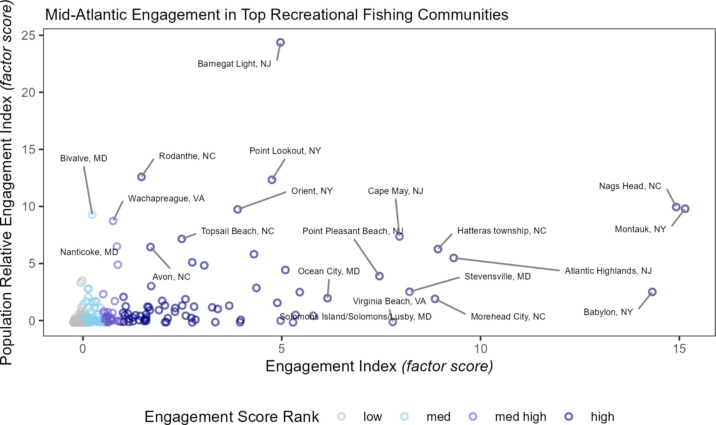

Figure 45: Recreational engagement and population relative engagement with labels for the top recreationally engaged fishing communities in the Mid-Atlantic.

Table 6: Socio-demographic indicator rankings (ranging from low = low vulnerability to high = high vulnerability) for [Mid-Atlantic] *or* [New England] communities most engaged in recreational fishing, 2022. Blank spaces indicate no data available.

Community | Personal Disruption | Population Composition | Poverty
Cape May, NJ | low | med | low
Montauk, NY | low | low | low
Point Pleasant Beach, NJ | med | low | low
Barnegat Light, NJ | low | low | low
Ocean City, MD | med | low | low
Virginia Beach, VA | low | low | low
Morehead City, NC | med | low | med
Hatteras township, NC | low | low | low
Wachapreague, VA | low | low | low
Avon, NC | high | low
Atlantic Highlands, NJ | low | low | low
Babylon, NY | low | low | low
Nags Head, NC | low | low | low
Point Lookout, NY | low | low | low
Nanticoke, MD | med high | low | low
Orient, NY | low | low
Bivalve, MD | med | high
Rodanthe, NC | low | low
Topsail Beach, NC | low | low | low
Solomons Island/Solomons/Lusby, MD | low | low | low
Stevensville, MD | med | low | low

Indicators: Community Climate Vulnerability in the Mid-Atlantic
The Community Climate Change Risk Indicators are calculated by multiplying the percent contribution of species to the total value landed in a community by their respective Total Vulnerability scores (based on NOAA’s Climate Vulnerability Assessment) for different sensitivity and exposure factors and then summing the resulting values by year. As a community (or region) shifts towards climate vulnerable species, its risk score increases. While there is not a long-term trend in total climate vulnerability across Mid Atlantic communities as a whole, a majority of communities rank either high or very high risk (Fig. 46). This suggests that a majority of Mid-Atlantic communities depend on climate vulnerable species to generate commercial fishery revenue.

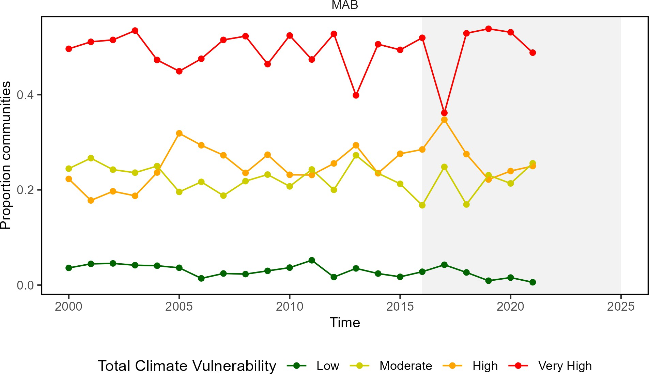

Figure 46: Proportion of Mid-Atlantic communities at each revenue climate vulnerability level over time.

Implications
A range of socioeconomic and climate vulnerability concerns are found throughout Mid-Atlantic fishing communities. These indicators provide a snapshot of the presence of socio-demographic concerns in most highly engaged commercial and recreational fishing communities in the Mid-Atlantic. These communities may be especially vulnerable to changes in fishing patterns due to regulations and/or ecosystem changes. Several of these top fishing communities, both commercial and recreational fishing communities, demonstrated medium to high socio-demographic vulnerability, indicating that they may be at a disadvantage responding to change.
There is evidence that a majority of Mid-Atlantic communities have high to very high total climate vulnerability based on revenue. Coastal fishing communities are greatly affected by climate change, both because of their physical location and because of their frequent social, cultural, and economic dependence on fishing. These impacts are expected to become more pressing as climatic changes become more extensive. Changes in ocean temperature and acidification affecting marine life have the potential to directly impact fisheries and fishery dependent livelihoods.

parent_report.Rmd 05_csvi_newengland.Rmd
Indicators: Fishing Engagement and Community Social Vulnerability
The engagement indices demonstrate the importance of commercial and recreational fishing to a given community relative to other coastal communities in a region. Social vulnerability indicators measure social factors that shape a community’s ability to adapt to change.
For this report, we focus on top communities with the highest engagement scores, the top communities with the

highest population relative engagement scores, and on three socio-demographic indicators within the CSVI toolset (poverty, personal disruption, population composition).
In 2022, New Bedford, MA stands out as having a particularly high engagement in commercial fishing, while Frenchboro, ME is much more engaged in commercial fishing relative to its population size (Fig. 47). Of particular concern among top communities are New Bedford and Boston, MA as they both have medium or higher scores for all three socio-demographic indicators, while Port Clyde-Tenants Harbor, ME ranked medium for two of the three indicator (Table 7).
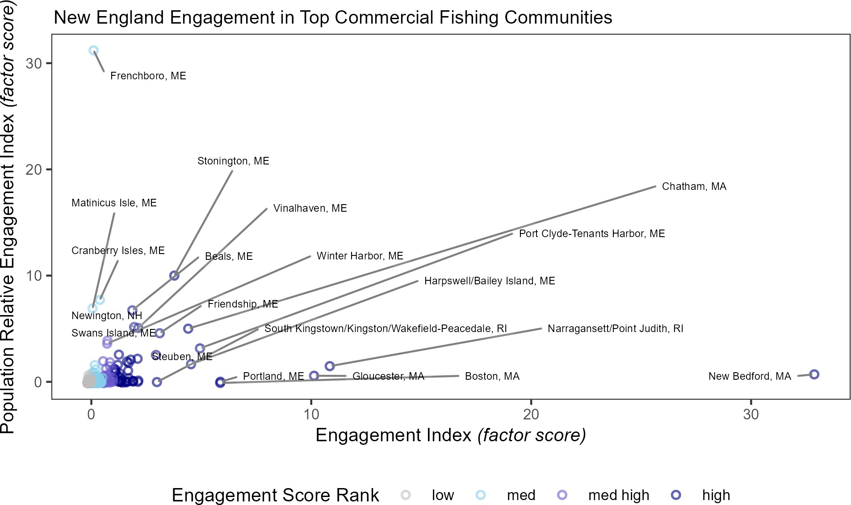

Figure 47: Commercial engagement and population relative engagement with labels for the top commercially engaged fishing communities in New England.

Table 7: Socio-demographic indicator rankings (ranging from low = low vulnerability to high = high vulnerability) for [Mid-Atlantic] *or* [New England] communities most engaged in commercial fishing, 2022. Blank spaces indicate no data available.

Community | Personal Disruption | Population Composition | Poverty
Cape May, NJ | low | med | low
Reedville, VA | low | low | low
Montauk, NY | low | low | low
Point Pleasant Beach, NJ | med | low | low
Hampton Bays/Shinnecock, NY | low | high | low
Barnegat Light, NJ | low | low | low

Table 7: Socio-demographic indicator rankings (ranging from low = low vulnerability to high = high vulnerability) for [Mid-Atlantic] *or* [New England] communities most engaged in commercial fishing, 2022. Blank spaces indicate no data available.

Community | Personal Disruption | Population Composition | Poverty
Bronx/City Island, NY | high | high | high
Newport News, VA | med | low | med
Hampton, VA | med | low | med
Wanchese, NC | low | low | low
Atlantic City, NJ | high | high | high
Ocean City, MD | med | low | low
Swan Quarter, NC | low | low | low
Wachapreague, VA | low | low | low
Quinby, VA | med | low | low
Bowers, DE | low | low | low
Little Creek, DE | high | low | high
Oak Beach, NY | low | low

Narragansett/Point Judith, RI; Newington, NH; and Gloucester, MA ranked as top communities for both commercial and recreational indices (Fig. 48), suggesting that they may be impacted simultaneously (to a greater degree than others) by commercial and recreational regulatory changes. Of the top-ranked recreational communities, only Provincetown, MA and Falmouth, MA had medium or higher ranks for more than one socio-demographic indicator (Table. 8) examined here (poverty, personal disruption, population composition). This suggests that future changes to recreational fishing conditions may disproportionately impact Provincetown and Falmouth.

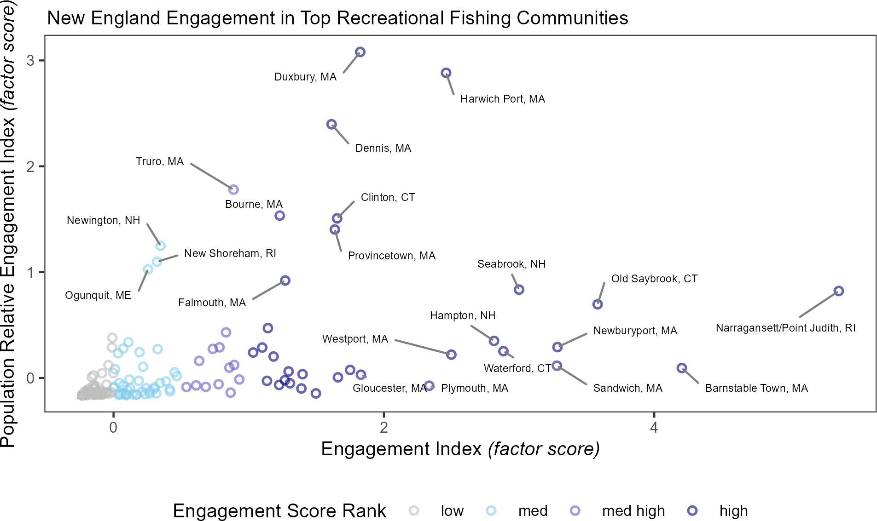

Figure 48: Recreational engagement and population relative engagement with labels for the top recreationally engaged fishing communities in New England.

Table 8: Socio-demographic indicator rankings (ranging from low = low vulnerability to high = high vulnerability) for [Mid-Atlantic] *or* [New England] communities most engaged in recreational fishing, 2022. Blank spaces indicate no data available.

Community | Personal Disruption | Population Composition | Poverty
Cape May, NJ | low | med | low
Montauk, NY | low | low | low
Point Pleasant Beach, NJ | med | low | low
Barnegat Light, NJ | low | low | low
Ocean City, MD | med | low | low
Virginia Beach, VA | low | low | low
Morehead City, NC | med | low | med
Hatteras township, NC | low | low | low
Wachapreague, VA | low | low | low
Avon, NC | high | low
Atlantic Highlands, NJ | low | low | low
Babylon, NY | low | low | low

Table 8: Socio-demographic indicator rankings (ranging from low = low vulnerability to high = high vulnerability) for [Mid-Atlantic] *or* [New England] communities most engaged in recreational fishing, 2022. Blank spaces indicate no data available.

Community | Personal Disruption | Population Composition | Poverty
Nags Head, NC | low | low | low
Point Lookout, NY | low | low | low
Nanticoke, MD | med high | low | low
Orient, NY | low | low
Bivalve, MD | med | high
Rodanthe, NC | low | low
Topsail Beach, NC | low | low | low
Solomons Island/Solomons/Lusby, MD | low | low | low
Stevensville, MD | med | low | low

Indicators: Community Climate Vulnerability in the New England
The Community Climate Change Risk Indicators are calculated by multiplying the percent contribution of species to the total value landed in a community by their respective Total Vulnerability scores (based on NOAA’s Climate Vulnerability Assessment) for different sensitivity and exposure factors and then summing the resulting values by year. As a community (or region) shifts towards climate vulnerable species, its risk score increases. While there is not a long-term trend in total climate vulnerability across New England communities as a whole, the proportion of communities with moderate vulnerability is decreasing and shifting more towards high or very high vulnerability scores (Fig. 49). This suggests that some communities are shifting towards being more dependent on climate-vulnerable species, particularly shellfish.

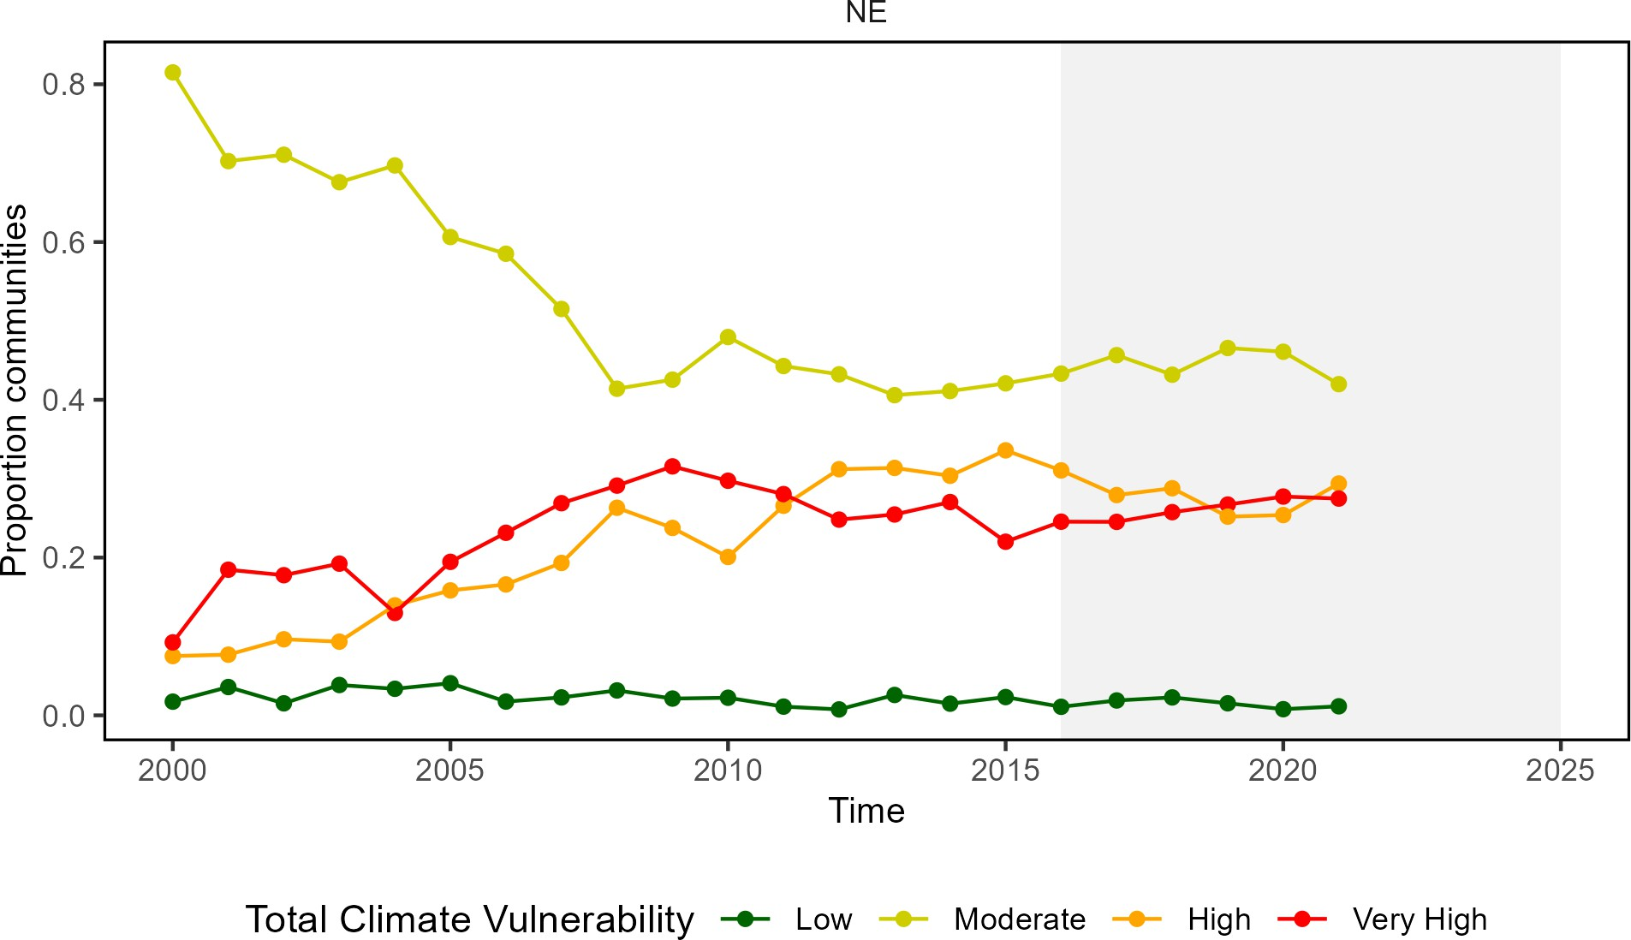

Figure 49: Proportion of New England communities at each revenue climate vulnerability level over time.

Implications
These indicators provide a snapshot of the presence of socio-demographic concerns in the most highly engaged commercial and recreational fishing communities in New England. These communities may be especially vulnerable to changes in fishing patterns due to regulations and/or ecosystem changes. Several of these top fishing communities, both commercial and recreational fishing communities, demonstrated medium to high socio-demographic vulnerability, indicating that they may be at a disadvantage responding to change.

parent_report.Rmd

Protected Species
Fishery management objectives for protected species generally focus on reducing threats and on habitat conserva- tion/restoration. Protected species include marine mammals protected under the Marine Mammal Protection Act, endangered and threatened species protected under the Endangered Species Act, and migratory birds protected under the Migratory Bird Treaty Act. In the Northeast U.S., endangered/threatened species include Atlantic salmon, Atlantic and shortnose sturgeon, all sea turtle species, giant manta ray, oceanic whitetip shark, and five baleen whales. Protected species objectives include managing bycatch to remain below potential biological removal (PBR) thresholds, recovering endangered populations, and monitoring unusual mortality events (UMEs). Here we report on performance relative to these objectives with available indicator data, as well as indicating the potential for future interactions driven by observed and predicted ecosystem changes in the Northeast U.S.

Indicators: bycatch, population (adult and juvenile) numbers, mortalities
Average indices for both harbor porpoise (Fig. 50) and gray seal bycatch (Fig. 51) are below current PBR thresholds, meeting management objectives, although uncertainty in the gray seal bycatch estimate has increased recently, and

gray seal bycatch is among the highest for marine mammals in the U.S.
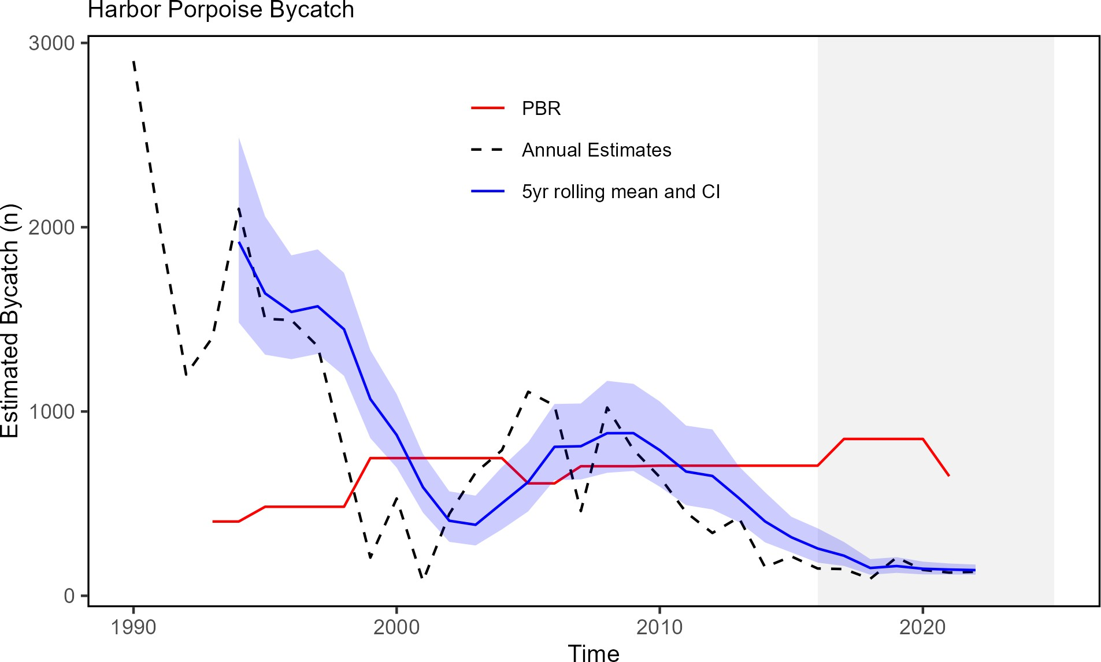

Figure 50: Harbor porpoise average bycatch estimate for Mid-Atlantic and New England gillnet fisheries (blue) and the potential biological removal (red).

The annual estimate for gray seal bycatch, most of which occurs in New England, has declined since 2019, in part driven by declining gillnet landings. In addition, estimates since 2019 have greater uncertainty stemming from low observer coverage in some times and areas since 2019. The rolling mean confidence interval remains just below the PBR threshold.

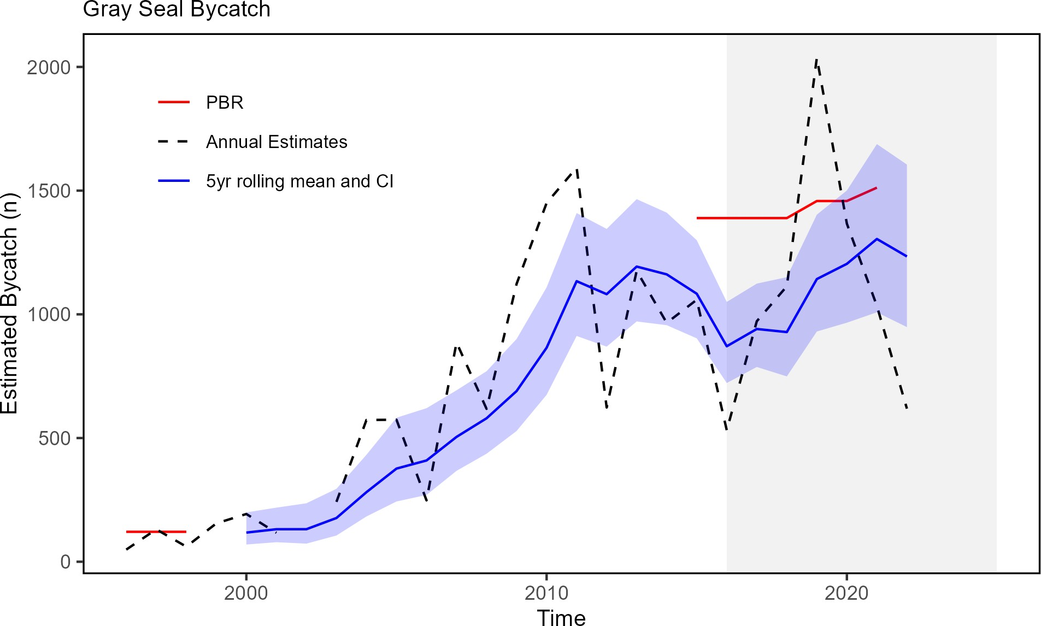

Figure 51: Gray Seal average bycatch estimate for gillnet fisheries (blue) and the potential biological removal (red).

The North Atlantic right whale population was on a recovery trajectory until 2010, but has since declined (Fig. 52). The sharp decline observed from 2015-2020 appears to have slowed, although the right whale population continues to experience annual mortalities above recovery thresholds. Reduced survival rates of adult females lead to diverging abundance trends between sexes. It is estimated that there are fewer than 70 adult females remaining in the population.
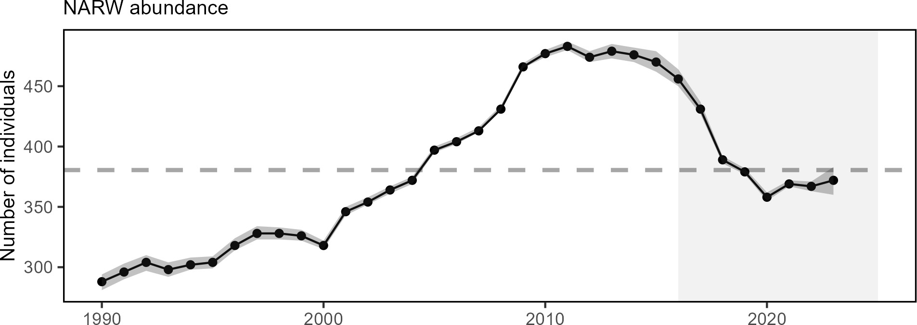

Figure 52: Estimated North Atlanic right whale abundance on the Northeast Shelf.

North Atlantic right whale calf counts have generally declined after 2009 to the point of having zero new calves observed in 2018 (Fig. 53). However, since 2020, calf births have been closer to the long-term average.
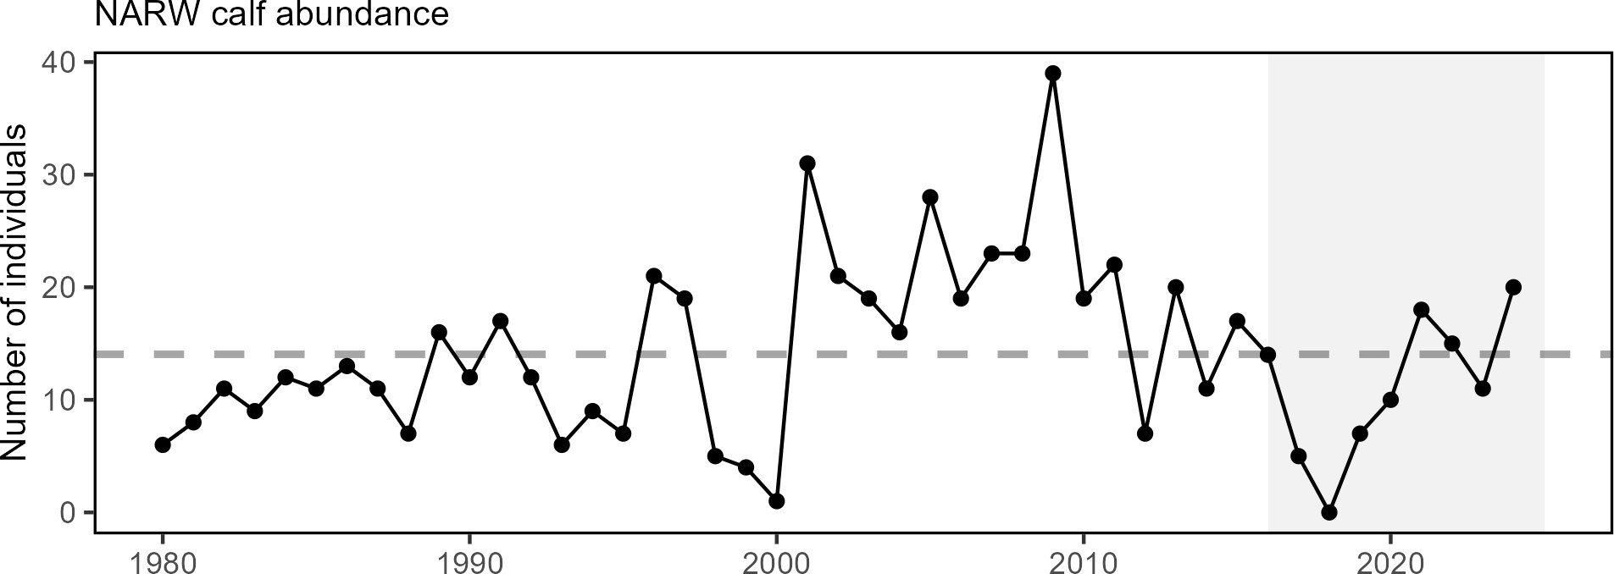

Figure 53: Number of North Atlantic right whale calf births, 1990 - 2022.

This year, the Unusual Mortality Event (UME) for North Atlantic right whales continued. From 2017 through 2 January 2025, the total UME right whale mortalities includes 41 dead stranded whales, 19 in the US and 22 in Canada. When alive but seriously injured whales (39) and sublethal injuries or ill whales (71) are taken into account, 151 individual whales are included in the UME. Recent research suggests that many mortalities go unobserved and the true number of mortalities are about three times the count of the observed mortalities. The primary cause of death is “human interaction” from entanglements or vessel strikes.
A UME continued from previous years for humpback whales (2016-present) and Atlantic minke whales (2018-present); suspected causes include human interactions. A UME for Northeast pinnipeds that began in 2018 for infectious disease is pending closure as of February 2025.

Implications
Bycatch management measures have been implemented to maintain bycatch below PBR thresholds. The downward trend in harbor porpoise bycatch could also be due to a decrease in harbor porpoise abundance in U.S. waters, reducing their overlap with fisheries, and a decrease in gillnet effort. The increasing trend in gray seal bycatch may be related to an increase in the gray seal population (U.S. pup counts), supported by the dramatic rise over the last three decades in observed numbers of gray seal pups born at U.S. breeding sites plus an increase in adult seals at the breeding sites, some of which are supplemented by Canadian adults.
Strong evidence exists to suggest that interactions between right whales and both the fixed gear fisheries in the
U.S. and Canada and vessel strikes in the U.S. are contributing substantially to the decline of the species. Further, right whale distribution has changed since 2010. Recent research suggests that recent climate driven changes in ocean circulation have resulted in right whale distribution changes driven by increased warm water influx through the Northeast Channel, which has reduced the primary right whale prey (the copepod Calanus finmarchicus) in the central and eastern portions of the Gulf of Maine. Additional potential stressors include offshore wind development, which overlaps with important habitat areas used year-round by right whales, including mother and calf migration corridors and foraging habitat. This area is also a primary right whale winter foraging habitat. Additional information can be found in the offshore wind risks section.
The UMEs are under investigation and are likely the result of multiple drivers. For all large whale UMEs, human interaction appears to have contributed to increased mortalities, although investigations are not complete.
A climate vulnerability assessment is published for Atlantic and Gulf marine mammal populations.

Risks to Meeting Fishery Management Objectives

Climate and Ecosystem Change
Risks to managing spatially
Shifting species distributions (changes in spatial extent or center of gravity) alter both species interactions and fishery interactions. In particular, shifting species distributions can affect expected management outcomes from spatial allocations and bycatch measures based on historical fish and protected species distributions. Species availability to surveys can also change as distributions shift within survey footprints, complicating the interpretation of survey trends.
Coastwide indicators are reviewed in this section to evaluate spatial change throughout the Northeast US shelf. Indicators are identical between the Mid Atlantic and New England reports.

Indicators: Fish and protected species distribution shifts As noted in the Seafood Production Implications section above, the center of distribution for a suite of 48 commercially or ecologically important fish species combined along the entire Northeast Shelf continues to show movement towards the northeast and generally into deeper water (Fig. 54). Distribution shifts have been noted for several highly migratory species, including sharks, billfish and tunas between 2002 and 2019.
Habitat model-based species richness suggests shifts of both cooler and warmer water species to the northeast. Similar patterns have been found for marine mammals, with multiple species shifting northeast between 2010 and 2017 in most seasons (Fig. 55).

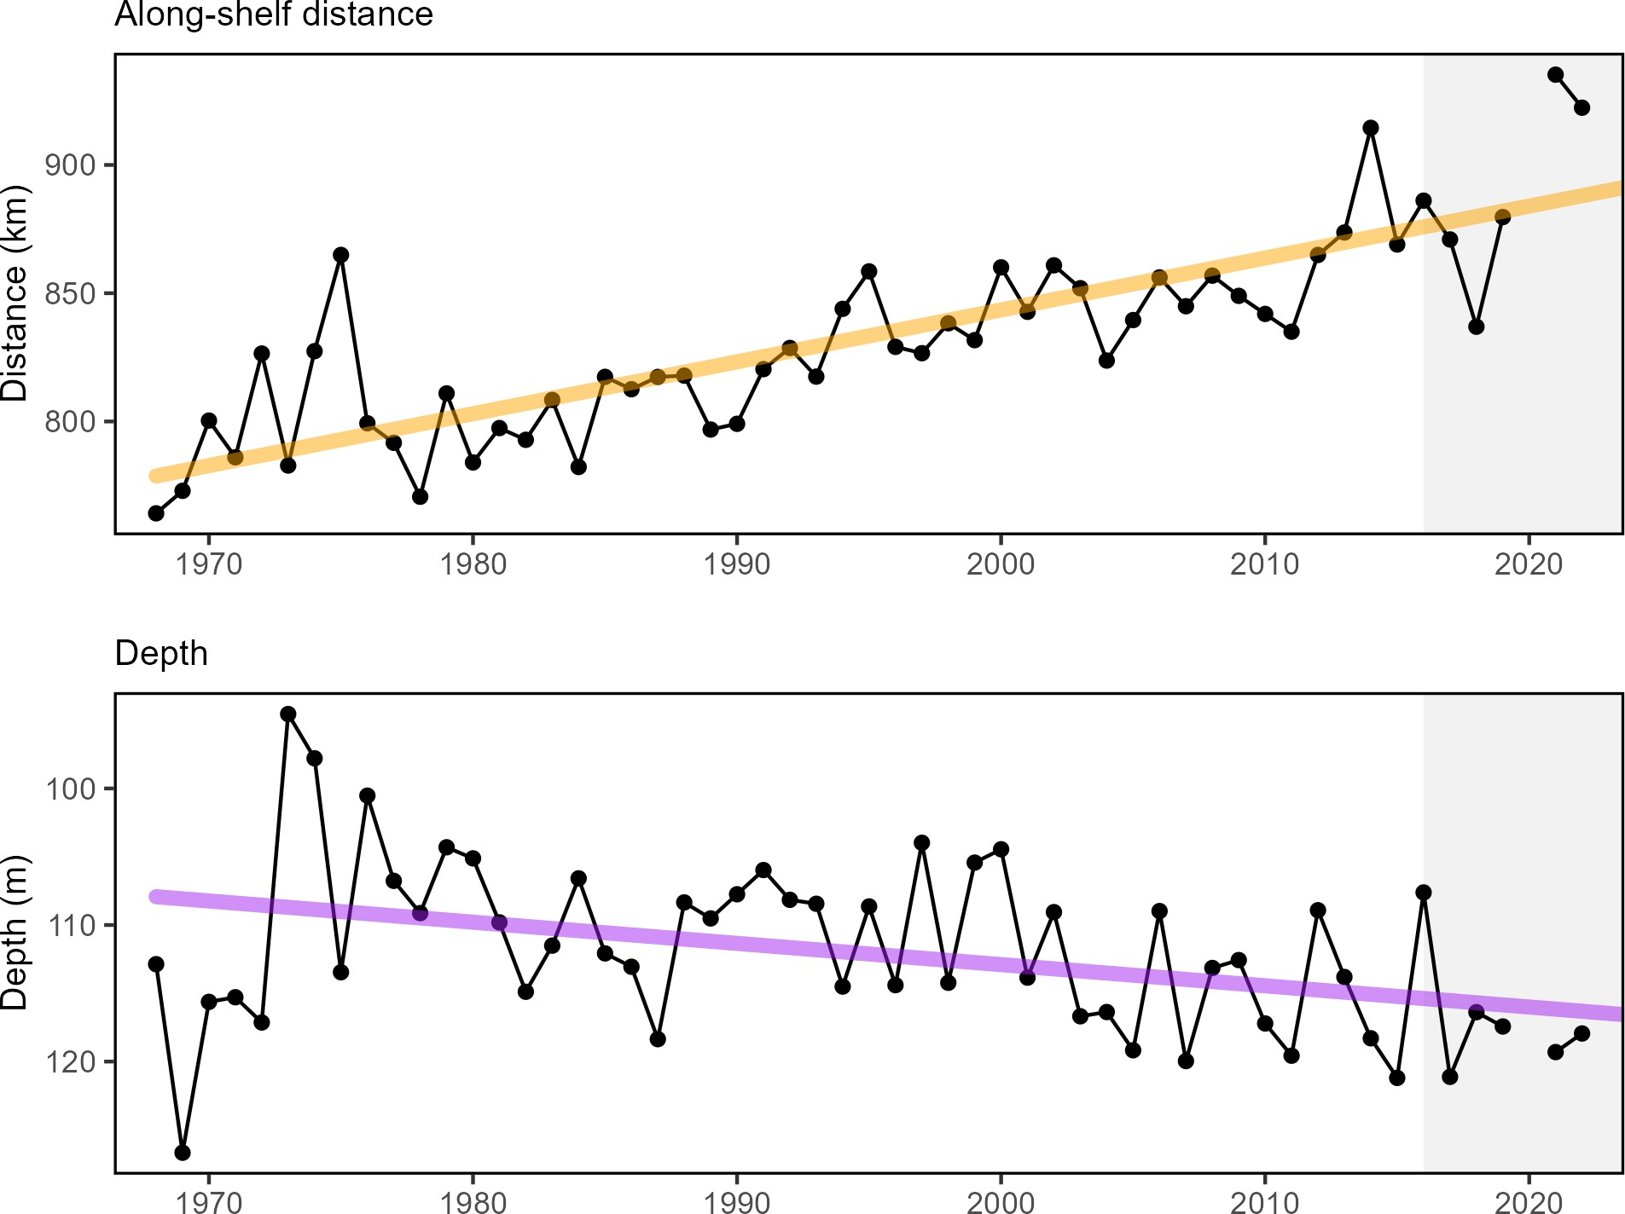

Figure 54: Aggregate species distribution metrics for species in the Northeast Large Marine Ecosystem: along shelf distance with increasing trend (orange), and depth with decreasing trend indicating deeper water (purple).

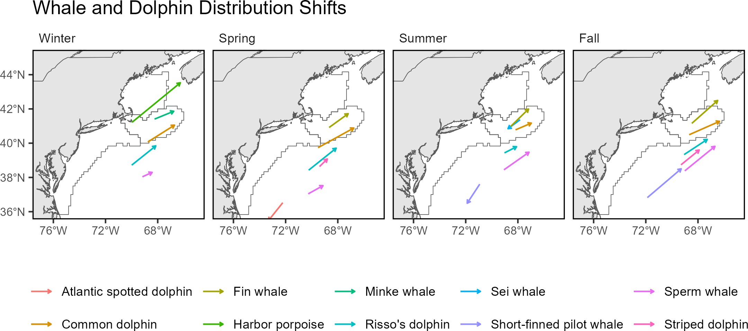

Figure 55: Direction and magnitude of core habitat shifts, represented by the length of the line of the seasonal weighted centroid for species with more than 70 km difference between 2010 and 2017 (tip of arrow).

Drivers: Mobile populations shift distributions to maintain suitable temperature and prey fields, possibly expanding ranges if new suitable habitat exists. Changes in managed species distribution is related, in part, to the distribution of forage biomass. Since 1982, the fall center of gravity of forage fish (20 species combined) has moved to the north and east (Fig. 56). Spring forage fish center of gravity has been more variable over time. Small copepods, widespread prey of many larval and juvenile fish, show a similar shift in center of gravity as forage fish, to the north and east in the fall, as well as northward in spring.

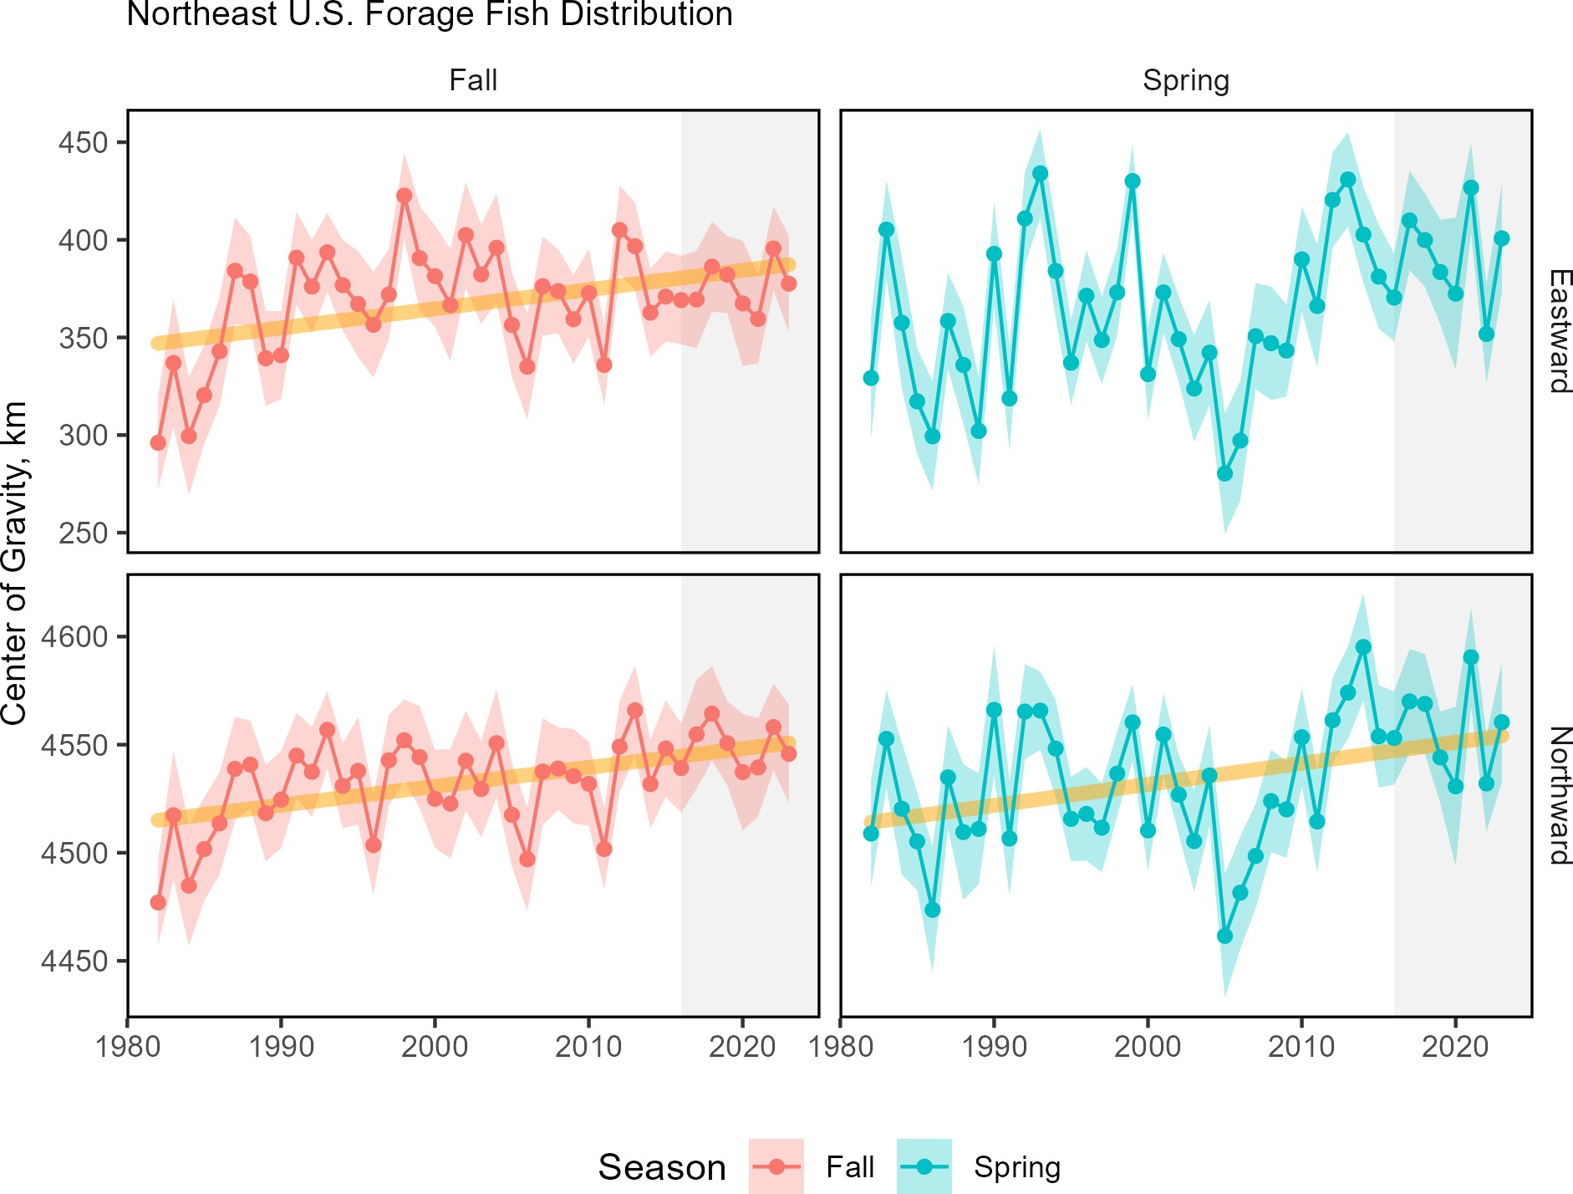

Figure 56: Eastward (top) and northward (bottom) shifts in the center of gravity for 20 forage fish species on the Northeast
U.S. Shelf, with increasing trend (orange) for fall eastward and northward center of gravity.

In contrast, macrobenthos center of gravity has shifted westward (Fig. 57). Macrobenthos are small bottom-dwelling invertebrates including polychaete worms, small crustaceans, bivalves (non-commercial), gastropods, nemerteans, tunicates, cnidarians, brittle stars, sea cucumbers, and sand dollars, and are prey for many managed species. Large copepods have a similar pattern to macrobenthos, trending westward in fall.

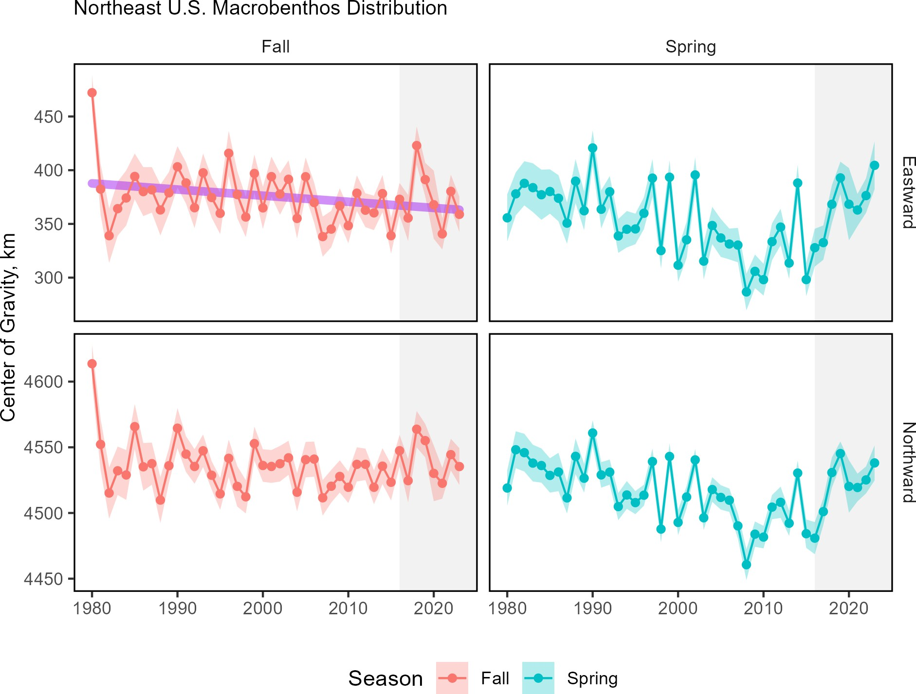

Figure 57: Eastward (top) and northward (bottom) shifts in the center of gravity for macrobenthos species on the Northeast
U.S. Shelf

Ocean temperatures influence the distribution, seasonal timing, and productivity of managed species (see sections below). The Northeast US shelf, including the Mid-Atlantic, has experienced a continued warming trend for both the long term annual sea surface (Fig. 58) and seasonal surface and bottom temperature. However, 2024 surface and bottom temperatures were near normal to cooler than normal conditions in all seasons in the MAB (see also the 2024 Highlights section).

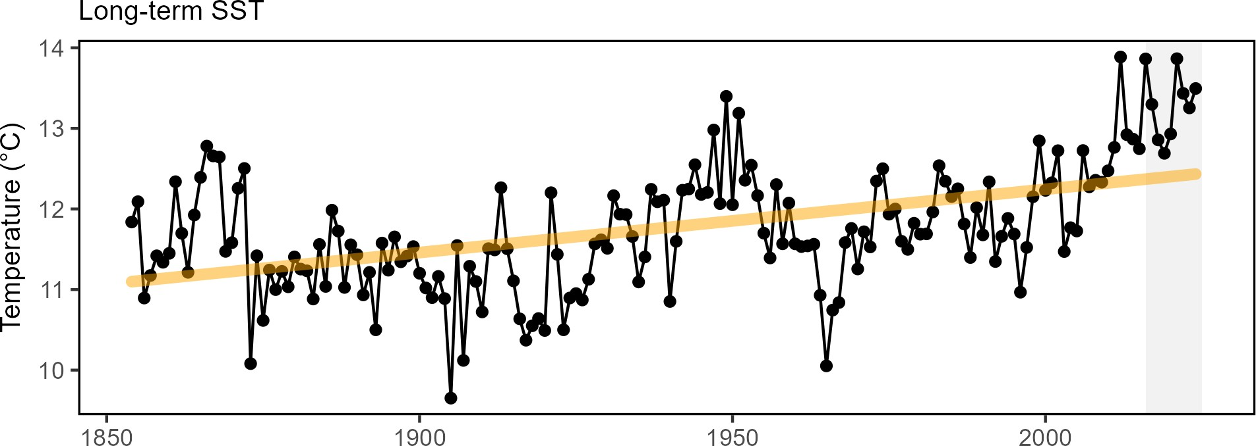

Figure 58: Northeast US annual sea surface temperature (SST, black), with increasing trend (orange).

Species suitable habitat can expand or contract when changes in temperature and major oceanographic conditions alter distinct water mass habitats.The variability of the Gulf Stream is a major driver of the predominant oceanographic conditions of the Northeast U.S. continental shelf. As the Gulf Stream has become less stable and shifted northward in the last decade (Fig. 59), warmer ocean temperatures have been observed on the northeast shelf and a higher proportion of Warm Slope Water has been present in the Northeast Channel. Since 2008, the Gulf Stream has moved closer to the Grand Banks, reducing the supply of cold, fresh, and oxygen-rich Labrador Current waters to the Northwest Atlantic Shelf. In 2024, however, the eastern portion of the Gulf Stream was further south, which could affect the composition of the source water entering the Gulf of Maine through the Northeast Channel (see 2024 Highlights).
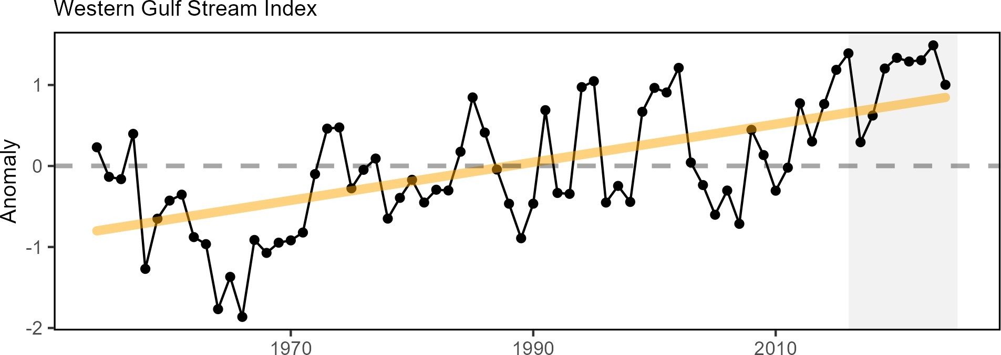

Figure 59: Index representing changes in the location of the western (between 64 and 55 degrees W) Gulf Stream north wall (black). Positive values represent a more northerly Gulf Stream position, with increasing trend (orange).

Changes in ocean temperature and circulation alter habitat features such as the Middle Atlantic Bight Cold Pool, a band of relatively cold near-bottom water from spring to fall over the northern MAB. The cold pool represents essential fish spawning and nursery habitat, and affects fish distribution and behavior. The cold pool has been getting warmer and its areal extent has been shrinking over time (Fig. 60). In 2024, however, the cold pool index

and extent were near the long-term average, likely due to the influx of Labrador Slope and Scotian Shelf waters into the system.
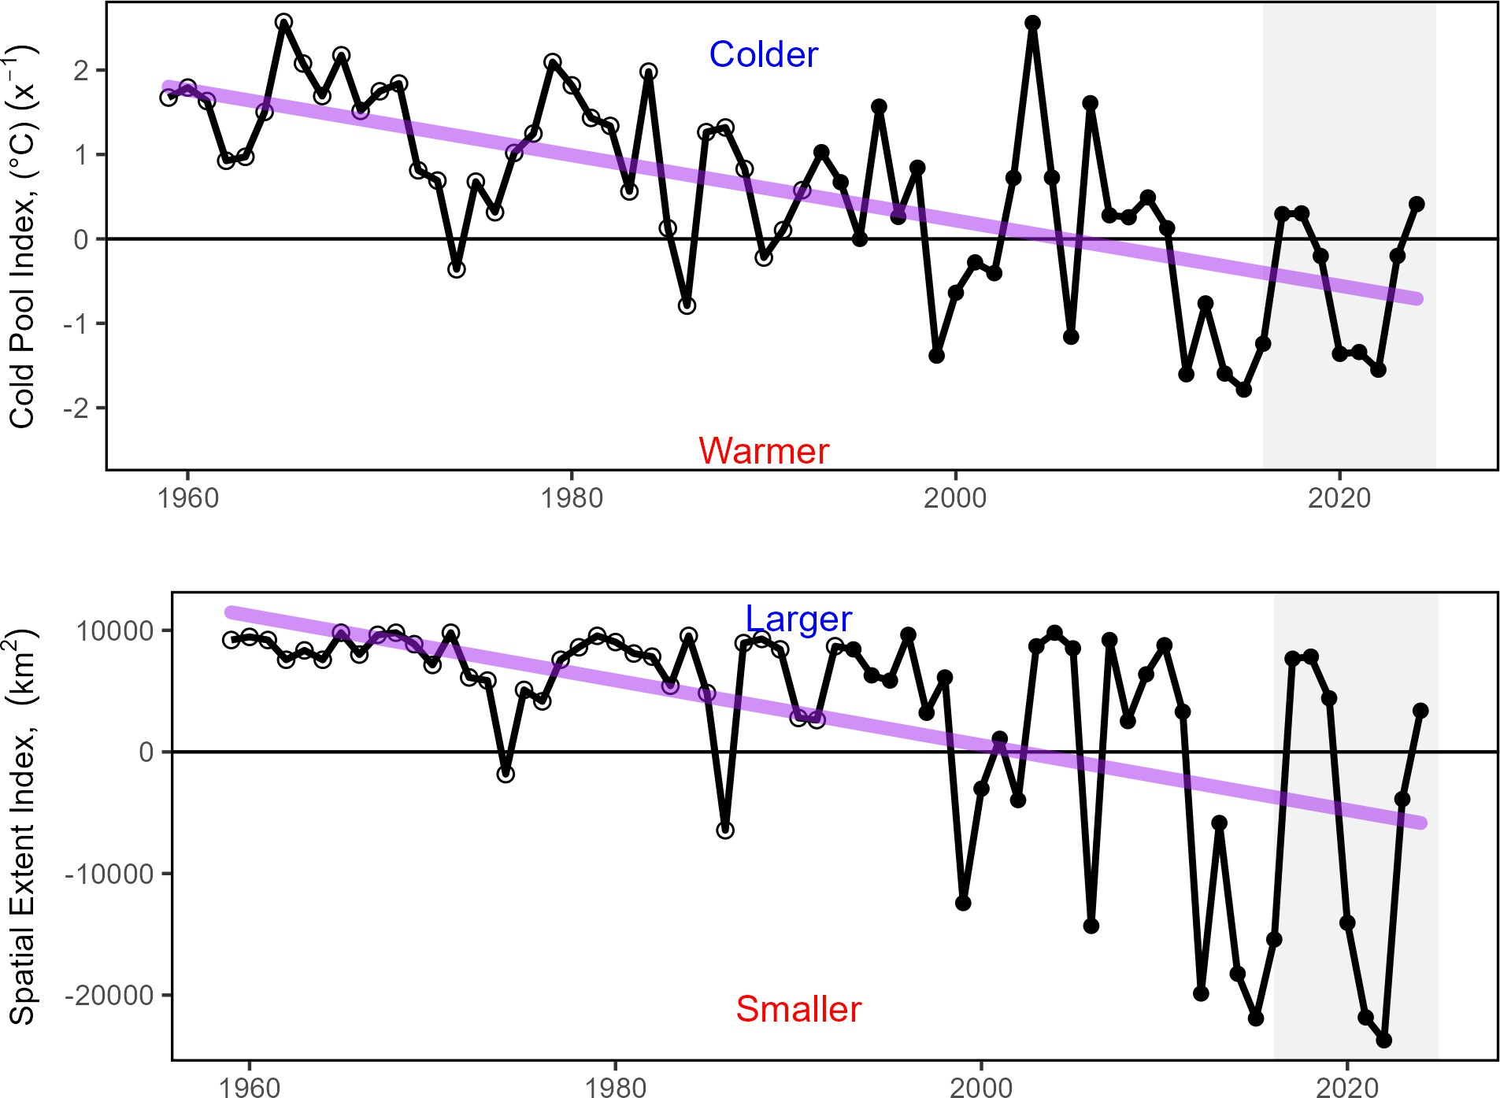

Figure 60: Seasonal cold pool mean temperature (top) and spatial extent index (bottom), based on bias-corrected ROMS-NWA (open circles) and GLORYS (closed circles), with declining trends (purple).

Future Considerations Distribution shifts caused by changes in thermal habitat and ocean circulation are likely to continue as long as long-term trends persist. Episodic and short-term events (see 2024 Highlights) may increase variability in the trends, however species distributions are unlikely to reverse to historical ranges in the short term. Increased mechanistic understanding of distribution drivers is needed to better understand future distribution shifts: species with high mobility or short lifespans react differently from immobile or long lived species.
Long-term oceanographic projections forecast a temporary pause in warming over the next decade due to internal variability in circulation and a southward shift of the Gulf Stream. Near-term forecasts are being evaluated to determine how well they are able to predict episodic and anomalous events that are outside of the long-term patterns.
Adapting management to changing stock distributions and dynamic ocean processes will require continued monitoring of populations in space and evaluating management measures against a range of possible future spatial distributions. Processes like the East Coast Climate Scenario Planning, and subsequent formation of the East Coast Climate Coordination Group, can help coordinate management.

Risks to managing seasonally
The effectiveness of seasonal management actions (fishing seasons or area opening/closing) depends on a proper alignment with the seasonal life cycle events (phenology) of fish stocks (e.g. migration timing and spawning). Changes in the timing of these biological cycles can reduce the effectiveness of management measures if not accounted for. The timing of seasonal patterns can also change the interactions between fisheries and non-target species thus influencing the amount of bycatch and the availability of species to surveys.

Indicators: Timing shifts Spawning timing is shifting earlier for multiple stocks, including haddock and yellowtail flounder. Spawning of both haddock stocks occurred earlier in the year, as indicated by more resting (post-spawning) stage fish in the 2010s as compared to earlier in the time series (Fig. 61). The northern (Cape Cod/GOM) yellowtail flounder stock shows earlier active spawning in recent years with a decline in pre-spawning resting females.The recent increase in resting females in the southern (SNE) stock also indicates a shift to earlier spawning (i.e. more post-spawn fish). Yellowtail flounder spawning is related to bottom temperature, week of year, and decade sampled for each of the three stocks.
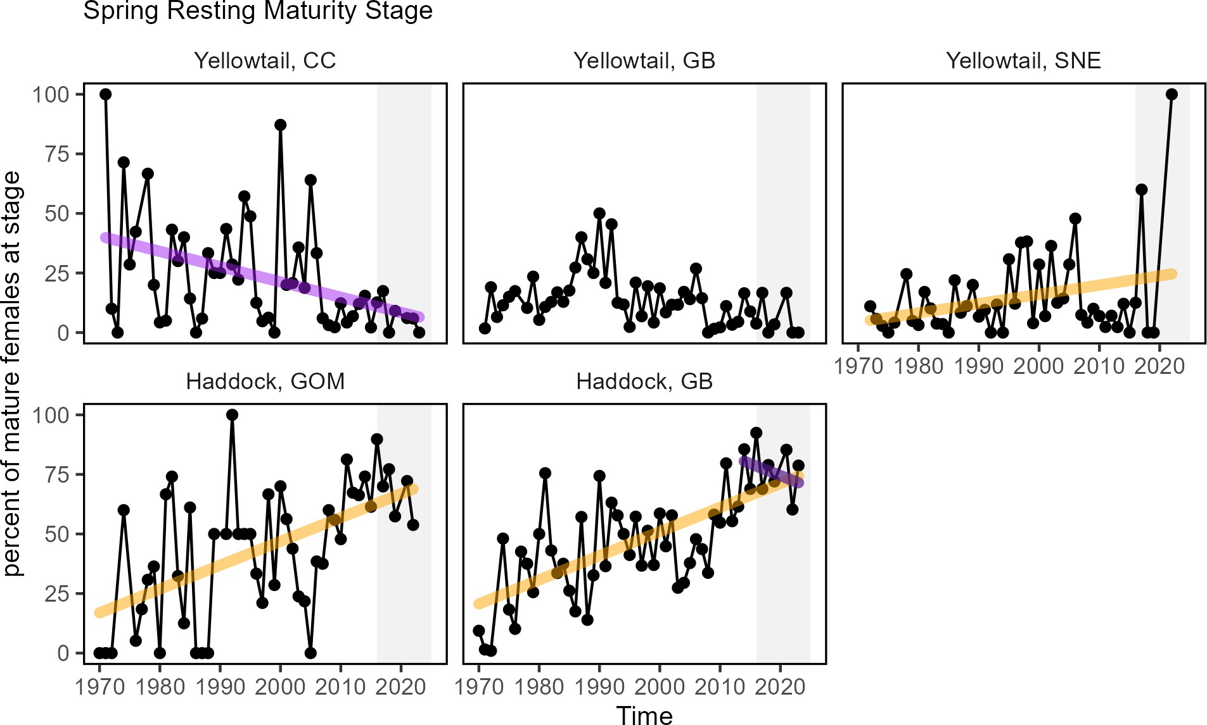

Figure 61: Percent resting stage (non-spawning) mature female fish (black) from spring NEFSC bottom trawl survey with significant increases (orange) and decreases (purple) from two haddock and three yellowtail flounder stocks: CC = Cape Cod Gulf of Maine, GOM = Gulf of Maine, GB = Georges Bank, SNE = Southern New England.

Migration timing of some tuna and large whale migrations has changed. An analysis of recreational fishing data between 2019 and 2022 identified multiple shifts in important HMS species. For example, Bigeye tuna were caught 50 days earlier; small and large bluefin tuna were caught 38 and 80 days earlier respectively in Massachusetts; and blue marlin in New York were caught 27 days earlier. In Cape Cod Bay, peak spring habitat use by right and humpback whales has shifted 18-19 days later over time.
Understanding whether seasonal patterns are changing for stocks requires regular observations throughout the year. For example, baseline work on cetacean presence in Southern New England shows different seasonal use patterns for

whale and dolphin species. Despite the importance of understanding seasonal patterns, we have few indicators that directly assess timing shifts of species. We plan on incorporating more indicators of timing shifts and phenology in future reports.

Drivers: The drivers of timing shifts in managed stocks are generally coupled to shifts in environmental or biological conditions, since these can result in changes in habitat quality or food availability within the year. Changes in the timing of fall phytoplankton blooms and seasonal shifts in zooplankton communities are indicators of changes in seasonal food availability to stocks.
Along with the overall warming trends in [the Mid-Atlantic Bight] or [New England], ocean summer conditions have been lasting longer (Fig. 62) due to the later transition from warm summer conditions to cooler fall temperatures. These transition dates relate how daily temperatures compare to the seasonal norm. Changes in the timing of seasonal environmental cycles can alter biological processes (migrations, spawning, etc.) that are triggered by seasonal events.
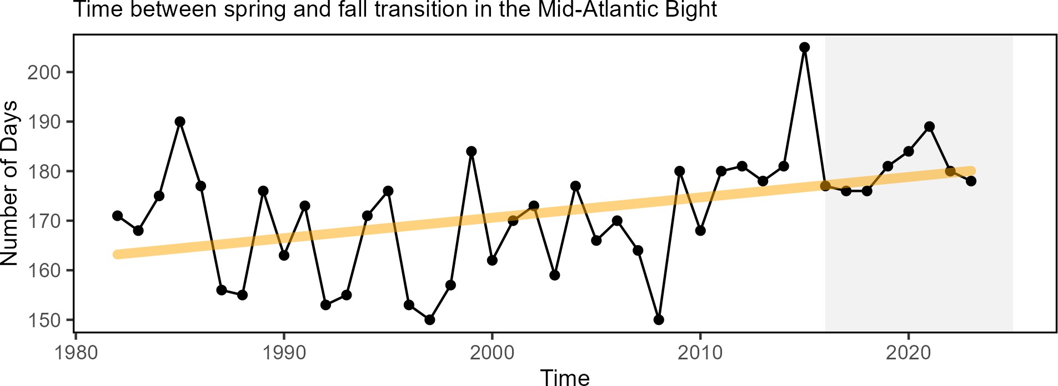

Figure 62: Ocean summer length in the MAB: the annual total number of days between the spring thermal transition date and the fall thermal transition date (black), with an increasing trend (orange).

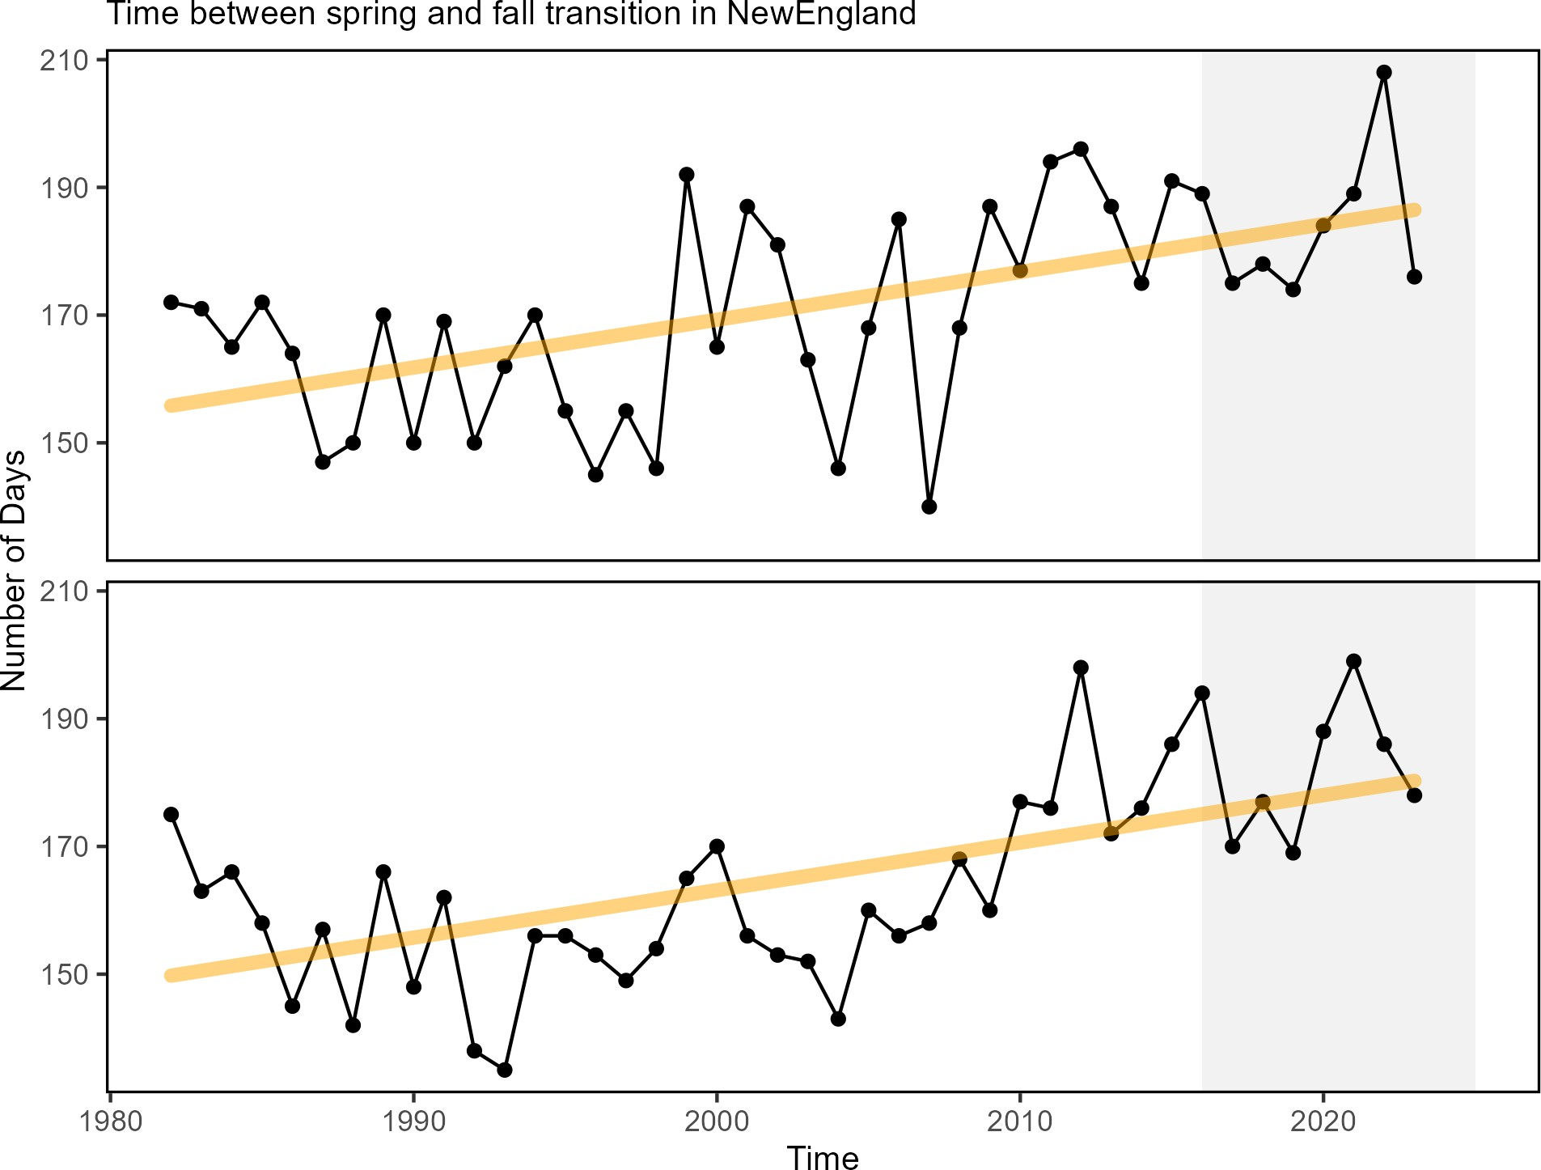

Figure 63: Ocean summer length: the annual total number of days between the spring thermal transition date and the fall thermal transition date.

06_risk_seasonal_midatlantic.Rmd
As noted above, the Middle Atlantic Cold Pool is a summer to early fall feature that creates seasonally suitable habitat for some species. Cold pool persistence, a measure of how long this feature is present in a given year, has been declining, so this habitat is available for a shorter portion of the year (Fig. 64). All cold pool indices were near the long-term average in 2024 and likely related to the influx of northern waters into the system (see 2024 Highlights section). A change in the timing of the autumn breakdown of the cold pool may impact the recruitment of species that depend on it for habitat, such as juvenile yellowtail flounder.

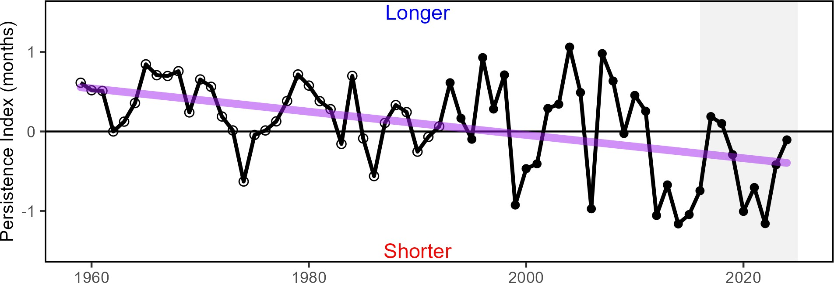

Figure 64: The Mid Atlantic Bight Cold Pool persistence index based on bias-corrected ROMS-NWA (open circles) and GLORYS (closed circles).

The seasonal timing of Mid-Atlantic phytoplankton blooms shows high interannual variability during the fall bloom period (October-December, Fig. 65). The significant increase in January chlorophyll suggests that the fall bloom period is continuing into the winter, with more chlorophyll now than in the late 1990s. The significant decrease of chlorophyll in September could be related to warmer temperatures persisting into early fall and increased nutrient limitation.
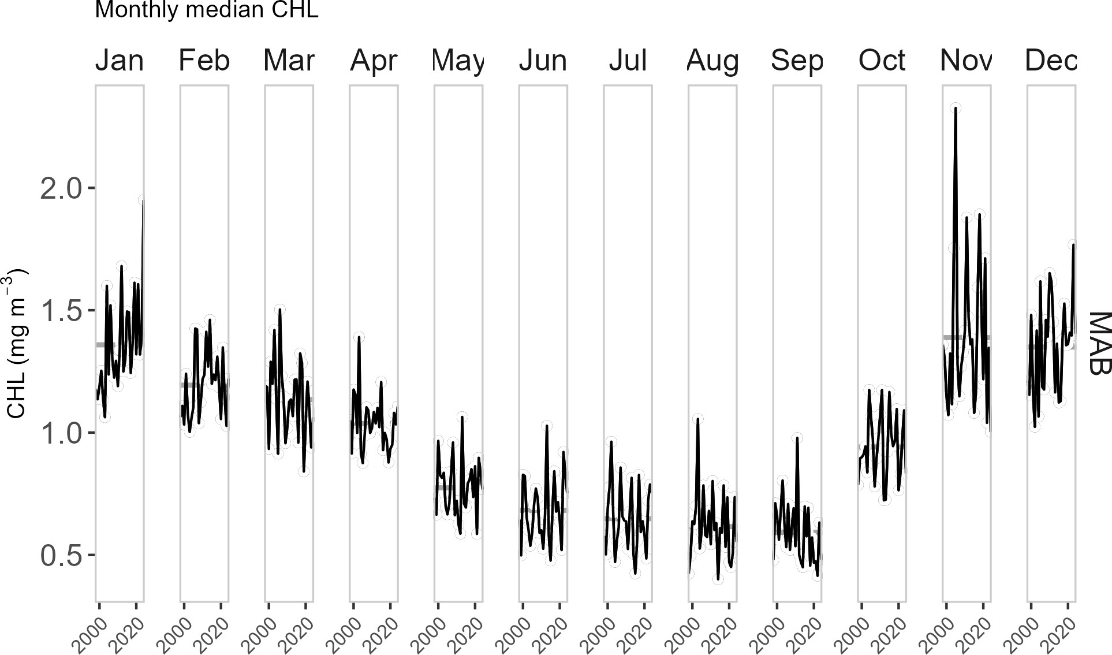

Figure 65: Monthly median chlorophyll a concentration in the MAB (black) with significant increase in January (orange line) and decrease in September (purple line).

parent_report.Rmd 06_risk_seasonal_newengland.Rmd
The Middle Atlantic Bight Cold Pool is a summer to early fall feature that creates seasonally suitable habitat for many species, including some managed by the NEFMC. Since the mid-2000s, the Cold Pool has persisted for a shorter portion of the year (Fig. 66). In 2024, however, all Cold Pool indices were near the long-term average and likely related to the influx of northern waters into the system (see 2024 highlights section). A change in the timing of the autumn breakdown of the Cold Pool may impact the recruitment of species that rely on it for seasonal cues and habitat. Southern New England-Mid Atlantic yellowtail flounder recruitment and settlement are related to the strength of the MAB Cold Pool (a factor of extent and persistence). The correlation of pre-recruit settlers to the Cold Pool is thought to represent a bottleneck in yellowtail flounder life history, whereby a local and temporary increase in bottom temperature can negatively impact the survival of settlers. Including the effect of Cold Pool variations on yellowtail recruitment reduced retrospective patterns and improved predictive skill in a stock assessment model. This is especially important given the long-term decline in the duration of the Cold Pool.


Figure 66: The Mid Atlantic Bight Cold Pool persistence index based on bias-corrected ROMS-NWA (open circles) and GLORYS (closed circles).

The seasonal timing of phytoplankton blooms shows a tendency towards an increased fall bloom over time in the GOM and GB, with chlorophyll significantly increasing October and November (GB) and December (GOM) (Fig. 67). January concentrations are trending higher since the late 1990s, but they are still below the mean spring and fall bloom values.

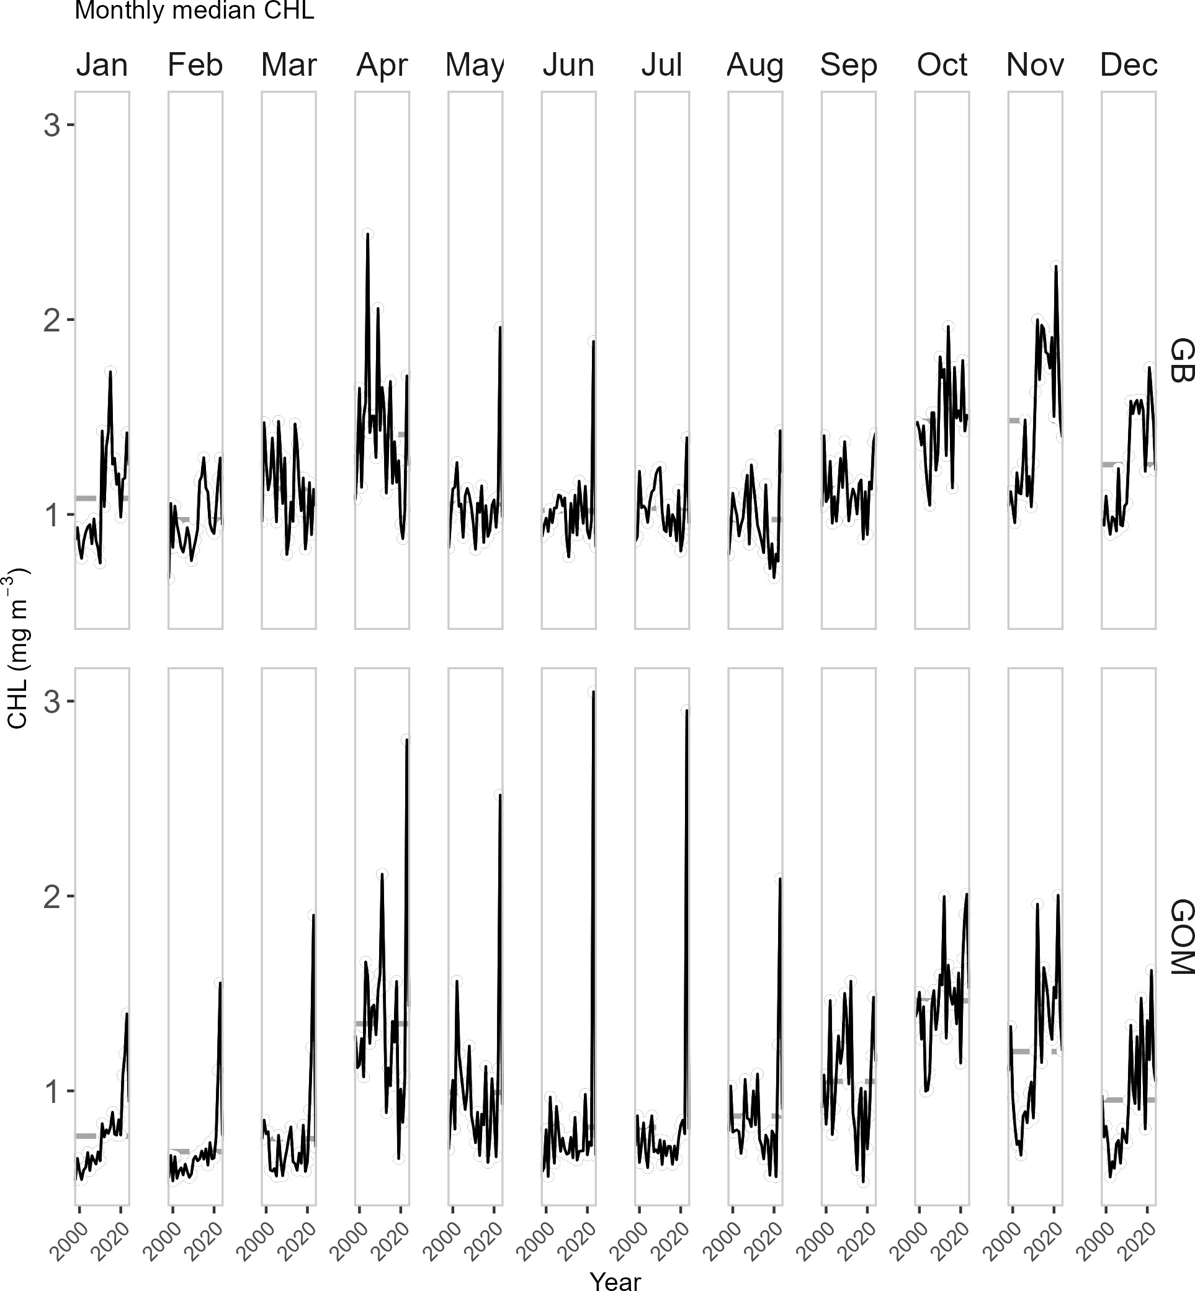

Figure 67: Monthly median chlorophyll a concentration time series for Georges Bank and Gulf of Maine. Significant positive trends (orange lines) in fall and early winter are based on a 26 year time series.

parent_report.Rmd
Future Considerations For species reliant on environmental processes to dictate the timing of their behavior (e.g. phytoplankton bloom timing, thermal transition, or the duration of the cold pool), it is possible that some changes are episodic and have interannual variability, while other timing effects can change on scales of years to

decades. Other species may rely on the general seasonal succession of environmental drivers (e.g. the timing of the fall turnover) to cue biological processes, and these long-term trends are unlikely to reverse in coming years. Such timing shifts in migration or spawning may continue. Management actions that rely on effective alignment of fisheries availability and biological processes should continue to evaluate whether prior assumptions on seasonal timings still hold, and new indicators should be developed to monitor timing shifts for stocks.

Risks to setting catch limits
The efficacy of short-term stock projections and rebuilding plans rely on accurate understanding of processes affecting stock growth, reproduction, and natural mortality. These biological processes are often driven by underlying environmental change. When observed environmental change occurs, there is a risk that established stock-level biological reference points may no longer reflect the current population and short-term projections become more uncertain.

07_risk_setting_catch_limits_midatlantic.Rmd
Indicators: Fish productivity and condition shifts Indicators of fish productivity are derived from observations (surveys) or models (stock assessments). Fish productivity has been declining in the Mid-Atlantic since the early 2000s, as described by the small-fish-per-large-fish anomaly indicator (derived from NEFSC bottom trawl survey) (Fig. 68). This decline in fish productivity is also shown by a similar analysis based on stock assessment model outputs (recruitment per spawning stock biomass anomaly).

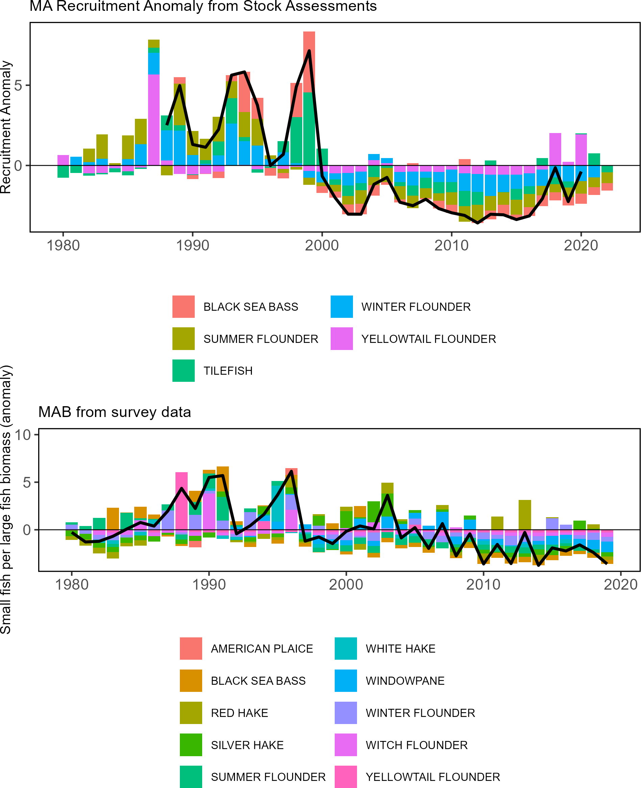

Figure 68: Fish productivity measures. Top: assessment recruitment per spawning stock biomass anomaly for stocks mainly in the Mid-Atlantic. The summed anomaly across species is shown by the black line, drawn across all years with the same number of stocks analyzed. Bottom: Small fish per large fish survey biomass anomaly in the Mid-Atlantic Bight.

The health of individual fish (i.e. fish condition, measured as weight for a given length) can contribute to population productivity through improved growth, reproduction and survival. Fish condition in the MAB was generally good prior to 2000, poor from 2001-2010 (concurrent with declines in productivity, Fig. 68), and a mix of good and poor since 2011. In 2024, condition continued to be mixed, with general improvement since a relatively low condition year in 2021 (Fig. 69). Preliminary analyses show that changes in temperature, zooplankton, fishing pressure, and population size influence the condition of different fish species.
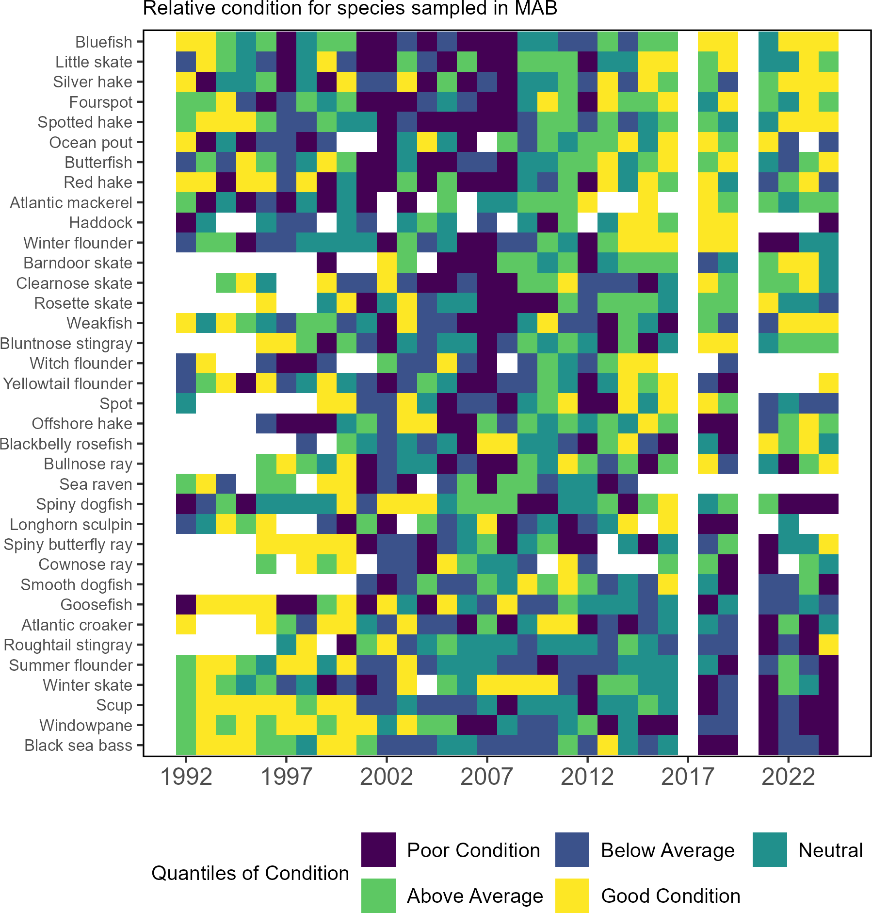

Figure 69: Condition factor for fish species in the MAB based on fall NEFSC bottom trawl survey data. MAB data are missing for 2017 due to survey delays, and no survey was conducted in 2020.

Drivers: Fish productivity and condition are affected by increasing metabolic demands from increasing temperature, combined with changes in the availability and quality of prey. Long-term environmental trends and episodic extreme temperatures, ocean acidification, and low oxygen events represent multiple stressors that can affect growth rates, reproductive success, recruitment, and cause mortality.

Biological Drivers: Forage quality and abundance The amount of forage fish available in the ecosystem combined with the energy content of the forage species determines the amount of energy potentially available to predators in the ecosystem. Changes in the forage base can drive managed and protected species production.
The energy content of juvenile and adult forage fish as prey is related to forage fish growth and reproductive cycles, as well as environmental conditions. The energy content of Atlantic herring was estimated to be highest of any forage species in the 1980s and 1990s, based on very small numbers of fish. Most observations from the NEFSC trawl surveys are below the previous estimates (Fig. ??). However, a recent study that included samples from additional sources indicated herring energy density peaked in summer, with some values closer to the historic estimates. Silver hake, longfin squid (Loligo in figure) and shortfin squid (Illex in figure) remain lower than previous estimates.
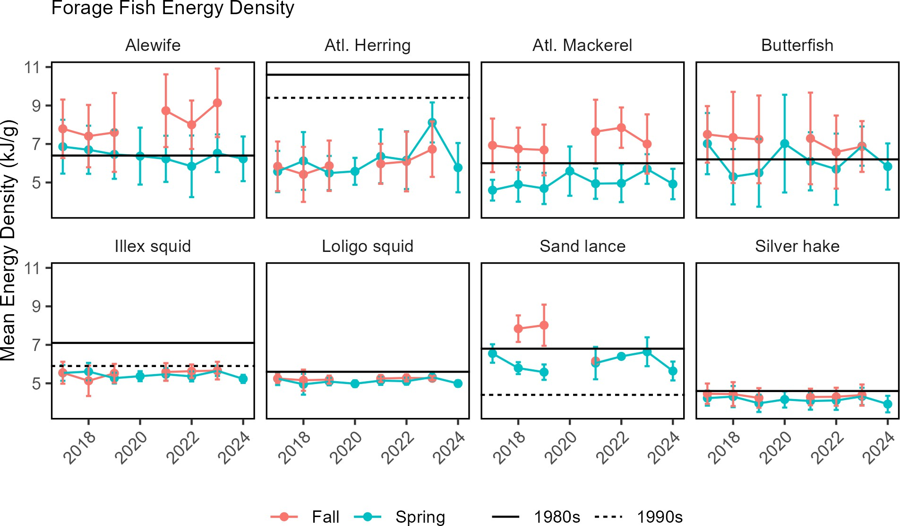

Changes in the overall abundance of forage fish can influence managed species productivity as it relates to changes in food availability. A spatially-explicit forage index for the Mid-Atlantic shows a long term declining trend in fall, with higher forage biomass in fall than spring (Fig. 70). Forage biomass was highest during fall in the early-1980s.

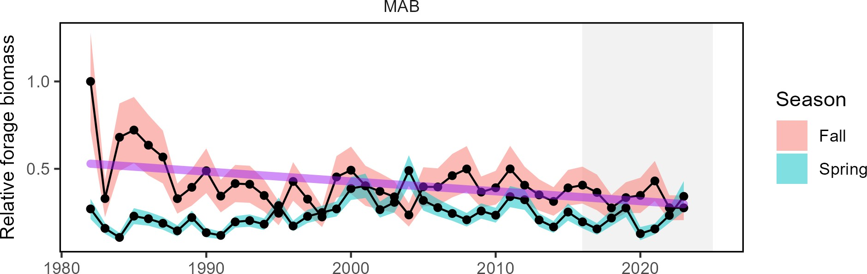

Figure 70: Forage fish index in the MAB for spring (blue) and fall (red) surveys, with a decline (purple) in fall. Index values are relative to the maximum observation within a region across surveys.

Benthic invertebrates are extremely important forage for some managed species (black sea bass, yellowtail and winter flounders, Atlantic cod, and haddock, and many skate species). Macrobenthos indices show long term declines in spring (Fig. 71). In contrast, megabenthos indices show long-term increases in spring in the MAB.

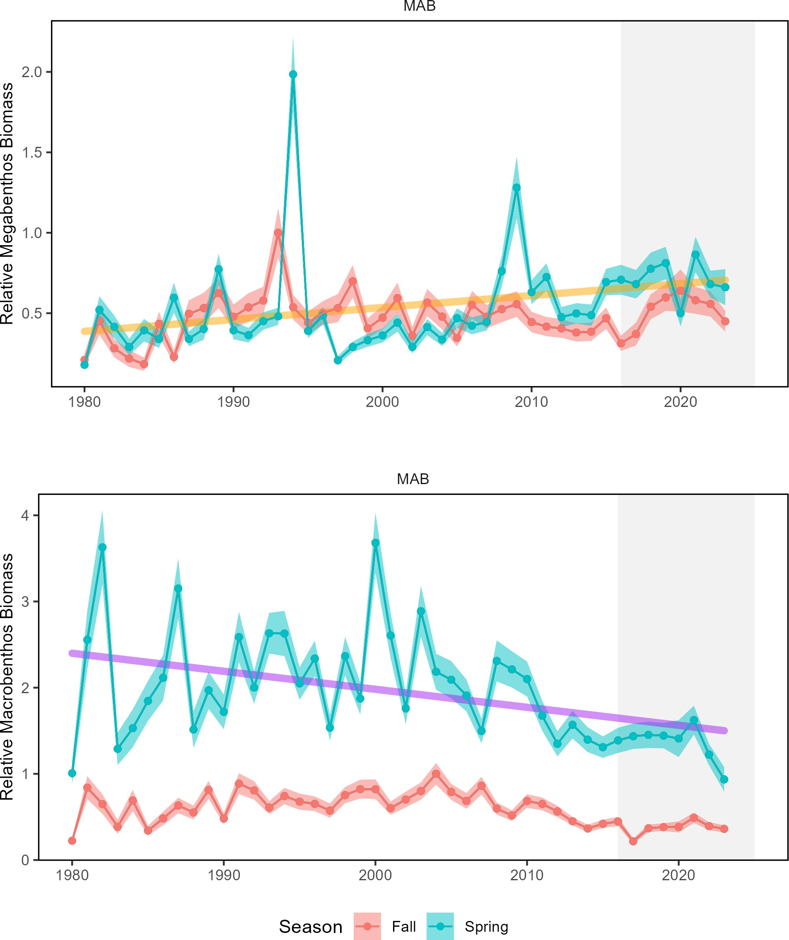

Figure 71: Changes in spring (blue) and fall (red) benthos abundance in the MAB for megabenthos (left) and macrobenthos (right).

Biological Drivers: Lower trophic levels Phytoplankton are the foundation of the food web and are the primary food source for zooplankton and filter feeders such as shellfish. Multiple environmental and oceanographic drivers affect the abundance, composition, spatial distribution, and productivity of phytoplankton. While changes in phytoplankton productivity could affect fish productivity (including forage), there is no clear long-term trend in Mid-Atlantic total primary production (Fig. 34).
Zooplankton communities in the Mid-Atlantic have high variability without trend for large copepods (Fig. 72), long term and recent decreasing trends for smaller bodied copepods, and increasing trends for krill (Euphausiids). Small copepods are less energy-rich than Euphausiids (krill) or the larger-bodied copepod Calanus finmarchicus. A changing mix of zooplankton prey can impact forage fish energy content and abundance, as well as the prey field of filter feeding whales.

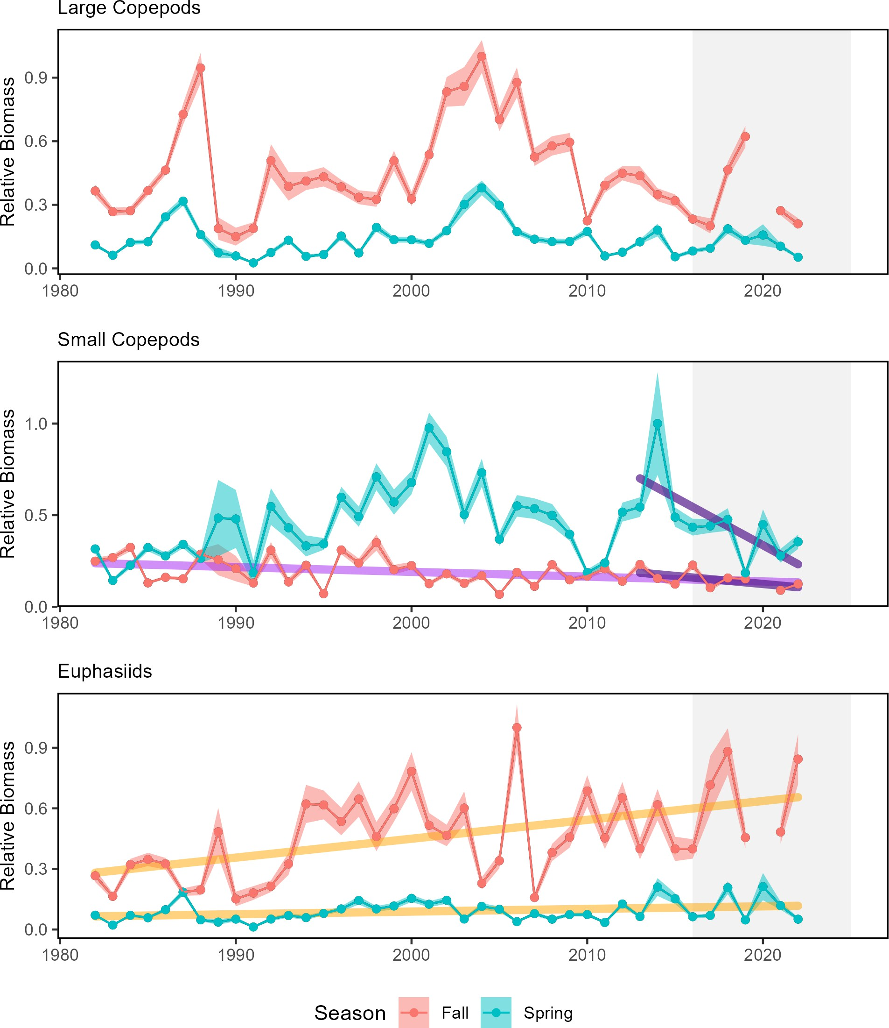

Figure 72: Changes in zooplankton abundance in the MAB for large (left) and small (center) copepods, and Euphausiids (right), with significant decreases (purple) in small copepods and increases (orange) in Euphausiids.

Environmental Drivers Fish production can also be directly related to the prevailing environmental conditions by altering metabolic (growth) and reproductive processes. Many species possess thermal tolerances and can experience

stressful or lethal conditions if temperatures exceed certain levels. Extreme temperatures at both the surface and bottom can exceed thermal tolerance limits for some fish, which we have observed in past years. However, in 2024, surface and bottom temperatures were near or below normal in the MAB. The amount of habitat exceeding a 24 C thermal tolerance was limited to the southern MAB and the conditions persisted for fewer than 30 days (Fig. 73).
In 2024, there were no marine heatwaves in the MAB. Only one marine heatwave occurred throughout the entire U.S. Northeast Shelf due to the cooler ocean conditions observed in the region. This surface marine heatwave occurred in the Gulf of Maine starting on May 29th, peaking on June 7th, and lasting 12 days.
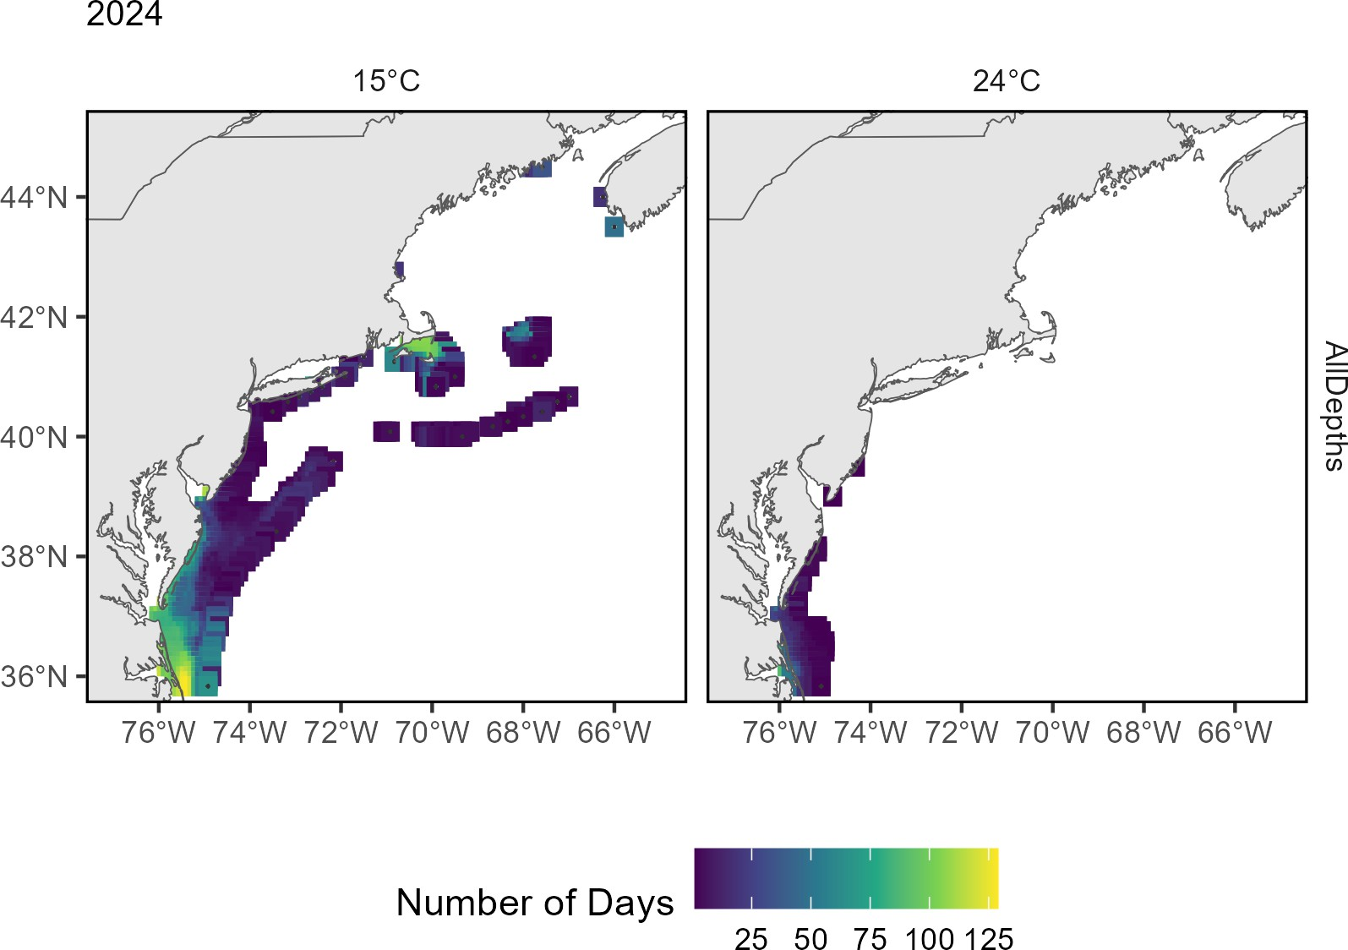

Figure 73: The number of days in 2024 where bottom temperature exceeds 15℃ (left) and 24℃ (right) based on the GLORYS 1/12 degree grid.

Ocean acidification risks vary among species and include reduced survival, growth, reproduction, and productivity, where high OA risk indicates potential negative effects to species. OA risk can also be heightened during colder conditions due to increased CO₂ absorption by the water or by transport of high CO₂ water masses (see highlights section). Higher OA risk conditions were observed for Atlantic sea scallop and longfin squid in Long Island Sound and the nearshore and mid shelf regions of the New Jersey shelf during summers of 2016, 2018, 2019, 2023, and 2024 (Fig. 74). The OA indicator observed on the Mid-Atlantic coastal shelf during summer 2024 was the most extreme recorded when compared to all of the years sampled (since 2007).

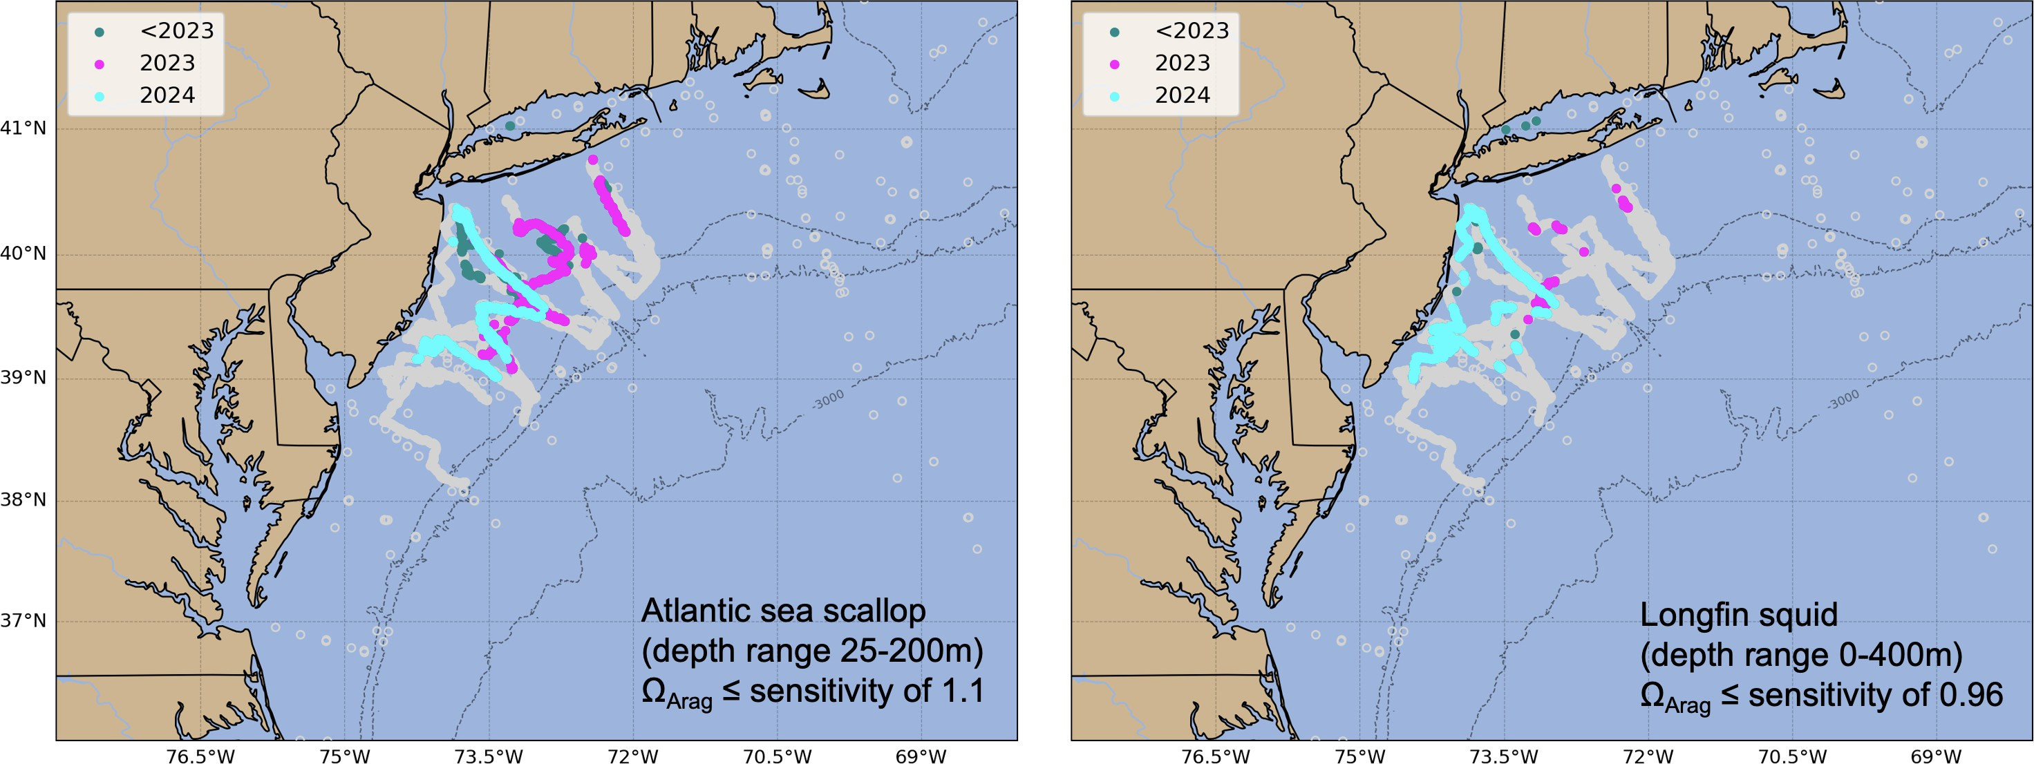

Figure 74: Locations where bottom aragonite saturation state (ΩArag ; summer only: June-August) were at or below the laboratory-derived sensitivity level for Atlantic sea scallop (left panel) and longfin squid (right panel) for the time periods 2007-2022 (dark cyan), 2023 only (magenta) and 2024 only (cyan). Gray circles indicate locations where bottom ΩArag values were above the species specific sensitivity values..

Low oxygen was detected on the MAB shelf in 2023, but not in 2024. Biological and oceanographic processes can affect the amount of oxygen present in the water column. During low oxygen (hypoxic) events, species growth is negatively affected, and very low oxygen can result in mortality.

Drivers: Predation The abundance and distribution of marine mammal, HMS, and shark predators can affect both the productivity and mortality rates on managed stocks. Predators can consume managed species or compete for the same resources, resulting in increased natural mortality or decreased productivity. The northeast shift in whales and dolphins (Fig. 55) indicates a change in the overlap between predators and prey. Since we also observe distribution shifts in managed species as well as forage species, the effect of changing predator distributions alone is difficult to quantify.
Indicators for shark populations, combined with information on gray seals (see Protected Species Implications section, above), suggests predator populations range from stable (sharks) to increasing (gray seals) in the MAB. Stock status is mixed for Atlantic Highly Migratory Species (HMS) stocks (including sharks, swordfish, billfish, and tunas) occurring throughout the Northeast U.S. shelf. While there are several HMS species considered to be overfished or that have unknown stock status, the population status for some managed Atlantic sharks and tunas is at or above the biomass target, suggesting the potential for robust (or rebuilt) predator populations among these managed species. Stable predator populations suggest stable predation pressure on managed species, but increasing predator populations may reflect increasing predation pressure.

parent_report.Rmd 07_risk_setting_catch_limits_newengland.Rmd
Indicators: Fish productivity and condition shifts Indicators of fish productivity are derived from observations
(surveys) or models (stock assessments). With the exception of two years (2006 and 2013), fish productivity has been below the long-term average in the Gulf of Maine since the early 2000s, as described by the small-fish-per-large-fish anomaly indicator (derived from NEFSC bottom trawl survey)(Fig. 75). This decline in fish productivity is also shown by a similar analysis based on stock assessment model outputs (recruitment per spawning stock biomass anomaly). Other signs of changing productivity in New England are the declines in common tern chicks per nest (Fig. 76) and continued low returns of hatchery Atlantic salmon(Fig. 77) despite short-term increases in adult salmon numbers.

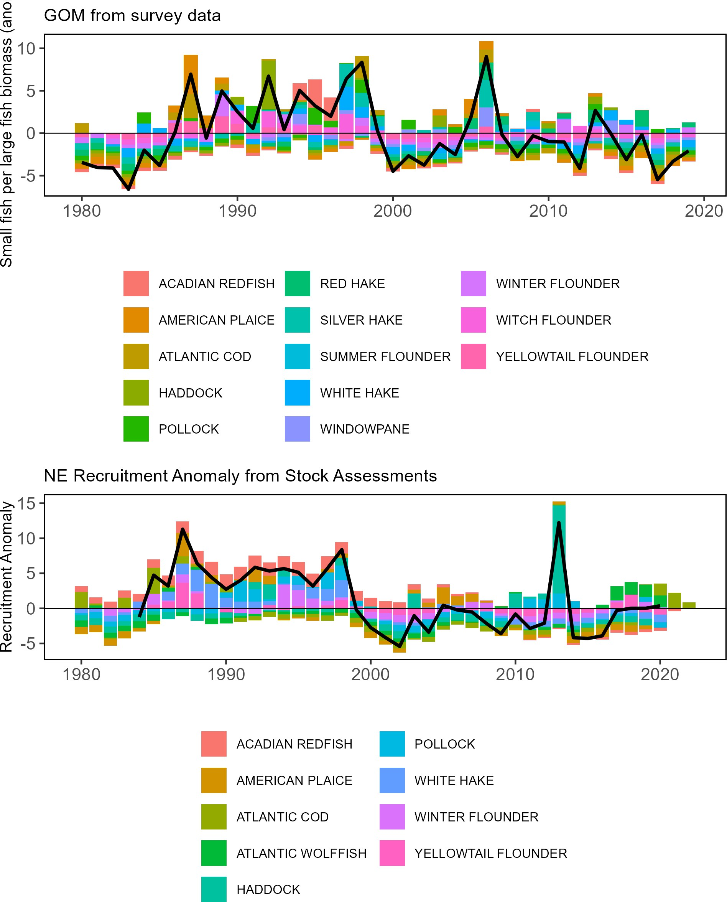

Figure 75: Fish productivity measures. Top: Small-fish-per-large-fish survey biomass anomaly in the Gulf of Maine. Bottom: assessment recruitment per spawning stock biomass anomaly for stocks managed by the New England Fishery Management Council region. The summed anomaly across species is shown by the black line, drawn across all years with the same number of stocks analyzed. 82

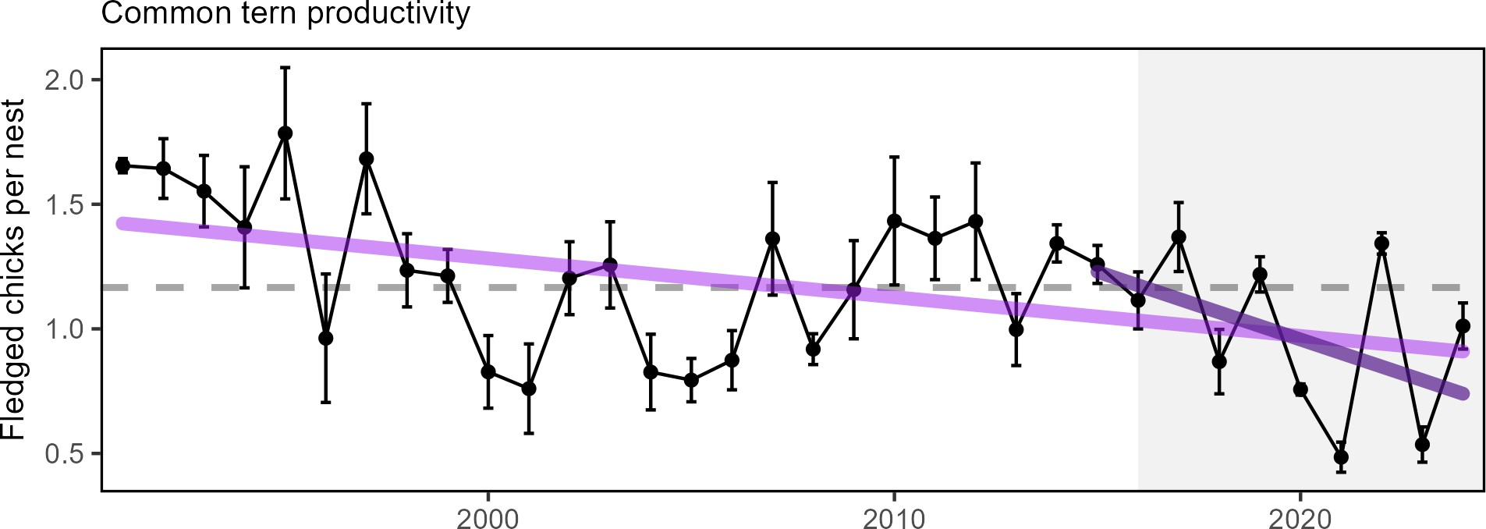

Figure 76: Productivity of Common terns in the Gulf of Maine.

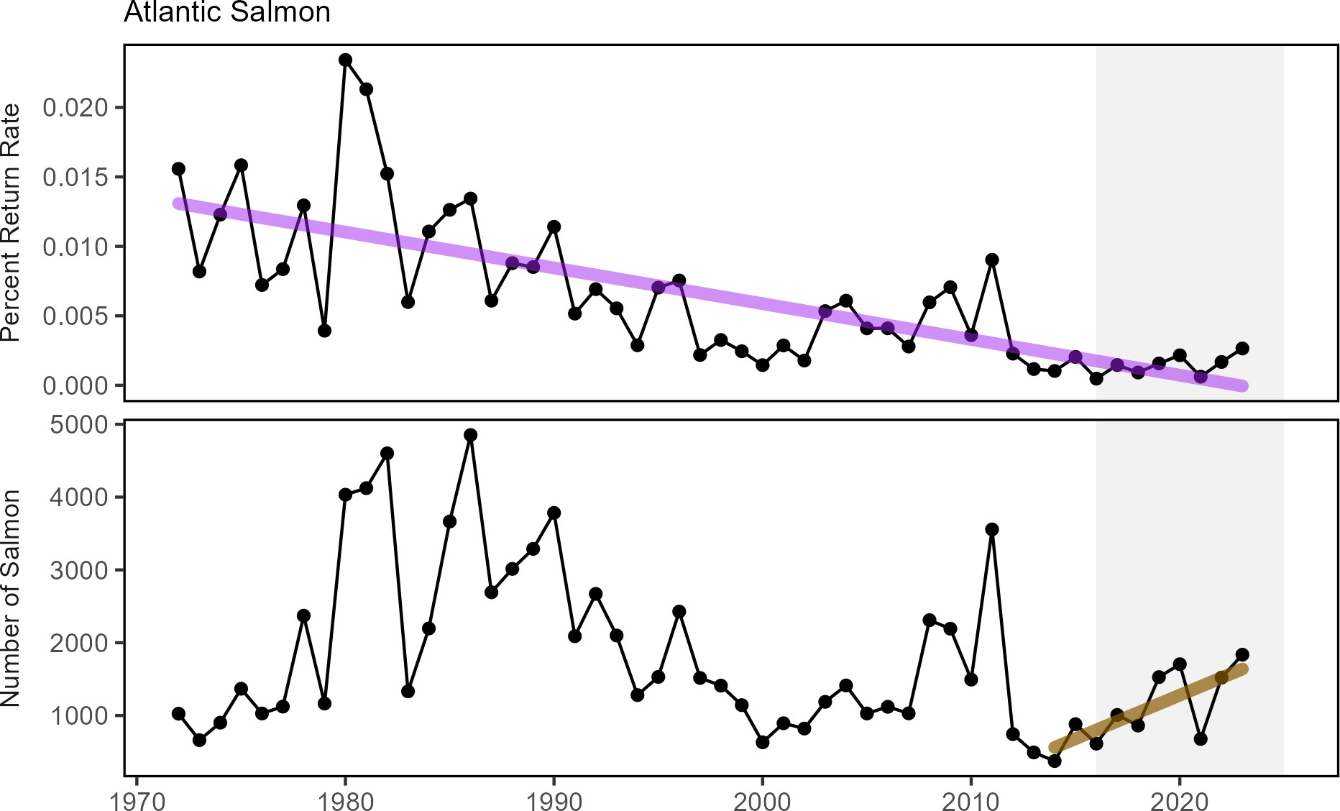

Figure 77: Return rate proportions and abundance of Atlantic salmon.

The health of individual fish (i.e., fish condition) can contribute to population productivity through improved growth, reproduction, and survival. Fish condition in the Gulf of Maine and Georges Bank regions were generally good prior to 2000, poor from 2001-2010 (concurrent with declines in fish productivity, Fig. 75), and a mix of good and poor since 2011. In 2024, fish condition was poor for most species on both Georges Bank and in the Gulf of Maine (Fig. 78).Preliminary analyses show that changes in temperature, zooplankton, fishing pressure, and population size influence the condition of different fish species.

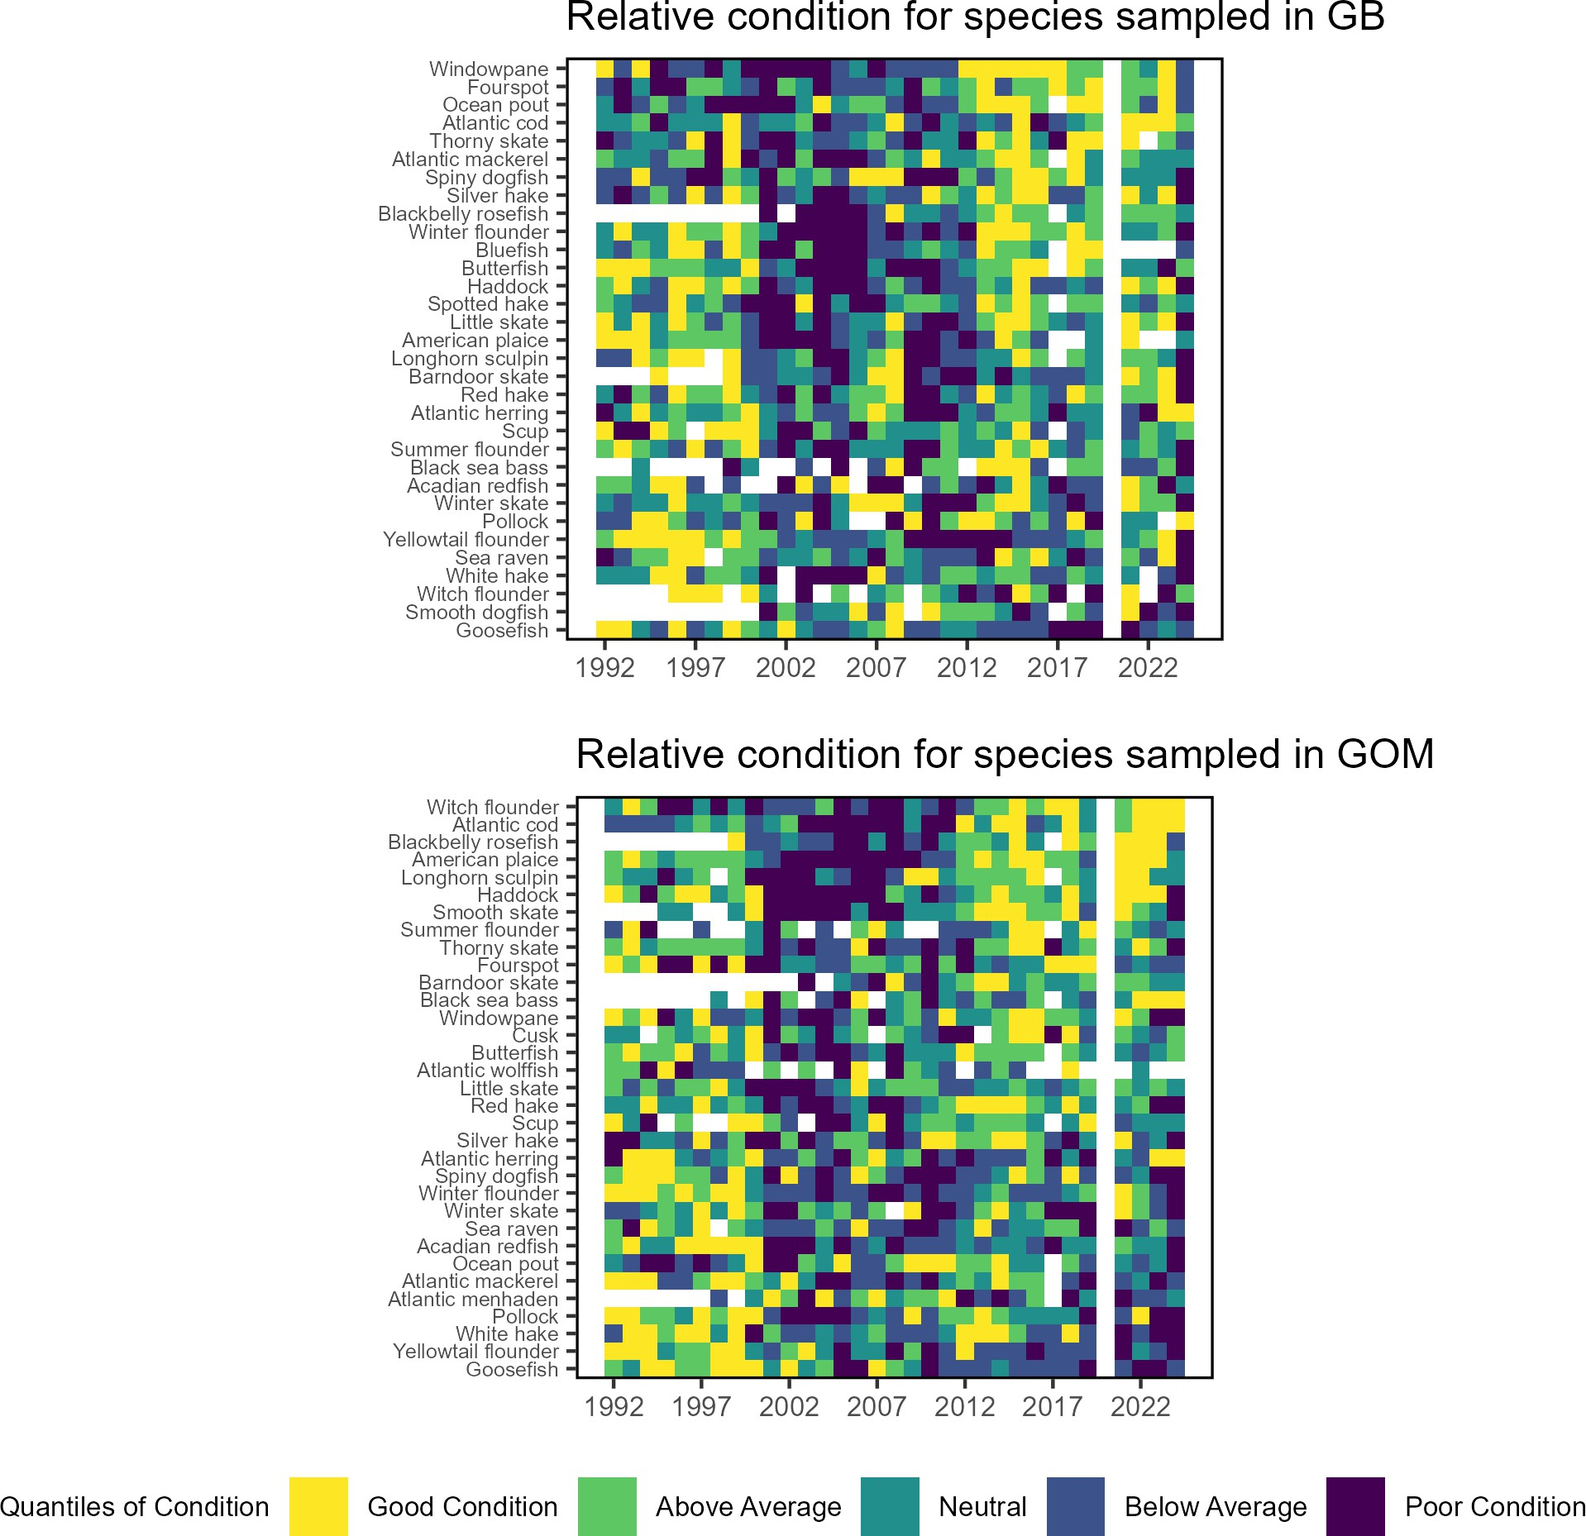

Figure 78: Condition factor for fish species in New England based on fall NEFSC bottom trawl survey data. No survey was conducted in 2020.

Drivers Fish productivity and condition are affected by increasing metabolic demands from increasing temperature, combined with changes in the availability and quality of prey. Long-term environmental trends and episodic extreme temperatures, ocean acidification, and low oxygen events represent multiple stressors that can affect growth rates, reproductive success, recruitment, and cause mortality.

Biological Drivers: Forage quality and abundance The amount of forage fish available in the ecosystem combined with the energy content of the forage species determines the amount of energy potentially available to predators in the ecosystem. Changes in the forage base can drive managed and protected species production.

The energy content of juvenile and adult forage fish as prey is related to forage fish growth and reproductive cycles, as well as environmental conditions. The energy content of Atlantic herring was estimated to be highest of any forage species in the 1980s and 1990s, based on very small numbers of fish. Most observations from the NEFSC trawl surveys are below the previous estimates (Fig. ??). However, a recent study that included samples from additional sources indicated herring energy density peaked in summer, with some values closer to the historic estimates. Silver hake, longfin squid (Loligo in figure) and shortfin squid (Illex in figure) remain lower than previous estimates.


Changes in the overall abundance of forage fish can influence managed species productivity as it relates to changes in food availability. New England fall forage biomass is stable with long-term increases in the spring GOM (Fig. 79). Forage biomass was highest during fall in the 1980s.

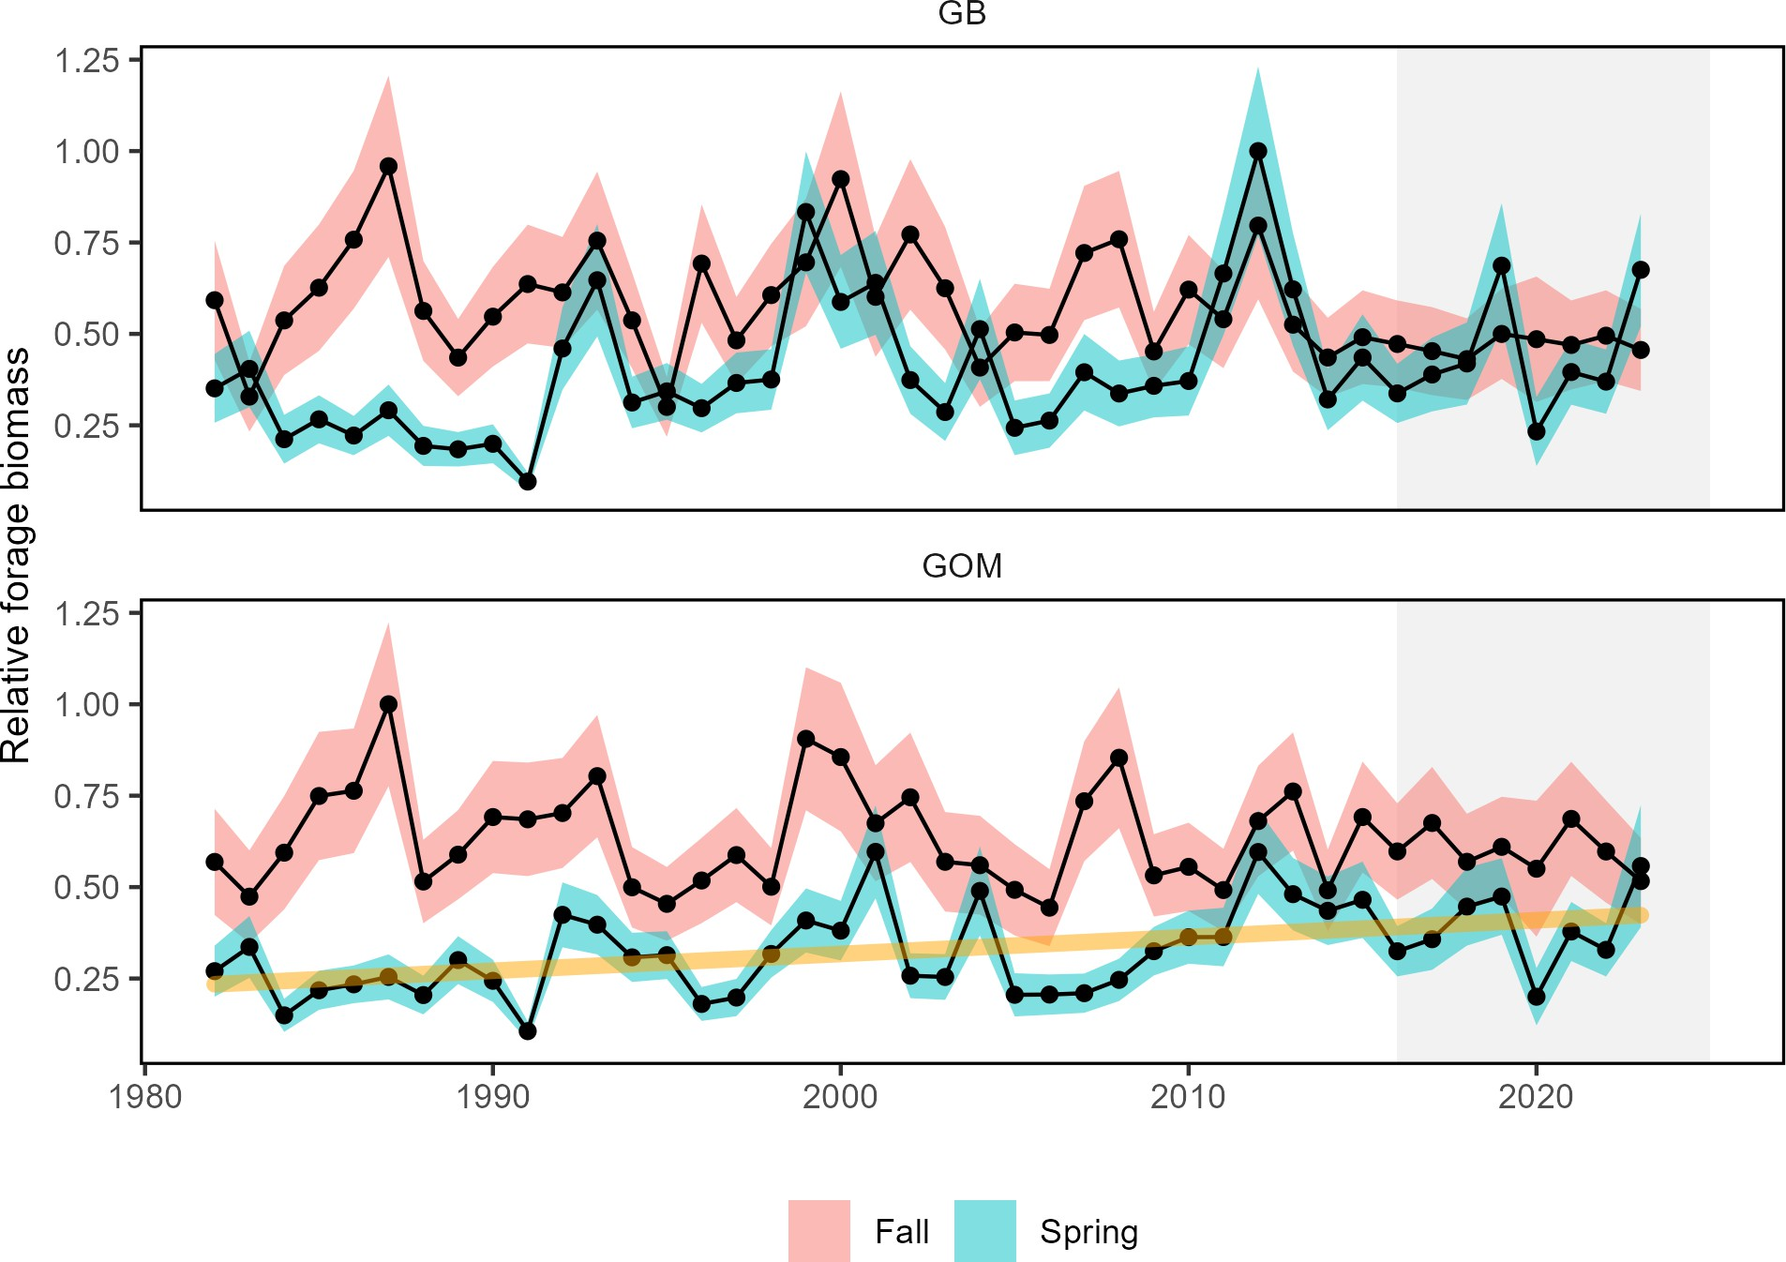

Figure 79: Forage fish index in GB (top) and GOM (bottom) for spring (blue) and fall (red) surveys. Index values are relative to the maximum observation within a region across surveys.

Benthic invertebrates are extremely important forage for some managed species (e.g. flatfish, juvenile cod and haddock) Macrobenthos indices show long term declines in spring. In contrast, megabenthos indices show long-term increases during the fall in both GB and GOM (Fig. 80).

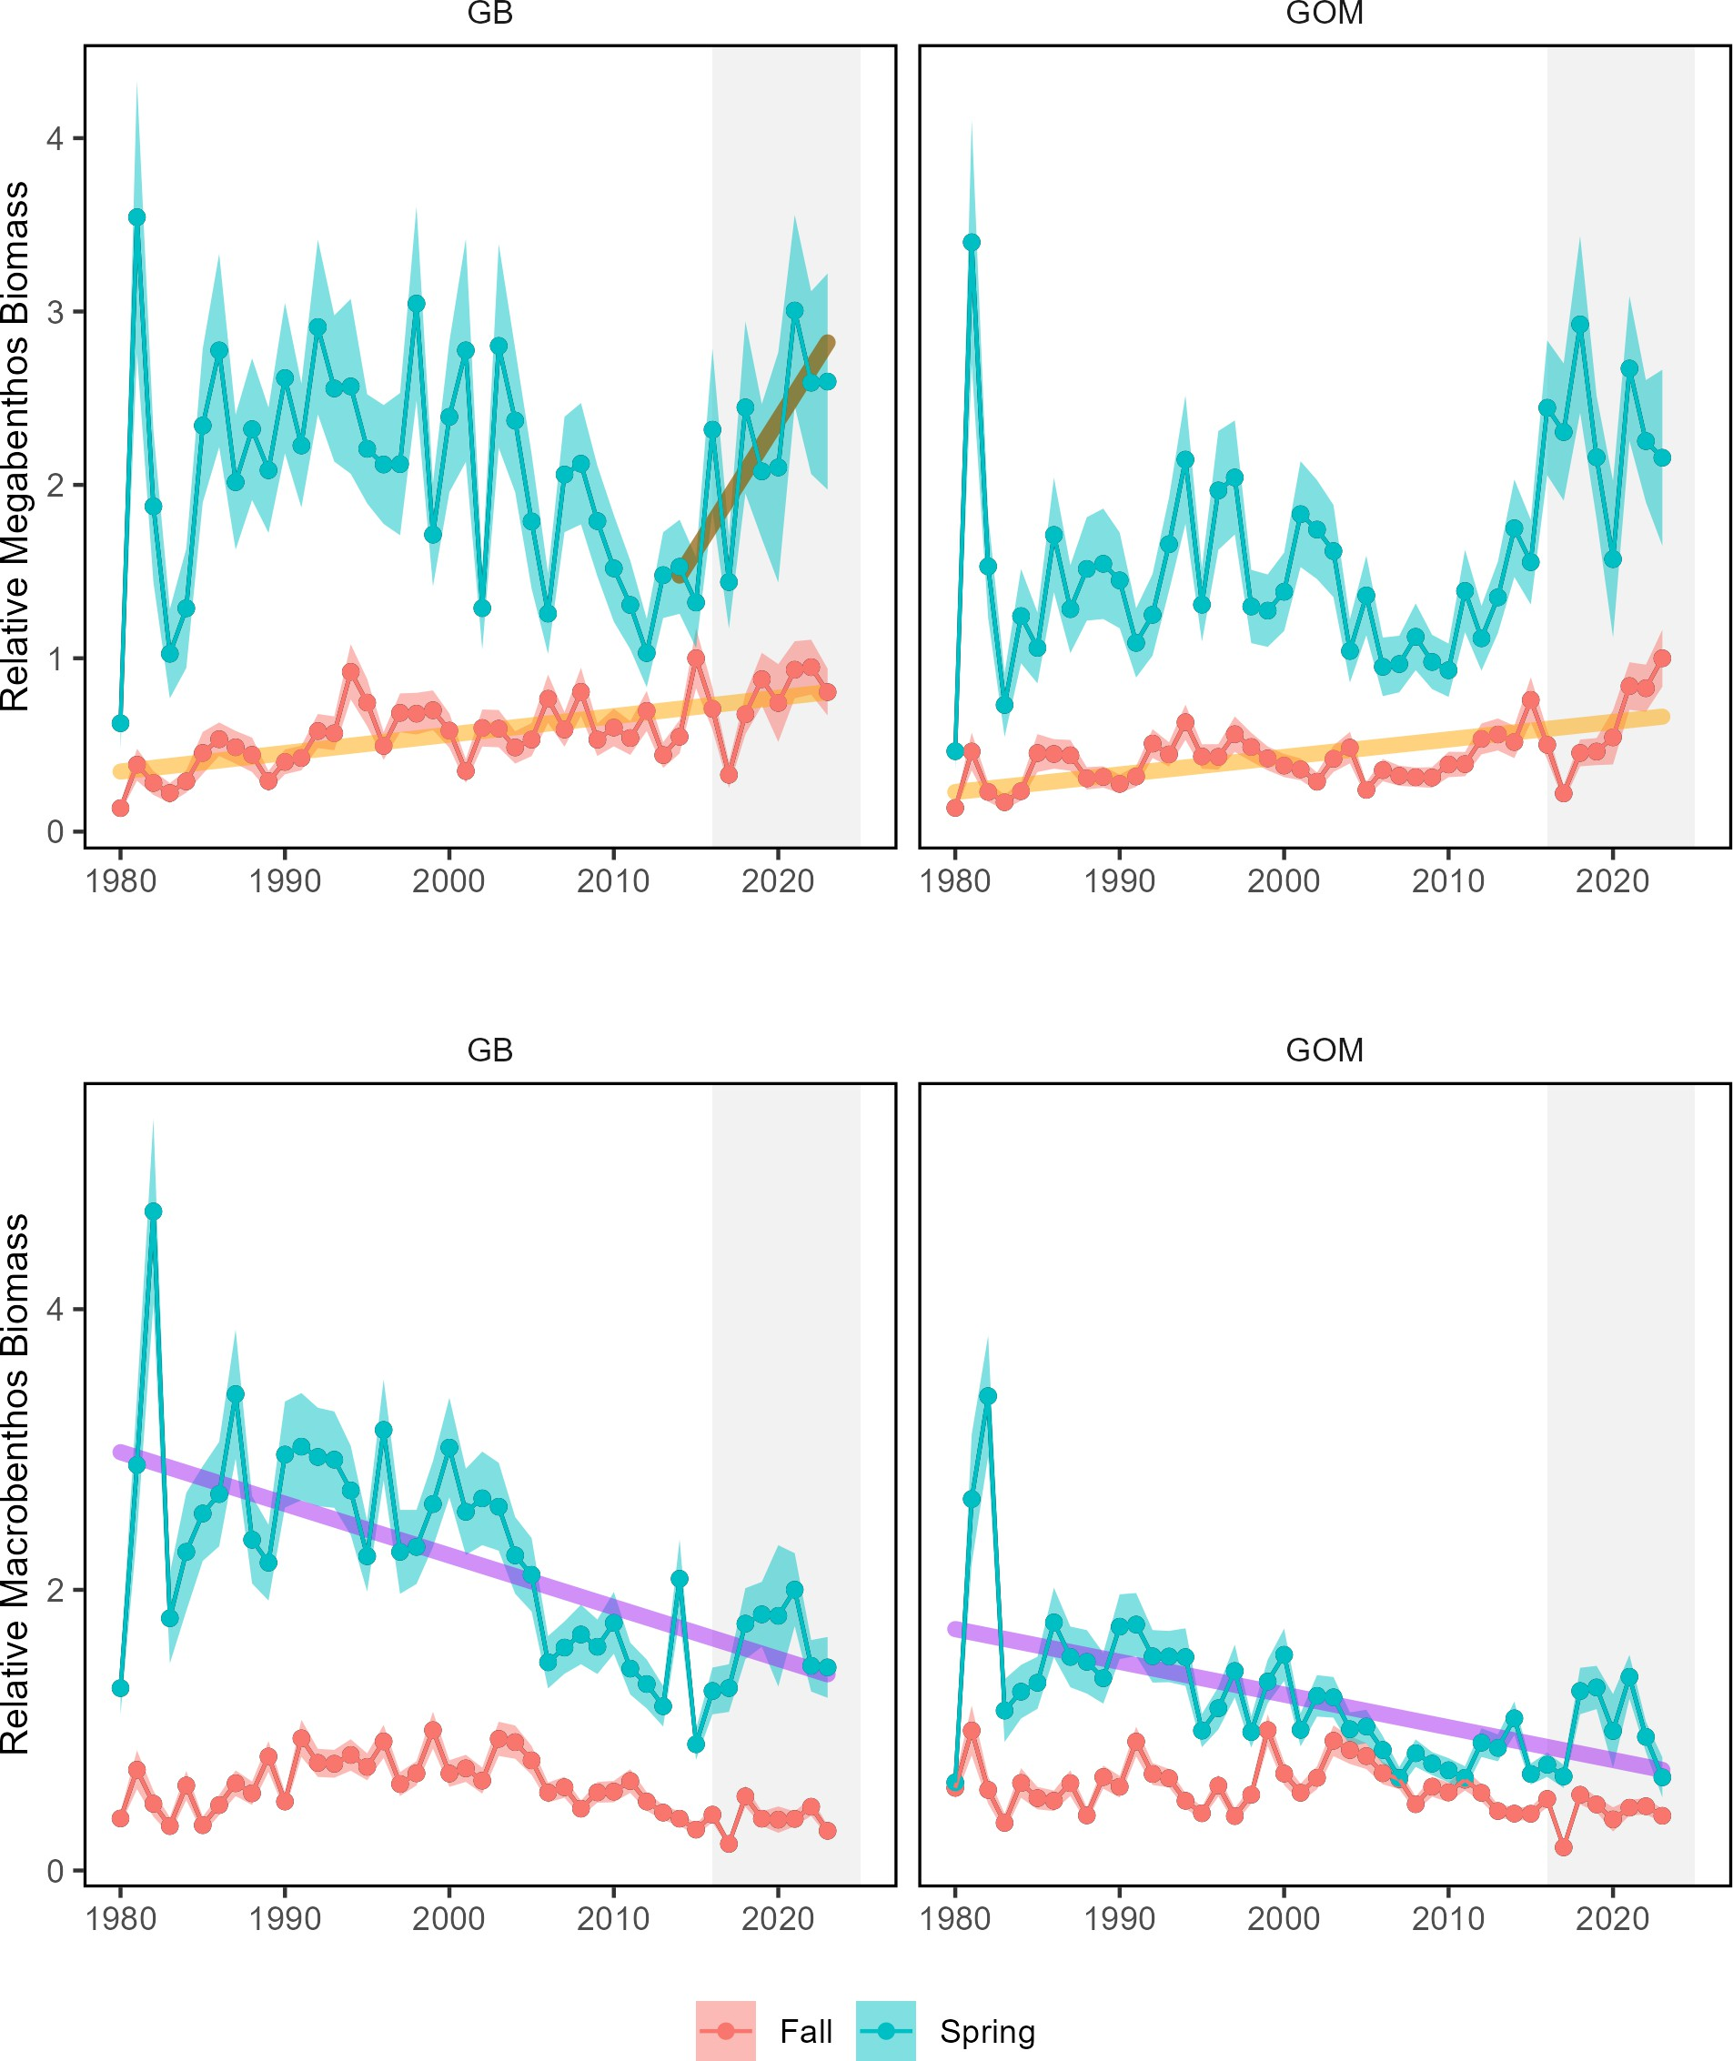

Figure 80: Changes in benthos abundance in New England for megabenthos (top) and macrobenthos (bottom).

Biological Drivers: Lower trophic levels Phytoplankton are the foundation of the marine food web and are the primary food source for zooplankton and filter feeders such as shellfish. Multiple environmental and oceanographic drivers affect the abundance, composition, spatial distribution, and productivity of phytoplankton. While changes in phytoplankton productivity could affect fish productivity (including forage), there is no clear long-term trend in New England total primary production (Fig. 40).
Zooplankton communities in New England have been changing in composition. There has been an increase in GOM small bodied copepods, a recent decline in large bodied copepods in GB, and long-term increases in euphausids in GB and GOM (Fig. 81). A changing mix of zooplankton prey can impact forage fish energy content and abundance, as well as the prey field of filter feeding whales.
Since 2010, the abundance of the lipid-rich older stages of Calanus finmarchicus in the GOM has declined. Ob- servations from a fixed time series station in Wilkinson Basin indicate that Calanus seasonal abundance in late summer-winter between 2020-2022 has declined to 20-40% of its population level in 2005-2008 but has rebounded to 60-70% in 2024 due to the presence of colder water(Fig. 82). However, spring abundances are still the same as 15-20 years ago. The seasonal differences in abundance change reflect differences in influence of primary seasonal drivers:
- Calanus reproductive output is tied to phytoplankton availability in late winter/early spring.
- Gulf of Maine source waters drive Calanus supply (high Calanus in Scotian Shelf/Labrodor shelf water (LSW) and less in warm slope water (WSW))
- Predation is likely higher with warmer temperatures

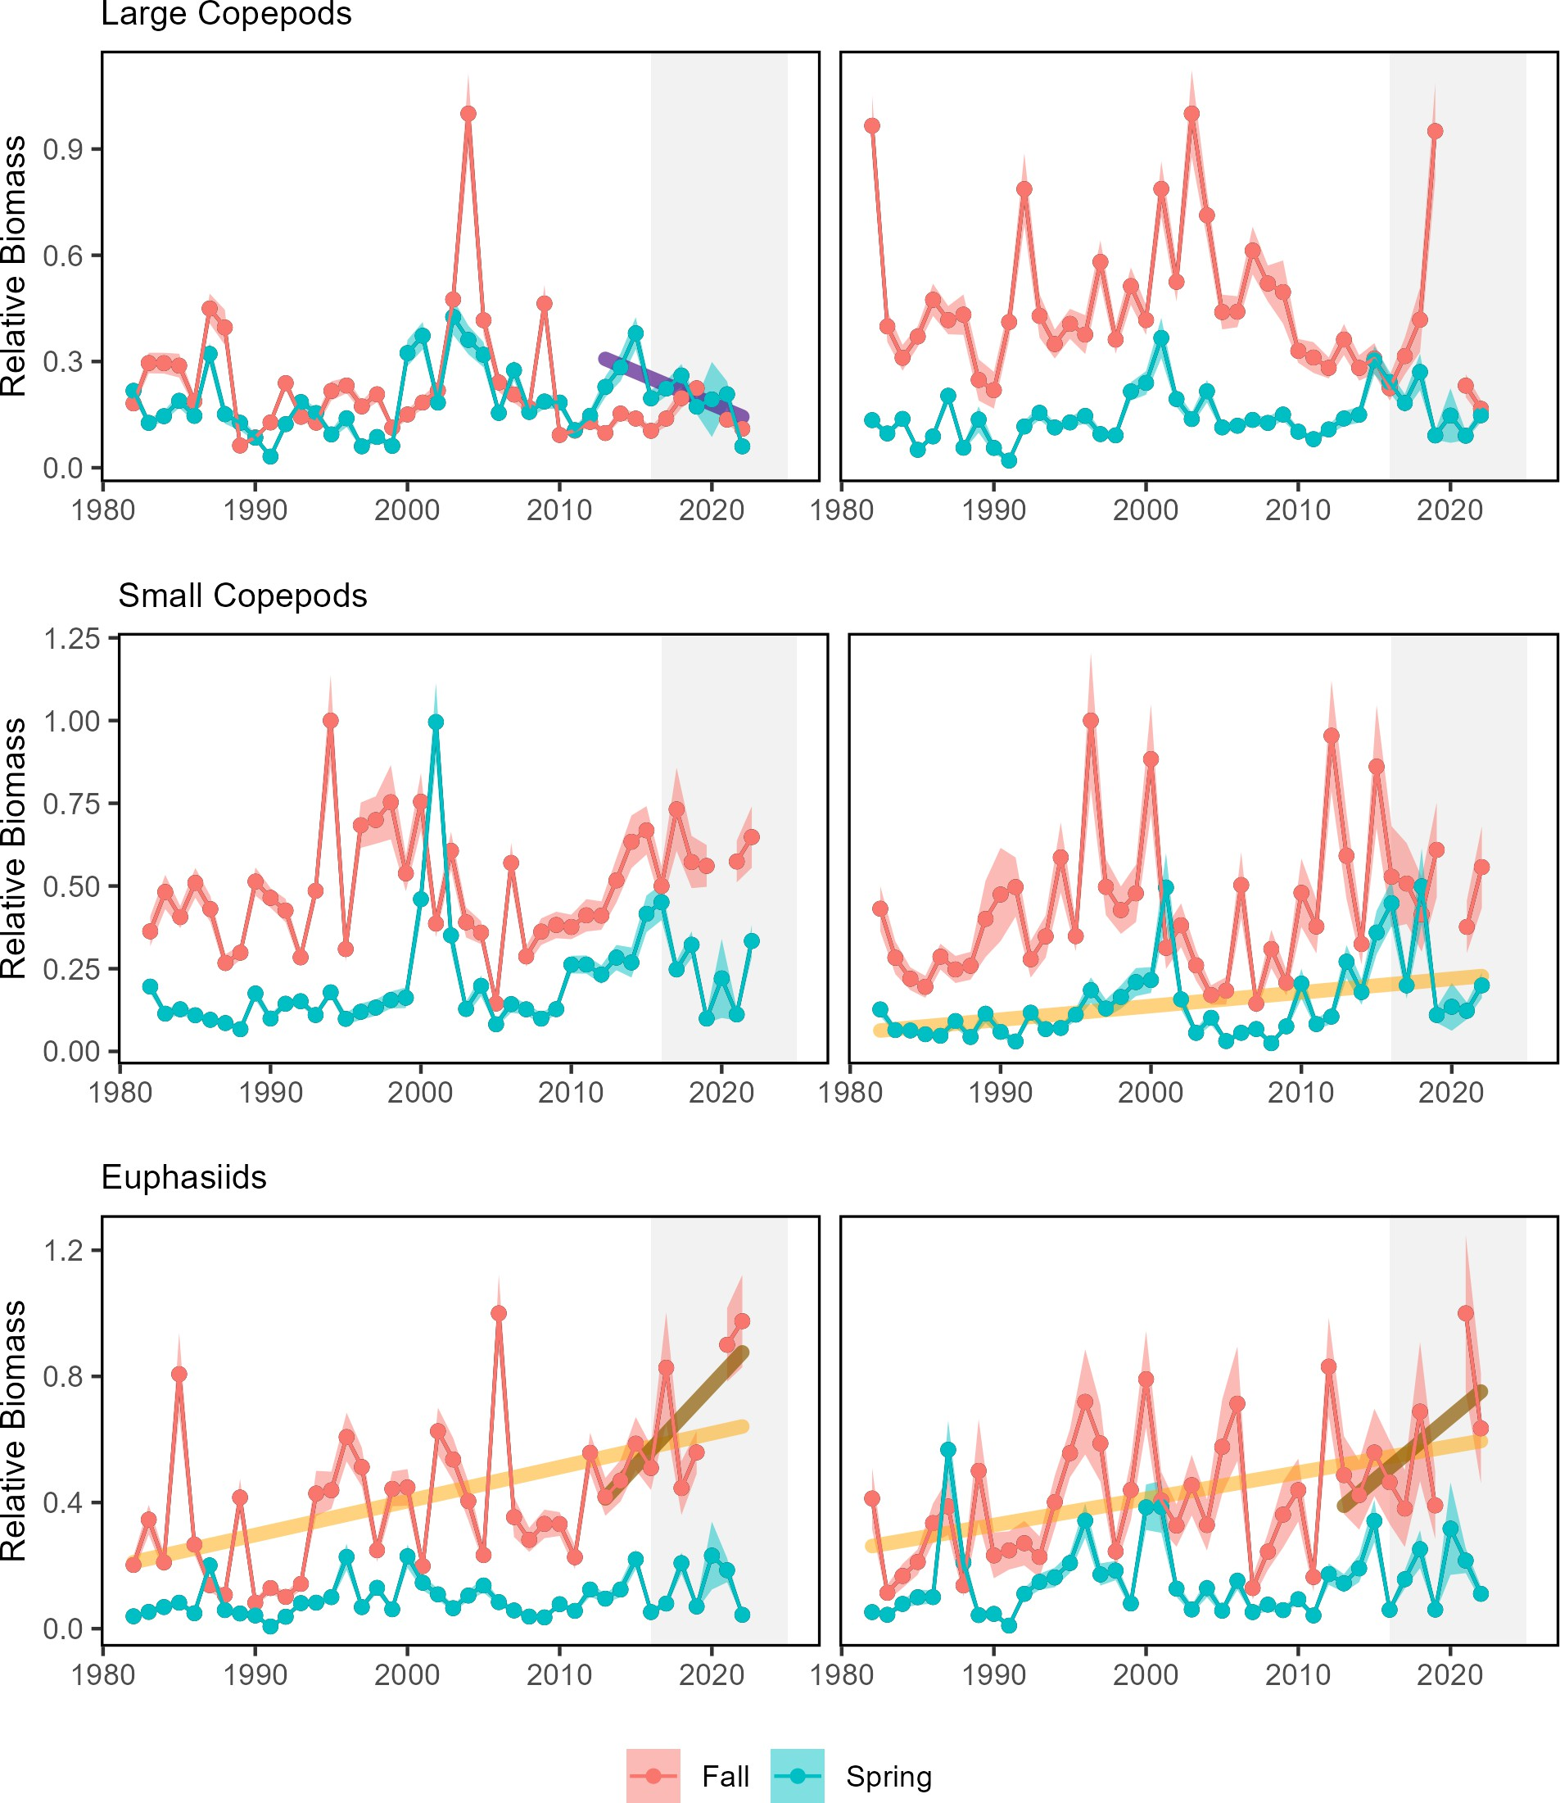

Figure 81: Georges Bank (GB) and Gulf of Maine (GOM) abundance anomalies three dominant zooplankton (Calanus finmarchicus, Calanus typicus, and Pseudocalanus spp.).

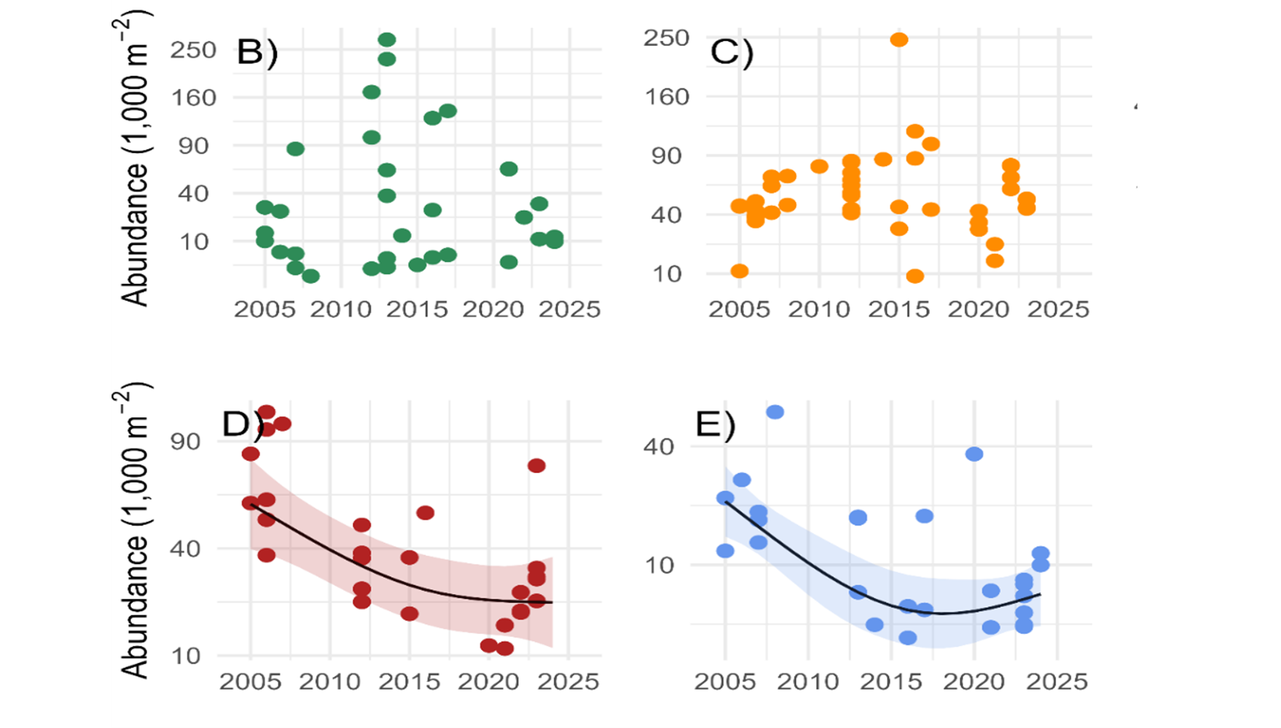
Figure 82: Abundance (no m⁻2) of *C. finmarchicus* C3-C6 estimated from 200µ vertical ring net tows. Individual data with fitted lines. Data from 2005-2010 (circles), 2011-2021 (triangles), and 2022-2024 (squares). WBTS station seasonal abundance time series for B) spring, C) summer, D) fall, E) winter. Vertical lines denote season boudnaries. If the seasonal abundance time series is significant, GAM predictions are calculated with day of year set to 1, 100, 200, and 300 for winter, spring, summer, and fall, respectively.

Environmental Drivers Fish production can also be directly related to the prevailing environmental conditions by altering metabolic (growth) and reproductive processes. Many species possess thermal tolerances and can experience stressful or lethal conditions if temperatures exceed certain levels. Extreme temperature at both the surface (Fig. 58) and bottom can exceed thermal tolerance limits for some fish. For example, 2012 had among the warmest surface and bottom temperatures (GB) in New England. A large proportion of the Georges Bank and Mid-Atlantic regions had bottom temperatures above the 15℃ thermal tolerance for most groundfish, with some days in the Mid-Atlantic exceeding the 24℃ potential mortality limit (Fig. 83).
In 2024, only one surface marine heatwave occurred throughout the entire U.S. Northeast Shelf due to the cooler ocean conditions observed in the region. This surface marine heatwave occurred in the Gulf of Maine starting on May 29th, peaking on June 7th, and lasting 12 days. This marine heatwave was not within the top 10 on record in terms of intesity.



Figure 83: The number of days in 2024 where bottom temperature exceeds 15℃ (left) and 24℃ (right) based on the GLORYS 1/12 degree grid.

Ocean acidification risks vary among species and include reduced survival, growth, reproduction, and productivity, where high OA risk indicates potential negative effects to species. OA risk can also be heightened during colder conditions due to increased CO₂ absorption by the water or by transport of high CO₂ water masses (see highlights section). Higher OA risk conditions were observed for Atlantic sea scallop and longfin squid in Long Island Sound and the nearshore and mid shelf regions of the New Jersey shelf during summers of 2016, 2018, 2019, 2023, and 2024 (Fig. 74). The OA indicator observed on the Mid-Atlantic coastal shelf during summer 2024 was the most extreme recorded when compared to all of the years sampled (since 2007).



Figure 84: Locations where bottom aragonite saturation state (ΩArag ; summer only: June-August) were at or below the laboratory-derived sensitivity level for Atlantic sea scallop (left panel) and longfin squid (right panel) for the time periods 2007-2022 (dark cyan), 2023 only (magenta) and 2024 only (cyan). Gray circles indicate locations where bottom ΩArag values were above the species specific sensitivity values..

Biological and oceanographic processes can affect the amount of oxygen present in the water column. During low oxygen (hypoxic) events, species’ growth is negatively affected and very low oxygen can result in mortality. The duration and extent of hypoxic events is being monitored, but long-term shelf-wide observations are not yet available. However, hypoxic events were detected off the coast of New Jersey in 2023 and were potentially responsible for fish, lobster, and crab mortalities. No hypoxic events were observed on the NE shelf in 2024.

Drivers: Predation The abundance and distribution of predators can affect both the productivity and mortality rates on managed stocks. Predators can consume managed species or compete for the same resources resulting in increased natural mortality or declining productivity, respectively. The northeast shift in some highly migratory species (Fig. 55) indicates a change in the overlap between predators and prey. Since we also observe distribution shifts in both managed and forage species, the effect of changing predator distributions alone is difficult to quantify.
Gray seals are fish predators with increasing populations in New England, however they are broad generalist feeders that do not generally target commercially-sized managed species. Stock status is mixed for Atlantic Highly Migratory Species (HMS) stocks (including sharks, swordfish, billfish, and tunas) occurring throughout the Northeast U.S. shelf. While there are several HMS species considered to be overfished or that have unknown stock status, the population status for some managed Atlantic sharks and tunas is at or above the biomass target, suggesting the potential for robust (or rebuilt) predator populations among these managed species. Stable predator populations suggest stable predation pressure on managed species, but increasing predator populations may reflect increasing predation pressure.

Future Considerations The processes that control fish productivity and mortality are dynamic, complex, and the result of the interactions between multiple system drivers. There is a real risk that short-term predictions in assessments and rebuilding plans that assume unchanging underlying conditions will not be as effective, given the observed ecological and environmental process changes documented throughout the report. Assumptions for species’ growth, reproduction, and natural mortality should continue to be evaluated for individual species. With observations of system-wide productivity shifts of multiple managed stocks, more research is needed to determine whether regime shifts or ecosystem reorganization are occurring, and how this should be incorporated into management

parent_report.Rmd
Future Considerations The processes that control fish productivity and mortality are dynamic, complex, and are the result of the interactions between multiple system drivers. There is a real risk that short-term predictions in assessments and rebuilding plans that assume unchanging underlying conditions will be highly uncertain and not be as effective, given the observed change documented in the prior sections in both ecological and environmental processes. Assumptions for species’ growth, reproduction, and natural mortality should continue to be evaluated for individual species. With observations of system-wide productivity shifts of multiple managed stocks, more research is needed to determine whether regime shifts or ecosystem reorganization are occurring, and how this should be incorporated into management.

Other Ocean Uses: Offshore Wind
Indicators: development timeline, revenue in lease areas, coastal community vulnerability
All reported potential offshore wind projected development timelines and data are subject to change and have been based on BOEM Environmental Impact Statements. Offshore wind development schedule and areas are subject to change based on the Executive Order Temporary Withdrawal of All Areas on the Outer Continental Shelf from Offshore Wind Leasing and Review of the Federal Government’s Leasing and Permitting Practices for Wind Projects.
As of January 2025, 30 offshore wind development projects are proposed for construction over the next decade in the Northeast (timelines and project data for 2025 are based on the Maryland Offshore Wind Final Environmental Impact Statement, Appendix D). Offshore wind areas are anticipated to cover more than 2.3 million acres by 2030 in the Greater Atlantic region (Fig. 85). An additional 800,000 lease acres are proposed for development beyond 2030 and 17 million acres are identified by BOEM as designated planning areas (Fig. 86).
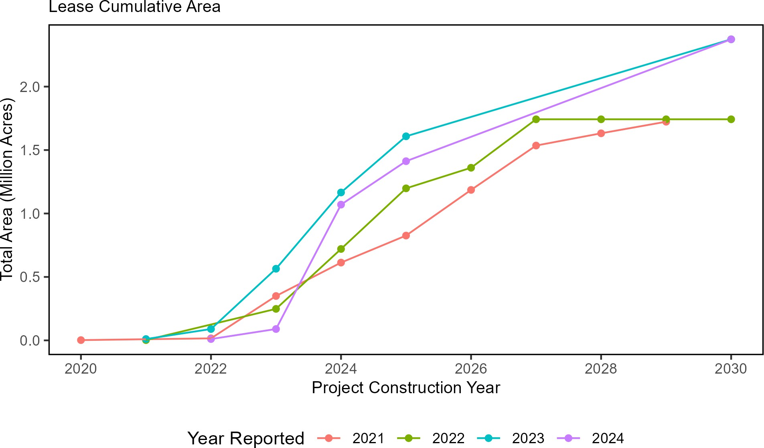

Figure 85: Total area proposed for wind develpment on the northeast shelf through 2030.

Just over 3,200 foundations and more than 12,000 miles of inter-array and offshore export cables are proposed to

date (Fig. 86). Based on current timelines, the areas affected would be spread out such that it is unlikely that any one region would experience full development at one time. Construction of three projects in Southern New England (Vineyard Wind, South Fork Wind Farm, and Revolution Wind) and two more in the Mid-Atlantic/New York Bight (Coastal Virginia Offshore Wind and Empire Wind 1) during 2024 affected fisheries managed by the Mid-Atlantic Fishery Management Council. It is likely that construction will begin on other projects in Southern New England and possibly the New York Bight during 2025 that will further affect regional fisheries.

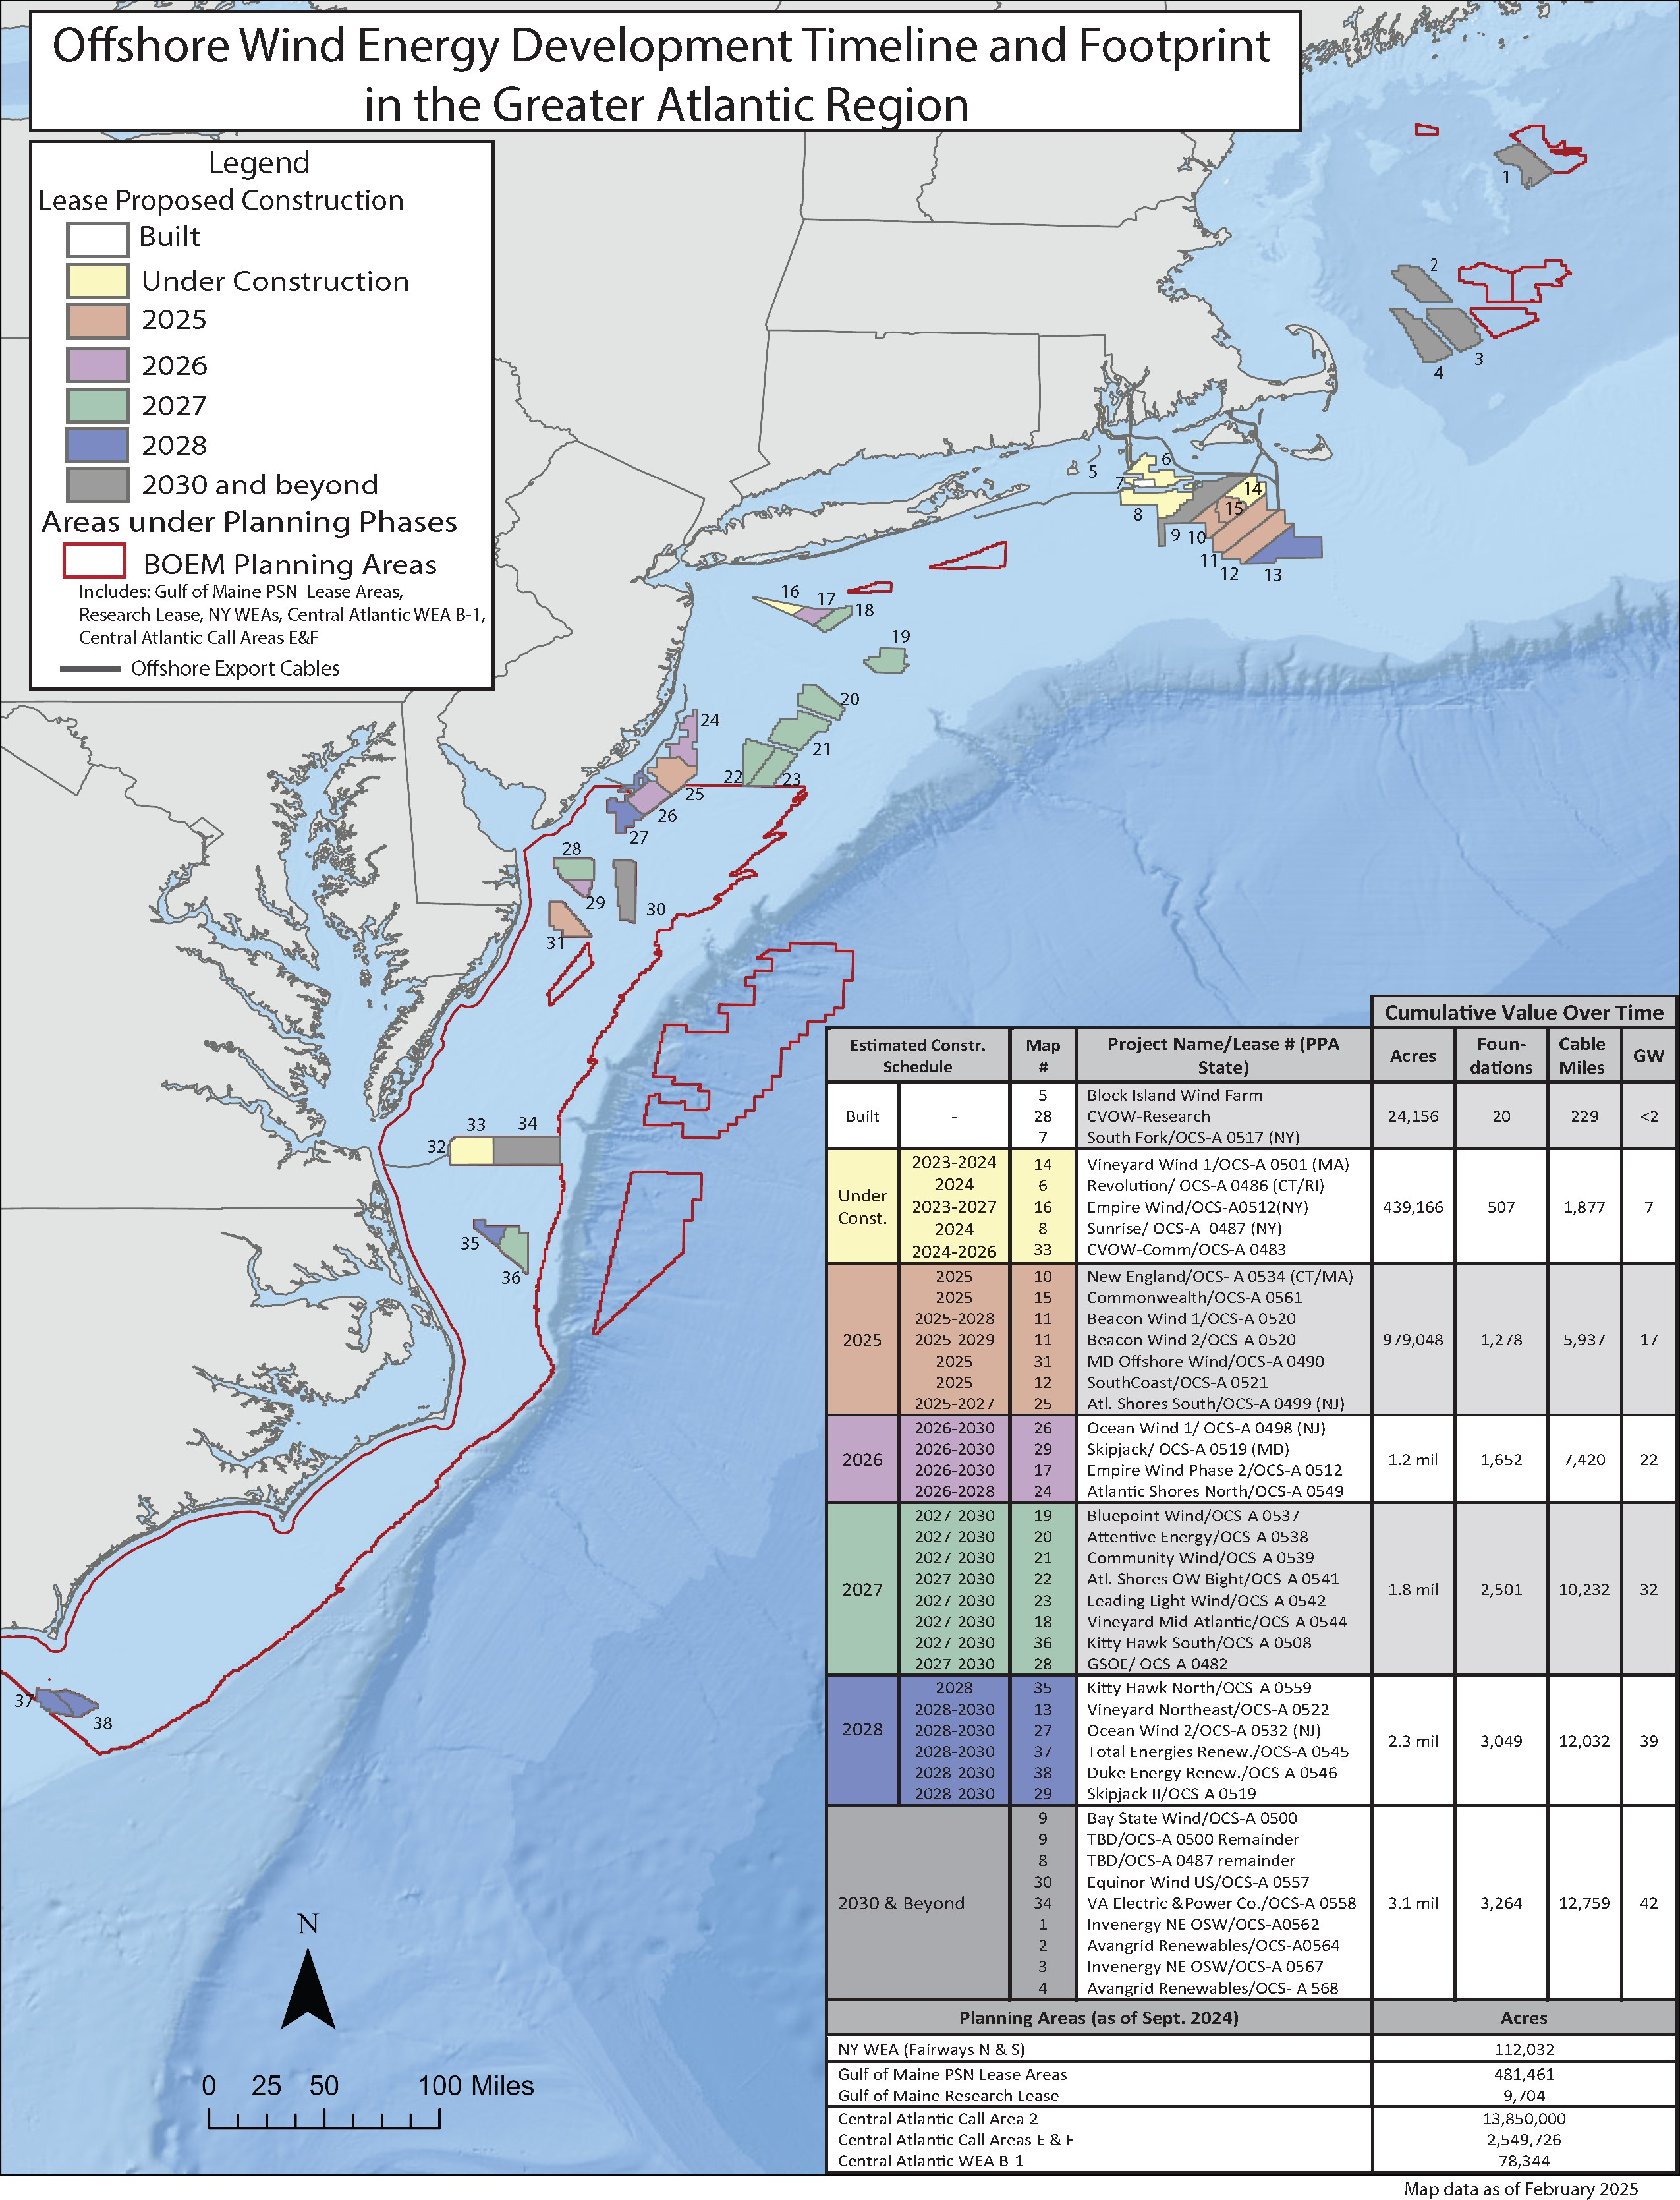
Figure 86: All Northeast Project areas by year construction ends (each project has a 2 year construction period).

08_offshore_wind_midatlantic.Rmd
Based on federal vessel logbook data, commercial fishery revenue from trips in the current offshore wind lease areas, including the newly designated lease areas in the Central Atlantic, have varied annually from 2008-2023, with less than $1 million in maximum annual revenue overlapping with these areas for most fisheries with the exception of the surfclam, monkfish, and longfin squid fisheries. Some fisheries see periodic spikes in revenue overlap with wind energy lease areas, including the surfclam ($6.5 million), longfin squid ($4.8 million), monkfish ($2.5 million), and summer flounder ($1.3 million) fisheries (Fig. 87).
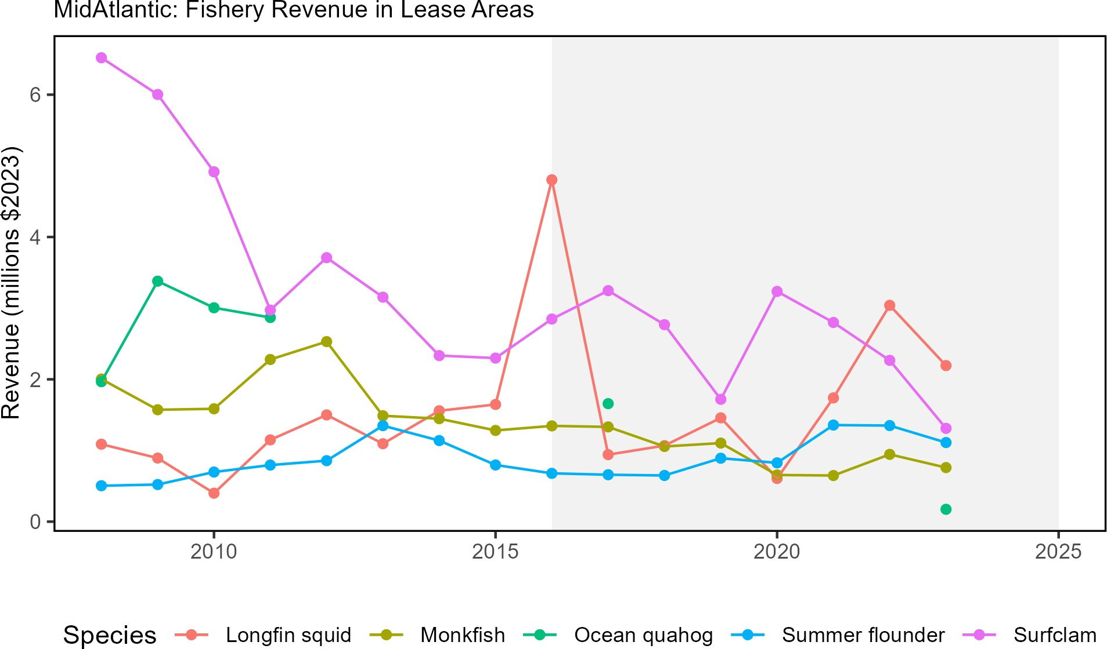

Figure 87: Fishery revenues from MAFMC managed species in the Wind energy lease areas.

Of MAFMC managed fisheries, the surfclam fishery would be the most affected by offshore wind development, with a maximum of 15% of annual regional fishery revenue occurring within existing wind lease areas during 2008-2023 (see Table 9). It should be noted that 2023 surfclam landings/revenue within lease areas may be artificially low due to potential misreporting issues. Future fishery resource overlap with wind leases, especially surfclams and ocean quahogs, may change due to species distribution shifts attributable to climate change and recruitment and larval dispersion pattern changes caused by hydrodynamic flow disruptions from turbine foundations, which could also affect fishery landings/revenue.
Offshore wind indicators are based on federal logbook data and do not include all data for all fisheries; therefore a complete evaluation of potential offshore wind energy development impacts would need to be supplemented by other data sources. For further information on the utility of the data, see the socioeconomic impacts of offshore wind development data reports page.

Table 9: Mid-Atlantic managed species Landings and Revenue from Wind Energy Areas. *Less than a maximum of 50,000 lb was reported landed annually in wind energy lease areas for these species.

NEFMC, MAFMC, and ASMFC  Managed Species | Maximum Percent Total Annual  Regional Species Landings | Maximum Percent Total Annual  Regional Species Revenue
Blueline Tilefish* | 13 | 16
Atlantic Surfclam | 16 | 15
Ocean Quahog | 12 | 11
Black Sea Bass | 9 | 10
Scup | 8 | 9
Atlantic Mackerel | 8 | 8
Chub Mackerel | 15 | 8
Longfin Squid | 8 | 8
Monkfish | 9 | 8
Butterfish | 8 | 7
Golden Tilefish | 6 | 6
Summer Flounder | 5 | 5
Bluefish* | 4 | 4
Spiny Dogfish | 2 | 3
Illex Squid | 2 | 2

Proposed wind development areas interact with the region’s federal scientific surveys. Scientific surveys are impacted by offshore wind in four ways: 1. Exclusion of NOAA Fisheries’ sampling platforms from the wind development area due to operational and safety limitations. 2. Impacts on the random-stratified statistical design that is the basis for scientific assessments, advice, and analyses. 3. Alteration of benthic and pelagic habitats, and airspace in and around the wind energy development, requiring new designs and methods to sample new habitats. 4. Reduced sampling productivity through navigation impacts of wind energy infrastructure on aerial and vessel survey operations.
Increased vessel transit between stations may decrease data collections that are already limited by annual days-at-sea day allocations. The total survey area overlap ranges from 1-70% for all Greater Atlantic federal surveys as of 2024. Individual survey strata have significant interaction with wind areas, including the sea scallop survey (up to 96% of individual strata) and the bottom trawl survey (up to 60% strata overlap). Additionally, up to 50% of the southern New England North Atlantic right whale survey’s area overlaps with proposed project areas and a region-wide survey mitigation program is underway.
The socio-demographic conditions, and resultant vulnerabilities, of some communities may further exacerbate the impacts of offshore wind development in the Northeast such that the impacts of offshore wind development are expected to differentially impact specific coastal communities (Fig. 88). Additionally, impacts of offshore wind development may unevenly affect individual operators, with some permit holders deriving a much higher proportion of revenue from wind areas than the port-based mean.

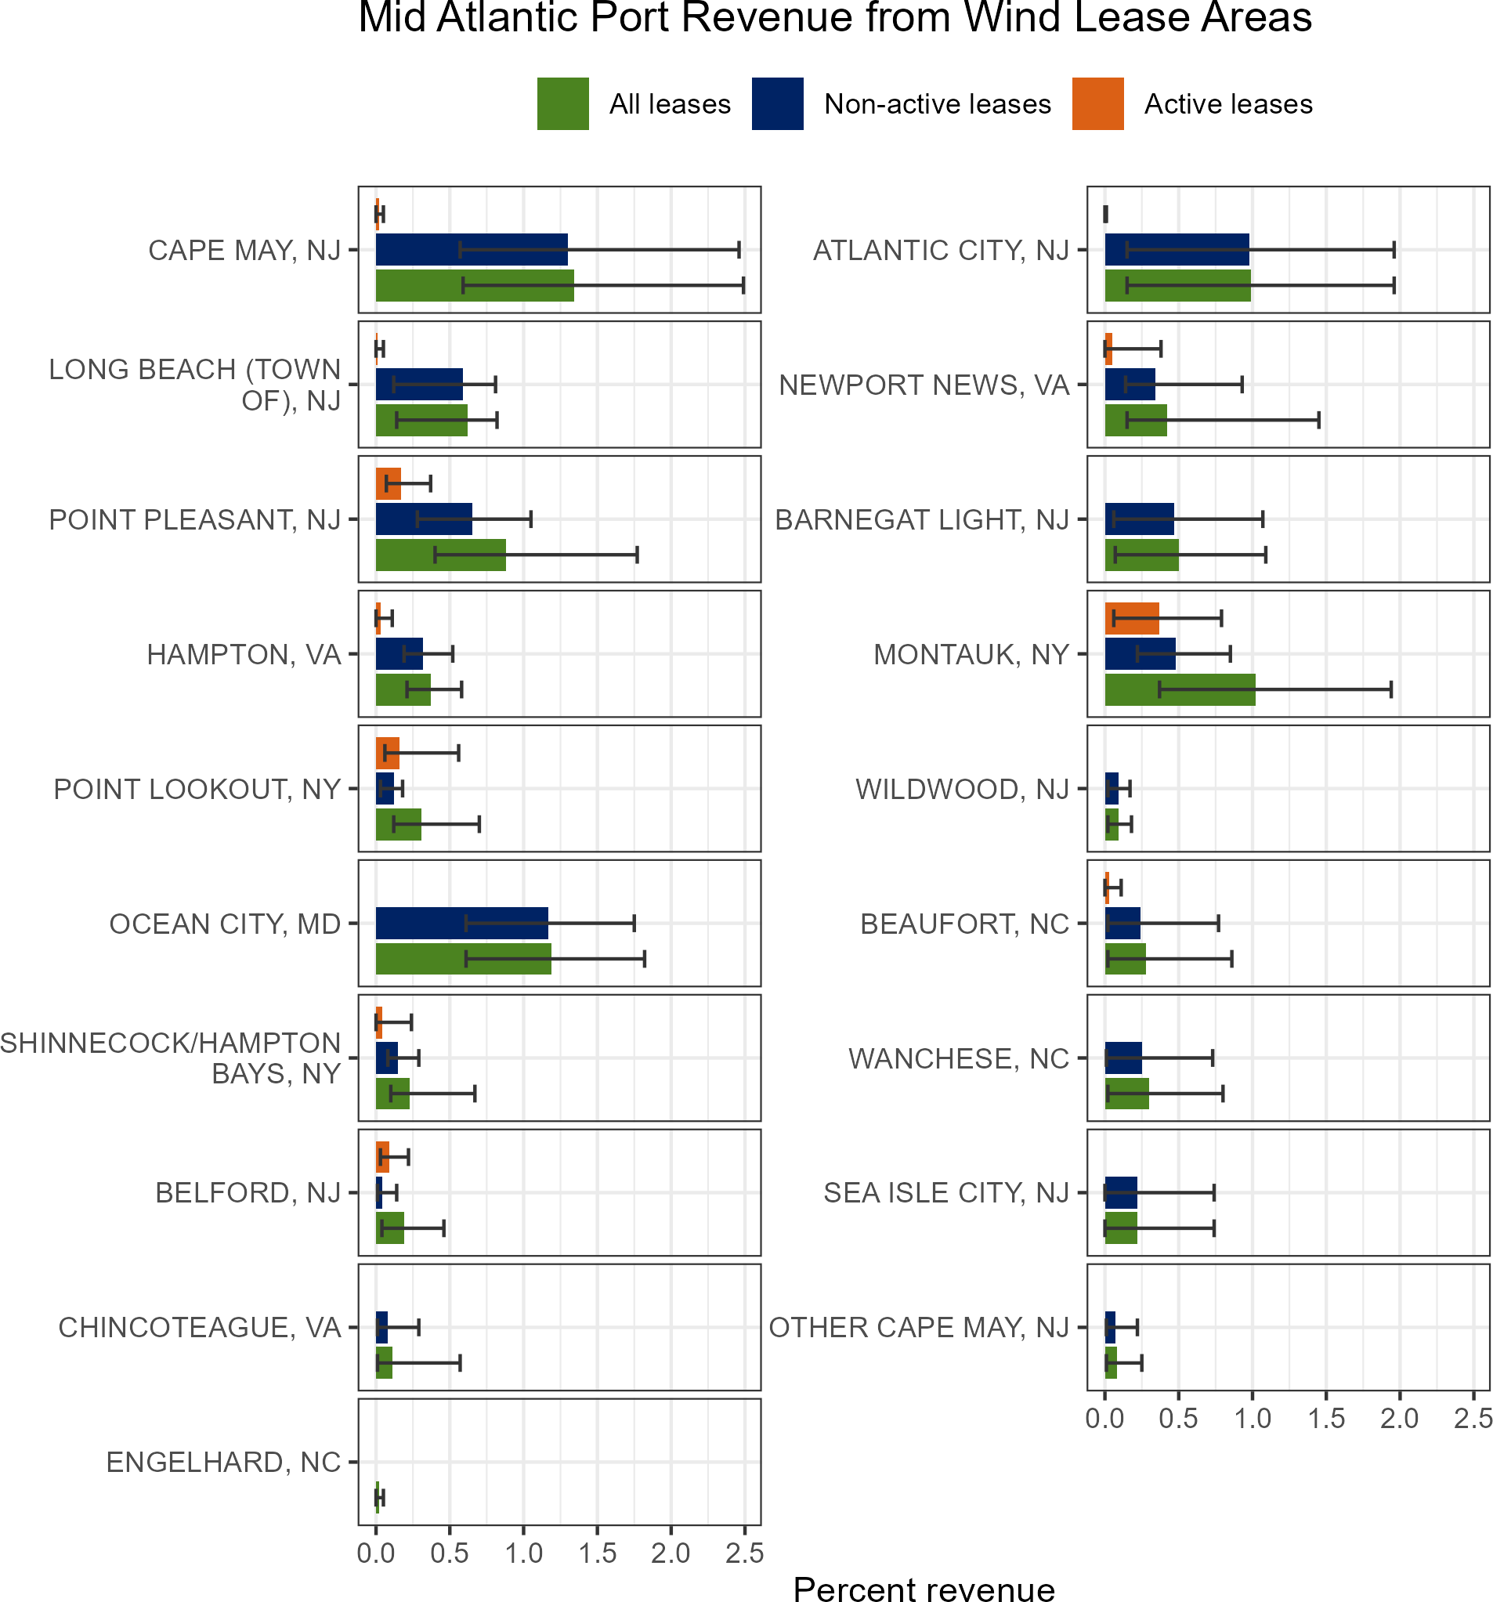

Figure 88: Percent of Mid-Atlantic port revenue from Wind Energy Areas (WEA) from all leases (active + non-active; green), non-active leases (blue), and active leases (orange).

For example, Atlantic City, NJ was in the top three potential revenue loss (historical minimum of 3% and maximum of 24%, respectively) from potential wind development areas based on 2008-2023 total port fisheries revenue. BOEM reports that cumulative offshore wind development (if all proposed projects are developed) could have moderate impacts on low-income members of communities with socio-demographic concerns who work in the commercial

fishing and for-hire fishing industry due to disruptions to fish populations, restrictions on navigation and increased vessel traffic, as well as existing vulnerabilities of low-income workers to economic impacts.
Some ports in New England land Mid-Atlantic managed species from wind areas as well. For the maximum percent value reported in each New England port, the majority (at least 50% based on both value and pounds) of those landings were Mid-Atlantic managed species within wind areas for Davisville/North Kingston and Point Judith, RI, and Hyannis and Menemsha, MA (Fig. 89).
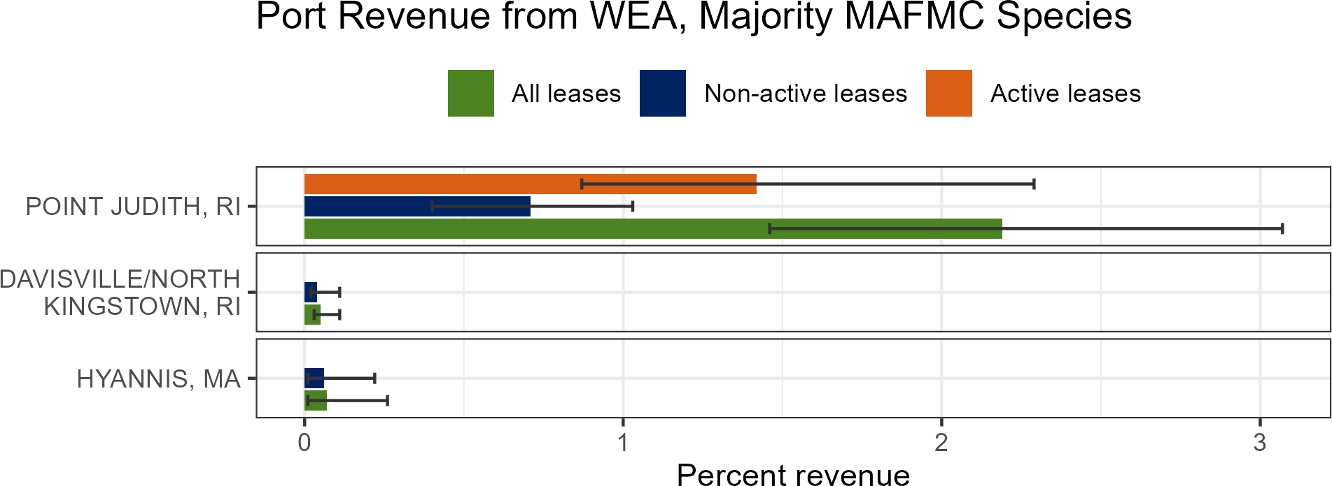

Figure 89: Percent of New England port revenue with majority MAFMC landings from Wind Energy Areas (WEA) from all leases (active + non-active; green), non-active leases (blue), and active leases (orange).

Top fishing communities with socio-demographic concerns (i.e., Atlantic City, NJ, and Hampton Bays, NY) should be considered in decision making to reduce the social and economic impacts and aid in the resilience and adaptive capacity of underserved communities. These are communities where we need to provide further resources to reach underserved and underrepresented groups and create opportunities for and directly involve these groups in the decision-making process.

parent_report.Rmd 08_offshore_wind_newengland.Rmd
Offshore floating wind is expected to be developed in the GOM. The Bureau of Ocean Energy Management (BOEM) leased four areas within the GOM for commercial development on October 29, 2024 (Fig. 86). BOEM also approved the state of Maine’s application to lease 9,700 acres (15 square miles) for the first floating offshore wind research site in federal waters of the GOM, which could have up to 12 turbines.
NEFSC has partnered with the Responsible Ocean Development Alliance (RODA) and the University of Rhode Island to conduct an Integrated Ecosystem Assessment (IEA) of the interactions between offshore wind, fisheries, and the environment in the GOM. The IEA report will be similar to the State of the Ecosystem, but fully dedicated to impacts of offshore wind. Data from the IEA will be suitable for inclusion in the environmental impact statements for any projects in the GOM.
Based on federal vessel logbook data, commercial fishery revenue from trips in the current offshore wind lease areas represents 2-15% of the total annual revenue for fisheries managed by the NEFMC from 2008-2023 (Table 10).Fishing revenue affected by offshore wind lease areas varies over time, but has largely declined over time. Maximum annual revenue for the fisheries with the most overlap with wind lease areas peaked at over $52 million for the sea scallop

fishery, $2.5 million for monkfish, $1.1 million for haddock, $943,000 for pollock, $840,000 for cod, just under $700,000 for skates and redfish, $662,000 for silver hake, and nearly $600,000 for Atlantic herring (Fig. 90). The scallop fishery is mainly affected by lease areas in the Mid-Atlantic, as the Northern Area scallop fishery is outside of the GOM lease areas. However, substantial groundfish landings/revenues overlap with the GOM lease areas, as noted above. Individual groundfish species are more affected than others, with up to 15% of historical annual revenues overlapping with existing lease areas for species such as yellowtail flounder (15%), pollock (11%) and 9% for redfish and white hake (Table 10). Future fishery resource overlap with wind leases, especially scallops, may change due to species distribution shifts attributable to climate change and recruitment and larval dispersion pattern changes caused by hydrodynamic flow disruptions from turbine foundations, which could also affect fishery landings/revenue.
Offshore wind indicators are based on federal logbook data and do not include all data for all fisheries; therefore a complete evaluation of potential offshore wind energy development impacts would need to be supplemented by other data sources. For further information on the utility of the data, see the socioeconomic impacts of offshore wind development data reports page.
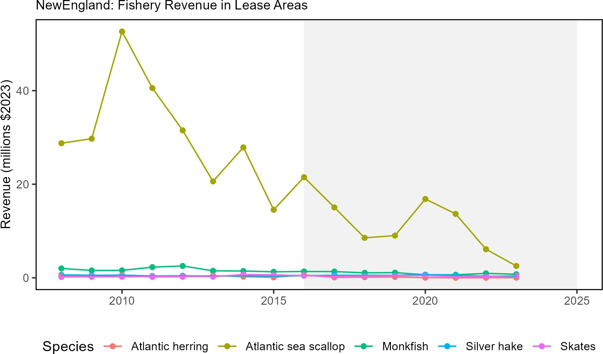

Figure 90: Fishery revenues from NEFMC managed species in the Wind energy lease areas.

Table 10: New England managed species Landings and Revenue from Wind Energy Areas. Skates includes barndoor, winter, clearnose, smooth, little, and general skates reported in logbooks. *Less than a maximum of 50,000 lb was reported landed annually in wind energy lease areas for these species..

NEFMC, MAFMC, and ASMFC  Managed Species | Maximum Percent Total Annual  Regional Species Landings | Maximum Percent Total Annual  Regional Species Revenue
Clearnose Skate* | 18 | 20
Barndoor Skate* | 19 | 18
Yellowtail Flounder | 15 | 15
Little Skate | 12 | 14
Pollock | 11 | 11

Table 10: New England managed species Landings and Revenue from Wind Energy Areas. Skates includes barndoor, winter, clearnose, smooth, little, and general skates reported in logbooks. *Less than a maximum of 50,000 lb was reported landed annually in wind energy lease areas for these species..

NEFMC, MAFMC, and ASMFC  Managed Species | Maximum Percent Total Annual  Regional Species Landings | Maximum Percent Total Annual  Regional Species Revenue
Winter Skate | 10 | 11
Redfish | 10 | 9
White Hake | 9 | 9
Atlantic Sea Scallop | 10 | 9
Monkfish | 9 | 8
Witch Flounder | 8 | 7
Red Hake | 11 | 7
Silver Hake | 8 | 7
American Plaice | 6 | 7
Haddock | 6 | 6
Smooth Skate* | 10 | 6
Atlantic Cod | 5 | 5
Atlantic Halibut* | 5 | 5
Winter Flounder | 4 | 4
Offshore Hake | 17 | 3
Spiny Dogfish | 2 | 3
Windowpane Flounder* | 3 | 3
Atlantic Herring | 3 | 2
Thorny Skate* | 2 | 2
Red Crab | 2 | 2
American Lobster | 1 | 2
Atlantic Wolffish* | 2 | 1

Proposed wind development areas interact with the region’s federal scientific surveys. Scientific surveys are impacted by offshore wind in four ways: 1. Exclusion of NOAA Fisheries’ sampling platforms from the wind development area due to operational and safety limitations. 2. Impacts on the random-stratified statistical design that is the basis for scientific assessments, advice, and analyses. 3. Alteration of benthic and pelagic habitats, and airspace in and around the wind energy development, requiring new designs and methods to sample new habitats. 4. Reduced sampling productivity through navigation impacts of wind energy infrastructure on aerial and vessel survey operations.
Increased vessel transit between stations may decrease data collections that are already limited by annual days-at-sea day allocations. The total survey area overlap ranges from 1-70% for all Greater Atlantic federal surveys as of 2024. Individual survey strata have significant interaction with wind areas, including the sea scallop survey (up to 96% of individual strata) and the bottom trawl survey (up to 60% strata overlap). Additionally, up to 50% of the southern New England North Atlantic right whale survey’s area overlaps with proposed project areas and a region-wide survey mitigation program is underway.
The socio-demographic conditions, and resultant vulnerabilities, of some communities may further exacerbate the impacts of offshore wind development in the Northeast such that the impacts of offshore wind development are expected to differentially impact specific coastal communities (Fig. 88). Additionally, impacts of offshore wind development may unevenly affect individual operators, with some permit holders deriving a much higher proportion of revenue from wind areas than the port-based mean.

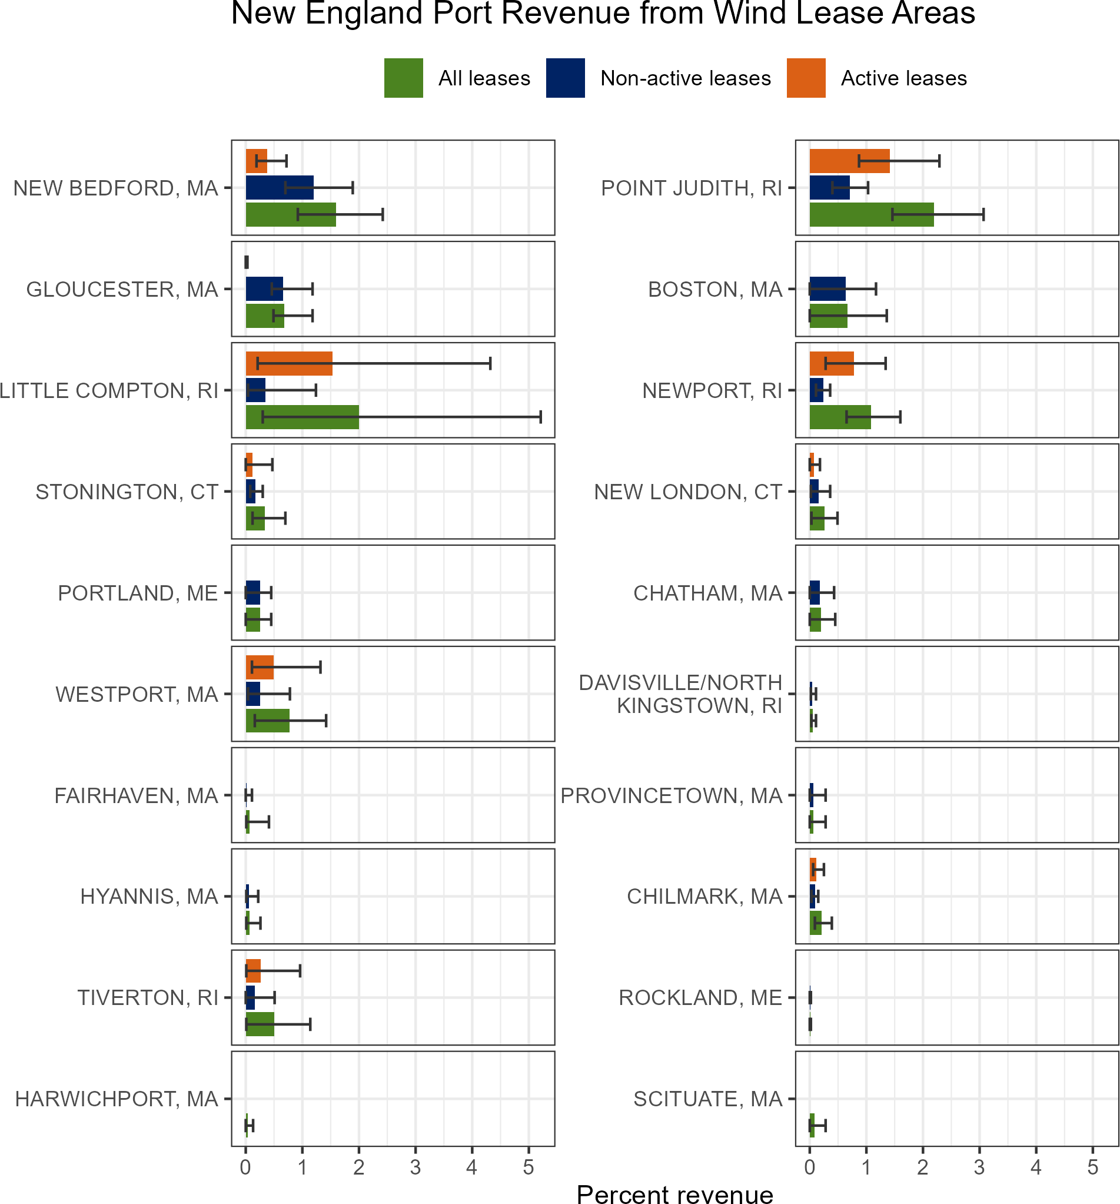

Figure 91: Percent of port fisheries revenue from Wind Energy Areas (WEA) from all leases (active + non-active; green), non-active leases (blue), and active leases (orange).

For example, Little Compton, RI had a minimum of 17% and maximum of 32% overlap of wind energy revenue to the total port revenue between 2008-2023 (Fig. 88). BOEM reports that cumulative offshore wind development (if all proposed projects are developed) could have moderate impacts on low-income members of vulnerable communities who work in the commercial fishing and for-hire fishing industry due to disruptions to fish populations, restrictions

on navigation, and increased vessel traffic as well as existing vulnerabilities of low-income workers to economic impacts.
Top fishing communities with high socio-demographic concerns such as New Bedford, MA and New London, CT should be considered in decision making to reduce the social and economic impacts and aid in the resilience and adaptive capacity of underserved communities. These two ports are also undergoing significant changes to support offshore wind development port infrastructure needs. Socio-demographic concerns also highlight communities where further resources are needed to reach underserved and underrepresented groups and create opportunities for, and directly involve, these groups in the decision-making process.
Some ports in the Mid-Atlantic land New England-managed species from wind areas as well. For the maximum percent value reported in each Mid-Atlantic port, the majority (at least 50% based on both value and pounds) of those landings were New England managed species within wind areas for nine communities (Fig. ??).
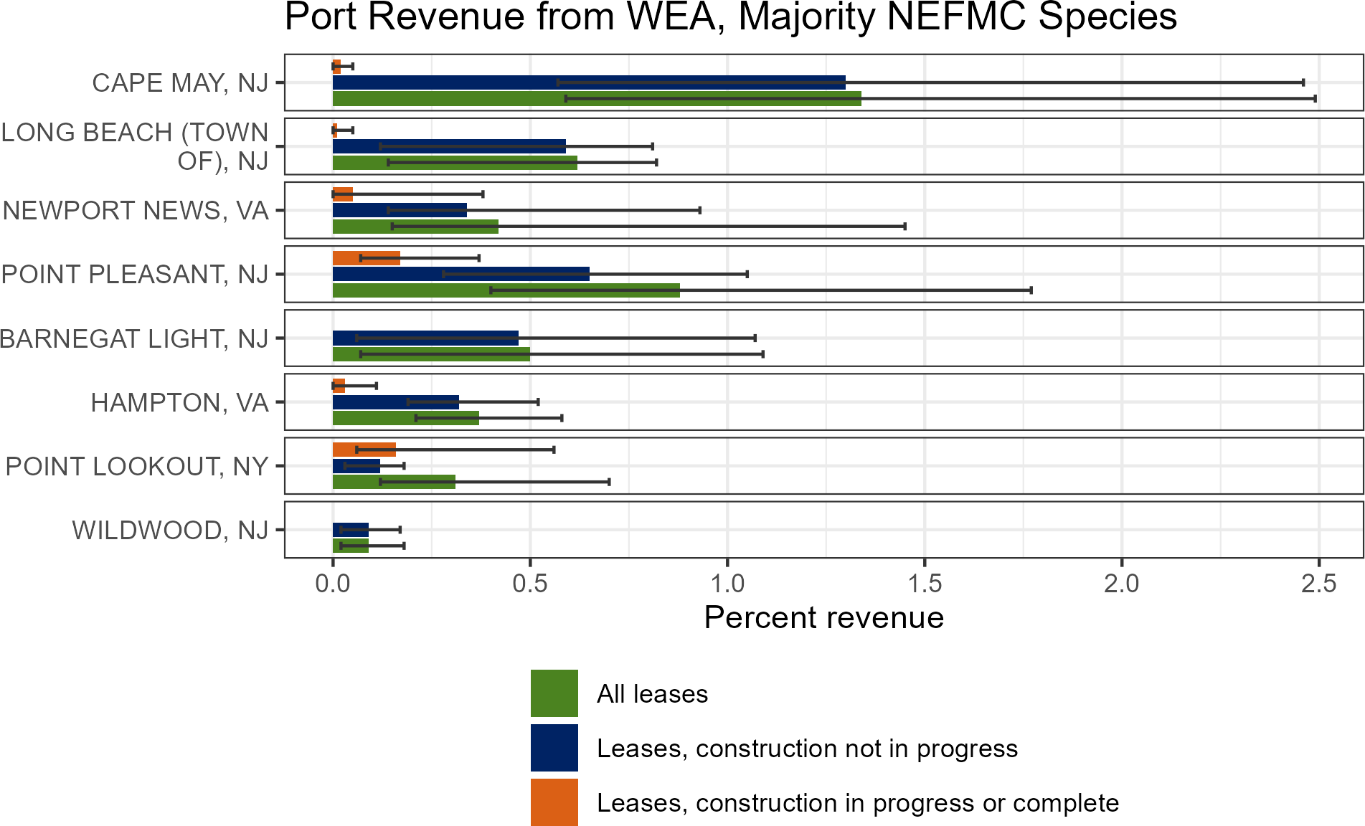

Figure 92: Percent of Mid-Atlantic port revenue with majority NEFMC landings from Wind Energy Areas (WEA) from all leases (active + non-active; green), non-active leases (blue), and active leases (orange).

parent_report.Rmd
Implications
Current plans for buildout of offshore wind in a patchwork of areas spreads the impacts differentially throughout the region (Fig. 86). [Up to 15% of maximum annual fisheries revenue for major Mid-Atlantic commercial species] or [Up to 12% of total average revenue for major New England commercial species] in lease areas could be forgone or reduced and associated effort displaced if all sites are developed. Displaced fishing effort can alter historic fishing area, timing, and method patterns, which can in turn change habitat, species (managed and protected), and fleet interactions. Several factors, including fishery regulations, fishery availability, and user conflicts affect where, when,

and how fishing effort may be displaced, along with impacts to and responses of affected fish species.
Planned development overlaps NARW mother and calf migration corridors and a significant foraging habitat that is used throughout the year (Fig. 93). Turbine presence and extraction of energy from the system could alter local oceanography and may affect right whale prey availability. For example, persistent foraging hotspots of right whales and seabirds overlap on Nantucket Shoals, where unique hydrography aggregates enhanced prey densities. Wind leases (OCS-A 0521 and OCS-A 0522) currently intersect these hotspots on the southwestern corner of Nantucket Shoals and a prominent tidal front associated with invertebrate prey swarms important to seabirds and possibly right whales. Proposed wind development areas also bring increased vessel strike risk from construction and operation vessels. In addition, there are a number of potential impacts to whales from pile driving and operational noise such as displacement, increased levels of communication masking, and elevated stress hormones.
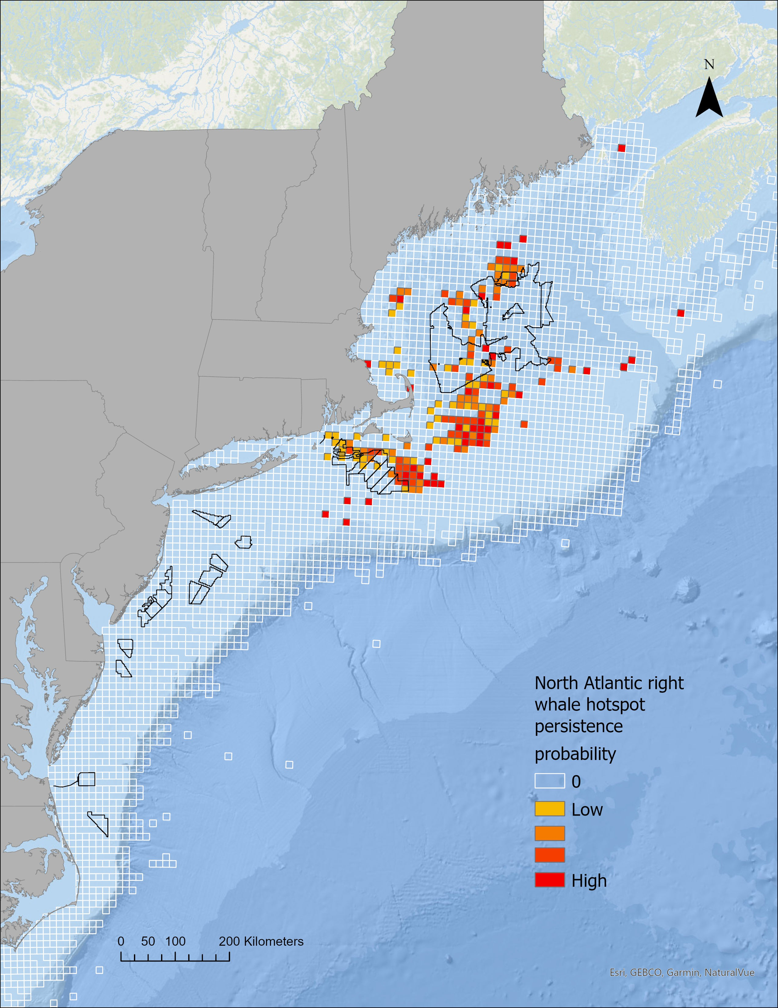

Figure 93: Northern Right Whale persistent hotspots (red shading) and Wind Energy Areas (black outlines).

Scientific data collection surveys for ocean and ecosystem conditions, fish, and protected species will be altered, potentially increasing uncertainty for stock assessments and associated management decision making. Increased vessel transit between stations may decrease data collections that are already limited by annual days-at-sea day allocations. As of 2024, the total survey area overlap ranges from 1-70% for all Greater Atlantic federal surveys. Individual survey strata have significant interaction with wind energy development, including the sea scallop survey (up to 96% of individual strata) and the bottom trawl survey (BTS, up to 60% strata overlap). Additionally, up to 50% of the southern New England North Atlantic right whale survey’s area overlaps with proposed project areas and a region-wide survey mitigation program is underway.
The increase of offshore wind development can have both positive (e.g., employment opportunities) and negative

(e.g., space-use conflicts) effects. Continued increase in coastal development and gentrification pressure has resulted in loss of fishing infrastructure space within ports. Understanding these existing pressures can allow for avoiding and mitigating negative impacts to our shore support industry and communities dependent on fishing. Some of the communities with the highest fisheries revenue overlap with offshore wind development areas that are also vulnerable to gentrification pressure are [Beaufort, NC, and Cape May, Barnegat Light, and Long Beach, NJ] or [Point Judith and Newport, RI; and Boston and New Bedford, MA].

2024 Highlights
This section intends to provide a record of noteworthy observations reported in 2024 across the Northeast U.S. region. The full ecosystem and fisheries impacts of many of these observations are still to be determined. They should, however, be noted and considered in future analyses and management decisions.
2024 global sea surface and air temperatures exceeded 2023 as the warmest year on record, but colder than average temperatures were observed in the Northeast U.S. Oceanographic and ecological conditions in the Northwest Atlantic were markedly different in 2024 compared to recent years.

Northwest Atlantic Phenomena Late 2023 and early 2024 observations indicate movement of cooler and fresher water into the Northwest Atlantic, although there are seasonal and local exceptions to this pattern. Anomalously cold (Fig. 94) and low salinity conditions were recorded throughout the Northeast Shelf and were widespread across the Slope Sea for much of the year. These cooler and fresher conditions are linked to the southward movement of the eastern portion of the Gulf Stream and possibly an increased influx of Labrador Slope and Scotian Shelf water into the system.
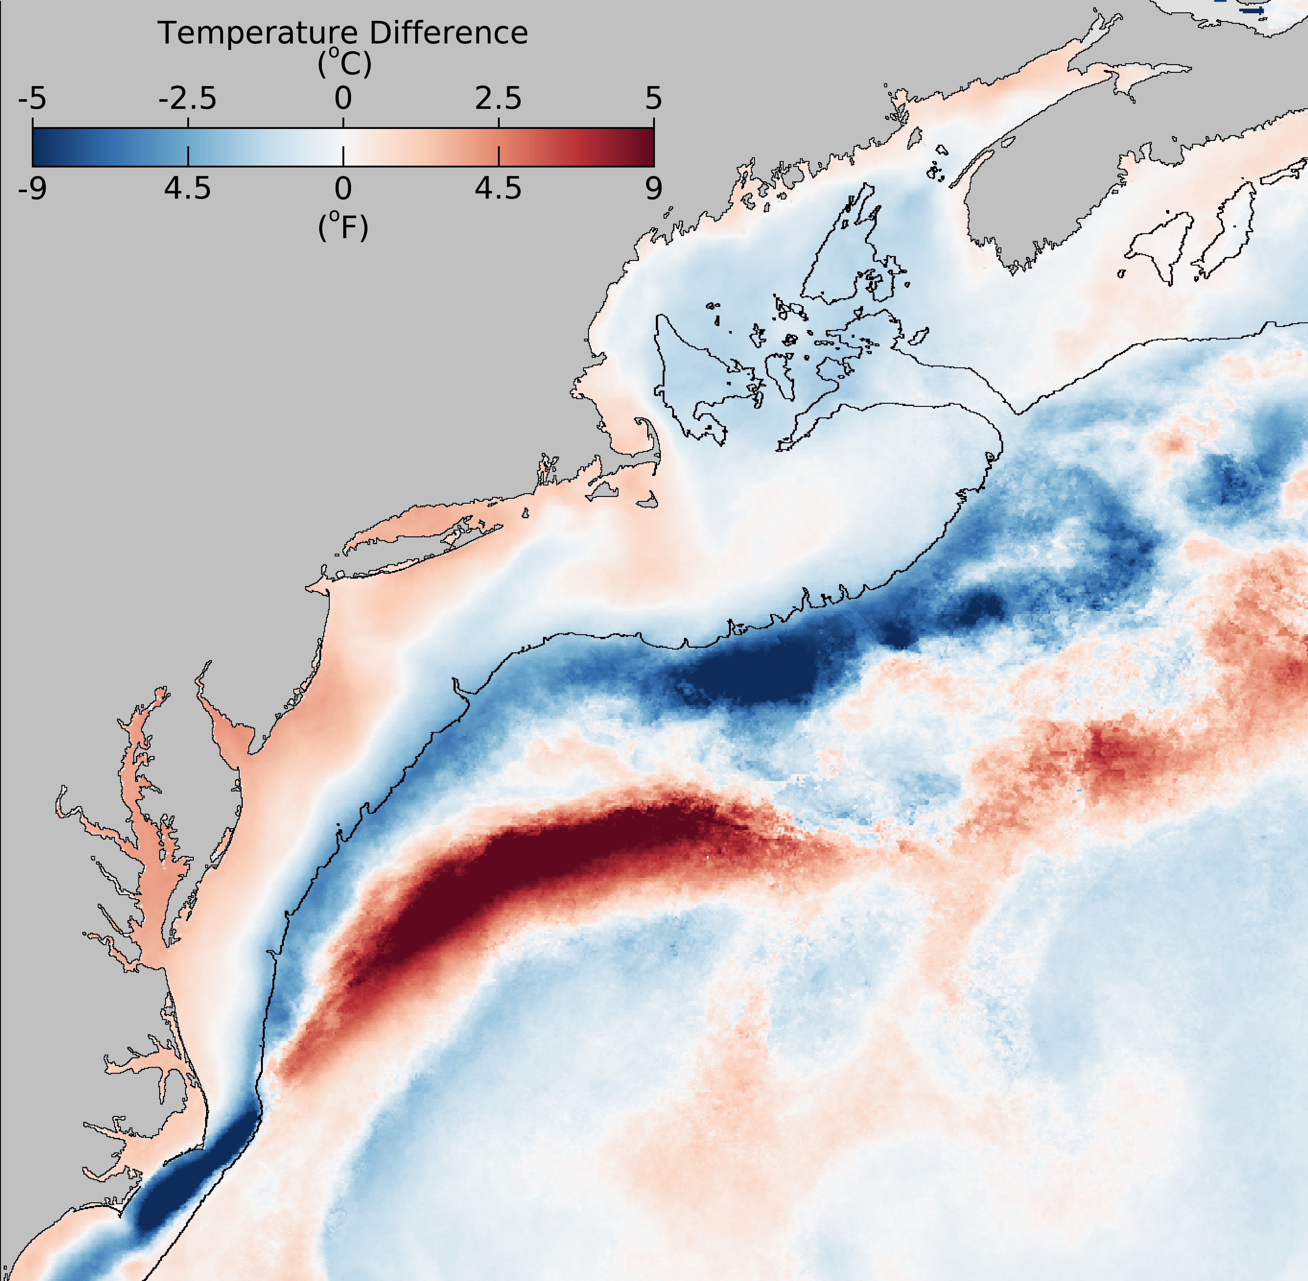

Figure 94: February 2024 sea surface temperature difference compared to the February 2000-2020 long-term mean from the NOAA Advanced Clear-Sky Processor for Ocean (ACSPO) Super-collated SST.

In 2023, Labrador Slope water accounted for more than 50% of the source water entering the Gulf of Maine through the Northeast Channel (Fig. 95); data are still being processed for 2024. Colder, fresher water detected deep in the Jordan Basin for the first half of 2024 suggests an increased influx of Labrador Slope and Scotian Shelf water, which resulted in colder and fresher conditions throughout the Northwest Atlantic and contributed to the increased size and colder temperatures of the Mid-Atlantic Cold Pool.

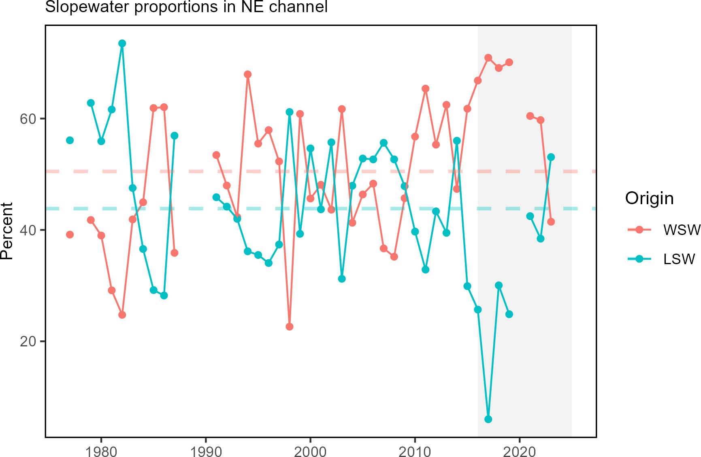

Figure 95: The proportion of Warm Slope Water (WSW) and Labrador Slope Water (LSW) enter the Gulf of Maine through the Northeast Channel from 1977 to 2023. The orange and teal dashed lines represent the long-term proportion averages for the WSW and LSW respectively.

Northeast Shelf and Local Phenomena The influx of the northern waters is likely linked to multiple observations across the Northeast Shelf including the uncommon presence of Arctic Calanus zooplankton species in the Gulf of Maine, delayed migration of many species, and redistribution of some species. Several members of the fishing community noted delayed migration of species into typical fishing grounds. In particular, they attributed the delayed migration of longfin squid, black sea bass, and haddock to the cooler water temperatures. Many also reported redistribution of some species. Specifically, pollock, bluefin tuna, Atlantic mackerel, longfin squid, bluefish, and bonito were observed in surprising or unusual locations. Some species, such as Atlantic mackerel, were reported outside of typical fishing grounds and in higher abundance compared to recent years. Anglers also reported good catches of red drum in Chesapeake Bay and record high (since 1995) numbers were observed at Poplar Island survey location.
In the summer, Chesapeake Bay recorded warm temperatures and low bottom water dissolved oxygen that resulted in less than suitable habitat for species such as striped bass and blue crabs. These poor conditions can affect their distribution, growth, and survival. Additionally, lower than average spring and summer salinity negatively impacted oyster hatchery operations and increased the area of available habitat for invasive blue catfish, potentially increasing predation on blue crabs and other important finfish species.
During the summer months there were multiple prolonged upwelling events that brought cold water to the surface off the New Jersey coast. There was also an atypical phytoplankton bloom south of Long Island in late June to early July 2024, possibly linked to an upwelling event (Fig. 96). The bloom was dominated by coccolithophores, which have an exoskeleton made up of calcium carbonate plates that can turn the water an opaque turquoise color. Large blooms of coccolithophores are unusual in this region, but they are not considered harmful and are grazed by

zooplankton. Additionally, there were observations of multiple whale species aggregating near the Hudson Canyon between May and August.
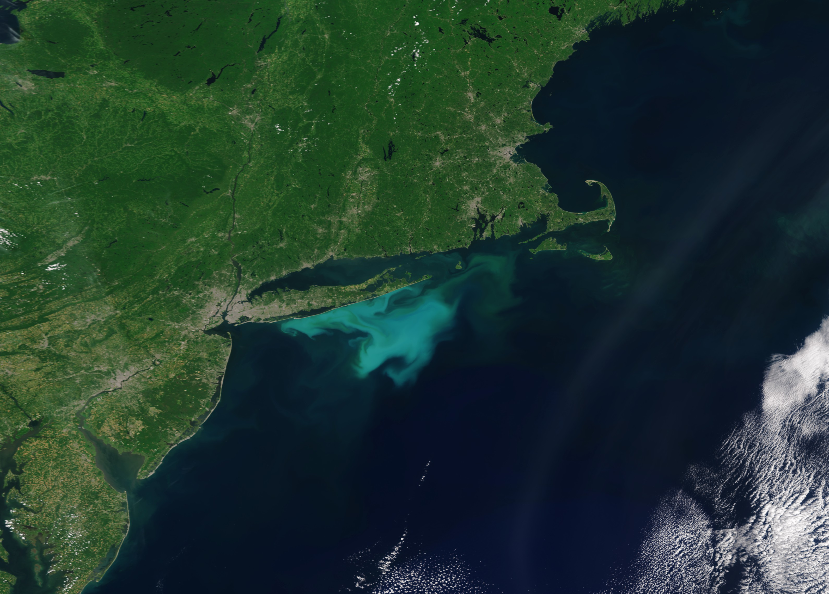

Figure 96: An OLCI Sentinel 3A true color image with enhanced contrast captured on July 2, 2024. Coccolithophores shed their coccolith plates during the later stages of the bloom cycle, which results in the milky turquoise water color (Image credit: NOAA STAR, OCView and Ocean Color Science Team).

Summer bottom ocean acidification (OA) risk in the Mid-Atlantic was the highest recorded since sampling began in 2007. High OA risk is measured as low aragonite saturation state(Ω). Similarly, the winter/early spring Gulf of Maine surface OA risk was significantly above the climatological average and near the sensitivity levels for cod (Ω<1.19) and lobster (Ω<1.09) (Fig.97). These observations were likely driven by the greater volume of fresher, less-buffered Labrador Slope water entering the Gulf of Maine and Mid-Atlantic, as well as cooler conditions. The 2023 and 2024 high summer OA risk has increased the extent of potentially unfavorable habitat for Atlantic sea scallops (Ω<1.1) and longfin squid (Ω<0.96). Additionally, for the first time, high OA risk conditions were observed outside of summer (fall for both species and spring for Atlantic sea scallops).
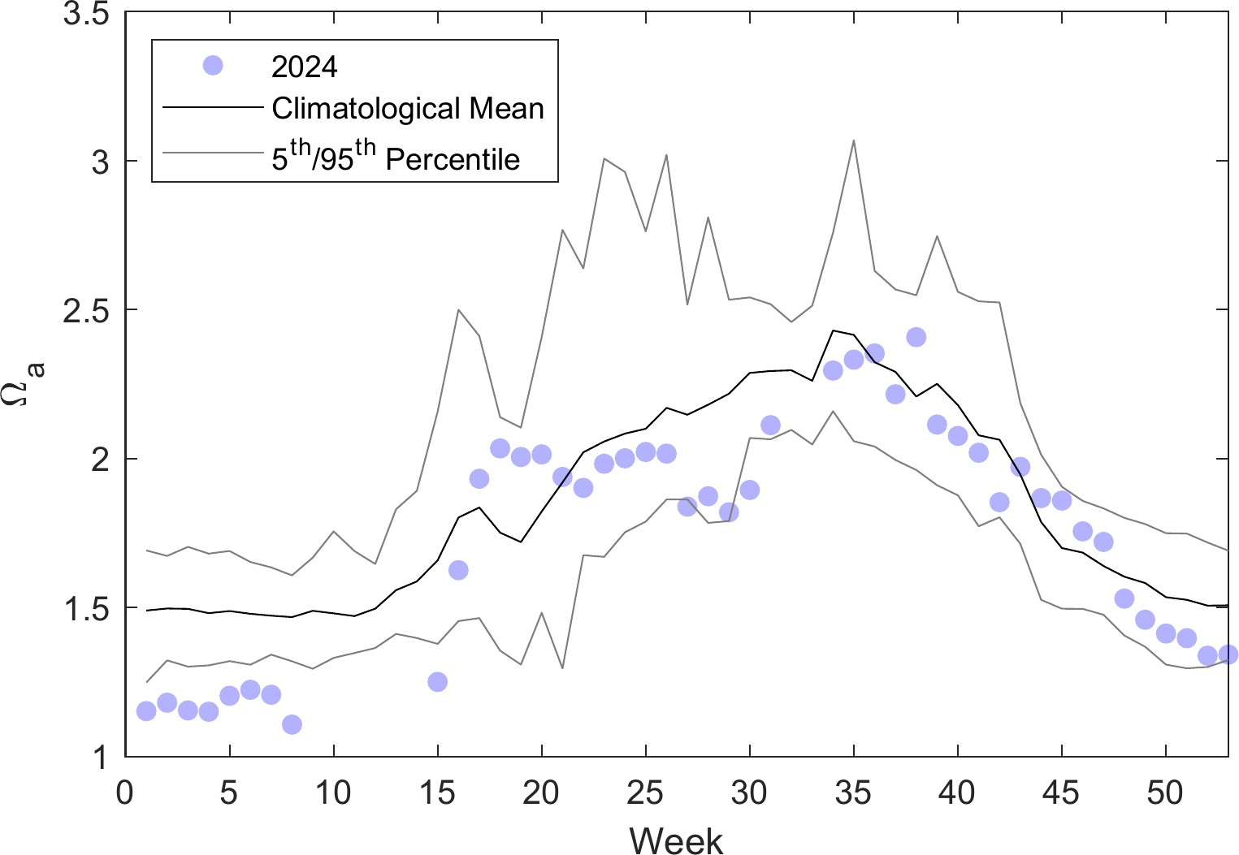

Figure 97: Weekly average surface aragonite saturation state measured at the long-term buoy location in the Gulf of Maine at
43.02 N and 70.54 W

In contrast to the documented die-off of scallops in the Mid-Atlantic Elephant Trunk region between the 2022 and 2023 surveys, in 2024 there was strong scallop recruitment in the southeastern portion of the Nantucket Lightship Area.

Contributors
Editors (NOAA NMFS Northeast Fisheries Science Center, NEFSC): Sarah Gaichas, Joseph Caracappa, Andy Beet, Brandon Beltz, Geret DePiper, Kimberly Hyde, Scott Large, Sarah Weisberg.
Contributors (NEFSC unless otherwise noted): Andrew Applegate (NEFMC), Kimberly Bastille, Aaron Beaver (Anchor QEA), Andy Beet, Brandon Beltz, Ruth Boettcher (Virginia Department of Game and Inland Fisheries), Mandy Bromilow (NOAA Chesapeake Bay Office), Joseph Caracappa, Samuel Chavez-Rosales, Baoshan Chen (Stony Brook University), Zhuomin Chen (UConn), Doug Christel (GARFO), Patricia Clay, Lisa Colburn, Jennifer Cudney (NMFS Atlantic HMS Management Division), Tobey Curtis (NMFS Atlantic HMS Management Division), Art Degaetano (Cornell U), Geret DePiper, Bart DiFiore (GMRI), Emily Farr (NMFS Office of Habitat Conservation), Michael Fogarty, Paula Fratantoni, Kevin Friedland, Marjy Friedrichs (VIMS), Sarah Gaichas, Ben Galuardi (GAFRO), Avijit Gangopadhyay (School for Marine Science and Technology, University of Massachusetts Dartmouth), James Gartland (VIMS), Lori Garzio (Rutgers University), Glen Gawarkiewicz (WHOI), Laura Gruenburg, Sean Hardison, Dvora Hart, Cliff Hutt (NMFS Atlantic HMS Management Division), Kimberly Hyde, John Kocik, Steve Kress (National Audubon Society’s Seabird Restoration Program), Young-Oh Kwon (Woods Hole Oceanographic Institution), Scott Large, Gabe Larouche (Cornell U), Daniel Linden, Andrew Lipsky, Sean Lucey (RWE), Don Lyons (National Audubon Society’s Seabird Restoration Program), Chris Melrose, Anna Mercer, Shannon Meseck, Ryan Morse, Ray Mroch (SEFSC), Brandon Muffley (MAFMC), Robert Murphy, Kimberly Murray, NEFSC staff, David Moe Nelson (NCCOS), Chris Orphanides, Richard Pace, Debi Palka, Tom Parham (Maryland DNR), CJ Pellerin (NOAA Chesapeake Bay Office), Charles Perretti, Kristin Precoda, Grace Roskar (NMFS Office of Habitat Conservation), Jeffrey Runge (U Maine), Grace Saba (Rutgers University), Vincent Saba, Sarah Salois, Chris Schillaci (GARFO), Amy Schueller (SEFSC), Teresa Schwemmer (URI), Tarsila Seara, Dave Secor (CBL), Emily Slesinger, Angela Silva, Adrienne Silver (UMass/SMAST), Talya tenBrink (GARFO), Abigail Tyrell, Rebecca Van Hoeck, Bruce Vogt (NOAA Chesapeake Bay Office), Ron Vogel (University of Maryland Cooperative Institute for Satellite Earth System Studies and NOAA/NESDIS Center for Satellite Applications and Research), John Walden, Harvey Walsh, Sarah Weisberg, Changhua Weng, Dave Wilcox (VIMS), Timothy White (Environmental Studies Program, BOEM), Sarah Wilkin (NMFS Office of Protected Resources), Mark Wuenschel, Qian Zhang (U Maryland).

Document Orientation
The figure format is illustrated in Fig 98a. Trend lines are shown when slope is significantly different from 0 at the p
< 0.05 level. An orange line signifies an overall positive trend, and purple signifies a negative trend. To minimize bias introduced by small sample size, no trend is fit for < 30 year time series. Dashed lines represent mean values of time series unless the indicator is an anomaly, in which case the dashed line is equal to 0. Shaded regions indicate the past ten years. If there are no new data for 2022, the shaded region will still cover this time period. The spatial scale of indicators is either coastwide, Mid-Atlantic states (New York, New Jersey, Delaware, Maryland, Virginia, North Carolina), or at the Mid-Atlantic Bight (MAB) Ecosystem Production Unit (EPU, Fig. 98b) level.





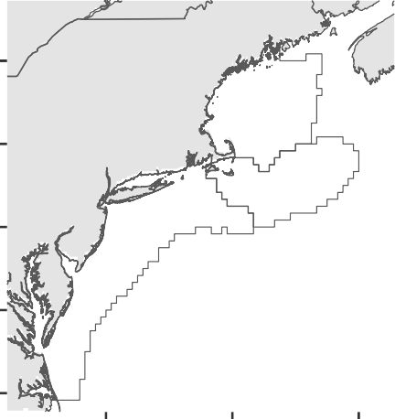
a b
Gulf of Maine
Georges Bank
Mid-Atlantic
Bight

0.202
44°N

0.201 42°N
Latitude

0.2
40°N

0.199
38°N

1985 1990 1995 2000 2005 2010 2015 2020 2025
Time
36°N

74°W 70°W 66°W

Longitude

Figure 98: Document orientation. a. Key to figures. b.The Northeast Large Marine Ecosystem.

Fish and invertebrates are aggregated into similar feeding categories (Table 11) to evaluate ecosystem level trends in predators and prey.

Table 11: Feeding guilds and management bodies.

Guild MAFMC Joint NEFMC State or Other

Apex Predator shark uncl, swordfish, yellowfin tuna, bluefin tuna
winter skate,

Piscivore

summer flounder, bluefish, northern shortfin squid, longfin squid

spiny dogfish, goosefish
clearnose skate, sea lamprey, sandbar shark, atlantic angel shark, atlantic thorny skate, torpedo, conger eel, spotted hake, cusk, fourspot flounder, offshore hake, silver windowpane, john dory, atlantic cutlassfish, blue runner, hake, atlantic cod, striped bass, weakfish, sea raven, northern stargazer, pollock, white hake, banded rudderfish, atlantic sharpnose shark, inshore

Planktivore

atlantic mackerel, chub mackerel, butterfish
red hake, atlantic
halibut, acadian redfish

atlantic herring
lizardfish, atlantic brief squid, northern sennet, king
mackerel, spanish mackerel

harvestfishes, smelts, round herring, alewife, blueback herring, american shad, menhaden, bay anchovy, striped anchovy, rainbow smelt, atlantic argentine, slender snipe eel, atlantic silverside, northern pipefish, atlantic moonfish, lookdown, blackbelly rosefish, lumpfish, northern sand lance, atlantic saury, mackerel scad, bigeye scad, round scad, rough scad, silver rag, weitzmans pearlsides, atlantic soft pout, sevenspine bay shrimp, pink glass shrimp, polar lebbeid, friendly blade shrimp, bristled longbeak, aesop shrimp, norwegian shrimp, northern shrimp, brown rock shrimp, atlantic thread herring, spanish sardine, atlantic bumper, harvestfish, striated argentine, silver anchovy

Table 11: Feeding guilds and management bodies.

Guild MAFMC Joint NEFMC State or Other

crab,unc, hagfish, porgy,red, sea bass,nk, atlantic hagfish, roughtail stingray, smooth dogfish, chain dogfish, bluntnose stingray, bullnose ray, southern stingray, longfin hake, fourbeard rockling, marlin-spike, gulf stream flounder, longspine snipefish, blackmouth bass, threespine stickleback, smallmouth flounder, hogchoker, bigeye, atlantic croaker, pigfish, northern kingfish, silver perch, spot, deepbody boarfish, sculpin uncl, moustache sculpin,

Benthivore black sea bass, scup, tilefish
barndoor skate, rosette skate, little skate, smooth skate, haddock, american plaice, yellowtail flounder, winter flounder, witch flounder, atlantic wolffish, ocean pout, crab,red deepsea
longhorn sculpin, alligatorfish, grubby, atlantic seasnail, northern searobin, striped searobin, armored searobin, cunner, tautog, snakeblenny, daubed shanny, radiated shanny, red goatfish, striped cusk-eel, wolf eelpout, wrymouth, fawn cusk-eel, northern puffer, striped burrfish, planehead filefish, gray triggerfish, shortnose greeneye, beardfish, cownose ray, american lobster, cancer crab uncl, jonah crab, atlantic rock crab, blue crab, spider crab uncl, horseshoe crab, coarsehand lady crab, lady crab, northern stone crab, snow crab, spiny butterfly ray, smooth butterfly ray, snakefish, atlantic midshipman, bank cusk-eel, red cornetfish, squid cuttlefish and octopod uncl, spoonarm octopus, bank sea bass, rock sea bass, sand perch, cobia, crevalle jack, vermilion snapper, tomtate, jolthead porgy, saucereye porgy, whitebone porgy, knobbed porgy, sheepshead porgy, littlehead porgy, silver porgy, pinfish, red porgy, porgy and pinfish uncl, banded drum, southern kingfish, atlantic spadefish, leopard searobin, dusky flounder, triggerfish filefish uncl, blackcheek tonguefish, orange filefish, queen triggerfish, ocean triggerfish

Benthos atlantic surfclam, ocean quahog
sea scallop sea cucumber, sea urchins, snails(conchs), sea urchin and sand dollar uncl, channeled whelk, blue mussel

