## GB Interpolation Analysis

GB By Subregion – 3 Spatial Function, Reset: T

residual 0: 3.137686

residual 1: 2.649275

residual 2: 1.737518

residual 3: 2.841805

rms: 2.649275 1.737518 2.841805

1 2 1.737518

2 1 2.649275

3 3 2.841805

function rank: 2 1 3

function rms: 1.737518 2.649275 2.841805

delta rms: 2.649275 2.985785 1.737518 2.860959 1.260116

NLSF limit= 1

axis Form f0 lambda

-- ---------- --------------- --------------

x Logistic 415308.000000 25722.076353

Ordinary Least Sq Residual: 1.7375184488388880

Bounds alpha: [ 5882.352963 11764.705926 100000.000000]

Bounds nugget:[ 0.068077 0.680767 1.157303]

Bounds sill: [ 1.157303 5.786517 19.674156]

GLSres: 1.747290

output fmax, SF, A= 540.337590 6.468926 0.000221

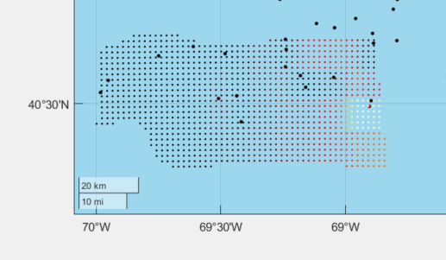

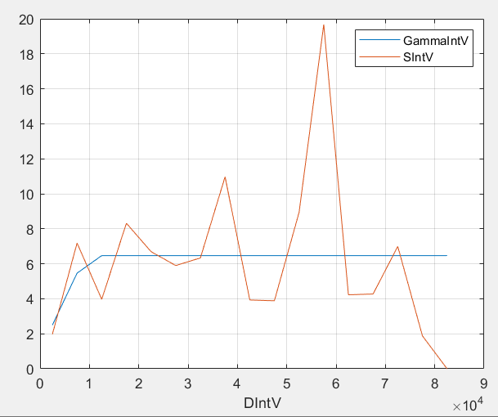

GB By Subregion – 3 Spatial Function, Reset: F

residual 0: 3.137686

residual 1: 2.649275

residual 2: 1.620793

residual 3: 1.602499

spatial function 1 postfit rms: 2.649275

spatial function 2 postfit rms: 1.620792

spatial function 3 postfit rms: 1.602499

ax Form f0 lambda

-- ---------- --------------- --------------

z Logistic 94.710800 49.770158

x Logistic 415308.000000 14334.268440

y Logistic 4510000.000000 50000.000000

Ordinary Least Sq Residual: 1.397974

Bounds alpha: [ 5882.352963 5882.352963 100000.000000]

Bounds nugget:[ 0.023323 0.209911 0.396498]

Bounds sill: [ 0.396498 3.568483 6.740467]

GLSres: 1.398780

output fmax, SF, A= 540.337590 6.468926 0.000221

Produces this result

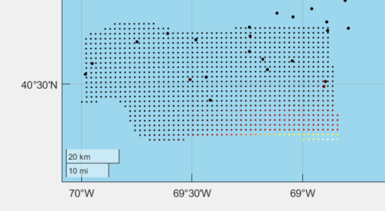

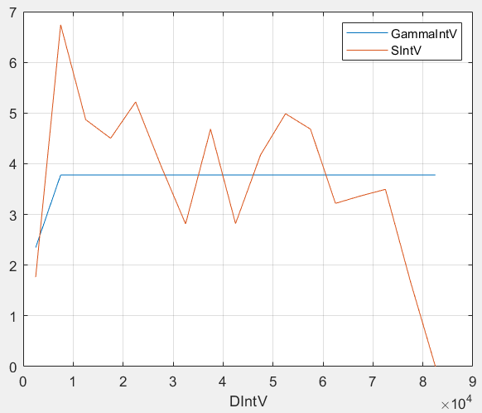

GB By Subregion – 0 Spatial Function,

residual 0: 3.1376862845259312

axis Form f0 lambda

-- ---------- --------------- --------------

Ordinary Least Sq Residual: 2.985785

Bounds alpha: [ 5882.352963 94117.647409 100000.000000]

Bounds nugget:[ 0.240467 0.240467 4.087933]

Bounds sill: [ 4.087933 32.703467 69.494867]

GLSres: 3.261343

output fmax, SF, A= 540.337590 6.468926 0.000221

With this result

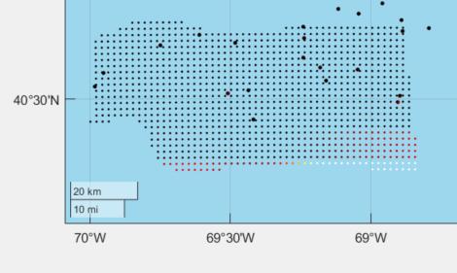

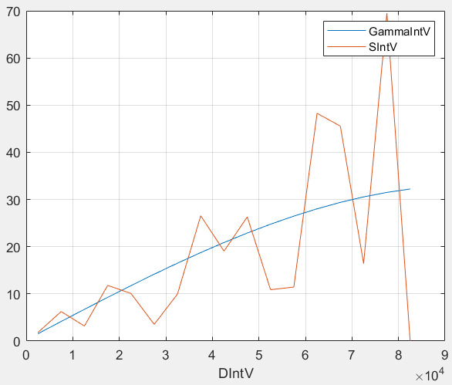

GB By Whole Region – 3 Spatial Function, Reset: T

NLSF_Least_Sq_Fit: Number Obs Points: 178 Number Spatial Functions: 3

residual 0: 2.424163

residual 1: 2.373200

residual 2: 2.305351

residual 3: 2.408123

rms: 2.373200 2.305351 2.408124

1 2 2.305351

2 1 2.373200

3 3 2.408124

function rank: 2 1 3

function rms: 2.305351 2.373200 2.408124

delta rms: 2.373200 2.410544 2.305351 2.400025 0.209105

NLSF limit= 1

axis Form f0 lambda

-- ---------- --------------- --------------

x Logistic 722740.000000 40152.418270

Ordinary Least Sq Residual: 2.3053514141515854

Bounds alpha: [ 561.797759 7865.168899 100000.000000]

Bounds nugget:[ 0.001083 0.001083 0.192696]

Bounds sill: [ 0.192696 4.432016 34.299947]

GLSres: 2.307050

output fmax, SF, A= 540.337590 2.182472 0.000221

Plot, focused on SW

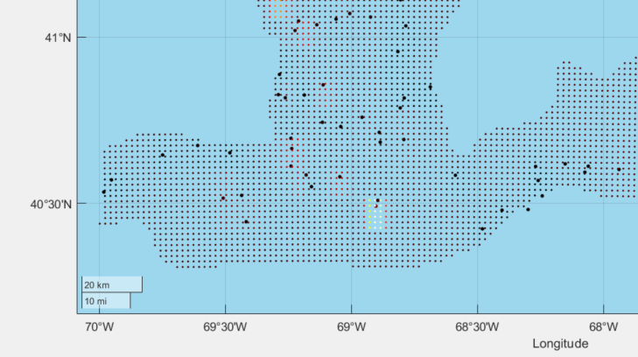

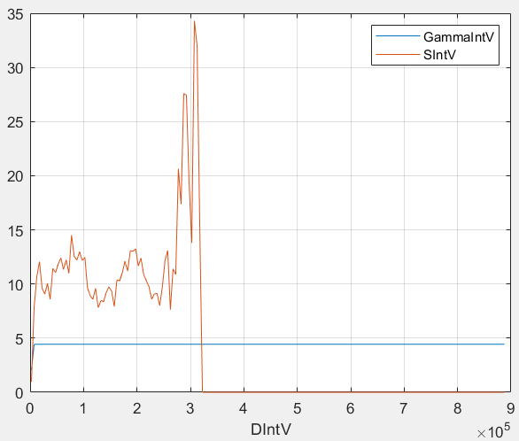

GB By Whole Region – 3 Spatial Function, Reset: F

NLSF_Least_Sq_Fit: Number Obs Points: 178 Number Spatial Functions: 3

residual 0: 2.424163

residual 1: 2.373200

residual 2: 2.297620

residual 3: 2.289853

spatial function 1 postfit rms: 2.373200

spatial function 2 postfit rms: 2.297620

spatial function 3 postfit rms: 2.289853

ax Form f0 lambda

-- ---------- --------------- --------------

z Logistic 18.789600 32.601437

x Logistic 722740.000000 42576.721502

y Logistic 4670000.000000 44438.879788

Ordinary Least Sq Residual: 2.286967

Bounds alpha: [ 561.797759 7865.168899 100000.000000]

Bounds nugget:[ 0.001018 0.082495 0.181286]

Bounds sill: [ 0.181286 4.169585 32.268966]

GLSres: 2.288940

output fmax, SF, A= 540.337590 2.182472 0.000221

num_points, num_survey 6802 178

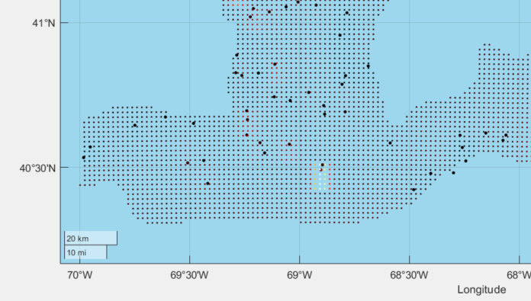

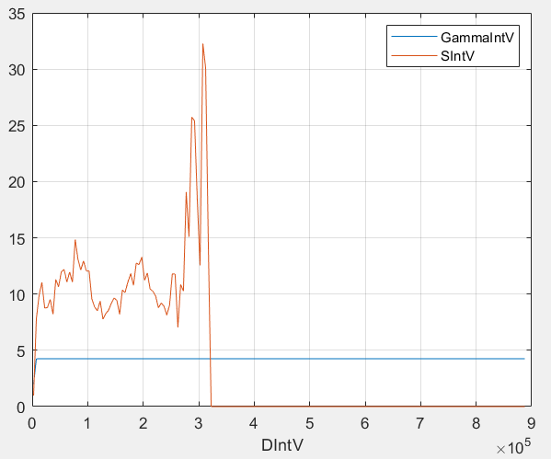

GB By Whole Region – 0 Spatial Function,

NLSF_Least_Sq_Fit: Number Obs Points: 178 Number Spatial Functions: 0

residual 0: 2.424163

Ordinary Least Sq Residual: 2.410544

Bounds alpha: [ 561.797759 8426.966518 100000.000000]

Bounds nugget:[ 0.002360 0.047208 0.420149]

Bounds sill: [ 0.420149 5.882088 74.786543]

GLSres: 2.412172

output fmax, SF, A= 540.337590 2.182472 0.000221

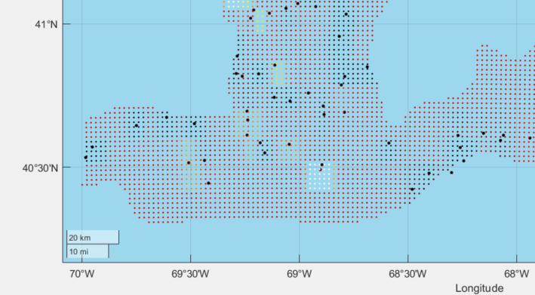

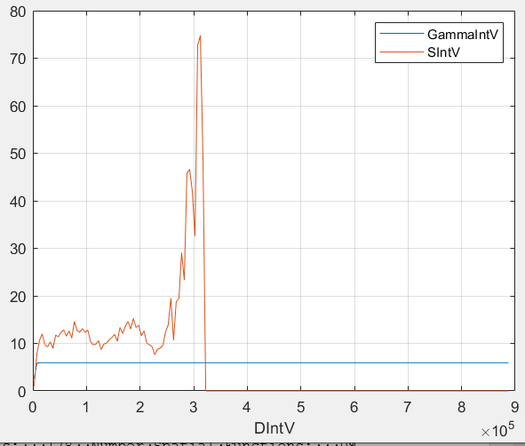

GB By Sub Region – 5 Spatial Function, Reset: T

residual 0: 3.137686

residual 1: 2.649275

residual 2: 1.737518

residual 3: 2.841805

Preconditioning Function Number 1 4

residual 4: 1.622094

Preconditioning Function Number 1 5

residual 5: 2.811530

rms: 2.649275 1.737518 2.841805 1.622094 2.811530

1 4 1.622094

2 2 1.737518

3 1 2.649275

4 5 2.811530

5 3 2.841805

function rank: 4 2 1 5 3

function rms: 1.622094 1.737518 2.649275 2.811530 2.841805

delta rms: 1.737518 2.985785 1.622094 2.849416 5.117381

delta rms: 2.649275 2.985785 1.622094 2.849416 0.659730

delta rms: 2.811530 2.985785 1.622094 2.849416 1.844185

NLSF limit= 3

ax Form f0 lambda

-- ---------- --------------- --------------

x Logistic 420815.751665 16014.437036

x Logistic 415308.000000 25722.076353

z Logistic 94.710800 49.770158

Ordinary Least Sq Residual: 1.622088

Bounds alpha: [ 5882.352963 5882.352963 100000.000000]

Bounds nugget:[ 0.045599 0.045599 0.775189]

Bounds sill: [ 0.775189 5.426321 13.178208]

GLSres: 1.626669

output fmax, SF, A= 540.337590 6.468926 0.000221

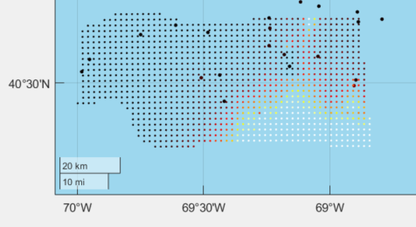

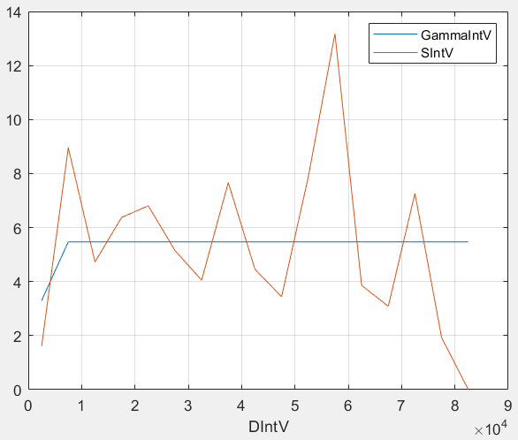

GB By Sub Region – 5 Spatial Function, Reset: F

NLSF_Least_Sq_Fit: Number Obs Points: 17 Number Spatial Functions: 5

residual 0: 3.137686

residual 1: 2.649275

residual 2: 1.620793

residual 3: 1.602499

Preconditioning Function Number 1 4

residual 4: 1.530629

Preconditioning Function Number 1 5

residual 5: 1.481185

spatial function 1 postfit rms: 2.649275

spatial function 2 postfit rms: 1.620793

spatial function 3 postfit rms: 1.602499

spatial function 4 postfit rms: 1.530629

spatial function 5 postfit rms: 1.481185

ax Form f0 lambda

-- ---------- --------------- --------------

z Logistic 94.710800 49.770158

x Logistic 415308.000000 14334.268440

y Logistic 4510000.000000 50000.000000

x Logistic 415308.000000 98156.000000

y Logistic 4510000.000000 50000.000000

Ordinary Least Sq Residual: 1.378898

Bounds alpha: [ 5882.352963 5882.352963 100000.000000]

Bounds nugget:[ 0.021821 0.109105 0.370956]

Bounds sill: [ 0.370956 3.709557 6.306247]

GLSres: 1.381035

output fmax, SF, A= 540.337590 6.468926 0.000221

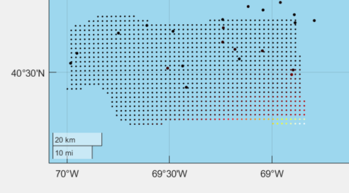

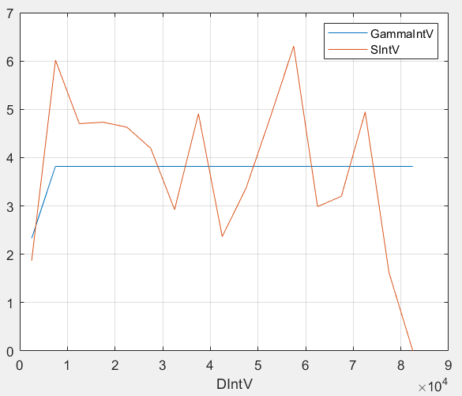

GB By Whole Region – 5 Spatial Function, Reset: T

NLSF_Least_Sq_Fit: Number Obs Points: 178 Number Spatial Functions: 5

residual 0: 2.424163

residual 1: 2.373200

residual 2: 2.305351

residual 3: 2.408124

Preconditioning Function Number 1 4

residual 4: 2.301943

Preconditioning Function Number 1 5

residual 5: 2.374214

rms: 2.373200 2.305351 2.408124 2.301943 2.374214

1 4 2.301943

2 2 2.305351

3 1 2.373200

4 5 2.374214

5 3 2.408124

function rank: 4 2 1 5 3

function rms: 2.301943 2.305351 2.373200 2.374214 2.408124

delta rms: 2.305351 2.410544 2.301943 2.399684 0.522141

delta rms: 2.373200 2.410544 2.301943 2.399684 0.144468

delta rms: 2.374214 2.410544 2.301943 2.399684 0.125745

NLSF limit= 3

ax Form f0 lambda

-- ---------- --------------- --------------

x Logistic 722740.000000 43788.874244

x Logistic 722740.000000 40152.418270

z Logistic 18.789600 32.601437

Ordinary Least Sq Residual: 2.291650

Bounds alpha: [ 561.797759 7865.168899 100000.000000]

Bounds nugget:[ 0.001015 0.001015 0.180702]

Bounds sill: [ 0.180702 4.336849 32.164964]

GLSres: 2.293783

output fmax, SF, A= 540.337590 2.182472 0.000221

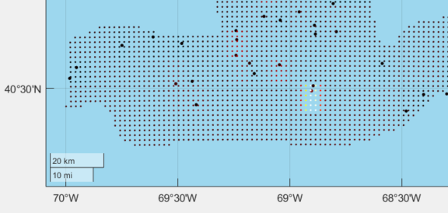

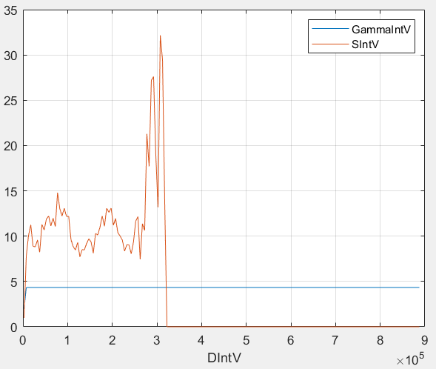

GB By Whole Region – 5 Spatial Function, Reset: F

NLSF_Least_Sq_Fit: Number Obs Points: 178 Number Spatial Functions: 5

residual 0: 2.424163

residual 1: 2.373200

residual 2: 2.297621

residual 3: 2.289854

Preconditioning Function Number 1 4

residual 4: 2.256346

Preconditioning Function Number 1 5

residual 5: 2.255261

spatial function 1 postfit rms: 2.373200

spatial function 2 postfit rms: 2.297621

spatial function 3 postfit rms: 2.289854

spatial function 4 postfit rms: 2.256346

spatial function 5 postfit rms: 2.255261

ax Form f0 lambda

-- ---------- --------------- --------------

z Logistic 18.789600 32.601437

x Logistic 722740.000000 42576.721502

y Logistic 4670000.000000 44438.879788

x Logistic 504641.949255 28636.970595

y Logistic 4460000.000000 210000.000000

Ordinary Least Sq Residual: 2.211018

Bounds alpha: [ 561.797759 7865.168899 100000.000000]

Bounds nugget:[ 0.001311 0.089119 0.233283]

Bounds sill: [ 0.233283 4.432368 41.524289]

GLSres: 2.213962

output fmax, SF, A= 540.337590 2.182472 0.000221

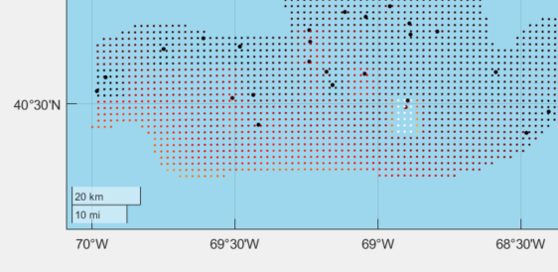

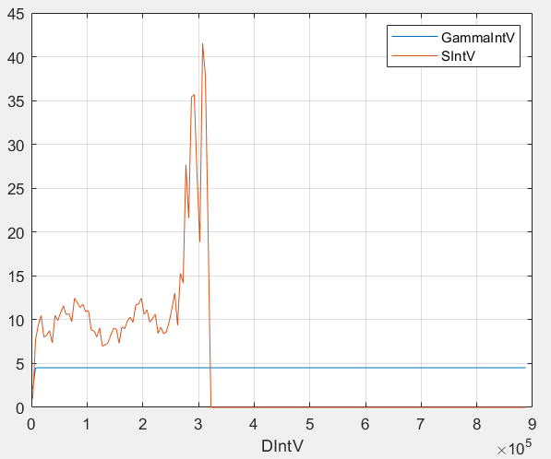

By Sub-Region: 3 SF 5 SF Whole Region: 3 SF 5 SF

  

   

By Sub-Region, Reset F: 3 SF 5 SF Whole Region: 3 SF 5 SF

 

   

By Sub-Region: 0 SF Whole Region: 0 SF

 

 