A
PROJECT REPORT ON
“CRIMEHUB”
SUBMITTED IN PARTIAL FULLFILMENT OF
THE REQUIREMENT FOR THE 6th SEMESTER OF
BACHELOR OF COMPUTER APPLICATION (B.C.A)

SUBMITTED BY
JAISWAR NEHA HIRALAL (5411)

UNDER THE GUIDENCE OF
MS. RIDDHI PATEL
SUBMITTED TO
S.S. AGRAWAL COLLEGE OF
COMMERCE & MANAGEMENT, NAVSARI-396445

ACADEMIC YEAR 2025-2026

ACKNOWLEDGEMENT

I am highly indebting to the grace of one Universal Being. Therefore, I would like to concentrate myself before the Supreme Being for the mental strength. He bestowed on me to go through the ups and downs of my life.

I would like to express my sincere thanks to our college, S. S. AGRAWAL COLLEGE OF COMMERCE AND MANAGEMENT and to our principal, Dr. Vaishali Parekh, for giving me a golden opportunity to work on the project.

It is my privilege to express deep sense of gratitude to my guide, Ms. Riddhi Patel, for her valuable guidance, necessary suggestions, essential encouragement and much needed support throughout the course of this project, which made this endeavor a complete success.

I would like to sincerely thank all my teachers who helped me with this project.

I owe my heartily thanks to my family and friends who have supported me throughout this project in one or the other way

PLACE: NAVSARI JAISWAR NEHA HIRALAL(5411)

DATE: 30-03-2026 (T.Y.B.C.A)

DECLARATION

I undersigned, hereby declare that this project report entitled "CrimeHub" is written and submitted by Jaiswar Neha Hiralal to S.S AGRAWAL COLLEGE OF COMMERCE AND MANAGEMENT, NAVSARI.

This is my original work and the report here is based on the knowledge and project work created by me. This project report will be submitted to VEER NARMAD SOUTH GUJARAT UNIVERSITY only and not to any other university.

PLACE: NAVSARI JAISWAR NEHA HIRALAL(5411)

DATE: 30-03-2026 (T.Y.B.C.A)

PREFACE

With the rapid growth of digital communication, online banking, and social media platforms, cyber crimes have increased significantly. Issues such as online fraud, phishing, hacking, and identity theft are becoming more common, yet many people face difficulties in reporting these crimes due to lack of awareness and complex traditional systems. This creates a strong need for a secure and efficient digital platform.
The project “CrimeHub” is developed as a web-based cyber crime reporting system that allows users to report incidents easily and track their complaint status. It provides a centralized platform for both citizens and authorities, reducing manual work and improving transparency in the reporting process.
This application is built using the MERN Stack (MongoDB, Express.js, React.js, Node.js), which ensures a fast, scalable, and responsive system. The frontend is developed using React.js for a smooth user interface, while Node.js and Express.js handle backend operations. MongoDB is used for efficient data storage and management. The system also uses JWT (JSON Web Token) for secure authentication and authorization of users and administrators.
An important part of this project is the system design, which includes ER diagrams, data flow diagrams, and structured database design. These components help in organizing data, maintaining relationships between users, complaints, and officers, and ensuring the overall efficiency of the system.
This report presents the complete development of the CrimeHub system, including its objectives, modules, system architecture, and implementation. The main aim of this project is to simplify cyber crime reporting and promote awareness, contributing to a safer and more secure digital environment.

INDEX
Sr.no | Title | Page No.
1. | Introduction  1.1 Existing System  1.2 Limitations of Existing System | 1-6
2. | Proposed System  2.1 Project Profile  2.2 Introduction to proposed system  2.3 Basic Functionality or scope  2.4 Objectives  2.5 Advantages  2.6 Limitation  2.7 Hardware and Software Requirement | 7-16
3. | Introduction to development environment  3.1 What is react?  3.2 Introduction to HTML  3.3 MongoDB  3.4 JavaScript | 17-23
4. | System Planning  4.1 Requirement Gathering  4.2 Feasibility Study  4.3 Process Model | 24-27
5. | System Requirement Specification  5.1 System Requirement  5.2 Module Specification | 28-31
6. | System Design  6.1 System Level Diagram  6.2 ER Diagram  6.3 Data Flow Diagram  6.4 Data Dictionary  6.5 Data Table | 32-51
7. | Screen Layouts  7.1 Form Layouts  7.2 Report Layouts | 52-89
8. | Testing  8.1 Testing  8.2 Type of Testing | 90-93
9. | Future Enhancement | 94-95
10. | References | 96-97

- Introduction

In today’s digital era, the use of the internet, social media, online banking, and digital payment systems has increased rapidly. While technology has made life easier, it has also led to a significant rise in cyber-crimes. Cyber-crimes include online fraud, hacking, phishing attacks, identity theft, cyber bullying, social media account hacking, financial scams, and data breaches.
Many victims of cyber-crimes face difficulties in reporting incidents due to:
- Lack of awareness
- Complicated legal procedures
- Physical visit requirements to police stations
- Delays in response
- Fear of sharing personal information
To overcome these problems, we developed CrimeHub, an online Cyber Crime Reporting System that provides a secure, simple, and user-friendly platform for citizens to report cyber-crimes digitally.
CrimeHub is a React Application designed to simplify the process of reporting and managing cyber-crime complaints.
Key points of CrimeHub Project:
- Centralized Cyber Crime Reporting System
CrimeHub provides a single online platform where users can report different types of cyber-crimes. Instead of visiting offices physically, users can submit complaints quickly and easily from their devices. All complaints are stored in one centralized system for proper management.
- Secure User Authentication & Authorization
The system ensures that only registered users and authorized admins can access specific features. Proper login mechanisms protect sensitive information and prevent unauthorized access.
- Real-time Complaint Tracking
Users can track the status of their complaints after submission. This increases transparency and keeps users informed about whether their complaint is pending, approved, or resolved.
- Admin Dashboard for Complaint Management
The admin dashboard allows administrators to view all submitted complaints, update their status, manage cases, and monitor system activities efficiently. It helps in better case handling and faster response
- User-Friendly Interface
CrimeHub is designed with a simple and clean interface so that people of all age groups can use it easily. The forms and navigation are straightforward and easy to understand.
- Structured Complaint Management
All complaints are stored with proper details such as complaint ID, date, description, and status. This structured format helps in maintaining accurate records and tracking case history.
- Cyber Crime Awareness Module
The system includes an awareness section where users can learn about common cyber threats such as phishing, online fraud, and identity theft. This helps users stay informed and protect themselves.
- Fast and Scalable Architecture
CrimeHub is built using modern web technologies like Angular for frontend and a backend server for data handling. The architecture is scalable, meaning new features can be added easily in the future.
- Report Generation & Analytics
The system can generate reports based on complaint data. These reports help administrators analyse trends, monitor performance, and make better decisions.
- Role-Based Access Control
The system separates user and admin roles.
- Users can submit and view complaints.
- Admins can manage and update complaints.
This ensures system integrity and prevents misuse.

1.1 Existing System
The existing system for reporting cyber-crimes is mostly manual and semi-digital. In many cases, victims must visit a police station physically to file a complaint. Although some government portals exist, they are often complex, slow, or not user-friendly for common citizens.
The traditional system lacks proper digital tracking, transparency, and user convenience.
- The victim visits the nearest police station.
- The victim explains the issue verbally.
- The complaint is written manually by an officer.
- Documents or evidence are collected physically.
- The complaint is registered in paper records or local systems.
- The victim receives limited updates about the case status.
In some regions, online portals are available, but they:
- Do not provide real-time tracking
- Have slow processing time
- The existing system typically follows these steps:

1. Physical Visit to Police Station
- The victim must visit the nearest police station or cyber-crime department to report the issue. This may involve long waiting times and multiple visits.

2. Manual Complaint Registration
- The complaint is written manually in registers or entered local systems by police officers. This increases dependency on human handling.

3. Submission of Evidence
- Victims must provide printed copies or physical storage devices (pen drives, CDs, etc.) to submit proof such as screenshots, emails, or transaction details.

4. Verification Process
- The authorities manually verify the complaint details and documents.

5. No Direct Tracking System
- After submission, the victim has limited or no direct access to track the complaint status online. They may need to call or revisit the station.

1.2 Limitations of Existing System
- Manual and paper-based complaint registration
In the existing system, complaints are often written on paper or recorded manually. In some cases, basic computer records are maintained, but they are not fully automated. This increases the chances of human errors such as incorrect data entry, lost files, or missing information. Manual handling also makes the process slow and less reliable.
- Time-consuming and slow complaint processing
Users usually need to visit a police station or contact authorities through phone or email to report cyber-crimes. This takes time and may require multiple visits or follow-ups. The process can be frustrating, especially for people who need immediate help.
- Physical presence required to report crimes
In the traditional system, people usually need to visit a police station or office to file a complaint. This can be difficult for those who live far away, are busy, or feel uncomfortable reporting cyber-crimes in person. It also consumes time and travel expenses.
- High chances of data loss and record duplication
Since records are often maintained manually or in separate systems, there is a higher risk of losing important documents. Files can be misplaced, damaged, or incorrectly stored. Duplicate records may also occur when the same complaint is entered multiple times, causing confusion and errors in handling cases.
- No proper complaint tracking mechanism
In many traditional systems, once a complaint is submitted, there is no proper way for users to track its progress. They cannot easily check whether the complaint is under review, approved, or resolved. This makes the process unclear and inconvenient.
- Lack of real-time status updates for users
Users do not receive instant updates about their complaint status. They may need to contact the office repeatedly to get information. This delay reduces efficiency and creates frustration among users.

- Limited cyber-crime awareness among the public
Many people do not know about common cyber threats like phishing, hacking, or online fraud. Due to lack of awareness, people become easy targets of cyber-criminals.

- Low transparency in complaint handling
The traditional system does not always provide clear information about how complaints are processed. Users may not know who is handling their case or what action is being taken. This lack of transparency reduces trust in the system.
- Heavy workload on authorities due to manual work
Authorities need to handle complaints manually, maintain records, and update case status physically or through basic systems. When the number of complaints increases, it becomes difficult to manage them efficiently. This can delay case processing and reduce overall productivity.

2.Proposed System

2.1 Project Profile
Attribute | Description
Project Title | CrimeHub – Cyber Crime Reporting and Management System
Domain | Cyber Security and Online Complaint Management System
Academic Year | 2025 – 2026
Project Type | React Application
Platform | Web-Based Application
Frontend Technologies | HTML5, CSS3, JavaScript, React.js
Backend Technologies | Node.js, Express.js
Database | MongoDB (NoSQL Database)
Development Tools | Visual Studio Code, MongoDB Compass
API Communication | RESTful APIs used to connect React frontend with Node.js backend
Architecture | Three-Tier Architecture (Presentation Layer – Application Layer – Database Layer)
User Roles | User (Citizen) and Admin (Authority)
Security Features | User authentication, password protection, role-based access control, secure database storage
Main Objective | To provide a secure, efficient, and user-friendly platform for reporting and managing cyber-crime complaints online.
Target Users | General public, students, working professionals, cyber-crime authorities

  - Introduction to proposed system
The proposed system, CrimeHub, is designed to overcome the limitations of traditional crime reporting methods. In the manual system, people often need to visit police stations to register complaints, which can be time-consuming and inconvenient.
CrimeHub allows users to register complaints online, upload evidence if required, and track the progress of their reports. The system also provides an admin panel where administrators can manage complaints, update statuses, and respond to users.
By using modern web technologies like React, Node.js, and MongoDB, the proposed system ensures better performance, scalability, and user experience.

  - Basic Functionality or scope
The CrimeHub system provides several important functionalities to improve the crime reporting and management process.
- User Registration and Login
Citizens can create accounts and securely log in to the system to submit complaints and track their status.
- Online Crime Reporting
Users can report crimes by filling out an online complaint form and submitting relevant details.
- Complaint Status Tracking
Registered users can view the current status of their complaints and check updates provided by the authorities.
- Super Officer / Officer Dashboard
Police officers can view all submitted complaints, update complaint status, and manage crime reports through an admin dashboard.
- Chatbot Assistance
The system includes a chatbot feature that helps users by answering common questions, guiding them on how to file complaints, and providing basic assistance within the platform.
- Officer Login Monitoring
The system records the login date and time of officers. A super administrator (Super Officer) can view login activity to monitor officer access and maintain accountability.

2.4 Objectives
The main objective of the CrimeHub project is to develop a secure, efficient, and user-friendly cyber-crime reporting system using modern web technologies. Since this is a major React-based full stack application, the objectives focus not only on solving real-world problems but also on implementing advanced technical concepts such as component-based architecture, API integration, authentication, and database management.
CrimeHub aims to simplify cyber-crime reporting while demonstrating practical implementation of React.js, Node.js, Express.js, and MongoDB in a real-time application.
- To Develop an Online Crime Reporting Platform
The main objective of this project is to design and develop a web-based application using Angular that allows users to report cyber-crimes online without physically visiting a police station. The system should be user-friendly, secure, and accessible from anywhere.

- To Enable Easy Complaint Submission
The system should allow users to:
- Enter complaint details
- Upload supporting documents
- Submit reports easily through structured forms

- To Implement Complaint Tracking System
Users should be able to:
- Track complaint status (Pending / Approved / Rejected / In Progress)
- View updates in real-time

- To Maintain Secure Data Storage
The system will securely store complaint data in a backend database (Node.js + MongoDB.
Objective:
- Prevent data loss
- Avoid duplication of records
- Maintain confidentiality of user information

- To Reduce Manual Work of Authorities
The project aims to:
- Digitize complaint handling
- Automatically organize reports
- Help admin manage complaints efficiently
- This reduces workload and improves processing speed

- To Provide Admin Management Panel
An Admin module will allow authorities to:
- View all complaints
- Update complaint status
- Approve or reject reports

- To Promote Cyber Crime Awareness
The platform may include:
- Awareness section
- Safety guidelines
- Common cyber-crime types
This helps educate users about cyber threats.

- To Build a Scalable and Responsive Web Application
Using Angular framework, the project will:
- Follow modular architecture
- Provide smooth UI/UX

2.5 Advantages
    - Easy Crime Reporting
The CrimeHub system allows citizens to report crimes easily through an online platform. Users can submit crime details without visiting a police station, which saves time and increases reporting convenience.

- Faster Communication Between Citizens and Police
CrimeHub creates a direct connection between citizens and police officers. Once a crime is reported, officers can quickly view the case and take action, improving response time.

- User-Friendly Interface
Since the system is built using React, it provides a modern and interactive user interface. The application is easy to navigate, making it simple for users to report and track cases.

- Real-Time Case Management
Police officers can manage cases efficiently through the officer dashboard. They can view reported cases, update case status, and close cases once they are resolved.

- Improved Data Organization
All crime reports are stored in a centralized database using MongoDB. This helps in maintaining organized records that can be accessed and managed easily.

- Secure Authentication System
The system includes a secure login and authentication system for both citizens and officers. This ensures that only authorized users can access sensitive information.

- Responsive Design
The CrimeHub platform can be accessed on different devices such as desktops, laptops, tablets, and mobile phones, making it more accessible to users.

- Efficient Case Tracking
Users can track the status of their reported cases. This increases transparency and helps citizens stay informed about the progress of their reports.

- Reduces Paperwork
The digital system reduces manual paperwork in police departments by storing crime reports and case updates electronically.

2.6 Limitation

- Internet Dependency
The system requires a stable internet connection to access the web application and submit complaints.

- Limited User Awareness
Some users may not be familiar with online systems, which may make it difficult for them to use the platform effectively.

- Data Accuracy Depends on User Input
The accuracy of crime reports depends on the information provided by users. Incorrect or incomplete data may affect investigation.

- Security Risks
If proper security measures are not implemented, there may be risks related to data privacy and unauthorized access.

- Limited Chatbot Capability
The chatbot can only answer predefined or common queries and may not handle complex questions or situations.

- Dependence on Admin Updates
Complaint status updates depend on police officers or administrators. If they do not update the system regularly, users may not receive timely information.

- System Maintenance Required
The system requires regular updates and maintenance to ensure smooth performance.

- Email Notification Issues
Sometimes email notifications may go to the spam folder or may not be delivered due to server issues.

2.7 Hardware and Software Requirements
Category | Component / Software | Minimum Requirement | Recommended Requirement | Purpose / Description
Hardware | Processor | Intel i3 / AMD Equivalent | Intel i5 or higher | Required to run development tools, Node.js server, and MongoDB smoothly
Hardware | RAM | 4 GB | 8 GB or more | Supports React development, backend server, and database operations
Hardware | Storage | 256 GB HDD | 512 GB SSD | Stores project files, dependencies, and database data
Hardware | System Type | 64-bit System | 64-bit System | Required for running modern development tools and Node.js
Hardware | Internet Connection | Required | High-speed Internet | Needed for installing packages, updates, and accessing the web application
Software | Operating System | Windows 10 / Linux / macOS | Latest Version OS | Platform to develop and run the application
Frontend Technology | HTML5 | Supported in modern browsers | Latest Version | Provides structure of web pages
Frontend Technology | CSS3 | Supported in modern browsers | Latest Version | Used for styling and responsive design
Frontend Technology | JavaScript | ES6 Support | Latest Version | Handles client-side logic and dynamic behaviour
Frontend Framework | React.js | Version 18+ | Latest Stable Version | Builds dynamic, component-based user interface
Backend Runtime | Node.js | Version 16+ | Latest LTS Version | Executes server-side JavaScript code
Backend Framework | Express.js | Compatible with Node.js | Latest Stable Version | Handles routing, APIs, and server logic
Database | MongoDB | Version 5+ | Latest Stable Version | Stores user data, complaint records, and admin data
Database Tool | MongoDB Compass | Compatible Version | Latest Version | GUI tool to manage MongoDB database
Development Tool | Visual Studio Code | Latest Version | Latest Version | Code editor for writing and managing project files
Package Manager | npm | Installed with Node.js | Latest Version | Installs project dependencies and libraries
Browser | Google Chrome / Firefox / Edge | Latest Version | Latest Version | Used for testing and running the web application
User Device Requirement | Desktop / Laptop / Mobile | 2 GB RAM | 4 GB RAM or more | Allows users to access CrimeHub via web browser

3.Introduction to the Development Environment

3.1 What is React.js?
React is a popular open-source JavaScript library used for building modern and interactive user interfaces, especially for single-page web applications. It was developed and maintained by Meta Platforms and was first released in 2013. React allows developers to create reusable UI components that efficiently update and render when data changes.
React follows a component-based architecture, which means the user interface is divided into small independent components. Each component manages its own structure, behaviour, and logic. This approach improves code reusability, maintainability, and scalability of applications.
One of the key features of React is the Virtual DOM (Document Object Model). Instead of updating the entire page when data changes, React updates only the parts of the page that have changed. This significantly improves the performance of web applications and provides a faster user experience.
React uses JSX (JavaScript XML), which allows developers to write HTML-like code inside JavaScript. JSX makes the code easier to understand and helps developers design user interfaces more efficiently.
React is widely used for building modern web applications such as dashboards, social media platforms, and e-commerce websites. It integrates easily with other technologies such as Node.js, Express.js, and MongoDB, which together form the popular MERN stack.
In conclusion, React is a powerful and flexible front-end library that simplifies the process of building dynamic and responsive user interfaces. Its component-based structure, performance optimization, and large developer community make it an excellent choice for modern web development.
- Unique Features of React:
- Component-Based Architecture
- Virtual DOM for faster rendering
- Reusable Components
- Easy Integration with APIs
- Large Community Support
- Open-Source Framework
Component-Based Architecture
React applications are built using components. A component is a reusable block of code that represents a part of the user interface such as a button, form, header, or navigation bar. These components can be reused throughout the application, reducing duplication and making development faster.

Virtual DOM
React uses a Virtual DOM, which is a lightweight copy of the real DOM. When changes occur, React first updates the Virtual DOM and then compares it with the previous version to identify the differences. Only the changed parts are updated in the real DOM, improving performance.
Reusability
React components can be reused in multiple parts of the application. This helps developers write less code and maintain the application more efficiently.
Open Source
React is an open-source library, which means developers can freely use and modify it. Its open-source nature encourages developers worldwide to contribute improvements and build libraries around it.
One-Way Data Binding
React follows a one-way data flow, which means data moves from parent components to child components. This makes the application easier to debug and helps maintain better control over data management within the application. It also improves application stability because developers can track how data changes across components.
JSX Syntax
React uses JSX (JavaScript XML) which allows developers to write HTML-like syntax inside JavaScript code. JSX makes the code more readable and easier to understand. It helps developers design user interfaces efficiently by combining structure and logic in a single component.

3.2 Introduction to HTML
HTML is the standard markup language used to create web pages and structure the content displayed in a web browser. HTML stands for HyperText Markup Language and is the backbone of all web pages.
HTML uses tags to define elements such as headings, paragraphs, images, tables, and links. These tags instruct the browser on how to display the content on the screen.
HTML documents are platform independent, meaning they can run on any operating system or browser that supports web standards. Modern browsers such as Google Chrome, Mozilla Firefox, and Microsoft Edge support HTML.
HTML is commonly used together with CSS for styling and JavaScript for adding interactivity.
- Structure of HTML:
An HTML document typically contains two main sections:
- Head Section – contains metadata such as the title of the page.
- Body Section – contains the visible content of the webpage.

- Example structure:
<html>
<head>
<title>My Web Page</title>
</head>
<body>
<h1>Welcome to CrimeHub</h1>
<p>This is a web application</p>
</body>
</html>

- HTML Forms:
HTML forms are used to collect user input such as login details, feedback, or report submissions.
The <form> tag is used to create forms and contains various input elements such as:
- Text fields
- Password fields
- Buttons
- Radio buttons
- Checkboxes

- Example:
<form method="POST" action="/submit">
<input type="text" name="username">
<input type="submit" value="Submit">
</form>

3.3 MongoDB
MongoDB is a popular open-source NoSQL database designed to store and manage large amounts of data efficiently. Unlike traditional relational databases, MongoDB stores data in JSON-like documents instead of tables and rows.
MongoDB is highly flexible and scalable, making it ideal for modern web applications. It allows developers to store structured and unstructured data easily.
MongoDB is widely used in modern web stacks such as the MERN Stack (MongoDB, Express, React, Node.js).
- Features of MongoDB:

- Document-Oriented Database
- High Performance
- Scalability
- Flexible Schema
- Open Source
- Document-Oriented Database
MongoDB stores data in the form of documents instead of traditional rows and columns used in relational databases. These documents are stored in JSON-like format (BSON), which allows data to be organized in a flexible and hierarchical structure.
- High Performance
MongoDB is designed to provide fast read and write operations, making it suitable for applications that handle large amounts of data. It uses indexing, efficient storage engines, and optimized query execution to retrieve data quickly and improve overall application performance.
- Scalability
MongoDB supports horizontal scaling, which means data can be distributed across multiple servers using a technique called sharding. This allows the database to handle very large datasets and high traffic by adding more servers instead of upgrading a single machine.
- Flexible Schema
Unlike traditional databases that require a fixed table structure, MongoDB allows a dynamic or flexible schema. This means documents in the same collection can have different fields and structures. Developers can easily modify the database structure without affecting existing data, making development faster and more adaptable.
- Open Source
MongoDB is an open-source database, which means its source code is freely available to developers. Organizations can use, modify, and distribute it without paying licensing fees. The large global community continuously contributes improvements, plugins, and tools that enhance MongoDB’s functionality and reliability.
- Example MongoDB Document:
{
"name": "Saima",
"email": "saima@gmail.com",
"complaint": "Cyber Fraud",
"status": "Pending"
}

3.4 JavaScript
JavaScript is a high-level programming language widely used for creating dynamic and interactive web applications. It is one of the core technologies of web development along with HTML and CSS.
JavaScript allows developers to add functionality such as:
- Form validation
- Interactive buttons
- Dynamic content updates
- Animations
- API communication
JavaScript runs directly in the web browser and is supported by all major browsers.
JavaScript is also used on the server side through Node.js, allowing developers to build full-stack applications using the same language.
- Example JavaScript Function:
function showMessage() {
alert("Welcome to CrimeHub");
}
- Example usage in HTML:
<button onclick="showMessage()">Click Me</button>
When the button is clicked, a popup message will appear.
- Importance of JavaScript:
- Enables interactive web pages
- Supports event handling
- Works with APIs and databases
- Used in front-end frameworks like React
- Essential for modern web development

4. System Planning

System planning is the initial stage of software development where the requirements, feasibility, and development approach of the system are analysed. It helps in understanding what the system should do and how it will be developed.

4.1 Requirement Gathering
Requirement gathering is the process of collecting all the necessary information needed to develop the system. It helps developers understand the needs of users and the functionalities required in the application.
For the CrimeHub system, requirements were gathered by studying existing crime reporting methods, analyzing user needs, and identifying problems in the traditional system.
Functional Requirements
These requirements describe what the system should do.
- Users should be able to register and log in to the system.
- Users should be able to submit crime complaints online.
- Users should be able to track complaint status.
- The system should allow geo-mapping to mark crime locations.
- The system should provide chatbot assistance for user queries.
- The system should send email notifications for complaint updates.
- Police officers should be able to view and manage complaints.
- The super officer should be able to monitor officer login time and date.
Non-Functional Requirements
These requirements describe how the system should perform.
- The system should be easy to use and user friendly.
- The system should provide secure authentication.
- The system should have fast response time.
- The system should ensure data privacy and protection.
- The system should be scalable and reliable.

4.2 Feasibility Study
A feasibility study is conducted to determine whether the proposed system is practical and beneficial before development begins.
1. Technical Feasibility
The system can be developed using modern web technologies such as React, Node.js, Express.js, and MongoDB. These technologies are widely used and support efficient development of web applications.
2. Economic Feasibility
The system is cost-effective because most development tools and technologies used are open source. The main expenses involve development time and system maintenance.
3. Operational Feasibility
The system is easy to operate and user-friendly. Citizens can easily submit complaints online, while administrators can manage reports through a dashboard.
4. Schedule Feasibility
The project can be completed within the planned time frame since the technologies used are well documented and widely supported.
4.3 Process Model
The CrimeHub system follows the Waterfall Model of software development.
The Waterfall model is a sequential development approach where each phase must be completed before moving to the next phase.
Phases of Waterfall Model
- Requirement Analysis
In this phase, system requirements are gathered and analyzed.
- System Design
The overall system architecture, database design, and interface design are created.
- Implementation
The actual coding of the system is performed using React, Node.js, and MongoDB.
- Testing
The system is tested to identify and fix errors or bugs.
- Deployment
After testing, the system is deployed for users.

- Maintenance
The system is regularly updated and maintained to improve performance and fix issues.
Advantages of Using the Waterfall Model
- Clear structure and well-defined milestones.
- Easy documentation and tracking of progress.
- Less complex due to step-by-step execution.
- Ideal for projects with fixed requirements.
Limitations
- Changes in requirements are difficult to accommodate after implementation begins.
- Testing occurs only at the end, leading to potential issues if bugs are found late.
- Time-consuming compared to agile models.
Requirement Analysis
Design
Development
Testing
Deployment
Maintenance

5. System Requirement Specification

System Requirement Specification (SRS) describes the functional and non-functional requirements of the system. It provides a detailed description of how the system will operate and what features it will provide to users and administrators.
5.1 System Requirement
The CrimeHub system requires both hardware and software components to operate efficiently.
Hardware Requirements
- Processor: Intel Core i3 / i5 or higher
- RAM: Minimum 4 GB
- Hard Disk: 256 GB or higher
- Input Devices: Keyboard and Mouse
- Display: Monitor
Software Requirements
- Operating System: Windows 10 / Windows 11
- Frontend Framework: React
- Backend: Node.js and Express.js
- Database: MongoDB
- Code Editor: Visual Studio Code
- Browser: Google Chrome or Microsoft Edge
System Requirements
- Internet connectivity
- Secure login and authentication system
- Database for storing user and complaint information
- Admin dashboard for managing complaints

5.2 Module Specification
The CrimeHub system is divided into different modules to organize the system efficiently.
1. User Module
This module allows users (citizens) to interact with the system.
Functions:
- User registration
- User login and authentication
- Submit crime complaints
- Track complaint status
- Provide feedback
2. Complaint Management Module
This module handles the creation and management of crime reports.
Functions:
- Submit new complaint
- Store complaint details in database
- View complaint history
- Update complaint status
3. Super Officer / Officer Module
This module is used by police officers to manage complaints.
Functions:
- Officer login
- View all complaints
- Update complaint status
- Manage user reports

4. Super Officer Module
This module is used by a higher authority to monitor officer activity.
Functions:
- View officer login activity
- Check officer login date and time
- Monitor complaint management activities
5. Chatbot Module
This module provides automated assistance to users.
Functions:
- Answer common queries
- Guide users on how to report crimes
- Provide basic help regarding system usage
6. Email Notification Module
This module sends email notifications to users.
Functions:
- Send complaint confirmation email
- Send complaint status updates
- Notify users about important alerts

6. System Design
4.1 System Level Diagram
Users:
Start
USER’S
Register
Login
Report
Status]
Spam Detection
Fill the Form & Submit
Check Complaint Status
Check Email is spam, fake or danger
End

SUPER Officer:
Login
Update status
End
Suspend
Added
Start
Database
ADMIN’S

Officers:
Login
View all complaint
Update status
End
Closed
Pending
Start
Select complaint
Database
Officer’s
Add Feedback

ER Diagram:
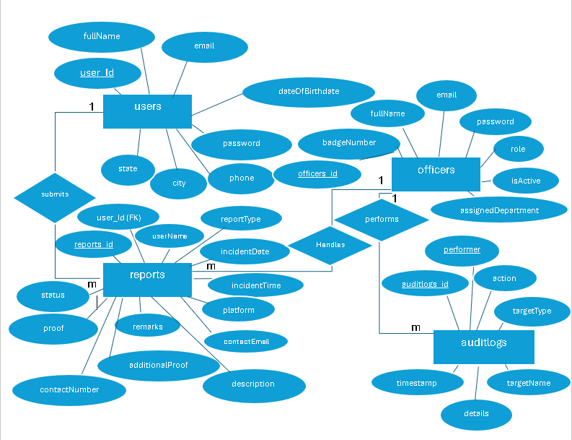

4.2 Data Flow Diagram
The Data Flow Diagram shows how information moves between users, system processes, and the database in the system.
I. External Entity
Symbol: Rectangle

Meaning:
A person, group, or system outside your process that sends or receives data.
Examples:
1. User
- Submits complaint
- Checks complaint status
2. Admin
- Views complaints
- Approves / Rejects / Updates status
II. Process
Symbol: Circle

Meaning:
An activity that transforms input data into output.
Examples:
- Submit Complaint Process
- Store Complaint Data
- Update Complaint Status
- View Complaint Status
.

III. Data Store
Symbol: Two Parallel Lines

Meaning:
A place where data is stored — like a database or file.
Examples:
- User Database
- Report Database
- Admin Database,
- Adminsfeedback Database
IV. Data Flow
Symbol: Arrow

Meaning:
Shows how data moves between processes, stores, and external entities.
Examples:
- Complaint Details → Complaint Database
- Status Update → User

Level 0
END USER
Officer
Submit Complaint
Report Complaint
Upload evidence
View all Complaint
Select Complaint
Update Status
CrimeHub

Track Complaint

End User – CrimeHub – Officer
- The End User sends information or reports (like a crime report) to CrimeHub.
- CrimeHub processes the request and sends it to the Officer.
- The Officer can respond or update the case through CrimeHub.
- The response is then sent back to the End User through the system
CrimeHub
Super Officer
Officer
Manage Officier
Add officier
View Officier Activies
Login Access
Saved activities

Super Officer – CrimeHub – Officer:
- The Officer’s activity logs are sent to CrimeHub.
- CrimeHub forwards these activity logs to the Super Officer for monitoring.
- The Super Officer reviews the officer’s activities and can manage or suspend the officer if necessary.
- The Super Officer does not interact with or manage crime cases directl

Level 1: User
1.0
Register
2.0
Login
3.0
Fill report
5.0
Submit complaint
6.0
Track complaint
4.0
Upload evidence
User
users
reports
Users data stored in Database
Send Response
Check Login Data
If Login data correct redirected to dashboard
Send Request
Enter username and password
Users report the complaint
Send Response
Send Request
Store the uploaded file
Send Request
Send Response
Send Response
Send Request

User
7.0
Email Spam
Ollema Ai
Send Response
Send Request
Send Response
Send Request

1.0 Register
- The user creates an account in the system by entering personal details such as name, email, and password.
- The information is stored in the system database.
2.0 Login
- After registering, the user logs into the system using their email and password.
The system verifies the credentials before granting access.
3.0 Fill Report
- Once logged in, the user fills out the complaint report form.
This includes details such as crime description, location, date, and other relevant information.
4.0 Upload Evidence
- The user uploads supporting evidence related to the complaint.
Evidence can include images, videos, or documents that help support the report.
5.0 Submit Complaint
- After completing the report and uploading evidence, the user submits the complaint.
The system stores the complaint and sends it to the appropriate authorities for further action.
6.0 Track Complaint
- The user can track the complaint status through the system.
The system provides updates such as received, under review, or resolved.
7.0 Email Spam Detection (AI)
- The system uses AI (Ollama AI) to analyze the email entered by the user.
- The AI checks whether the email is: Fake, Spam, Dangerous or suspicious

Level 1 :Super Officier
1.0
Login
2.0
Add Officier
3.0
Suspend/Restore Officier
4.0
Activity Log
Super Officier
Redirected to Dashboard If Login details are correct
Enter Id and Password
verify
Add’s Officer’s
Suspend/Restore Officier access
Auditlogs
Send Over All Activity Details
View All Activity Details
Update Access

Officier

1.0 Login
- The Super Officer logs into the CrimeHub system using login credentials.
- The system verifies the credentials using stored data.
- If the login is successful, the Super Officer gains access to the management features.

2.0 Add Officer
- After logging in, the Super Officer can add new officers to the system.
- The Super Officer enters officer details such as name, email, badge ID, or department.
- The system stores this information in the officer database.
3.0 Suspend / Restore Officer
- The Super Officer can manage officers by changing their status.
- If an officer violates rules or shows suspicious activity, the Super Officer can suspend the officer.
- If the issue is resolved, the Super Officer can restore the officer’s access.
4.0 Activity Log
- The system records all officer activities in the activity log.
- These logs are sent to the Super Officer for monitoring and review.
- This helps the Super Officer track officer actions and ensure proper behavior.
Level 1 : Officier
2.0
View Allotted Cases

1.0
Login
Officier
3.0
Activity Log
Officier
AuditLogs
Reports
Enter Id and Password
If Login data correct redirected to dashboard
Send Request
Send allotted Cases Only
View and submitted Feedback and status
Send Response
Sends Activity Details Automatically by System
Save Activity

1.0 Login
- The Officer logs into the CrimeHub system using their credentials (such as email and password).
- The system verifies the login information with the stored data in the database.
- If the details are correct, the officer is granted access to the system.

2.0 View Allotted Cases
- After logging in, the Officer can view the cases that are assigned to them.
- These cases are retrieved from the case database.
- The officer can read the complaint details, evidence, and status of the case.
- This helps the officer understand which cases they need to handle.

3.0 Activity Log
- Every action performed by the Officer (such as viewing cases, updating information, or accessing the system) is recorded in the Activity Log.
- These logs are stored in the system for monitoring and security purposes.
- The Super Officer can later review these logs to monitor officer activities.

4.3 Data Dictionary

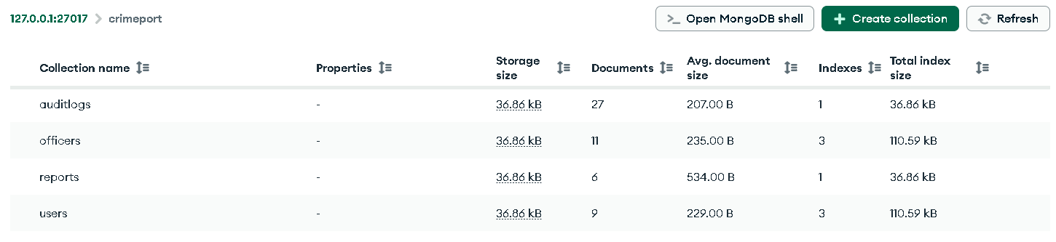
- The database name is crimeport, which stores all the data required for the system.
- auditlogs collection: stores the activity logs of officers. Every action performed by an officer, such as login or system activity, is recorded here so that the Super Officer can monitor officer behavior. This collection currently contains 27 documents.
- officers collection :stores the information of police officers registered in the system. It includes details such as officer name, email, badge ID, and account status. This collection currently contains 11 documents.
- reports collection :stores the crime complaints submitted by users. Each report includes details like crime description, location, evidence, and complaint status. Officers use this information to investigate cases. This collection currently contains 6 documents.
- users collection :stores the details of citizens who register in the CrimeHub system. It contains information such as name, email, and login credentials. These users can report crimes and track their complaints. This collection currently contains 9 documents.

- User
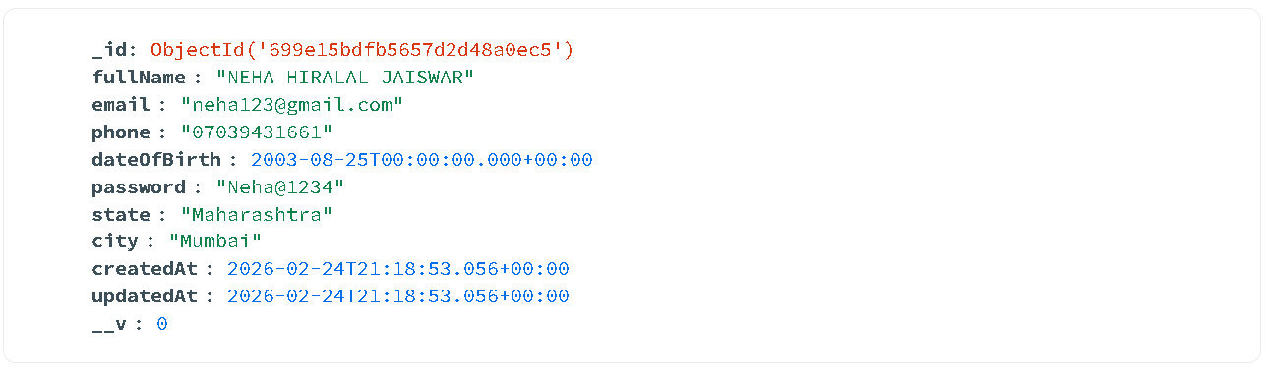

- Officier
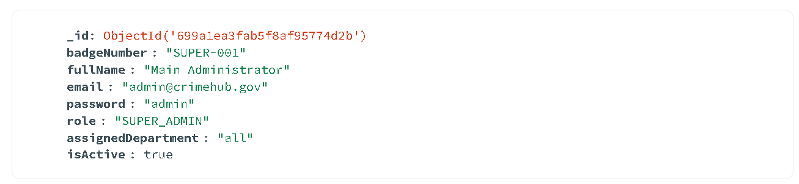
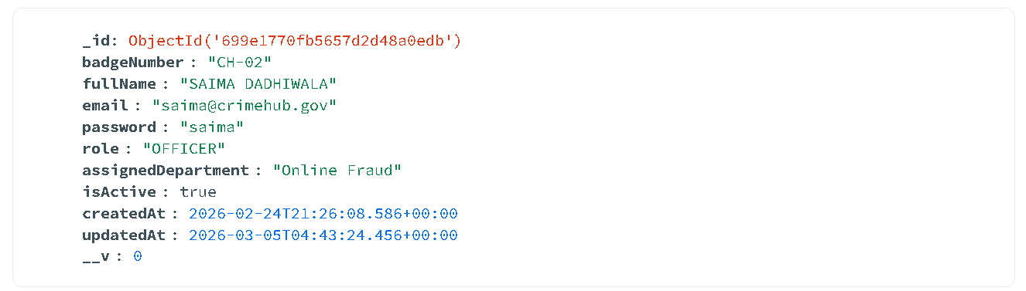
- Report
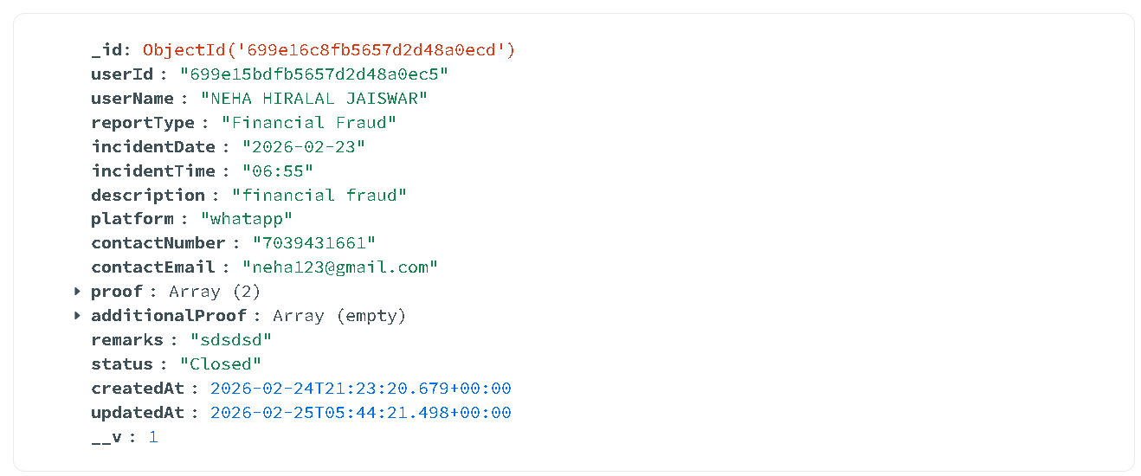

- AuditLogs
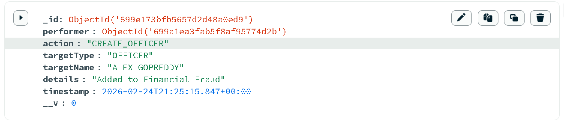

4.4 Data Table
- User Collection
Field Name | Data Type | Description
_id | ObjectId | Unique identifier automatically generated by MongoDB for each user record
fullname | String | Stores the full name of the registered user
email | String | User’s email address used for login and communication
phone | String | Contact number of the user
dateOfBirth | Date | Stores the user’s date of birth
password | String | Password used by the user to log into the system
state | String | State where the user resides
city | String | City where the user lives
createdAt | Date | Date and time when the user account was created
updatedAt | Date | Date and time when the user information was last updated
__v | Number | Version key used by Mongoose to track document updates

- Officier Collection
Field Name | Data Type | Description
_id | ObjectId | Unique identifier automatically generated by MongoDB for the officer record.
badgeNumber | String | Unique badge number assigned to the officer (e.g., CH-02).
fullName | String | Name of the officer registered in the system.
email | String | Official email address used by the officer to log into the CrimeHub system.
password | String | Password used by the officer to access the system.
role | String | Defines the role of the user in the system. Here it is OFFICER.
assignedDepartment | String | Department in which the officer works (e.g., Online Fraud).
isActive | Boolean | Indicates whether the officer account is active. True means the officer can access the system.
createdAt | Date | Date and time when the officer account was created in the database.
updatedAt | Date | Date and time when the officer information was last updated.
__v | Number | Version key used by Mongoose to track document updates.

- Report Collection
Field Name | Data Type | Description
_id | ObjectId | Unique identifier automatically generated by MongoDB for the complaint record.
userId | ObjectId | ID of the user who submitted the complaint. It links the report to the user in the users collection.
userName | String | Name of the user who reported the complaint.
reportType | String | Type of crime reported by the user (e.g., Financial Fraud).
incidentDate | Date | Date when the crime incident occurred.
incidentTime | String | Time when the incident happened.
description | String | Detailed explanation of the crime provided by the user.
platform | String | Platform where the fraud or crime occurred (e.g., WhatsApp).
contactNumber | String | Mobile number of the complainant for communication.
contactEmail | String | Email address of the complainant.
proof | Array | Stores uploaded evidence files related to the complaint.
additionalProof | Array | Stores extra supporting evidence if provided.
remarks | String | Additional comments or notes related to the complaint.
status | String | Current status of the complaint (e.g., Closed).
createdAt | Date | Date and time when the complaint was submitted in the system.
updatedAt | Date | Date and time when the complaint record was last updated.
__v | Number | Version key used by Mongoose to track document updates.

- AuditLogs

Field Name | Data Type | Description
_id | ObjectId | Unique identifier automatically generated by MongoDB for the activity log record.
performer | ObjectId | ID of the user (usually Super Officer or Admin) who performed the action in the system.
action | String | The type of action performed. In this case CREATE_OFFICER, meaning a new officer was added.
targetType | String | Specifies the type of entity affected by the action, here it is OFFICER.
targetName | String | Name of the officer on whom the action was performed (e.g., ALEX GOPREDDY).
details | String | Additional information about the action. Here it shows that the officer was added to the Financial Fraud department.
timestamp | Date | Date and time when the action occurred in the system.
__v | Number | Version key used by Mongoose to track document updates.

7. Screen Layouts

- HomePage

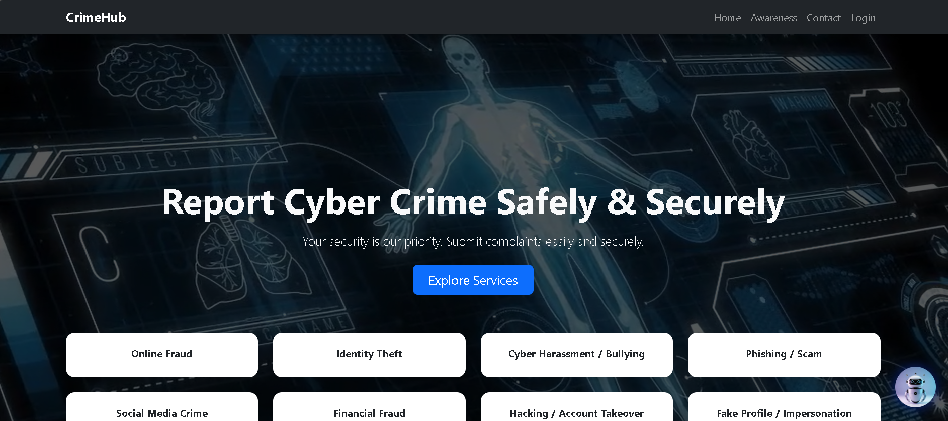
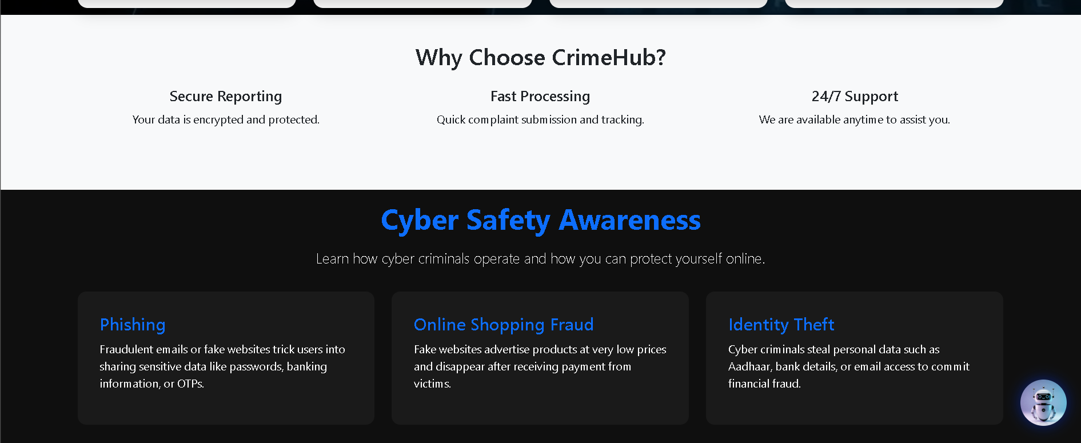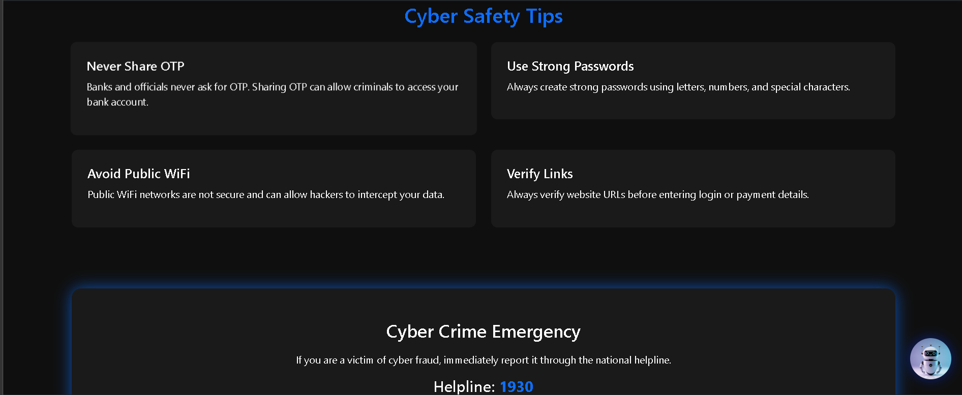

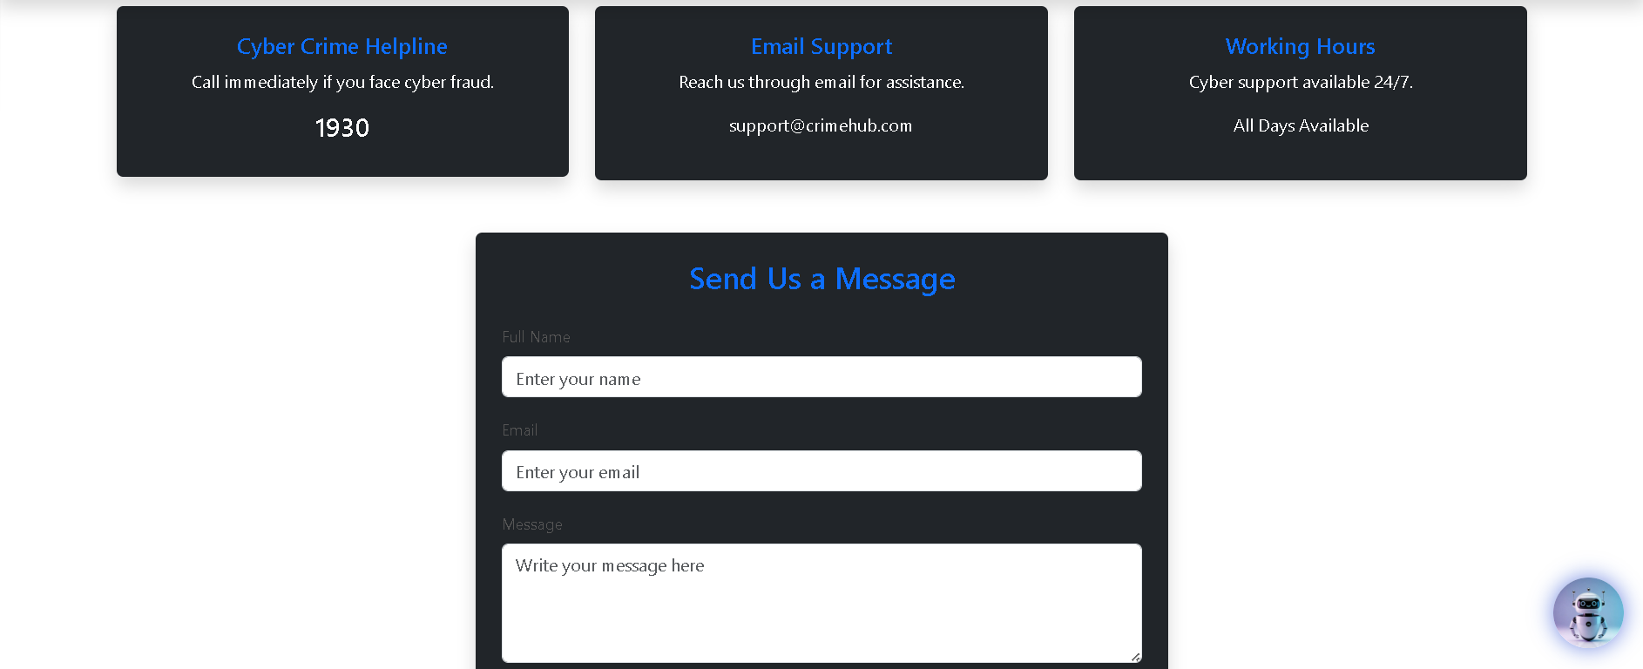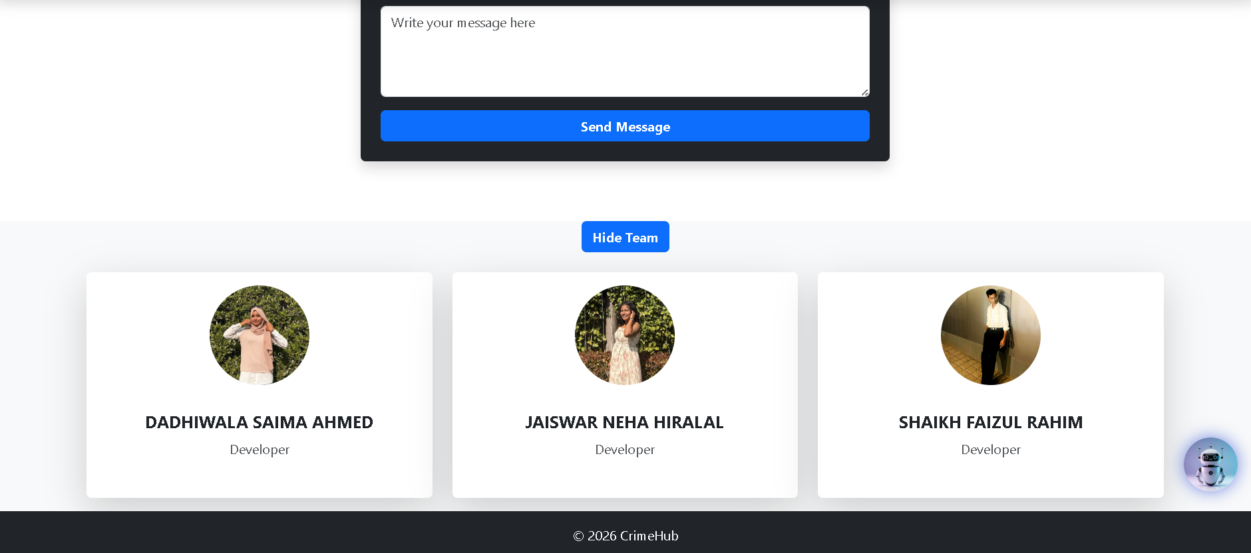
1. Header / Hero Section
- The top section displays the title “Report Cyber Crime Safely & Securely.”
- It informs users that they can submit complaints easily and securely.
- A button “Explore Services” allows users to view the available services.
2. Crime Categories
- Below the hero section, different types of cyber crimes are displayed as buttons.
- These include:
  - Online Fraud
  - Identity Theft
  - Cyber Harassment / Bullying
  - Phishing / Scam
  - Social Media Crime
  - Financial Fraud
  - Hacking / Account Takeover
  - Fake Profile / Impersonation
- Users can select a category when reporting a cyber crime.
3. Why Choose CrimeHub
This section explains the benefits of using the system:
- Secure Reporting – User data is encrypted and protected.
- Fast Processing – Complaints are submitted and tracked quickly.
- 24/7 Support – Help is available anytime for users.
4. Cyber Safety Awareness
This section educates users about common cyber crimes such as:
- Phishing – Fake emails or websites that steal personal information.
- Online Shopping Fraud – Fake online stores that collect payment but do not deliver products.
- Identity Theft – Criminals steal personal details to commit financial fraud.
5. Cyber Safety Tips
Important safety tips are provided to help users protect themselves:
- Never Share OTP with anyone.
- Use Strong Passwords with letters, numbers, and special characters.
- Avoid Public WiFi when accessing sensitive information.
- Verify Links before entering login or payment details.
6. Cyber Crime Emergency
- This section provides the national cyber crime helpline number (1930).
- Victims can immediately contact the helpline for urgent cyber fraud cases.
7. Contact Information
Users can reach support through:
- Cyber Crime Helpline: 1930
- Email Support: support@crimehub.com
- Working Hours: 24/7 support available.
8. Contact Form
- The “Send Us a Message” form allows users to send queries to the CrimeHub team.
- Users must enter:
  - Full Name
  - Email
  - Message
- Then click Send Message to submit.
9. Team Section
- The page displays the developers of the CrimeHub project:
  - DADHIWALA SAIMA AHMED
  - JAISWAR NEHA HIRALAL
  - SHAIKH FAIZUL RAHIM
10. Footer
- The footer contains navigation links such as Home, Awareness, Contact, and Login.
- It also shows the copyright information (© 2026 CrimeHub).

- Login Page

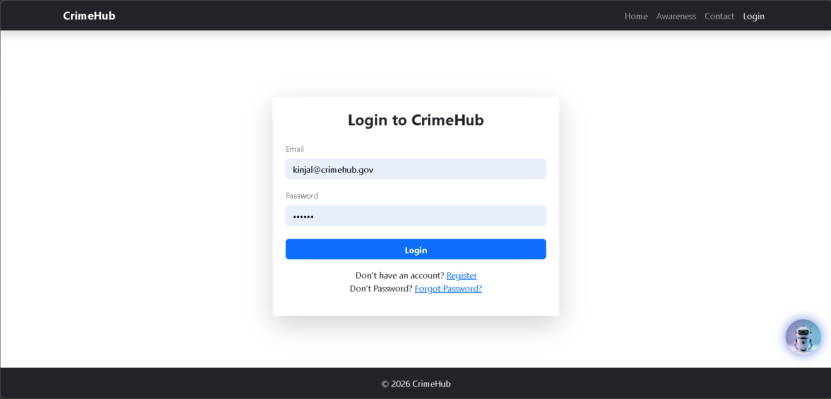
1. Navigation Bar
- At the top of the page, the CrimeHub navigation menu is displayed.
- It contains links such as:
  - Home – redirects to the homepage.
  - Awareness – provides cyber safety information.
  - Contact – allows users to send messages or contact support.
  - Login – opens the login page for users.
2. Login Form
- In the center of the page, a Login to CrimeHub form is displayed.
- Users must enter the following details:
  - Email – the registered email address of the user.
  - Password – the account password.
3. Login Button
- After entering the credentials, the user clicks the Login button.
- The system verifies the email and password from the database and grants access if the details are correct.

4. Register Option
- If a user does not have an account, they can click the Register link.
- This redirects the user to the registration page where a new account can be created.
5. Forgot Password
- The Forgot Password option allows users to reset their password if they cannot remember it.
6. Chatbot Icon
- A chatbot icon is visible at the bottom-right corner of the page.
- This chatbot helps users by answering questions or guiding them through the system.
7. Footer
- At the bottom of the page, the footer displays © 2026 CrimeHub, indicating the copyright of the system.

- Register Page

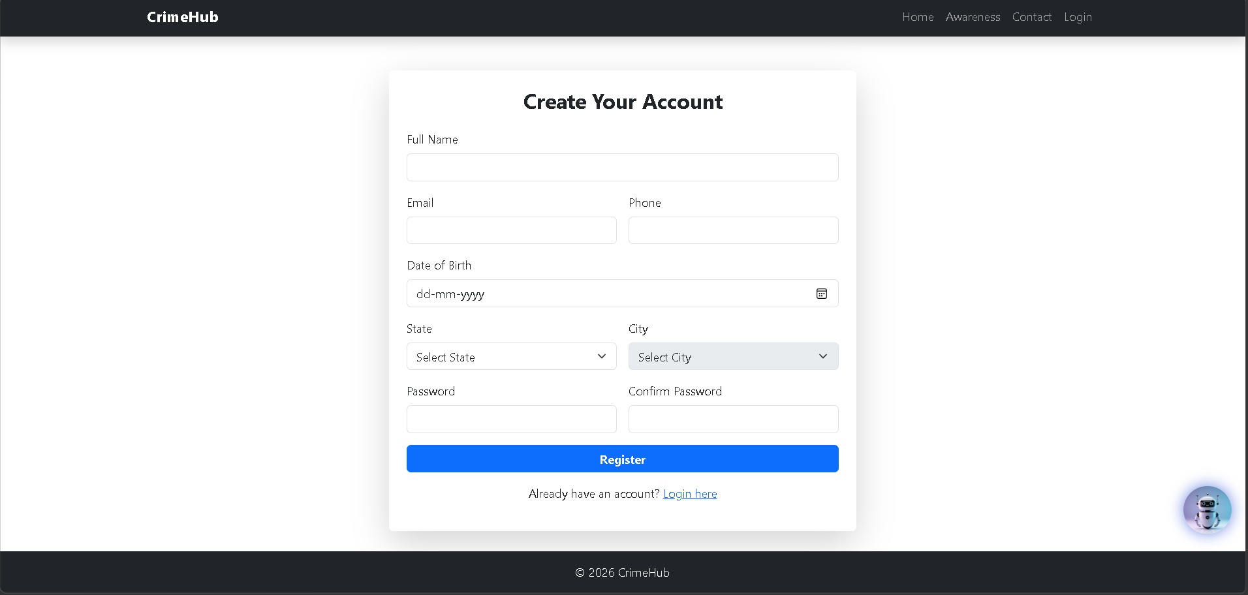
1. Navigation Bar
- The top section contains the CrimeHub navigation menu.
- It includes links such as:
  - Home – redirects to the homepage.
  - Awareness – provides cyber safety information.
  - Contact – allows users to contact the support team.
  - Login – opens the login page for existing users.
2. Registration Form
- In the center of the page, the heading “Create Your Account” is displayed.
- This form allows new users to register in the CrimeHub system.
3. User Information Fields
The user must enter the following details:
- Full Name – Name of the user.
- Email – Email address used for login and communication.
- Phone – Contact number of the user.
- Date of Birth – User’s birth date.
- State – State where the user lives.
- City – City where the user resides.
4. Password Fields
- Password – User creates a secure password.
- Confirm Password – User re-enters the password to confirm it.
5. Register Button
- After filling all required details, the user clicks the Register button.
- The system stores the information in the database and creates the user account.
6. Login Option
- At the bottom, there is a message “Already have an account? Login here”.
- This allows existing users to go directly to the login page.
7. Chatbot Icon
- A chatbot icon is visible in the bottom-right corner.
- It helps users by answering questions or guiding them while using the system.
8. Footer
- The footer shows © 2026 CrimeHub, indicating the system’s copyright.

- Forget Password
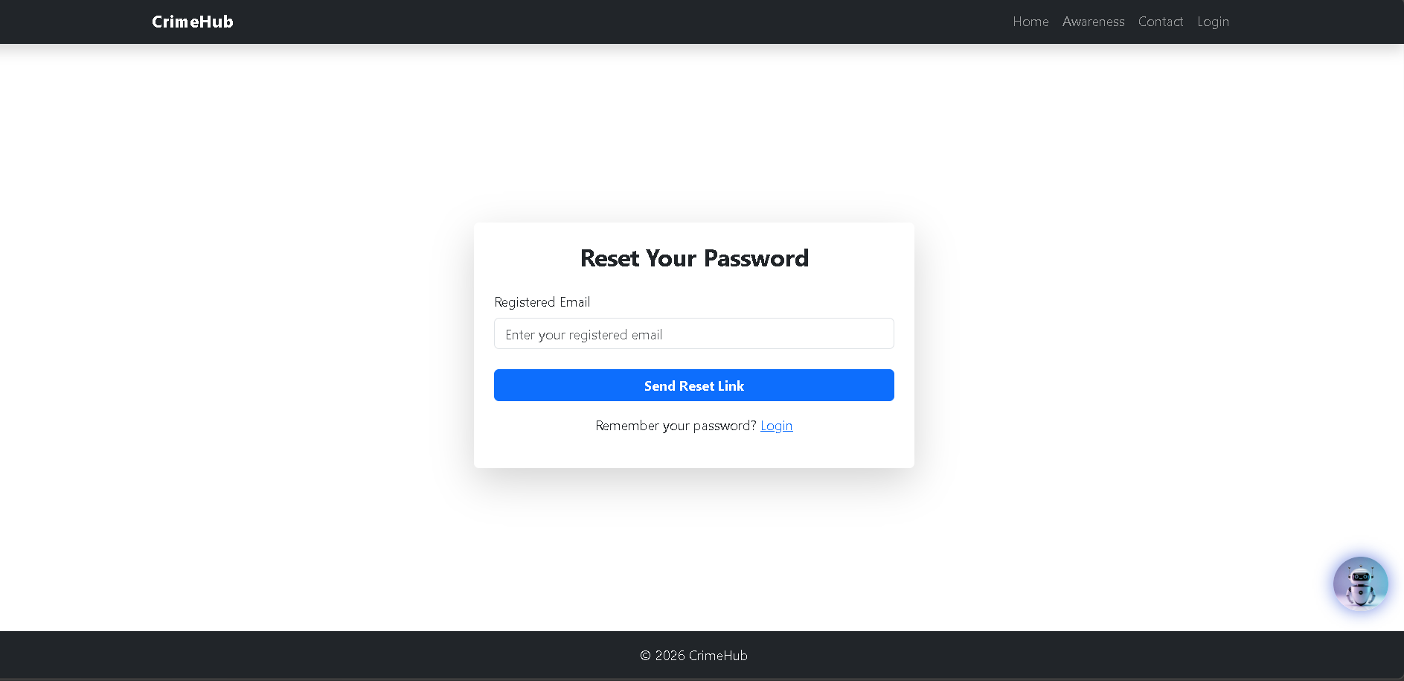
1. Navigation Bar
At the top of the page, there is a navigation bar with the CrimeHub logo on the left and several menu options on the right:
- Home – Redirects users to the homepage.
- Awareness – Provides information about cybercrime awareness and safety tips.
- Contact – Allows users to reach the support team.
- Login – Takes existing users to the login page.
2. Password Reset Section
In the center of the page, a card-style form titled “Reset Your Password” is displayed. This section allows users to request a password reset.
3. Email Input Field
- Registered Email – The user must enter the email address that was used during account registration.
- The placeholder text “Enter your registered email” guides the user on what to input.

4. Send Reset Link Button
- The “Send Reset Link” button submits the request.
- Once clicked, the system sends a password reset link to the user’s registered email address.
- The user can then follow that link to create a new password.
5. Login Redirect
Below the button, there is a message:
“Remember your password? Login”
- The Login link allows users who recall their password to return directly to the login page.
6. Chatbot Icon
A chatbot icon is located in the bottom-right corner of the page.
It provides assistance to users by answering questions or guiding them through the password recovery process.
7. Footer
At the bottom of the page, the footer displays © 2026 CrimeHub, indicating the system’s copyright.

- Create New Password

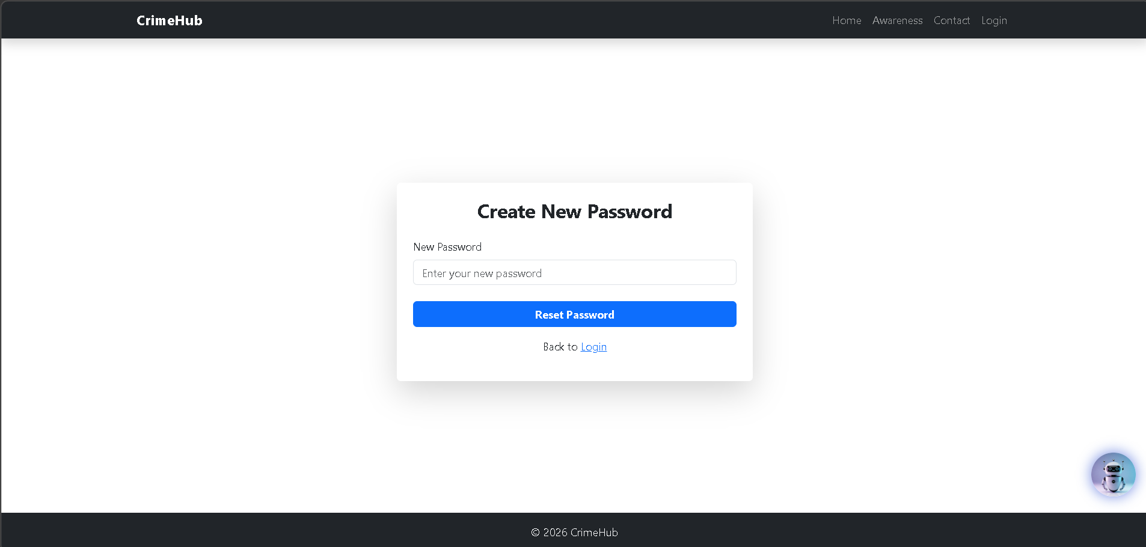
1. Navigation Bar
At the top of the page, there is a navigation bar containing:
- CrimeHub logo on the left.
- Menu options on the right:
  - Home – Redirects to the homepage.
  - Awareness – Provides cybercrime awareness information and safety tips.
  - Contact – Allows users to contact support.
  - Login – Takes users to the login page.
2. Password Reset Form
In the center of the page, a form titled “Create New Password” is displayed.
This section allows users to create a new password for their account after accessing the reset link sent to their email.
3. New Password Field
- New Password – The user enters a new secure password.
- The placeholder “Enter your new password” guides the user on what to input.
4. Reset Password Button
- The “Reset Password” button submits the new password.
- Once clicked, the system updates the user’s password in the database.
- After successful reset, the user can log in using the new password.
5. Login Redirect
Below the button, there is a “Back to Login” link.
- This allows the user to return directly to the login page.
6. Chatbot Icon
A chatbot icon appears at the bottom-right corner of the page.
It provides assistance by helping users with questions or guiding them through the password reset process.
7. Footer
At the bottom of the page, the footer displays © 2026 CrimeHub, indicating the copyright of the system.

- Chatbot
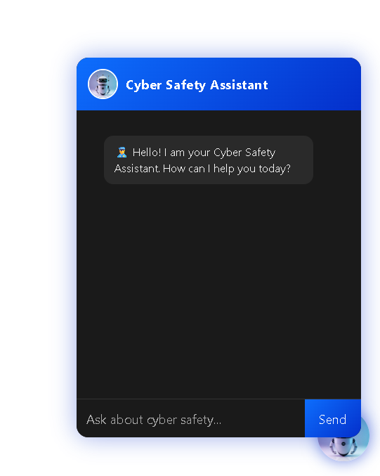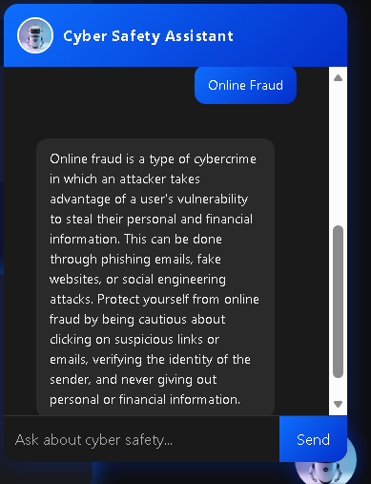

1. Chatbot Header
At the top of the chatbot window, there is a blue header section displaying:
- A robot avatar icon, representing the assistant.
- The title “Cyber Safety Assistant”, indicating that the chatbot provides help related to cyber security and online safety.

2. Welcome Message
Below the header, the chatbot displays an initial greeting message:
“Hello! I am your Cyber Safety Assistant. How can I help you today?”
This message introduces the chatbot and invites users to ask questions related to cyber safety, online scams, or security practices.
3. Chat Area
The dark central area represents the conversation section where:
- The chatbot responses appear.
- User messages will also be displayed once they start interacting with the assistant.
4. Message Input Field
At the bottom of the chatbot interface, there is a text input field with the placeholder:
“Ask about cyber safety…”
Users can type their questions here, such as:
- How to avoid phishing scams
- How to create strong passwords
- How to report cybercrime
5. Send Button
Next to the input field is the “Send” button.
- After typing a question, the user clicks this button to send the message to the chatbot.
- The chatbot will then respond with helpful cyber safety information

User Dashboard

- Home

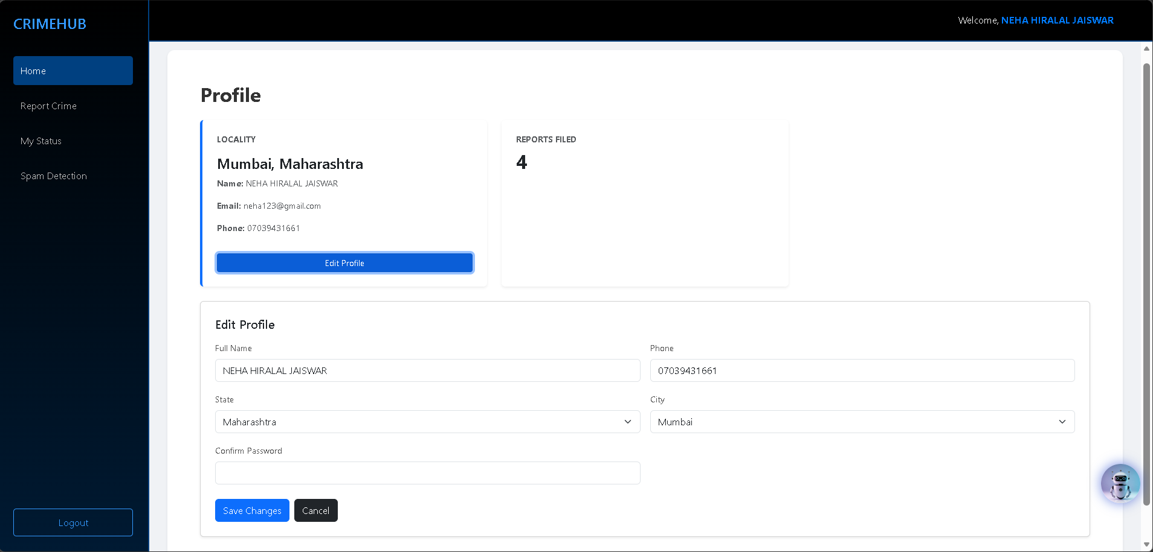
1. Sidebar Navigation Menu
On the left side, there is a vertical sidebar containing the main navigation options:
- Home – Displays the user dashboard and profile information.
- Report Crime – Allows users to submit a cybercrime complaint through the system.
- My Status – Enables users to track the status of their previously submitted complaints.
- Spam Detection – Provides a feature to detect suspicious or spam messages.
- Logout – Allows the user to securely exit the system.
The Home option is currently highlighted, indicating that the user is viewing the main dashboard page.
2. Top Header Bar
At the top of the page, there is a header displaying a welcome message:
“Welcome, NEHA HIRALAL JAISWAR”
This confirms that the user has successfully logged into the CrimeHub system.
3. Profile Section
The main area of the dashboard contains the Profile section, where the user's personal information is displayed.
The profile card shows:
- Locality: Mumbai, Maharashtra
- Email: neha123@gmail.com
- Contact: 07039431661
This section helps users verify their registered details within the system.
4. Reports Filed Section
Next to the profile card, there is another information card labeled “Reports Filed”.
- The number 3 indicates that the user has submitted three cybercrime reports through the CrimeHub platform.
This feature gives users a quick overview of their complaint activity.
5. Chatbot Icon
At the bottom-right corner, there is a Cyber Safety Assistant chatbot icon.
- Users can click this icon to open the chatbot.
- The chatbot provides cyber safety guidance, answers to common questions, and assistance while using the system.
This layout makes the system user-friendly and easy to navigate.

- Report Crime

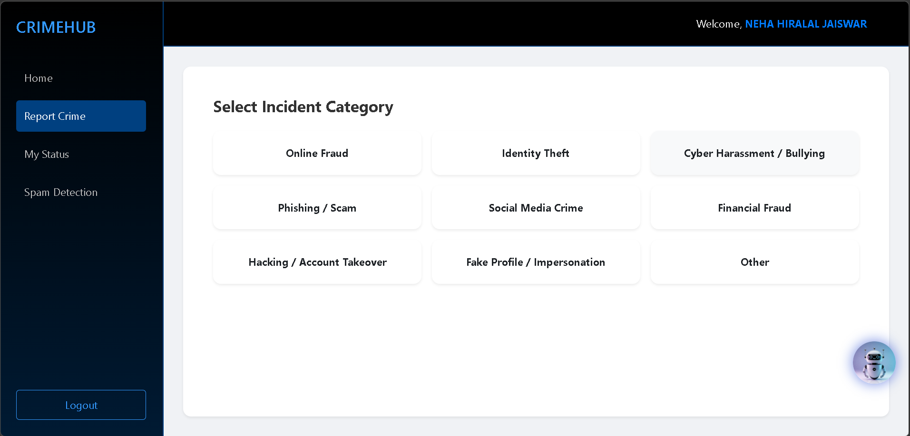

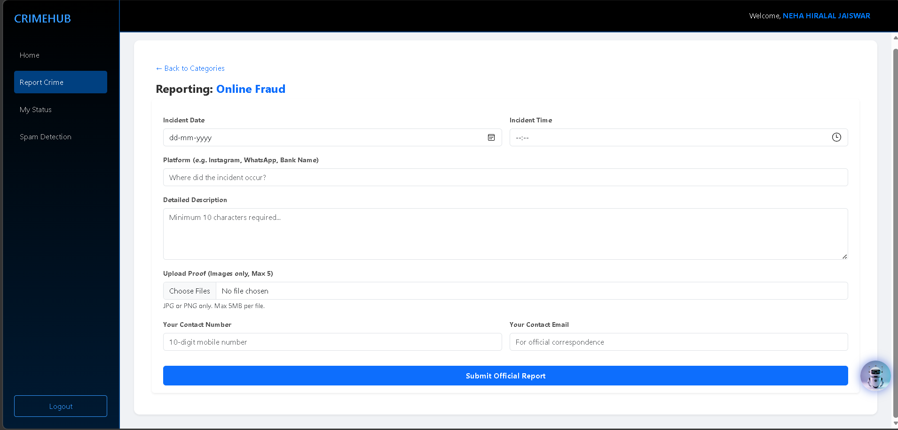
Incident Selection Section
The main content area is titled "Select Incident Category." It presents a grid of clickable cards that categorize different types of cybercrimes:
- Online Fraud & Financial Fraud.
- Identity Theft & Fake Profile / Impersonation.
- Cyber Harassment / Bullying & Social Media Crime.
- Phishing / Scam.
- Hacking / Account Takeover.
- Other.
This structure helps the user quickly classify their complaint for more efficient processing.
Reporting Form: Online Fraud
The main content area features a detailed reporting form specifically for Online Fraud. It includes a "Back to Categories" link and the following fields:
- Incident Date & Time: Selectors to specify exactly when the fraud occurred.
- Platform: A text field to enter where the incident took place (e.g., Instagram, WhatsApp, or a specific bank).
- Detailed Description: A large text area for the user to explain the event, requiring a minimum of 10 characters.
- Upload Proof: A file upload section allowing up to 5 images (JPG or PNG, max 5MB each) to serve as evidence.
- Contact Information: Fields for a 10-digit mobile number and a Contact Email for official correspondence.
- My Status

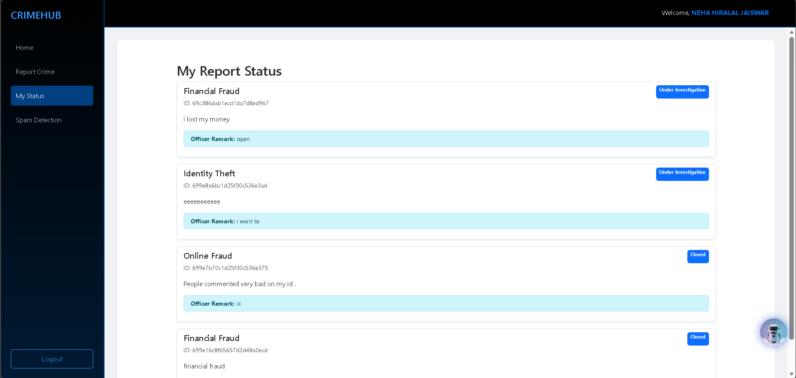
The main area displays a list of submitted complaints, each represented by a card showing the category, a unique ID, the user's description, and the current progress.
Report 1: Identity Theft
- Status: Pending (indicated by a yellow tag).
- ID: 699e8a6bc1d25f30c536e3ad
- Description: "eeeeeeeeee"
- Notes: This report is currently awaiting review by an officer.
Report 2: Online Fraud
- Status: Closed (indicated by a green tag).
- ID: 699e7b70c1d25f30c536e375
- Description: "People commented very bad on my id ."
- Officer Remark: "iii"
- Notes: This case has been processed and finalized.
Report 3: Financial Fraud
- Status: Closed (indicated by a green tag).
- ID: 699e16c8fb5657d2d48a0ecd
- Description: "financial fraud"
- Officer Remark: "sdsdsd"
- Notes: This case has also been resolved or closed.
- Spam Detection

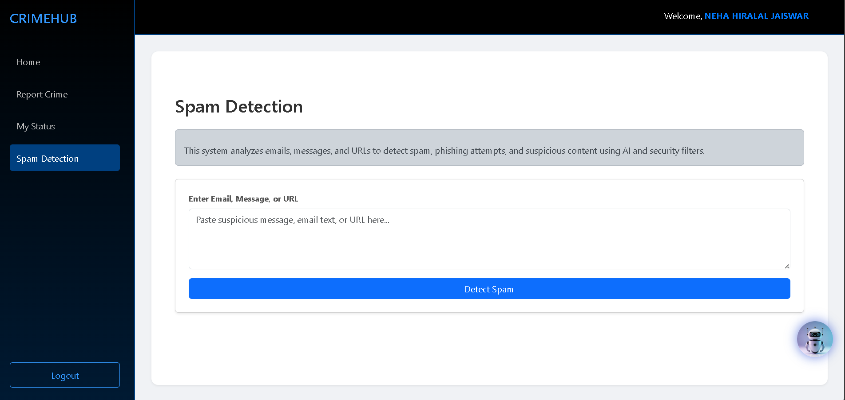
The Spam Detection page provides educational information about the feature:
- Definition: Describes the system as a tool to identify unwanted, fraudulent, or malicious messages.
- Availability: Note stating this feature will soon allow users to analyze suspicious messages and detect potential spam using intelligent filtering techniques

- Official Login

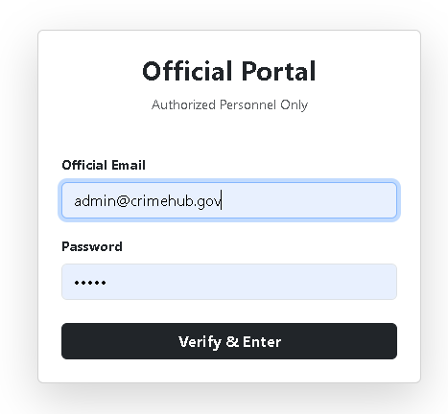
The Official Portal interface is a restricted access point for "Authorized Personnel Only". It includes:
- Official Email: Input fields shown with examples such as "neha123@gmail.com" and "admin@crimehub.gov".
- Password: A masked text field for secure entry.
- Verify & Enter: A dark button to authenticate the user.
- Super Officier Dashboard
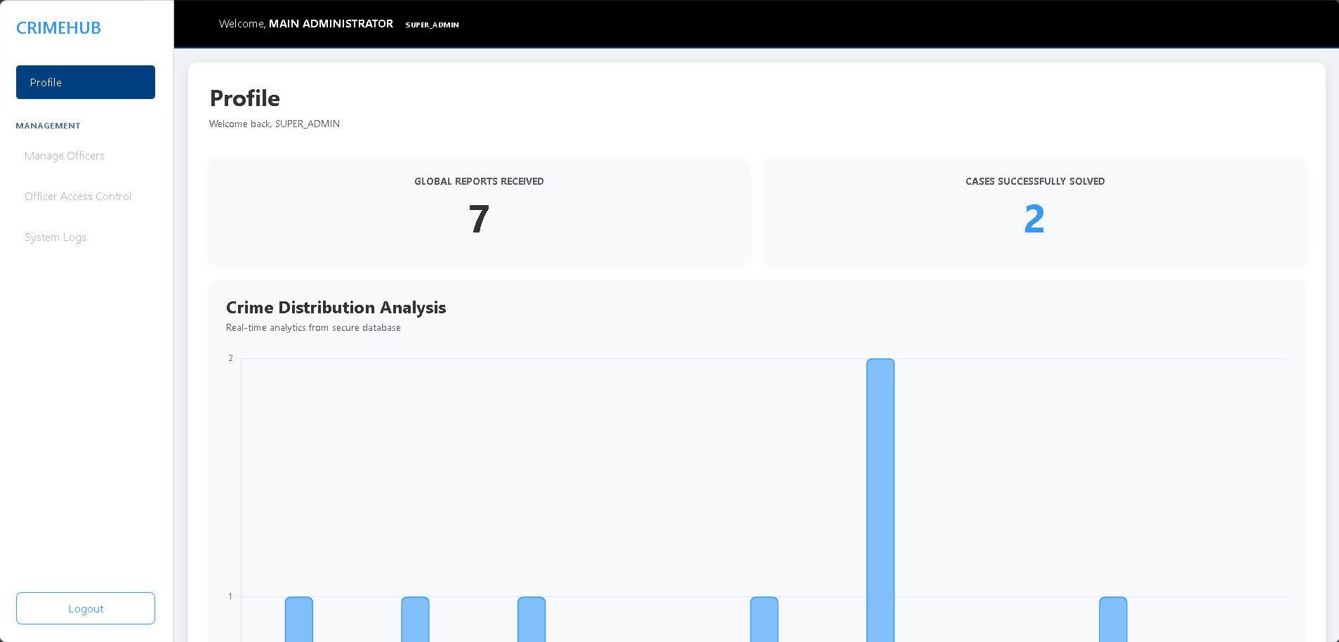

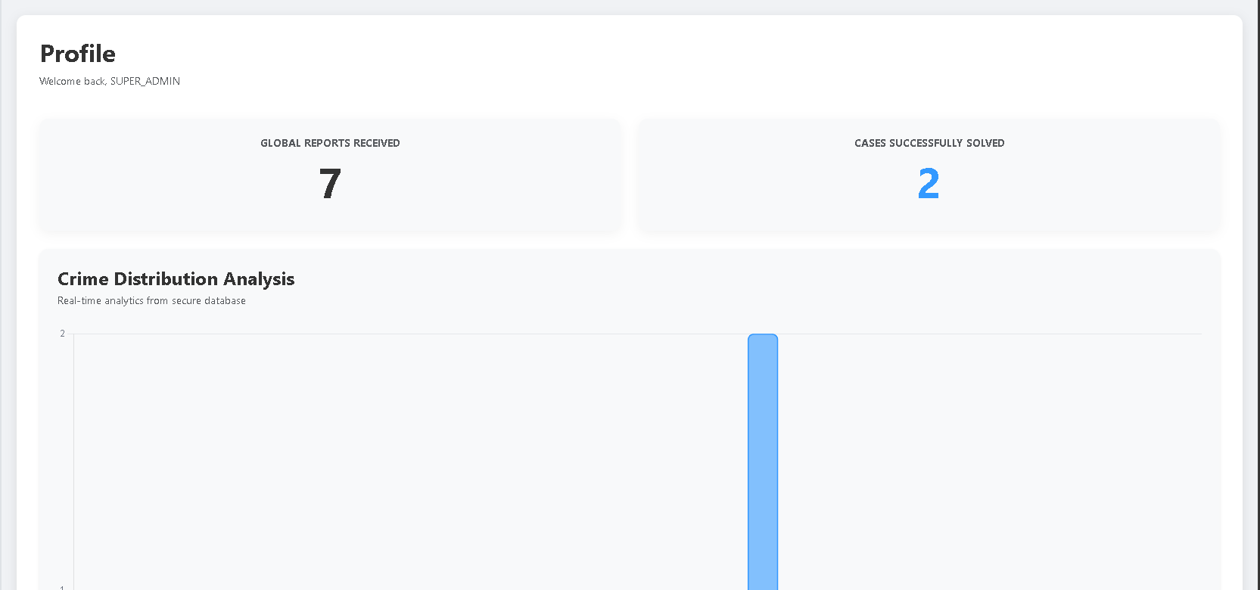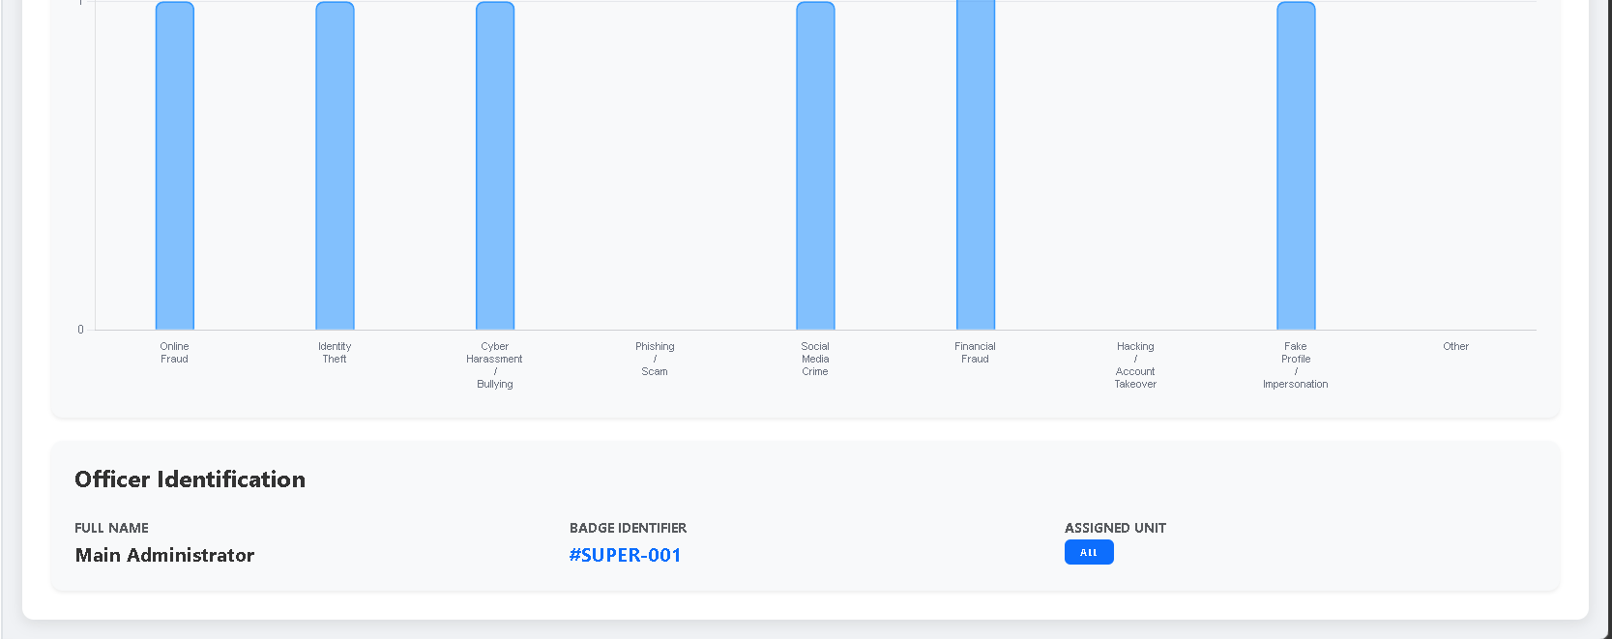

1.Top Navigation & Officier Info
- At the top left, it displays "Welcome, MAIN ADMINISTRATOR", confirming your role as the highest-level user (SUPER_ADMIN).
- Profile Greeting: The main content area also greets you with "Welcome back, SUPER_ADMIN."
2. Activity Statistics
The dashboard highlights two primary performance metrics:
- Global Reports Received (6): This likely tracks the total number of incident reports or cases submitted across the entire system.
- Cases Successfully Solved (2): This shows the number of those reports that have been closed or resolved.

3. Officer Identification
This section provides specific details about the logged-in account:
- Full Name: Main Administrator.
- Badge Identifier: #SUPER-001 (a unique ID for system tracking).
- Assigned Unit: Set to ALL, indicating that as a Super Admin, you have oversight across all departments or divisions rather than being restricted to one.
4. Sidebar Menu
The left-hand sidebar allows you to navigate to other administrative functions:
- Manage Officers: Likely where you can add, edit, or view personnel.
- Suspend Officer: A disciplinary tool for revoking access.
- System Logs: An audit trail to see who has performed what actions within the software.
- UI Controls: Options for Dark Mode and a Logout button.
- Manage Officers
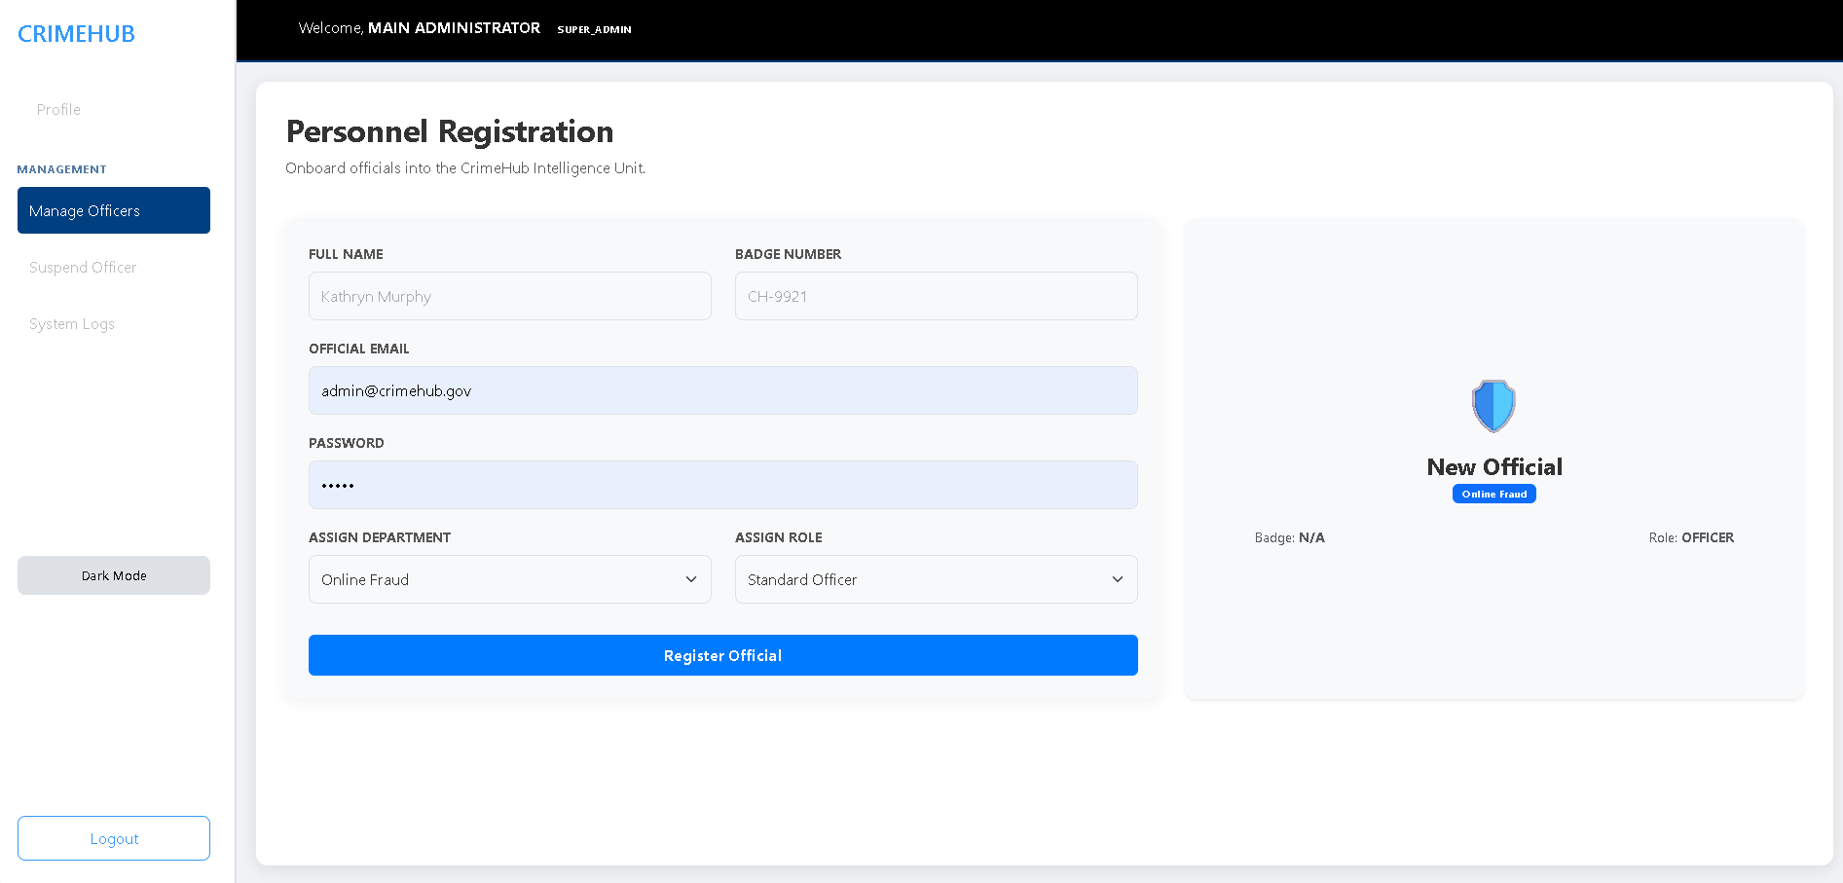
The interface includes a structured form for capturing essential official data:
- Official Identification: Fields are provided for the Full Name and a unique Badge Number.
- Security Credentials: Admins must enter an Official Email and a Password.
- Organizational Assignment: Two dropdown menus facilitate the placement of the official:
  - Assign Department: Options include specialized units like Online Fraud.
  - Assign Role: Enables the selection of specific ranks, such as Standard Officer.
- Submission: A prominent blue Register Official button saves the profile to the system.
- Access Control Officer

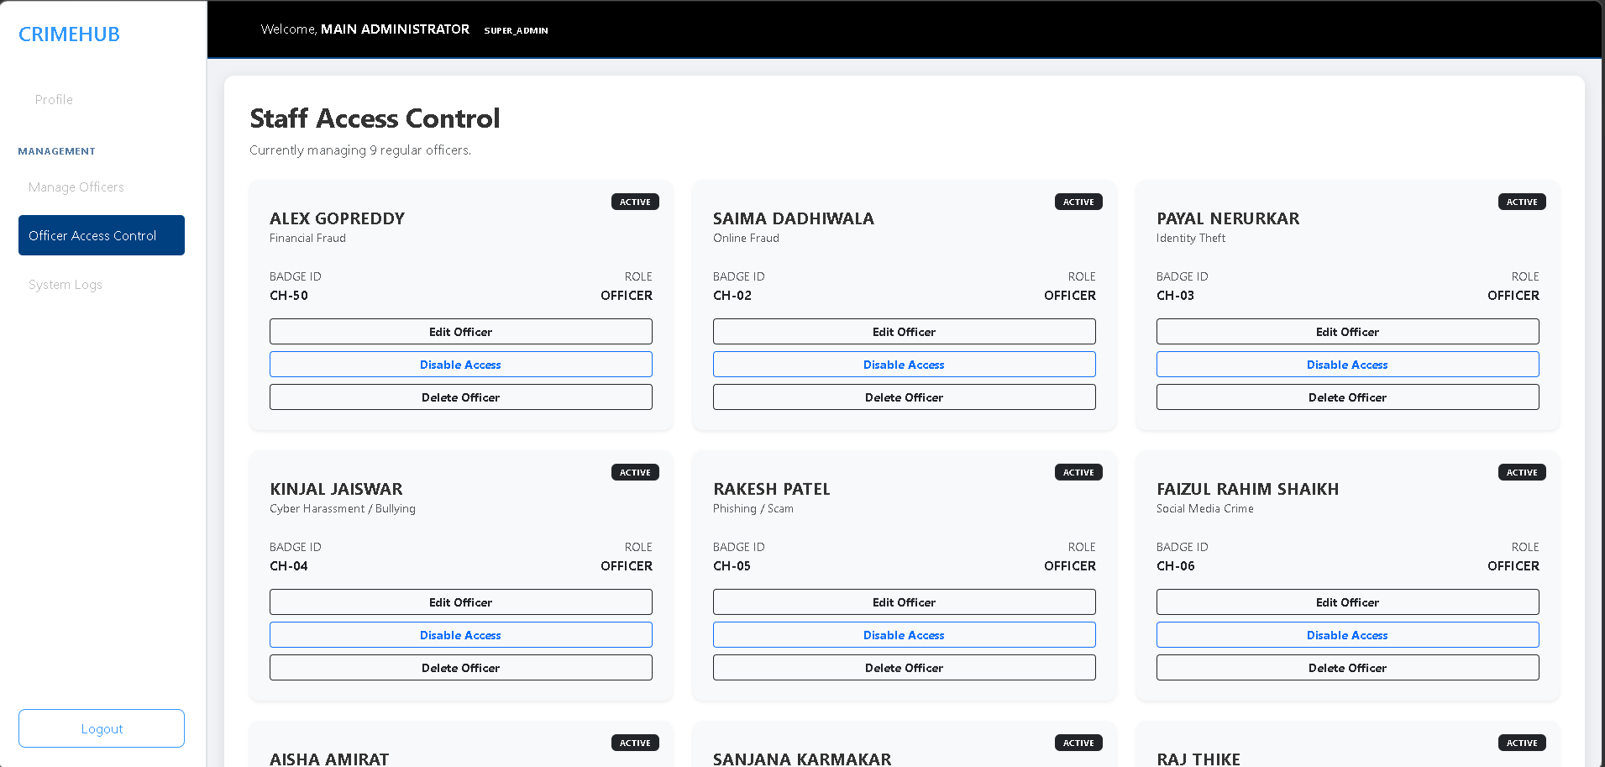
The Staff Access Control section allows administrators to manage the status of existing personnel.
- Officer Overview: The system currently indicates it is managing 10 regular officers.
- Personnel Cards: Each officer is represented by a card showing their:
  - Name & Specialization: (e.g., Alex Gopreddy - Financial Fraud, Saima Dadhiwala - Online Fraud).
  - Status: A green "ACTIVE" badge indicating current system access.
  - Identification: Displays the specific Badge ID (e.g., CH-01, CH-02) and assigned Role (Officer).
- Administrative Actions: Each card features a prominent Suspend Officer button, allowing for immediate revocation of system access.

- System Log

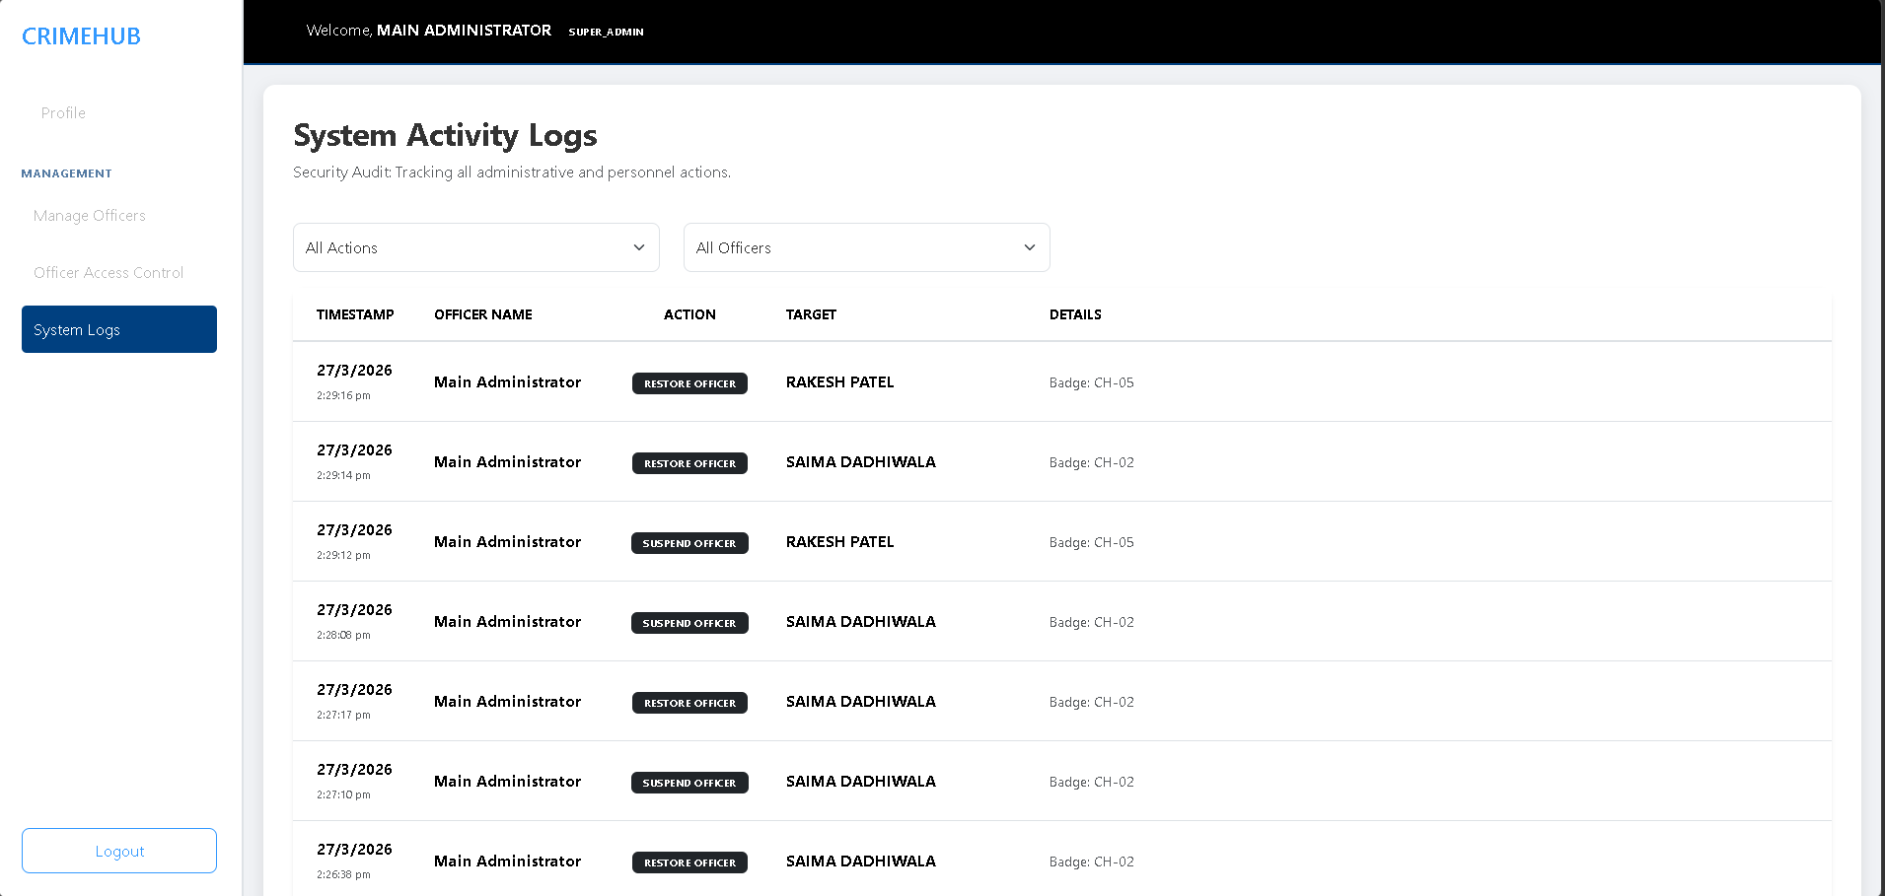
System Activity Logs: This module provides a security audit trail of all administrative and personnel actions. The log displays a chronological table including:
• Timestamp: The exact date and time of the event.
• Officer Name: The person who performed the action (e.g., Main Administrator or Saima Dadhiwala).
• Action: Color-coded badges for events like SUSPEND OFFICER (red), RESTORE OFFICER (green), and UPDATE REPORT STATUS (blue).
• Target & Details: Identifies the individual or report affected, along with specific metadata like Badge IDs or feedback notes.

- Officier Dashboard
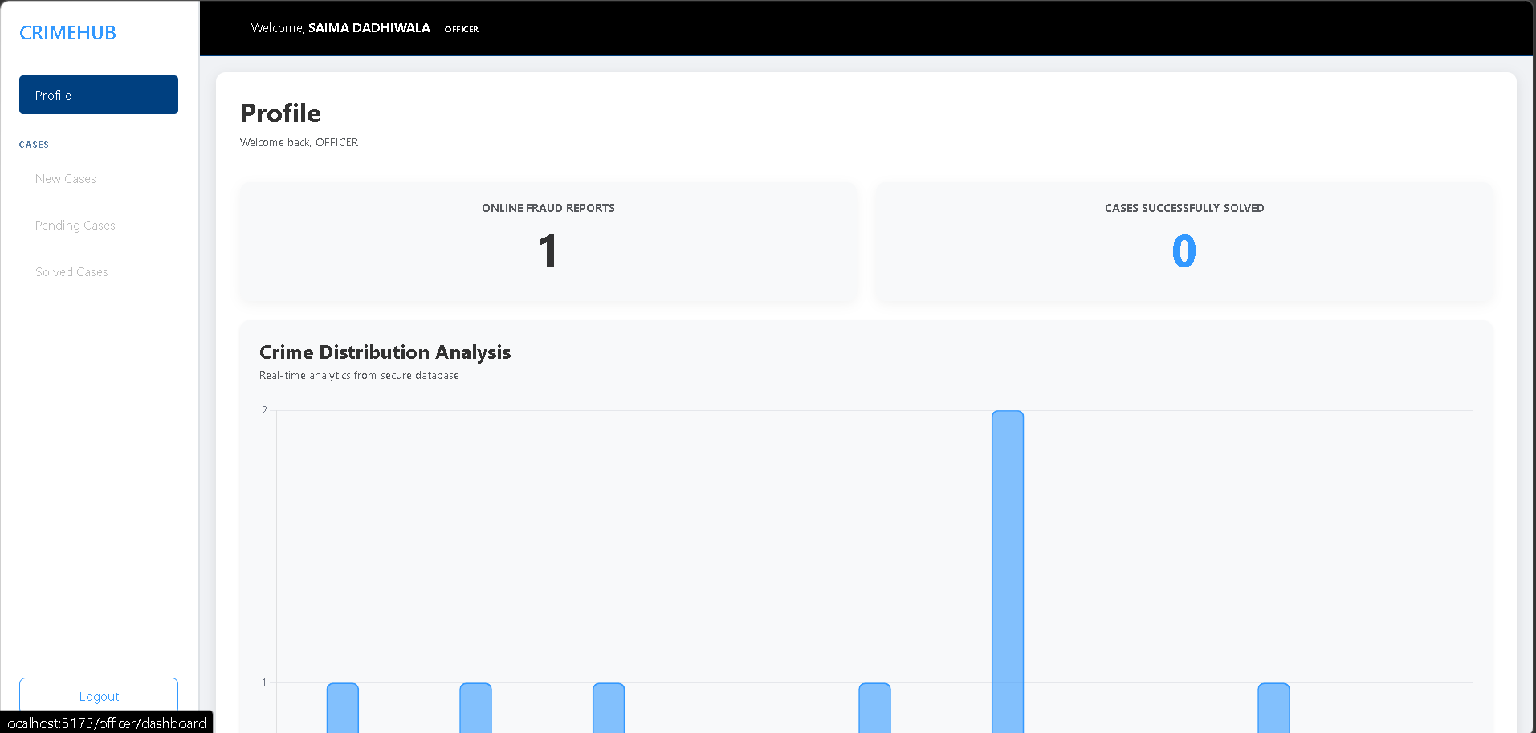
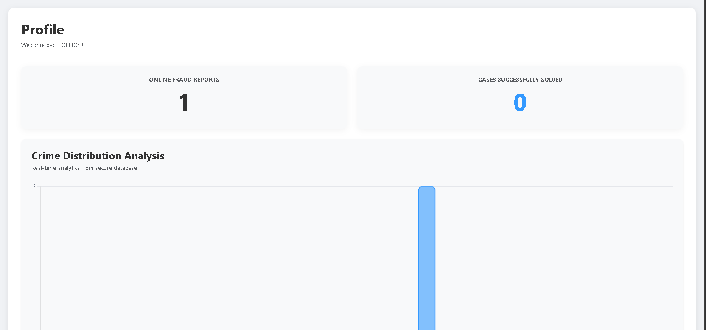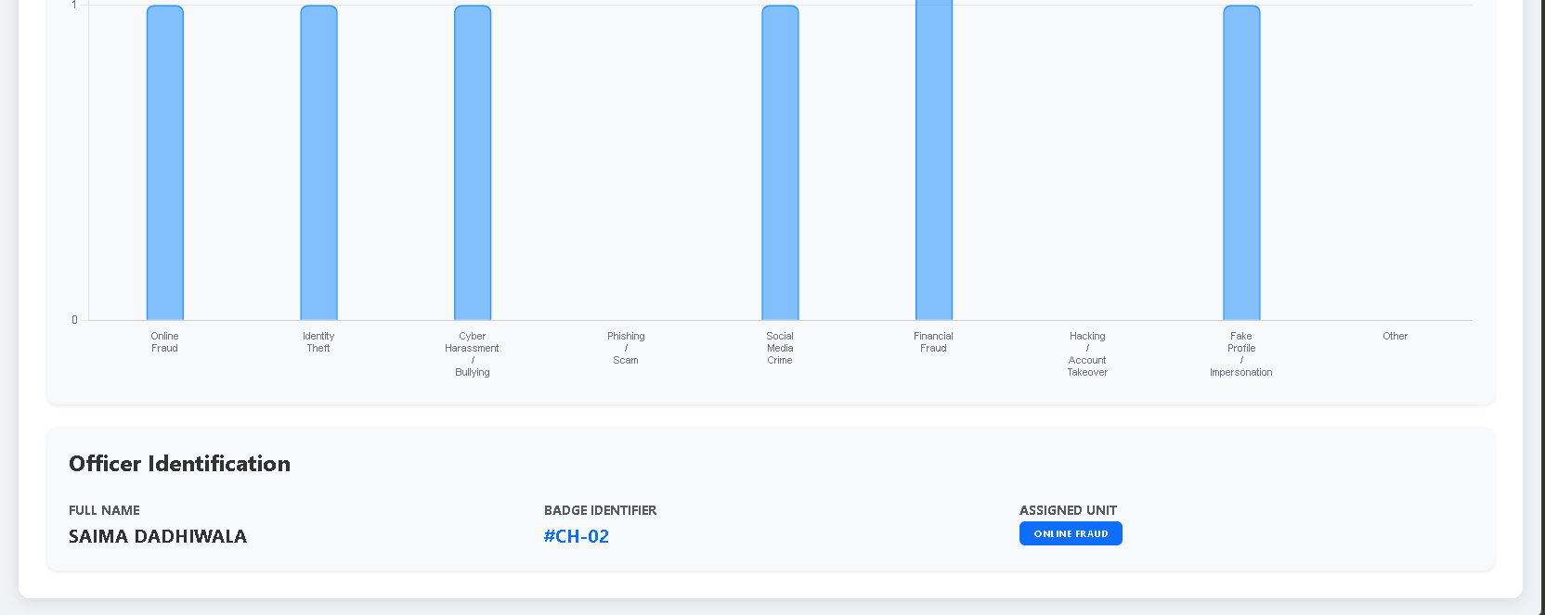

When a specific officer, such as Saima Dadhiwala, logs in, they are greeted with a personalized Profile dashboard.
- Performance Metrics: The dashboard displays statistics relevant to their assigned unit, such as "Financial Fraud Reports" and "Cases Successfully Solved".
- Identification: Confirms the user's Full Name, Badge Identifier ( #CH-04), and Assigned Unit.

- Cases
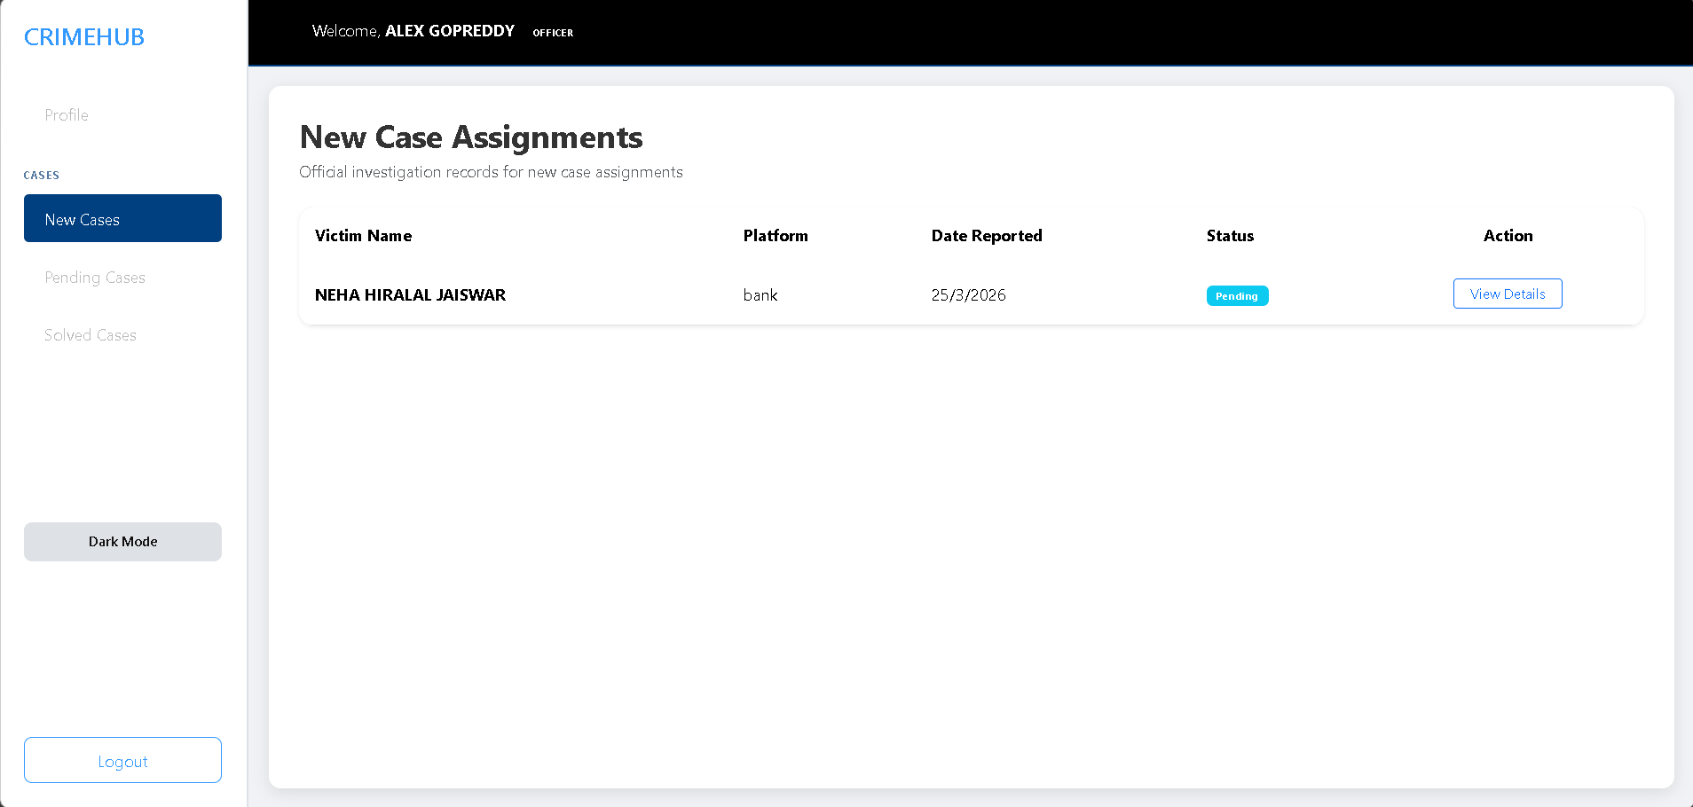
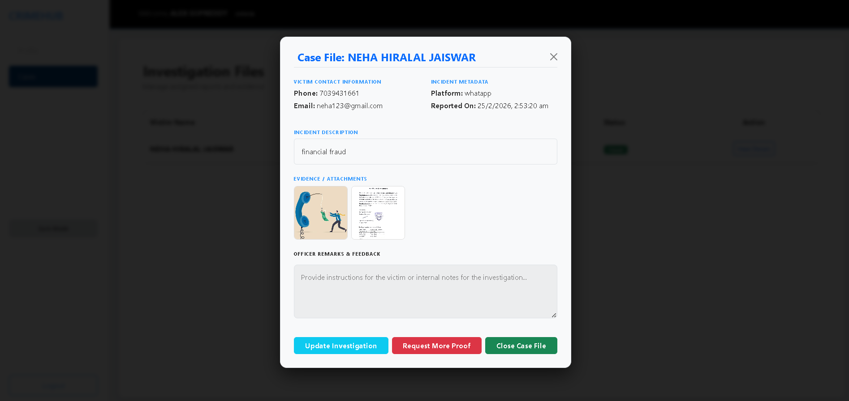
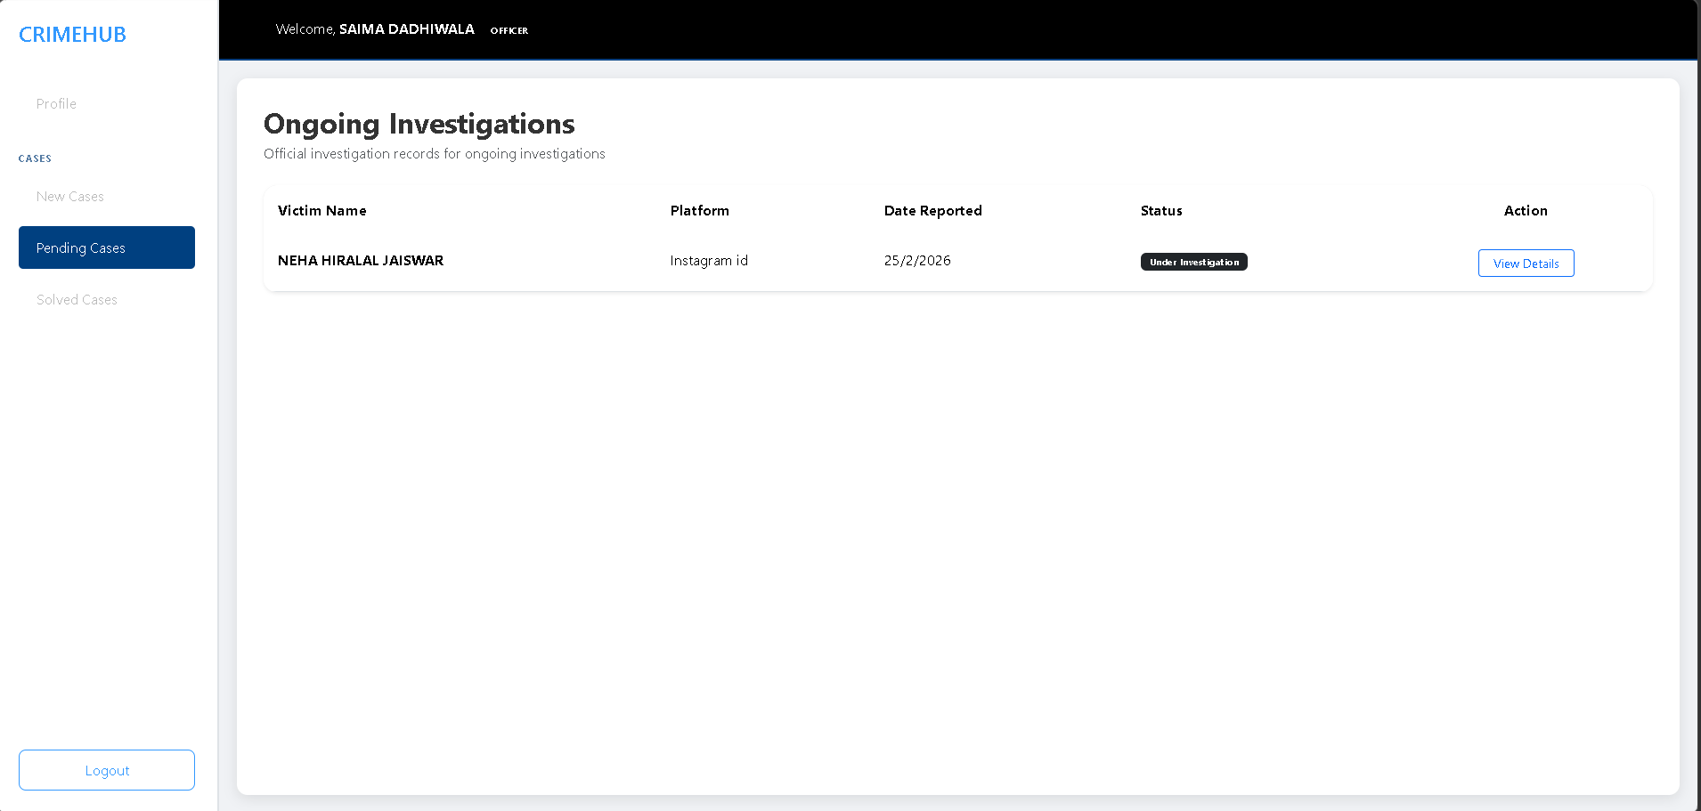
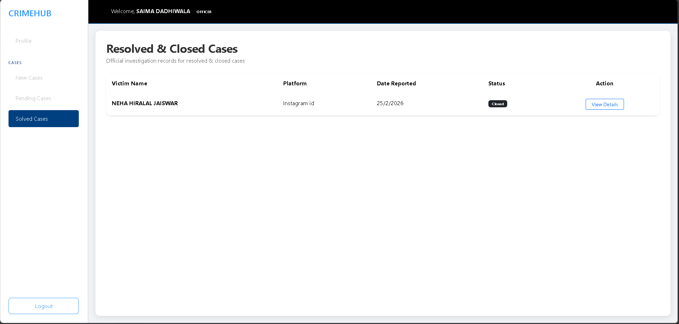
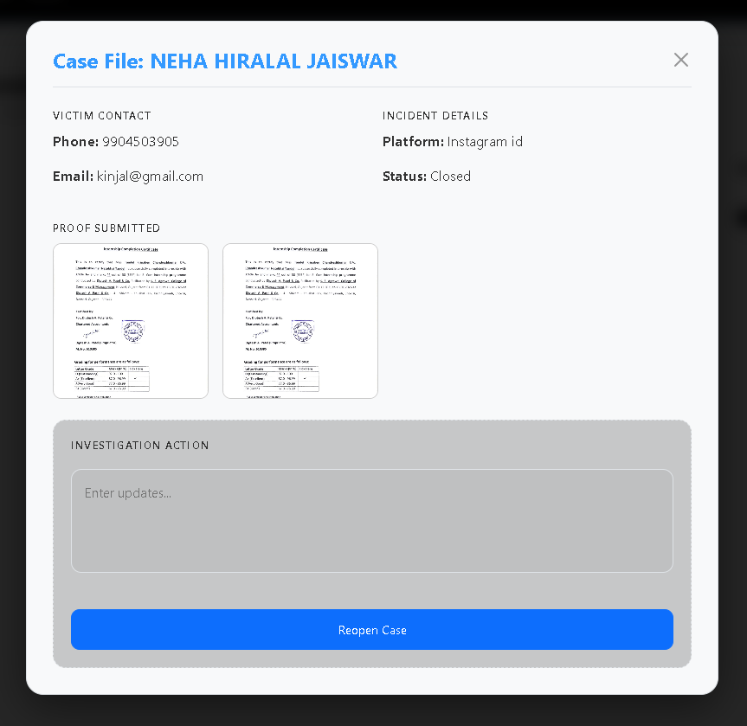
The Cases section allows officers to manage assigned reports and evidence. It features a table listing:
- Victim Name (e.g., Neha Hiralal Jaiswar).
- Platform (e.g., WhatsApp).
- Date of the report.
- Status (e.g., Closed).
Case File Details & Actions
Clicking "View Details" opens a comprehensive case file overlay:
- Victim & Incident Metadata: Displays contact info (phone/email) and reporting timestamps.
- Evidence / Attachments: Contains uploaded files or screenshots related to the incident.
- Officer Remarks: A text area for internal notes or instructions for the victim.
- Decision Buttons: Officers can Update Investigation, Request More Proof, or Close Case File.

- Form Layouts

- Register Form

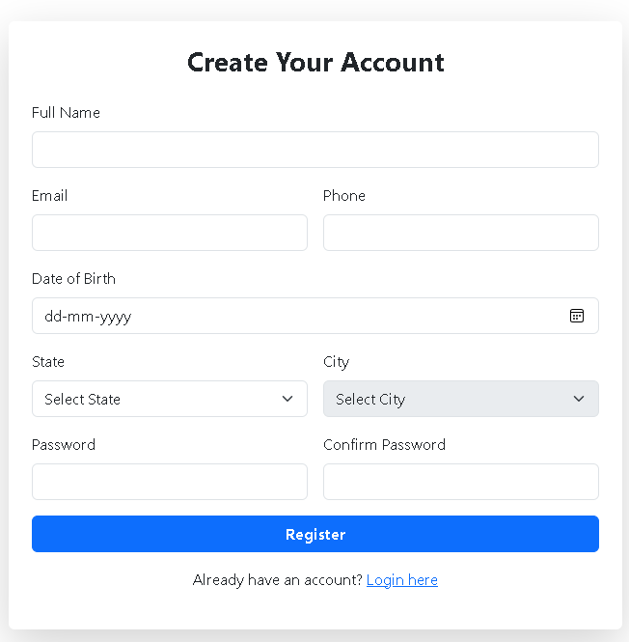

Field Name | Input Type | Required | Validation Rules | Format | Error Message
Full Name | Text Field | Yes | Must contain only alphabets and spaces. Minimum 3 characters. | Neha Hiralal Jaiswar | "Full name must contain only letters and be at least 3 characters."
Email | Email Field | Yes | Must follow standard email format. Must be unique in database. | neha123@gmail.com | "Enter a valid email address."
Phone Number | Text / Tel Field | Yes | Must contain exactly 10 digits. Only numbers allowed. | 7039431661 | "Phone number must be 10 digits."
Date of Birth | Date Picker | Yes | User must be at least 18 years old. Date must not be in the future. | 2000-05-14 | "You must be at least 18 years old."
State | Dropdown | Yes | Must select a valid state from the predefined list. | Maharashtra | "Please select a state."
City | Dropdown | Yes | City must belong to the selected state. Cannot be empty. | Mumbai | "Please select a city."
Password | Password Field | Yes | Minimum 6–8 characters. Must include letters and numbers. | Neha@123 | "Password must contain at least 8 characters."
Confirm Password | Password Field | Yes | Must match the password field. | Neha@123 | "Passwords do not match."
Register Button | Button | - | Enabled only when all fields are valid. | - | -

- Login Form
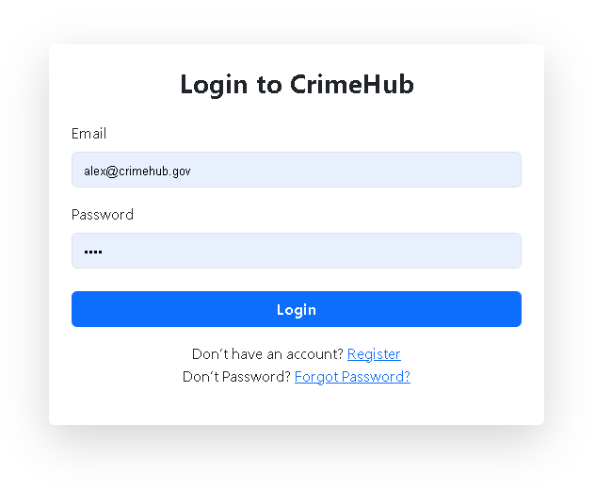
Field Name | Input Type | Required | Validation Rules | Error Message
Email | Email Field | Yes | Must follow standard email format (user@gov.com). Cannot be empty. | "Please enter a valid email address."
Password | Password Field | Yes | Must contain minimum 6 characters. Cannot be empty. | "Password must be at least 6 characters."
Login Button | Button | - | Enabled only when email and password fields are filled. | -
Register Link | Hyperlink | No | Redirects user to registration page if account does not exist. | -
Forgot Password Link | Hyperlink | No | Redirects user to password recovery page. | -

- Forget password Form
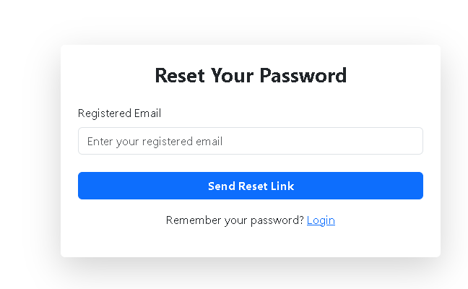
Field Name | Input Type | Required | Validation Rules | Error Message
Registered Email | Email Field | Yes | Must follow valid email format and must exist in the system database. | "Please enter a valid registered email address."
Send Reset Link Button | Button | - | Enabled only when email field is filled with valid format. | -
Login Link | Hyperlink | No | Redirects user to login page if they remember their password. | -
Message Alert | Alert Message | - | Displays success or error message returned from backend. | "Something went wrong"

- Reset Password Form
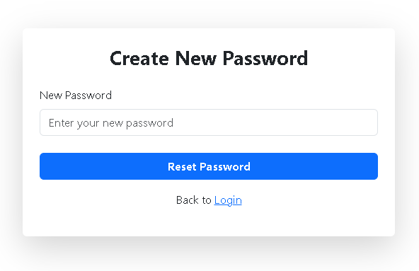
Field Name | Input Type | Required | Validation Rules | Error Message
New Password | Password Field | Yes | Must contain minimum 6–8 characters. Should include letters, numbers, or special characters for stronger security. | "Password must be at least 6 characters."
Reset Password Button | Button | - | Enabled only when password field is filled. | -
Login Link | Hyperlink | No | Redirects user to login page | -
Message Alert | Alert Message | - | Displays success or error message returned from backend. | "Error resetting password"

- Report Form
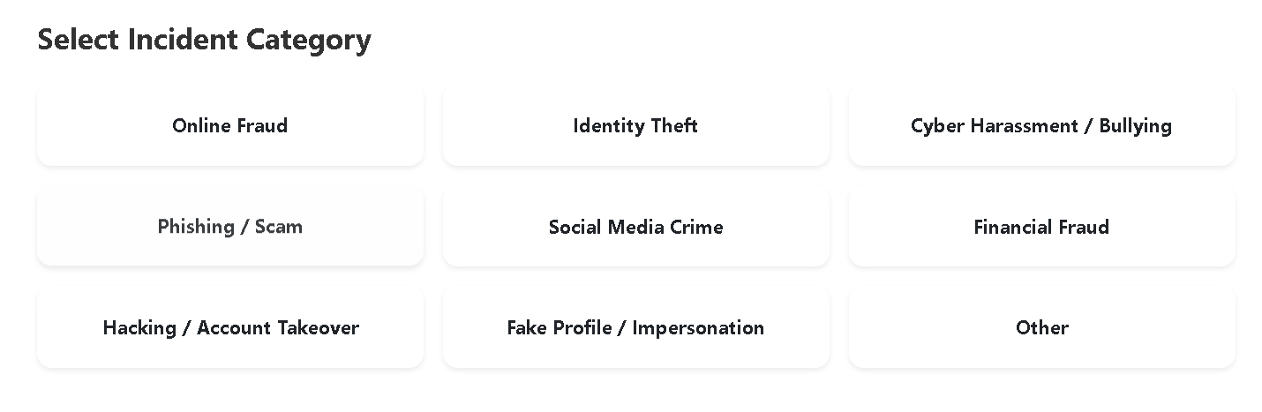
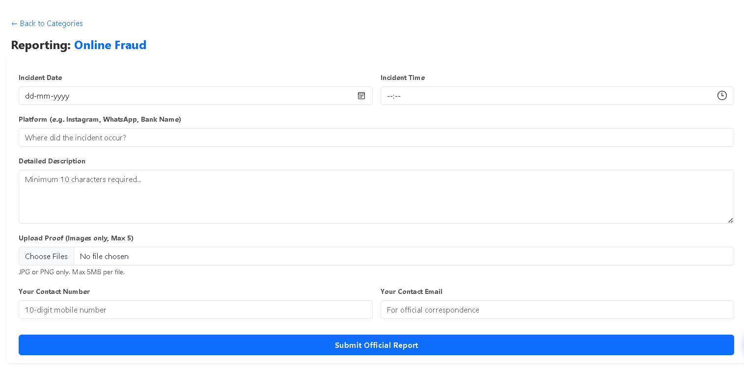

Field Name | Input Type | Required | Validation Rules | Error Message
Report Type (Incident Category) | Card Selection | Yes | User must select one crime category before proceeding to form. | "Please select a crime category."
Incident Date | Date Picker | Yes | Date cannot be in the future. Must be a valid date. | "Please select a valid incident date."
Incident Time | Time Picker | Yes | Must be valid time format (HH:MM). | "Please enter the incident time."
Platform | Text Field | Yes | Minimum 3 characters. Must specify where the incident occurred. | "Please specify the platform."
Detailed Description | Text Area | Yes | Minimum 10 characters describing the incident. | "Description must contain at least 10 characters."
Upload Proof | File Upload | Yes | Only image files (JPG/PNG). Maximum 5 files. Maximum 5MB per file. | "Only JPG/PNG images allowed. Maximum 5 files."
Contact Number | Tel Field | Yes | Must be exactly 10 digits. Only numbers allowed. | "Enter a valid 10-digit mobile number."
Contact Email | Email Field | Yes | Must follow valid email format. | "Enter a valid email address."
Submit Official Report | Button | - | Enabled only when all required fields are valid. | -

- Officier Login

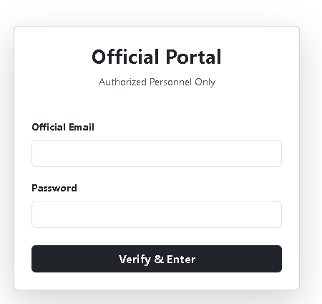

Field Name | Input Type | Required | Validation Rule | Validation Method | Error Message
Official Email | Email Input | Yes | Must follow valid email format | HTML5 type="email" validation | "Please enter a valid official email address."
Password | Password Input | Yes | Field cannot be empty | HTML required attribute | "Password is required."
Login Button | Submit Button | Yes | Disabled while API request is processing | React state loading | Button shows "Verifying..."
Error Message | Alert Box | No | Displays backend validation error | setError() state | "Login failed. Check your credentials."

- Manage Officier

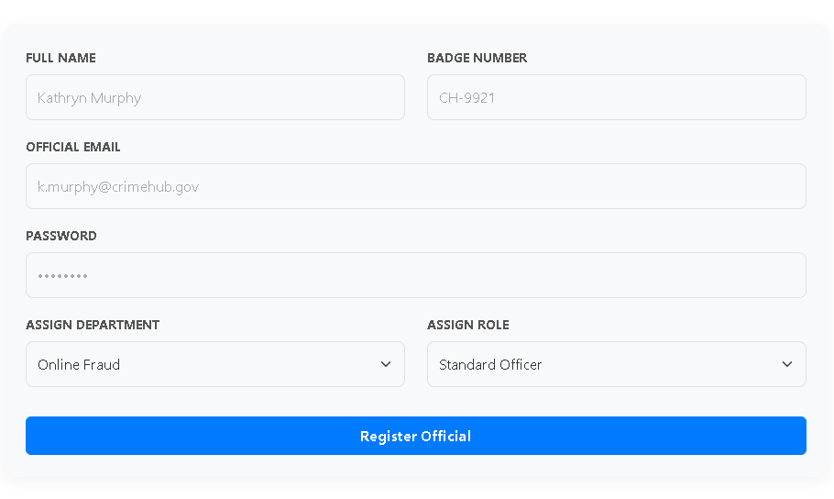
Field Name | Input Type | Required | Validation Rule | Validation Method | Error Message
Full Name | Text Input | Yes | Must contain alphabet characters, minimum 3 characters | HTML required + optional regex | "Please enter the officer's full name."
Badge Number | Text Input | Yes | Must follow department badge format (example: CH-9921) | Pattern validation | "Enter a valid badge number."
Official Email | Email Input | Yes | Must follow valid email format | HTML5 type="email" | "Please enter a valid official email address."
Password | Password Input | Yes | Minimum 6–8 characters recommended | Required validation | "Password is required."
Assign Department | Dropdown Select | Yes | Must select from predefined department list | Controlled select field | "Please select a department."
Assign Role | Dropdown Select | Yes | Must be either OFFICER or SUPER_ADMIN | Controlled select field | "Please select a valid role."
Register Official Button | Submit Button | Yes | Submits form data to backend API | onSubmit event | Shows success or error alert

- Case Form
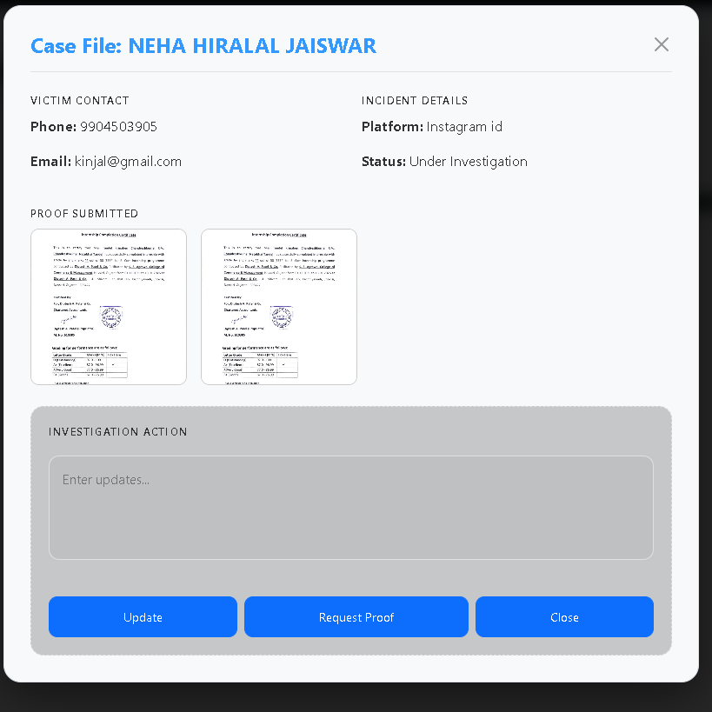

Field / Action | Input Type | Required | Validation Rule | Validation Method | Error Handling
Fetch Assigned Cases | API Request | Yes | Requires valid officer authentication token | JWT token from localStorage | Console error if request fails
Case Selection | Button Click | Yes | Officer must select a case before updating | setSelectedCase(item) state | No action if case not selected
Officer Remarks | Textarea | Optional (recommended) | Should contain investigation notes or instructions | React state remarks | Empty remarks allowed but not recommended
Case Status Update | Button Action | Yes | Must select one of predefined statuses | Button triggers handleUpdateStatus() | Alert if update fails
Evidence Image Display | Image Preview | No | Images must exist in server /uploads directory | Dynamic image URL construction | Placeholder shown if image fails to load
Modal Close | Button | Yes | Clears selected case data | setSelectedCase(null) | Modal closes safely

8. Testing

8.1 Testing
Testing is the process of evaluating a software application to ensure that it meets the specified requirements and works correctly under different conditions. It helps identify bugs, errors, and missing functionalities before the system is deployed.
In the CrimeHub system, testing was performed to ensure that the web application functions correctly for both citizens and police officers, and that all features such as case reporting, authentication, and case management work smoothly.
The main objectives of testing the CrimeHub system are:
- To verify that all features work according to requirements.
- To detect and fix errors or bugs in the system.
- To ensure the security of user data.
- To check system performance and responsiveness.
- To ensure compatibility across different browsers and devices.
8.2 Type of testing
- Unit Testing
Unit testing is performed to test individual components of the application.
In the CrimeHub project, unit testing was done for various React components, such as:
- Login component
- Registration component
- Report Crime form
- Officer dashboard
- Case list component
Each component was tested independently to verify that it behaves correctly.
Example:
- Checking if the login form accepts valid inputs
- Ensuring the report crime form submits data correctly
- Verifying that API requests are triggered properly
- Integration Testing
Integration testing verifies that different components work correctly when combined.
In CrimeHub, integration testing ensured that:
- Frontend (React) properly communicates with Backend API
- Data is correctly stored in MongoDB database
- User authentication works with backend validation
Example scenarios tested:
- User registration → data stored in database
- User login → token generated → access granted
- Reporting a crime → case saved in database → visible to officers
- System Testing
System testing evaluates the complete application to ensure that all modules function together as expected.
In CrimeHub, the full system was tested including:
- User authentication system
- Crime reporting functionality
- Officer dashboard
- Case status updates
- Case viewing and filtering
This testing ensures the entire application behaves correctly as a complete system.
- Functional Testing
Functional testing ensures that each feature performs according to its intended functionality.
Examples tested in CrimeHub:
Feature | Expected Result
User Registration | User account created successfully
User Login | User redirected to dashboard
Report Crime | Case submitted successfully
View Cases | User can see submitted cases
Officer Login | Officer dashboard loads
Close Case | Case status updated

- Performance Testing
Performance testing ensures that the application performs efficiently under different conditions.
For CrimeHub, the following were tested:
- Page loading speed
- API response time
- Handling multiple case records
- Smooth navigation between pages
The React application was optimized to reduce unnecessary re-renders and improve load time.
- Security Testing
Security testing ensures that user data is protected and unauthorized access is prevented.
The following security measures were tested:
- Password encryption
- Secure login authentication
- Protected routes for officer dashboard
- Prevention of unauthorized case access
Example:
- Users cannot access officer pages without officer login.
- Unauthorized users are redirected to the login page.

9. Future Enhancement

The CrimeHub system is designed to provide a simple and efficient platform for reporting cybercrime complaints. However, the system can be further improved by adding additional features and technologies in the future.
  - Mobile Application
In the future, a mobile application can be developed for Android and iOS platforms. This will allow users to easily report cybercrime incidents and track complaint status directly from their smartphones.
  - Real-Time Notifications
The system can include real-time notifications such as email or SMS alerts. Users will receive notifications when their complaint status is updated or when feedback is provided by the administrator.
  - Advanced Security Features
Additional security mechanisms such as two-factor authentication (2FA), CAPTCHA verification, and stronger encryption methods can be implemented to improve system security and protect user data.
  - AI-Based Crime Detection
Artificial Intelligence can be integrated to automatically analyze complaints and detect patterns of cybercrime. This can help administrators identify serious threats and prioritize complaints more efficiently.
  - Integration with Government Systems
The system can be connected with official cybercrime portals or law enforcement databases. This will allow faster investigation and better coordination with authorities.
  - Multilingual Support
Future versions of the system can support multiple languages so that users from different regions can easily use the platform.
  - Complaint Analytics Dashboard
An analytics dashboard can be developed for administrators to view statistics such as the number of complaints, types of cybercrimes, and resolution rates. This will help in better decision-making.

10. References

- React Official Documentation
React Documentation. (2024).
Available at: https://react.dev
Accessed for understanding component structure, state management, and frontend development.
- MongoDB Documentation
MongoDB Inc. (2024).
Available at: https://www.mongodb.com/docs
Used for database operations and backend data storage.
- Node.js Documentation
Node.js Foundation. (2024).
Available at: https://nodejs.org/en/docs
Used for backend server implementation and API communication.
- Express.js Official Documentation
Express.js Documentation. (2024).
Available at: https://expressjs.com/
This documentation was used to understand routing, middleware, and server-side development for building REST APIs in the CrimeHub system.

