# OCR INTERNSHIP

# 

GUI application which allows you to print text from your input image

INSTALLATION

You need to have the following installed on you PC:

* Python latest verion
* OpenCV python library
* Tesseract OCR library
* Tkinter library

Features

* Open Image
* Blur Image
* Auto Crop
* Manual Crop
* OCR
* Show Text
* Save Image
* Close All Windows

## Open Image

## This feature allows us to open the image from any directory of PC.

## 

## Blur Image

## This feature allows us to Blur the image that we have opened

## 

## Auto Cropping

This feature allows us to crop image directly by pressing the autocrop button in app

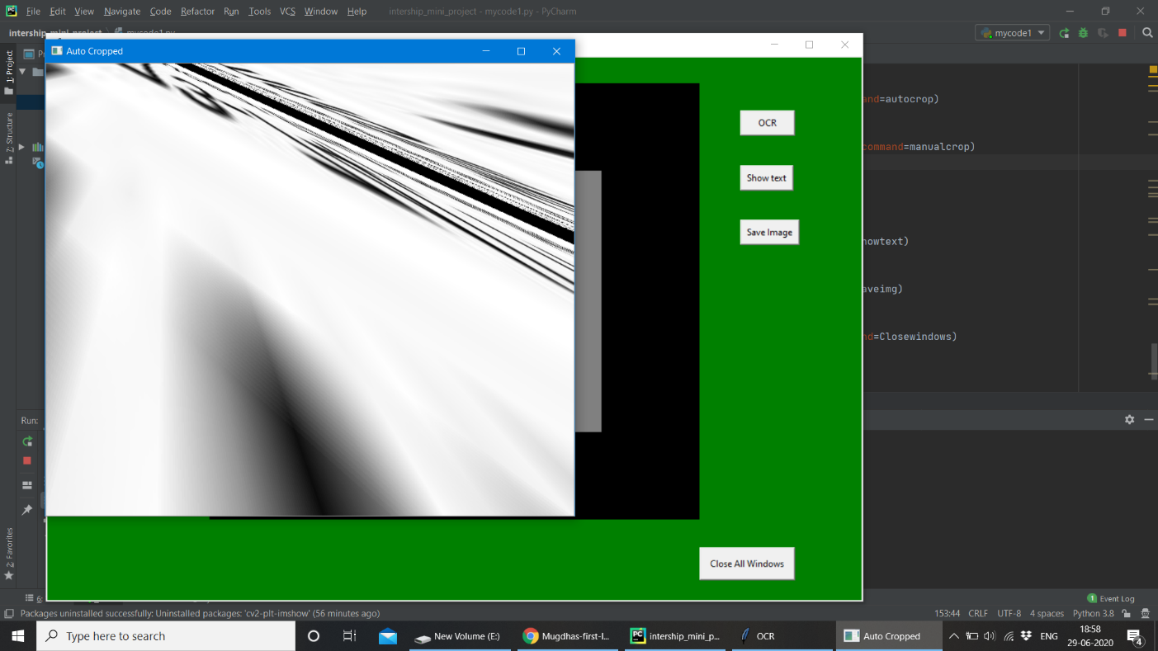

## Manual Cropping

This is the backup option to the autocrop option .The autocrop option may not always crop the image as we want,so by this feature we select four points on the image as crop it the way we want. 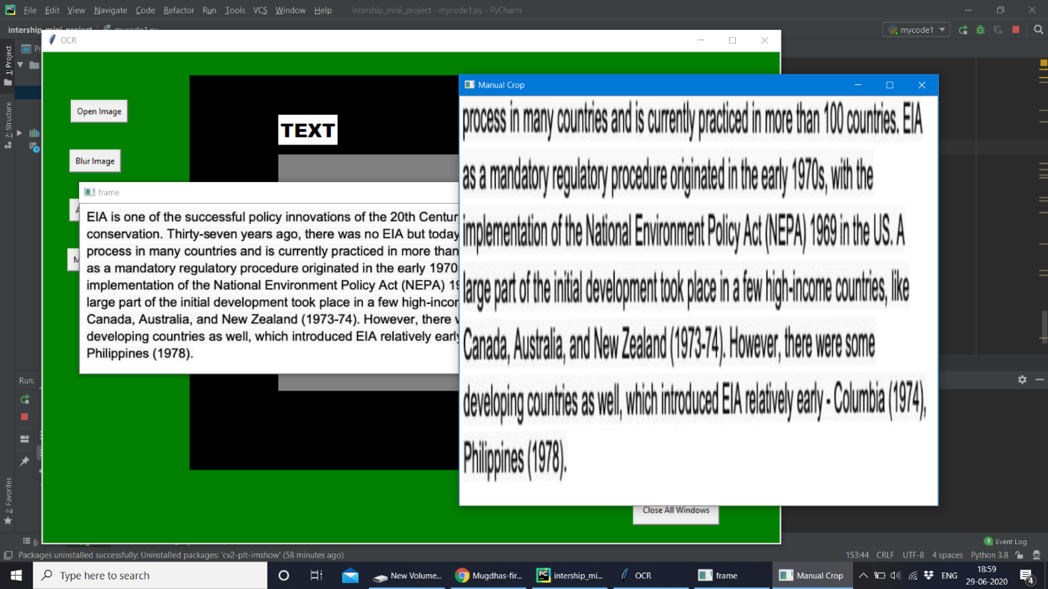

## OCR

This feature allows us to bound every word of the text in the image with rectangles.

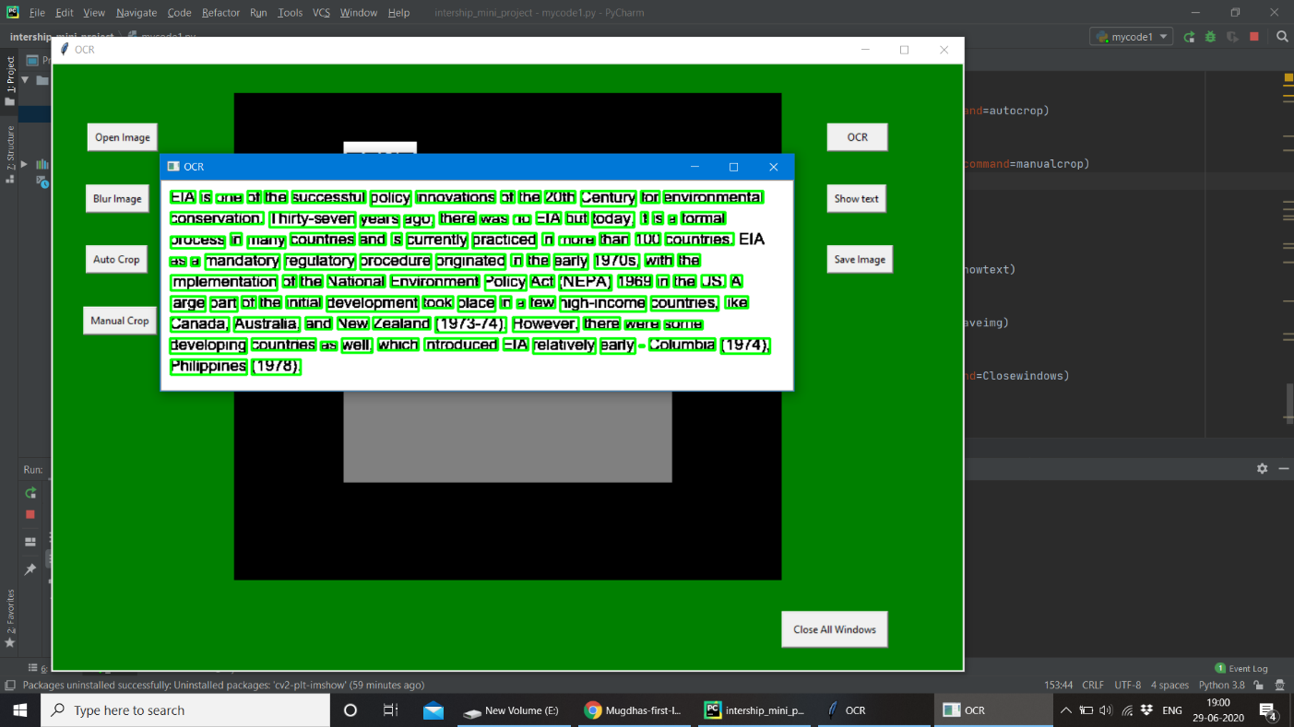

**Show Text**

This allows us to get the text in frame of our app where we can ,edit or copy paste it from there.

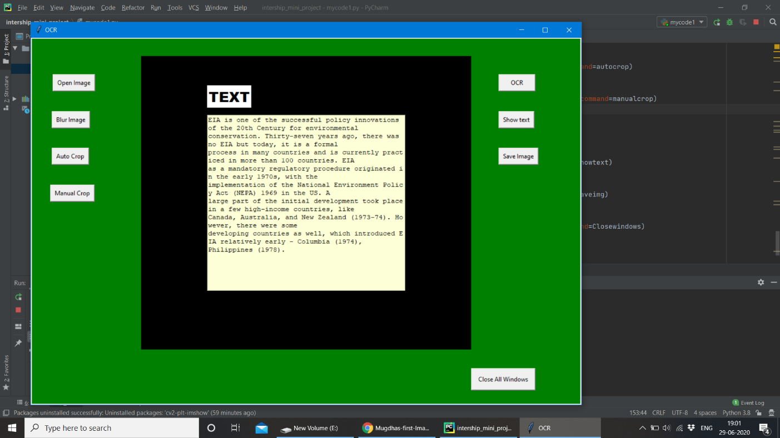

**Save Image**

It saves the image to directory that want.