DYNAMIC MODEL OF TOYOTA PRIUS

Figure below shows the power train configuration of the THS. The planetary gear has three nodes: the sun gear, the carrier gear, and the ring gear; which are connected to the generator, engine and vehicle, respectively. In addition, an electric motor is also attached to the ring gear, which enables direct motor propulsion and efficient regenerative braking. The power generated by the engine is transferred to the vehicle through two paths: a mechanical path and an electrical path. The mechanical path consists of power transfer from the carrier gear directly to the ring gear, which is connected to the final drive of the vehicle. Part of the engine power transfers through the sun gear. The power is then transformed to the electrical form through the generator. The power is then either pumped into the battery, or to the electric motor. Obviously, engine power going through the second (electrical) path is less efficient than the mechanical path from an instantaneous viewpoint. However, the energy stored in the battery may be used later in a more efficient manner which helps to improve the overall vehicle fuel economy.

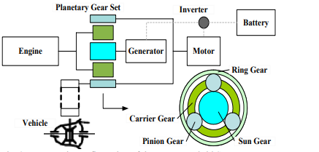

POWER TRAIN CONFIGURATION FOR TOYOTA HYBRID SYSTEM

CONTROL STRATEGY

Even though a linear control approach is possible, as discussed in the previous section, the control algorithms used in many HEV prototype vehicles are rule-based. This is because of the multiple-input and multiple-objective nature of the control problem. It is intuitive that since the engine is the predominant power source—and if we can operate the engine at an efficient manner, the overall vehicle efficiency will be reasonable. This simple idea is an easy way to provide a near-optimal solution quickly, even though there is no guarantee of its closeness to optimality. For engineers pressed for time, the rule-based design strategy is a safe approach. Hermance presented the basic idea of the rule-based control logic of the THS system. Similar description can be also found in . In the following, a rule-based control strategy is developed following these references to approximate the control law used in the THS.

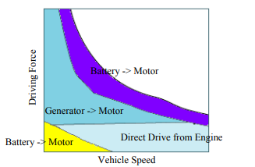

As shown in the Figure, the driving force can be provided by motor and/or engine. When the power demand is low and the battery SOC is sufficiently high, the motor works individually to drive the vehicle. As the vehicle speed increases, power demand increases, or the battery SOC becomes too low, the engine will be started to supply the power. The generator cooperates with the motor to help start the engine. Within the engine operating range, its engine power will be split through the planetary gear system. Part of the power goes to the vehicle driving wheel through the ring gear. The rest drives the generator to charge the battery and/or directly supply the motor power. In other words, although the engine fully supplies the power at this stage, the power is split and executed through two paths, the ring gear to the final wheel and the generator to the motor. As the power demand keeps increasing, the engine might be stretched to operate outside of its efficient range. For those cases, the motor can provide assistant power so that the engine efficiency remains high (as long as the battery is able 137 to supply power). When the vehicle decelerates, the regenerative control system commands the motor to operate as a generator to recharge the battery. The friction brake is used whenever the requested braking power exceeds the capability of the motor or the battery. The engine and other components in the THS are set to free-rolling. To simplify the system, the effect of engine brake is ignored. Table I summarizes the basic ideas discussed above.

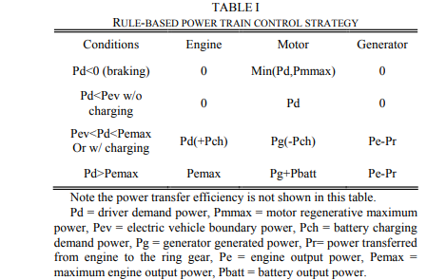

CONCLUSION

A dynamic model of the Toyota Prius hybrid system, THS, was developed in this paper. A rule-based controller was implemented to control the overall behavior of the vehicle in a Matlab/Simulink model. Simulation results confirms that the vehicle mimics the behavior of the THS operation reasonable well. This dynamic model is currently used for control and system analysis. We are also exploring configuration, component design and control methods to further improve the vehicle performance.

WHEN COMPARED WITH VOLVO XC90

TOYOTA PRIUS VOLVO XC90

